SSO-MXSS-Enhancement
By Prangya
This is to move the MXSS-SSO-Enhancement code from Stage to Prod.
Env: Prod
Time; 3-4hr
Impact: N/A, as MXSS has no real participants.
Business Justification::
This MXSS-Enhancement will add the patient's MRN and UID, then encrypt them before adding them to the token for UUX to read.
This has been implemented and tested in the Stage environment.
Implementation:
Create the following AWS services.
1> Create a federation lambda function:
- This would be the exact same as Stage lambda to read MRN and UID from SAML.
- This should have the same IAM role as currently in Stage.
- This will encrypt the PHI and store in Dynamo.
- Add Python Layer to install the dependencies libraries.
2> Create a secret key to store the Public Certificate.
3> Create a pre-token lambda function:
- This would be the exact same as the Stage lambda to read MRN and UID from Dynamo and to add it to the Token..
- This should have the same IAM role as currently in Stage.
4>Create a DynamoDB table: To store the encrypted MRN and UID for 120sec[TTL=120sec]
5> In Cognito:
Add into Cognito SignUp:
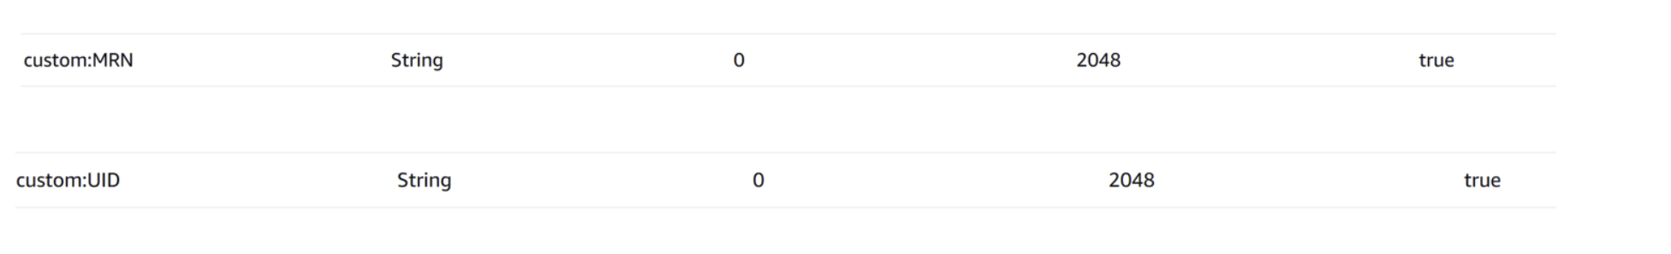

Add the following custom Attributes to App Client
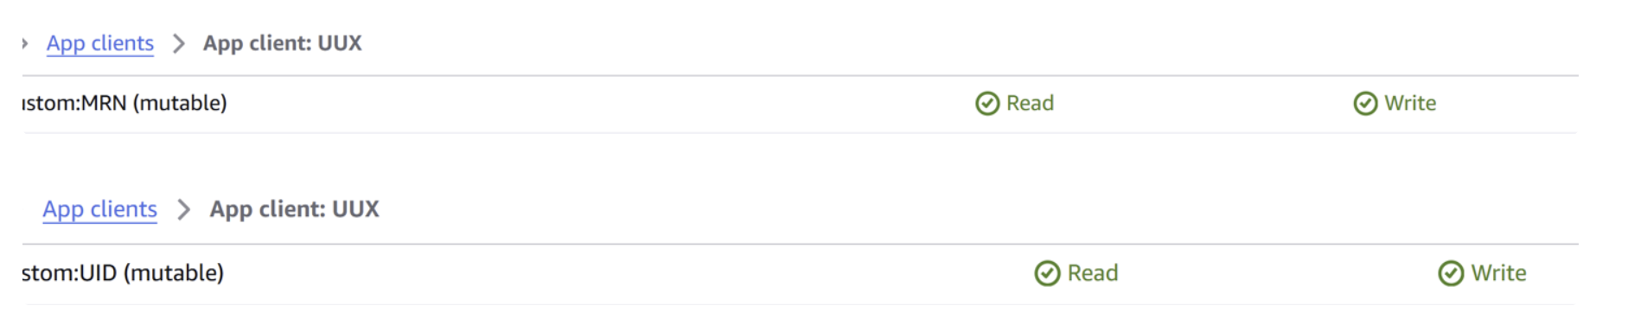

6>Add the Lambda Triggers into Cognito:
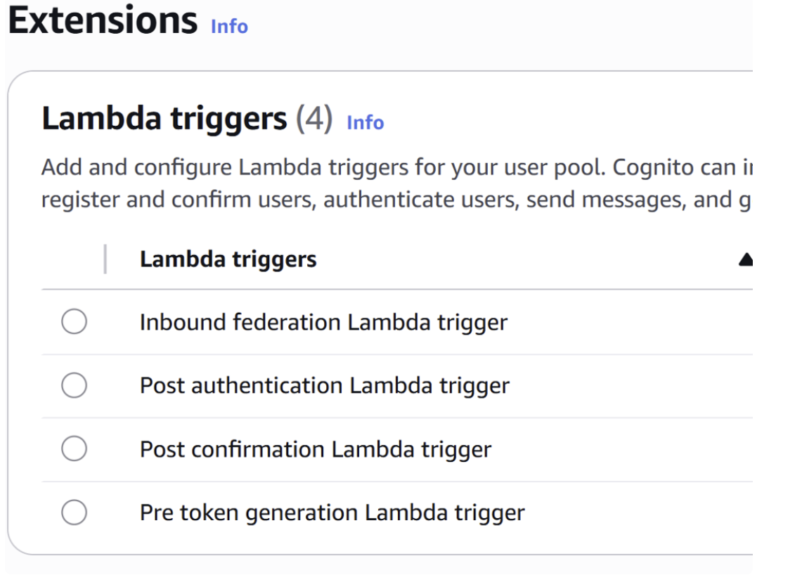
Add Environment Variable to Federation Lambda Function:
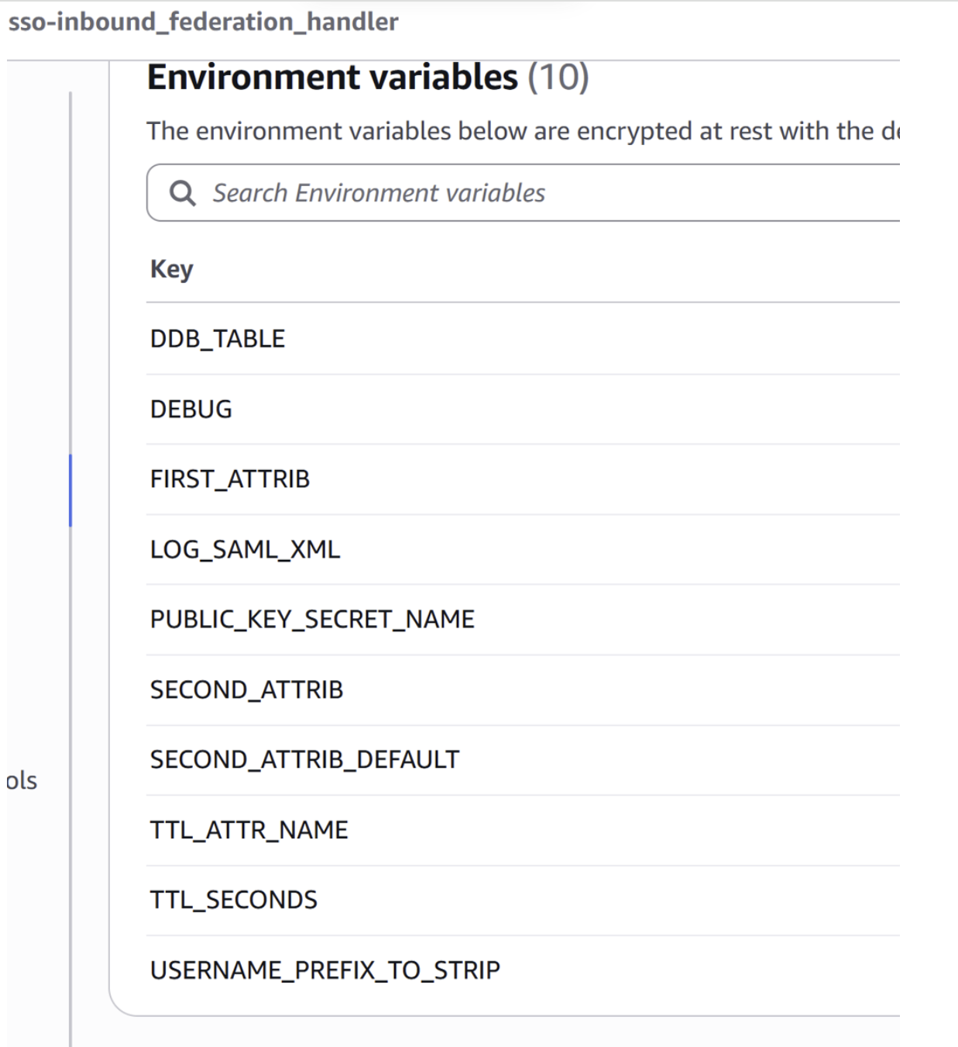
Add following environment variables to Pre-token generation lambda function:
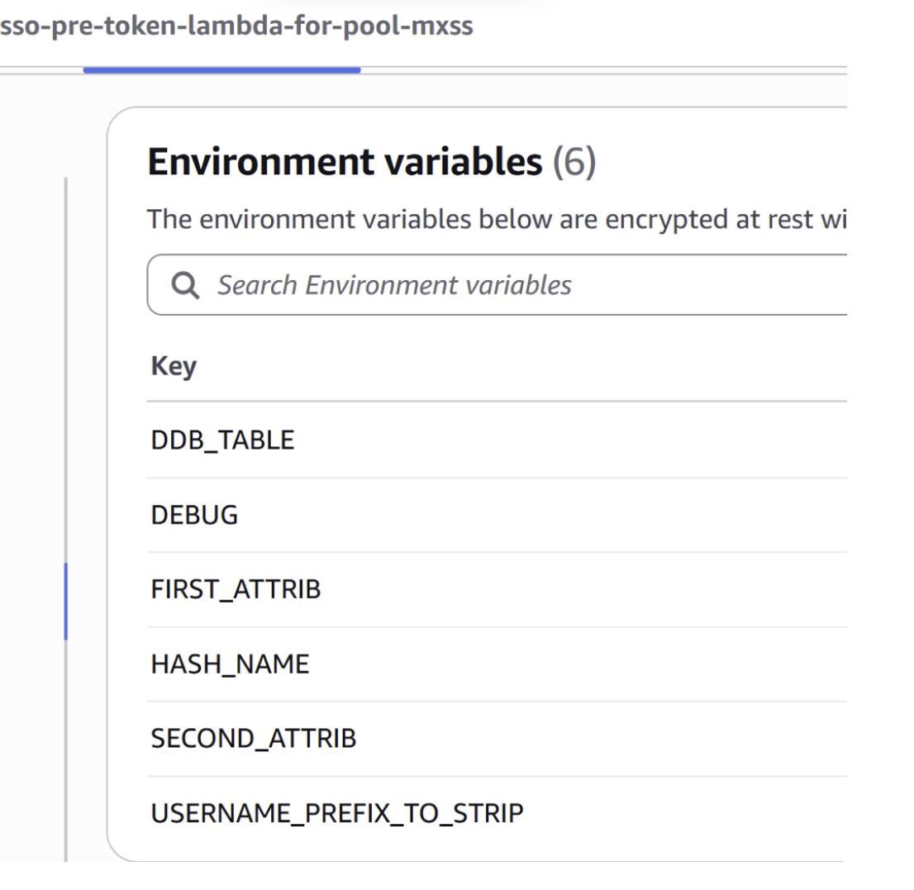
RollBack: Remove federation lambda, pre-token lambda, dynamo, IAM role,Custom UID and MRN properties.
Understanding the Encryption Method:
RSA-OAEP with SHA-256 -
Explanation
1. What is RSA-OAEP with SHA-256? RSA-OAEP-SHA256 is a modern, secure publickey encryption method. It combines: - RSA: Asymmetric encryption (public/private key) - OAEP: Optimal Asymmetric Encryption Padding for security - SHA-256: Hash function used for randomness and masking inside OAEP
2. Why RSA alone is not enough RSA by itself is deterministic and vulnerable to attacks. OAEP adds randomness, masking, and protection against chosen ciphertext attacks.
3. What OAEP does internally: - Generates a random seed - Uses SHA256 inside MGF1 to create two masks - Mixes the seed and plaintext into a padded, randomized block - Ensures identical plaintext encrypts differently each time
4. Why SHA256? SHA256 provides strong hashing, resistance to collision attacks, and modern cryptographic strength. Using SHA256 with OAEP is the recommended standard.
5. High-level encryption steps:
1) Take plaintext
2) Generate random seed
3) Use SHA256 + MGF1 to mask seed & plaintext
4) RSA encrypt the padded block
5) Base64-encode the ciphertext for storage (e.g., in DynamoDB)
6. Decryption (done outside Lambda): - Base64 decode - Use private key to reverse RSA-OAEP-SHA256 - OAEP unmasks the seed and plaintext
7. Here Federation Lambda uses RSA-OAEP-SHA256 - Securely encrypt sensitive identifiers (MRN, UID) - Store only ciphertext in DynamoDB - Ensure only the private-key holder can decrypt - Strong protection even if database is compromised.
In summary RSA-OAEP-SHA256 = RSA encryption + strong OAEP padding + SHA-256 hashing. It provides confidentiality, randomness, and modern cryptographic security.

Changes required in ENTRAID:
Cory to add followings on ENTRAID:
custom:MRN- String
custom:UID- String

