**Ashutosh Upadhyay**

Co-founder at Liger Mobility

## About

Passionate about leading teams to build innovative products & services, that deliver value to end users. Have set up and grown teams from scratch, by leveraging core strengths - Technology, Product Management & Entrepreneurship. Rich experience in Engineering, Enterprise, Cloud and Mobile Software, iOT, AI, Advanced Tech.

Linkedin : <https://www.linkedin.com/in/ashutoshu/>

**Dr.Jayant Kumar (PhD)**

Executive Business Leader, Board Member, Passionate EV R&D, Startup, International Business

## About

Ex-Managing Director and CEO of TechnoPro India (Executive Member of Japan HQ).   
Responsible to setup India Business with a vision to provide solutions to Japanese and Global customers in Digital Engineering, AI&ML, Cloud, EVs and R&D under GDC framework.   
  
Specialists in :  
- Revenue Generation, Managing P&L  
- New Market Development  
- Driving Business development and Partner Management   
- Capability building through research matrix   
- Enterprise Customer Relationship Management  
- Engaging with Stakeholders and Executive Board in meeting cross border challenges and mitigating them through teams of all 'shapes and sizes.  
  
Management Speaker at various Technology and Innovation industry Forums.( Mobility, Business Eco-systems)  
   
Successful team builder with an open and collaborative management style leading to high employee engagement.  
Jayant is fluent in Japanese and English and capable in leading and managing teams in either language.

Linkedin : <https://www.linkedin.com/in/jayantzuno/>

# John A R

Power Electronics | Electric Vehicles (EV) | Drives & Control

Linkedin : <https://www.linkedin.com/in/john-a-r/>

# Mohan Satyaranjan

Entrepreneur: Smart, Connected, Secure Systems for Sustainable Living (Energy, Blockchain, Smart Supply Chain, IoT).

**About**

Led multiple different teams (many of them built from scratch) in different organizations. Without an exception, all of them were recognized as, “High Performing”: great innovators, customer focused, creating lasting value, and pool of great leadership talent.   
  
Had great success in attracting, motivating, and retaining great talent.   
  
Have more than 25 years of R&D experience (products and solutions for the enterprise, service provider, SMB & consumer).  
  
Extremely versatile, and successful in each of them: Have been focused on uCPE/NFC/SDN, Cloud, Virtualisation, M2P, P2P, and Intelligent Systems in the last 6 years. Led development of Ethernet Switches, and Network Automation Platform & Applications (M2A: Junos Space & Apps.) at Juniper, Routers (at Cisco), Storage Virtualisation & Management Software (at NetApp), Mobility (was lead for World’s first GPRS Phone at Motorola) at Motorola, and M2M & Industrial Automation at RDCIS.  
  
Did research in Reconstruction from Incomplete Data & Medical Imaging. Have exploited Machine Intelligence for industrial control systems.  
  
Started tinkering early. Current hobby: tinkering in the area of 'Secure, Sustainable, Efficient Living' (Energy/Water/Food/Security) in the IoE world.  
  
 Expert at Cycle-Time Reduction at Optimal Cost; Recognised for superior execution, and disruption  
  
Specialties: Engineering & Product/General Management, Cloud Technologies, Virtualisation, Collaboration (P2P:VoIP, Social Media, Video, Presence), M2M(IoT), Machine to Analytics, Mobility, Data Sc., Networking, Machine Intelligence, AGILE, Mentoring, and Leadership.

Linkedin : <https://www.linkedin.com/in/mohan-satyaranjan/>

# Dr. Ramesh Singh

Analysis and Design of Electric Vehicles

**About**

Presently working as Vice President Motor Engineering at Omega Seiki Private Limited Delhi, since December 2022.   
I am also an Ambassador to IEEE Smart Cities and a Senior Member of IEEE USA.  
In my long professional career of 21 years, I have been actively involved in imparting technical knowledge and skills to young minds (undergraduate and graduate students of engineering), particularly in the domain of Electrical Machines, Renewable Energy Systems, Power Systems, Smart Grids, and Electric Vehicles.  
  
Specialties:   
Operation of Induction Motor Drive in v/f mode. Application of synthetic braking and regenerative braking on IM drive for EV applications. Cost-effective backfitting of two-wheeler scooter.   
Finite Element Analysis, Mathematical Modelling, Induction Machines, Electric Vehicle, Smart Grids, WECS, MATLAB, MotorSolve, and PROTEUS.  
Using Finite Element Analysis software MOTORSOLVE designed a model of the Three Phase and Six Phase (Dual Stator) Induction Machine and analyzed its performance under different operating conditions. Calculated its efficiency, Temperature profile, Flux density, Current density for different winding configurations and phase belts.  
  
Designed a Mathematical model of a Three-phase and Six Phase (Dual Stator) Induction Machine (with both symmetrical and asymmetrical winding configurations).   
Tested the developed model for motoring as well as generating mode under balanced and unbalanced conditions.   
Successfully performed synthetic braking on the models.  
  
Designed and developed hardware prototypes of 5 HP and 7.5 HP Three Phase Induction Machine and taught the same to BTech 4th year students.  
  
Designed and developed a hardware prototype of a 5HP Dual Stator Induction Machine using an old IM by rewinding it for six phases. Tested and calculated the different performance indices of the same machine. Run the machine as a motor and coupled it with another 7.5 HP IM to operate it as a generator. Tested the generator under different loading conditions in grid coupled and off-grid mode.  
  
Designed and developed hardware of single-phase and three-phase transformers from 50VA to 5kVA rating.  
• Two winding transformers  
• Three winding transformers (Star/Star, Star/Star/Delta/ Zigzag type).  
• Variable Inductors (Single Phase and Three Phase type).  
  
Design of Electronic and Control circuits and generating Gerber files of Relay, Inverter, Controllers, Choppers, etc.

Linkedin : <https://www.linkedin.com/in/dr-ramesh-singh-b376674/>

# Naveenkumar Marati, PhD

 Architect -E-mobility, Fast Charging,Off-Board Charging|| Power Electronics || EV and Hybrid Electric Vehicle||Frontline Manager||Senior Member IEEE|| Certified SAFe 5 Scrum Master

**About**

Dr. Naveenkumar has 10+ years of experience in the field of power electronics and control which includes 5+ years of Automotive experience in the R&D. Has demonstrated experience in Design, Modelling and Digital Control of Power Electronic Converters, Power Electronic Converters for Renewable Energy Sources , Power Electronics Application in Power Systems, Hybrid Electric Vehicles and Electric Vehicle and its applications. He also has a good hand-on experience with micro controllers (TI, STM, etc,.) including its integration with power electronic converters.  
  
Worked with Valeo (a French automotive organization) Research and development center Chennai, India. Working with the latest technologies like GaN switches for DC-DC Converter and On-board Charger for the applications of Hybrid Electric vehicle and Electric Vehicle power train systems.  
  
Currently working with Wipro in Engineering Research and Development for Electric Vehicle COE Team. Working Hybrid and Electric Vehcile architecture and components. Handling a Team for the development of inverter and motorcontrol unit in the application EV and HEV applications.

Linkedin : <https://www.linkedin.com/in/naveenkumar-marati-phd-3b274546/>

# Adrustavantha R

Power Electronics | Electric Vehicles | Battery technology

**About**

A Power Electronics enthusiast working as an senior electrical researcher (R&D) with 2.5 years of experience. I am Passionate about creating sustainable solutions to practical engineering challenges that could make the Green and Sustainable Society.  
  
Circuits design and Simulation : -   
* Basic analog and digital control circuits design  
* Power Electronics : DC- DC converters, DC- AC Inverters single and 3 phase  
* Tools : MATLAB(simulink/simscape), LTSPICE, PSIM, PSPICE  
  
PCB Design and Hardware Testing : -   
* Tool : KICAD   
* Schematics design, simulation, Layout design and gerber plots  
* b.o.m generations and coordinating for pcb prototyping  
* Initial power testing of PCB and debugging  
  
Firmware development and Debugging : -  
* Controllers : TI (C2000 family), Renesas, Microchip, ESP32  
* IDE : Code Composer Studio (CCS), e2 studio, MPLAB, VSCode, Arduino  
* Peripherals : ADC, DAC, PWM and GPIO  
* Communication protocols : UART/SCI, SPI, I2C and CAN  
* Version control : git, github, TortoiseHg  
* Project management : Kanban, Agile, Jira  
  
  
* All posts posted and opinions expressed are my personal opinions only. Not from my employer or company *

Linkedin : <https://www.linkedin.com/in/adrustavanthar/>

# Giridhar Joshi

Vehicle Engineering and data Analytics | AiML | Connected Vehicles (IoT) platform for business intelligence

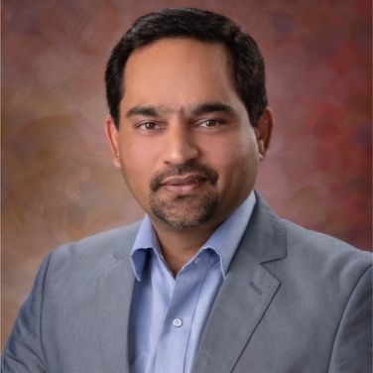

**About**

• Active in the automotive Iot and data analytics area, presented at many conferences, also well recognised for the application of data analytics science within the automotive industry.  
• Gained diverse skill sets – Analytics, Data Science, automotive engineering, etc.  
• Developed a predictive analytics model for Electric Vehicle Range Prediction   
• Built measurable consumer engagement impact through data analysis products   
• Generated measurable revenue impact through Data analysis models  
• Deduct qualitative and quantitative inferences from experimentation data that lead to product optimization  
• Expert at data interpretation and story telling to communicate the results in simple and engaging manner.  
• Design and implement predictive models and simulations to optimize business decisions and product development   
• Deep product sense, with a solid understanding of user engagement and monetization strategies for software  
  
  
The Precognition of Digital Vehicle Twin: Transforming Telematics Data into a Strategic Asset!   
  
Giridhar is mainly into Automotive Telematics and Analytics. in this role he primarily drives product and technology/innovation. Develops Libraries of case studies using automotive data.   
  
Giridhar comes with a unique confluence of skills spanning Automotive engineering, Business Administration, and Data Analytics (AiML).   
  
With his deep domain experience of 20+ years in Automotive engineering and AimL, Giridhar is developing the Digital Vehicle Twin: connected vehicle ecosystem.  
  
The Digital vehicle Twin enables a comprehensive view of vehicle data and improves vehicle lifecycle management, By using AI-powered analytics that detects and diagnoses problems before they compromise vehicle abilities.  
  
This adds tremendous value to the whole ecosystem including automakers, Dealers, and End customers by giving insights into the data.   
  
DVT's precognitive powers allow vehicle Manufacturers to deliver an exceptional ownership experience to their customers by staying a step ahead of the customer's requirements.  
This not only helps them develop the next generation product but also serves the existing customers' Needs "before" they ask.

Linkedin : <https://www.linkedin.com/in/joshigiridhar/>

# Dr. JASWANTH NIDAMANURI

Assistant Professor, School of Technology, Woxsen University Hyderabad || Ex-Project Scientist - IHuB-Data, IIITH || ML, DL- ADAS, Multi-Sensor & Modality || Computer Vision and DL Research Consultant - Open to Help

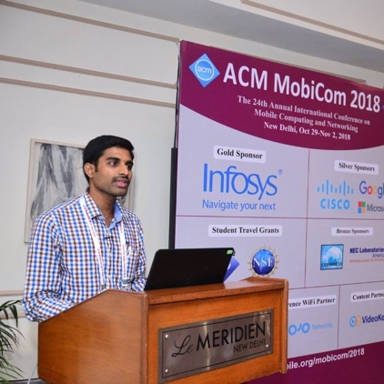

## About

I am a conﬁdent, organised and motivated research scholar with a perfect integration of computer vision, AI, Machine Learning and Deep Learning concepts.   
  
Research Areas -   
Computer Vision, Machine Learning, Deep Learning for L3/L4 ADAS and Vehicular Platooning.  
  
Projects Experienced:   
1. Advanced Lane Assistance, Tracking & Analysis with CNN's.  
2. Driver Drowsiness Detection and warning using Deep Learning.  
3. Pedestrian Detection.  
4. Object Recognition.  
5. Facial Expression Recognition using VGG net.  
6. State-of-Art Object Detection Algorithms.  
7. Distance estimation - single view camera  
8. Pothole detection and analysis  
  
Me @ :  
Interested and Working in Artificial intelligence, Machine Learning, computer vision and Deep Learning concepts for Advanced Driver Assisted Systems (ADAS) for Indian traffic towards Autonomous Driving.

Linkenin : <https://www.linkedin.com/in/dr-jaswanth-nidamanuri-669a97b7/>

# Aftab M. Hussain

Associate Professor | Flexible Electronics | Smart Cities

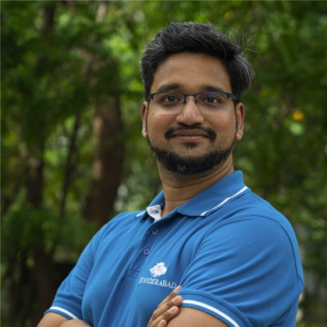

## About

Over 10 years of hands-on experience in:  
-> High voltage electronic systems  
-> Cloud connected IoT devices and their applications  
-> Micro-fabrication (processing in a Class-100 cleanroom)  
-> Physical characterization of thin films (SEM, AFM, XRD, Raman Spectroscopy)  
-> Electrical characterization of semiconductor devices, material thin films  
  
100+ papers, 1800+ citations, 12 patents

Linkedin : <https://www.linkedin.com/in/aftab-m-hussain-b9b22518/>

# Anbumani Subramanian

Principal Engineer at Intel

## About

• 20 years of industry experience in developing software applications, algorithms and solutions   
• Strong experience in design, development and leading teams to create novel, proof-of-concept ideas in AI/ML, computer vision, imaging  
• Rich experience in collaboration with academic and industry partners to develop large-scale, real-world applications   
  
• Technical interests - AI, machine learning, geo-spatial data analytics, computer vision, image analysis, human-computer interaction  
  
• Notable contributions - India Driving Dataset (IDD), gesture recognition, vision system for autonomous boat  
• 10 patents; several peer-reviewed, top-tier research publications

Linkedin : https://www.linkedin.com/in/anbumanisubramanian/