Time plot for minimum temperatures from 2008-2017 (Australia, Albury)

Pranav Gopalkrishna, 1940223

2022-01-11

# DATA SET

This data set contains daily meteorological data from 2008-2017, for different cities in Australia. The observations are of various types, including minimum temperature, predictions of rainfall, and measures of sunshine.

## Viewing a few rows

data = read.csv(  
"~/Documents/Study/computerScience/programming/r/data/weatherAustralia.csv")[c(1, 2, 3, 5, 9, 14)]  
head(data)

**Date Location MinTemp Rainfall WindGustSpeed Humidity9am**  
01/12/08 Albury 13.4 0.6 44 71  
02/12/08 Albury 7.4 0.0 44 44  
03/12/08 Albury 12.9 0.0 46 38  
04/12/08 Albury 9.2 0.0 24 45  
05/12/08 Albury 17.5 1.0 41 82  
06/12/08 Albury 14.6 0.2 56 55

This data is a time-series data, with many observation fields. We will focus on **MinTemp**(minimum daily temperature), **Rainfall, WindGustSpeed,** and**,** **Humidity9am** (humidity at 9AM) . Other columns have been omitted in the above table for convenience. Also, since the data is taken from different locations across Australia, we will focus on data taken for **Albury** alone.

## Creating numerical vectors for each measure

MINIMUM TEMPERATURE  
mintemp = data$MinTemp  
mintemp = mintemp[data$Location == "Albury"]

RAINFALL  
rainfall = data$Rainfall  
rainfall = rainfall[data$Location == "Albury"]

WIND GUST SPEED  
windgustspeed = data$WindGustSpeed  
windgustspeed = windgustspeed[data$Location == "Albury"]

HUMIDITY AT 9AM  
humidity = data$Humidity9am  
humidity = humidity[data$Location == "Albury"]

# OBTAINING TIME-SERIES OBJECTS

## Inspecting time points

Inspecting the dates (useful when defining the time-series end points)…

dates = as.Date(data$Date, "%d/%m/%y")  
summary(dates)

**Min:** "2008-12-01"  
**1st Quartile:** "2011-01-18"  
**Median:** "2013-05-10"  
**3rd Quartile:** "2015-06-03"  
**Max:** "2017-06-25"

Hence, the data is taken daily from **2008-12-01** to **2017-06-25**. (Default format is yyy-mm-dd, so to read the dates appropriately from the data set, I have specified the format dd/mm/yyyy, since this is how it is present in the data set)

## Creating time series objects

We already have the various measures for Albury as a numerical vectors, so we must simply convert it to a time-series objects (i.e. objects of class ‘ts’)…

mintemp = ts(  
 mintemp,  
 start = c(2008, 12, 1),  
 end = c(2017, 6, 25),  
 frequency = 365)  
rainfall = ts(  
 rainfall,  
 start = c(2008, 12, 1),  
 end = c(2017, 6, 25),  
 frequency = 365)  
windgustspeed = ts(  
 windgustspeed,  
 start = c(2008, 12, 1),  
 end = c(2017, 6, 25),  
 frequency = 365)  
humidity = ts(  
 humidity,  
 start = c(2008, 12, 1),  
 end = c(2017, 6, 25),  
 frequency = 365)

### NOTE

c(2008, 12, 1) => 2008-12-01

c(2017, 6, 25) => 2017-06-25

frequency = 365 => the data has daily observations  
(12 => monthly, 4 => quarterly, 1 => annually)

# TIME PLOTS

## General function to create time plots

timeplot = function(timeseries, name){  
 ts.plot(timeseries,  
 main = paste(name, "(Australia, Albury, 2008-2017)"),  
 ylab = name,  
 xlab = "Year",  
 col = "purple")}

## Plots

timeplot(mintemp, "Minimum temperature")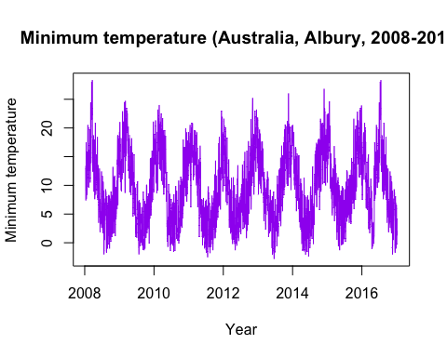

Here, we do not observe any **trend** across the years. The fluctuations in the minimum temperature are **seasonal** in nature, repeating in a similar pattern for each each. There is no **cyclical** **fluctuations** observable in the data. **Irregular fluctuations** can be seen in the slight but noticeable and fairly random variations in the spikes of the data within each seasonal cycle and the overall seasonal fluctuations themselves.

timeplot(rainfall, "Rainfall")

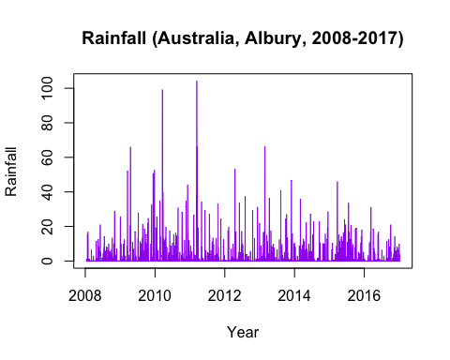

Here, we do not observe a constant **trend** across the years. The fluctuations in the rainfall are **seasonal** in nature, repeating in a roughly similar pattern for each each. There is no **cyclical** **fluctuations** observable in the data. **Irregular fluctuations** are much larger here, and also present themselves seemingly. We may also observe more outliers, further indicating a greater impact on rainfall by irregular factors.

timeplot(windgustspeed, "Wind gust speed")

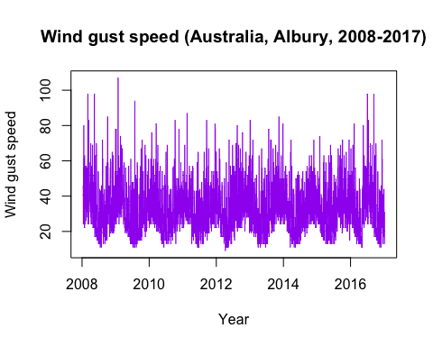

Here, we do not observe any **trend** across the years. The fluctuations in the wind gust speeds are **seasonal** in nature, repeating in a similar pattern for each each. There is no **cyclical** **fluctuations** observable in the data. **Irregular fluctuations** can be seen in the fairly noticeable and random variations in the spikes of the data within each seasonal cycle and the overall seasonal fluctuations themselves.

timeplot(humidity, "Humidity at 9AM")

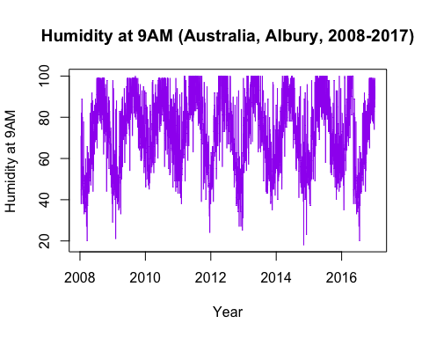

Here, we do not observe any **trend** across the years. The fluctuations in the humidity at 9AM are **seasonal** in nature, repeating in a similar pattern for each each. There is no **cyclical** **fluctuations** observable in the data. **Irregular fluctuations** can be seen in the noticeable and random variations in the spikes of the data within each seasonal cycle and the overall seasonal fluctuations themselves.