EXPLORATORY DATA ANALYSIS ON CARS DATASET
Internship Minor Project Report

Submitted By:
Pranil Shirsath

Project:
Exploratory Data Analysis (EDA)

Dataset:
Car Details v3 Dataset

Tools Used:
Python, Pandas, NumPy, Matplotlib, Seaborn and Google Colab

Academic Year: 2026

Date of Submission: 27/092026

Objective
The main objective of this project is to perform Exploratory Data Analysis (EDA) on a real-world used-car dataset. The analysis focuses on understanding the structure and quality of the dataset, cleaning the available data, identifying patterns and relationships between variables, detecting unusual observations, and communicating the findings through statistical analysis and visualizations.
The project uses Python-based data analysis libraries including Pandas, NumPy, Matplotlib and Seaborn. Google Colab was used as the development environment.

Dataset Overview
The dataset used for this project is the Car Details v3 dataset. It contains information about used vehicles, including their manufacturing year, selling price, kilometres driven, fuel type, seller type, transmission, ownership history, mileage, engine capacity, maximum power, torque and number of seats.
The original dataset contains 8,128 records and 13 attributes.

Main Attributes

Attribute | Description
name | Name/model of the vehicle
year | Manufacturing year
selling_price | Selling price of the vehicle
km_driven | Kilometres driven
fuel | Fuel type
seller_type | Type of seller
transmission | Transmission type
owner | Ownership history
mileage | Fuel efficiency
engine | Engine capacity
max_power | Maximum power
torque | Engine torque
seats | Number of seats

Data Quality Analysis and Cleaning
The dataset was first examined to identify missing values, duplicate records and unsuitable data types.

Duplicate Records
The original dataset contained 1,202 duplicate records. Exact duplicate rows were removed to prevent repeated observations from affecting the analysis. After removing duplicates, 6,926 records remained.

Missing Values
Missing values were identified in attributes such as mileage, engine, maximum power, torque and seats. For numerical analysis, analysis-ready numerical variables were created and relevant missing numerical values were treated using median imputation.

Data Type Conversion
Several numerical attributes were originally stored as text along with their units. The numerical portions were extracted and converted into analysis-ready variables: mileage_value, engine_cc and max_power_bhp.

Feature Engineering
A new feature called vehicle_age was created from the manufacturing year using: Vehicle Age = 2026 − Manufacturing Year. This feature was used to examine the relationship between vehicle age and selling price.

Cleaning Summary

Stage | Records
Before cleaning | 8,128
Duplicate records removed | 1,202
After duplicate removal | 6,926
The cleaned dataset was then used for descriptive and visual analysis.

Descriptive Statistics
Descriptive statistics were calculated to understand the central tendency, spread and distribution of the numerical variables.

Selling Price
The mean selling price in the cleaned dataset is approximately ₹5,17,271, while the median selling price is
₹4,00,000. The difference indicates the influence of higher-priced vehicles on the overall average.

Fuel Type
The dataset is primarily composed of diesel and petrol vehicles: Diesel 3,755, Petrol 3,077, CNG 56 and LPG 38. Diesel is the most frequently represented fuel type.

Transmission
The cleaned dataset contains both manual and automatic vehicles. The average selling price of automatic vehicles is considerably higher than that of manual vehicles in this dataset.

Numerical Variables
The analysis considered manufacturing year, selling price, kilometres driven, number of seats, mileage, engine capacity, maximum power and vehicle age. These variables were used for visualization, correlation analysis and outlier detection.

Visual Exploratory Data Analysis
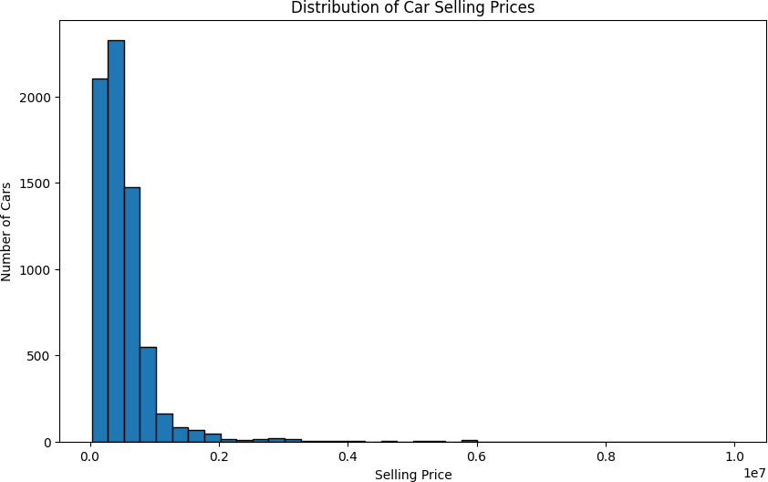
Figure 1 — Distribution of Car Selling Prices
Observation: The selling price distribution is concentrated toward the lower price range, with fewer vehicles at substantially higher prices.
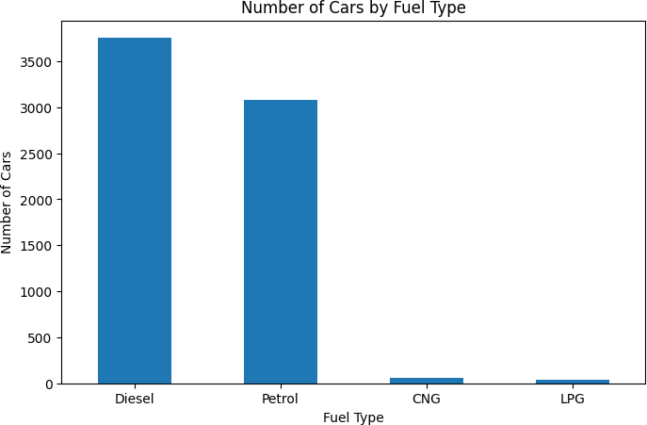
Figure 2 — Number of Cars by Fuel Type
Observation: Diesel cars form the largest group in the dataset, followed by petrol cars, while CNG and LPG vehicles represent much smaller groups.
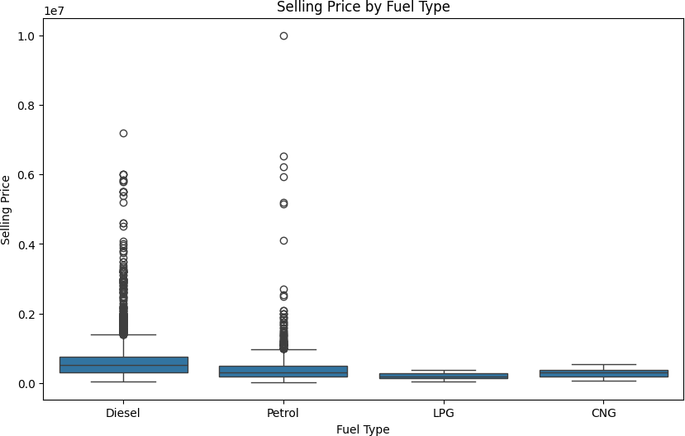
Figure 3 — Selling Price by Fuel Type
Observation: The box plot shows differences in selling-price distributions across fuel types and also reveals high-price observations within some categories.

Visual Exploratory Data Analysis (continued)
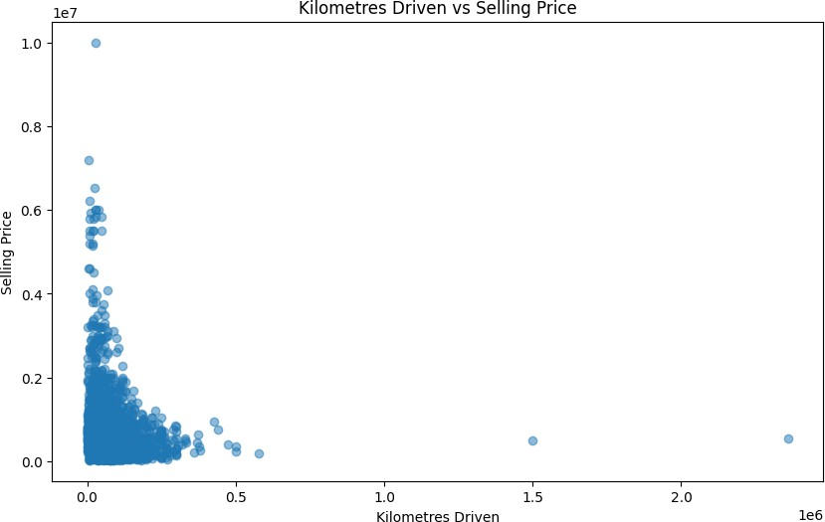
Figure 4 — Vehicle Age vs Selling Price
Observation: Selling prices generally tend to be lower for older vehicles, although the relationship is not perfectly uniform.
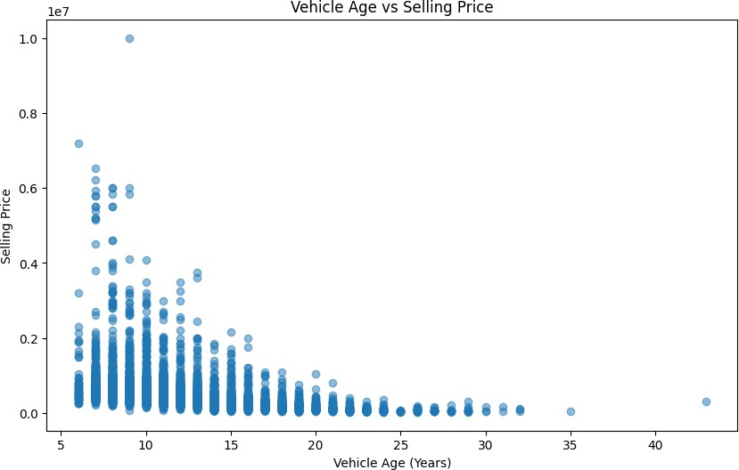
Figure 5 — Kilometres Driven vs Selling Price
Observation: Vehicles with higher kilometres driven generally show lower selling prices, although considerable variation exists among individual vehicles.
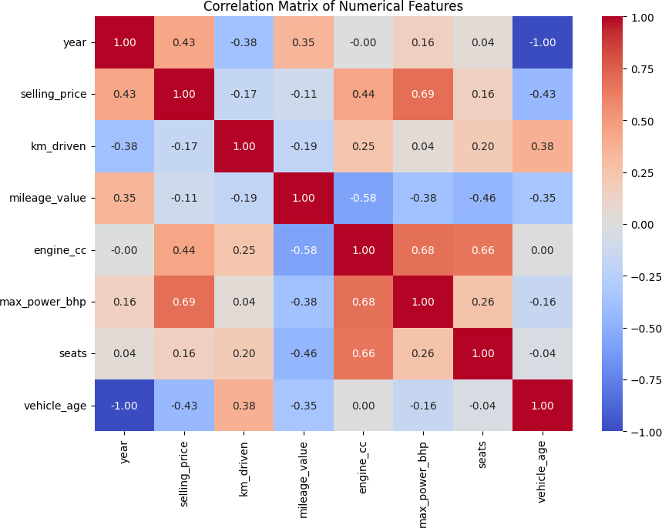
Figure 6 — Average Selling Price by Transmission
Observation: Automatic vehicles have a substantially higher average selling price than manual vehicles in this dataset.

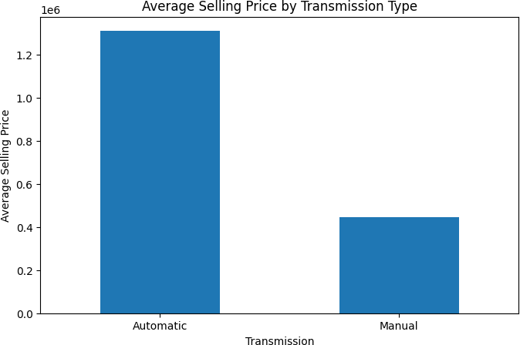
Figure 7 — Correlation Matrix
Observation: The correlation matrix shows the strength and direction of relationships among the numerical variables and helps identify variables that are associated with selling price.

Outlier Analysis
The IQR method was used to identify potential outliers. For selling price, the upper limit was ₹12,08,750 and 328 observations were identified as potential outliers. For kilometres driven, the upper limit was 190,000 km and 167 observations were identified as potential outliers.
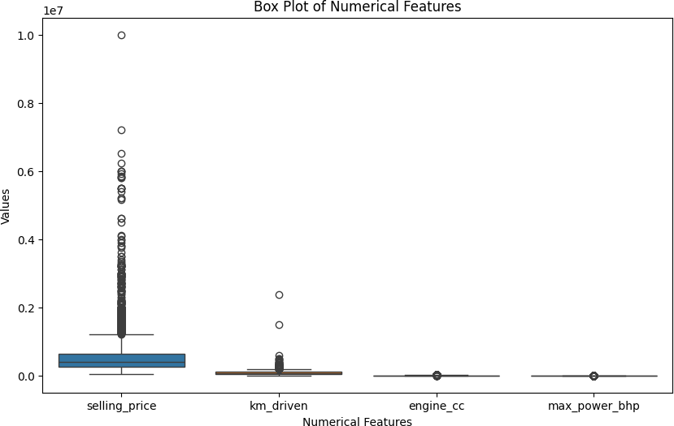
Figure 8 — Outlier Box Plot
Observation: The box plot highlights unusual observations in numerical variables. These observations were retained because they may represent genuine vehicles rather than data-entry errors.

Key Findings
  - The original dataset contained 8,128 records and 13 attributes. After removing 1,202 exact duplicate records, 6,926 records remained for analysis.
  - Diesel is the most common fuel type, followed by petrol. CNG and LPG vehicles form much smaller groups.
  - The mean selling price is higher than the median selling price, indicating that higher-priced vehicles influence the overall average.
  - Automatic vehicles have a substantially higher average selling price than manual vehicles in this dataset.
  - Vehicle age shows a general negative relationship with selling price, with older vehicles tending to have lower selling prices.
  - Kilometres driven also shows a general negative relationship with selling price, although there is considerable variation between individual vehicles.
  - Outlier analysis identified unusual observations in numerical variables. These observations were retained because they may represent genuine vehicles rather than data-entry errors.

Limitations
The dataset represents used-car listings and may not represent the entire automobile market. Some numerical attributes were originally stored as text along with their measurement units. Duplicate records were present and removed during preprocessing. Some analysis-ready numerical variables contained missing values and were treated using median imputation. The analysis identifies associations between variables but does not establish causal relationships. Different car models have different numbers of observations, so comparisons between individual models may not always be equally representative.

Conclusion
The exploratory data analysis provided an understanding of the characteristics and pricing patterns of vehicles in the dataset. The data was inspected for dimensions, data types, missing values and duplicate records. During preprocessing, duplicate records were removed, text-based numerical attributes were converted into usable numerical values, and missing numerical values were treated using median imputation. Descriptive statistics and visualizations were then used to study selling price, fuel type, transmission, vehicle age, kilometres driven and other numerical characteristics. Outlier analysis also
identified unusual observations that may represent genuine vehicles. Overall, the project demonstrates how EDA can be used to clean real-world automobile data, identify patterns and communicate findings through statistical summaries and visualizations.

References
  - Kaggle — Vehicle Dataset / Car Details Dataset — https://www.kaggle.com/
  - Pandas Documentation — https://pandas.pydata.org/docs/
  - NumPy Documentation — https://numpy.org/doc/
  - Matplotlib Documentation — https://matplotlib.org/stable/
  - Seaborn Documentation — https://seaborn.pydata.org/

