ASSIGNMENT 1

1. SELECT * FROM customers WHERE customer_key > 3;

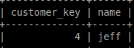

2. SELECT c.name, o.order_num, o.product_num FROM customers c, orders o where c.customer_key=o.customer_key;
OR
SELECT name,order_num,product_num FROM customers c INNER JOIN orders o ON c.customer_key = o.customer_key;

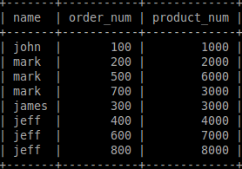

3. SELECT c.name, p.product_description FROM customers c, orders o, products p where c.customer_key=o.customer_key AND o.product_num=p.product_num;
OR
SELECT c.name,p.product_description FROM customers c INNER JOIN orders o ON c.customer_key=o.customer_key INNER JOIN products p ON o.product_num = p.product_num;

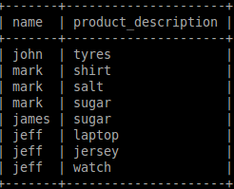

4. SELECT o.order_num FROM orders o INNER JOIN products p ON o.product_num=p.product_num WHERE p.product_category = "garments" OR p.product_category = "electronics";
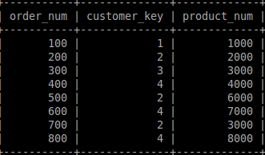

5. SELECT p.product_num,product_description,product_category,price FROM products p LEFT JOIN orders o ON p.product_num = o.product_num WHERE o.order_num IS NULL;

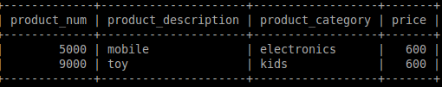

6. SELECT * FROM products p where p.product_category NOT LIKE "g%";

