Assignment 2

1. SELECT c.customer_key,name,TotalPrice FROM customers c LEFT JOIN (SELECT customer_key,SUM(t.price) AS TotalPrice FROM (SELECT o.customer_key,p.product_num,p.price FROM orders o INNER JOIN products p ON o.product_num = p.product_num)t GROUP BY t.customer_key)z ON c.customer_key = z.customer_key;

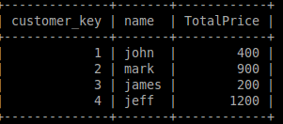

2. SELECT c.customer_key,name, MAX(TotalPrice) FROM customers c LEFT JOIN (SELECT customer_key, SUM(t.price) AS TotalPrice FROM (select o.customer_key,p.product_num,p.price FROM (SELECT * FROM orders where customer_key IN (SELECT customer_key FROM orders GROUP BY customer_key HAVING COUNT(customer_key)>1))o INNER JOIN products p ON o.product_num = p.product_num)t GROUP BY t.customer_key)z ON c.customer_key = z.customer_key;
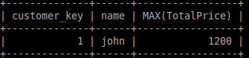

3. SELECT DISTINCT o.product_num, p.product_description FROM orders o, products p where o.product_num=p.product_num;

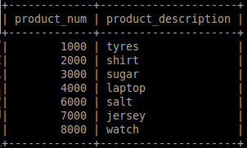

4. SELECT product_category, AVG(price) AS AVERAGE FROM products GROUP BY product_category;

