DES PUNE UNIVERSITY
School of Engineering and Technology Computer Engineering and Technology
Program: B.Tech. Computer Science and Engineering

Academic Year: 2024-25 | Year: Second Year Div: A | Term: I
PRN No.: 1012412056 | Name: Pranav Panchal
Subject: DSV
Assignment No.: 4
Date: 24/10/24

Title:Temporal Data Visualization: A Visual Journey Through Time

Temporal data, or time-series data, is a cornerstone of data analysis. It records measurements over time, enabling us to track trends, identify patterns, and make informed predictions. Visualizing temporal data effectively is crucial for understanding these patterns and making data-driven decisions.

Key Visualizations for Temporal Data:

Line Chart:

Purpose: To show trends and patterns over time.

Example: Tracking daily sales over a year.

Insights: Identify seasonal trends, growth rates, and anomalies.

Bar Chart:

Purpose: To compare values across different time periods.

Example: Comparing monthly sales between two years.

Insights: Identify peak and off-peak periods, measure year-over-year growth.

Area Chart:

Purpose: To visualize the magnitude of change over time.

Example: Tracking website traffic over a quarter.

Insights: Identify periods of growth or decline, compare multiple metrics.

Histogram:

Purpose: To visualize the distribution of data over time intervals.

Example: Analyzing website traffic by hour of the day.

Insights: Identify peak usage times, identify patterns in user behavior.

Heatmap:

Purpose: To visualize patterns in data across multiple time dimensions.

Example: Analyzing sales by day of the week and hour of the day.

Insights: Identify busy times, identify slow periods.

Best Practices for Temporal Data Visualization:

Clear Labeling: Use clear and concise labels for axes and data points.

Consistent Time Intervals: Ensure consistent time intervals (e.g., daily, weekly, monthly) for accurate comparisons.

Data Cleaning and Preparation: Clean and preprocess data to remove outliers and inconsistencies.

Color Coding: Use color effectively to highlight specific trends or patterns.

Interactivity: Consider adding interactive features like tooltips and zooming to provide more detailed insights.

Contextualization: Provide context for the visualization, such as relevant time periods, events, or industry trends.

By effectively visualizing temporal data, you can gain valuable insights into past performance, identify trends, and make informed predictions about future trends.

Information about about Understanding Temporal Categories

Temporal categories refer to data that is categorized by time, such as dates, times, months, years, etc. Visualizing temporal data can help us identify trends, patterns, and anomalies over time.

Visualizations for Temporal Categories

Here are two common visualizations used for temporal data:

1. Chart

Question: How has a particular metric changed over time?

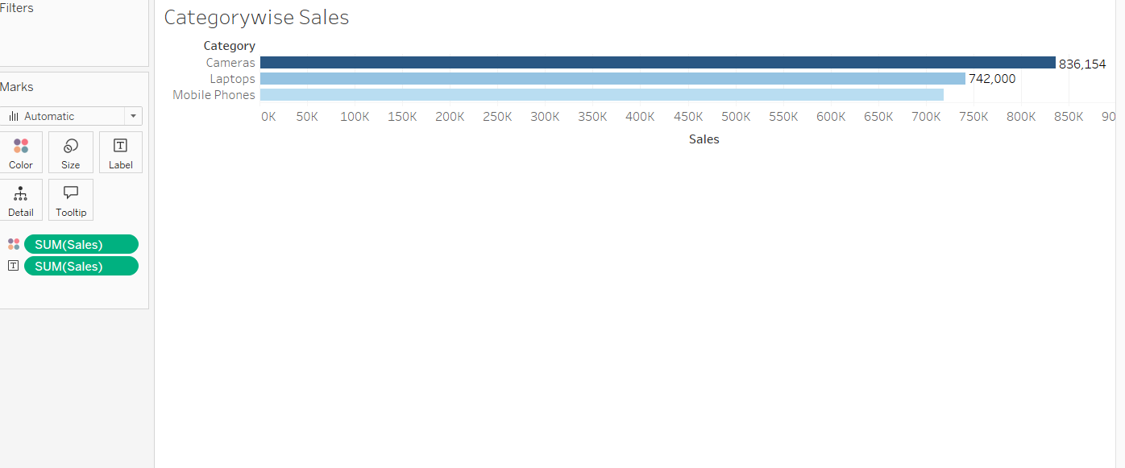

Explanation of Visualizations:

Bar Chart & Line Chart:-

- Audience: Sales managers, analysts.

Purpose:
  - Bar Chart: Used to compare sales or profit across different categories or regions.
  - Line Chart: Shows trends over time (e.g., sales over the months or years).
  - Message: Bar charts highlight which categories or regions perform best, while line charts reveal sales trends and seasonality, helping businesses plan inventory and marketing.

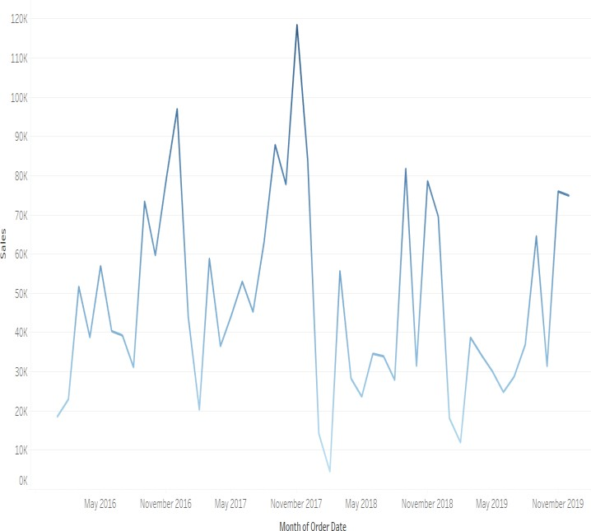
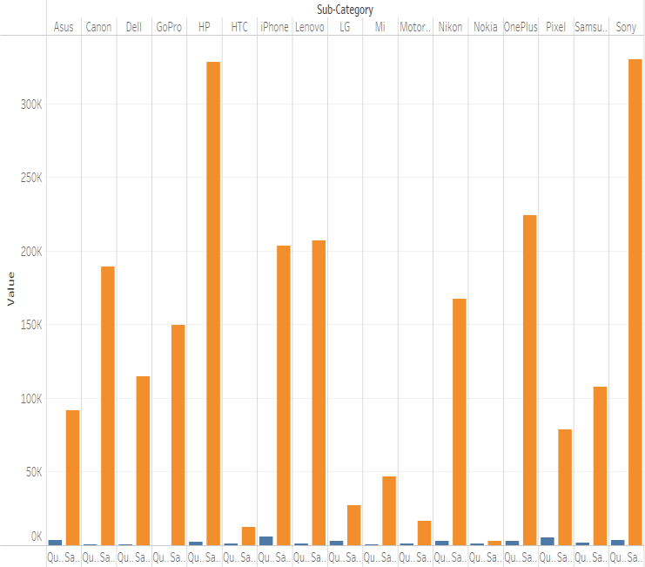

Bar Chart Line Chart

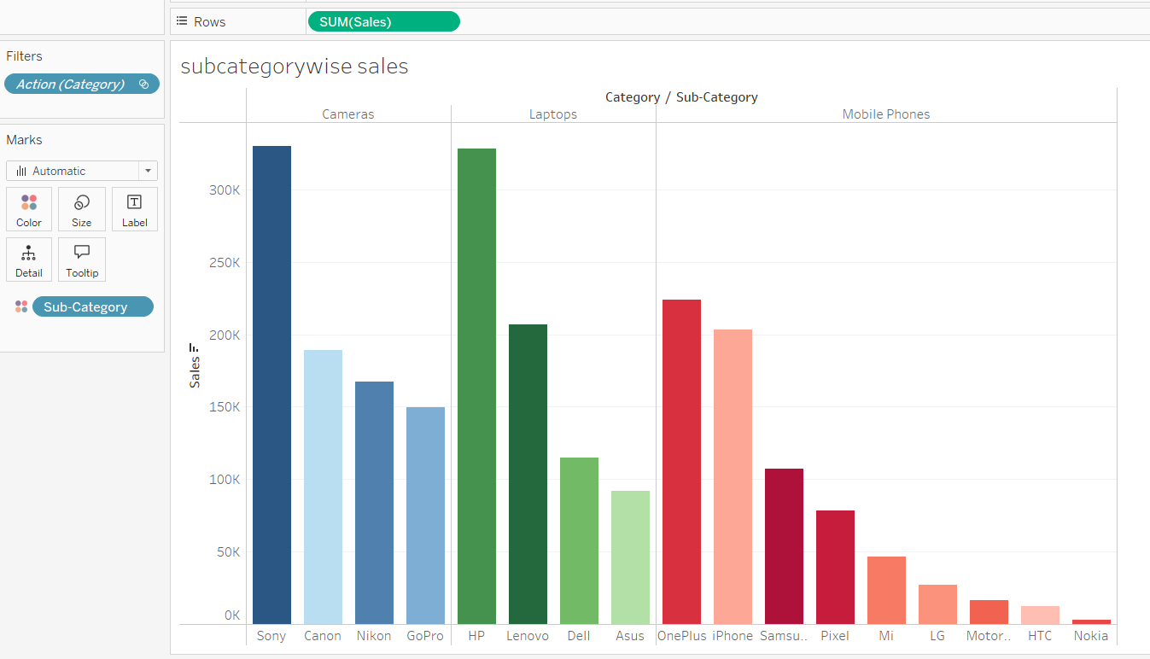

About Dataset:
The Superstore dataset is a popular dataset often used for data analysis and visualization, particularly in the context of business intelligence and data science projects. It typically includes transactional data from a fictional retail store and includes various attributes such as:
  - Order ID: Unique identifier for each order.
  - Order Date: Date when the order was placed.
  - Ship Date: Date when the order was shipped.
  - Customer ID: Unique identifier for each customer.
  - Customer Name: Name of the customer.
  - Segment: The market segment (e.g., Consumer, Corporate, Home Office).
  - Country: Country of the customer.
  - City: City of the customer.
  - State: State of the customer.
  - Postal Code: Postal code of the customer.
  - Product ID: Unique identifier for each product.
  - Product Name: Name of the product.
  - Category: Category of the product (e.g., Furniture, Office Supplies, Technology).
  - Sub-Category: More specific category within the main category.
  - Sales: Total sales amount for the order.
  - Quantity: Number of units sold.
  - Discount: Discount applied to the order.
  - Profit: Profit earned from the order.

Use Cases
- Sales Analysis: Understand sales trends over time, identify top-selling products, and analyze customer buying behavior.
- Profitability Analysis: Evaluate which products or categories are most profitable and which are underperforming.
- Customer Segmentation: Group customers based on their buying patterns, which can help in targeted marketing.
- Supply Chain Management: Analyze shipping times and logistics to improve delivery efficiency

Purpose of the Dataset:
Here are three key purposes of the Superstore dataset:
- Business Analytics Practice: It helps analysts and students develop skills in data analysis and business intelligence.
- Sales and Profitability Evaluation: The dataset allows for the assessment of sales trends and profitability, helping businesses make informed decisions.
- Customer Insights and Segmentation: It enables the analysis of customer behavior and segmentation for targeted marketing strategies.

Key Parameters used in the Visualizations:
A typical Superstore sales dataset contains details of a retail store's sales performance, with the following key parameters:
- Order ID: Unique identifier for each sales order.
- Product Category: Category of the sold product (e.g., Office Supplies, Furniture, Technology).
- Product Sub-category: Specific subcategories under each product category.
- Sales: Total sales value for each order.
- Profit: Profit generated from each sale.
- Discount: Percentage discount applied on the sales order.
- Quantity: Number of products sold.
- Customer Segment: Market segment of the customer (e.g., Consumer, Corporate).
- Ship Mode: Mode of shipping for each order (e.g., Standard, Express).
- Region: Geographic region (e.g., East, West) where the order was placed.
- Order Date: Date when the order was placed.

LINK:-
https://public.tableau.com/views/Book1_17326442207570/BarChart?:language=en-US&publish=yes&:sid=&:redirect=auth&:display_count=n&:origin=viz_share_link

Conclusion:

Temporal data visualizations are essential for understanding trends, patterns, and anomalies over time. By effectively employing line charts, bar charts, area charts, histograms, and heatmaps, we can gain valuable insights from time-series data.
To ensure effective visualization, it is crucial to:
- Choose the Right Visualization: Select the chart type that best suits the data and the insights you want to convey.
- Data Preparation: Clean and preprocess data to remove outliers and inconsistencies.
- Clear Labeling: Use clear and concise labels for axes and data points.
- Effective Color Coding: Use color to highlight specific trends or patterns.
- Interactivity: Incorporate interactive features like tooltips and zooming.
- Contextualization: Provide context for the visualization, such as relevant time periods, events, or industry trends.

