Fo= 1000; % this is changed to 2,3,10Khz
Fs= 25*Fo;
t = 0:1/Fs:10/Fo;
m = 2*sin(2*pi*Fo*t)+randn(size(t)); %A=2
figure(1);
plot(t,m);
xlabel('time');
ylabel('x(t)+noise');
title('Signal contaminated with noise');
mu = 10^-4;
err_max = 10^-3;
N=256;
w = zeros(N,1);
error = 1;
x = zeros(N,1);
x_new = zeros(N,1);
i = 1;
while(error > err_max)
y = w'*x;
e = m(i) - y;
w_new = w + mu*x*e;
if(i == 1)
error = 1;
else
error = (sumsqr(w_new-w))/(sumsqr(w));
end
w = w_new;
x(1) = m(i);
for k = 2:N
x_new(k) = x(k-1);
end
x = x_new;
i = i+1;
end
Z=(abs(fftshift(fft(w,512)))).^2;
f = (Fs/2)*linspace(-1,1,512);
figure(2);
subplot(211);
plot(f,Z);
xlabel('Frequency');
ylabel('Amplitude');
title('Adaptive Filter response');
subplot(212);
P=filter(w,1,m);
plot(t,P);
xlabel('t');
ylabel('y(t)');
title('Filter Output');
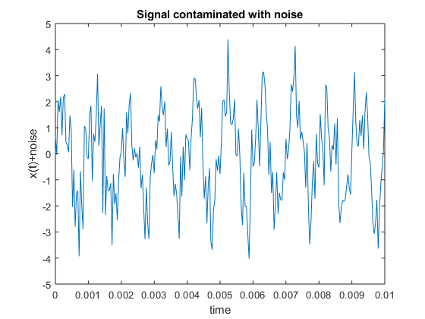
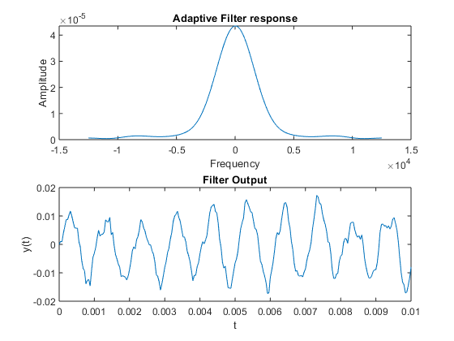
Published with MATLAB® R2018a

