EXPERIMENT NO. 03
AIM: Simulation of differentiator circuit using Pspice.
PROBLEM STATEMENT: To design op - amp as differentiator and plot its input and output waveforms.
SOFTWARE REQUIRED: PSPICE software
COMPONENT REQUIRED:
- uA741 operational amplifier
- Two resistors (R1 = 220Ω, Rf = 2.2kΩ)
- Two Capacitor (C1 = 1 uF, Cf=0.01uF)
- Sinusoidal voltage source (VSIN)
- Two DC voltage sources (+15 V and –15 V)
- Ground terminals
- Voltage markers for input and output
THEORY:
In the differentiator circuit the input is connected to the inverting output of the Op-Amp through a capacitor(C) and a negative feedback is provided to the inverting input terminal through a resistor (Rf), which is same as an integrator circuit with feedback capacitor and input resistor being replaced with each other. Here the circuit performs a mathematical differentiation operation, and the output is the first derivative of the input signal, 180' out of phase and amplified with a factor Rf*C. The capacitor on the input allows only the AC component and restrict the DC, at low frequency the reactance of capacitor is very high causing a low gain and high frequency vice versa but and high frequency the circuit becomes unstable.
The ideal differentiator circuit consists of Capacitor (C) at the input and Resistor (R) in the feedback path
The output voltage is given by:
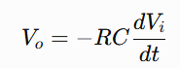
Where:
- $V_{o}$= Output Voltage
- $V_{i}$= Input Voltage
- $R$= Feedback Resistance
- $C$= Input Capacitance

For a sinusoidal input,
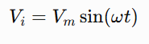
The output becomes
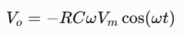
Thus, the output leads the input by 90°

CIRCUIT DIAGRAM:
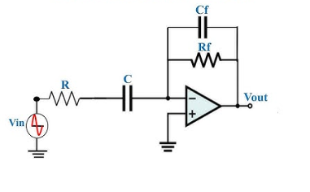
Fig1: Practical Differentiator Circuit
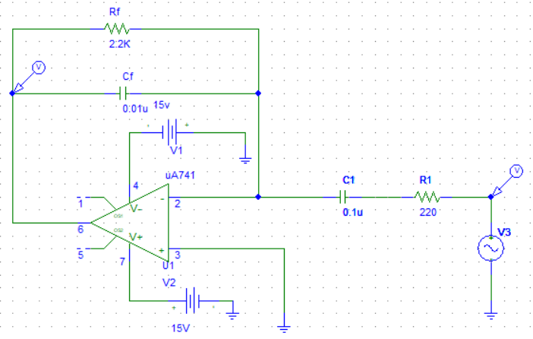
Fig 2: Schematic of Differentiator Circuit Using Pspice
PROCEDURE:
- Design DIFFERENTIATOR as per circuit diagram in Pspice Schematic.
- Connect the non-inverting (+) terminal (Pin 3) of the uA741 to ground.
- Connect the input signal through R1 and C1 in series to the inverting (–) terminal (Pin 2).
- Connect Rf (2.2 kΩ) between the output (Pin 6) and the inverting input to provide feedback.
- Apply +15 V to Pin 7 and –15 V to Pin 4 of the op-amp.
- Configure the sinusoidal input source (VSIN):
DC Offset (VOFF)= 0 V
Amplitude(VAMP) = 1 V
Frequency = 1000Hz
- Create a Transient Analysis simulation profile.
- Set the simulation parameters:
Print Step = 1 µs
Final Time = 5 ms
Step Ceiling =0.1 µs
- Place voltage probes at the input and output nodes.
- Save the project and click Run Simulation.
- Observe the input and output waveforms in the Probe window.

OBSERVATIONS:

S.No | Signal | Amplitude | Time Period
1. | Sine wave input
2. | Cosine wave output

OUTPUT:
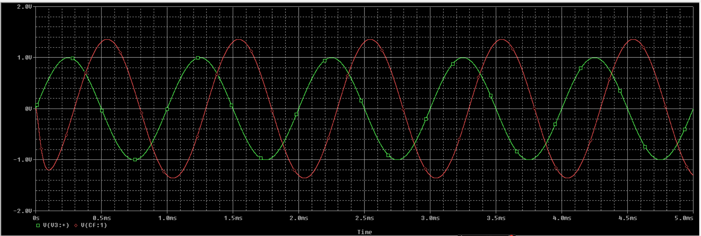

RESULT:
DIFFERENTIATOR Circuit is studied and gets the output waveforms using PSPICE Software.

CONCLUSION

VIVA VOCE:

- What is differentiator circuit?
- What is the main limitation of an ideal differentiator?
- How is an ideal differentiator modified to make it practical?
- What are the applications of differentiators?
- Why capacitor is used in differentiator?
- Why are ±15 V supplies commonly used with the uA741 op-amp?

