Experiment 1: Introduction to Modern JavaScript and DOM

1a. Link a JavaScript file with the HTML page
index.html
<!DOCTYPE html>
<html lang="en">
<head>
<meta charset="UTF-8">
<meta name="viewport" content="width=device-width, initial-scale=1.0">
<title>Linking JS</title>
</head>
<body>
<h1>Check the browser console!</h1>
<p>If the JavaScript file is linked correctly, you will see a message in the console (Press F12 to open).</p>
<script src="script.js"></script>
</body>
</html>
script.js
console.log("Success! The external JavaScript file is linked correctly.");
Output:
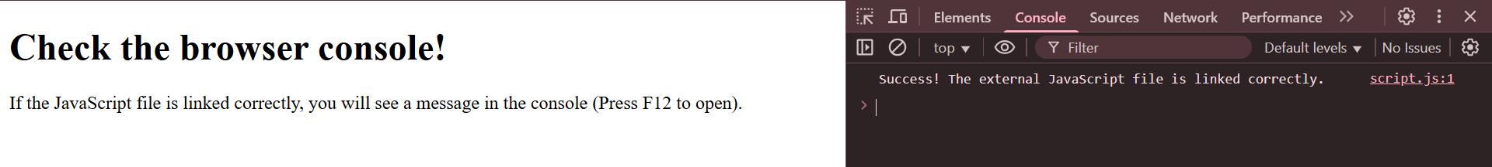

1b. Select elements in an HTML page using selectors
index.html
<!DOCTYPE html>
<html lang="en">
<head>
<title>DOM Selectors</title>
</head>
<body>
<h1 id="main-title">This is the Main Title</h1>
<p class="content-para">This is a paragraph with a class.</p>
<p class="content-para">This is another paragraph with the same class.</p>
<div>A div element.</div>
<script src="script.js"></script>
</body>
</html>
script.js
const titleElement = document.getElementById('main-title');
console.log("Selected by ID:", titleElement);
const firstParagraph = document.querySelector('.content-para');
console.log("Selected first element by class with querySelector:", firstParagraph);
const allParagraphs = document.querySelectorAll('.content-para');
console.log("Selected all elements by class with querySelectorAll:", allParagraphs);
Output:
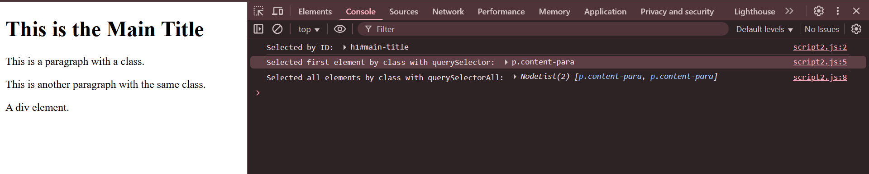

1c. Implement event listeners
index.html
<!DOCTYPE html>
<html lang="en">
<head>
<title>Event Listeners</title>
<style>
#event-area { padding: 50px; background-color: #f0f0f0; border: 1px solid #ccc; text-align: center; }
</style>
</head>
<body>
<div id="event-area">Move your mouse over this area.</div>
<script src="script.js"></script>
</body>
</html>
script.js
const eventArea = document.getElementById('event-area');
eventArea.addEventListener('mouseover', function() {
console.log('Event triggered: Mouse is over the area!');
eventArea.style.backgroundColor = 'lightgreen';
});
eventArea.addEventListener('mouseout', function() {
console.log('Event triggered: Mouse has left the area!');
eventArea.style.backgroundColor = '#f0f0f0';
});
Output:
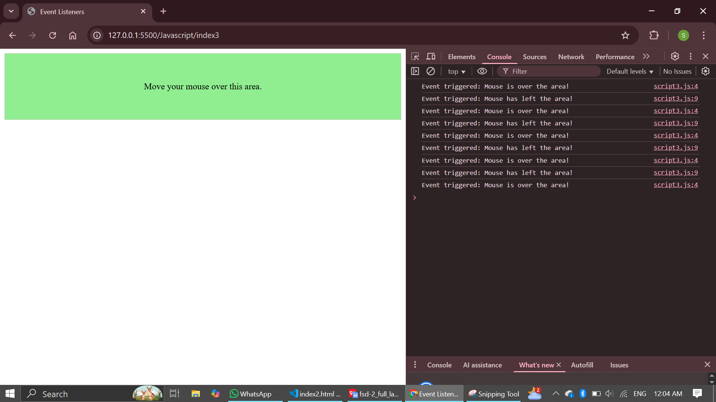

1d. Handle the click events for HTML button elements
index.html
<!DOCTYPE html>
<html lang="en">
<head>
<title>Button Click Event</title>
</head>
<body>
<p id="message">Click the button to see a message.</p>
<button id="action-button">Click Me</button>
<script src="script.js"></script>
</body>
</html>
script.js
const messageParagraph = document.getElementById('message');
const actionButton = document.getElementById('action-button');
actionButton.addEventListener('click', () => {
messageParagraph.textContent = 'Button was clicked! Event handled.';
});
Output:
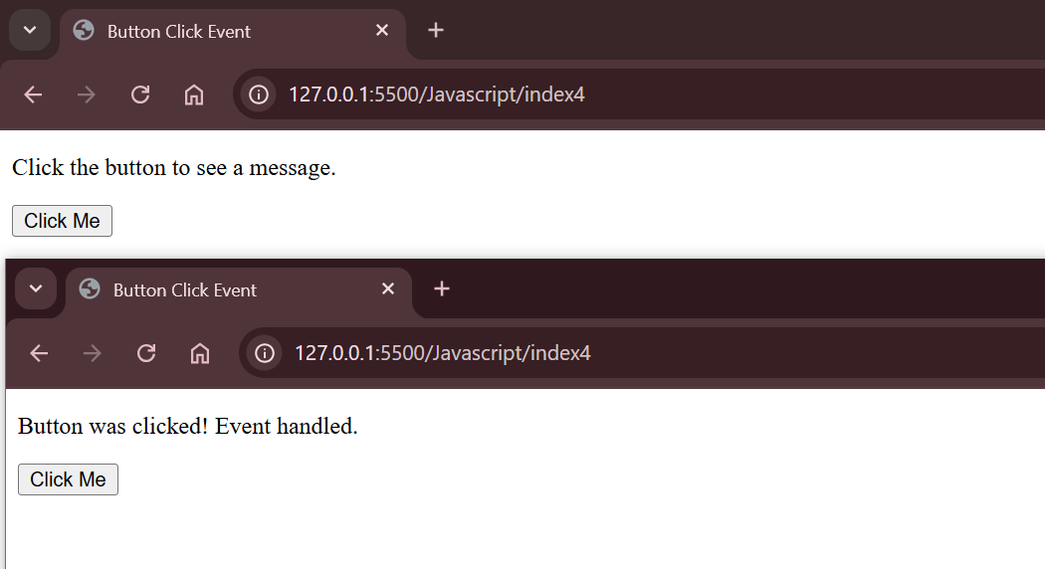

1e. Program with three types of functions
index.html
<!DOCTYPE html>
<html lang="en">
<head>
<title>Types of Functions</title>
</head>
<body>
<h1>Check the browser console for function outputs.</h1>
<script src="script.js"></script>
</body>
</html>
script.js
// 1. Function Declaration
function declaredFunction(a, b) {
console.log('Called Function Declaration');
return a + b;
}
declaredFunction(5, 3);
// 2. Function Expression
const functionExpression = function(a, b) {
console.log('Called Function Expression');
return a * b;
};
functionExpression(5, 3);
// 3. Arrow Function
const arrowFunction = (a, b) => {
console.log('Called Arrow Function');
return a - b;
};
arrowFunction(5, 3);
Output:
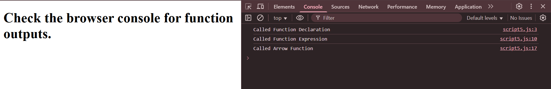

1f Manipulate Styles of HTML Elements using Javascript

<!DOCTYPE html>
<html>
<head>
<title>Change Style Example</title>
</head>
<body style="text-align:center; margin-top:50px;">

<h1 id="heading">Welcome to My Page!</h1>
<button onclick="changeStyle()">Change Style</button>

<script>
function changeStyle() {
const heading = document.getElementById("heading");
heading.style.color = "white";
heading.style.backgroundColor = "purple";
heading.style.fontSize = "40px";
heading.style.padding = "20px";
heading.style.borderRadius = "10px";
heading.style.transition = "0.5s"; // smooth effect
}
</script>

</body>
</html>

Output :
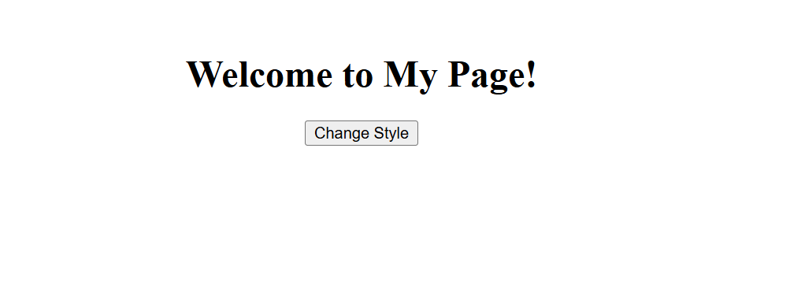


1g Remove an HTML Element from the DOM

<!DOCTYPE html>
<html>
<head>
<title>Remove Element Example</title>
</head>
<body style="text-align:center; margin-top:50px;">

<h1 id="message">Hello, I am going to disappear!</h1>
<button onclick="removeElement()">Remove Element</button>

<script>
function removeElement() {
const element = document.getElementById("message");
element.remove(); // removes the element from the DOM
}
</script>

</body>
</html>

Output :
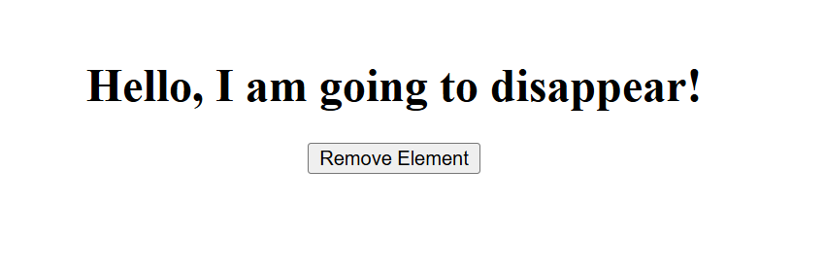


1h Validate a form input using Javascript

<!DOCTYPE html>
<html>
<head>
<title>Form Validation Example</title>
<style>
body {
font-family: Arial, sans-serif;
text-align: center;
margin-top: 50px;
}
input {
padding: 10px;
margin: 5px;
width: 250px;
}
.error {
color: red;
font-size: 14px;
}
</style>
</head>
<body>

<h2>Sign Up Form</h2>

<form id="myForm" onsubmit="return validateForm()">
<input type="text" id="name" placeholder="Enter your name"><br>
<input type="email" id="email" placeholder="Enter your email"><br>
<input type="submit" value="Submit">
</form>

<p id="errorMsg" class="error"></p>

<script>
function validateForm() {
const name = document.getElementById("name").value.trim();
const email = document.getElementById("email").value.trim();
const errorMsg = document.getElementById("errorMsg");

// Clear previous error message
errorMsg.textContent = "";

// Validate name
if (name === "") {
errorMsg.textContent = "Please enter your name.";
return false; // Prevent form submission
}

// Validate email
const emailPattern = /^[^ ]+@[^ ]+\.[a-z]{2,3}$/;
if (!email.match(emailPattern)) {
errorMsg.textContent = "Please enter a valid email address.";
return false;
}

alert("Form submitted successfully!");
return true; // Allow form submission
}
</script>

</body>
</html>

Output :
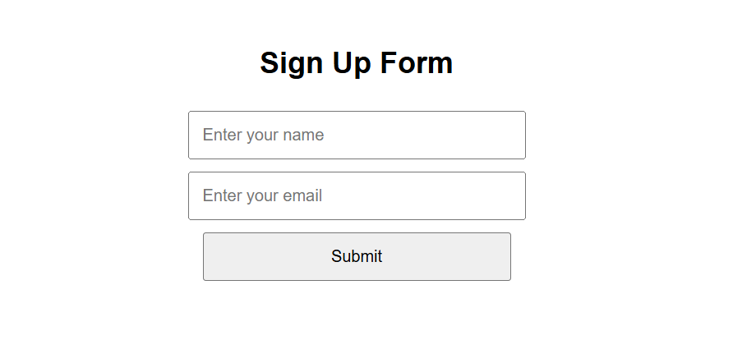
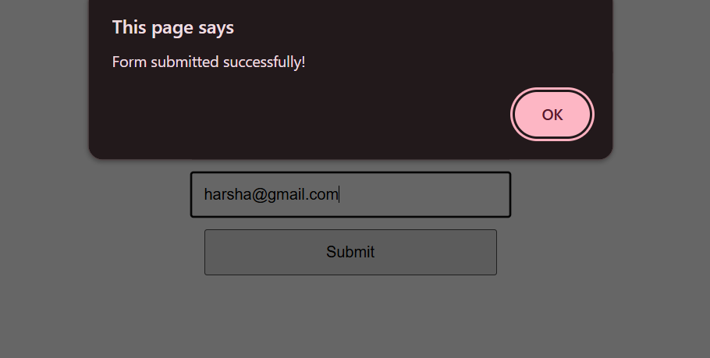

1i Change Image on Button Click

<!DOCTYPE html>
<html>
<head>
<title>Change Image Example</title>
</head>
<body style="text-align:center; margin-top:50px;">

<h2>Change Image with JavaScript</h2>

<!-- Image -->
<img id="myImage" src="https://via.placeholder.com/200x150?text=Image+1" alt="Image" width="200" height="150">
<br><br>

<!-- Button -->
<button onclick="changeImage()">Change Image</button>

<script>
function changeImage() {
const img = document.getElementById("myImage");

// Check current image source and switch to another
if (img.src.includes("Image+1")) {
img.src = "https://via.placeholder.com/200x150?text=Image+2";
} else {
img.src = "https://via.placeholder.com/200x150?text=Image+1";
}
}
</script>

</body>
</html>

Output :
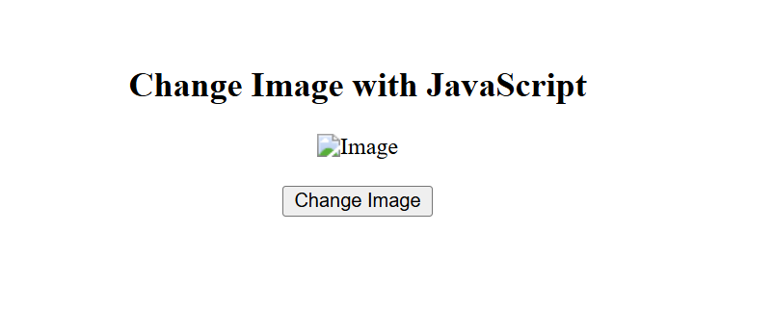

1j Count the Numbers of Clicks on a Button

<!DOCTYPE html>
<html>
<head>
<title>Button Click Counter</title>
</head>
<body style="text-align:center; margin-top:50px; font-family:Arial;">

<h2>Click Counter</h2>

<button onclick="countClicks()">Click Me!</button>

<p>You have clicked the button <span id="count">0</span> times.</p>

<script>
// initialize counter
let clickCount = 0;

function countClicks() {
clickCount++; // increase count by 1
document.getElementById("count").textContent = clickCount; // update display
}
</script>

</body>
</html>

Output :
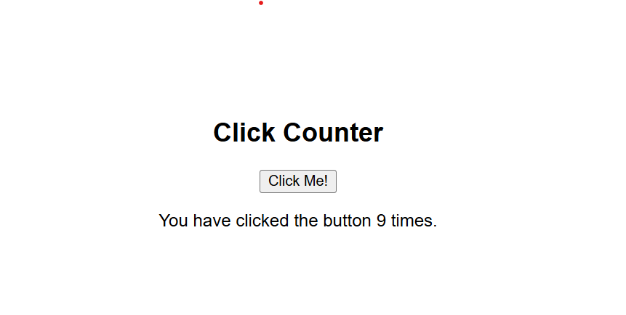

Experiment 2: Basics of React.js

2a. Counter button using React class components
App.js
import React from 'react';
class App extends React.Component {
constructor(props) {
super(props);
this.state = { count: 0 };
}
incrementCount = () => {
this.setState({ count: this.state.count + 1 });
};
decrementCount = () => {
this.setState({ count: this.state.count -1});
};
render() {
return (
<div>
<button onClick={this.incrementCount}>Like</button>
<button onClick={this.decrementCount}>Dislike</button>
<h1>Count: {this.state.count}</h1>
</div>
);
}
}
export default App;
Output:
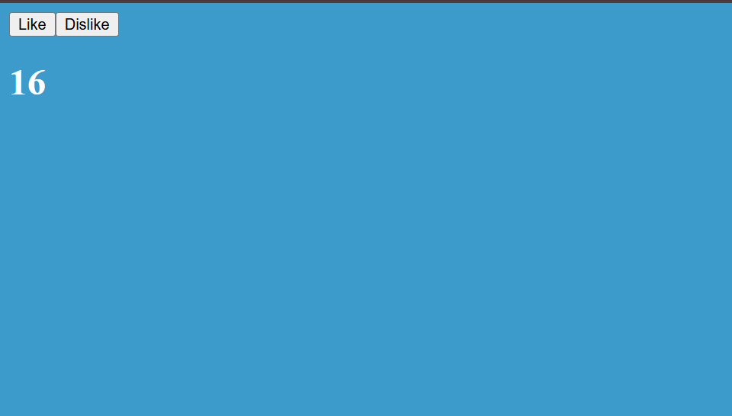

2b. Counter button using React functional components
App.js
import React, { useState } from 'react';
function App() {
const [count, setCount] = useState(0);
const incrementCount = () => {
setCount(count + 1);
};
const decrementCount = () => {
setCount(count - 1);
};
return (
<div>
<button onClick={incrementCount}>Like</button>
<button onClick={decrementCount}>Dislike</button>
<p>Count: {count}</p>
</div>
);
}
export default App;
Output:

2c. Handle button click events in the functional component
App.js
import React from 'react';
function App() {
const handleButtonClick = () => {
alert('Button was clicked!');
};
return (
<div>
<button onMouseOver={()=>{setCount(count-1)}}>Hover me...</button>
<h1>{count}</h1>
</div>
);
}
export default App;
Output:
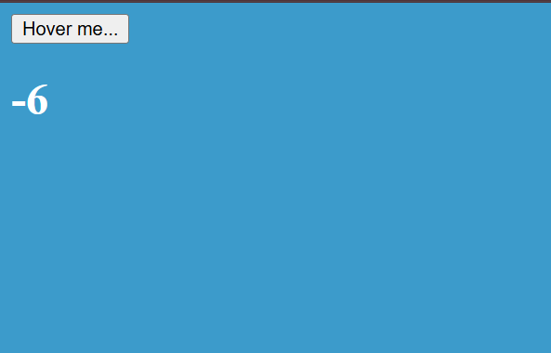

2d. Conditionally render a component
App.js
import React, { useState } from 'react';
function SecretMessage() {
return <p>This is a secret message!</p>;
}
function App() {
const [count, setCount] = useState(0)
return (
<>
<button onMouseOver={() => setCount(count + 1)}>Hover me...</button>
<h1>{count}</h1>
{count >= 10 ? <h1>Congratulations!! you reached 10 Likes...</h1> : <h1>You can do it.. Keep clicking!!</h1>}
</>
)
}
export default App;
Output:
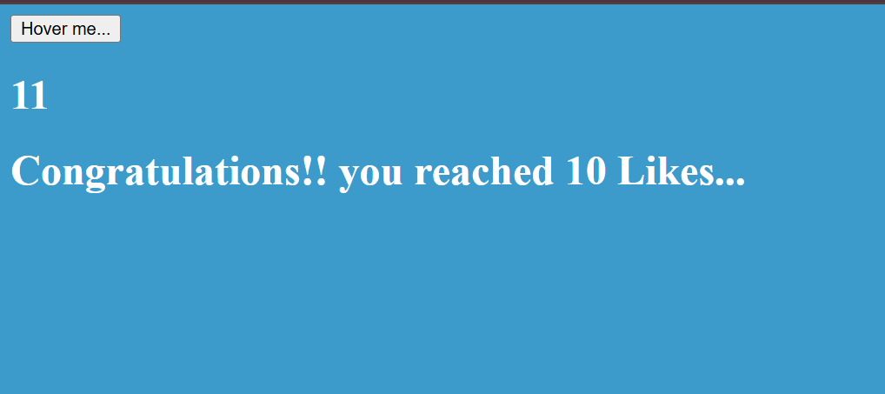

2e. Display text using String literals
App.js
import React from 'react';
function App() {
const [count, setCount] = useState(0)
const name='Full Stack Development';
return (
<>
<h1>{name}</h1>
<button onMouseOver={() => setCount(count + 1)}>Hover me...</button>
<h1>{count}</h1>
{count >= 10 ? <h1>Congratulations!! you reached 10 Likes...</h1> : <h1>You can do it.. Keep clicking!!</h1>}
</>
)
}
export default App;
Output:
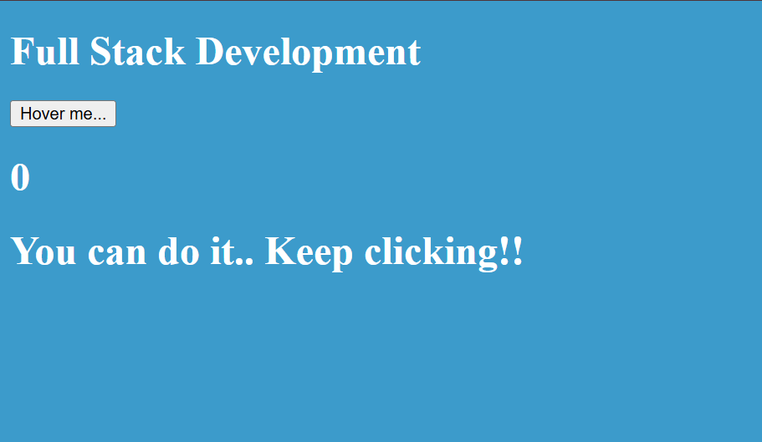

Experiment 3: Important concepts of React.js

3a. Counter button using the useState hook
App.js
import React, { useState } from 'react';
function App() {
const [count, setCount] = useState(0);
const incrementCount = () => {
setCount(count + 1);
};
const decrementCount = () => {
setCount(count - 1);
};
return (
<div>
<button onClick={incrementCount}>Like</button>
<button onClick={decrementCount}>Dislike</button>
<p>Count: {count}</p>
</div>
);
}
export default App;
Output:

3b. Fetch data from an API using the useEffect hook
App.js
import React, { useState, useEffect } from 'react';
function App() {
const [post, setPost] = useState(null);
useEffect(() => {
fetch('https://jsonplaceholder.typicode.com/posts/1')
.then(response => response.json())
.then(data => setPost(data));
}, []);
return (
<div>
<h1>Fetching Data with useEffect</h1>
{post ? (
<div>
<h2>{post.title}</h2>
<p>{post.body}</p>
</div>
) : (
<p>Loading post...</p>
)}
</div>
);
}
export default App;
Output:
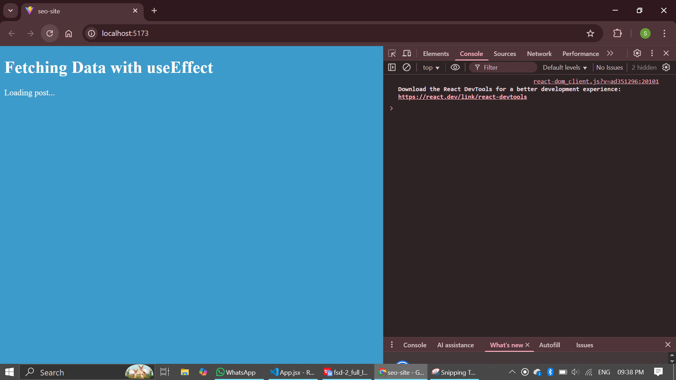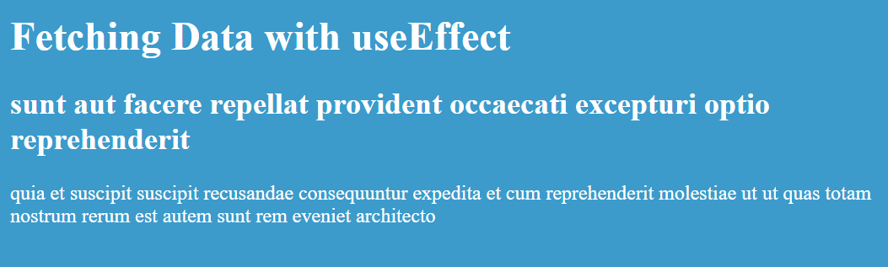

3c. Two components sharing data using Props
App.js
import React from 'react';
function GreetingCard(props) {
return <h2>Hello, {props.userName}!</h2>;
}
function App() {
return (
<div>
<h1>Parent-Child Communication with Props</h1>
<GreetingCard userName="Alice" />
</div>
);
}
export default App;
Output:
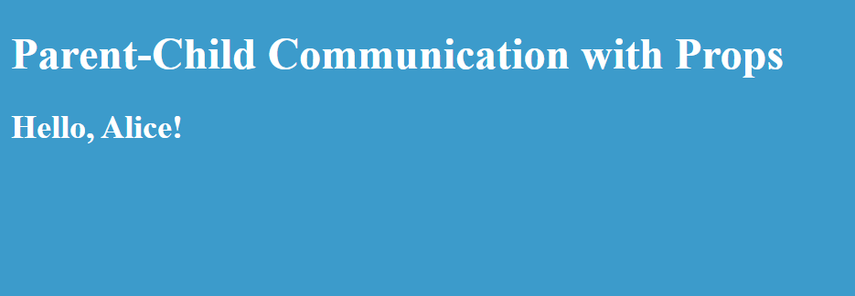

3d. Implement forms in React
App.js
import React, { useState } from 'react';
function App() {
const [name, setName] = useState('');
const handleSubmit = (event) => {
event.preventDefault();
alert(`A name was submitted: ${name}`);
};
return (
<div>
<h1>React Forms</h1>
<form onSubmit={handleSubmit}>
<label>
Name:
<input type="text" value={name} onChange={e => setName(e.target.value)} />
</label>
<button type="submit">Submit</button>
</form>
</div>
);
}
export default App;
Output:
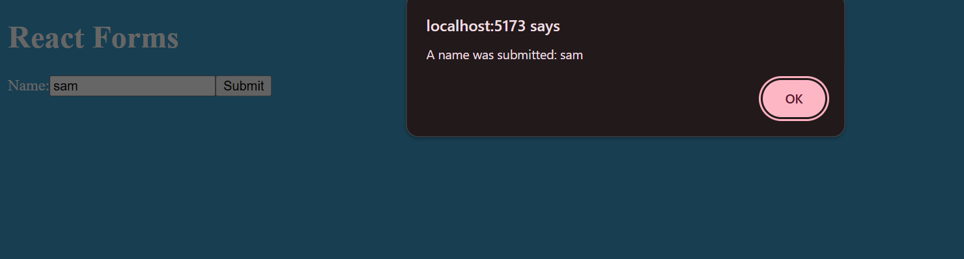

3e. Iterative rendering using map() function
App.js
import React from 'react';
const users = [
{ id: 1, name: 'Alice' },
{ id: 2, name: 'Bob' },
{ id: 3, name: 'Charlie' },
];
function App() {
return (
<div>
<h1>Rendering Lists with .map()</h1>
<ul>
{users.map(user => (
<li key={user.id}>{user.name}</li>
))}
</ul>
</div>
);
}
export default App;
Output:
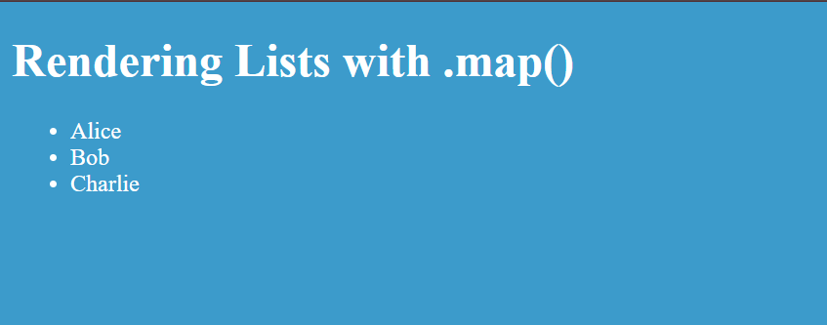

Experiment 4: Introduction to Node.js and Express.js

4a. ‘Hello world’ message in a route using Express
app.js
const express = require('express');
const app = express();
const port = 3000;
app.get('/', (req, res) => {
res.send('Hello World!');
});
app.listen(port, () => {
console.log(`Server running at http://localhost:${port}/`);
});
Output:
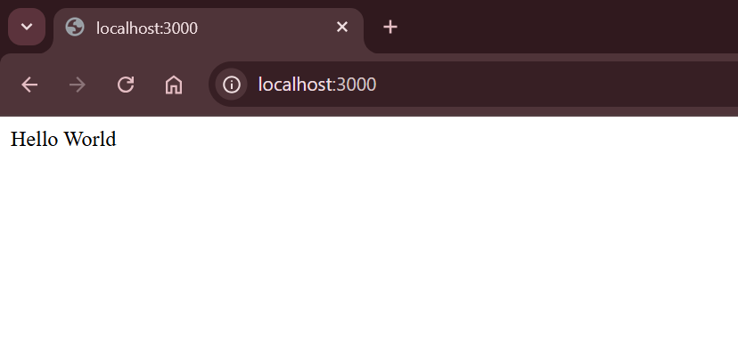

4b. Small website with multiple routes
app.js
const express = require('express');
const app= express();
const port = 3000;
app.get('/',(req,res)=>{
res.send('Hello World');
});
app.get('/:id', (req,res) => {
const id = req.params.id;
console.log('got id route, id=', id);
res.send(`Hello!! ${id}`);
});
// Use a different route pattern so it doesn't conflict with `/:id`
app.get('/name/:name',(req,res)=>{
const name = req.params.name;
res.send(`Hello!! ${name}`);
});
app.listen(port,()=>{
console.log(`Example app listening on port ${port}`);
});
Output:
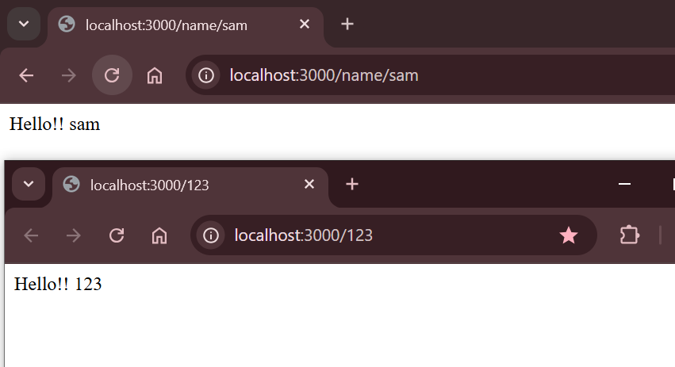

4c. Print ‘hello world’ in the browser console
app.js
const express = require('express');
const app = express();
const port = 3000;
app.get('/', (req, res) => {
res.send(`<script>console.log('Hello World');</script>`);
});
app.listen(port, () => {
console.log(`Server running at http://localhost:${port}/`);
});
Output:
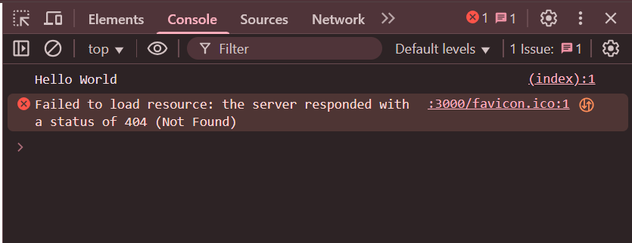

4d. Implement CRUD operations using Express.js
app.js
const express = require('express');
const app = express();
app.use(express.json());
const port = 3000;
let users = [{ id: 1, name: 'Alice' }];
// READ
app.get('/users', (req, res) => res.json(users));
// CREATE
app.post('/users', (req, res) => {
const newUser = { id: Date.now(), name: req.body.name };
users.push(newUser);
res.status(201).json(newUser);
});
// UPDATE
app.put('/users/:id', (req, res) => {
const user = users.find(u => u.id === parseInt(req.params.id));
if (!user) return res.status(404).send('User not found.');
user.name = req.body.name;
res.json(user);
});
// DELETE
app.delete('/users/:id', (req, res) => {
users = users.filter(u => u.id !== parseInt(req.params.id));
res.status(204).send();
});
app.listen(port, () => console.log(`CRUD server on port ${port}`));
Output:
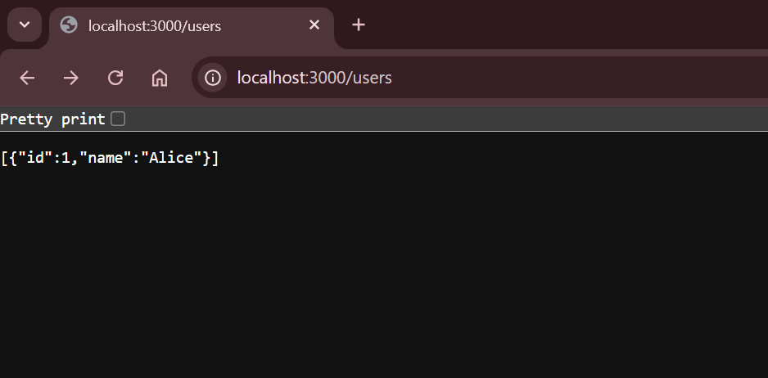

4e. Connection between API and Database using Express-MySQL
app.js
const express = require('express');
const mysql = require('mysql2');
const app = express();
const port = 3000;
const db = mysql.createConnection({
host: 'localhost',
user: 'root',
password: '',
database: 'sivakoti'
});
db.connect(err => {
if (err) throw err;
console.log('Connected to MySQL database.');
});
app.get('/categories', (req, res) => {
db.query('SELECT * FROM categories', (err, results) => {
if (err) throw err;
res.json(results);
});
});
app.listen(port, () => console.log(`API server on port ${port}`));
Output:
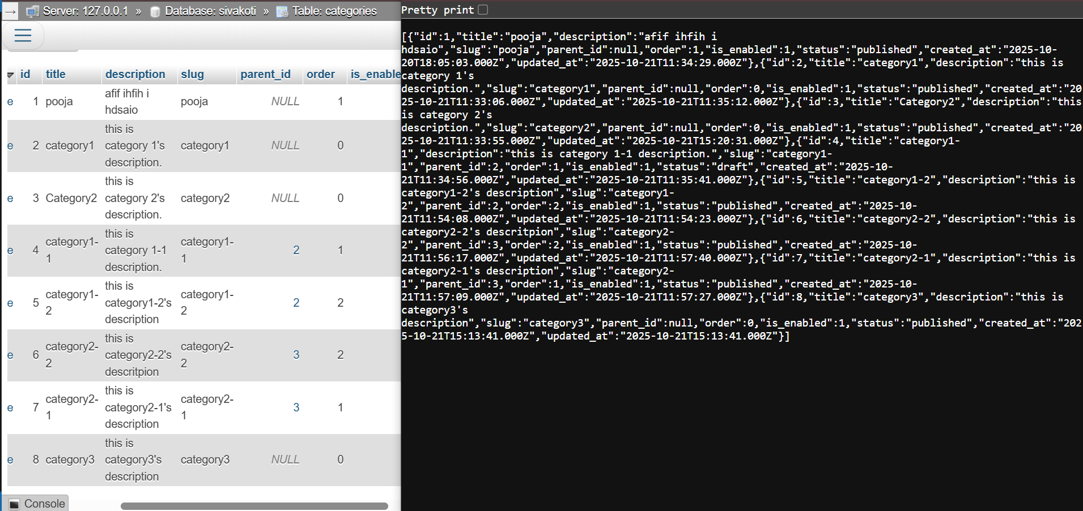
Experiment 5: Introduction to MySQL

5a. Create a Database and a table
SQL Commands
CREATE DATABASE IF NOT EXISTS company_db;
USE company_db;
CREATE TABLE employees (
id INT AUTO_INCREMENT PRIMARY KEY,
first_name VARCHAR(100) NOT NULL,
email VARCHAR(100) UNIQUE NOT NULL
);
Output:
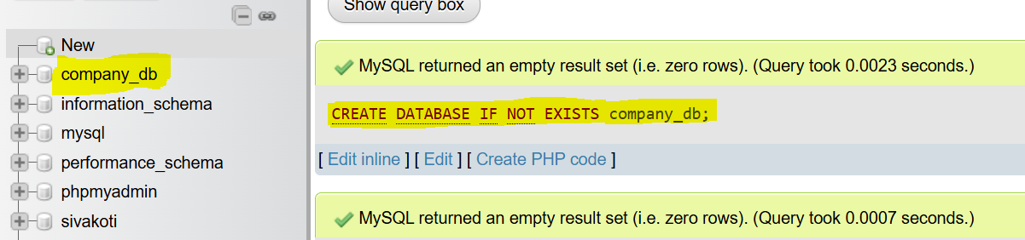

5b. Create, insert, and update data in a table
SQL Queries
USE company_db;
-- INSERT
INSERT INTO employees (first_name, email) VALUES ('John Doe', 'john.doe@example.com'), ('Jane Smith', 'jane.smith@example.com');
-- SELECT
SELECT * FROM employees;
-- UPDATE
UPDATE employees SET email = 'j.smith@example.com' WHERE first_name = 'Jane Smith';
-- DELETE
DELETE FROM employees WHERE id = 1;
Output:
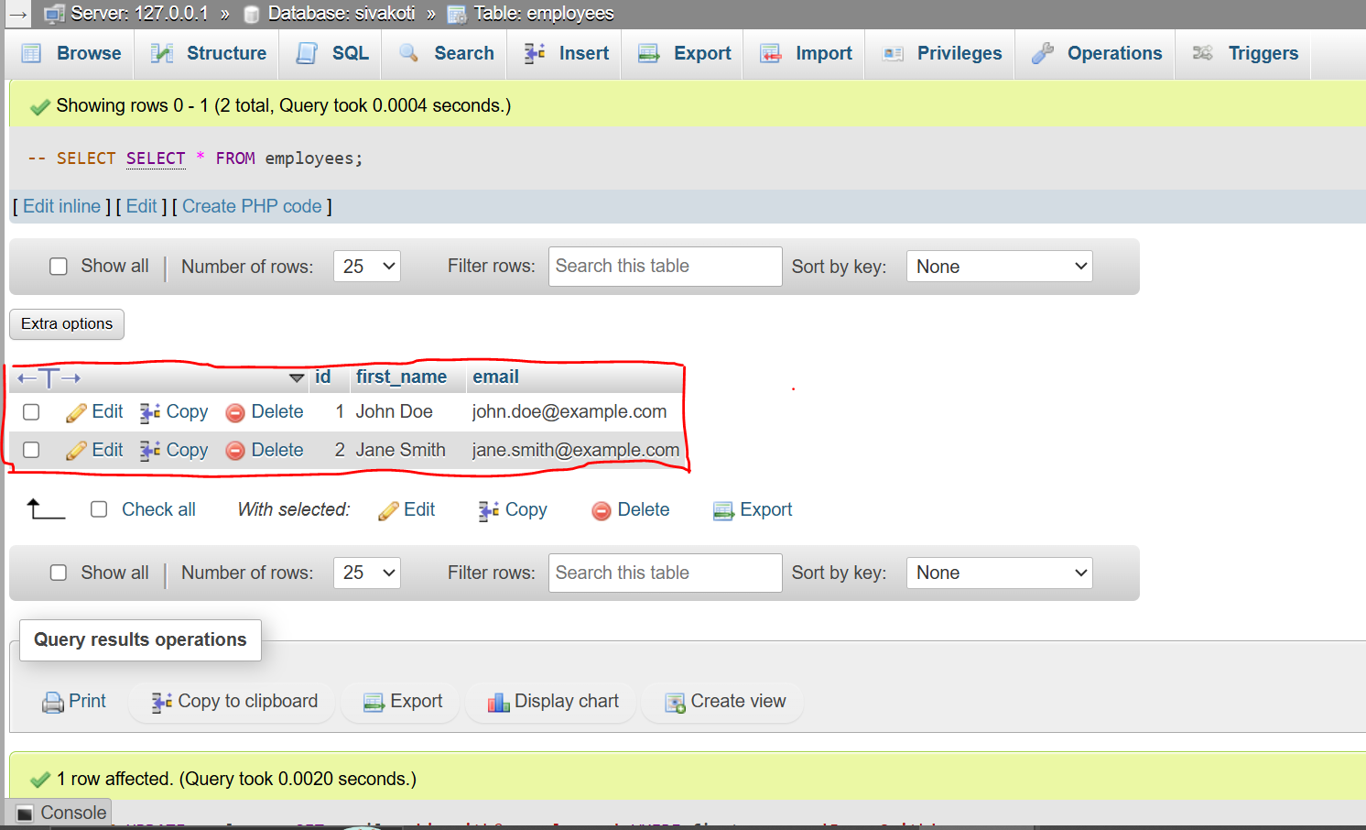

5c. Implement subqueries
SQL Queries
USE company_db;
-- Setup supporting table
CREATE TABLE departments (dept_id INT PRIMARY KEY, dept_name VARCHAR(100));
INSERT INTO departments VALUES (1, 'Engineering'), (2, 'Marketing');
ALTER TABLE employees ADD COLUMN department_id INT;
UPDATE employees SET department_id = 1;
-- Find employees in the 'Engineering' department using a subquery
SELECT first_name, email FROM employees
WHERE department_id = (SELECT dept_id FROM departments WHERE dept_name = 'Engineering');
Output:
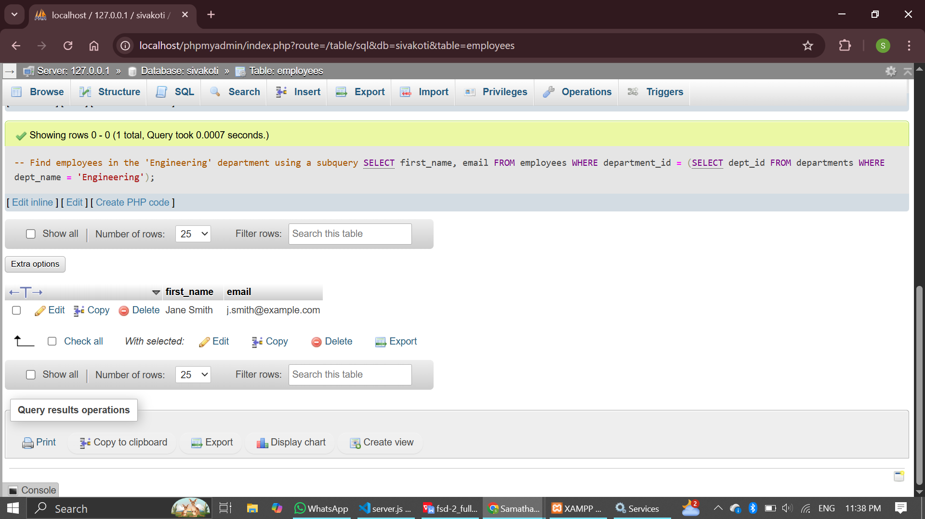

5d. Create script files in MySQL Workbench
setup_script.sql
DROP DATABASE IF EXISTS company_db;
CREATE DATABASE company_db;
USE company_db;
CREATE TABLE employees (
id INT AUTO_INCREMENT PRIMARY KEY,
first_name VARCHAR(100) NOT NULL
);
INSERT INTO employees (first_name) VALUES ('Alice'), ('Bob');
SELECT 'Database setup complete.' AS status;
Output:
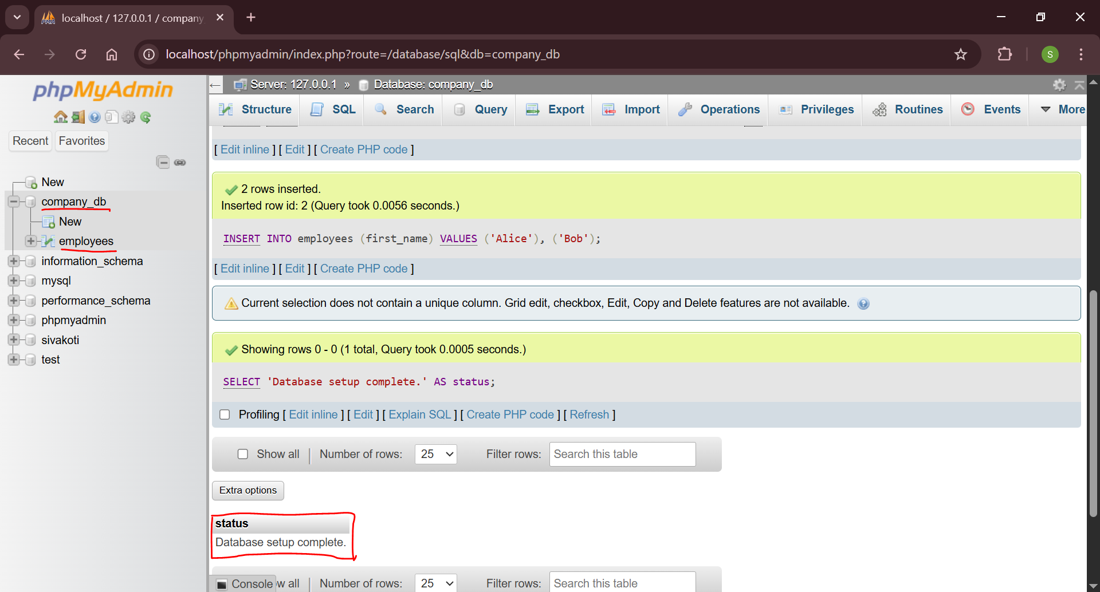

5e. Initialize a database.sql file for an API project
/database/database.sql
CREATE DATABASE IF NOT EXISTS my_api_db;
USE my_api_db;
CREATE TABLE IF NOT EXISTS products (
product_id INT AUTO_INCREMENT PRIMARY KEY,
product_name VARCHAR(255) NOT NULL,
price DECIMAL(10, 2) NOT NULL
);
INSERT INTO products (product_name, price) VALUES
('Laptop', 1200.00),
('Mouse', 25.50)
ON DUPLICATE KEY UPDATE product_name=product_name;
Output:
