**WEEK 6 HANDS_ON EXERCISES**

**ReactJS-HOL Exercise 1:**

**App.js:**

import React from 'react';

function App() {

  return (

    <div>

      <h1>Welcome to the first session of React</h1>

    </div>

  );

}

export default App;

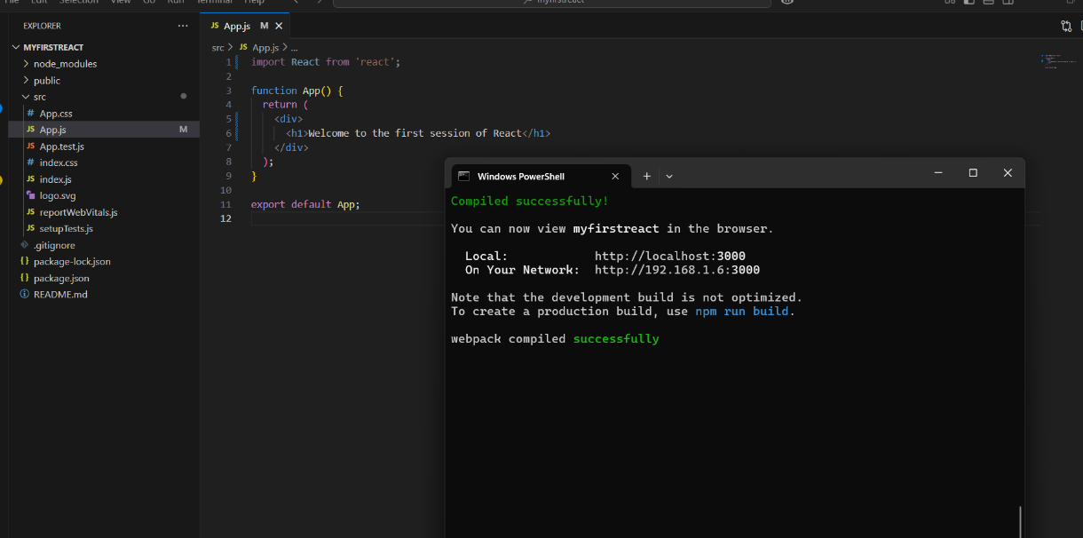**OUTPUT:**

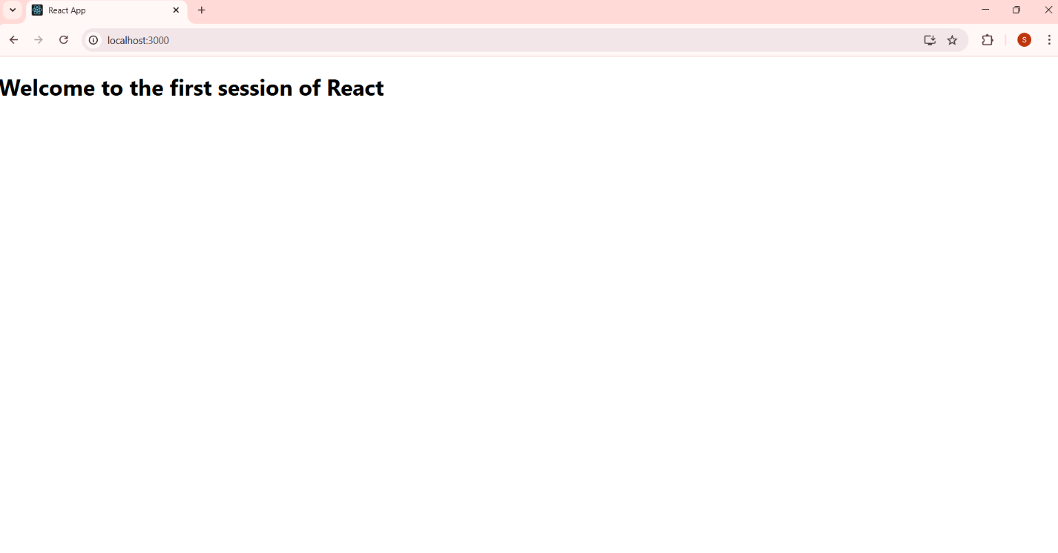

**ReactJS-HOL Exercise 2:**

**Home.js:**

import React, { Component } from 'react';

class Home extends Component {

  render() {

    return (

      <div>

        <h2>Welcome to the Home page of Student Management Portal</h2>

      </div>

    );

  }

}

export default Home;

**About.js:**

import React, { Component } from 'react';

class About extends Component {

  render() {

    return (

      <div>

        <h2>Welcome to the About page of the Student Management Portal</h2>

      </div>

    );

  }

}

export default About;

**Contact.js:**

import React, { Component } from 'react';

class Contact extends Component {

  render() {

    return (

      <div>

        <h2>Welcome to the Contact page of the Student Management Portal</h2>

      </div>

    );

  }

}

export default Contact;

**App.js:**

import React from 'react';

import './App.css';

import Home from './Components/Home';

import About from './Components/About';

import Contact from './Components/Contact';

function App() {

  return (

    <div className="App">

      <h1>Student Management Portal</h1>

      <Home />

      <About />

      <Contact />

    </div>

  );

}

export default App;

**OUTPUT:**

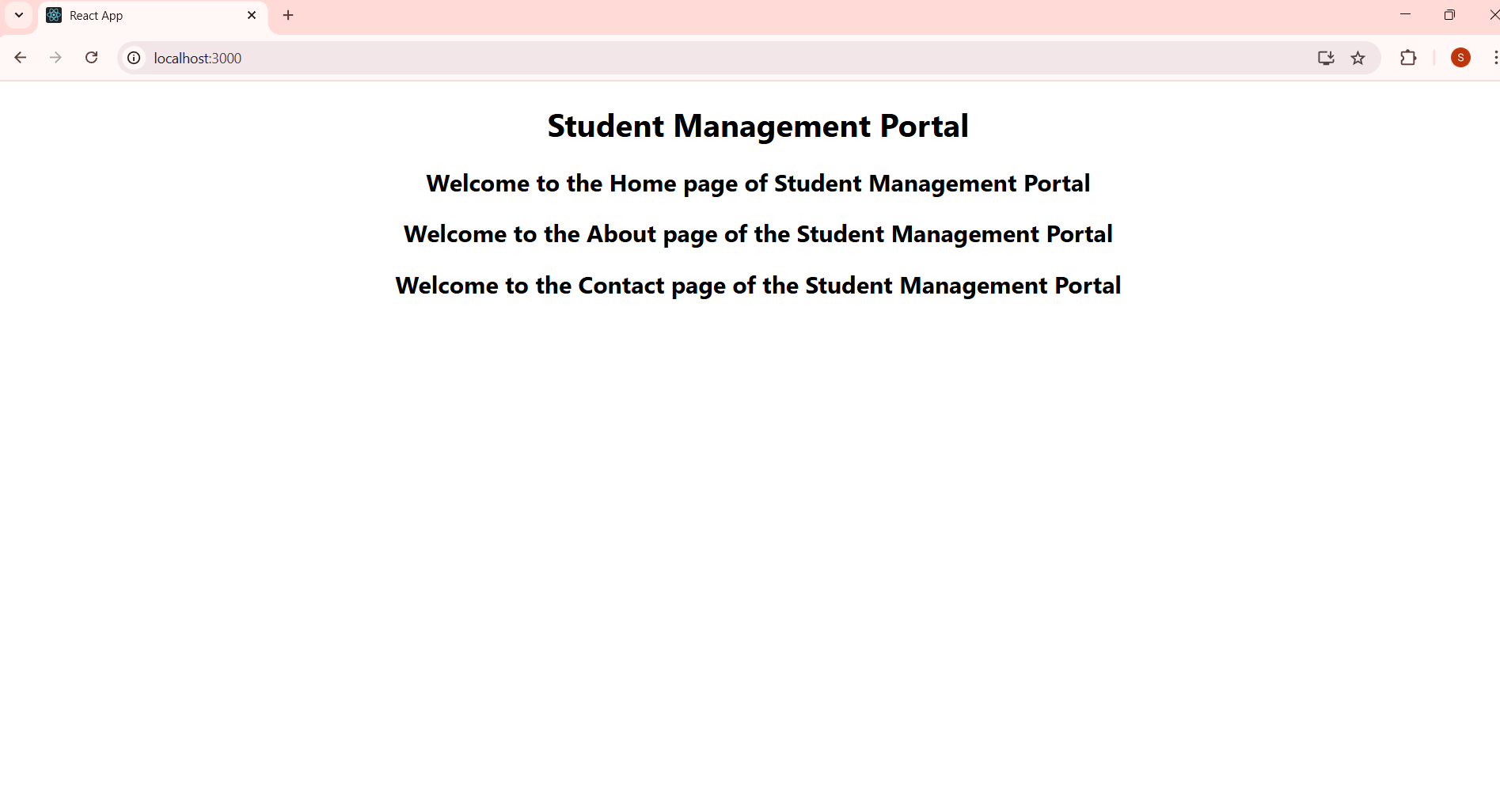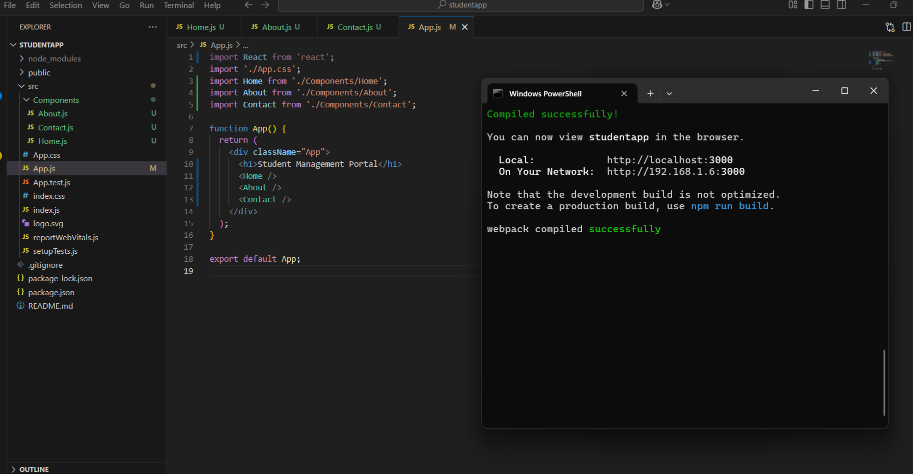

**ReactJS-HOL Exercise 3:**

**CalculatorScore.js:**

import '../Stylesheets/mystyle.css';

const percentToDecimal = (decimal) => {

    return (decimal.toFixed(2) + '%');

}

const calcScore = (total, goal) => {

    return percentToDecimal(total / goal);

}

export const CalculateScore = ({ Name, School, total, goal }) => (

    <div className="formatstyle">

        <h1><font color="Brown">Student Details:</font></h1>

        <div className="Name">

            <b><span> Name: </span> </b>

            <span>{Name}</span>

        </div>

        <div className="School">

            <b><span> School: </span> </b>

            <span>{School}</span>

        </div>

        <div className="Total">

            <b><span>Total: </span> </b>

            <span>{total}</span>

            <span> Marks</span>

        </div>

        <div className="Score">

            <b>Score:</b>

            <span>{calcScore(total, goal)}</span>

        </div>

    </div> );

**Mystyle.css:**

.Name {

    font-weight: 300;

    color: blue;

}

.School {

    color: crimson;

}

.Total {

    color: darkmagenta;

}

.formatstyle {

    text-align: center;

    font-size: large;

}

.Score {

    color: forestgreen;

}

**App.js:**

import { CalculateScore } from './Components/CalculateScore';

function App() {

  return (

    <div>

      <CalculateScore

        Name={"Pranith"}

        School={"Bala Bharathi High School"}

        total={284}

        goal={3}

      />

    </div>

  );

}

export default App;

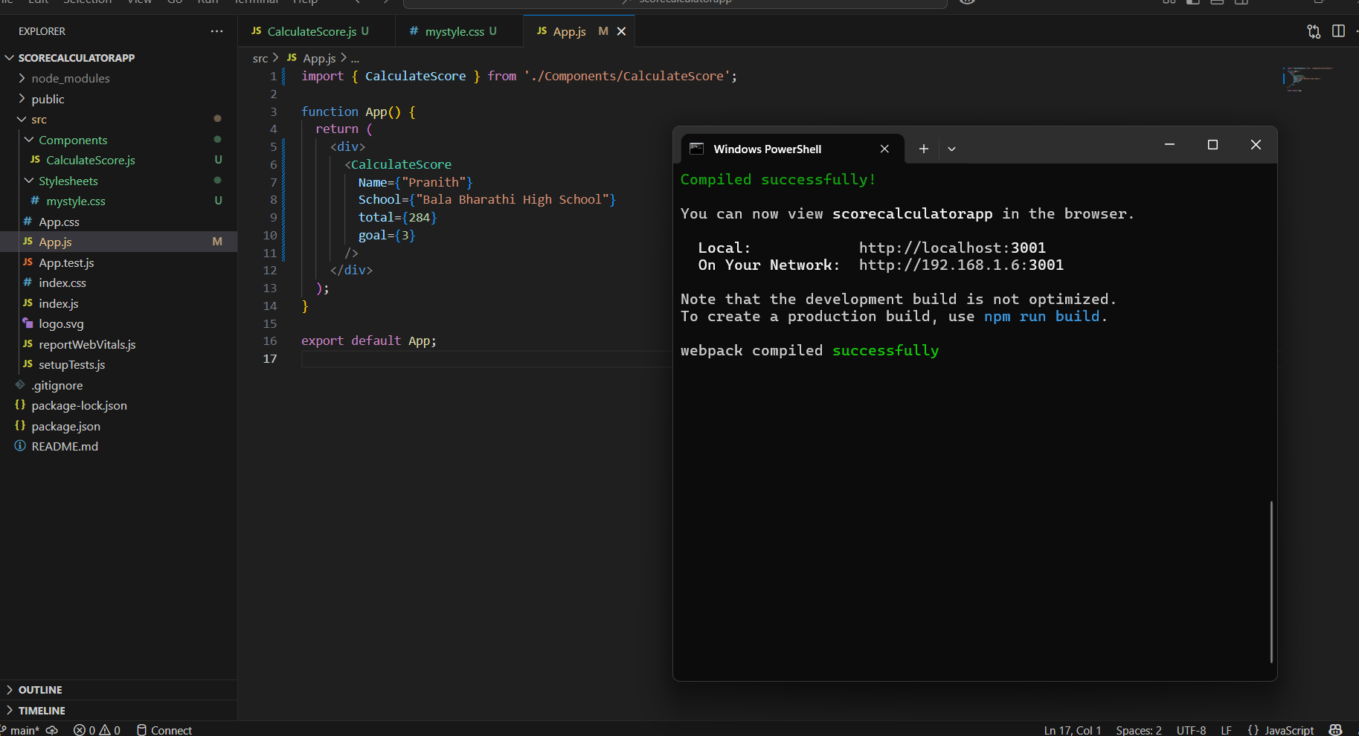**OUTPUT:**

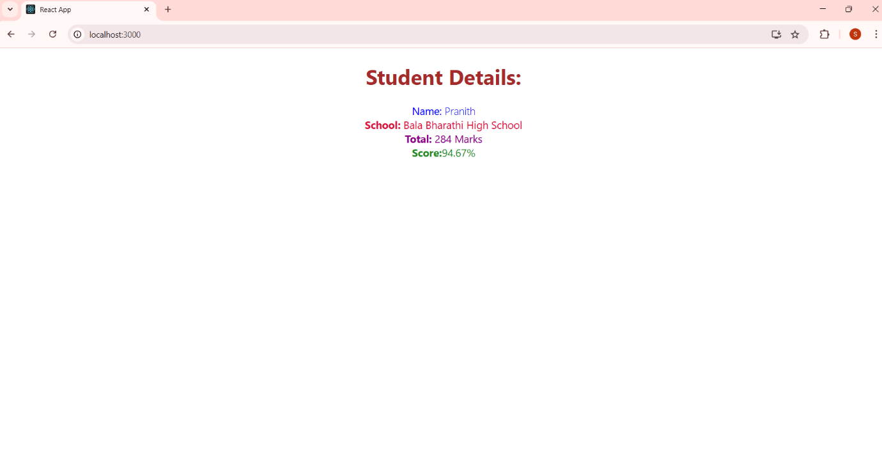

**ReactJS-HOL Exercise 4:**

**Post.js:**

import React from 'react';

class Post extends React.Component {

    render() {

        const { title, body } = this.props;

        return (

            <div>

                <h3>{title}</h3>

                <p>{body}</p>

            </div>

        );

    }

}

export default Post;

**Posts.js:**

import React from 'react';

import Post from './Post';

class Posts extends React.Component {

    constructor(props) {

        super(props);

        this.state = {

            posts: []

        };

    }

    loadPosts() {

        fetch('https://jsonplaceholder.typicode.com/posts')

            .then(response => response.json())

            .then(data => this.setState({ posts: data }));

    }

    componentDidMount() {

        this.loadPosts();

    }

    render() {

        return (

            <div>

                <h2>Posts</h2>

                {this.state.posts.map(post => (

                    <Post key={post.id} title={post.title} body={post.body} />

                ))}

            </div>

        );

    }

    componentDidCatch(error, info) {

        alert('An error occurred while rendering.');

        console.error('Error:', error);

        console.error('Info:', info);

    }

}

export default Posts;

**App.js:**

import React from 'react';

import Posts from './Posts';

function App() {

    return (

        <div className="App">

            <h1>Blog Application</h1>

            <Posts />

        </div>

    );

}

export default App;

**OUTPUT:**

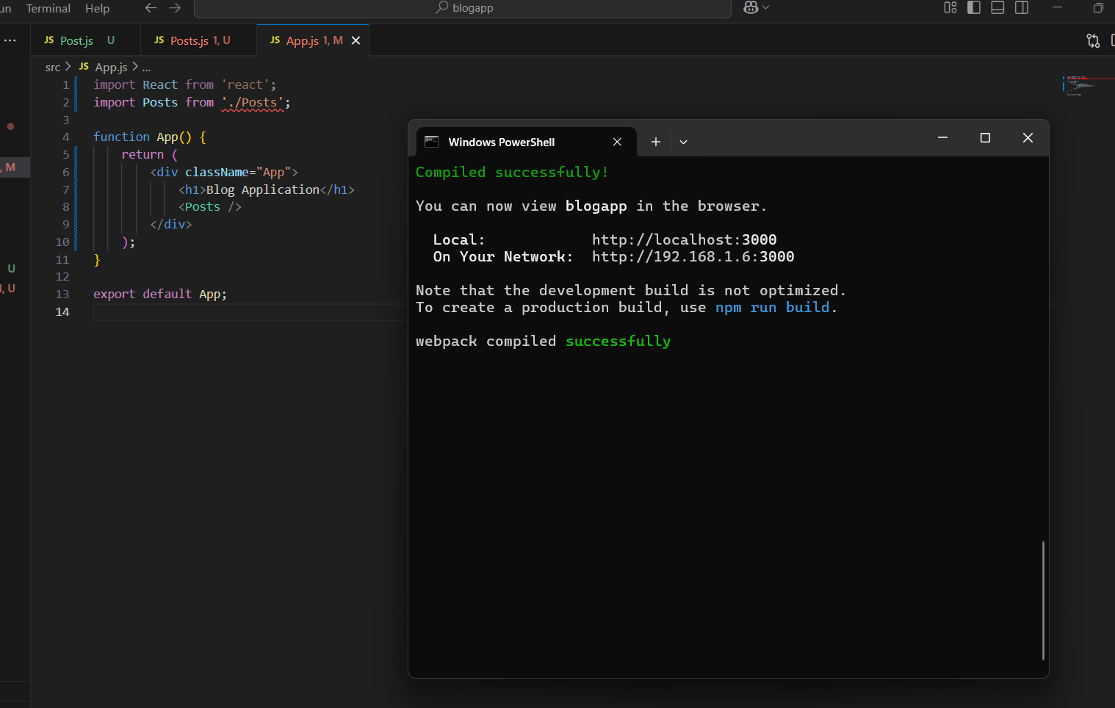

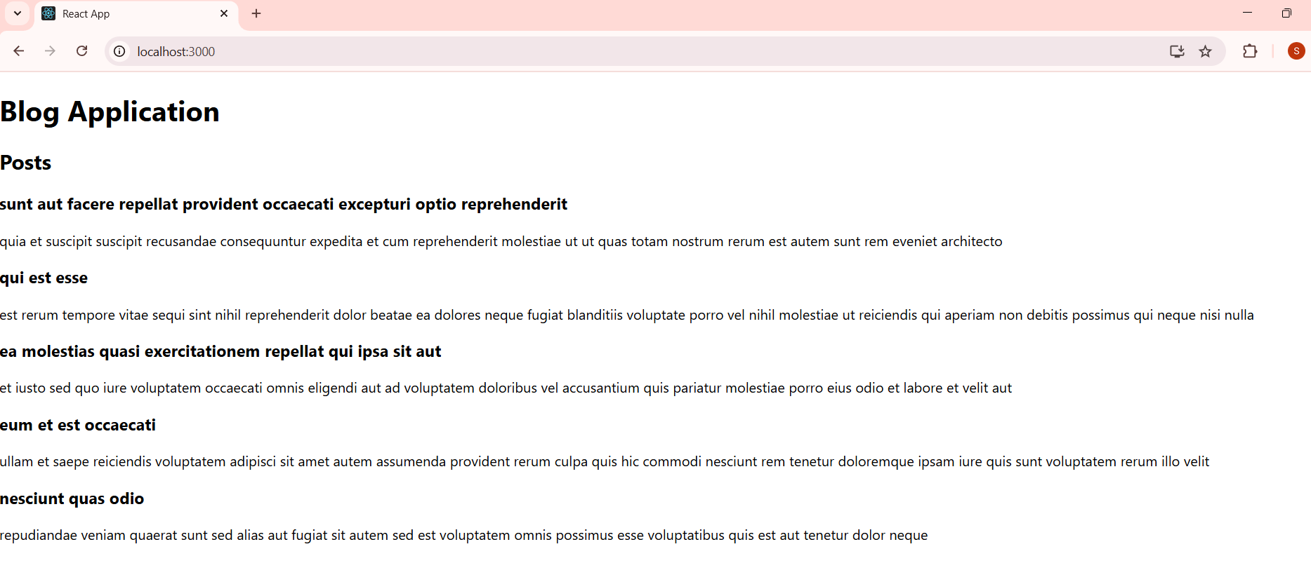

**ReactJS-HOL Exercise 5:**

**Cohort.js:**

import React from 'react';

import CohortDetails from './CohortDetails';

const Cohort = () => {

  const cohorts = [

{

id: 'INTADMDF10',

title: '.NET FSD',

startDate: '22-Feb-2022',

status: 'Scheduled',

coach: 'Aathma',

trainer: 'Jojo Jose'

},

{

id: 'ADM21JF014',

title: 'Java FSD',

startDate: '10-Sep-2021',

status: 'Ongoing',

coach: 'Apoorv',

trainer: 'Elisa Smith'

},

{

id: 'CDBJF21025',

title: 'Java FSD',

startDate: '24-Dec-2021',

status: 'Ongoing',

coach: 'Aathma',

trainer: 'John Doe'

}

  ];

  return (

    <div>

      <h2>Cohort Dashboard</h2>

      {cohorts.map((cohort, index) => (

        <CohortDetails key={index} cohort={cohort} />

      ))}

    </div>

  );

};

export default Cohort;

**Cohortdetails.js:**

import React from 'react';

import styles from './CohortDetails.module.css';

const CohortDetails = ({ cohort }) => {

const { id, title, startDate, status, coach, trainer } = cohort;

const titleStyle = {

color: status.toLowerCase() === 'ongoing' ? 'green' : 'blue'

};

return (

<div className={styles.box}>

<h3 style={titleStyle}>{id} - {title}</h3>

<dl>

<dt>Started On:</dt>

<dd>{startDate}</dd>

<dt>Current Status:</dt>

<dd>{status}</dd>

<dt>Coach:</dt>

<dd>{coach}</dd>

<dt>Trainer:</dt>

<dd>{trainer}</dd>

</dl>

</div>

);

};

export default CohortDetails;

**CohortDetails.module.css:**

.box {

  width: 300px;

  display: inline-block;

  margin: 10px;

  padding: 10px 20px;

  border: 1px solid black;

  border-radius: 10px;

}

dt

{

  font-weight: 500;

}

**App.js:**

import logo from './logo.svg';

import './App.css';

import { CohortsData} from './Cohort'

import CohortDetails from './CohortDetails';

function App() {

  return (

  <div>

    <h1>Cohorts Details</h1>

    {CohortsData.map(cohort => <CohortDetails cohort={cohort}/>)}

  </div>

  );

}

export default App;

**OUTPUT:**

