**IMAGE CLUSTERING USING TRANSFER**  **LEARNING (VGG16 ,VGG19,RESNET50)**

**ABSTRACT**

For the problems with the image clustering, the replacement of pixel image data with features derived by an advanced neural network such as vgg16,vgg19,reset50 improves clustering accuracy. The basic features derived and the chosen CNN architecture by extension may also have a more effect on the performance of the clusters.

In reality, the choice of design is always arbitrary, since cross validation cannot be used for unattended learning difficulties. However, even when pretrained on the same results, weights found in various pretrained CNN architectures can help.

We revisit the problem of clustering the picture as a multi-vision problem that regards many, pre-trained architectures as extractor features as various 'views' of the same data. We will give an algorithm of k implies for features derived by pretrained models.

We follow three steps:

1. using multiple pretrained architectures(vgg16,vgg19,resnet 50) separately as feature extractors that reduces the computation cost.
2. Running k means to cluster the images for each separate models.
3. Finding the best fit model based on accuracy and F-score.

**INTRODUCTION**

Images to us, humans, are naturally processed through our vision and brain systems. We learn to recognise what things are without being explicitly told how to do so. To a computer, images are a series of numbers representing the brightness of different colours in particular parts of the image.

In traditional classification problems, we present the computer with images and labels describing what the images represent. We then ask it to learn how to classify similar images by looking at the ones we gave it. Using deep convolutional networks the computer detects patterns in the images and relates them to the classification labels using fully connected neural networks

In unsupervised learning, the computer is asked to infer a pattern, structure, or relationship in the data that we cannot see. One method of applying this is clustering where we ask the computer to mark similar data points with the same label. Unsupervised clustering has been used for image classification before.

Therefore, with the help of this project we can reduce the computational cost and cluster the images into separate folders. This project can be applied for real-time applications to cluster the different types of images.

In this Project first we will reshape all the size of images to (224*224) pixels as each image has different size of pixels .After reshaping of images we are normalizing the image as the each pixel in the image vary from 0 to 1.Therefore,each image in RGB(Red,Blue,Green) color so that each image size is (224*224*3)

Then,we are taking the pre-trained models of VGG16(Visual

GeometrGroup),VGG19((Visual Geometry Group),ResNet50 that are well trained on imagenet data set that consist of 1000 catagories or classes.VGG16 has 16 hidden layers that consist of convolution layers , pooling layers and fully convolution layers. VGG19 has 19 hidden layers that consist of convolution layers , pooling layers and fully convolution layers. ResNet50 has 50 hidden layers that consist of convolution layers , pooling layers and fully convolution layers.

We will remove the fully convolution layers of Vgg16, Vgg19, ResNet50 as we are not classifying the classes into 1000 categories we are taking the weights of Vgg16,Vgg19, ResNet50 so that the image features are reduces from 1,50,528 (224*224*3) to 25000 features.while training the Vgg16,Vgg19,ResNet50 models. Therefore the output of Vgg16,Vgg19, ResNet50 will be images of reduced features. This method is called Transfer Learning.

Transfer learning (TL), which focuses on storing knowledge gained in solving one problem and applying it to a specific, but related problem, may be a research problem in machine learning. For example, when it comes to recognising cars, the information learned when learning to recognise cars might apply. This field of study refers to the long tradition of psychological literature on learning transmission, but formal relationships are minimal between the two disciplines. From a sensible point of view, reuse or transfer of knowledge from previously learned tasks for training recent tasks has the potential to considerably increase reinforcement learning sample performance

PCA(Principle Component Analysis) can be done for dimensionality reduction and to find the varience between two points and it also remove noise from the points so that clustering before PCA is done by many researches . We can do clustering without PrincipleComponent Analysis also. The outputs of Vgg16,Vgg19,ResNet50 is pipelined to Principle Component Analysis where dimensionality reduction can be done and is pipe lined to K-means Clustering algorithm.

KMeansiisitheisimplestiunsupervisedilearningialgorithmithatisolvesiclusteringiproblem. K meansalgorithmipartitioniniobservationsiintoikiclustersiwhereieachiobservationibelongsitoithei clusteriwithitheinearestimeaniservingiasiaiprototypeiofitheicluster.Therefore ,we will get six model for comparison as three models without PCA and with PCA.At last we are performing the f-score for confusion matrix for all the six models and choose which one is fit for our dataset.

The six models for comparison in this project are:

1. Combination of VGG16 and Principle Component Analysis and K-Means Algorithm
2. Combination of VGG19 and Principle Component Analysis and K-Means Algorithm
3. Combination of ResNet50 and Principle Component Analysis and K-Means Algorithm
4. Combination of VGG16 and K-Means Algorithm
5. Combination of VGG19 and K-Means Algorithm
6. Combination of ResNet50 and K-Means Algorithm

#### Models for Transfer Learning

Perhaps three of the more popular models are as follows:

VGG (e.g. VGG16 or VGG19).

GoogleNet (e.g. InceptionV3).

Residual Network (e.g. ResNet50).

These models have been used extensively both because of their success and because they have implemented unique architectural developments, such as VGG, initial modules(GoogleNet), and residual modules (ResNet).

Keras offers access to a range of high-performance pre-trained models designed for the identification of images.

They are accessible through the Application API, include the built-in feature for the loading of a model with, or without, the pre-trained weights (e.g. scaling of size and pixel values).First, a pre-trained model is loaded, and Keras is able, provided the speed of your internet connection, to download the specified model weights. Weights will be saved to your home directory in the keras/models/ folder and loaded for the next time it is used.

**Literature Survey**

[1] Joint Unsupervised Learning of DeepRepresentations and Image Clusters  **- Jianwei Yang, Devi Parikh, DhruvBatra Virginia Tech**

In this article, they suggest a recurring structure for deep representations and image clusters for Joint Unattended Learning (JULE). In our context, successive activities are expressed in a clustering algorithm as recurrent steps stacked on top of the representations generated by a Convolutionary Neural Network (CNN). During preparation, picture clusters and representation are revised together: picture clustering is carried out on the front, when rearward representation is learning. Our main theory in this context is that effective representations benefit the effects of the clustering of images and provide supervisory cues for the learning of representation.By combining two processes within a single model, we can achieve not only more efficient representations but also accurate image clusters with a uniform weighted triplet loss and optimising it from one end to the other. Comprehensive tests demonstrate that our approach is above the cutting-edge image clustering across a range of image datasets. In addition, as moved to other functions, the studied representations generalise well.

A basic yet powerful end-to-end learning system is proposed to learn from an unlabeled picture collection deep representation and image clusters jointly.We articulate collaborative learning in a recurring context, where agglomerative clustering activities are articulated in the forward way and interpretation of CNN is expressed as a retrospective way. We extract one loss function to direct deep representation and aggregate classification, which makes optimization smooth over both tasks .Our research findings reveal that the structure proposed exceeds previous image clustering approaches and learns profound representations that can be transferred to additional tasks and databases.

They also suggested in this paper an approach to learn deep representations and image clusters together. For our strategy, we have merged and formulated the agglomeration clustering with CNNs. In order to break the cycles into many intervals we used a partly unrolling approach. We have gradually merged climbs during the front pass, which are led by one weighted triple-loss element, and learned representation in the backward pass.Extensive experimentation with the subject matter of image graphics, profound representation transition learning and image recognition show that our approach can provide more accurate image clusters and discrimination that are widespread in many different datasets and tasks.

[2]PCA Based Clustering for Brain Tumor Segmentation of T1w MRI Images

#### - IremErsozKaya,Ayc¸aC¸akmakPehlivanli,EmineGezmezSekizkardes

Medical images are large pieces of material that have a hard time saving and processing. The reduction techniques are also widely used as a pre-processing stage to make the image data less abstract, so that an adequate low-dimensional representation will identify high-dimensional data. PCA is one of the best-known data-reduction multivariate techniques. This paper focuses on T1weighted MRI images clustering with different common Principe Component Analysis (PCA) algorithms for brain tumour segmentation and dimension reduction. Our main objective is to compare various PCA algorithm variants for two cluster approaches on MRIs.

Other 3 other sizes were used in this analysis in order to evaluate their methodology as well as the original size of 512 lines and 512 pixels per row, 256x256, 128x128 and 64x64.

The PCA techniques have been applied in three different formats and the original formats in order to meet the objective. The MRI images have been resized. PPCA and EM-PCA were slightly higher than some, based on the restoration error rates of the application data. The way the prophetic vectors were collected will trigger this. The EM-PCA and the PPCA algorithms are both a probabilistic approach in order to find a principal subspace without computing explicitly the sample covariance matrix, which provides an efficient way of calculating the matrix, particularly for large and high variance results, in difficult cases.These situations will quickly raise the issue of overfitting. Moreover, due to probabilistic estimations, the methods should handle missing data. In the analysis 5 centroids were determined in view of the histogram of the original image. In addition, the optimum value for parameter C of the FCM algorithm was determined via a sequence of launches. For each C value the algorithm was carried out with increments of 0 to 30 and the value of 5 was eventually added to the parameter. Due to FCM's and K-clustering Mean's findings, FCM overperformed the K-Means clustering, using a PCA algorithm for resized T1w MRI images. The result is confirmed by the fact that it can easily be achieved by the initial conditions of the clusters in finding the best locations in the centroids.

FCM is however searching for cluster centres to minimise the number of squared errors.

The EM-PCA and PPCA achieve the success with the two clustering algorithms on the resized

MRI images in line with the above-mentioned outcomes. It is inferred therefore that the two Clustering algorithms, FCM and K-Eans, work effectively both as the ACCEPTED MANUSCRIPT MANUSCRIPT 27 PPCA and the EM-PPCA algorithms.

### **SOFTWARE REQUIREMENTS**

The purpose of the interface program concerning this software product is depicted in each interface.

Programming Language: Python 3

Platform IDE: Anaconda (Jupyter Notebook) Version: 3.6.5

Operating system: Windows 10 ,macOS, Linux

### DESIGN

#### 4.1 UseCase Diagram

A case scheme can be any kind of diagram specified by a Use-case study within the Unified Modeling Language (UML). The aim is to provide a graphical summary of the system's features in terms of actors, their objectives (represented as cases of use), and any dependencies between those cases. Usage case diagram is mostly intended to demonstrate which machine functions the actor performs. The actors' roles are also seen throughout the structure.

**F**

**i**

**g**

**4**

**.**

**1**

U

s

e

**F**

**i**

**g**

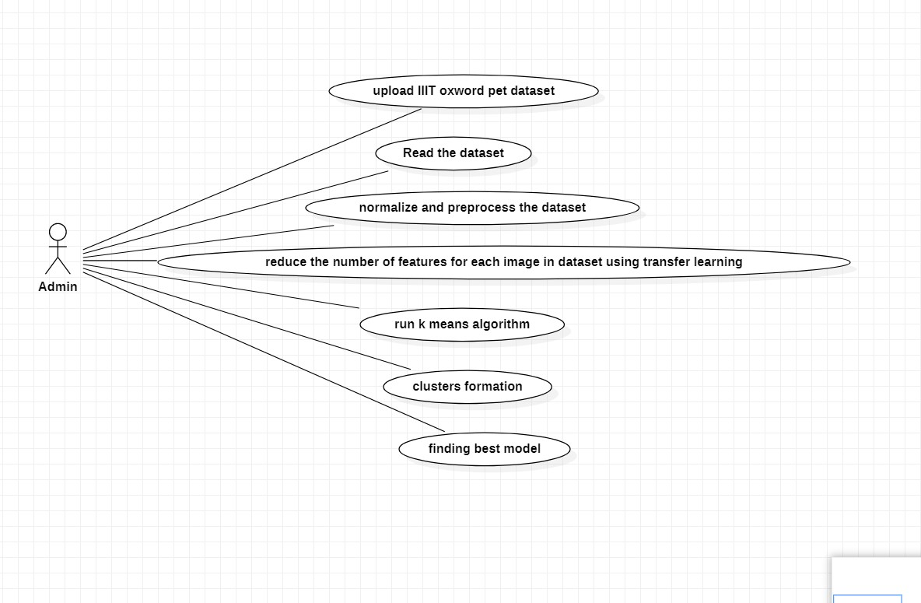

**4.1** UseCase Diagram for image clustering using transfer learning.

### IMPLEMENTATION

#### 5.1 Data Exploration

The general notion of representing images by using convolutional networks and then separating them using unsupervised clustering algorithms is applicable to many datasets. In our case here, we will be using the Oxford IIIT Pet dataset, comprising of images of 37 categories of pet breeds, 12 of cats, and 25 of dogs. The images are of different scales, poses and light levels.

This is in contrast to some other datasets which will have a more uniform set of images.

8 images were removed from the Egyptian Mau cat images, however this category was not actually used during our testing and therefore did not affect the results. The images were also manually moved from being in a single folder, to placing images of the different breeds in their own subfolders. Images were already labelled in their filenames with which breed they were of, and so we do not expect this process to have misplaced any breed images in the wrong folder. This was done to simplify the process of loading the images into memory for the algorithms to work on them.

**Exploratory Visualization**

To start with, we do a count and a list of the number of breed images available. This count was done by code written as part of this project and gives the table result below. The codes were assigned by me, in order to facilitate referencing the different breeds, and were consequently used as labels when measuring algorithm performance. The choice of labels does not affect algorithm performance, as the separation algorithm is never exposed to them, and they are only used after it has produced its results.

The dataset has 7380 images, roughly distributed at around 200 images for each breed, with some breeds having less images from source, or because the images were corrupt.

### **CONCLUSION**

#### Free-Form Visualization

When the GMM algorithm was unable to process the large featureset of the images, on the available computing capabilities, after they’ve been passed through the convolutional networks, PCA was identified as a dimensionality reduction method.

Traditionally when PCA is used, we chose the number of component we want to use based on how much explained variance we need. There is a compromise between the reduction in dimensionality possible and the amount of information conserved.

One good way of visualising this are charts of explained variance vs number of components. We can see below such charts for the three neural networks used when given images of the first breed combination.

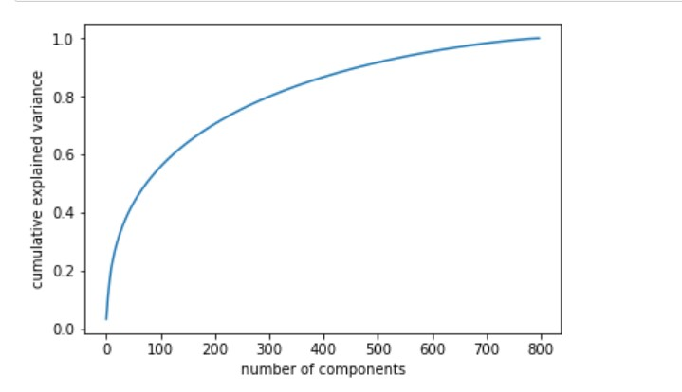

Graph of cumulative variance of PCA components of VGG16 architecture with x-axis as number of components and y-axis has cumulative variance

### REFERENCES

|  |
| --- |
|  |

1.Jianwei Yang, Devi Parikh, Dhruv Batra Virginia Tech,” Joint Unsupervised Learning of Deep Representations and Image Clusters,” In ICASSP, pages 8595–8598. IEEE, 2016

2.Irem Ersoz Kaya , Ayc¸a C¸ akmak Pehlivanli , Emine Gezmez Sekizkardes¸ , ¨ Turgay Ibrikc¸i , PCA Based Clustering for Brain Tumor Segmentation of T1w MRI Images, Computer Methods and Programs in Biomedicine (2016), doi: 10.1016/j.cmpb.2016.11.011

3. Dehariya, V. K., Shrivastava, S. K., & Jain, R. C. (2010). Clustering of Image Data Set Using K-Means and Fuzzy K-Means Algorithms. 2010 International Conference on Computational Intelligence and Communication Networks. doi:10.1109/cicn.2010.80

4 . Turgay Celik. (2009). Unsupervised Change Detection in Satellite Images Using Principal Component Analysis and $k$-Means Clustering. IEEE Geoscience and Remote Sensing Letters, 6(4), 772–776. doi:10.1109/lgrs.2009.2025059

5.Baumgartner, R., Ryner, L., Richter, W., Summers, R., Jarmasz, M., & Somorjai, R. (2000). Comparison of two exploratory data analysis methods for fMRI: fuzzy clustering vs. principal component analysis. Magnetic Resonance Imaging, 18(1), 89–94. doi:10.1016/s0730725x(99)00102-2