AI-Powered Fact Verification Agent
Team Name: DECIPHERX
Team members: PRANITHA P(7376242IT255),
NETHRA B(7376242IT230)

1. Introduction
The AI-Powered Fact Verification Agent is an intelligent web-based application developed to verify textual factual claims using Artificial Intelligence and real-time web evidence retrieval.
The application combines the Tavily Search API for retrieving reliable online evidence with the Groq API running the Llama 3.x Large Language Model for reasoning and verification.
Tavily Search API was selected because it is specifically designed for AI-powered search and returns relevant, trustworthy information that can be directly used for Retrieval-Augmented Generation (RAG). This enables our application to retrieve factual evidence before performing AI reasoning.
Groq API was chosen because it provides high-speed inference for open-weight Large Language Models such as Llama 3.x, enabling faster response generation while maintaining strong reasoning capabilities.
Unlike conventional AI chatbots that directly generate responses, our application follows an evidence-first verification approach, where supporting information is collected before AI reasoning begins. This improves transparency, reduces unsupported responses, and provides users with reliable explanations backed by trusted sources.
The application is designed using a modular architecture consisting of a React frontend, FastAPI backend, and AI services, making it scalable, maintainable, and suitable for future enhancements.

2. Problem Statement
The rapid spread of misinformation across social media platforms, news websites, blogs, and messaging applications makes it increasingly difficult for users to determine the authenticity of information. Manual verification requires comparing multiple trusted sources, which is time-consuming and often impractical.
Although modern AI chatbots can answer factual questions, they may sometimes generate inaccurate or unsupported responses due to hallucinations or outdated knowledge.
The proposed AI-Powered Fact Verification Agent addresses this challenge by retrieving evidence from trusted online sources and using AI reasoning to generate transparent, explainable, and evidence-backed verification reports.

3. Methodology
The proposed system follows an evidence-based verification workflow consisting of the following stages.
Step 1 – Claim Submission
The user enters a textual factual claim through the React-based web interface.
React was chosen because it enables the development of reusable components and provides a fast, interactive, and responsive user experience. Vite was used as the build tool for its fast startup time and hot module replacement, while Tailwind CSS helped rapidly create a clean and responsive interface during the hackathon.
Example:
"Spain won the 2022 FIFA World Cup."

Step 2 – Backend Processing
The submitted claim is sent to the FastAPI backend, where the input is validated before further processing.
FastAPI was selected because it is lightweight, high-performance, and well-suited for developing REST APIs that communicate efficiently with external AI services.
The backend is implemented in Python, which provides excellent support for AI integration and backend development.

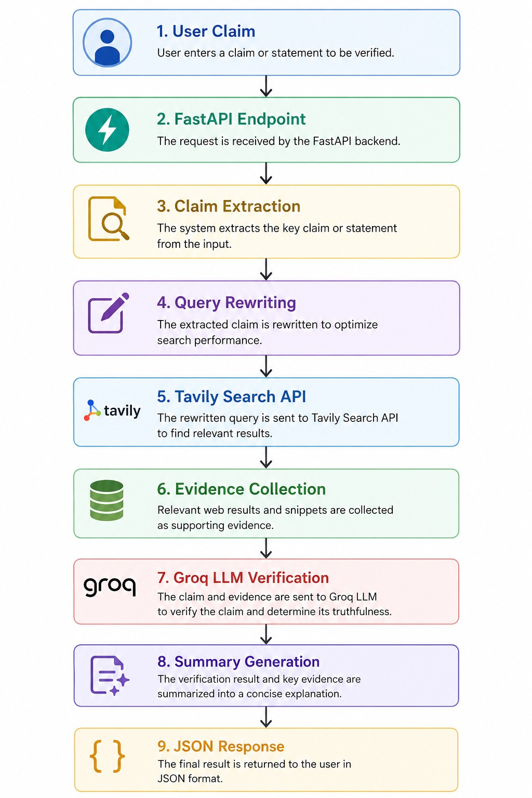

Step 3 – Evidence Retrieval
The backend sends the claim to the Tavily Search API.
We chose Tavily because it retrieves relevant and trustworthy information specifically optimized for AI applications. Instead of performing a normal web search, Tavily returns structured evidence that improves the quality of AI reasoning.
The retrieved evidence becomes the factual context for verification instead of relying solely on the AI model's internal knowledge.

Step 4 – AI-Based Verification
The retrieved evidence, together with the user's claim, is forwarded to the Groq API, which runs the Llama 3.x Large Language Model.
The Groq API was selected because it provides very low inference latency, allowing verification reports to be generated quickly.
The Llama 3.x model was chosen because it is an open-weight Large Language Model capable of understanding context, analyzing evidence, and generating explainable verification reports with strong reasoning performance.

Step 5 – Result Generation
Finally, the application displays a structured verification report containing:
- Verification Verdict
- Confidence Score
- AI-generated Explanation
- Supporting Evidence
- Reference URLs
This evidence-first workflow minimizes hallucinations and improves transparency by ensuring that AI reasoning is supported by retrieved evidence.

4. Result
The developed application successfully verifies textual factual claims by combining real-time evidence retrieval with AI reasoning.
The system provides:
- Accurate verification verdicts
- Confidence scores
- Explainable AI-generated reasoning
- Supporting evidence
- Trusted reference URLs
The responsive user interface enables users to quickly verify claims and understand the reasoning behind each decision.
The project successfully demonstrates the practical application of Retrieval-Augmented AI for fact verification within a hackathon environment.

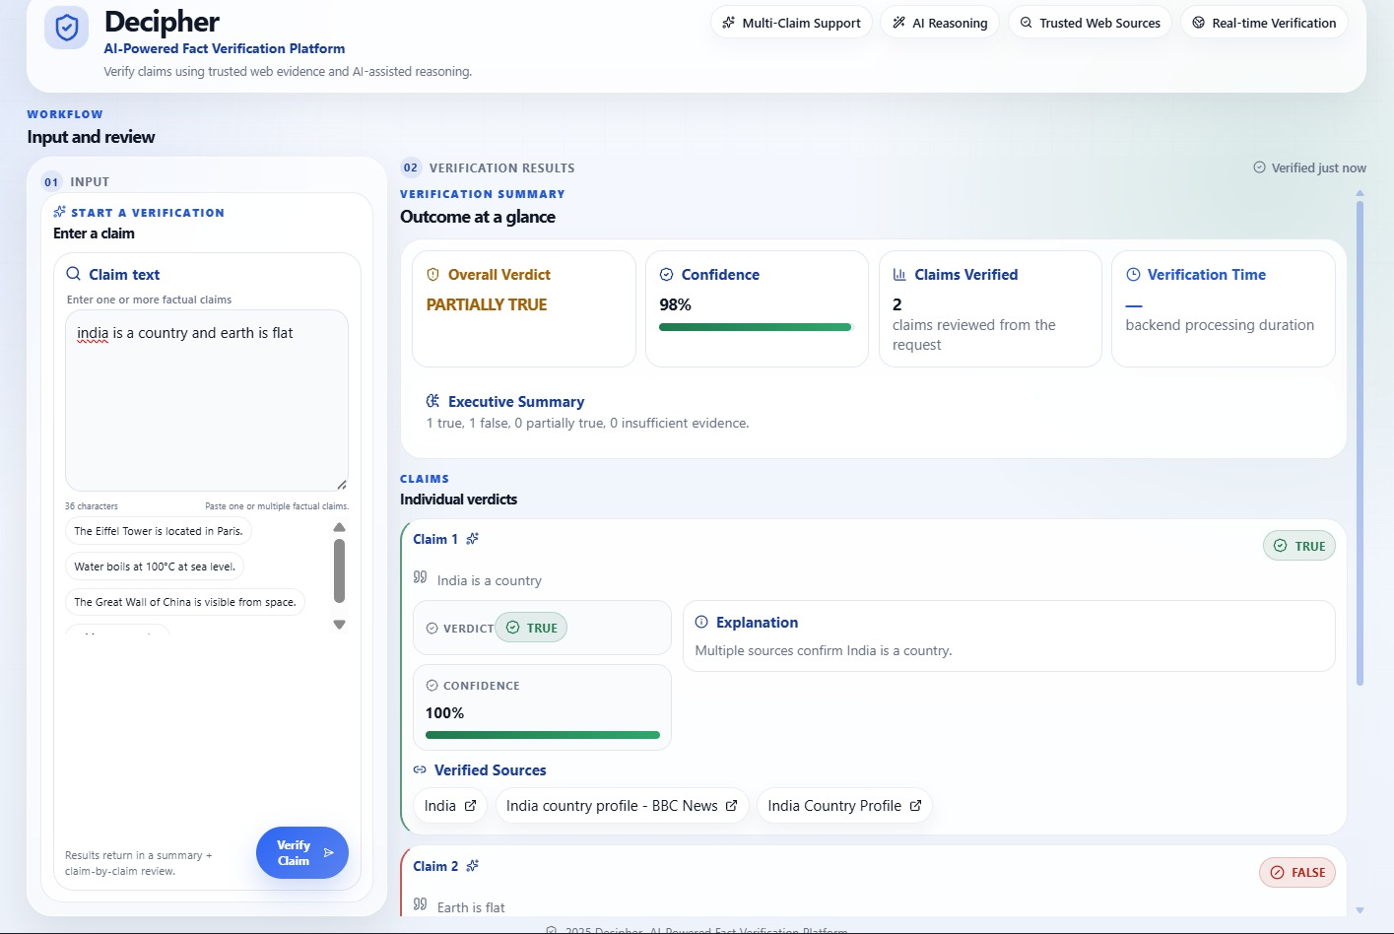
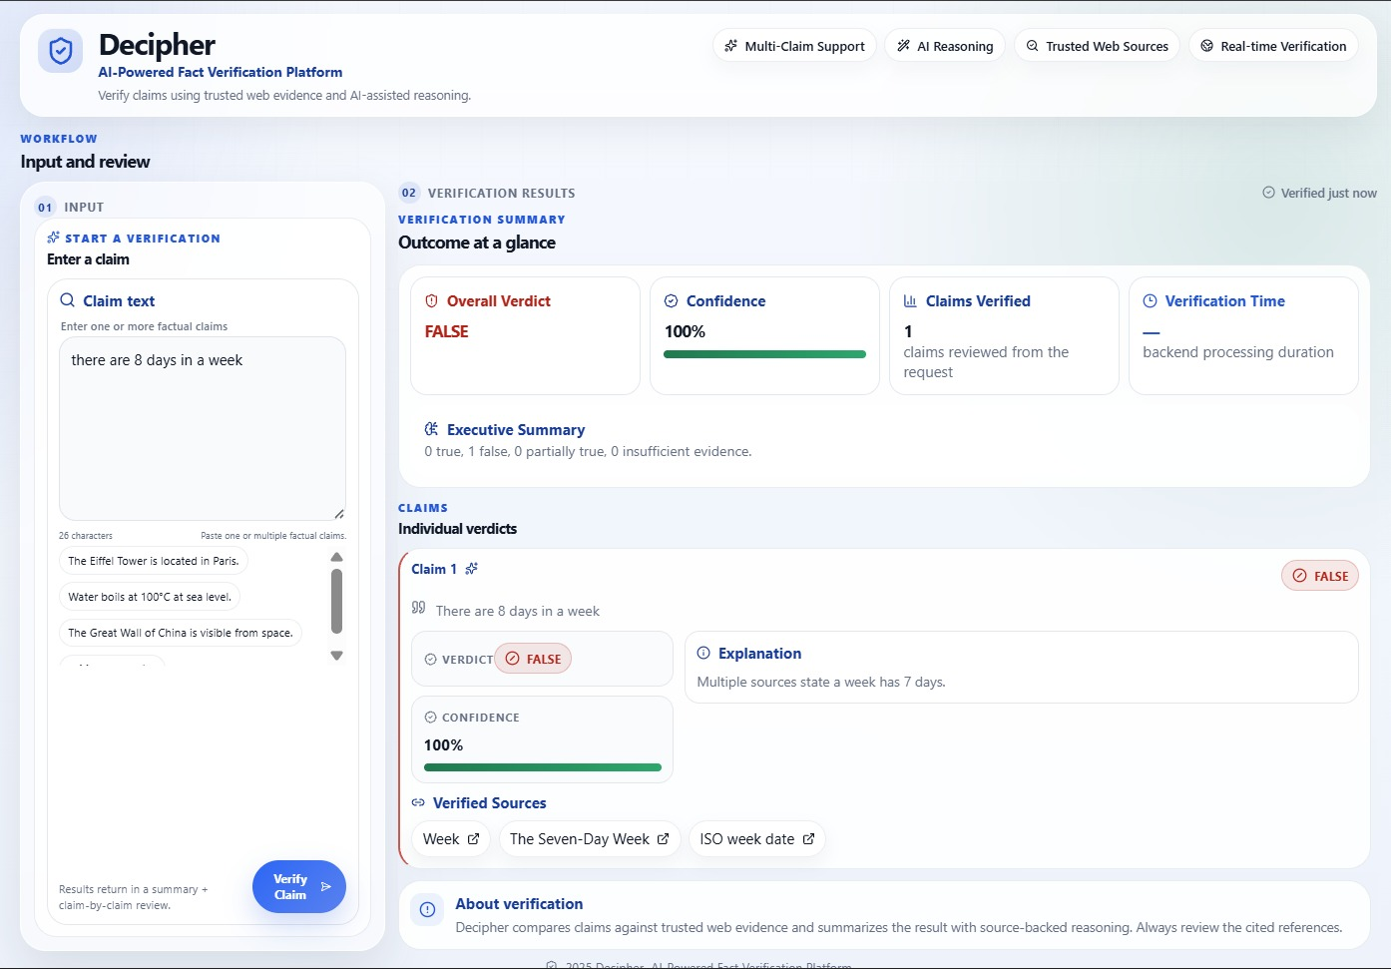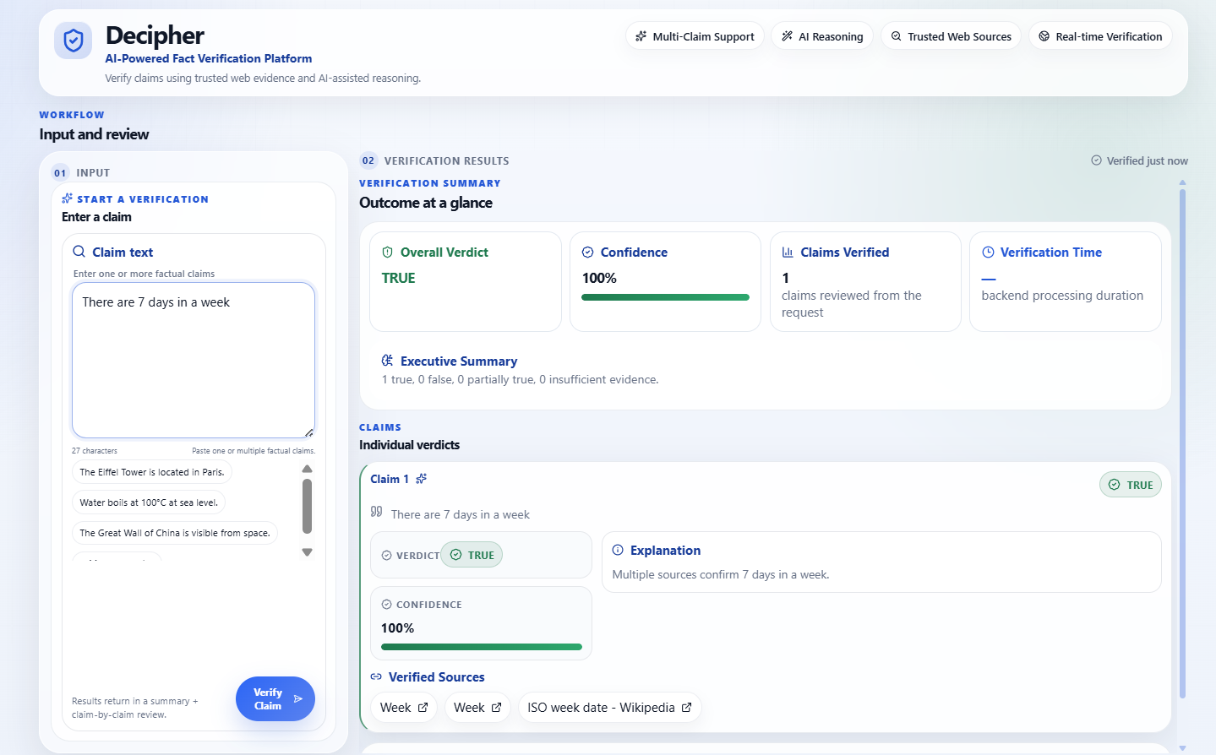
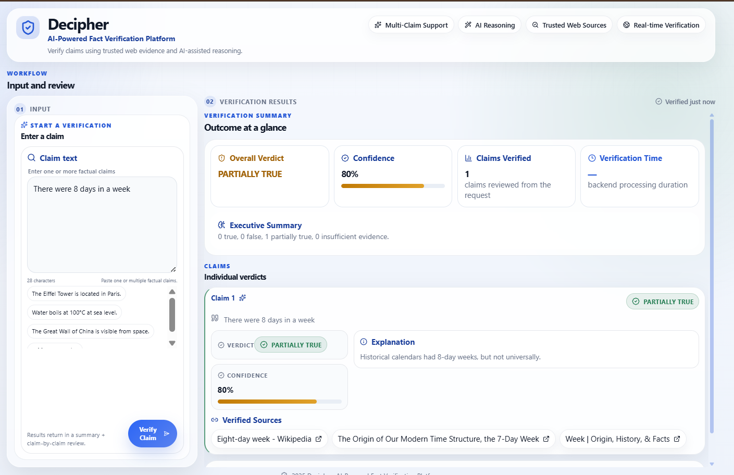

5. Conclusion
The AI-Powered Fact Verification Agent provides a practical solution for combating misinformation through evidence-based AI verification.
By combining Tavily Search API for trusted evidence retrieval with the Groq API running the Llama 3.x model for reasoning, the system produces transparent and explainable verification reports instead of simple chatbot responses.
The modular architecture built using React, FastAPI, and Python makes the application scalable and suitable for future enhancements such as verification history, multilingual support, multimedia verification, and database integration.
Overall, the project demonstrates how Artificial Intelligence can be effectively combined with trusted evidence sources to improve the reliability and transparency of automated fact verification.

6. GitHub Repository
GitHub Link: https://github.com/pranithaa-p/ai_powered_fact_verification
Backend Link: https://ai-powered-fact-verification.onrender.com
Frontend Link: https://ai-powered-fact-verification.vercel.app/

7. Referred resources
https://arxiv.org/abs/2005.11401

