SOFTWARE REQUIREMENTS SPECIFICATION (SRS)

AI-Powered Fact Verification Agent
Team: DecipherX
Date: 31 July 2026

1. Introduction

1.1 Project Overview
The AI-Powered Fact Verification Agent is a web-based application developed to verify factual claims using Artificial Intelligence (AI) and real-time web search. The application combines the Tavily Search API for evidence retrieval with the Groq API running the Llama 3.x language model for reasoning. The generated output includes an evidence-backed verdict together with supporting references and an explanation.
The system follows a modular client-server architecture in which the React frontend manages user interaction while the FastAPI backend coordinates communication with external AI services. This design improves maintainability, scalability, and ease of future enhancement.

1.2 Problem Statement
The rapid spread of misinformation across digital platforms makes manual verification difficult and time-consuming. Users often encounter conflicting information from multiple sources and struggle to determine authenticity.
The proposed system addresses this challenge by automatically retrieving reliable evidence and producing explainable verification results, helping users make informed decisions without manually comparing numerous webpages.

1.3 Proposed Solution
The solution accepts a textual claim, retrieves relevant evidence through the Tavily Search API, and forwards both the claim and the retrieved evidence to the Groq API for AI-based reasoning. The system returns a structured verification report containing:
- Verification Verdict
- Confidence Score
- AI-generated Explanation
- Supporting Evidence
- Reference URLs

1.4 Objectives
- Verify textual factual claims.
- Retrieve supporting evidence from trusted online sources.
- Generate explainable AI-based verification reports.
- Provide a simple and responsive web interface.
- Demonstrate integration of modern AI technologies.

1.5 Scope
The application focuses on verifying text-based factual claims. It is intended as a hackathon prototype demonstrating AI-assisted fact verification using web search and language models. Future versions may include multimedia verification, multilingual support, and persistent storage.

2. Overall System Description
The application follows a client-server architecture consisting of a React frontend and a FastAPI backend. The backend retrieves supporting evidence using the Tavily Search API and sends the collected context to the Groq API for reasoning. The generated report is returned to the frontend and presented to the user in an easy-to-understand format.

2.1 System Modules
Module | Description
User Interface | Allows users to enter claims and view verification reports.
Claim Processing | Receives and validates claims through FastAPI.
Evidence Retrieval | Retrieves relevant evidence using the Tavily Search API.
AI Verification Engine | Uses the Groq API with Llama 3.x for reasoning.
Result Presentation | Displays verdict, confidence, explanation and references.

2.2 System Workflow
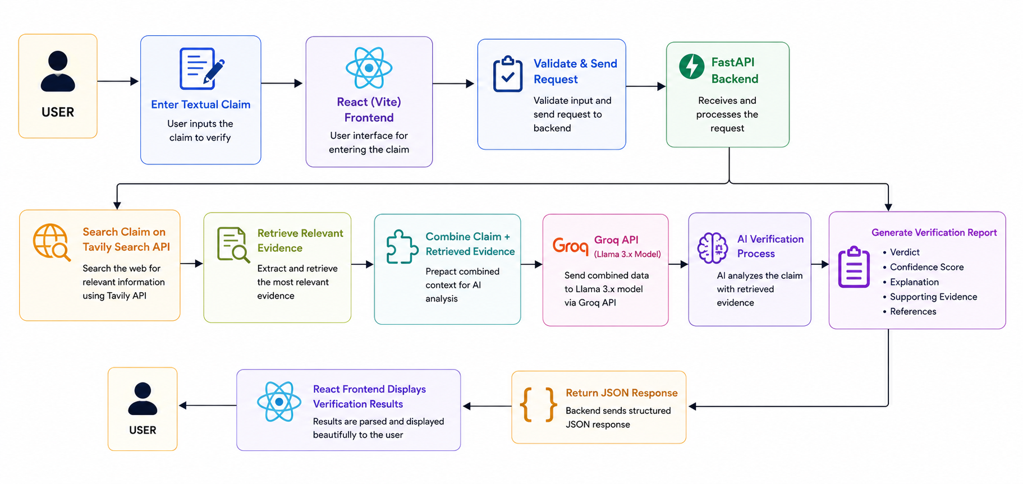

The workflow begins when the user submits a claim. The backend retrieves relevant evidence through the Tavily Search API and combines the retrieved information with the original claim. The Groq API analyzes the evidence and produces an explainable verification report, which is finally displayed to the user.

2.3 Expected Output
Output | Description
Verdict | True, False, Partially True or Insufficient Evidence
Confidence Score | Confidence level for the generated verdict
Explanation | Reasoning behind the decision
Supporting Evidence | Relevant search snippets
References | URLs used for verification

3. Development Phases

Phase 1: Requirement Analysis
The project requirements, objectives, and scope are analyzed to understand the problem of misinformation. Suitable technologies, APIs, and development tools are selected, and the overall system workflow is designed.
Phase 2: Frontend Development
The user interface is developed using React and Vite. It provides a responsive interface where users can enter claims, submit verification requests, and view the generated verification results.
Phase 3: Backend Development
The backend is implemented using FastAPI to process user requests, validate inputs, communicate with external APIs, and return structured verification results to the frontend.
Phase 4: Evidence Retrieval
The Tavily Search API is integrated to retrieve relevant and reliable information related to the submitted claim. The collected evidence is prepared for AI-based analysis.
Phase 5: AI-Based Verification
The claim and retrieved evidence are sent to the Groq API, where the Llama 3.x language model analyzes the information and generates a verification report containing the verdict, confidence score, explanation, and supporting references.

Phase 6: Testing and Integration
The frontend and backend are integrated and tested to ensure smooth communication. Functional testing, input validation, and error handling are performed to verify the system's reliability and accuracy.
Phase 7: Deployment and Documentation
The application is optimized for performance and prepared for deployment. Technical documentation, including the SRS and system architecture, is completed to support future maintenance and enhancements

4. Functional Requirements
- Accept textual claims.
- Validate user input.
- Retrieve evidence from trusted online sources.
- Generate AI-based verification reports.
- Display verdict, confidence score, explanation and references.
- Handle API failures gracefully.

5. Non-Functional Requirements
Performance: Generate responses within a few seconds depending on API latency.
Reliability: Produce evidence-backed verification reports.
Security: Store API keys securely using environment variables.
Usability: Provide an intuitive and responsive interface.
Scalability: Allow future integration of databases and additional AI models.

6. Technology Stack
Layer | Technology | Purpose
Frontend | React + Vite | User Interface
Styling | Tailwind CSS | Responsive Design
Backend | FastAPI | REST APIs
Language | Python 3.12 | Backend Logic
Search | Tavily Search API | Evidence Retrieval
Inference | Groq API | AI Reasoning
Model | Llama 3.x | Language Model
NLP (Future) | Hugging Face Transformers | Future NLP Extensions
Version Control | Git & GitHub | Collaboration

7. Software and Hardware Requirements
- Windows 10/11 or Linux
- Python 3.12
- Node.js
- Visual Studio Code
- Git and GitHub
- Tavily API Key
- Groq API Key
- Modern Web Browser
- Intel Core i5/Ryzen 5 or higher
- Minimum 8 GB RAM
- 10 GB Free Storage
- Stable Internet Connection

8. System Architecture
The architecture separates presentation, application logic, evidence retrieval and AI reasoning into independent layers. This modular design improves maintainability and enables future expansion without major architectural changes.

9. Future Enhancements
- User authentication and authorization.
- Verification history using SQLite or PostgreSQL.
- Multilingual claim verification.
- Image and multimedia verification.
- Hugging Face transformer integration for additional NLP capabilities.
- Support for multiple open-weight language models.

10. References
- React Documentation
- FastAPI Documentation
- Tavily Documentation
- Groq Documentation
- Hugging Face Documentation
- Python Documentation

11. Conclusion
The AI-Powered Fact Verification Agent demonstrates a practical approach to automated fact verification by combining evidence retrieval with AI reasoning. The modular architecture, explainable output, and scalable design make it suitable as a hackathon prototype and provide a strong foundation for future development.

