To Create a package of your own, follow the following steps:

* Go to File-> New Project-> New Directory /Existing directory-> R Package

Give the R package name. Under Create package based on source files heading-> browse the R file that has the functions that we created during the class (Write the code for your functions in this .R file. These functions calculates the model metrics to evaluate the model performance)

Under the Create Project as subdirectory of heading: Give a location so that bare minimum folders are present. The structure of the package created looks as follows.

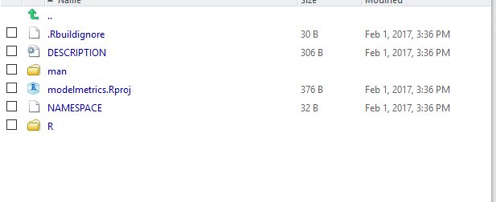

* Then install.packages(“devtools”,dependencies=TRUE)

After Installing devtools package, load the library.

Library(devtools)

library(roxygen2)

* Then add the documentation to the description file as follows where you mention title of the package, description, author, license etc. MIT is the generic license that we mention while creating the package.

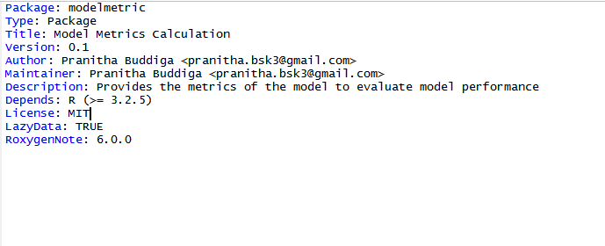

Then the documentation is built by clicking on build and reload option on the right. Once the documentation is successfully built, then we need to work on creating the help pages for the functions present in the library.

* The library is already loaded and when we click on it and see there are no help pages in the package

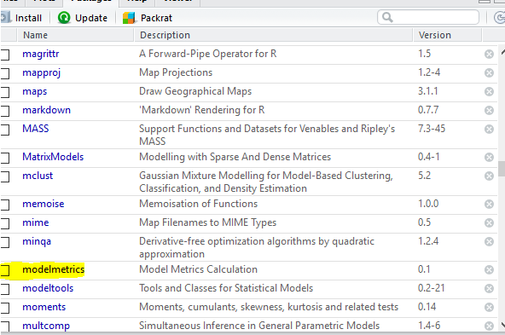

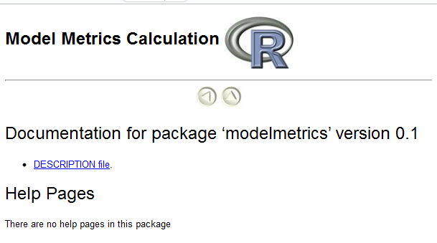

* Then go to the .R file and document it ( discussed later in the next step) and then build and load it. On successful building it create .rd files in the man folder

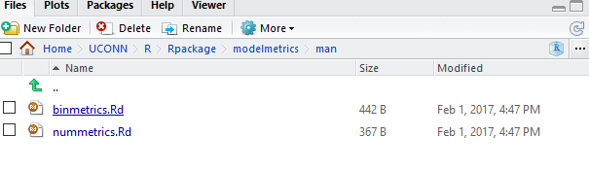

* We need to add the documentation that includes listing out the title of the function, arguments and then if there is a single function export it using @export in the R file. Then Build and Reload the R file.

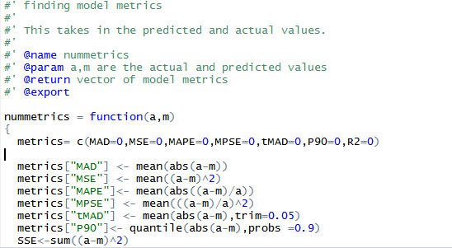

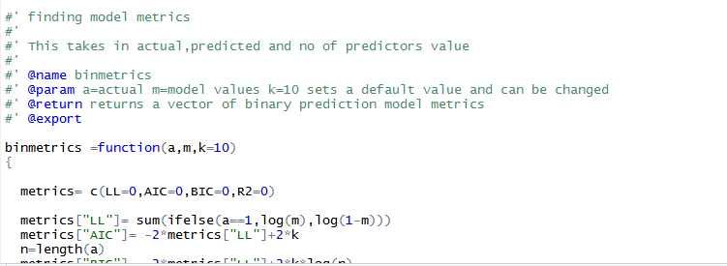

* Once its built. Create the package clicking on More options to the right and then Create the source package. On successful package creation, it will create a tar file. Modlemetric_0.1.tar.gz file will be created and which can be shared across for others to install and use this package.
* To check the functionality of the package. Place the tar.gz file in the working directory and Run the following commands in order

install.packages("fitbitdatasummary_0.1.tar.gz",repos=NULL)

library(help=modelmetric)

library(modelmetric)

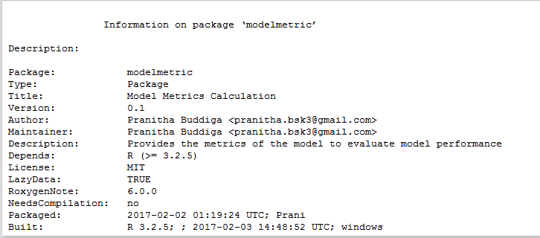

?binmetrics – Gives the help page for the binmetrics function

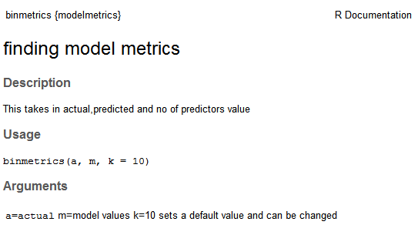

Follow the steps as is and create your own packages!