CHAPTER-1
SYNOPSIS

1. SYNOPSIS
1.1 Title of the Project
“ElevateHire: Placement training and Networking system”
1.2 Objective of the Project
The objective of this project is to design and develop a unified web platform that connects students, colleges, and recruiters for end-to-end placement lifecycle management. The system aims to streamline resume creation, opportunities posting, assessment, and certification validation while providing transparent interaction among all stakeholders.
The platform is designed to:
- Automate eligibility filtering and candidate shortlisting.
- Provide AI-assisted resume analysis and job matching insights.
- Enable structured and secure communication between recruiters and candidates.
- Offer performance analytics dashboards for institutions.
- Establish a verified digital professional profile system for students.
- Reduce manual administrative workload in campus placement processes.
1.3 Project Category
Web Application / Educational Technology (EdTech) / Human Resources Technology (HRTech)
1.4 Software and Hardware Requirements
Software Requirements
- Operating System: Windows 10/11, Linux or macOS
- Frontend: Flutter Web (Dart)
- Backend: Supabase Functions (TypeScript) or equivalent serverless platform
- Database: PostgreSQL
- IDE/Tools: VS Code / Android Studio, Git & GitHub, Web Browser (Chrome/Edge)
- External Services: Email API (e.g., Resend), Certification Provider APIs
Hardware Requirements
- Development Machine: Intel i5/Ryzen 5, 8 GB RAM (16 GB recommended), 256 GB SSD, broadband internet
- Client Devices: Desktop/Laptop/Tablet/Smartphone with stable internet connection
1.5 Structure of the Program
1.5.1 Analysis
Traditional placement workflows are fragmented across spreadsheets, emails and offline records, causing difficulty in tracking applicants, validating achievements and aligning candidates with the right openings. The proposed system provides an integrated platform where students manage profiles and preparation, colleges control academic and placement activities, and recruiters access verified candidate data with minimal manual intervention. A centralized feed, structured modules and role-based access reduce redundancy, improve transparency and support data-driven decision-making during the placement process.
1.5.2 Data Structures
- User & Role Entities: Tables for Students, College Admins and Recruiters linked through role-based access control.
- Profiles & Resumes: Structured records storing academic details, experience, skills and AI-generated resume templates.
- Posts & Feed: Entities for announcements, achievements, opportunities and interactions forming a social-style feed.
- Assessments & Question Bank: Tables for aptitude/technical tests, questions (including AI-generated items) and attempts.
- Certifications: Records for uploaded certificates with category tags, issuing authority, validity and verification status.
- Jobs & Applications: Structures for college-posted and recruiter-posted opportunities and corresponding student applications.
1.5.3 Module Description
1. Student Module
The Student Module acts as the central workspace for managing academic and professional development. It includes profile management, achievement posting, and an integrated resume builder with AI-assisted suggestions and job match insights.
Students can access aptitude practice tests, apply to opportunities, and track applications in real time. They can enroll in courses offered by colleges and recruiters through the Learning Hub and earn certifications to enhance their profiles.
The module also provides certification management with validation status, a personal analytics dashboard for performance tracking, a Mock Interview System with structured feedback, and a Practice Centre to improve communication, technical, and interview skills.
2. College Module
The College Module enables institutional administrators to manage placement operations, academic coordination, and student performance tracking within a centralized system.
It includes:
- Creation and management of departments, student batches, and placement cycles.
- Posting campus drives, internships, projects, and internal opportunities through the Campus Feed.
- Moderation and management of the Campus Feed to ensure structured institutional communication.
- Creation of personalized learning content and institution-specific courses to support student skill development.
- Verification of student certifications category-wise (technical, soft skills, MOOCs, etc.) with structured approval workflows.
- Design and evaluation of mock tests, practice sets, and interview assessments.
- Question bank management including adding, updating, and organizing questions with expected keywords.
- Monitoring student performance in assessments, mock interviews, and applications through analytics dashboards.
- Tracking placement statistics and generating institutional performance reports.
3. Recruiter Module
The Recruiter Module enables secure onboarding, company profile creation, and structured recruitment management within the platform.
Recruiters can post job and internship opportunities, search and filter candidates based on skills, certifications, assessment scores, and resume data, and review category-validated certifications to improve trust in shortlisting decisions.
The module also allows recruiters to offer skill-based courses and learning programs to students, contributing to industry-aligned training. Recruiters can publish updates, hiring announcements, and opportunity-related posts through the platform feed to engage directly with eligible student groups.
It includes Recruiter AI Insights, an intelligent resume analysis system that evaluates how well a candidate’s resume matches a specific job role. The system extracts resume content, prioritizes recruiter-defined requirements, and generates a weighted match score. Recruiters can instantly analyze applications, view match percentages, and identify matched and missing skills to support faster, data-driven hiring decisions. Real-time application statistics further enhance recruitment efficiency.
4. Intelligent Conversational Assistant
ElevateAI is the platform’s intelligent conversational layer designed to act as a 24/7 career assistant that bridges static data and actionable guidance.
The system is role-aware and dynamically adapts based on the logged-in user. For students, it provides mentorship support such as learning recommendations, job discovery, and mock test guidance. For recruiters, it assists with job posting, candidate search, and recruitment management. For college administrators, it supports performance tracking and certification verification workflows.
The assistant operates using a heuristic navigation engine that enables actionable responses. Instead of only providing text-based guidance, it can trigger deep navigation within the platform, redirect users to relevant modules, and use confirmation flows for sensitive actions.
ElevateAI is integrated with the platform database to enable live data retrieval, including entity search (profiles, organizations, courses), recent job postings, and sample assessment questions. It also provides structured procedural guidance for platform-specific tasks such as certificate verification.
The current Beta version uses a high-performance local heuristic parser to ensure fast, secure, and platform-aligned responses. Future enhancements may integrate advanced large language models through server-side functions to enable broader conversational capabilities while maintaining structured action handling.

1.6 Limitations
- The platform requires continuous internet connectivity for real-time assessments, feed updates, AI analysis, and data synchronization.
- AI-based job matching and resume insights rely on keyword and heuristic analysis, which may not fully capture contextual or domain-specific expertise.
- Certification validation is limited to supported providers and predefined categories; some credentials may require manual verification.
- The current ElevateAI assistant (Beta) operates on a heuristic engine and may have limited conversational depth compared to full-scale language models.
- Large-scale deployment across multiple institutions may require advanced cloud scaling and performance optimization.

1.7 Future Scope of the Project
- Integration of advanced large language models to enhance AI job matching, resume analysis, and conversational intelligence.
- Implementation of AI-driven mock interview simulations with real-time speech analysis and performance scoring.
- Predictive analytics to estimate placement probability based on skills, assessments, and historical placement data.
- Blockchain-based certification verification for immutable and tamper-proof credential validation.
- Deep integration with external Learning Management Systems (LMS) and MOOC platforms for automatic academic and certification synchronization.
- Expansion into multi-institution, multi-company ecosystems with advanced enterprise-grade analytics dashboards.

CHAPTER 2
SOFTWARE REQUIREMENTS SPECIFICATION (SRS)

2 SOFTWARE REQUIREMENTS SPECIFICATION (SRS)
2.1 Introduction
The Software Requirements Specification (SRS) document provides a detailed description of the ElevateHire platform. It defines the functional and non-functional requirements, technical specifications, system architecture, constraints, and expected behavior of the system.
This document acts as a reference framework for developers, testers, administrators, and stakeholders to ensure that the implementation aligns with the core objective of building an AI-enhanced placement training and networking ecosystem that bridges academia and industry.
2.2 Purpose
The purpose of ElevateHire is to provide a centralized, AI-driven placement management system where:
- Students can build verified digital professional identities and enhance career readiness.
- Colleges can manage placement workflows, validate credentials, and monitor performance analytics.
- Recruiters can identify verified talent and automate resume screening using AI-based insights.
The system replaces fragmented, manual placement processes with a structured, automated, and data-driven platform.
2.3 Scope
ElevateHire is a full-stack web application with modular architecture and role-based access control.
The scope includes:
- Student, College, and Recruiter dashboards
- AI-Powered Resume Matching Engine
- ElevateAI Conversational Assistant (Beta)
- Certification Validation and Trust System
- Mock Interview and Practice Center
- Learning Hub with course enrollment and certification generation
- Campus Feed and Professional Networking System
- Analytics and Reporting Dashboard
The system is designed to support scalable deployment across multiple institutions and recruitment organizations.
2.4 Functional Requirements
Functional requirements define the expected operations and behaviors of the system.
2.4.1 User Authentication and Authorization
- Secure role-based access for Students, College Administrators, and Recruiters.
- Email-based registration and verification.
- JWT-based session handling.
- Role-Level Access Control (RLAC) with Row-Level Security policies.
2.4.2 Student Module
- Profile management including academic records, skills, projects, internships, and achievements.
- AI-assisted resume builder with structured templates.
- AI-powered Resume Matching and Job Insights system.
- Access to aptitude practice tests and AI-generated assessments.
- Mock Interview system with structured evaluation.
- Course enrollment from colleges and recruiters through the Learning Hub.
- Certification upload, validation tracking, and trust scoring.
- Application submission and real-time status tracking.
- Personal analytics dashboard displaying performance metrics and skill gaps.
- Networking system for professional connections.
2.4.3 College Module
- Bulk student data management and department-level organization.
- Creation and management of placement drives and institutional events.
- Campus Feed moderation and announcement system.
- Certification validation workflow with approval/rejection mechanisms.
- Mock test and question bank management.
- Creation of institution-specific learning content and courses.
- Analytics dashboards for placement tracking and performance reporting.
2.4.4 Recruiter & AI Insights Module
- Company onboarding and recruiter profile management.
- Job and internship lifecycle management (create, update, close).
- Advanced candidate search and filtering.
- Recruiter AI Insights for automated resume evaluation using weighted keyword analysis.
- Real-time match score generation and skill gap identification.
- Application-level analytics and hiring pipeline management.
- Course offering capability for industry-driven training programs.
- Opportunity and hiring announcements via platform feed.
2.4.5 ElevateAI Conversational Assistant
- Role-aware conversational support.
- Deep-link navigation within the platform.
- Entity search (profiles, organizations, courses).
- Live data retrieval (jobs, assessment questions).
- Structured task guidance for platform workflows.

2.5 Non-Functional Requirements

2.5.1 Performance
- Resume analysis and match score generation must complete within 2–3 seconds.
- Database queries must respond within acceptable latency thresholds under concurrent usage.

2.5.2 Scalability
- Backend infrastructure must support horizontal scaling.
- Modular service architecture to allow feature expansion.
2.5.3 Reliability
- Use of PostgreSQL transactions to maintain data integrity.
- Backup and restore mechanisms via Supabase.
2.5.5 Usability
- Responsive UI compatible with desktop, tablet, and mobile devices.
- Consistent Material Design 3 interface standards.
- Clear navigation and accessible interface structure.

2.6 Software Requirements

2.6.1 Frontend Technologies
- Framework: Flutter (Web/Desktop/Mobile)
- Language: Dart
- State Management: Riverpod
- UI Framework: Material Design 3
- Typography: Google Fonts

2.6.2 Backend Technologies
- Platform: Supabase (Backend-as-a-Service)
- Database: PostgreSQL (with JSONB support)
- Authentication: Supabase Auth (JWT-based)
- Serverless Functions: Deno-based Edge Functions
- File Storage: Supabase Storage

2.6.3 Development & Deployment Tools
- Version Control: Git and GitHub
- Frontend Hosting: Vercel
- Backend Hosting: Supabase Cloud
- Development Environment: Visual Studio Code, Flutter DevTools

2.7 System Architecture

ElevateHire follows a Modular Feature-Based Architecture consisting of:
- Presentation Layer: Flutter UI components organized by feature modules.
- Data Layer: Repository pattern communicating with Supabase APIs.
- External Integration Layer: Edge Functions connecting to AI services and third-party APIs.

This layered separation ensures maintainability, scalability, and testability.

2.8 Assumptions and Constraints

2.8.1 Assumptions
- Uploaded resumes are text-searchable PDFs.
- Users have stable internet connectivity.
- Users operate on modern web browsers.

2.8.2Constraints
- Performance may depend on Supabase free-tier resource limits unless upgraded.
- AI-based heuristic matching may not fully replace human judgment in hiring decisions.
- Real-time operations depend on cloud service availability.

CHAPTER 3
SYSTEM DESIGN

3. SYSTEM DESIGN
3.1 Introduction
System Design defines the architecture, components, interfaces, and data flow mechanisms required to satisfy the system requirements specified in the SRS.
For ElevateHire, the design emphasizes:
- Modular feature-based architecture
- Secure role-based data access
- Real-time synchronization
- AI-assisted processing
- Scalability using serverless backend infrastructure
The system follows a layered architecture separating presentation, business logic, and data layers to ensure maintainability and extensibility.

3.2 System Architecture
3.2.1 High-Level Architecture
ElevateHire follows a modern three-tier architecture consisting of:
- Presentation Layer (Flutter Web/Application)
- Application & Platform Logic Layer (Supabase Services + AI Engine)
- Data Layer (PostgreSQL with Row-Level Security)
Architectural Characteristics
- Secure communication through HTTPS and WebSocket protocols.
- JWT-based authentication and session handling.
- Row-Level Security (RLS) for enforcing role-based data isolation.
- Real-time updates for feeds, applications, and notifications.
- Serverless logic execution for AI processing and email communication.
This architecture ensures separation of concerns and supports scalable expansion.

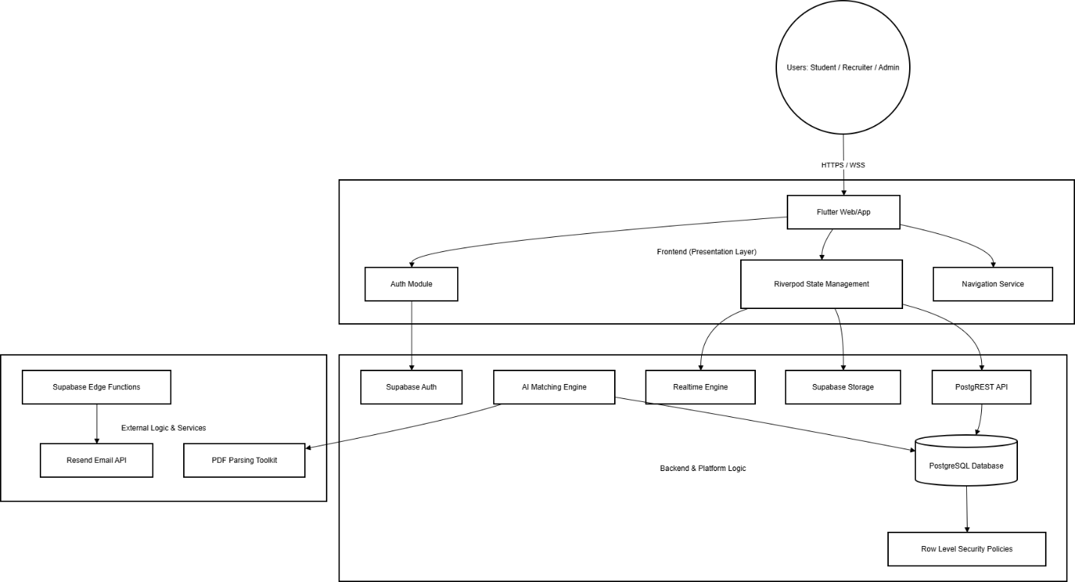

Figure 3.2.1: High-Level Architecture

3.3 Detailed System Design

3.3.1 Modules and Their Functionality
The system is divided into independent yet interoperable modules, each responsible for a specific domain of functionality.
Module | Core Functionality | Key Components
Authentication | Secure user access and session control | Supabase Auth, JWT Tokens, Role-Based Routing
Student Portal | Professional profile management and skill development | Resume Builder, Practice Arena, Mock Interview
Recruiter Portal | Job lifecycle management and applicant screening | Job Management, AI Resume Insights
College Admin Module | Institutional placement oversight and validation | Placement Tracker, Certification Verification Engine
Verification Engine | Certificate authentication and trust scoring | Trust Score Calculator, Validation Rules
AI Assistant | Conversational navigation and contextual support | ElevateAI (Beta), Local Heuristic Parser
Networking System | Professional communication and updates | Connections, Real-time Messaging, Campus Feed

Table3.3.1: Modules and Their Functionality
3.4 Use Case Diagram
The use case diagram illustrates the interactions between system actors and core functionalities.
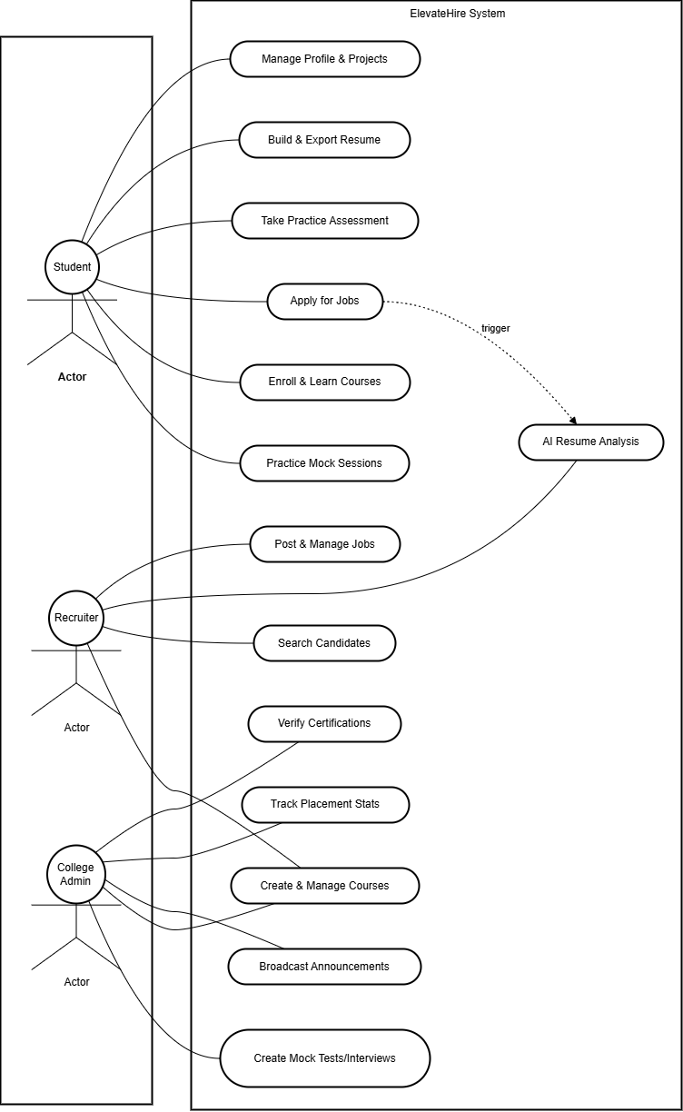
Figure 3.4: Use Case Diagram

CHAPTER-4
DATABASE DESIGN

4.DATABASE DESIGN
4.1 Introduction
The database design of ElevateHire is implemented using a normalized and modular PostgreSQL schema managed through Supabase. The schema emphasizes:
- Referential integrity through foreign key constraints
- Role-based data isolation via Row-Level Security (RLS)
- High concurrency support
- Scalable multi-tenant institutional management
The database is designed to support the complete lifecycle of placement training, recruitment workflows, certification validation, and real-time learning operations.
4.2 Database Overview
The ElevateHire database is structured into logical modules to ensure scalability, maintainability, and performance optimization. The schema consists of more than 70 tables, covering identity management, recruitment processes, learning systems, certification tracking, and engagement features.
Module Breakdown
- Identity & Institutional Module
Manages users, profiles (Student/Recruiter/College), and organizational hierarchies such as departments and programs.
- Recruitment Lifecycle Module
Handles job postings, interview round sequencing, submissions, evaluations, application tracking, and offer management.
- Skill & Validation Engine
Tracks certification validation workflows, skill scoring, and provider trust metrics.
- Academic & Aptitude Module
Manages learning courses, lecture structures, aptitude question banks, and assessment attempts.
- Engagement & Communication Module
Supports the professional feed, networking connections, messaging, and automated notification logs.

4.3 Database Structure (ER Diagram)
- The following ER diagram provides a high-level representation of the relationships between the core entities.
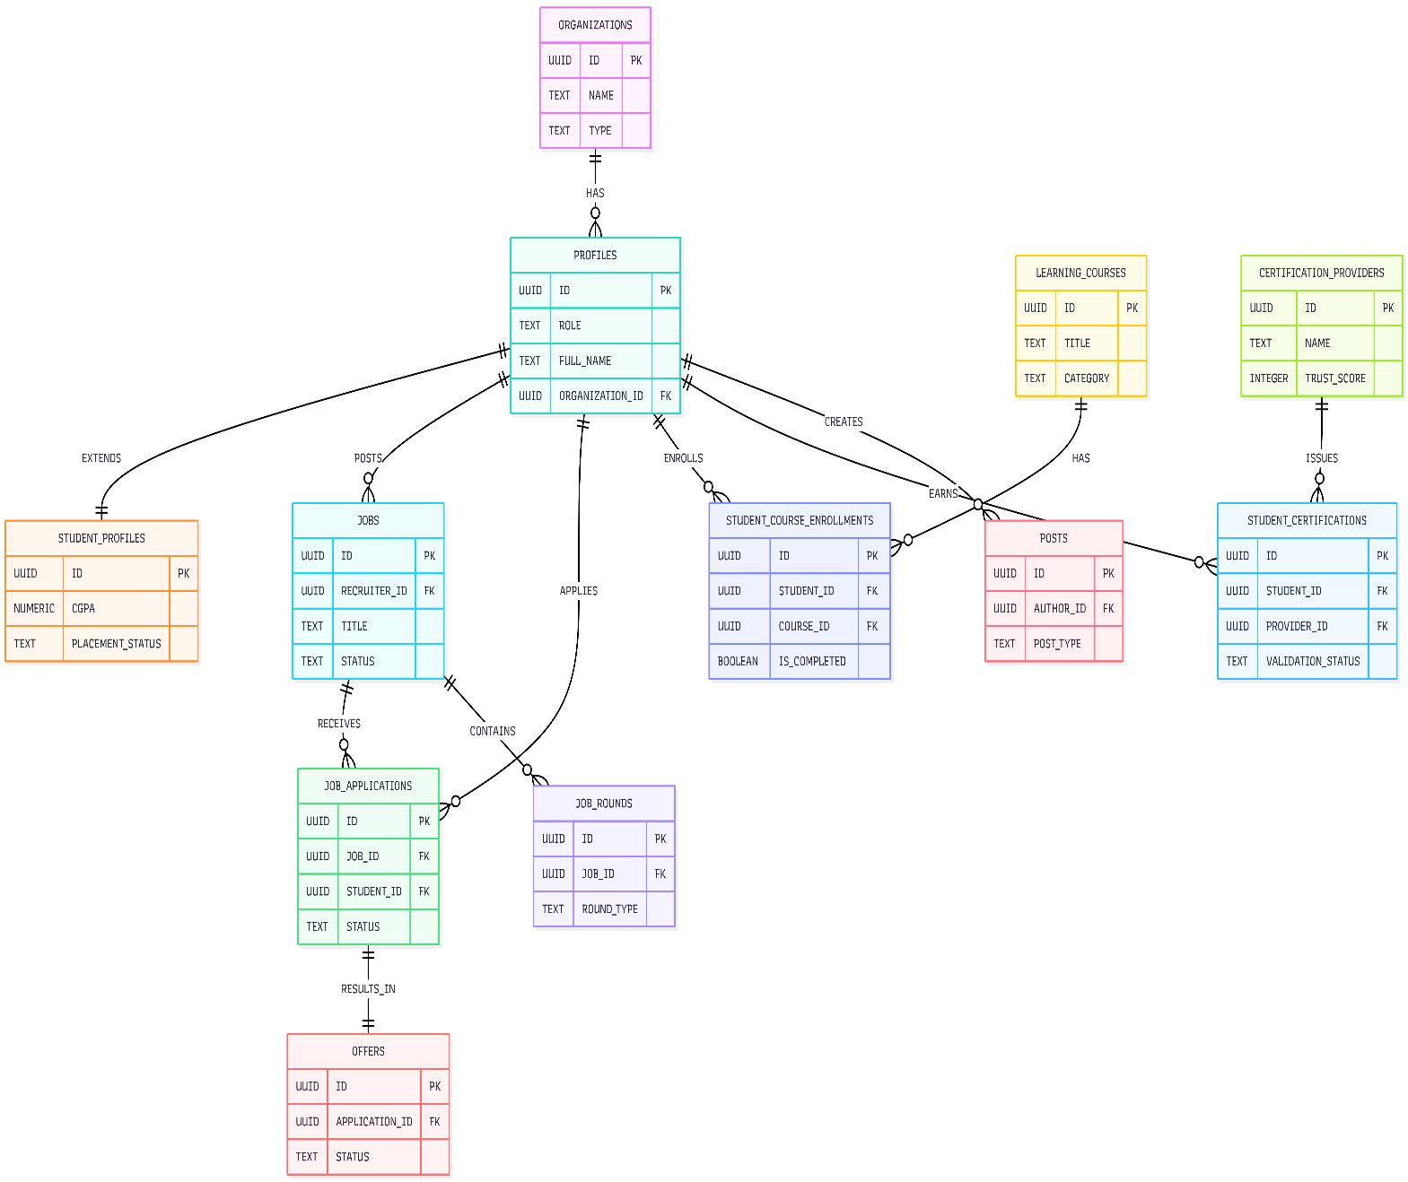

Figure 4.1: High-Level Entity Relationship Diagram of the ElevateHire Database Schema

4.4.1 Identity & Organizational Structure
- The ORGANIZATIONS entity represents colleges and companies.
- The PROFILES entity stores all user identities (Students, Recruiters, College Users).
- Each profile belongs to one organization through a foreign key relationship.
- The STUDENT_PROFILES table extends the base PROFILES entity with academic-specific attributes such as CGPA and placement status.
This layered identity model supports multi-tenant institutional deployment.
4.4.2 Recruitment Lifecycle Relationships
- A Recruiter (Profile) can create multiple JOBS.
- A Job can receive multiple JOB_APPLICATIONS.
- Each application may progress through multiple JOB_ROUNDS.
- A finalized application may result in one OFFER.
This structure enables structured multi-stage hiring workflows and prevents data redundancy.
4.4.3 Learning & Enrollment Relationships
- LEARNING_COURSES store structured educational content.
- Students enroll through STUDENT_COURSE_ENROLLMENTS.
- The enrollment table acts as a junction table between Students and Courses.
This many-to-many mapping ensures scalable course management.
4.4.4 Certification & Validation Relationships
- CERTIFICATION_PROVIDERS define trusted issuing authorities.
- Students upload certifications stored in STUDENT_CERTIFICATIONS.
- Each certification references a provider and includes validation status tracking.
This design supports a trust-based verification model.
4.4.5 Social & Engagement Relationships
- The POSTS entity allows profiles to create content.
- Each post references the author profile.
- Additional tables (comments, likes, connections) extend engagement functionality.
This enables professional networking capabilities within the platform.
4.5 Normalization Strategy
The database follows Third Normal Form (3NF) principles:
- Elimination of Data Redundancy
Repeated data such as organization details are stored in a centralized ORGANIZATIONS table.
- Functional Dependency Control
Non-key attributes depend only on primary keys (e.g., job details depend solely on job_id).
- Separation of Concerns
Identity, recruitment, learning, and certification systems are separated into modular entities.
This ensures consistency, maintainability, and performance optimization.
4.6 Key Constraints & Integrity Enforcement
The database ensures data consistency through:
- Primary Keys (UUID-based) for uniqueness.
- Foreign Key Constraints to enforce referential integrity.
- CHECK Constraints to validate enumerated fields (e.g., job status, difficulty levels).
- Unique Constraints for critical identifiers such as certificate numbers.
- Row-Level Security (RLS) policies to restrict unauthorized data access.

4.7 Security Model
Security is implemented at the database level using Supabase features:
- JWT-based authentication via Supabase Auth.
- Row-Level Security policies restricting data visibility by role.
- Secure file storage for resumes and certificates.
- Controlled access to sensitive tables such as job applications and evaluations.
This layered security approach ensures confidentiality and data isolation across institutions and recruiters.
4.8 Scalability & Performance Considerations
The schema is designed to support:
- High concurrency during assessments and recruitment drives.
- JSONB storage for semi-structured AI-related data.
- Indexed foreign keys for fast relational joins.
- Modular table expansion without redesigning core entities.
The use of PostgreSQL ensures robust transactional consistency and horizontal scalability.
4.9 Conclusion
The database design of ElevateHire demonstrates a modular, scalable, and secure relational architecture capable of handling complex placement workflows, AI-driven assessments, certification validation, and real-time engagement systems. The schema effectively balances normalization with flexibility, enabling both structured querying and semi-structured data storage.

CHAPTER-5
DETAIL DESIGN

5. DETAIL DESIGN
5.1 Introduction
The Detailed Design phase translates the high-level system architecture into a granular technical blueprint. For ElevateHire, this involves defining the internal logic of Flutter components, the state management lifecycle using Riverpod, and the structured interaction between frontend modules and Supabase backend services.
This chapter serves as the implementation reference for functional modules, defining service responsibilities, data flows, and modular boundaries.
5.2 System Overview
ElevateHire is implemented using a Feature-First Modular Architecture. Instead of separating code purely by technical layers (controllers, views, services), each functional domain (Authentication, Student, Recruiter, College, Networking) encapsulates its own:
- Presentation Layer
- Domain Layer
- Data Layer
This approach ensures high cohesion within modules and minimal coupling across features.
5.2.1 Key Technical Pillars
Presentation Layer
Built using Flutter with Material Design 3. Widgets are reactive and rebuild only when dependent Riverpod providers change state.
State Management
Managed by Riverpod using:
- StateNotifierProvider for synchronous state control
- AsyncNotifier for asynchronous database operations
- FamilyProvider for parameterized data fetching
Data Access Layer
Implements the Repository Pattern. UI components never directly access Supabase. All database interactions are encapsulated within repositories.

5.3 Module-wise Detailed Design
5.3.1 Authentication & Identity Module
Purpose
Secure session handling and role-based feature initialization.
Service Components
AuthRepository
Encapsulates Supabase authentication methods:
- Sign in
- Sign out
- Session refresh
- Token validation
RoleGuard
Middleware logic that validates profiles.role before route access.
IdentityHelper
Fetches extended metadata (organization_id, verification status, completion score).
Internal Flow
- User submits login credentials.
- AuthRepository validates via Supabase Auth (JWT issued).
- IdentityHelper fetches corresponding profile record.
- RoleGuard validates user role.
- Application routes to:
  - Student Home
  - Recruiter Dashboard
  - College Panel
Data Interaction
- auth.users
- profiles
- organizations
Security Enforcement
- Row-Level Security (RLS)
- JWT-based authentication
- Route protection middleware
5.3.2 Student & Career Module
Purpose
Manage student digital identity, projects, resume intelligence, and assessment lifecycle.
Service Components
ResumeMatchingService
Implements keyword tokenization and coverage scoring between:
- Job.requirements
- Resume.text_content
ProjectService
Handles:
- Media uploads to Supabase Storage
- Feed post synchronization
- Project metadata persistence
AssessmentEngine
Manages:
- Timers
- Question randomization
- Score calculation
- Attempt persistence
Internal Flow
- Student updates project details.
- Media assets uploaded to Supabase Storage.
- Database record created in student_projects.
- Feed post auto-generated via Networking module.
- Skill recalculation triggered using:
  - Extracted tech stacks
  - Assessment results
State Management
- studentProfileProvider
- studentProjectsProvider
- aptitudeAttemptProvider
Data Interaction
- student_profiles
- student_projects
- resumes
- aptitude_attempts
- student_skill_scores
5.3.3 Recruiter & Job Insights Module
Purpose
Enable structured job posting, automated screening, and applicant analytics.
Service Components
JobRepository
Handles transactional creation of:
- jobs
- job_rounds
ApplicantScanner
Executes batch scoring logic:
- Fetch new applications
- Run ResumeMatchingService
- Persist match_score
Internal Flow
- Recruiter creates job with requirements.
- Job stored in jobs.
- Students apply via job_applications.
- ApplicantScanner processes new applications.
- Resume parsed locally.
- Match Score computed.
- Score persisted for recruiter dashboard filtering.
Data Interaction
- jobs
- job_applications
- job_rounds
- offers
- profiles
Optimization
- Index on job_id and student_id
- Precomputed match_score field
- Lazy-loaded application analytics
5.3.4 College & Placement Module
Purpose
Provide institutional placement monitoring and certification validation.
Service Components
VerificationService
Uses validation_rules and provider trust scores to determine:
- Auto approval
- Manual review
- Rejection
AnalyticsService
Executes aggregation queries:
- Placement percentage
- Average package
- Department-wise distribution
Internal Flow
- Student uploads certification.
- VerificationService checks:
  - Provider trust_score
  - Pattern match rules
- If threshold met → Auto-verified
- Else → Admin review queue
- Upon approval:
  - Trust Score updated
  - Skill points recalculated
Data Interaction
- student_certifications
- validation_rules
- offers
- college_departments
- student_profiles
5.3.5 Networking Module
Purpose
Enable professional interaction, feed generation, and real-time social engagement.
Service Components
FeedService
Implements:
- Paginated fetching
- Sort by recency and relevance

InteractionManager
Handles:
- Likes
- Comments
- Connection requests
- Real-time updates via Supabase Realtime
Internal Flow
- User creates post.
- Post saved in posts.
- FeedProvider updates via realtime listener.
- Engagement metrics update counters incrementally.
Data Interaction
- posts
- post_likes
- post_comments
- connections
- messages
5.4 Modular Decomposition Components
To ensure maintainability, the system is decomposed into shared infrastructure components.
- Shared UI Components
Located in lib/core/widgets.
Includes reusable buttons, cards, chips, and layout wrappers.
- Navigation Service
Centralized route management.
Supports deep linking and role-based route protection.
- Supabase Client Service
Singleton provider ensuring consistent backend connectivity.
- Local Rule Engine
Parses natural language commands for ElevateAI Beta Assistant.
5.5 Software Package Structure
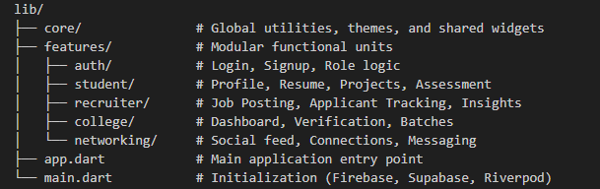
Figure 5.5: Software Package Structure
Each feature contains:
- presentation/
- domain/
- data/
This enforces clean architectural separation.
5.6 Data Flow Architecture
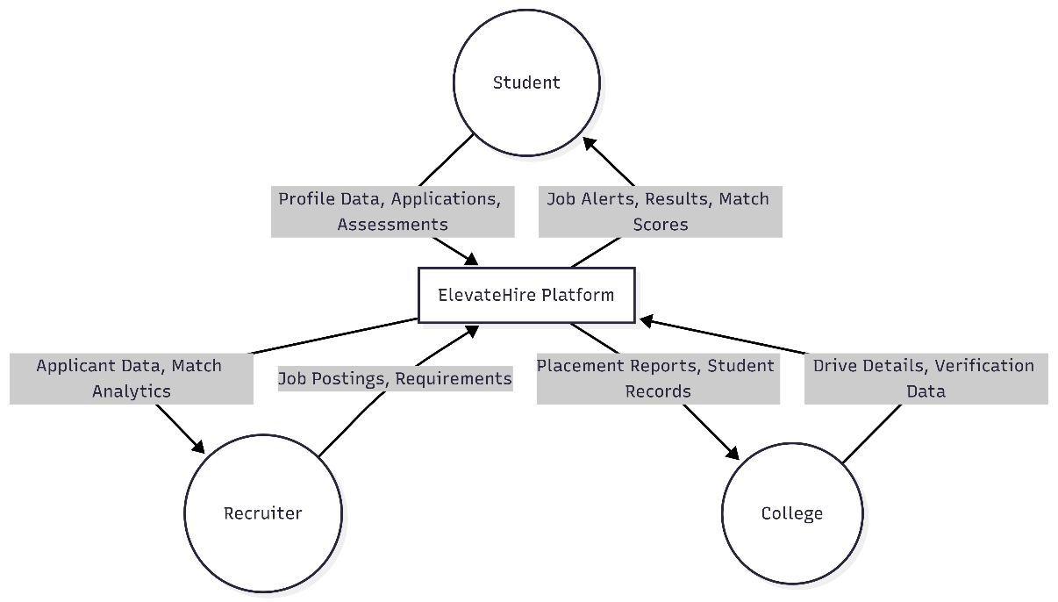
Figure 5.6: Level-0 Data Flow Diagram

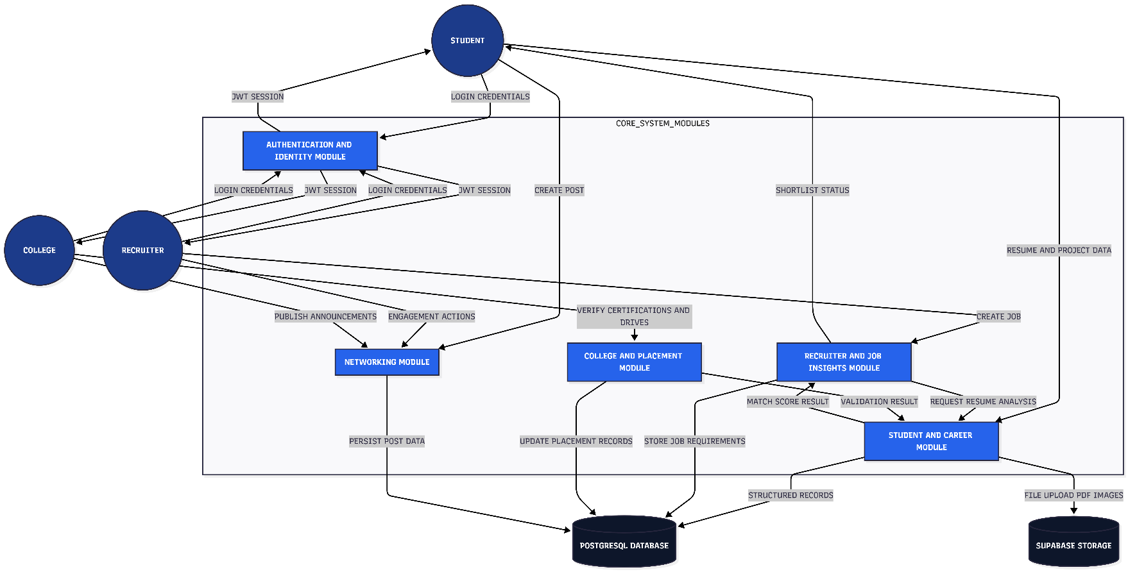

Figure 5.6.1: Level-1 Data Flow Diagram

5.7 Error Handling Strategy
- Repository-level try-catch wrappers
- Standardized Failure objects
- Graceful UI fallback states
- Constraint-level validation at database
5.8 Scalability Considerations
- Multi-tenant organization model
- Indexed foreign keys
- Controlled Realtime subscriptions
- JSONB usage for semi-structured metadata
- Provider auto-dispose for memory optimization

CHAPTER-6
CODING

6. CODING
6.1 Introduction
The coding phase of ElevateHire transforms system design specifications into fully functional software modules. This stage emphasizes modular architecture, clean code principles, structured state management, and scalable backend interaction.
The implementation is carried out using Flutter (Dart) for the frontend and Supabase (PostgreSQL, Auth, Storage, Realtime) for backend services. Special focus is given to maintainability, extensibility, and separation of concerns to support long-term evolution of the platform.
6.2 Programming Practices
6.2.1 Top-Down and Bottom-Up Approaches
The development of ElevateHire followed a hybrid strategy combining both bottom-up and top-down methodologies to ensure stability, flexibility, and efficient feature delivery.
Bottom-Up Approach:
The development began with constructing foundational components and core infrastructure. Low-level elements such as the Supabase client configuration, reusable UI components (buttons, input fields, layout containers), data models, and repository interfaces were implemented first. This approach ensured that higher-level modules were built upon a stable, reusable, and well-tested base architecture.
Top-Down Approach:
After establishing the core infrastructure, feature development followed a top-down methodology. High-level functional requirements were decomposed into smaller modules, such as the Student Resume Builder, Job Posting System, AI Resume Matching Engine, and Mock Interview System. User interface prototypes were created early, followed by gradual integration with backend services and business logic. This allowed rapid validation of workflows while maintaining architectural consistency.
The combination of both approaches enabled structured development while supporting iterative feature enhancement.
6.2.2 Structured Programming Principles
ElevateHire follows structured programming to improve clarity and reliability.
Modularity
Each feature is isolated inside a dedicated folder with presentation, domain, and data layers.
Single Responsibility Principle (SRP)
Each class performs one well-defined task:
- AuthRepository handles authentication.
- ResumeMatchingService handles resume scoring.
- VerificationService handles certification validation.
Controlled Flow Structures
Standard control constructs (if/else, switch-case, try/catch) ensure predictable execution and error handling.
6.2.3 Verification and Quality Assurance
Verification was embedded into development workflows.
- Static analysis using Dart Analyzer and lint rules.
- Type safety enforced via null safety.
- Isolated module testing using Flutter DevTools.
- Logging-based validation for AI match scoring and rule parsing.
6.3 Source Code Snippets
6.3.1 Authentication Repository
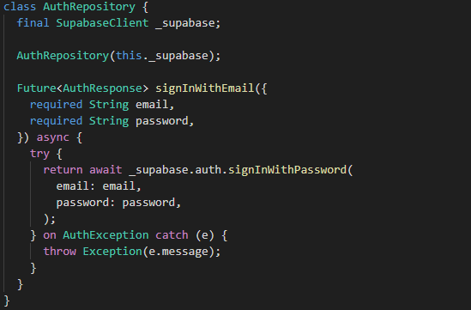
Figure 6.3.1: Authentication Repository Code Snippet

This repository abstracts Supabase authentication, ensuring the UI does not directly interact with backend APIs.
6.3.2 Resume Matching Service
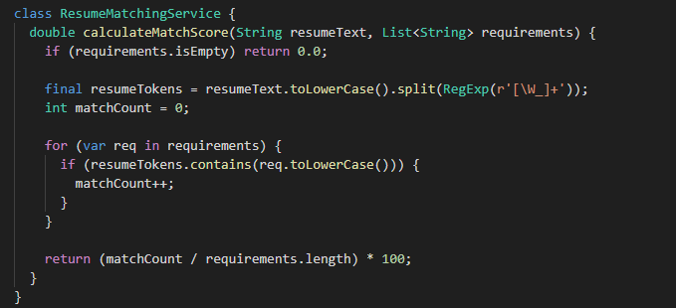
Figure 6.3.2: Resume Matching Service Code Snippet
This logic performs:
- Keyword tokenization
- Requirement matching
- Weighted coverage calculation
The result is stored in job_applications.overall_score.
6.3.3 Application Entry Point
The main entry point initializes:
- Supabase backend connection
- Riverpod state container
- Global AI Assistant overlay

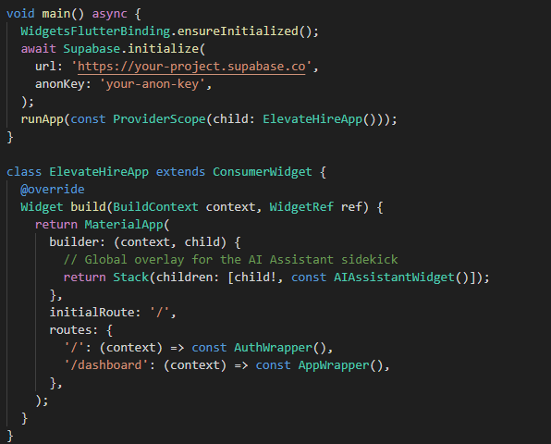
Figure 6.3.3: Resume Matching Service Code Snippet
6.3.4 ElevateAI Heuristic Engine
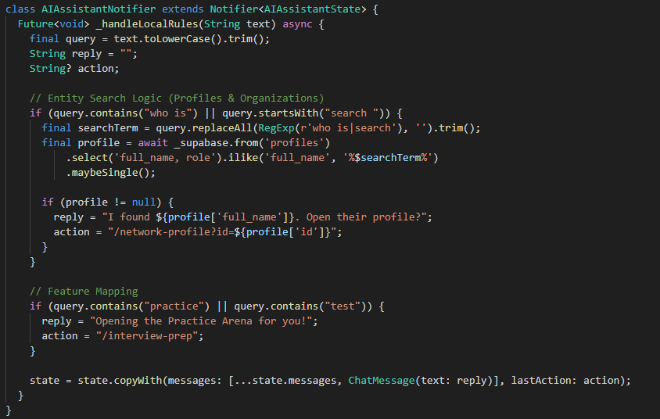
Figure 6.3.4: ElevateAI Heuristic Engine Code Snippet
This engine uses:
- Local heuristic parsing
- Entity lookup in PostgreSQL
- Deep linking for navigation
- Action confirmation logic
It operates without external LLM dependency in Beta mode
6.4 Error Handling Strategy
ElevateHire implements layered error handling:
- Repository Layer: Catches Supabase exceptions.
- Domain Layer: Validates business rules.
- Presentation Layer: Displays user-friendly error messages.
All critical flows include null safety and fallback mechanisms.
6.5 Performance Optimization Techniques
- Lazy loading for feed and job listings.
- Pagination for large datasets.
- Indexed columns for job search and resume matching.
- Local caching of frequently accessed profile data.
- Efficient JSONB querying in PostgreSQL.
6.6 Security Considerations in Code
- JWT-based authentication.
- Role-based route guards.
- Row-Level Security (RLS) enforced at database level.
- Controlled file access via Supabase Storage policies.
- Input sanitization before database writes.
6.7 Future Enhancements in Coding Layer
The current system is modular and extendable. Future improvements may include:
- Migration of Resume Matching to Supabase Edge Functions for distributed processing.
- Integration of vector embeddings for semantic resume analysis.
- Real-time interview scoring using AI speech evaluation.
- Advanced analytics using materialized SQL views.
- Native mobile build optimization for Android and iOS.
- Event-driven architecture using Supabase triggers for automation workflows.

6.8 Conclusion
The coding structure of ElevateHire reflects a scalable, modular, and AI-integrated architecture. By combining Flutter’s reactive UI system with Supabase’s serverless backend, the platform ensures real-time performance, structured data integrity, and maintainable feature expansion.
The system is designed not only for current placement lifecycle automation but also for future intelligent career ecosystem development.

CHAPTER-7
TESTING

- TESTING
7.1 Introduction
Testing is a critical phase in the ElevateHire development lifecycle, ensuring that the platform operates reliably, securely, and in alignment with defined requirements. The testing process was designed to validate system correctness, role-based security, AI-driven analytics accuracy, and database integrity across multiple modules.
This chapter outlines the testing objectives, methodologies, validation procedures, and representative test cases executed during development.
7.2 Testing Objectives
The primary objectives of testing were:
- Functional Accuracy: Validate correctness of resume matching, assessment scoring, and placement analytics.
- Security Enforcement: Ensure Row-Level Security (RLS) policies prevent unauthorized cross-role data access.
- Data Integrity: Confirm relational consistency across PostgreSQL tables.
- Reliability: Ensure real-time synchronization via Supabase Realtime operates without data inconsistency.
- Performance: Validate resume parsing and match score computation within acceptable response time.
- Usability: Ensure intuitive and responsive UI behavior across device types.
7.3 Testing Methods
The following testing methodologies were applied:
7.3.1 Manual Testing
Used for validating UI workflows, routing logic, role transitions, and visual components.
7.3.2 Unit Testing
Focused on validating business logic such as:
- ResumeMatchingService scoring logic
- Skill recalculation algorithms
- Validation rules processing

7.3.3 Integration Testing
Validated interaction between:
- Authentication and role-based routing
- Job posting and application flow
- Certificate upload and verification workflow
- Mock interview scoring and skill update
7.3.4 Simulated Dataset Testing
Mock datasets were inserted into:
- profiles
- jobs
- student_certifications
- aptitude_attempts
This ensured realistic stress conditions and verified relational integrity.
7.3.5 User Acceptance Testing (UAT)
Simulated real-world usage by testing the platform from three perspectives:
- Student
- Recruiter
- College
7.4 Testing Steps
7.4.1 Unit Testing
Individual components were tested in isolation.
Example:
- ResumeMatchingService was tested with controlled keyword sets.
- Score accuracy validated up to two decimal precision.
7.4.2 Integration Testing
Validated multi-module workflows:
- Student applies for job → Match score generated → Recruiter sees ranked candidate.
- Certificate uploaded → Validation rule triggered → College approval updates trust score.
- Mock interview completed → Skill score recalculated → Dashboard reflects updated readiness.
7.4.3 Validation Testing
Ensured proper input handling:
- Email and password validation during signup.
- Mandatory job fields enforcement.
- Only supported resume formats accepted.
- Required course fields validation before publishing.
7.4.4 Output Testing
Verified correctness of generated outputs:
- Match Score percentage chip rendering.
- Placement analytics charts reflecting offers data.
- Resume PDF generation matching stored profile JSON.
- Mock interview feedback storage and display.
7.4.5 Security Testing
Special focus was given to:
- Student attempting to access College dashboard.
- Recruiter attempting to modify another organization's job.
- Direct database query simulation against RLS policies.
All unauthorized attempts were blocked.
7.5 Testing Cases
The following test cases were executed to validate the functional correctness, security enforcement, AI-driven analytics, real-time communication, and overall system stability of the ElevateHire platform. Each test case represents a practical scenario derived from real user workflows across Student, Recruiter, and College roles. The results confirm that the system behaves as expected under normal operating conditions.
Test Case ID | Feature | Description | Expected Result | Actual Result | Status
TC-01 | Authentication | Login with valid Recruiter credentials | Redirect to Recruiter Dashboard | Redirected successfully | Pass
TC-02 | AI Matcher | Upload resume with 5/10 matching keywords | System shows 50% match score | Shown 50.0% | Pass
TC-03 | Security | Student attempts to access College Drive settings | Access denied via RLS and routing | Access Denied | Pass
TC-04 | Job Post | Recruiter creates job without required salary field | Validation error displayed | Validation message shown | Pass
TC-05 | Candidate Search | Search for "Flutter" skill | Relevant students listed | Listed 12 students | Pass
TC-06 | Certificate Validation | Student uploads new certificate | Status set to Pending Verification | Status: Pending | Pass
TC-07 | Analytics | Complete mock interview session | Skill proficiency updates immediately | Score updated | Pass
TC-08 | Learning | Enroll in "Advanced Dart" course | Course added to My Courses list | Course enrolled | Pass
TC-09 | Mock System | College creates Technical Round mock | Session visible in student Prep Arena | Session published | Pass
TC-10 | Networking | Student follows Recruiter | Recruiter appears in Connections list | Followed successfully | Pass
TC-11 | Feed | Post project update to campus feed | Visible to Connections | Post visible | Pass
TC-12 | Resume Builder | Export resume using "Modern Clean" template | PDF matches structured profile data | PDF generated correctly | Pass
TC-13 | Identity | Change profile picture | Avatar updates across all modules | Avatar updated | Pass
TC-14 | Placement Drive | College closes active drive | Drive status updates to Completed | Status updated | Pass
TC-15 | ElevateAI Navigation | Ask "How to post a job?" or "Practice arena" | AI provides guide and navigation option | Guide shown and navigated | Pass
TC-16 | ElevateAI Search | Query specific student or course name | AI retrieves entity and provides link | Entity found and link offered | Pass
TC-17 | Messaging | Send real-time message to connected user | Message appears instantly via Realtime | Message received successfully | Pass
Table 7.5 :Test Cases
7.6 Testing Summary
The testing phase confirmed that:
- All core modules function as designed.
- RLS security prevents cross-role data exposure.
- Database integrity is preserved under concurrent operations.
- UI responsiveness is stable across major browsers.
No critical defects were found in the final testing cycle.

CHAPTER-8
SCREENSHOTS

8.1 Introduction
This chapter presents some visual representations of the ElevateHire platform to demonstrate the implemented features and user interface across different modules. The screenshots provide evidence of functional implementation and system usability across Student, Recruiter, and College roles.
8.2 Unified Login Interface
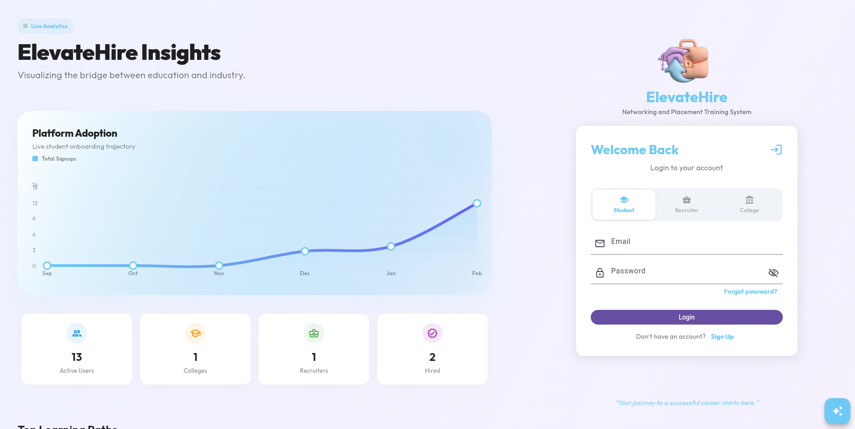
Figure 8.2: Unified Login Interface
8.3 Student Module
8.3.1 Student Dashboard
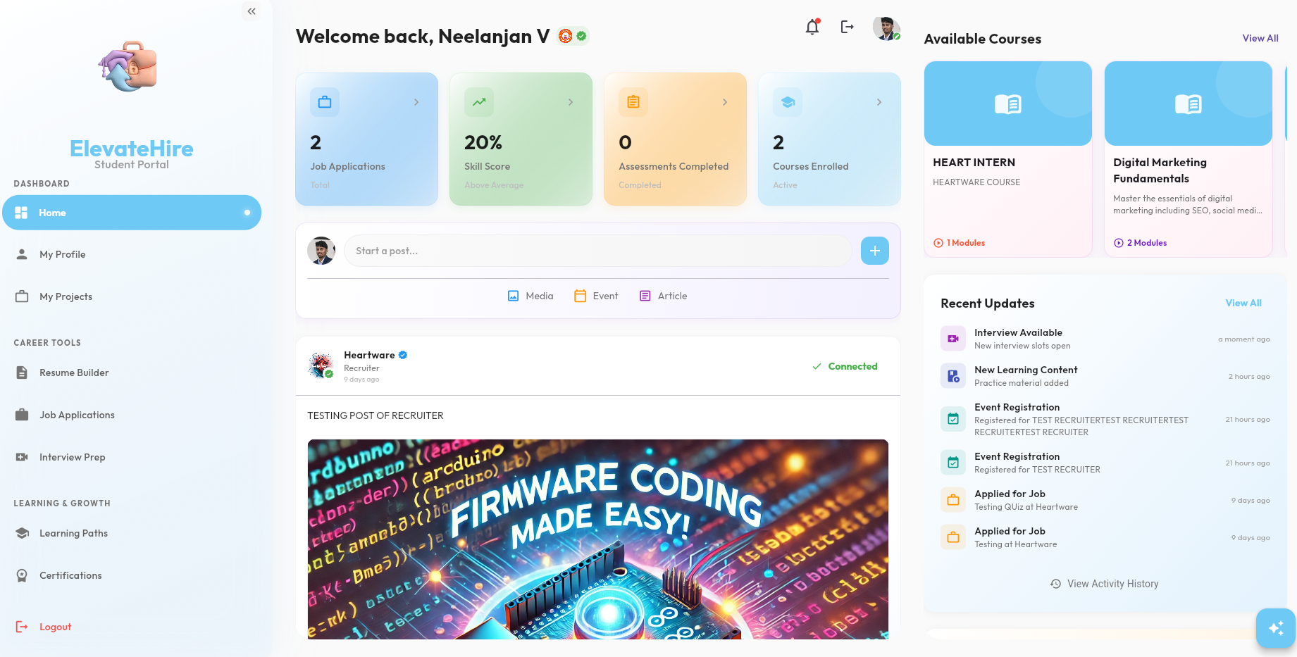
Figure 8.3: Student Dashboard

8.3.2 Project Portfolio
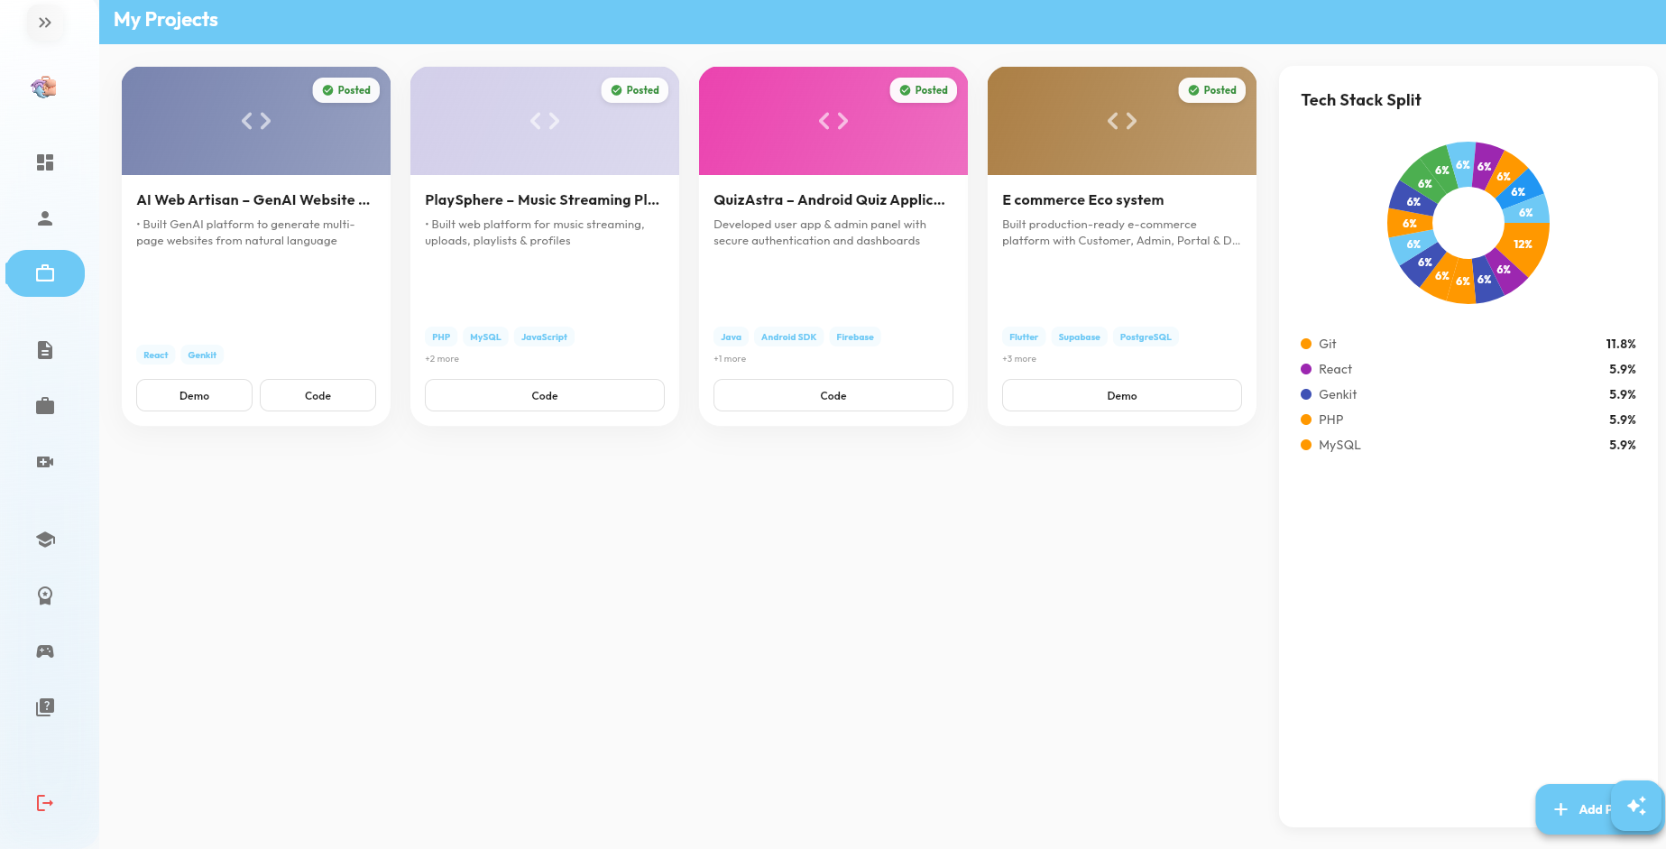
Figure 8.3.2: Project Portfolio

8.3.4 AI Resume Matching
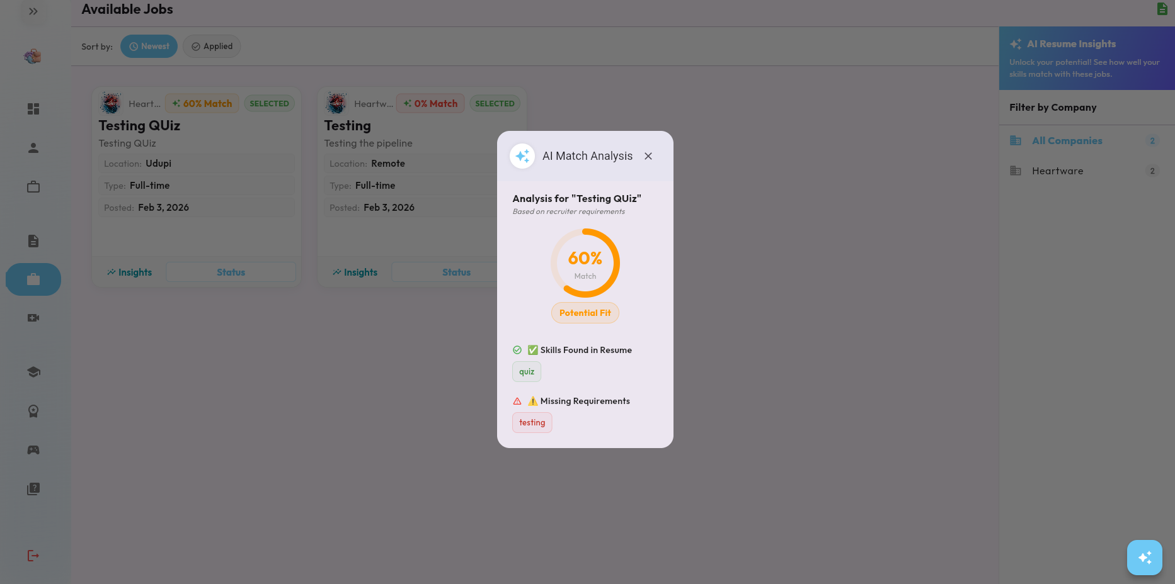
Figure8.3.4: AI Resume Matching Insights Dialog

8.3.5 Resume Builder
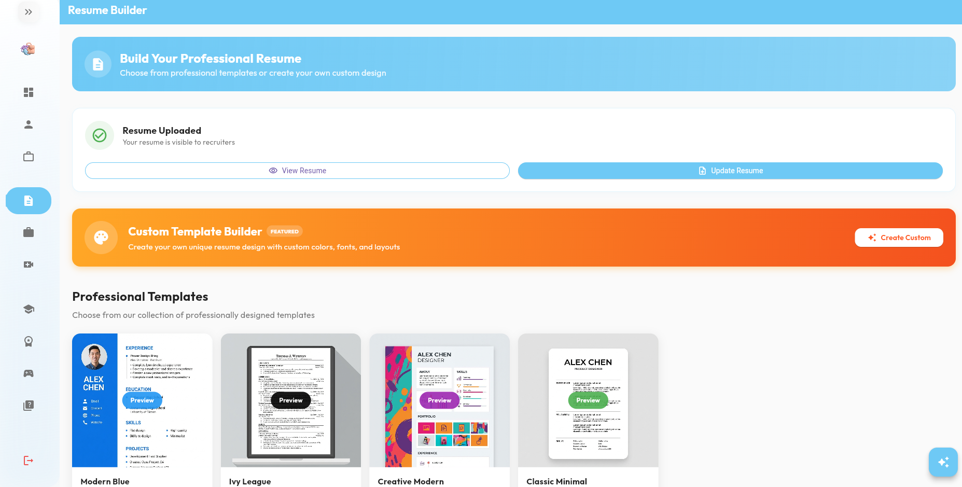
Figure 8.3.5: Resume Builder

8.3.6 Learning Hub
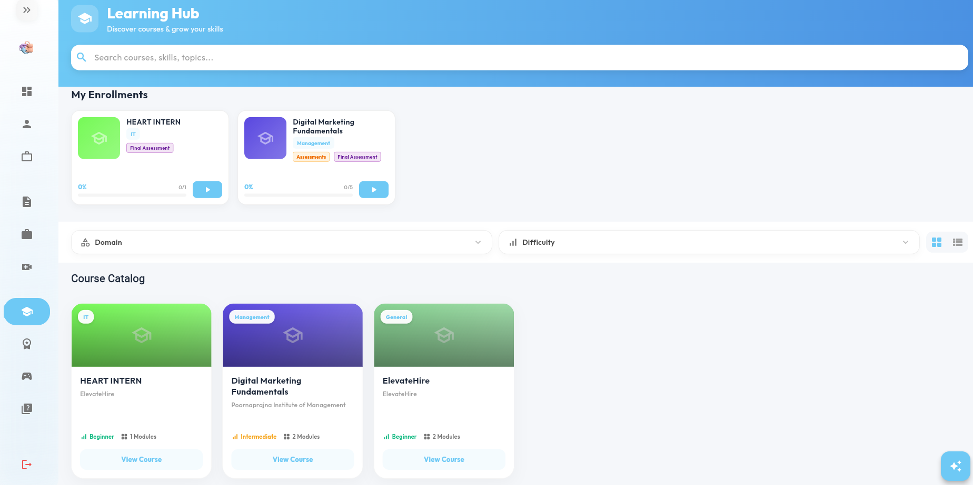
Figure 8.3.6 Learning Hub
8.4 College Module
8.4.1 College Dashboard
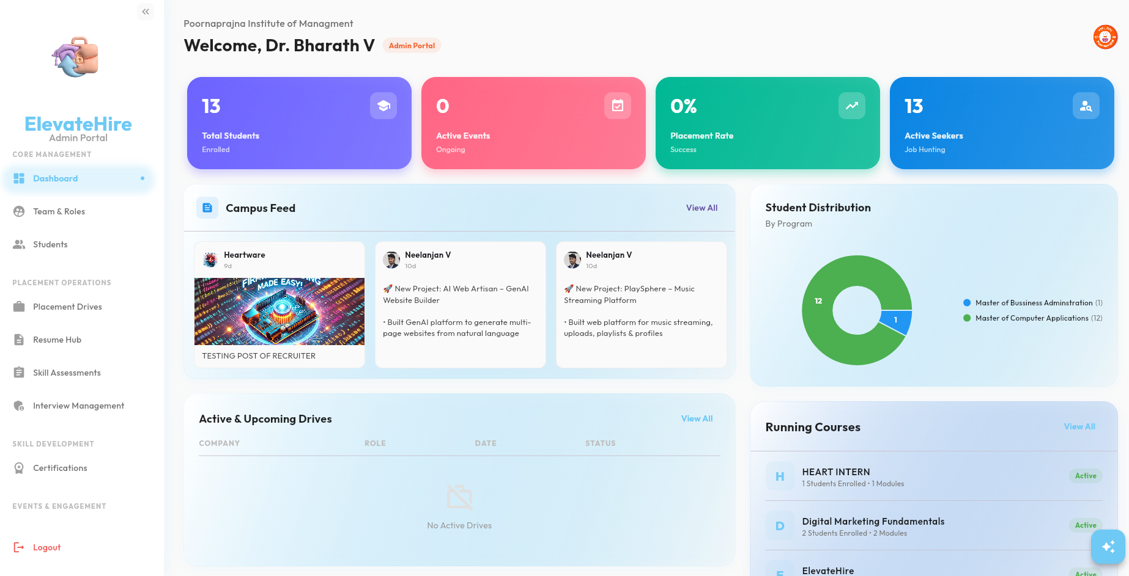
Figure 8.4.1 College Dashboard

8.4.2 Placement Tracking
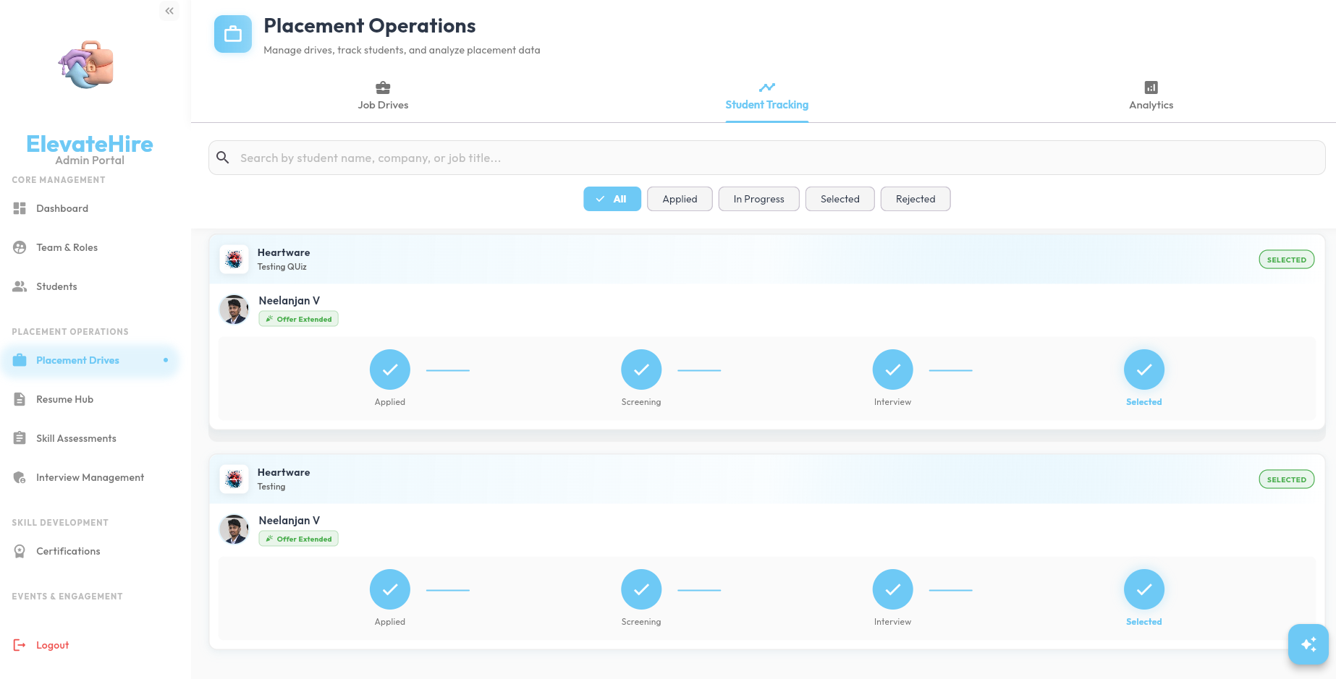
Figure 8.4.2:Placment Tracking
8.4.3 Analytics Insights
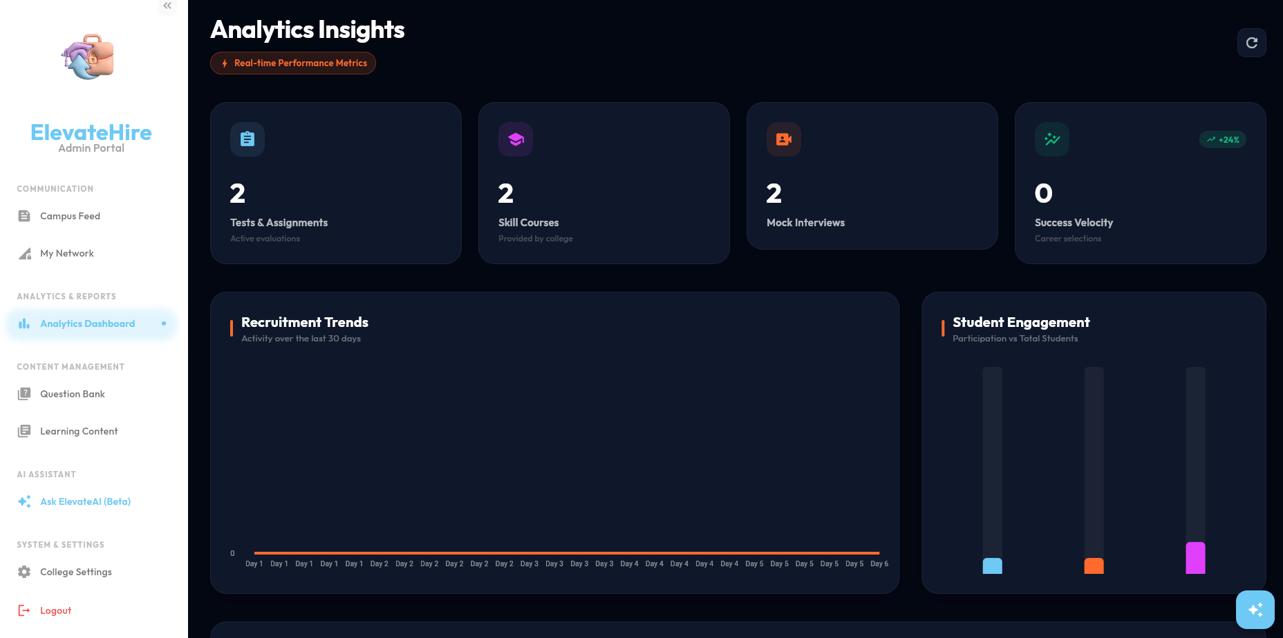
Figure 8.4.3: Analytics Insights
8.5 Recruiter Module
8.5.1 Recruitment Dashboard
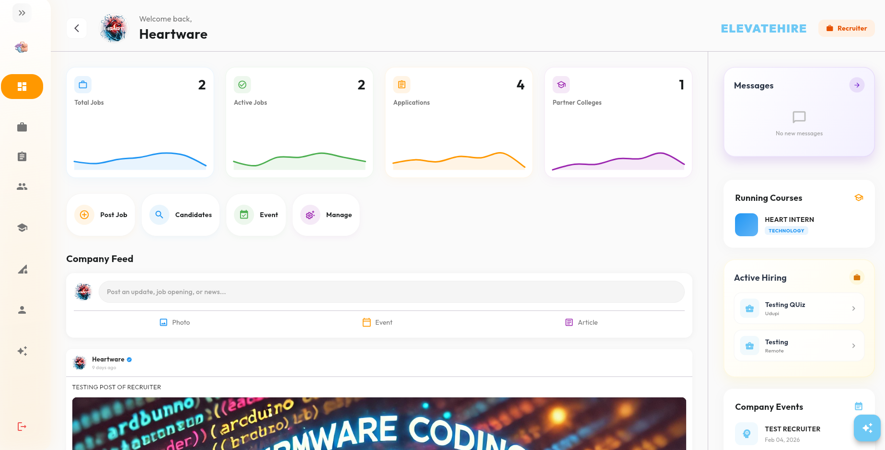
Figure 8.5.1: Recruitment Dashboard
8.5.2 Job Posting
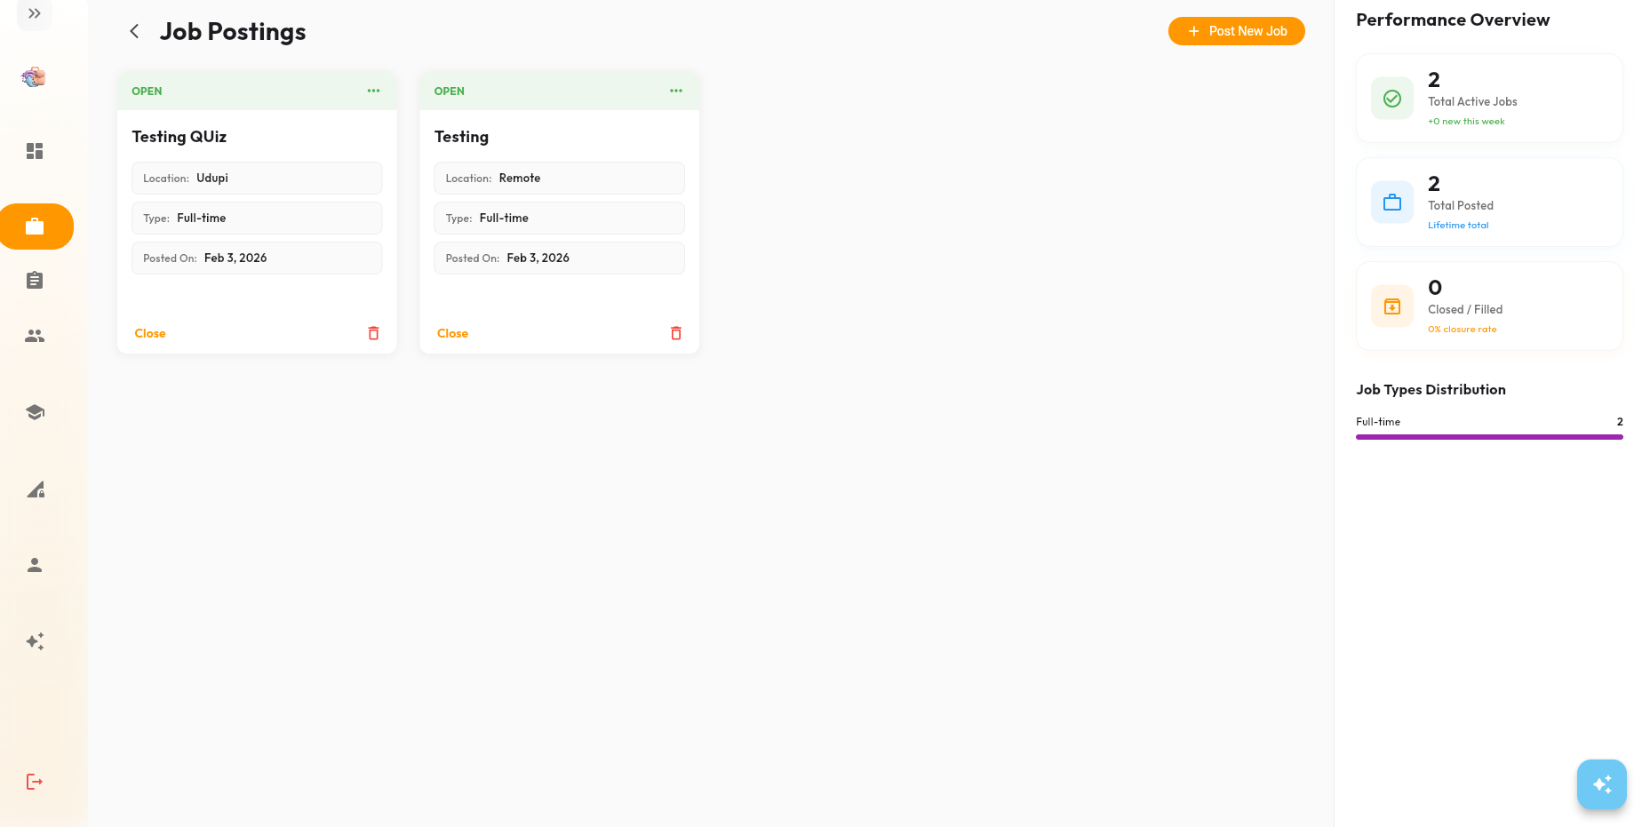
Figure 8.5.2 Job posting
8.5.3 Candiates
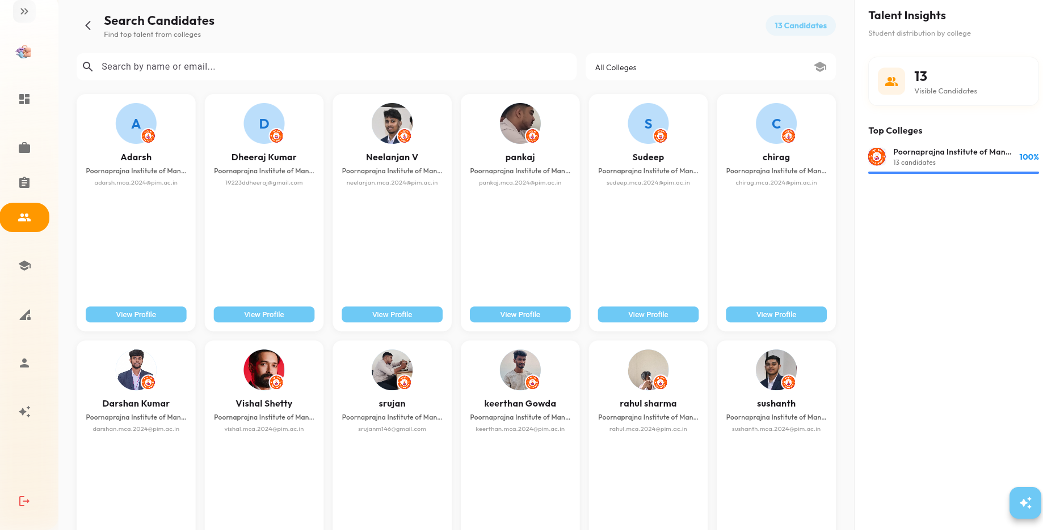

Figure 8.5.3 Canditates

8.6 ElevateAI-Beta
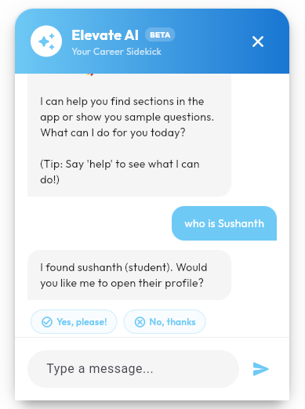
Figure 8.6 Elevate AI Beta Chatbot
8.7 Conclusion
The following section presents selected screenshots from the ElevateHire platform to visually demonstrate key features and user interfaces implemented for different user roles. These images highlight the login flow, student dashboard, recruiter analytics, college placement tools, networking feed, and AI Assistant interactions. They serve to validate the system’s functionality and design consistency. For a complete experience of the working application, please visit the live deployment at: https://elevate-hire-app.vercel.app/.

CHAPTER-9
CONCLUSION AND FUTURE ENHANCEMENT

9.CONCLUSION AND FUTURE ENHANCEMENT

9.1 Conclusion
The development of ElevateHire successfully addresses the need for a transparent and technology-driven placement ecosystem. By unifying students, recruiters, and colleges into a single digital platform, the system streamlines the transition from academics to professional careers.
The project highlights the impact of structured data management, modular architecture, and AI-assisted intelligence in improving recruitment workflows. Key achievements include a unified multi-role platform, an AI-powered resume matching engine, scalable real-time performance using Flutter and Supabase, institutional analytics and verification tools, and integrated professional networking features.
In summary, ElevateHire provides a strong technological foundation for modern recruitment, transforming traditional placement processes into a more efficient, data-driven, and merit-based system.
9.2 Future Enhancement
Although ElevateHire provides a comprehensive placement ecosystem, the platform is designed for continuous improvement. Future enhancements may include:
- Advanced AI Integration – Incorporating Large Language Models for personalized resume suggestions, mock interview feedback, and career guidance.
- Integrated Video Interview System – Enabling in-platform live interviews with AI-assisted monitoring and evaluation.
- Blockchain Credential Verification – Implementing secure, tamper-proof academic and certification validation.
- Native Mobile Applications – Developing Android and iOS apps to improve accessibility and enable push notifications.
- Corporate Training Expansion – Extending the platform to support onboarding and continuous employee upskilling.
These enhancements will strengthen ElevateHire’s scalability, intelligence, and global adoption potential.

CHAPTER-10
BIBLIOGRAPHY

10.BIBLIOGRAPHY
References
Flutter Developers. (n.d.). Flutter documentation. https://docs.flutter.dev/
Martin, R. C. (2017). Clean architecture: A craftsman's guide to software structure and design. Prentice Hall.
Material Design. (n.d.). Material Design 3 guidelines. https://m3.material.io/
PostgreSQL Global Development Group. (n.d.). PostgreSQL documentation. https://www.postgresql.org/docs/
Resend. (n.d.). Resend documentation. https://resend.com/docs
Riverpod. (n.d.). Riverpod documentation. https://riverpod.dev/
Supabase. (n.d.). Supabase documentation. https://supabase.com/docs
The Dart Team. (n.d.). Dart language documentation. https://dart.dev/guides
Yourdon, E., & Constantine, L. L. (1979). Structured design: Fundamentals of a discipline of computer program and systems design. Prentice Hall.
Microsoft. (n.d.). Visual Studio Code documentation. https://code.visualstudio.com/docs

