
MANGALORE UNIVERSITY
Mangalagangothri-574199

MINI PROJECT REPORT ON
ElevateHire: Placement training and Networking system

Project Associates
NEELANJAN V  P05PP24S126036 | SUSHANTH R  P05PP24S126049
III Semester Master of Computer Applications
Department of MCA, PIM
Under the Guidance of
Mrs. Priya k
Assistant Professor
Department of MCA, PIM

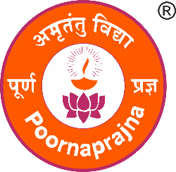
Department of MCA
Poornaprajna Institute of Management, Udupi
Managed By: Udupi Shree Adamaru Matha Education Council
Approved by AICTE & Affiliated to Mangalore University
2025-2026
Poornaprajna Institute of Management, Udupi
Managed By: Udupi Shree Adamaru Matha Education Council
Approved by AICTE & Affiliated to Mangalore University

DEPARTMENT OF MCA

CERTIFICATE

This is to certify that the project report titled “ElevateHire: Placement Training and Networking System” has been successfully carried out in the Department of MCA by NEELANJAN V (Register Number: P05PP24S126036) and SUSHANTH R (Register Number: P05PP24S126049), students of III Semester MCA, under the supervision and guidance of Mrs. Priya k, Department of MCA, Poornaprajna Institute of Management, Udupi.
This mini project report is submitted in partial fulfilment of the requirements for the award of the degree of Master of Computer Applications (MCA) under Mangalore University during the academic year 2025–2026.

Head of the Dept. Guide

Submitted for the viva-voice held on …………….. at Poornaprajna Institute of Management, Udupi.

External Examiner Internal Examiner

