
BansilalRamnathAgarwalCharitableTrust’s

VishwakarmaInstituteofTechnology, Pune
(AnautonomousInstituteofSavitribaiPhulePuneUniversity)

Department of Multidisciplinary Engineering

Division | CS(AI)- A
Batch | B3
GR-no | 12
Rollno | 55
Name | Soham Kolhatkar (12310981)

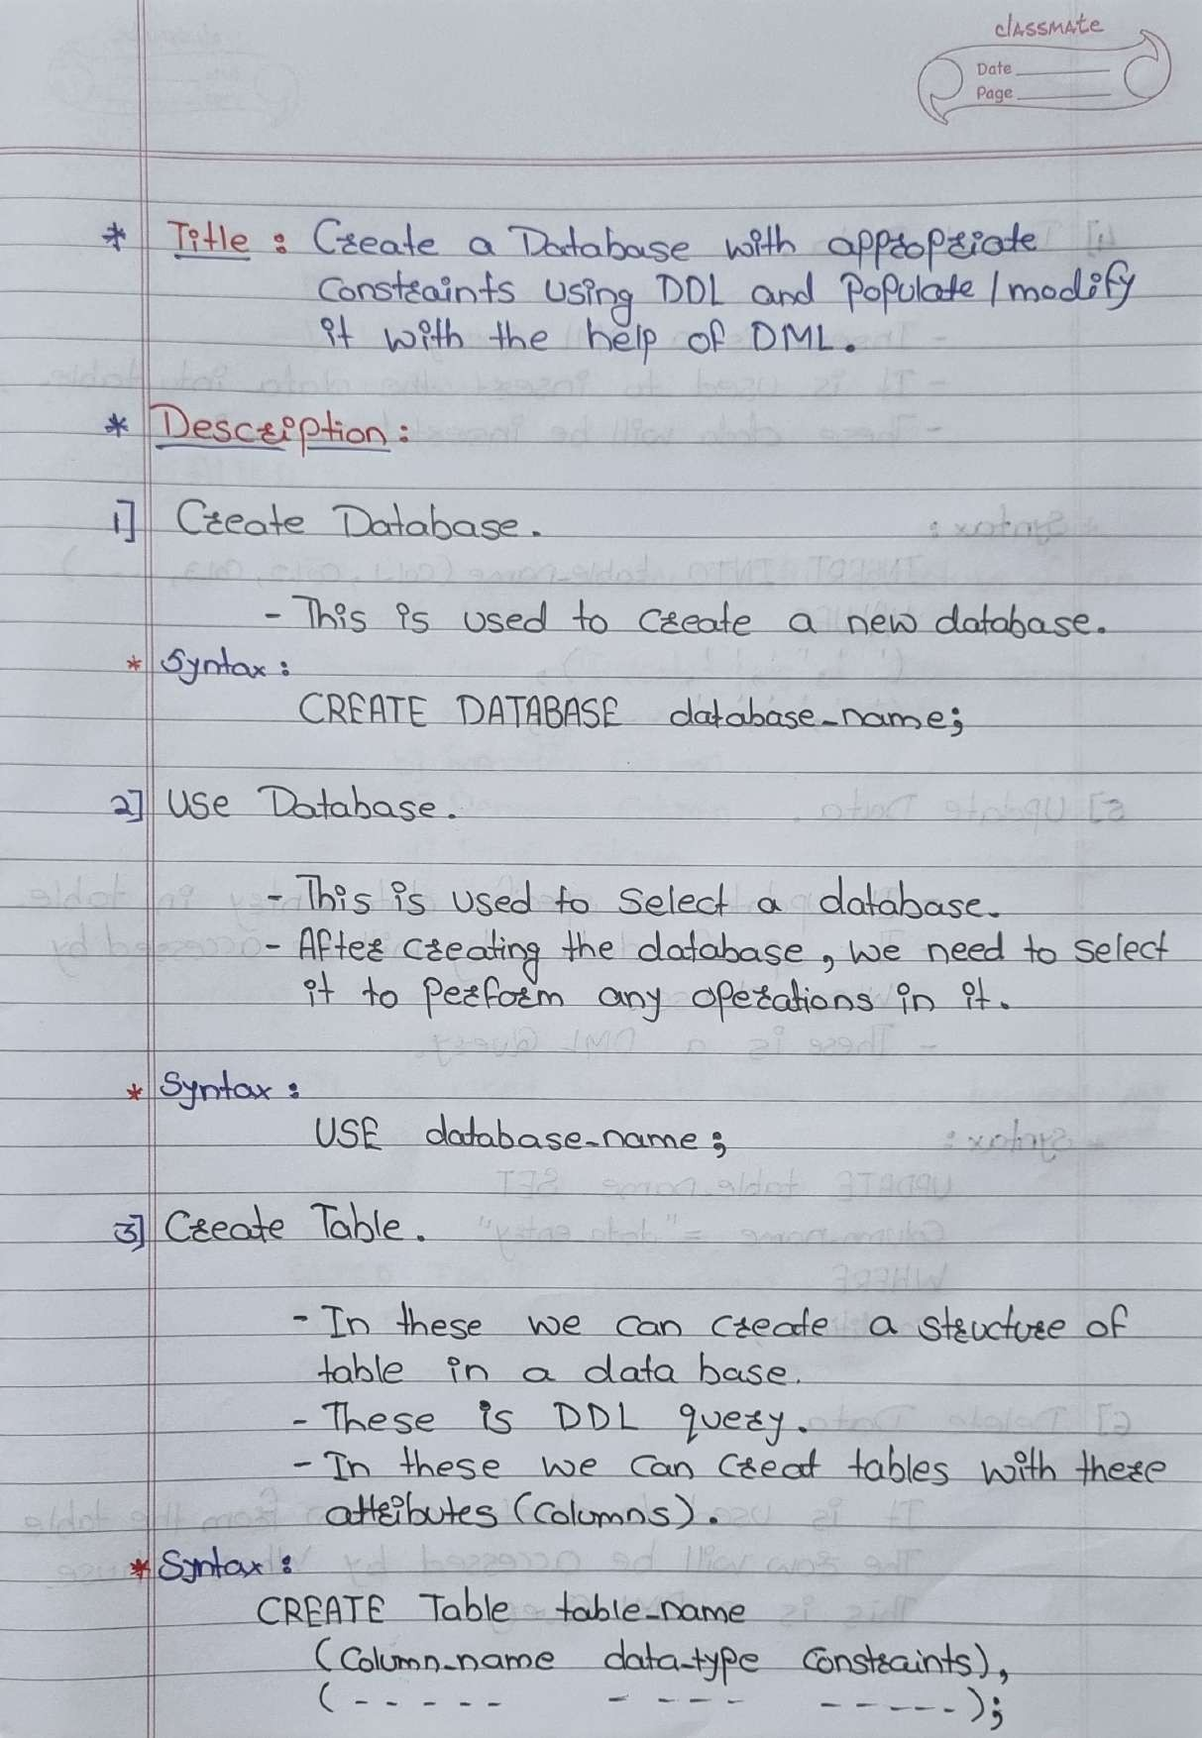

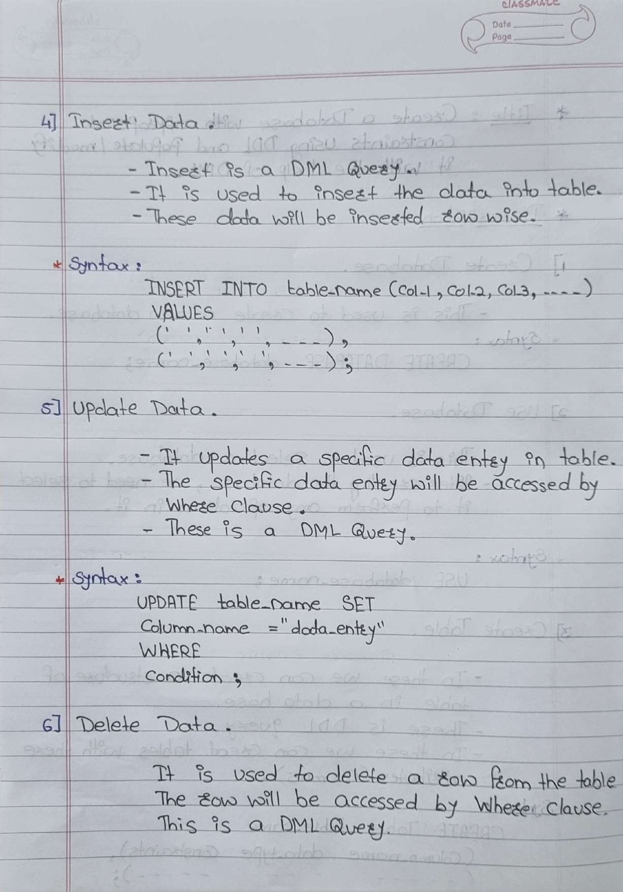

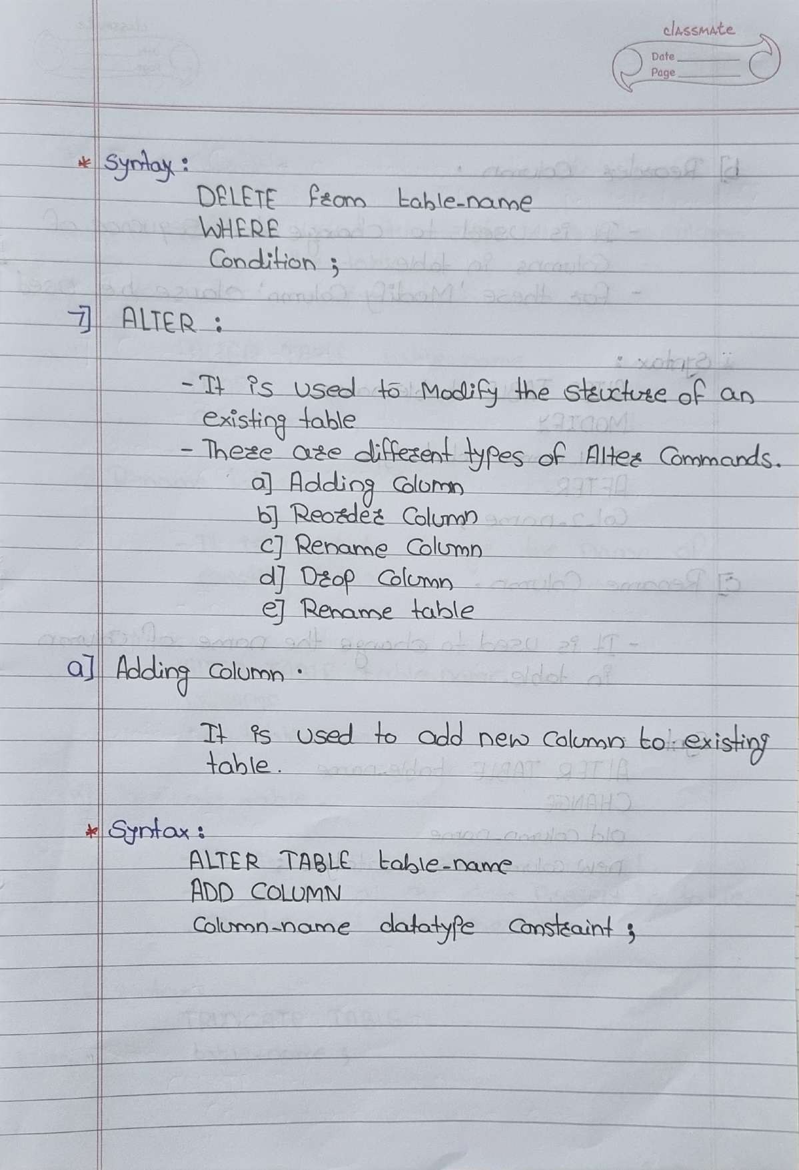

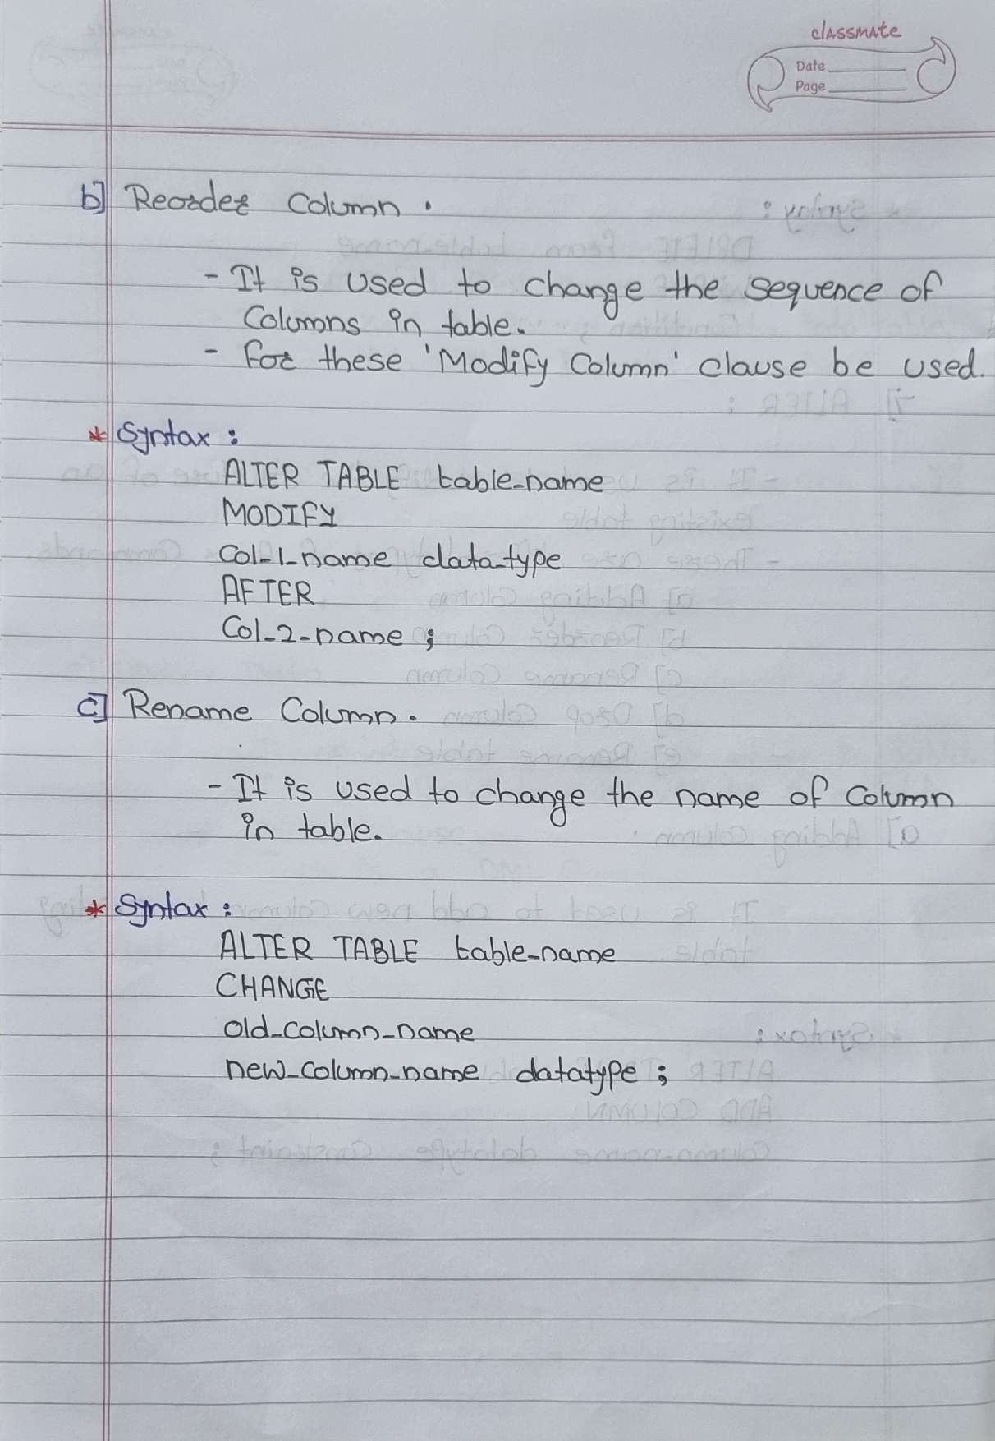

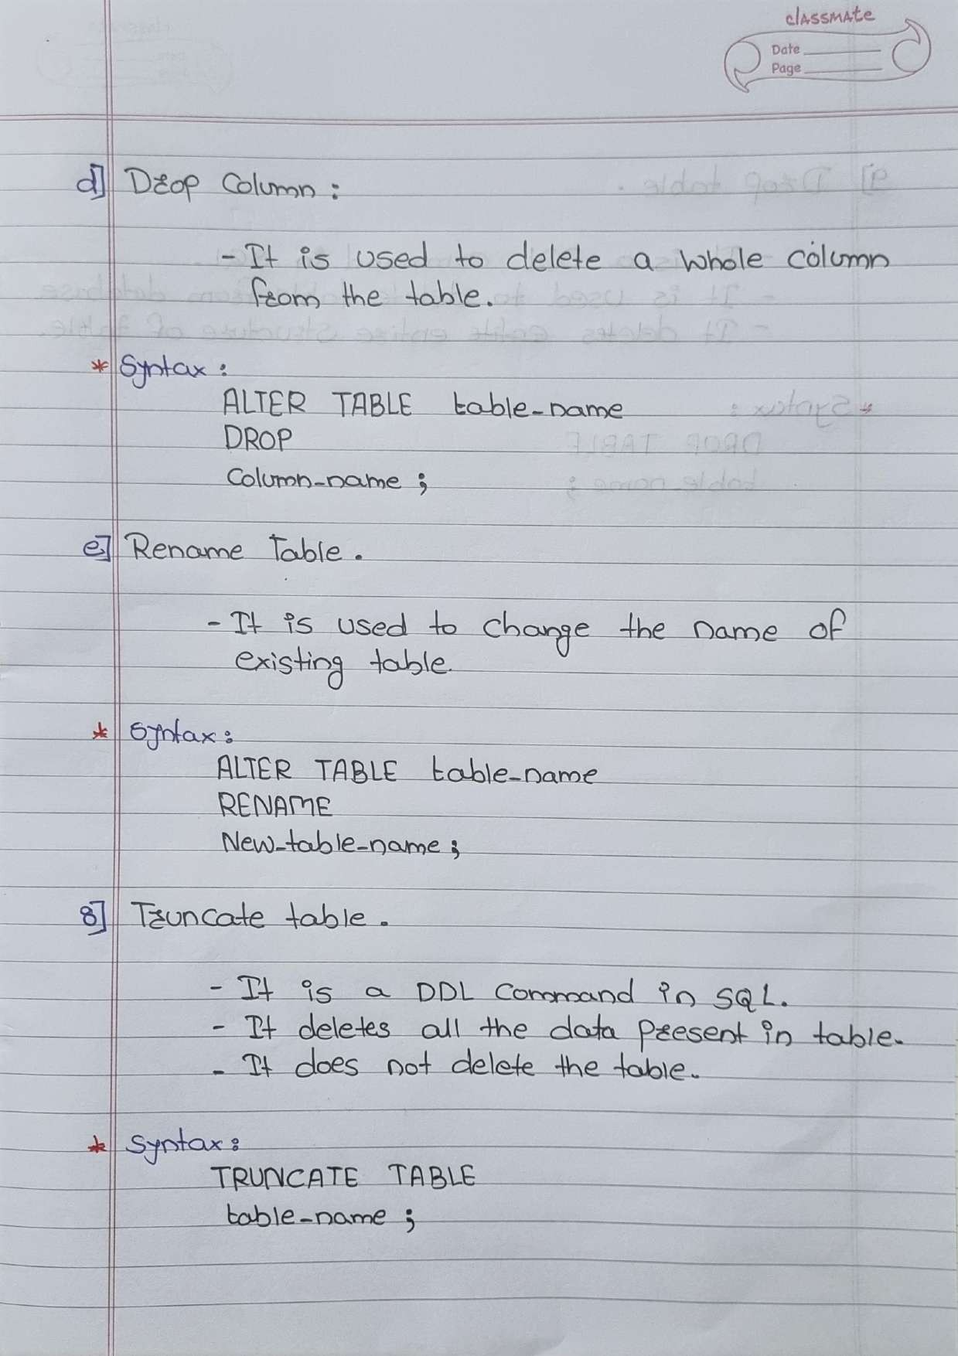

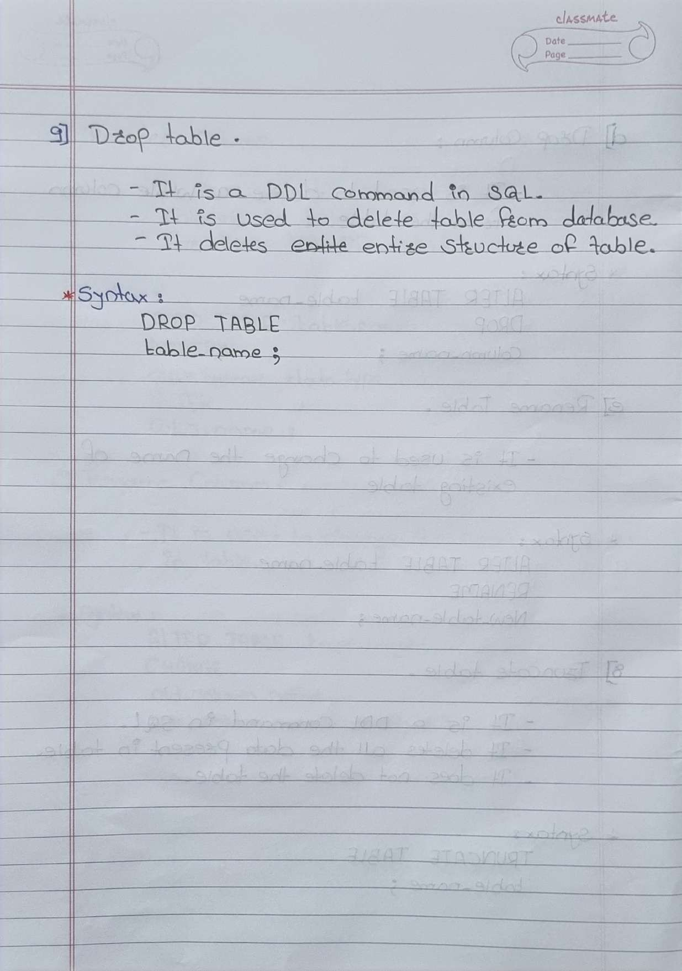

- CREATE DATABASE :

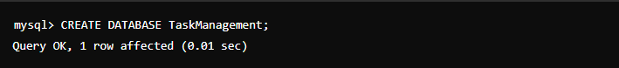

- USE DATABASE :

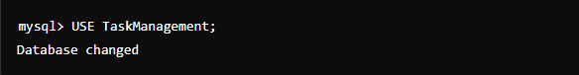

- CREATE TABLE :

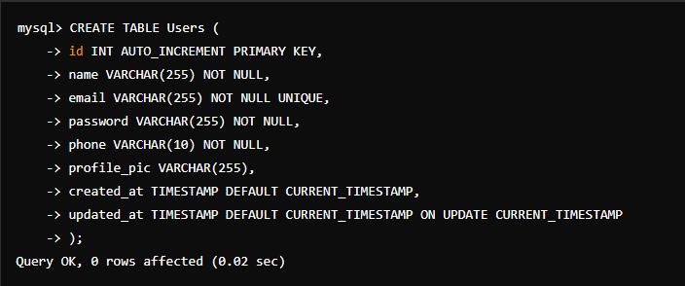
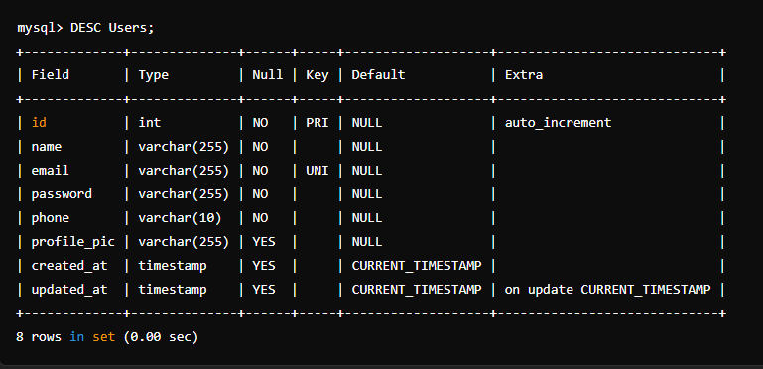

- INSERT DATA :

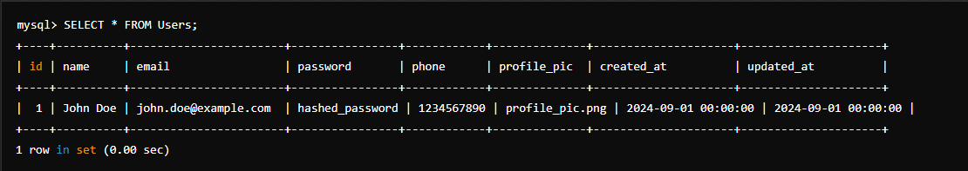

- UPDATE DATA :

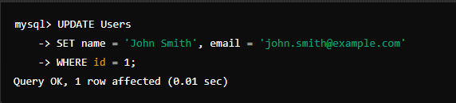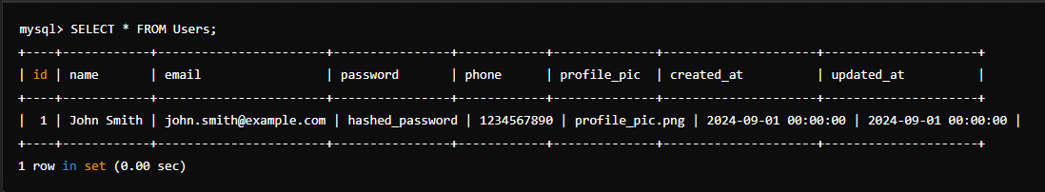

- DELETE DATA :
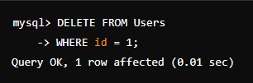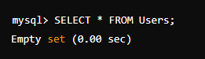

- ALTER :
  - ADD COLUMN :
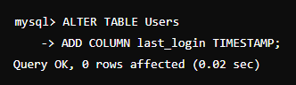
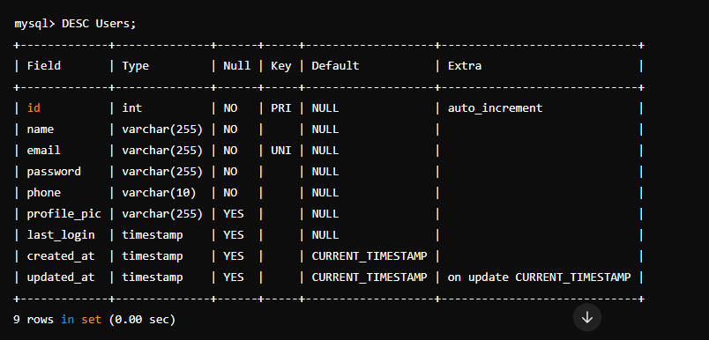

  - RENAME COLUMN :
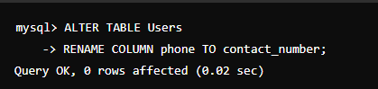
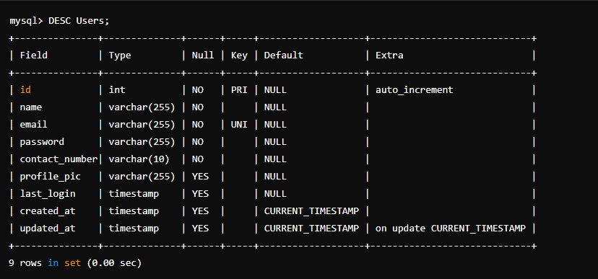
  - DROP COLUMN :

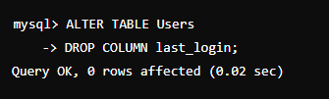
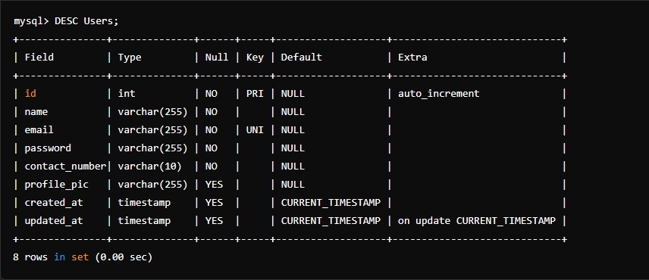

  - RENAME TABLE :

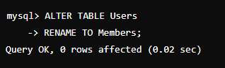
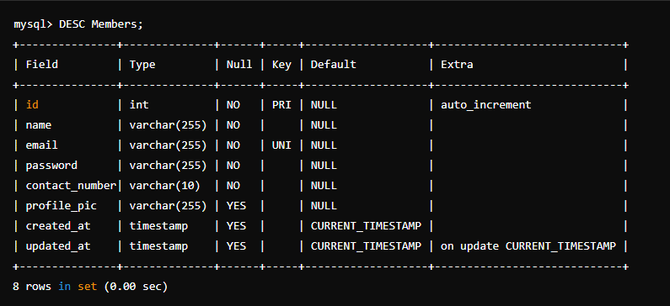

  - TRUNCATE TABLE :

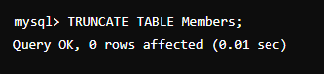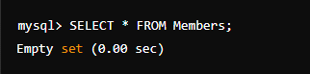

  - DROP TABLE :

