- Required Software
# | Name | Version | URL
 | Oracle Database | 12.1.0.2.0 Enterprise edition | http://www.oracle.com/technetwork/database/enterprise-edition/downloads/index-092322.html
 | SQL Developer | 18.1 | http://www.oracle.com/technetwork/developer-tools/sql-developer/downloads/index.html
 | Spring Source Tool Suite (IDE) | 3.9.4 | https://spring.io/tools/sts/all
 | Oracle WebLogic Server | 12.2.1.2 | http://www.oracle.com/technetwork/middleware/weblogic/downloads/wls-main-097127.html
 | Apache Maven | 3.3.9 | https://maven.apache.org/
 | JDK | 1.8 | http://www.oracle.com/technetwork/java/javase/downloads/jdk8-downloads-2133151.html
 | Android Studio | 3.1.3 | https://developer.android.com/studio/
 | Android Developer Studio | 28.0
 | Ionic | 3.20
 | Apache Cordova | 8.0.0

- Oracle WebLogic – Creating JNDI Data Source
  - Prerequisite: Considering the Oracle Weblogic is already installed and domain is already created. Oracle database is installed, and HR schema is unlocked.
  - Start Oracle Weblogic server - %WebLogic_HOME%\user_projects\domains\base_domain\ run startWebLogic.cmd
  - Go to browser http://localhost:port/console and login into weblogic with user/pass provided while installing weblogic.
  - On the left-hand side panel click on the Data Sources under Services menu. Select New > Generic Data Source and fill the data as per the below screenshot.

- Import Maven project
  - After project pull go to File > Import project into workspace
  - Select Existing Maven project
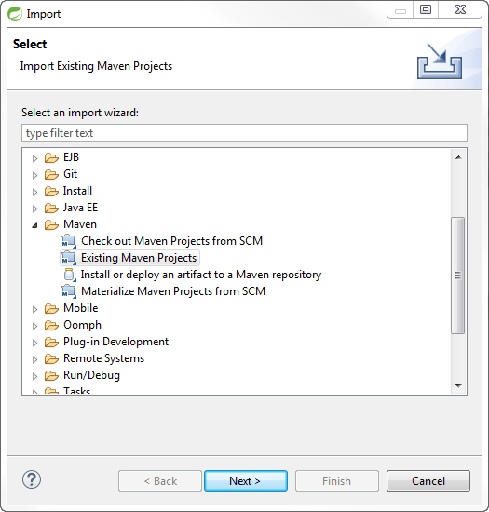
  - Select Project directory and click on the pom.xml file and hit finish
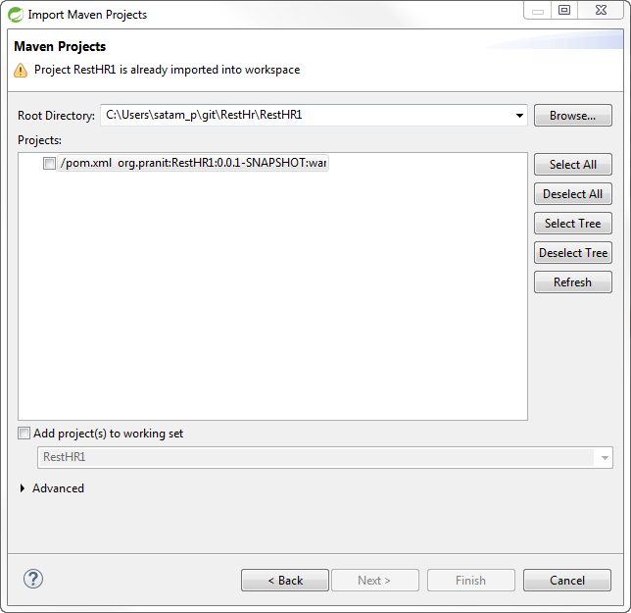

- Installation of Ionic Framework
  - Download NodeJs from the link https://nodejs.org/en/
  - Create Ionic folder under your project working directory and execute “npm install -g ionic” command from the command prompt.
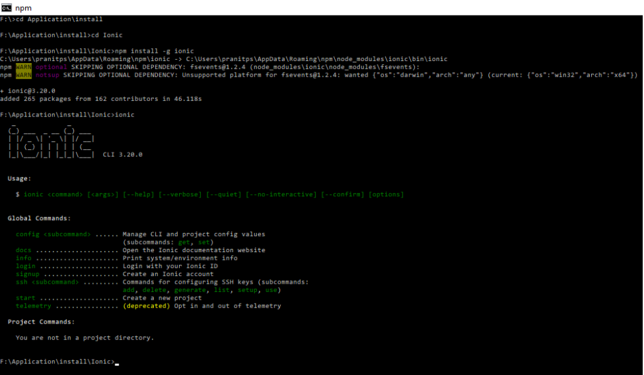
- Installation of Apache Cordova
  - Execute “npm install -g cordova” command from the command prompt.
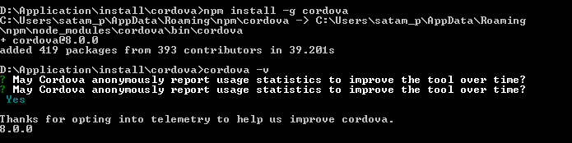

- Useful Links
  - Oracle JDBC maven drive installation
    - https://blogs.oracle.com/dev2dev/get-oracle-jdbc-drivers-and-ucp-from-oracle-maven-repository-without-ides#settings
    - https://blogs.oracle.com/dev2dev/get-oracle-jdbc-drivers-from-the-oracle-maven-repo-netbeans-eclipse-intellij
  - Using GitHub with Spring Source Tool Suite IDE
    - http://ojitha.blogspot.com/2013/04/how-to-github-projects-in-spring-tool.html
    - https://github.com/collab-uniba/socialcde4eclipse/wiki/How-to-import-a-GitHub-project-into-Eclipse
  - Oracle database installation and unlocked HR database
  - Oracle WebLogic installation and domain creation
  - Download apache maven and installation
  - STS, Node.js, Angular, Ionic
    - http://javasampleapproach.com/tool/setup-angular-ide-spring-tool-suite
    - http://javasampleapproach.com/java-integration/integrate-angular-4-springboot-web-app-springtoolsuite
    - Ionic framework installation instructions - https://ionicframework.com/getting-started

