Computer Graphics – Assignment Solution Journal
Computer Graphics, Sem-5
Assignment 10
Design an Advanced Realistic Rendering Technique

Cover Page
Student Name | ______________________________________
Roll No. / Division | ______________________________________
Programme / Semester | B.Tech – Semester V
Course / Code / Scheme | Computer Graphics / PCIT03T / R-2024
Module / Max Marks | Module 1 / 10 Marks
Course Outcome | CO6: Design and evaluate graphics systems and algorithms involving curves, surfaces, and display architectures.
Date of Submission | ______________________________________

Assignment Details (from the assignment sheet)
Question | Study flat, Gouraud and Phong shading. Propose an improved rendering approach considering realism, computational efficiency and hardware limitations.
Bloom / Type / Difficulty | Apply / Case study / Medium
Industry Context | Animation Industry
Expected Time / Resources | 2 hrs / Module 1
Assessment Evidence | Written document
Rubric Focus (10 Marks) | Realism (4), Computational efficiency (4), Hardware limitations (2)

Marking Scheme at a Glance (10 Marks)
# | Criterion | Marks | Where in this journal
1 | Realism | 4 | Section 3
2 | Computational efficiency | 4 | Section 4
3 | Hardware limitations | 2 | Section 5

1. Study of Existing Shading Techniques
This study supports all three criteria; the marks are earned in Sections 3 to 5.
Shading decides the colour of every pixel inside a polygon. All three techniques below use the same lighting model; they differ in where the lighting equation is evaluated. Note: the Phong reflection model (the lighting equation) and Phong shading (the interpolation method) are different things.
Lighting model used (Blinn-Phong form): I = ka·Ia + kd·max(N·L, 0)·IL + ks·max(N·H, 0)^n·IL, where N is the unit surface normal, L the unit direction to the light, H = (L + V) / |L + V| the half-vector between L and the viewer direction V, and n the shininess.
 | Flat shading | Gouraud shading (1971) | Phong shading (1975)
Idea | One normal and one colour for the whole polygon. | Light the vertices (using vertex normals), then interpolate the colours across the polygon. | Interpolate the normals across the polygon, then light every pixel.
Where lighting is computed | Once per polygon | Once per vertex | Once per pixel
Appearance | Faceted, each polygon visible. | Smooth, but highlights are smeared or lost. | Smooth with sharp, correctly placed highlights.
Main artifacts | Facets and Mach bands (the eye exaggerates brightness steps). | A highlight inside a polygon is missed if the vertices are dark; diamond-shaped highlights. | Silhouette still polygonal; most expensive.
Cost | Lowest | Low | Highest
Best used for | Flat-sided objects, quick previews. | Matte surfaces, fixed-function hardware, distant objects. | Shiny, curved surfaces.

Experiment used in this study
The three techniques were implemented in Python (software rasterizer with barycentric interpolation) and run on a low-polygon sphere. The sphere has 60 visible triangles, one directional light (L = (0.55, 0.55, 0.63), normalised), a viewer on the +Z axis, shininess n = 60, and a 360 × 360 image. The reference is the ideal smooth sphere with exact normals at every pixel. Errors are measured against this reference over the 79,710 pixels covered by the mesh.

2. Results of the Experiment
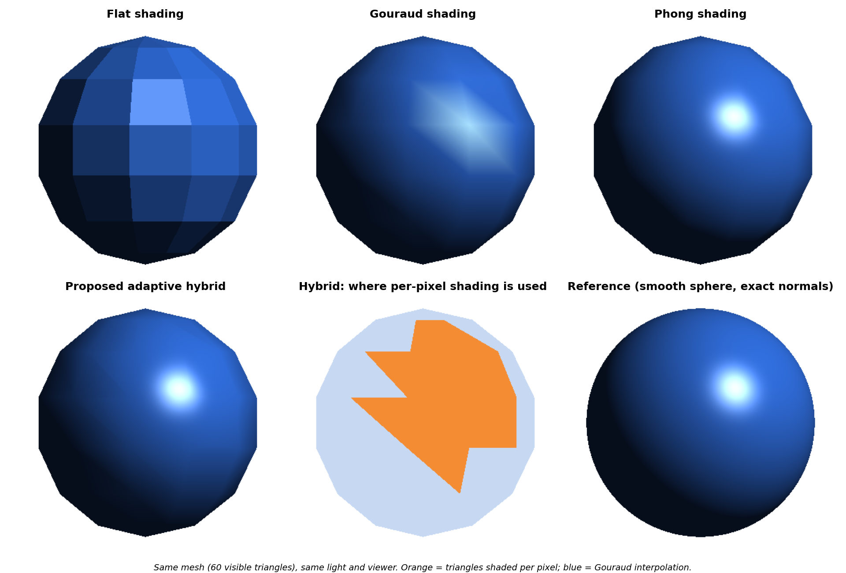
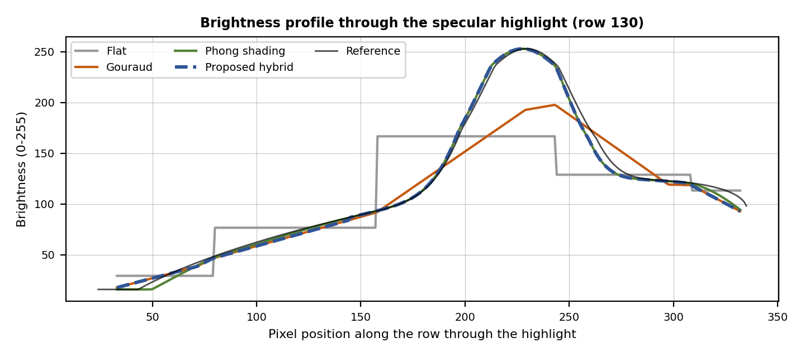

3. Realism [4 Marks]
Marking scheme (4 marks): realism of the three existing techniques analysed with evidence (2) + realism of the proposed approach with measured evidence (2).

(a) Realism of the existing techniques (2 marks)
Technique | Error (RMSE, 0–255) | Largest error | Highlight peak (reference 255) | Visible problem
Flat | 23.0 | 168.8 | 250.5 | Facets; highlight is a flat polygon.
Gouraud | 13.5 | 111.3 | 254.8 | Highlight smeared into a diamond and too dim over most of the area.
Phong shading | 4.1 | 26.1 | 255.0 | Very close to the reference; only the outline is polygonal.

Analysis: flat shading has the largest error because the brightness is constant within each polygon, giving visible facets (the profile shows steps). Gouraud removes the steps but its profile is a straight line between vertices, so the highlight is a low, wide hump instead of a sharp peak, and the error is still more than three times that of Phong shading. Phong shading follows the reference closely, so realism of a shiny object depends mainly on evaluating the specular term per pixel. None of the three corrects the polygonal silhouette, which is a geometry problem and needs more triangles or tessellation.

(b) Realism of the proposed approach (2 marks)
Proposed approach: Adaptive Hybrid Shading (AHS). Use cheap Gouraud interpolation where it is accurate and per-pixel Blinn-Phong only where a specular highlight can appear.
Step | Action
1 | Per vertex: compute the lighting (ambient + diffuse + specular) and the vertex colour, as in Gouraud shading.
2 | Per triangle (not per pixel), compute the mean normal n̄ and the spread ρ = the largest angle between n̄ and a vertex normal.
3 | Highlight test: let φ = the angle between n̄ and the half-vector H. The triangle may contain a highlight if φ − ρ ≤ θh, where θh = arccos(ε^(1/n)) is the angle at which the specular term drops below a small threshold ε.
4 | If the test is true, shade every pixel of the triangle per pixel (interpolate and normalise the normal, then Blinn-Phong). Otherwise interpolate the vertex colours.
5 | Optional extras: use normal maps for fine detail in flagged triangles; shade far objects with Gouraud only (level of detail).

Method | Error (RMSE) | Highlight peak | Triangles with per-pixel lighting | Pixels with per-pixel lighting
Gouraud | 13.5 | 254.8 | 0 of 60 | 0%
Phong shading | 4.1 | 255.0 | 60 of 60 | 100%
Proposed hybrid (ε = 0.01) | 4.9 | 255.0 | 14 of 60 | 40.7%

Result: the hybrid keeps the full highlight peak (255, as in the reference) and reduces the error from 13.5 (Gouraud) to 4.9, close to the 4.1 of full Phong shading. The remaining small difference comes from the Gouraud triangles. A faint seam can appear where the two modes meet (visible near the top of the hybrid image), which can be reduced by flagging a margin of neighbouring triangles or blending across the boundary.

4. Computational Efficiency [4 Marks]
Marking scheme (4 marks): cost model of the existing techniques (2) + measured saving of the proposed approach and its trade-off (2).

(a) Cost of the existing techniques (2 marks)
Technique | Lighting evaluations | Per-pixel work | Estimated cost at 1920 × 1080, one light
Flat | 1 per polygon | Write one constant colour | Lowest (about 1 operation per pixel)
Gouraud | 1 per vertex (60 triangles use about 40 vertices here) | Interpolate 3 colour values (about 6 operations) | 12.4 million operations
Phong shading | 1 per pixel | Interpolate and normalise the normal, N·L, N·H, power function (about 40 operations) | 82.9 million operations
Operation counts are estimates (not measured timings): about 40 floating-point operations for one Blinn-Phong evaluation (normalise, two dot products, power, mixing) and about 6 for interpolating a colour. Cost grows with the number of pixels for Phong shading but only with the number of vertices for the lighting part of Gouraud, which is why Gouraud was used on early hardware.

(b) Efficiency of the proposed approach (2 marks)
The share of pixels that need full per-pixel lighting depends on the highlight threshold ε. A smaller ε is safer (more triangles flagged); a larger ε is cheaper. Measured on the same sphere:
ε | Angle θh | Triangles flagged | Pixels with per-pixel lighting | RMSE (0–255) | Estimated cost (% of Phong)
0.001 | 27.0° | 18 of 60 | 48.8% | 4.7 | 56.5%
0.01 | 22.2° | 14 of 60 | 40.7% | 4.9 | 49.6%
0.05 | 18.0° | 12 of 60 | 35.8% | 5.0 | 45.5%
0.2 | 13.2° | 8 of 60 | 25.9% | 5.1 | 37.0%
0.5 | 8.7° | 7 of 60 | 23.7% | 5.2 | 35.1%

Analysis: with ε = 0.01 the hybrid needs full lighting for only 40.7% of the pixels, with an estimated cost of about 49.6% of full Phong shading, and an error of 4.9 against 4.1 for Phong shading. At ε = 0.2 the cost drops to about 37.0% with an error of 5.1, still far better than Gouraud (13.5). The per-triangle test itself costs only a few operations per triangle, which is negligible compared with the per-pixel savings.
Limits of this evidence: one object, one light, one view. In a full scene most triangles are far from any highlight, so the saving is expected to be larger, but this was not measured. With several lights, the test is repeated for each light (or for the strongest lights only).

5. Hardware Limitations [2 Marks]
Marking scheme (2 marks): hardware constraints identified (1) + adaptation or fallback in the proposed approach (1).
Hardware constraint | Effect on rendering | Adaptation in the proposed approach
Fixed-function or very old GPUs | Only flat and Gouraud shading are available; no per-pixel shaders. | Fall back to Gouraud with a finer mesh; the highlight test still tells where to add triangles.
Limited pixel (fragment) shader power on mobile GPUs | Per-pixel lighting for every pixel drains battery and causes heat. | Per-pixel shading only in flagged triangles; far objects use Gouraud.
Branching on GPUs | Threads that take different paths in the same group slow each other down. | The decision is made per triangle, so almost all pixels of a triangle follow the same path.
Memory bandwidth | Large buffers (for example deferred shading g-buffers) are costly on tile-based mobile GPUs. | Forward shading with a per-triangle flag stored in a tiny buffer; no extra full-screen buffers.
Low precision (16-bit floats) | The power function with a high exponent can be inaccurate and band. | Use a lookup table or a polynomial for N·H raised to n; keep normals in 16-bit but normalise carefully.
No hardware tessellation | Silhouettes stay polygonal. | Use mesh level of detail with more triangles on silhouettes; not solved by shading alone.
Fixed power or frame-time budget | Frame must be drawn in about 16.7 ms at 60 frames per second. | Raise ε when the frame is late (fewer flagged triangles), lower it when time is available: a quality knob.

Conclusion
Flat shading is cheapest but unrealistic, Gouraud shading is cheap but loses highlights, and Phong shading is realistic but expensive. Adaptive Hybrid Shading keeps the highlight of Phong shading at roughly half the estimated per-pixel work in this experiment, and it adapts to hardware by raising or lowering one threshold.

Student Self-Assessment
☐ I studied flat, Gouraud and Phong shading and their artifacts.
☐ I measured realism against a reference.
☐ I analysed computational cost with data.
☐ I considered hardware limitations and fallbacks.
☐ My proposal and analysis reflect my own work.

Assessment Rubric Mapping (10 Marks)
Criterion | Marks | Where addressed in this journal
Realism | 4 | Section 3: existing techniques with evidence (2) + proposed approach with evidence (2)
Computational efficiency | 4 | Section 4: cost of existing techniques (2) + measured saving and trade-off (2)
Hardware limitations | 2 | Section 5: constraints (1) + adaptations (1)

References
1. H. Gouraud, “Continuous Shading of Curved Surfaces,” IEEE Transactions on Computers, vol. C-20, no. 6, 1971.
2. B. T. Phong, “Illumination for Computer Generated Pictures,” Communications of the ACM, vol. 18, no. 6, 1975.
3. J. F. Blinn, “Models of Light Reflection for Computer Synthesized Pictures,” SIGGRAPH ’77 Proceedings, 1977.
4. D. Hearn and M. P. Baker, Computer Graphics with OpenGL, 4th ed., Pearson, 2011.
5. T. Akenine-Möller, E. Haines and N. Hoffman, Real-Time Rendering, 4th ed., CRC Press, 2018.
6. Course notes and Module 6 material, Computer Graphics, Semester V.

Declaration: I commit to submitting original work, free from plagiarism or copying from the internet or peers, and to honouring deadlines for a fair and transparent assessment.
Signature of Student: ____________________ Roll No: ____________

