Computer Graphics – Assignment Solution Journal
Computer Graphics, Sem-5
Assignment 11
Poster: Innovative Applications of Computer Graphics

Cover Page
Student Name | ______________________________________
Roll No. / Division | ______________________________________
Programme / Semester | B.Tech – Semester V
Course / Code / Scheme | Computer Graphics / PCIT03T / R-2024
Module / Max Marks | Module 1 / 10 Marks
Course Outcome | CO1 to CO6 (all course outcomes)
Date of Submission | ______________________________________

Assignment Details (from the assignment sheet)
Question | Prepare a poster on an innovative application (Metaverse, Digital Twins, AI-based Graphics, Virtual Production or Medical Simulation) including problem statement, graphics concepts used, benefits and future scope.
Bloom / Type / Difficulty | Apply / Case study / Medium
Industry Context | Animation Industry
Expected Time / Resources | 2 hrs / Module 1
Assessment Evidence | Poster and written document (the sheet lists a written document)
Rubric Focus (10 Marks) | Problem statement (2.5), Graphics concepts used (2.5), Benefits (2.5), Future scope (2.5)

Marking Scheme at a Glance (10 Marks)
# | Criterion | Marks | Where in this journal
1 | Problem statement | 2.5 | Poster panel 1 and Section 2
2 | Graphics concepts used | 2.5 | Poster panel 2 and Section 3
3 | Benefits | 2.5 | Poster panel 3 and Section 4
4 | Future scope | 2.5 | Poster panel 4 and Section 5

1. The Poster: Virtual Production
Application chosen: Virtual Production (an LED stage showing a real-time 3D background). The poster file is submitted along with this document (A3 portrait, PDF and PNG).
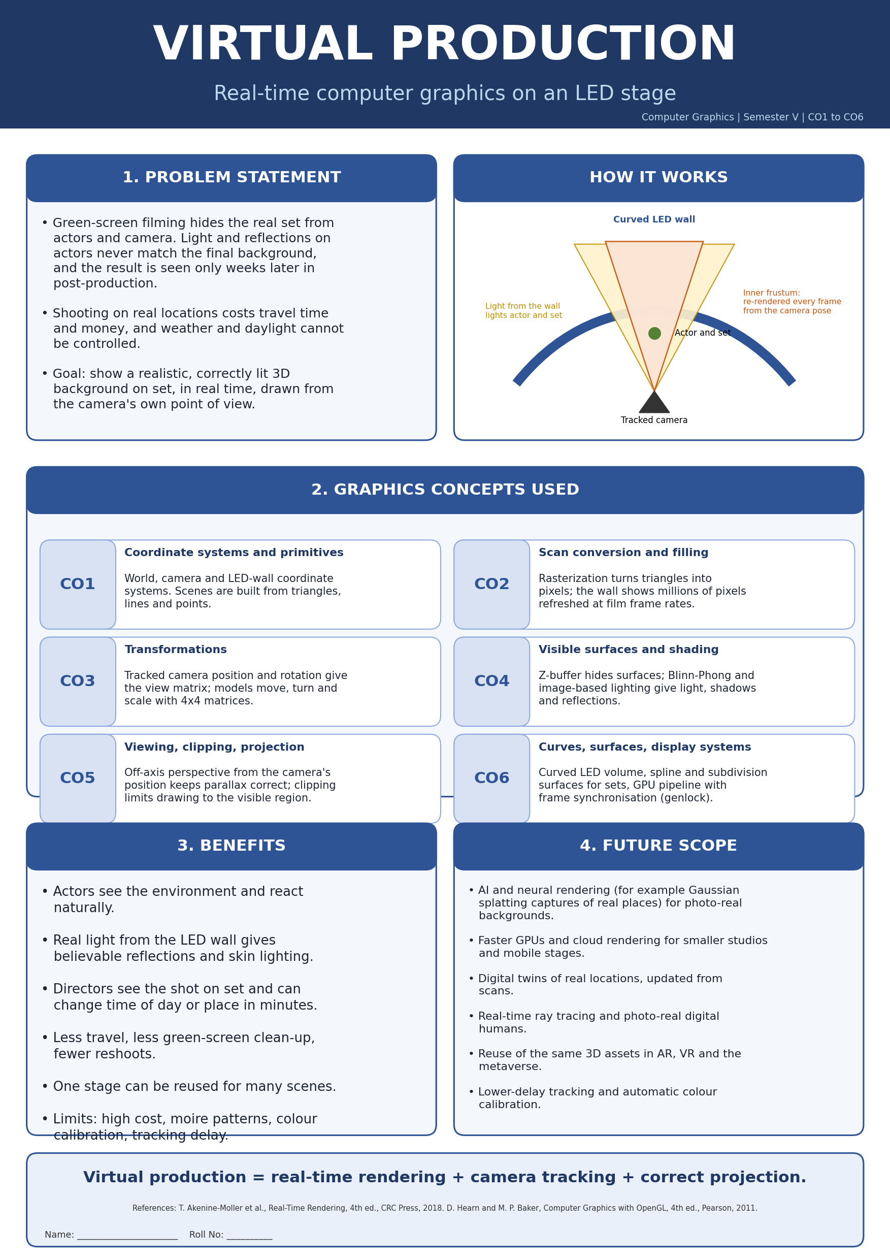

2. Problem Statement [2.5 Marks]
Marking scheme (2.5 marks): problem clearly stated (1) + context, people affected and existing approaches (0.75) + objective and scope (0.75).
Item | Description
Context | Film, television and animation studios must place actors in places that are expensive, far away, dangerous or not real (another planet, a historic city, a storm).
Problem | Green-screen filming hides the real set from actors and camera. Light and reflections on actors never match the final background, and the result is seen only weeks later in post-production.
People affected | Actors and camera crew (cannot see the world they act in), directors (cannot judge the shot on set), producers (travel and reshoot cost), visual-effects artists (long clean-up in post-production).
Existing approaches and their limits | Real locations: costly, weather and light uncontrolled. Green screen: no correct light or reflections on actors, colour spill, final look seen late. A flat video playing on a screen: the picture does not change when the camera moves, so perspective looks fake.
Objective | Goal: show a realistic, correctly lit 3D background on set, in real time, drawn from the camera's own point of view.
Scope and assumptions | Studio shooting with a curved or flat LED wall, one tracked camera, and a real-time 3D engine. Cost figures and brand names are outside the scope.

3. Graphics Concepts Used [2.5 Marks]
Marking scheme (2.5 marks): concepts from CO1 to CO6 correctly mapped to the application (1.5) + worked examples with numbers (1).
CO | Concept | How it is used in virtual production | Where in the system
CO1 | Coordinate systems and primitives | The 3D scene is built from triangles (and lines and points for guides). World, camera and LED-wall coordinate systems must agree. | Scene model; calibration of the stage.
CO2 | Scan conversion and polygon filling | Each triangle is rasterized to pixels; the wall shows several million pixels refreshed at film frame rates. | GPU rendering of the wall image.
CO3 | 2D and 3D transformations | The tracked camera pose (rotation and translation) gives the view matrix; props are moved, rotated and scaled with 4×4 matrices. | Camera tracking to render engine.
CO4 | Visible surfaces, illumination and shading | The Z-buffer removes hidden surfaces; Blinn-Phong or physically based shading, shadows and image-based lighting give realistic light on the background and on the actors. | Real-time shaders in the engine.
CO5 | Viewing, clipping and projection | An off-axis perspective projection from the camera’s position keeps parallax correct; clipping limits drawing to the visible region and the wall edges. | Projection set-up for the inner frustum.
CO6 | Curves, surfaces and display architectures | Curved wall geometry, spline or subdivision surfaces for smooth sets and props; GPU pipeline, multi-GPU or multi-display output and frame synchronisation (genlock). | Display and stage architecture.

Worked example 1: off-axis projection (CO5)
A flat LED wall is 10 m wide and 5 m high and lies in the plane z = 0, centred at the origin. The camera is at (1, 0.2, 6) m, looking at the wall, near plane n = 0.1 m. The frustum edges at the near plane follow from similar triangles: left = (−5 − 1)·n / d, right = (5 − 1)·n / d, bottom = (−2.5 − 0.2)·n / d, top = (2.5 − 0.2)·n / d, with d = 6 m.
Edge | Calculation | Value (m)
Left | (−5 − 1) × 0.1 / 6 | -0.1000
Right | (5 − 1) × 0.1 / 6 | 0.0667
Bottom | (−2.5 − 0.2) × 0.1 / 6 | -0.0450
Top | (2.5 − 0.2) × 0.1 / 6 | 0.0383
The frustum is not symmetric because the camera is not at the centre of the wall. A normal symmetric projection would give a wrong perspective; the asymmetric (off-axis) matrix makes the picture on the wall look correct from the camera, and it is recomputed every frame as the camera moves.

Worked example 2: size of the display (CO2, CO6)
Assuming an LED pixel pitch of 2.6 mm (an assumed value), a 10 m × 5 m wall has 10 / 0.0026 ≈ 3846 pixels across and 5 / 0.0026 ≈ 1923 pixels high, a total of about 7.4 million pixels. At 24 frames per second this is about 178 million pixels per second just to fill the wall, which is why a powerful GPU or several GPUs are needed.

Worked example 3: tracking delay (CO3)
If the camera pans at 30° per second and the total delay from tracking to the displayed image is 40 ms, the background is drawn for a camera direction that is 30 × 0.04 = 1.2° old. This misalignment shows as a lag between the actor and the background, so low-delay tracking and prediction of the next camera pose are essential.

4. Benefits [2.5 Marks]
Marking scheme (2.5 marks): benefits explained for the main stakeholders (1.5) + limitations and measurable indicators (1).
Stakeholder | Benefit | Graphics reason
Actors | See and react to the environment instead of an empty green room. | Real-time rendering shows the scene on set.
Camera and lighting crew | Natural reflections and skin lighting; less green spill. | The wall emits light that matches the scene (CO4).
Directors | See the shot as it will look; change time of day or place in minutes. | Scene parameters and lights change instantly in the engine.
Producers | Less travel, fewer reshoots, less clean-up in post-production. | Final pixels are captured in the camera.
Environment and safety | Fewer flights and location set-ups; dangerous scenes are filmed in a studio. | Virtual sets replace physical travel.

Limitations
- High cost of the LED wall, tracking and computers.
- Moiré patterns when the camera focuses on the wall; the wall is usually kept slightly out of focus.
- Colour calibration between the wall and the camera must be carefully managed.
- Tracking and rendering delay (see worked example 3) and the limited size of the stage.

Indicators to measure success
Indicator | How to measure
Reshoots and location trips avoided | Count per production compared with a similar earlier production.
Time from shot to final image | Hours in post-production per minute of finished footage.
Background alignment error | Delay and angle error between tracking and displayed image (worked example 3).
Colour match | Colour difference between the wall and the camera under test charts.

5. Future Scope [2.5 Marks]
Marking scheme (2.5 marks): near-term and long-term developments (1.5) + research directions, risks and ethics (1).
Time frame | Development | Graphics area
Near term | Lower-delay tracking and automatic colour calibration; faster GPUs and real-time ray tracing for better reflections. | Rendering, hardware, CO4 and CO6
Medium term | AI and neural rendering of real places (for example Gaussian splatting captures, see Assignment 8) for photo-real backgrounds; cloud rendering for smaller studios and mobile stages. | Neural rendering, scene capture
Long term | Digital twins of real locations updated from scans; photo-real digital humans; one asset library used for film, games, AR, VR and the metaverse. | Digital twins, real-time characters

Research directions
- Rendering the inner frustum for several cameras at once without extra cost.
- Predicting camera motion to cancel tracking delay.
- Matching the wall light to the real scene automatically (colour and brightness).
- Compressing neural and splat-based scenes so they render in real time on a stage.

Risks and ethics
- Digital humans: need consent and clear rules so that a person’s face or voice cannot be used without permission.
- Jobs: some location and green-screen work may shrink, while new technical roles appear; training is needed.
- Energy use: large LED walls and GPU clusters use a lot of power; efficiency should be measured against the travel they replace.

6. Design Notes for the Poster
Item | Choice and reason
Layout | Title band, then Problem statement with a how-it-works diagram, then the six course outcomes, then Benefits and Future scope, then a one-line key message. The four rubric items each have their own labelled panel.
Visuals | A top-view diagram of the LED wall, tracked camera, actor and inner frustum, so the main idea is understood in a few seconds.
Colour and type | Navy and blue headings with light panels for good contrast; large title, readable body text for A3 printing.
Tool | The sheet suggests Canva. This poster was generated with Python so that it could be produced from the same text; it can be rebuilt in Canva by copying the text from the panels.
Poster file: CG_Assignment11_Poster_Virtual_Production.pdf (A3) and .png. Check the printed poster, add your name and roll number, and change the topic if you prefer another example.

Student Self-Assessment
☐ My poster states the problem clearly.
☐ I linked the concepts to the course outcomes.
☐ I explained the benefits and the limitations.
☐ I described realistic future developments and risks.
☐ My poster and document reflect my own work.

Assessment Rubric Mapping (10 Marks)
Criterion | Marks | Where addressed in this journal
Problem statement | 2.5 | Section 2: problem (1) + context and stakeholders (0.75) + objective and scope (0.75)
Graphics concepts used | 2.5 | Section 3: CO1 to CO6 mapping (1.5) + worked examples (1)
Benefits | 2.5 | Section 4: benefits (1.5) + limitations and indicators (1)
Future scope | 2.5 | Section 5: developments (1.5) + research, risks and ethics (1)

References
1. T. Akenine-Möller, E. Haines and N. Hoffman, Real-Time Rendering, 4th ed., CRC Press, 2018.
2. D. Hearn and M. P. Baker, Computer Graphics with OpenGL, 4th ed., Pearson, 2011.
3. J. D. Foley, A. van Dam, S. K. Feiner and J. F. Hughes, Computer Graphics: Principles and Practice, 2nd ed. in C, Addison-Wesley, 1996.
4. B. Kerbl, G. Kopanas, T. Leimkühler and G. Drettakis, “3D Gaussian Splatting for Real-Time Radiance Field Rendering,” ACM Transactions on Graphics, vol. 42, no. 4, 2023.
5. Course notes and material for Modules 1 to 6, Computer Graphics, Semester V.

Declaration: I commit to submitting original work, free from plagiarism or copying from the internet or peers, and to honouring deadlines for a fair and transparent assessment.
Signature of Student: ____________________ Roll No: ____________

