Computer Graphics – Assignment Solution Journal
Computer Graphics, Sem-5
Assignment 1
Design Analysis of Computer Graphics Applications

Cover Page
Student Name | ______________________________________
Roll No. / Division | ______________________________________
Programme / Semester | B.Tech – Semester V
Course / Code / Scheme | Computer Graphics / PCIT03T / R-2024
Module / Max Marks | Module 1 / 10 Marks
Course Outcome | CO1: Explain the core concepts of computer graphics including coordinate systems and graphics primitives.
Date of Submission | ______________________________________

Assignment Details (from the assignment sheet)
Question | Select any one real-world application (Gaming, AR/VR, Medical Imaging, Animation, CAD, Simulation). Analyze graphics techniques used, algorithms involved, hardware/software requirements, and challenges and possible improvements. Prepare a report with architecture/block diagram.
Bloom / Type / Difficulty | Analyze / Case based / Medium
Industry Context | Animation Industry
Expected Time / Resources | 2 hrs / Module 1
Assessment Evidence | Case study report
Rubric Focus (10 Marks) | Graphics techniques (2), Algorithms (2), Hardware/software (2), Challenges (2), Improvements (2)

Marking Scheme at a Glance (10 Marks)
# | Criterion | Marks | Where in this journal
1 | Graphics techniques | 2 | Section 1 (with architecture diagram, Section 2)
2 | Algorithms | 2 | Section 3
3 | Hardware / software | 2 | Section 4
4 | Challenges | 2 | Section 5
5 | Improvements | 2 | Section 6

Application Selected: Real-Time 3D Gaming
Why gaming? A modern 3D game uses almost every Module 1 concept (coordinate systems, graphics primitives, transformations, viewing and rasterization) and must run them 60 or more times per second. This makes it a complete case study of a real-time graphics system.
Scope: a typical third-person or first-person 3D game on a PC or console, rendering triangle meshes with textures, lighting and shadows.

1. Graphics Techniques Used [2 Marks]
Marking scheme (2 marks): techniques correctly identified (1) + each explained with a game example (1).
Technique | Purpose in a game | Example in a game scene
Polygon (triangle) mesh modelling | Represent objects as vertices, edges and triangular faces. | A character made of thousands of triangles.
Geometric transformations | Translate, rotate and scale objects with 4×4 homogeneous matrices. | Moving a character, opening a door.
Viewing and projection | View matrix places the camera; perspective projection gives depth. | First-person camera looking down a corridor.
Clipping and culling | Discard geometry outside the view or facing away. | Rooms behind the player are not drawn.
Rasterization (scan conversion) | Convert projected triangles into pixels. | Every visible triangle becomes pixels.
Hidden surface removal (Z-buffer) | Keep only the nearest surface at each pixel. | A wall hides the enemy behind it.
Illumination and shading | Light models (Blinn-Phong) and shading give surfaces depth. | Sunlight on a building, highlights on metal.
Texture mapping | Wrap 2D images on surfaces for detail. | Brick, grass and skin textures.
Shadows and reflections | Shadow maps and environment maps add realism. | Character shadow on the ground.
Anti-aliasing | Smooth jagged edges. | Smooth edges on fences and wires.
Animation | Skeletal and keyframe animation with interpolation. | Running, jumping, gun recoil.
Post-processing | Screen-space effects on the final image. | Bloom, motion blur, colour grading.

2. Architecture / Block Diagram
Required by the assignment; supports the Graphics techniques (2) and Hardware / software (2) criteria.
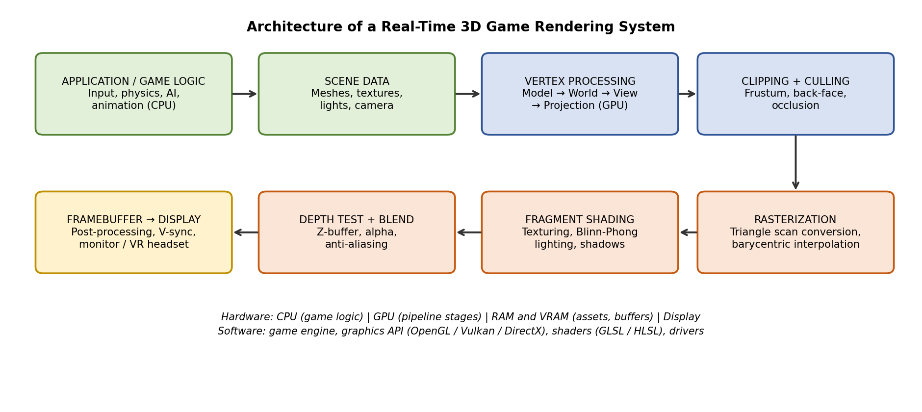
Explanation: game logic on the CPU updates object positions, animation and camera. The GPU then runs the graphics pipeline: vertex processing converts model coordinates to world, view and clip coordinates; clipping and culling remove unseen geometry; rasterization creates fragments; fragment shading applies textures and lighting; depth testing keeps the nearest fragment; and the framebuffer is sent to the display. Each stage corresponds to a Module 1 concept (coordinate systems and primitives) or a technique in Section 1.

3. Algorithms Involved [2 Marks]
Marking scheme (2 marks): algorithms identified and linked to pipeline stages (1) + working explained with a formula or pseudo-code (1).
Algorithm | Pipeline stage | Working idea
DDA and Bresenham line algorithms | Rasterization (lines, wireframes, UI) | Choose the pixel nearest the ideal line incrementally; Bresenham uses only integer additions and a decision parameter.
Triangle rasterization (edge functions / barycentric coordinates) | Rasterization | A pixel is inside if all three edge functions are non-negative; barycentric weights interpolate colour, depth and texture coordinates.
Cohen-Sutherland / Liang-Barsky / Sutherland-Hodgman clipping | Clipping | Keep only the part of a line or polygon inside the view volume, clipping against each boundary in turn.
Back-face culling | Culling | Discard a face if its normal points away from the viewer (N · V < 0).
Z-buffer | Depth test | Store a depth per pixel; write a fragment only if it is nearer than the stored depth.
Painter’s algorithm | Transparency | Sort transparent objects far to near and draw in that order.
Blinn-Phong illumination | Shading | Combine ambient, diffuse and specular light terms per pixel.
Texture mapping with bilinear filtering and mipmaps | Shading | Look up colour from an image using (u, v); mipmaps avoid shimmering at distance.
Shadow mapping | Shading | Render depth from the light; a point is in shadow if it is farther than the stored light depth.
Ray-triangle intersection (Möller-Trumbore) with BVH | Ray tracing (reflections) | Test rays against triangles; a bounding volume hierarchy skips most triangles.

Z-buffer pseudo-code: for each pixel (x, y): zbuf = +∞. For each fragment (x, y, z, colour): if z < zbuf[x][y] then zbuf[x][y] = z and frame[x][y] = colour.
Blinn-Phong: I = ka·Ia + kd·(N·L)·IL + ks·(N·H)^n·IL, where N is the surface normal, L the light direction, H the half-vector between L and the view direction, and n the shininess.

4. Hardware and Software Requirements [2 Marks]
Marking scheme (2 marks): hardware requirements with role (1) + software requirements with role (1). Values are indicative and depend on the game and settings.
Hardware | Role | Typical requirement (indicative)
CPU | Game logic, physics, AI, issuing draw calls. | Multi-core processor (about 4–8 cores).
GPU | Runs the graphics pipeline in parallel. | Dedicated GPU with several GB of VRAM for 1080p play.
RAM / VRAM | Stores meshes, textures, buffers. | About 8–16 GB RAM; VRAM sized to texture quality.
Storage | Streams large world assets. | SSD preferred for fast loading.
Display | Shows the framebuffer. | 60–144 Hz monitor; VR headset for immersive modes.
Input devices | Controller, keyboard, mouse, motion trackers. | Low-latency input.

Software | Examples | Role
Game engine | Unity, Unreal Engine, Godot | Scene management, rendering, physics, tools.
Graphics API | OpenGL, Vulkan, DirectX, Metal | Talks to the GPU and runs the pipeline.
Shader languages | GLSL, HLSL | Programs for vertex and fragment stages.
Content tools | Blender, Maya, texture painting tools | Create models, textures and animations.
OS and drivers | Windows, Linux, consoles; GPU drivers | Hardware access and performance.
Profilers | RenderDoc, GPU vendor profilers | Find rendering bottlenecks.

5. Challenges [2 Marks]
Marking scheme (2 marks): at least four challenges identified (1) + cause and effect explained for each (1).
Challenge | Cause | Effect
Real-time frame budget | 60 frames per second leaves 1000 / 60 ≈ 16.7 ms per frame (8.3 ms at 120 fps) for all logic and drawing. | Missed deadlines cause stutter and lag.
Overdraw and fill rate | Many overlapping surfaces and transparent effects are shaded repeatedly. | Wasted GPU work, lower frame rate.
Memory and bandwidth limits | High-resolution textures and large worlds exceed VRAM and bus speed. | Texture pop-in, loading stalls.
Cost of realistic lighting | Accurate shadows, reflections and global illumination are expensive. | Quality must be traded against speed.
Aliasing | Pixels are discrete, so edges are sampled coarsely. | Jagged edges and shimmering.
Latency and motion sickness (VR) | Delay between head movement and the displayed image. | Discomfort and nausea.
Hardware diversity | Many GPUs, mobile heat and battery limits. | Hard to give consistent performance.

6. Possible Improvements [2 Marks]
Marking scheme (2 marks): improvements matched to the challenges (1) + expected benefit and trade-off stated (1).
Improvement | Addresses | How it helps | Trade-off
Level of detail (LOD) | Frame budget, overdraw | Distant objects use fewer triangles. | Visible switching if poorly blended.
Frustum and occlusion culling | Frame budget, overdraw | Skip objects that cannot be seen. | Culling tests cost time.
Batching and instancing | Frame budget | Draw many copies in one call, fewer CPU-GPU calls. | Less per-object variety.
Texture compression and streaming | Memory and bandwidth | Smaller textures, load only what is needed. | Slight quality loss.
Temporal anti-aliasing and upscaling | Aliasing, frame budget | Render at lower resolution and reconstruct detail. | Possible ghosting or blur.
Hardware ray tracing with denoising | Lighting cost | Accurate reflections and shadows. | Needs modern GPUs; costly.
Foveated and variable-rate shading | VR latency, fill rate | Shade less where the eye does not look. | Needs eye tracking for best effect.
Profile-driven optimisation | All | Measure first, then fix the real bottleneck. | Needs developer time.

Student Self-Assessment
☐ I selected one real-world application and analysed it.
☐ I identified techniques and algorithms with their pipeline stages.
☐ I listed hardware and software requirements.
☐ I explained challenges and matched improvements.
☐ My report and diagram reflect my own understanding.

Assessment Rubric Mapping (10 Marks)
Criterion | Marks | Where addressed in this journal
Graphics techniques | 2 | Section 1 and architecture diagram: techniques identified (1) + examples (1)
Algorithms | 2 | Section 3: algorithms linked to stages (1) + formula or pseudo-code (1)
Hardware / software | 2 | Section 4: hardware (1) + software (1)
Challenges | 2 | Section 5: challenges (1) + cause and effect (1)
Improvements | 2 | Section 6: matched improvements (1) + benefit and trade-off (1)

References
1. D. Hearn and M. P. Baker, Computer Graphics with OpenGL, 4th ed., Pearson, 2011.
2. J. D. Foley, A. van Dam, S. K. Feiner and J. F. Hughes, Computer Graphics: Principles and Practice, 2nd ed. in C, Addison-Wesley, 1996.
3. T. Akenine-Möller, E. Haines and N. Hoffman, Real-Time Rendering, 4th ed., CRC Press, 2018.
4. B. T. Phong, “Illumination for Computer Generated Pictures,” Communications of the ACM, vol. 18, no. 6, 1975.
5. I. E. Sutherland and G. W. Hodgman, “Reentrant Polygon Clipping,” Communications of the ACM, vol. 17, no. 1, 1974.
6. T. Möller and B. Trumbore, “Fast, Minimum Storage Ray-Triangle Intersection,” Journal of Graphics Tools, vol. 2, no. 1, 1997.
7. Course notes and Module 1 material, Computer Graphics, Semester V.

Declaration: I commit to submitting original work, free from plagiarism or copying from the internet or peers, and to honouring deadlines for a fair and transparent assessment.
Signature of Student: ____________________ Roll No: ____________

