Computer Graphics – Assignment Solution Journal
Computer Graphics, Sem-5
Assignment 2
Comparative Analysis and Implementation of Graphics Algorithms

Cover Page
Student Name | ______________________________________
Roll No. / Division | ______________________________________
Programme / Semester | B.Tech – Semester V
Course / Code / Scheme | Computer Graphics / PCIT03T / R-2024
Module / Max Marks | Module 1 / 10 Marks
Course Outcome | CO2: Apply scan conversion and polygon filling techniques to generate and manipulate basic graphical primitives.
Date of Submission | ______________________________________

Assignment Details (from the assignment sheet)
Question | Select any two algorithms from DDA vs Bresenham line drawing, Boundary Fill vs Flood Fill, Cohen-Sutherland vs Liang-Barsky clipping. Compare working principle, computational efficiency, applications and limitations. Implement and analyze the algorithms.
Bloom / Type / Difficulty | Analyze / Analytical / Medium
Industry Context | Animation Industry
Expected Time / Resources | 2 hrs / Module 1
Assessment Evidence | Written content
Rubric Focus (10 Marks) | Working principle (3), Computational efficiency (3), Applications (3), Limitations (1)

Marking Scheme at a Glance (10 Marks)
# | Criterion | Marks | Where in this journal
1 | Working principle | 3 | Section 1 and Section 2 (implementation and worked trace)
2 | Computational efficiency | 3 | Section 3 (operation count, measured benchmark, accuracy)
3 | Applications | 3 | Section 4
4 | Limitations | 1 | Section 5

Algorithms Selected
Pair compared: DDA (Digital Differential Analyzer) and Bresenham line drawing. Both convert a line between two integer endpoints into pixels (scan conversion), so they can be compared fairly. Both were implemented in C and measured on the same machine; every output and timing in this journal comes from that program.

1. Working Principle [3 Marks]
Marking scheme (3 marks): DDA principle (1) + Bresenham principle with decision parameter (1) + worked example trace (Section 2) (1).
Aspect | DDA | Bresenham
Idea | Step one pixel along the axis with the larger change and add a constant increment to the other coordinate. | Move one pixel along the major axis and use an integer decision parameter to choose between two candidate pixels.
Formulae | steps = max(|dx|, |dy|); xinc = dx / steps; yinc = dy / steps; x = x + xinc; y = y + yinc; plot(round(x), round(y)). | p0 = 2dy − dx. If p < 0: plot (x+1, y) and p = p + 2dy. Else plot (x+1, y+1) and p = p + 2dy − 2dx.
Number type | Floating point (or fixed point). | Integers only.
Why it works | Slope m = dy/dx is constant, so each unit step in x changes y by exactly m. | The sign of p tells which pixel centre is nearer the true line, derived from the distance between the line and the two candidate pixels.

Derivation of p0 (first octant, 0 ≤ m ≤ 1): after plotting (xk, yk), the next pixel is (xk+1, yk) or (xk+1, yk+1). Let d1 and d2 be the distances of the true line from these two pixels. The decision parameter pk = Dx(d1 − d2) = 2Dy·xk − 2Dx·yk + c has the same sign as d1 − d2. Substituting the start point gives p0 = 2Dy − Dx, and pk+1 − pk = 2Dy when yk is unchanged, or 2Dy − 2Dx when y increases.

2. Implementation and Worked Example
Implementation supports the Working principle (3) and Computational efficiency (3) criteria. The worked trace earns the third mark of Working principle.
#include <stdio.h>
#include <stdlib.h>

/* DDA: step along the longer axis, add a fixed increment to the other */
int dda(int x0,int y0,int x1,int y1,int out[][2]){
int dx=x1-x0, dy=y1-y0, n=0;
int steps = abs(dx)>abs(dy) ? abs(dx) : abs(dy);
float xinc=(float)dx/steps, yinc=(float)dy/steps;
float x=x0, y=y0;
for(int k=0;k<=steps;k++){
out[n][0]=(int)(x+0.5f); out[n][1]=(int)(y+0.5f); n++;
x+=xinc; y+=yinc; /* two float additions per pixel */
}
return n;
}

/* Bresenham, first octant (0 <= m <= 1, x0 < x1): integers only */
int bres(int x0,int y0,int x1,int y1,int out[][2]){
int dx=x1-x0, dy=y1-y0, n=0;
int p=2*dy-dx, twody=2*dy, twodydx=2*(dy-dx);
int x=x0, y=y0;
for(int k=0;k<=dx;k++){
out[n][0]=x; out[n][1]=y; n++;
x++;
if(p<0) p+=twody; /* keep y */
else { y++; p+=twodydx; } /* step y */
}
return n;
}

Output for the line (2,2) to (10,7) (dx = 8, dy = 5, slope 0.625)
k | DDA x | DDA y | DDA plot |  | Bresenham p | Bresenham plot | Same?
0 | 2.000 | 2.000 | (2,2) |  | 2 | (2,2) | yes
1 | 3.000 | 2.625 | (3,3) |  | −4 | (3,3) | yes
2 | 4.000 | 3.250 | (4,3) |  | 6 | (4,3) | yes
3 | 5.000 | 3.875 | (5,4) |  | 0 | (5,4) | yes
4 | 6.000 | 4.500 | (6,5) |  | −6 | (6,5) | yes
5 | 7.000 | 5.125 | (7,5) |  | 4 | (7,5) | yes
6 | 8.000 | 5.750 | (8,6) |  | −2 | (8,6) | yes
7 | 9.000 | 6.375 | (9,6) |  | 8 | (9,6) | yes
8 | 10.000 | 7.000 | (10,7) |  | 2 | (10,7) | yes

Program result: both algorithms produced the same 9 pixels. In Bresenham’s trace, p = 2 (not negative) at k = 0 moves y up to 3; p = −4 keeps y at 3 for the next pixel, and so on.

Pixel Comparison (from the program output)
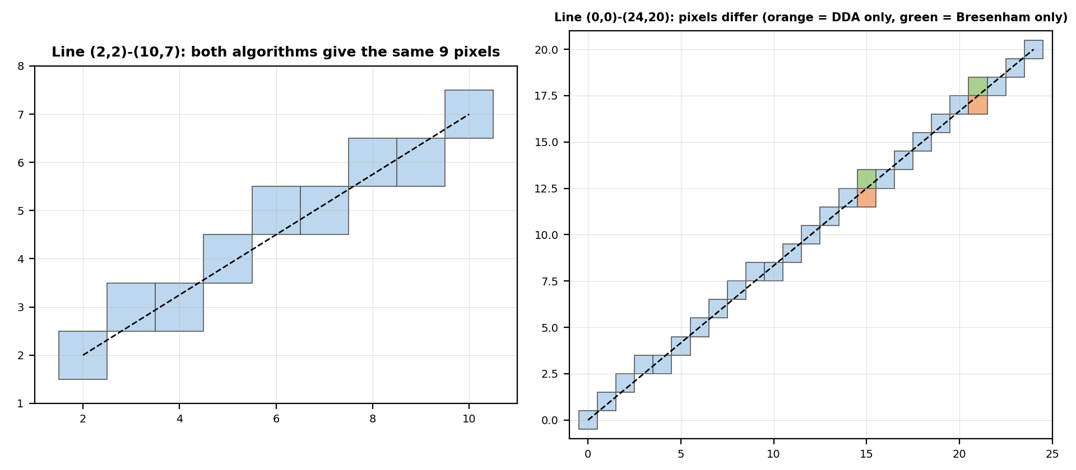
Left: the example line, identical pixels. Right: for the line (0,0) to (24,20) the algorithms differ in 2 pixels. The true line passes exactly halfway between two pixels at x = 15 (y = 12.5) and x = 21 (y = 17.5). At such ties DDA’s floating-point rounding chose the lower pixel, while Bresenham chose the upper one. Both are equally close to the ideal line.

3. Computational Efficiency [3 Marks]
Marking scheme (3 marks): operation count per pixel (1) + measured benchmark (1) + accuracy / error analysis (1).

(a) Operations per pixel (inner loop)
Operation | DDA | Bresenham
Additions | 2 floating-point (x and y) | 1 integer addition (p), plus y++ when p ≥ 0
Rounding | 2 (add 0.5 and truncate) | None
Comparison | Loop counter only | 1 integer comparison (p < 0)
Multiplication / division | None in the loop; 2 divisions once for the increments | None in the loop; 2dy and 2(dy − dx) computed once
Arithmetic type | Float: slower on hardware without a floating-point unit | Integer: fast on any hardware

(b) Measured benchmark
Setup: 200,000 lines of about 1000 pixels each (about 200 million pixels) with no drawing, compiled with gcc -O0 (optimisation off, because -O2 removed the loops). Five runs on the same machine, times in seconds:
Algorithm | Run 1 | Run 2 | Run 3 | Run 4 | Run 5
DDA | 0.569 | 0.575 | 0.528 | 0.548 | 0.486
Bresenham | 0.414 | 0.487 | 0.408 | 0.428 | 0.392
Result: median DDA 0.548 s (about 2.7 ns per pixel) against median Bresenham 0.414 s (about 2.1 ns per pixel). Bresenham was about 1.3 times faster here. The gap is small because modern CPUs add floats very quickly; on small microcontrollers without a floating-point unit the gap would be much larger. Timings depend on the machine and compiler.

(c) Accuracy
For 20,000 random first-octant lines (20,085,247 pixels) the program found at least one differing pixel in 56.26% of lines, but only 47,608 pixels (0.237%) differed. The differences occur at exact halfway points, where either pixel is equally valid. DDA also accumulates a small floating-point error on very long lines, because its increment is only an approximation, whereas Bresenham’s integer arithmetic is exact.

4. Applications [3 Marks]
Marking scheme (3 marks): DDA applications (1) + Bresenham applications (1) + choosing between them for a scenario (1).
 | DDA | Bresenham
Typical uses | Teaching and quick software line drawing on PCs; incremental interpolation of colour, depth and texture coordinates along polygon edges in scan-line filling; grid traversal for ray casting in simple 3D engines and tile games. | Raster displays and embedded graphics libraries on microcontrollers; CAD wireframes; plotters and printers; pixel-art and tile-game line tools and line-of-sight tests; basis of the midpoint circle and ellipse algorithms.
Why suited | Simple, easy to extend to many attributes at once. | Integer-only, fast, and gives consistent pixels.

Choosing between them
Scenario | Choice | Reason
Small LCD on a microcontroller without a floating-point unit | Bresenham | Integer arithmetic only; faster and exact.
Classroom demo or fast prototype on a PC | DDA | Shortest code to write and understand.
Interpolating colour and depth along a polygon edge | DDA-style increments | Attributes change by a fixed step per scan line.
Large number of long lines in a CAD viewer | Bresenham | Lowest cost per pixel and no drift.

5. Limitations [1 Mark]
Marking scheme (1 mark): limitations of both algorithms stated (0.5 each).
 | DDA | Bresenham
Limitations | Rounding on every pixel; floating-point error accumulates on long lines; slower where floating point is costly; inconsistent choice at exact ties. | Basic version handles one octant only (needs sign and axis swapping for others); integer endpoints only; no sub-pixel accuracy.
Shared limits | Lines are one pixel thick and show jagged edges (aliasing); no anti-aliasing or line-width control without extra work.

Conclusion
Bresenham is the better general-purpose line algorithm: it was measured about 1.3 times faster, uses only integers and never drifts. DDA is simpler and remains useful for teaching and for interpolating attributes. For ordinary lines both give almost the same picture, differing only at ties.

Note on the other pairs
The sheet allows other pairs. Boundary Fill vs Flood Fill and Cohen-Sutherland vs Liang-Barsky can be added in the same structure if your teacher expects more than one comparison.

Student Self-Assessment
☐ I compared the working principle of both algorithms.
☐ I implemented both algorithms and verified their output.
☐ I analysed efficiency with an operation count and measurements.
☐ I discussed applications and limitations.
☐ My implementation and analysis reflect my own work.

Assessment Rubric Mapping (10 Marks)
Criterion | Marks | Where addressed in this journal
Working principle | 3 | Section 1 (DDA 1 + Bresenham 1) and Section 2 trace (1)
Computational efficiency | 3 | Section 3: operation count (1) + benchmark (1) + accuracy (1)
Applications | 3 | Section 4: DDA (1) + Bresenham (1) + selection scenario (1)
Limitations | 1 | Section 5

References
1. D. Hearn and M. P. Baker, Computer Graphics with OpenGL, 4th ed., Pearson, 2011 (Line drawing algorithms).
2. J. E. Bresenham, “Algorithm for Computer Control of a Digital Plotter,” IBM Systems Journal, vol. 4, no. 1, 1965.
3. J. D. Foley, A. van Dam, S. K. Feiner and J. F. Hughes, Computer Graphics: Principles and Practice, 2nd ed. in C, Addison-Wesley, 1996.
4. Course notes and Module 1 material, Computer Graphics, Semester V.

Declaration: I commit to submitting original work, free from plagiarism or copying from the internet or peers, and to honouring deadlines for a fair and transparent assessment.
Signature of Student: ____________________ Roll No: ____________

