Computer Graphics – Assignment Solution Journal
Computer Graphics, Sem-5
Assignment 4
Design a Map Visualization System Using Transformations

Cover Page
Student Name | ______________________________________
Roll No. / Division | ______________________________________
Programme / Semester | B.Tech – Semester V
Course / Code / Scheme | Computer Graphics / PCIT03T / R-2024
Module / Max Marks | Module 1 / 10 Marks
Course Outcome | CO3: Apply the concepts of 2D and 3D transformations.
Date of Submission | ______________________________________

Assignment Details (from the assignment sheet)
Question | Develop a conceptual design for a navigation system including translation for movement, scaling for zoom, rotation for orientation, and reflection/shearing applications. Explain how transformations improve user experience.
Bloom / Type / Difficulty | Apply / Design / Medium
Industry Context | Animation Industry
Expected Time / Resources | 2 hrs / Module 1
Assessment Evidence | Written document
Rubric Focus (10 Marks) | For each transformation (2.5)

Marking Scheme at a Glance (10 Marks)
# | Criterion | Marks | Where in this journal
1 | Translation for movement | 2.5 | Section 3
2 | Scaling for zoom | 2.5 | Section 4
3 | Rotation for orientation | 2.5 | Section 5
4 | Reflection / shearing applications | 2.5 | Section 6
 | User experience explanation | included | Counted inside each section and summarised in Section 7

1. Conceptual Design: CityNav
Each transformation section is worth 2.5 marks: concept and matrix (1) + application in the navigation system with a worked example (1) + user experience benefit (0.5).
CityNav is a conceptual navigation and map visualization system for a phone. The map is stored in world (map) coordinates. The screen shows only a window of the map, so every frame the system converts map coordinates to screen coordinates using a chain of 2D transformations that respond to the user’s gestures and the phone’s sensors.
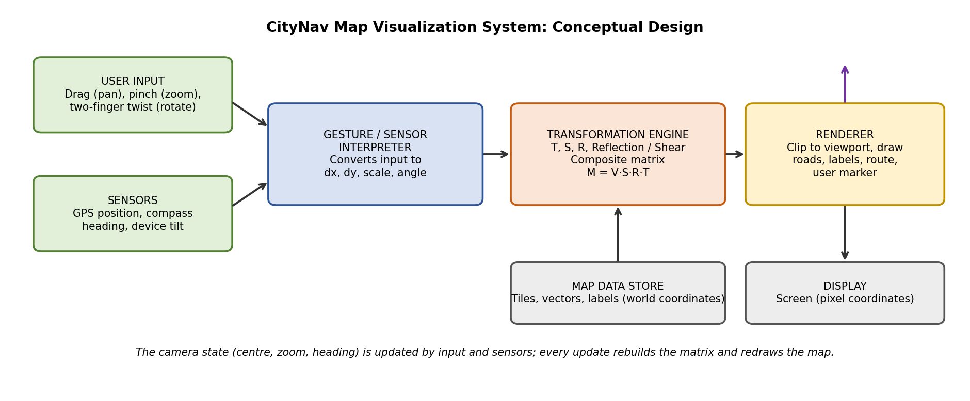
Camera state: centre (cx, cy), zoom s, heading θ. Gestures and sensors update this state; the transformation engine rebuilds one composite 3×3 homogeneous matrix and the renderer draws the visible map. Homogeneous coordinates are used so that translation, which is not a plain 2×2 matrix operation, can be combined with scaling, rotation and reflection by simple matrix multiplication.

2. Effect of Each Transformation on the Map
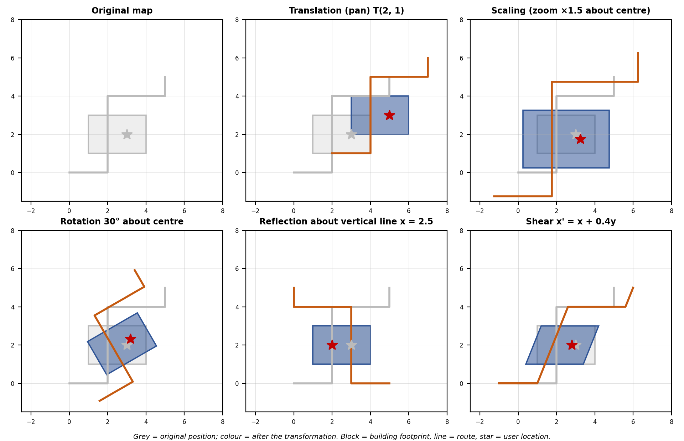
Transformation | Matrix (homogeneous) | Map operation
Translation T(tx, ty) | [1 0 tx] [0 1 ty] [0 0 1] | Pan, follow the user
Scaling S(sx, sy) | [sx 0 0] [0 sy 0] [0 0 1] | Zoom in and out
Rotation R(θ) | [cos θ, −sin θ, 0] [sin θ, cos θ, 0] [0 0 1] | Heading-up map, compass
Reflection about the x-axis | [1 0 0] [0 −1 0] [0 0 1] | Map y-up to screen y-down
Shear in x, factor k | [1 k 0] [0 1 0] [0 0 1] | Tilted (2.5D) view, slanted labels

3. Translation for Movement [2.5 Marks]
Marking scheme (2.5 marks): concept and matrix (1) + application with worked example (1) + user experience benefit (0.5).
Concept: translation moves every point by the same offset: x′ = x + tx, y′ = y + ty. In homogeneous form P′ = T(tx, ty) · P.
Use in CityNav | How it works
Panning by dragging | A finger drag of (Δpx, Δpy) pixels becomes a map offset (Δpx / s, Δpy / s), divided by the zoom s so the map follows the finger exactly.
Following the user | The user marker moves with each GPS update: x′ = x + v·Δt·sin ψ, y′ = y + v·Δt·cos ψ (speed v, heading ψ from north).
Re-centring | A “my location” button translates the camera so the user marker sits at the screen centre.
Worked example: a landmark at (120, 80) is panned with T(30, −20) → (150, 60). A car moving east (ψ = 90°) at 10 m/s for 2 s moves (20, 0) metres, so a marker at (500, 300) m becomes (520, 300) m.
User experience: direct, smooth movement makes the map feel attached to the finger and keeps the user’s position in view without manual searching.

4. Scaling for Zoom [2.5 Marks]
Marking scheme (2.5 marks): concept and matrix (1) + application with worked example (1) + user experience benefit (0.5).
Concept: scaling multiplies coordinates: x′ = sx·x, y′ = sy·y. Scaling about the origin would push the content away from the user, so zoom is done about a focus point c: M = T(c) · S(s) · T(−c).
Use in CityNav | How it works
Pinch zoom | The focus c is the midpoint of the two fingers; the point under the fingers stays fixed on screen.
Zoom levels | Each zoom level doubles the scale (s = 2, 4, 8 …), and the system switches to more detailed data (see level of detail in Section 7).
Uniform scaling | sx = sy keeps shapes and angles correct; non-uniform scaling would distort roads and buildings, so it is not used.
Worked example: zoom ×2 about the focus c = (100, 100) for the point P = (160, 120). T(−c) gives (60, 20); S(2) gives (120, 40); T(c) gives (220, 140). The focus itself stays at (100, 100).
User experience: zooming around the point of interest keeps the user oriented; they never have to pan back after zooming.

5. Rotation for Orientation [2.5 Marks]
Marking scheme (2.5 marks): concept and matrix (1) + application with worked example (1) + user experience benefit (0.5).
Concept: rotation by angle θ about the origin: x′ = x cos θ − y sin θ, y′ = x sin θ + y cos θ. To rotate about the screen centre or user position c, use T(c) · R(θ) · T(−c).
Use in CityNav | How it works
Heading-up mode | The map is rotated by −θ (the compass heading) so that the direction of travel always points up the screen.
North-up mode | No rotation; north stays at the top, preferred when planning a route.
Compass needle | The needle icon is rotated by +θ so it still points to north.
Two-finger twist | The angle between the fingers gives Δθ, applied about the finger midpoint.
Worked example: heading θ = 30°, so the map is rotated by −30°. A point 50 units east and 50 units north of the user, (50, 50), becomes x′ = 50·cos(−30°) − 50·sin(−30°) = 43.30 + 25.00 = 68.30 and y′ = 50·sin(−30°) + 50·cos(−30°) = −25.00 + 43.30 = 18.30. So (50, 50) → (68.30, 18.30).
User experience: a map that turns with the user matches the real view, so “turn left” is a left turn on the screen. This removes the mental rotation that confuses many users.

6. Reflection and Shearing Applications [2.5 Marks]
Marking scheme (2.5 marks): reflection and shear matrices (1) + applications with worked examples (1) + user experience benefit (0.5).
 | Reflection | Shearing
Concept | Mirror image about a line. About the x-axis: (x, y) → (x, −y). About the vertical line x = a: T(a) · F · T(−a), with F = diag(−1, 1, 1). | Slants the shape: x′ = x + k·y, y′ = y (x-shear). Areas are preserved but angles change.
Applications in CityNav | (1) Converting map coordinates (y up) to screen coordinates (y down): y′ = H − y. (2) Mirroring symmetrical indoor floor plans or a left/right route preview. (3) Placing a mirrored icon for the opposite direction. | (1) Tilted 2.5D view: building tops are shifted in proportion to their height, so flat footprints look three-dimensional. (2) Slanted street labels that follow a road direction. (3) Straightening a skewed scanned paper map.
Worked example | Viewport height H = 600: the map point (300, 200) → screen (300, 400). Reflection about x = 250: (300, 200) → (200, 200). | k = 0.5: point (10, 20) → (20, 20); point (10, 40) → (30, 40). A building 20 units tall has its roof moved 10 units sideways.
User experience | Correct orientation of the map on screen, and consistent behaviour on any display. | Depth is understood quickly without a full 3D engine, and labels follow roads for easy reading.

7. How Transformations Improve User Experience
Included in every section above (the 0.5 mark in each); this section summarises and shows the full pipeline.
Transformation | Without it | With it | UX quality
Translation | Fixed map; the user cannot explore. | Free panning and automatic following. | Direct manipulation, continuity
Scaling | One level of detail only. | Overview to street level in a pinch. | Control, focus on interest
Rotation | User must mentally rotate the map. | Map matches the direction of travel. | Orientation, lower mental effort
Reflection | Upside-down map on screens. | Correct coordinates on any display. | Correctness, consistency
Shearing | Flat, hard to read heights. | Quick sense of depth; readable labels. | Readability, visual depth

Composite pipeline and worked example
Order of operations (right to left for column vectors): M = V · S · R · T, where T moves the camera centre to the origin, R rotates by −heading, S zooms, and V flips y and moves the origin to the viewport centre. Changing the order would give a different result, for example rotating about the map origin instead of the user.
Stage | Operation | Point
Map point | Landmark in map coordinates | (300, 200)
T(−c) | Camera centre c = (250, 150) moved to the origin | (50, 50)
R(−30°) | Heading-up rotation | (68.30, 18.30)
S(2) | Zoom ×2 | (136.60, 36.60)
V | Flip y and shift to the viewport centre (400, 300): (400 + x, 300 − y) | (536.60, 263.40)

Level of detail and clipping: after the matrix is applied, only the visible part of the map is drawn (clipping), and the zoom level decides how many roads and labels are shown. This keeps the app fast and the screen uncluttered.

Student Self-Assessment
☐ I designed a navigation system using transformations.
☐ I gave the matrix and a worked example for each transformation.
☐ I explained the order of the composite transformation.
☐ I explained how each transformation improves user experience.
☐ My design and explanations reflect my own work.

Assessment Rubric Mapping (10 Marks)
Criterion | Marks | Where addressed in this journal
Translation for movement | 2.5 | Section 3: concept (1) + application (1) + UX (0.5)
Scaling for zoom | 2.5 | Section 4: concept (1) + application (1) + UX (0.5)
Rotation for orientation | 2.5 | Section 5: concept (1) + application (1) + UX (0.5)
Reflection / shearing | 2.5 | Section 6: matrices (1) + applications (1) + UX (0.5)

References
1. D. Hearn and M. P. Baker, Computer Graphics with OpenGL, 4th ed., Pearson, 2011 (Two- and three-dimensional geometric transformations).
2. J. D. Foley, A. van Dam, S. K. Feiner and J. F. Hughes, Computer Graphics: Principles and Practice, 2nd ed. in C, Addison-Wesley, 1996.
3. Course notes and Module 3 material, Computer Graphics, Semester V.

Declaration: I commit to submitting original work, free from plagiarism or copying from the internet or peers, and to honouring deadlines for a fair and transparent assessment.
Signature of Student: ____________________ Roll No: ____________

