Computer Graphics – Assignment Solution Journal
Computer Graphics, Sem-5
Assignment 5
Design a Clipping-Based Graphics Application

Cover Page
Student Name | ______________________________________
Roll No. / Division | ______________________________________
Programme / Semester | B.Tech – Semester V
Course / Code / Scheme | Computer Graphics / PCIT03T / R-2024
Module / Max Marks | Module 1 / 10 Marks
Course Outcome | CO5: Utilize and analyze viewing, clipping, and projection techniques to display 2D and 3D scenes accurately.
Date of Submission | ______________________________________

Assignment Details (from the assignment sheet)
Question | Develop a case study/application using clipping concepts (for example GIS map visualization, video editing system, window-based image viewer). Explain clipping algorithm selection, advantages and performance considerations.
Bloom / Type / Difficulty | Apply / Design / Medium
Industry Context | Animation Industry
Expected Time / Resources | 2 hrs / Module 1
Assessment Evidence | Written document
Rubric Focus (10 Marks) | Clipping algorithm selection (4), Advantages (2), Performance considerations (4)

Marking Scheme at a Glance (10 Marks)
# | Criterion | Marks | Where in this journal
1 | Clipping algorithm selection | 4 | Section 2
2 | Advantages | 2 | Section 3
3 | Performance considerations | 4 | Section 4

1. Case Study: GIS Map Visualization (CityGIS Viewer)
Application: CityGIS Viewer, a web or desktop GIS tool that shows a city map made of vector data: roads and rivers (polylines), districts and land parcels (polygons), points of interest, and text labels. The whole city may hold millions of features, but the screen window (viewport) shows only a small part at any moment.
Why clipping? Clipping removes the parts of the map that fall outside the viewport before drawing. Without it, the system would process and draw everything and could also draw outside the map window.
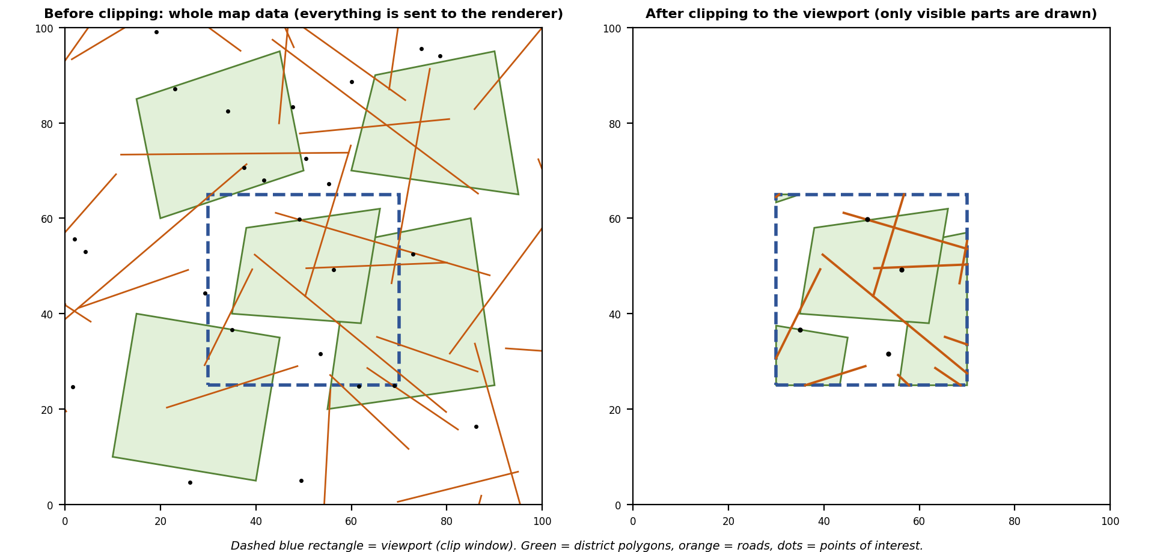
Result of the demonstration above (Liang-Barsky for roads, Sutherland-Hodgman for polygons, point-in-window test for points): of 34 roads only 11 remain, of 25 points of interest only 4 remain, and the district polygons are cut exactly at the window edge.

2. Clipping Algorithm Selection [4 Marks]
Marking scheme (4 marks): algorithm chosen for each feature type with reasons (1.5) + comparison of candidate algorithms (1) + worked example (1) + final clipping pipeline (0.5).

(a) Algorithm chosen for each map feature
Map feature | Candidates | Selected | Reason
Points of interest | Point-in-window test | Point-in-window test | Four comparisons: xmin ≤ x ≤ xmax and ymin ≤ y ≤ ymax.
Roads, rivers (line segments) | Cohen-Sutherland, Liang-Barsky, Nicholl-Lee-Nicholl | Cohen-Sutherland, with a bounding-box test first | Most map segments are far outside or fully inside the viewport, so cheap region-code tests accept or reject them without any intersection calculation (measured in Section 4).
Districts, parcels (polygons) | Sutherland-Hodgman, Weiler-Atherton | Sutherland-Hodgman for the rectangular viewport | Simple, handles any polygon against a convex window, clips against each edge in turn. A concave polygon may leave extra edges along the border, which is invisible for filled polygons.
Irregular user-drawn region | Sutherland-Hodgman, Weiler-Atherton | Weiler-Atherton | Needed only when the clip window is concave or the polygon must split into separate pieces correctly.
Text labels | All-or-none, per character | All-or-none (hide if not fully inside) | Cutting a word in half is unreadable; labels are checked against the viewport and dropped or moved.

(b) Comparison of the candidate line-clipping algorithms
 | Cohen-Sutherland | Liang-Barsky | Nicholl-Lee-Nicholl
Idea | 4-bit region codes for each endpoint; accept, reject or cut at a window edge, then repeat. | Parametric line P(t) = P0 + t·d; the window gives four inequalities that bound t between t0 and t1. | Divides the plane into regions around the window; picks the exact edges to clip against.
Intersections | Computed one at a time; endpoints may be recomputed several times. | One division per boundary test, no repeated codes. | Fewest intersections, but many cases.
Complexity | Simple to code. | Simple and compact; extends easily to 3D. | Most complex.
Best when | Most lines are trivially accepted or rejected. | Many lines cross the window; parametric form or 3D needed. | Maximum speed in 2D with a rectangular window.

(c) Worked example
Clip the line P0(−20, 40) to P1(120, 90) against the window 0 ≤ x ≤ 100, 0 ≤ y ≤ 100.
Liang-Barsky boundary | p | q | r = q / p | Effect
Left (p = −dx) | −140 | −20 | 0.1429 | Entering: t0 = max(0, 0.1429) = 0.1429
Right (p = dx) | 140 | 120 | 0.8571 | Leaving: t1 = min(1, 0.8571) = 0.8571
Bottom (p = −dy) | −50 | 40 | −0.8 | Entering: t0 stays 0.1429
Top (p = dy) | 50 | 60 | 1.2 | Leaving: t1 stays 0.8571
Here dx = 140 and dy = 50. Since t0 < t1 the line is visible. Clipped endpoints: at t0 = 0.1429, (−20 + 0.1429·140, 40 + 0.1429·50) = (0, 47.14); at t1 = 0.8571, (100, 82.86).
Same line with Cohen-Sutherland: P0 lies left of the window (code 0001) and P1 lies right of it (code 0010). The AND of the codes is 0000, so the line is not trivially rejected, and the OR is not 0000, so it is not trivially accepted. Cut at x = 0: y = 40 + 50·(20 / 140) = 47.14. Cut at x = 100: y = 40 + 50·(120 / 140) = 82.86. The result is the same, found with two intersection calculations.

(d) Final clipping pipeline
Step | Action
1 | Feature bounding box against the viewport (or a tile index); skip the feature entirely if disjoint.
2 | Select features by zoom level (level of detail).
3 | Points: point-in-window test. Lines: Cohen-Sutherland. Polygons: Sutherland-Hodgman. Labels: all-or-none.
4 | Transform the surviving geometry to screen coordinates and draw.

3. Advantages [2 Marks]
Marking scheme (2 marks): advantages of clipping for the application (1) + advantages of the selected algorithm choices (1).

Advantages of clipping in the GIS viewer
Advantage | Explanation
Draws only what is visible | Off-screen roads and districts are never rasterized, saving processor and GPU time.
Smooth zoom and pan | Less work per frame keeps the frame rate high while moving.
Lower memory and bandwidth | Only features near the viewport are loaded or sent to the GPU.
Correct display | Nothing is drawn outside the map window; polygons end exactly at the window edge.
Supports many windows | The same data can feed a main map and a mini-map, each clipped to its own window.

Advantages of the selected algorithms
Choice | Advantage
Bounding-box test before clipping | Rejects whole features in a few comparisons.
Cohen-Sutherland region codes | Bit operations decide most segments; no division for them.
Sutherland-Hodgman | One simple routine clips every polygon, easy to extend to a new window edge, and works well with hardware pipelines.
All-or-none labels | Keeps text readable and cheap to test.

4. Performance Considerations [4 Marks]
Marking scheme (4 marks): measured algorithm cost (1) + early rejection and spatial indexing (1) + level of detail and simplification (1) + hardware, precision and caching (1).

(a) Measured algorithm cost
Setup: both algorithms were written in C and run on 2,000,000 random line segments in a 1000 × 1000 map with a square window centred in the map. Output of the two algorithms was compared and matched. Times are medians of five runs on one machine (gcc -O0); they depend on the machine.
Short segments (length 20 to 200), typical of road data:
Window | Trivial accept | Trivial reject | Needs clipping | C-S intersections | L-B divisions | C-S time | L-B time
100 × 100 | 0.2% | 97.6% | 2.2% | 78,613 | 3,890,649 | 0.067 s | 0.075 s
400 × 400 | 10.9% | 78.4% | 10.7% | 254,226 | 5,352,409 | 0.073 s | 0.096 s
900 × 900 | 68.9% | 12.0% | 19.1% | 418,288 | 8,017,951 | 0.046 s | 0.099 s

Long segments (length 600 to 1500), most of which cross the window:
Window | Trivial accept | Trivial reject | Needs clipping | C-S intersections | L-B divisions | C-S time | L-B time
100 × 100 | 0.0% | 92.3% | 7.7% | 842,198 | 5,259,199 | 0.093 s | 0.090 s
400 × 400 | 0.0% | 64.6% | 35.4% | 1,650,491 | 6,337,669 | 0.110 s | 0.112 s
900 × 900 | 4.7% | 10.5% | 84.8% | 2,286,500 | 8,076,698 | 0.093 s | 0.113 s

What the measurements show: Cohen-Sutherland was faster or equal in every case. The advantage is largest when most segments are accepted or rejected from their region codes: with a 900 × 900 window and short segments it took 0.046 s against 0.099 s for Liang-Barsky. With long segments that all cross the window the two were almost equal. Liang-Barsky always performs up to four divisions per line (5 to 8 million in these runs), whereas Cohen-Sutherland computed only 0.08 to 2.3 million intersections. This supports choosing Cohen-Sutherland for map data, and shows that algorithm choice depends on how the data is distributed.

(b) Early rejection and spatial indexing
- Test each feature’s bounding box first; a million-road city map reduces to a few thousand candidate features.
- Store the map in tiles or a spatial index (quadtree or R-tree) so that only tiles overlapping the viewport are even examined.
- Cache the result for the current viewport; when the user pans a little, reuse most of it and clip only the newly exposed strip.

(c) Level of detail and simplification
- Show only major roads at low zoom and add minor streets at high zoom, so fewer segments need clipping.
- Simplify long polylines for the current zoom (for example with the Douglas-Peucker algorithm) to cut the number of segments.
- Drop or merge labels that would overlap, which also reduces clipping work.

(d) Hardware, precision and memory
- GPUs clip triangles in hardware and offer a scissor test for the final rectangle, so heavy clipping can be delegated to the GPU.
- Use consistent floating-point precision; very large world coordinates (for example metres across a country) lose precision, so convert to coordinates relative to the viewport before clipping.
- Process features in batches and in parallel (multiple threads or GPU), and keep the data in compact arrays for fast memory access.

5. Conclusion
For the GIS viewer the best design is a layered one: reject whole features by bounding box or tile, choose features by zoom level, clip road segments with Cohen-Sutherland and districts with Sutherland-Hodgman, and hide labels that do not fit. The benchmark shows that cheap early rejection matters more than the choice between the two line algorithms, and that the best algorithm depends on the data. The same structure applies to a video editor (clip layers to the frame) and an image viewer (clip the image to its window).

Student Self-Assessment
☐ I developed a case study using clipping.
☐ I selected algorithms for each type of map feature with reasons.
☐ I explained the advantages of clipping.
☐ I analysed performance with measured data and optimisation strategies.
☐ My case study and analysis reflect my own work.

Assessment Rubric Mapping (10 Marks)
Criterion | Marks | Where addressed in this journal
Clipping algorithm selection | 4 | Section 2: feature mapping (1.5) + comparison (1) + worked example (1) + pipeline (0.5)
Advantages | 2 | Section 3: clipping advantages (1) + algorithm advantages (1)
Performance considerations | 4 | Section 4: measured cost (1) + early rejection (1) + level of detail (1) + hardware and precision (1)

References
1. D. Hearn and M. P. Baker, Computer Graphics with OpenGL, 4th ed., Pearson, 2011 (Two-dimensional viewing; clipping algorithms).
2. J. D. Foley, A. van Dam, S. K. Feiner and J. F. Hughes, Computer Graphics: Principles and Practice, 2nd ed. in C, Addison-Wesley, 1996.
3. Y.-D. Liang and B. A. Barsky, “A New Concept and Method for Line Clipping,” ACM Transactions on Graphics, vol. 3, no. 1, 1984.
4. I. E. Sutherland and G. W. Hodgman, “Reentrant Polygon Clipping,” Communications of the ACM, vol. 17, no. 1, 1974.
5. K. Weiler and P. Atherton, “Hidden Surface Removal Using Polygon Area Sorting,” SIGGRAPH ’77 Proceedings, 1977.
6. Course notes and Module 3 material, Computer Graphics, Semester V.

Declaration: I commit to submitting original work, free from plagiarism or copying from the internet or peers, and to honouring deadlines for a fair and transparent assessment.
Signature of Student: ____________________ Roll No: ____________

