Computer Graphics – Assignment Solution Journal
Computer Graphics, Sem-5
Assignment 6
Research Study on Advanced Texture Mapping Techniques

Cover Page
Student Name | ______________________________________
Roll No. / Division | ______________________________________
Programme / Semester | B.Tech – Semester V
Course / Code / Scheme | Computer Graphics / PCIT03T / R-2024
Module / Max Marks | Module 1 / 10 Marks
Course Outcome | CO4: Analyze visible surface detection algorithms and implement illumination and shading models for realistic rendering.
Date of Submission | ______________________________________

Assignment Details (from the assignment sheet)
Question | Watch the YouTube video uploaded by Justin Solomon (MIT) on Texture mapping and explore the things that you understood from this video.
Bloom / Type / Difficulty | Analyze / Review / Medium
Industry Context | Animation Industry
Expected Time / Resources | 2 hrs / Module 1
Assessment Evidence | Written document
Rubric Focus (10 Marks) | Summary (10). The sheet gives no breakdown, so this journal uses the split below.

Marking Scheme at a Glance (10 Marks)
# | Criterion | Marks | Where in this journal
1 | Overview of the lecture and context | 2 | Section 1
2 | Key concepts explained | 4 | Section 2
3 | Worked examples and diagrams | 2 | Section 3
4 | Personal understanding and applications | 2 | Section 4

Important: I could not open or play the video (the page could not be fetched), so this summary is built from the standard texture-mapping content of the MIT 6.837 Introduction to Computer Graphics course and Module 4. Watch the video, tick the topics in the checklist in Section 4, correct anything that differs, and add your own points before submitting.

1. Overview of the Lecture and Context [2 Marks]
Marking scheme (2 marks): what texture mapping is and why it is needed (1) + where it fits in the graphics pipeline and what the lecture covers (1).
What texture mapping is: texture mapping applies a 2D image (the texture) to the surface of a 3D model so that the surface appears detailed, such as brick, wood, skin or text, without adding more triangles. Each point on the surface is given a pair of texture coordinates (u, v), and the colour is read from the image at that position.
Why it is needed: modelling every brick as geometry would need millions of triangles. A texture stores that detail as pixels (texels) and costs only one image lookup per screen pixel, so it is the cheapest way to add realism.
Place in the pipeline: vertices carry (u, v); the rasterizer interpolates them across each triangle; the fragment (pixel) shader looks up the texture with those interpolated coordinates, filters the result and combines it with lighting. This connects directly to the illumination and shading models of CO4.
No. | Topics covered in this study
1 | Texture coordinates and mapping a 3D surface to a 2D image
2 | Interpolating (u, v) across a triangle, and perspective-correct interpolation
3 | Filtering: nearest and bilinear for magnification; aliasing and mipmaps for minification
4 | Trilinear and anisotropic filtering
5 | Wrapping modes and other kinds of maps (normal / bump, environment, shadow, procedural)

2. Key Concepts Explained [4 Marks]
Marking scheme (4 marks): each of the four concept groups below is worth 1 mark (definition, formula or method, and why it matters).

2.1 Texture coordinates and mapping [1 Mark]
Every vertex stores (u, v), normally in the range 0 to 1, which locate a point on the image. Ways to obtain them: (1) an artist unwraps the model like a flat pattern (UV unwrapping); (2) a parametric surface gives them directly; (3) a projection, such as planar, cylindrical or spherical mapping, computes them from the position. For a point (x, y, z) on a unit sphere, spherical mapping uses u = 0.5 + atan2(z, x) / (2π) and v = 0.5 − asin(y) / π. Problems to manage are stretching (an uneven mapping), seams where the image edges meet, and poles of a sphere where many texels collapse to a point.

2.2 Interpolation and perspective correctness [1 Mark]
Inside a triangle, (u, v) at a pixel is a barycentric combination of the three vertex values. Linear interpolation in screen space is wrong for a perspective view, because equal steps on the screen are not equal steps on the surface: textures would appear to bend or swim. The correct method interpolates u / w, v / w and 1 / w linearly in screen space and divides at each pixel: u = (u / w) / (1 / w). Here w is the depth value from the perspective division. Section 3 gives a numeric example.

2.3 Filtering: magnification and minification [1 Mark]
Case | Problem | Solution
Magnification (one texel covers many pixels) | Nearest-texel lookup looks blocky. | Bilinear filtering blends the four nearest texels using the fractional part of (u, v).
Minification (many texels fall in one pixel) | Sampling a single texel causes aliasing: shimmering and moiré patterns, especially in the distance. | Mipmaps: pre-filtered copies of the texture at half size each (level 0 is the full image). The level is chosen from how many texels one pixel covers: level = log2(footprint).
Between mip levels | Visible jump when the level changes. | Trilinear filtering: bilinear in two neighbouring levels, then a blend between them (8 texel reads).
Oblique surfaces (floors, roads at grazing angles) | The pixel footprint is long and thin, so mipmaps blur too much. | Anisotropic filtering takes several samples along the long direction of the footprint.

2.4 Wrapping and other kinds of maps [1 Mark]
When (u, v) goes outside 0 to 1, the wrapping mode decides what happens: repeat (tile), clamp to edge, or mirror. Textures can store much more than colour:
Map | What is stored | Effect
Colour (diffuse) map | Surface colour | Visible detail and pattern
Normal / bump map | Surface normal directions (or height) | Lighting acts as if the surface were bumpy, with no extra geometry
Specular / roughness map | Shininess per texel | Different materials on one surface
Environment (cube) map | Image of the surroundings | Cheap reflections
Shadow map | Depth seen from the light | Shadows by comparing depths
Light map | Pre-computed lighting | Realistic static lighting at low cost
Procedural texture | A formula (for example noise) instead of an image | Unlimited detail, no repetition, small memory

3. Worked Examples and Diagrams [2 Marks]
Marking scheme (2 marks): correct calculations with steps (1) + clear diagrams linked to the concepts (1).
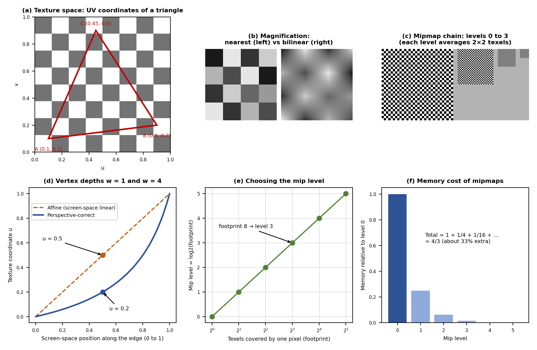

Example 1: bilinear filtering
Texel values: c00 = 10, c10 = 30 (bottom row) and c01 = 50, c11 = 90 (top row). Sample at fractional position (fx, fy) = (0.25, 0.5). First blend horizontally: bottom = 10 + 0.25·(30 − 10) = 15; top = 50 + 0.25·(90 − 50) = 60. Then blend vertically: value = 15 + 0.5·(60 − 15) = 37.5.

Example 2: perspective-correct interpolation (diagram d)
Along a screen-space edge, one end has u = 0 and w = 1, the other u = 1 and w = 4. At the screen midpoint (t = 0.5), affine interpolation gives u = 0.5, which is wrong. Perspective-correct: u / w = 0 / 1 = 0 and 1 / 4 = 0.25 at the ends, so interpolated u / w = 0.5·0 + 0.5·0.25 = 0.125, and 1 / w = 0.5·1 + 0.5·0.25 = 0.625. Then u = 0.125 / 0.625 = 0.2. The midpoint of the screen edge corresponds to only 20% along the texture, because the far part of the edge is compressed on screen.

Example 3: mip level and memory (diagrams e and f)
If one pixel covers 8 × 8 texels along its longest side, the footprint is 8, so level = log2(8) = 3: the level that is 8 times smaller than the original. All levels together take 1 + 1/4 + 1/16 + … = 4/3 of the original memory, which is about 33% extra, a small price for removing aliasing.

4. Personal Understanding and Applications [2 Marks]
Marking scheme (2 marks): clear statement of what was understood and its significance (1) + applications and open questions (1).

What I understood
- Texture mapping adds detail through images instead of geometry, using (u, v) coordinates stored at the vertices.
- The hard part is not reading the image but sampling it correctly: perspective-correct interpolation and filtering decide whether the result looks right or wrong.
- Mipmaps solve minification aliasing at a cost of only one third more memory.
- The same lookup idea powers many techniques: normal maps, environment maps and shadow maps.

Applications
Area | Use of texture mapping
Games | Surface detail, normal maps and baked lighting at real-time speed.
Film and animation | Painted textures, procedural materials, displacement for hero assets.
AR / VR | Textured scenes and environment maps for convincing reflections.
CAD and architecture | Material previews such as wood, brick and glass.
Maps and GIS | Satellite imagery draped over terrain.

Questions for further study
- How does anisotropic filtering decide how many samples to take?
- How are texture seams hidden when an object is unwrapped?
- How do virtual textures stream very large images that do not fit in memory?

Video coverage checklist (tick after watching)
Topic | In the video? | Notes
UV coordinates and mapping surfaces to images | ☐
Interpolation of texture coordinates / perspective correctness | ☐
Magnification and bilinear filtering | ☐
Minification, aliasing and mipmaps | ☐
Anisotropic filtering, wrapping modes | ☐
Normal, environment or shadow maps | ☐

Student Self-Assessment
☐ I watched the video and checked the topics in the checklist.
☐ I explained the key concepts in my own words.
☐ I verified the worked examples.
☐ I listed applications and questions.
☐ My summary reflects my own understanding.

Assessment Rubric Mapping (10 Marks)
Criterion | Marks | Where addressed in this journal
Overview of the lecture | 2 | Section 1: definition and need (1) + pipeline and topics (1)
Key concepts explained | 4 | Section 2: four concept groups, 1 mark each
Worked examples and diagrams | 2 | Section 3: calculations (1) + diagrams (1)
Personal understanding and applications | 2 | Section 4: understanding (1) + applications and questions (1)
The sheet gives “Summary (10)” without a breakdown; the 2 + 4 + 2 + 2 split above is assumed, so confirm it with your teacher.

References
1. Lecture video: Texture Mapping, Justin Solomon, MIT 6.837 Introduction to Computer Graphics (link given in the assignment sheet).
2. MIT OpenCourseWare, 6.837 Computer Graphics (Fall 2012), Lecture 16: Texture Mapping and Shaders (lecture notes).
3. D. Hearn and M. P. Baker, Computer Graphics with OpenGL, 4th ed., Pearson, 2011.
4. T. Akenine-Möller, E. Haines and N. Hoffman, Real-Time Rendering, 4th ed., CRC Press, 2018 (Texturing).
5. L. Williams, “Pyramidal Parametrics,” SIGGRAPH ’83 Proceedings, 1983 (mipmapping).
6. Course notes and Module 4 material, Computer Graphics, Semester V.

Declaration: I commit to submitting original work, free from plagiarism or copying from the internet or peers, and to honouring deadlines for a fair and transparent assessment.
Signature of Student: ____________________ Roll No: ____________

