Computer Graphics – Assignment Solution Journal
Computer Graphics, Sem-5
Assignment 7
Simulation of Object Movement in Virtual Environment

Cover Page
Student Name | ______________________________________
Roll No. / Division | ______________________________________
Programme / Semester | B.Tech – Semester V
Course / Code / Scheme | Computer Graphics / PCIT03T / R-2024
Module / Max Marks | Module 1 / 10 Marks
Course Outcome | CO4: Analyze visible surface detection algorithms and implement illumination and shading models for realistic rendering.
Date of Submission | ______________________________________

Assignment Details (from the assignment sheet)
Question | Design a simulation scenario (satellite movement, vehicle simulation or robotic movement) and analyze coordinate systems, transformations, animation techniques and rendering challenges.
Bloom / Type / Difficulty | Analyze / Simulation / Medium
Industry Context | Animation Industry
Expected Time / Resources | 2 hrs / Module 1
Assessment Evidence | Written document
Rubric Focus (10 Marks) | Coordinate systems (2.5), Transformations (2.5), Animation techniques (2.5), Rendering challenges (2.5)

Marking Scheme at a Glance (10 Marks)
# | Criterion | Marks | Where in this journal
1 | Coordinate systems | 2.5 | Section 2
2 | Transformations | 2.5 | Section 3
3 | Animation techniques | 2.5 | Section 4
4 | Rendering challenges | 2.5 | Section 5

1. Simulation Scenario: OrbitSim (Satellite Movement)
OrbitSim is a real-time 3D simulation of a satellite in low Earth orbit. The scene contains the Earth, a satellite model, a trail showing its path, the Sun as the light source, and three cameras: a globe view, a chase camera behind the satellite, and a ground-station view. The user can speed up time and rewind.
Why a satellite? it needs several coordinate systems at once, the motion follows a known physical law, and its enormous differences of scale (a 10 m satellite, a 6,378 km planet, a Sun 150 million km away) create real rendering problems.
Orbit parameter | Value (assumed) | Calculation
Altitude | 400 km (like the International Space Station) | Given
Semi-major axis a (circular orbit) | 6778.137 km | Earth radius 6378.137 + 400
Orbital period T | 5553.6 s = 92.56 min | T = 2π √(a³ / μ), μ = 398600.4418 km³/s²
Orbital speed v | 7.669 km/s | v = √(μ / a)
Mean motion n | 0.0648° per second | n = 2π / T
Orbits per day | 15.56 | 86400 / T
Inclination i, ascending node Ω | 51.6°, 40° (assumed) | Orientation of the orbit plane

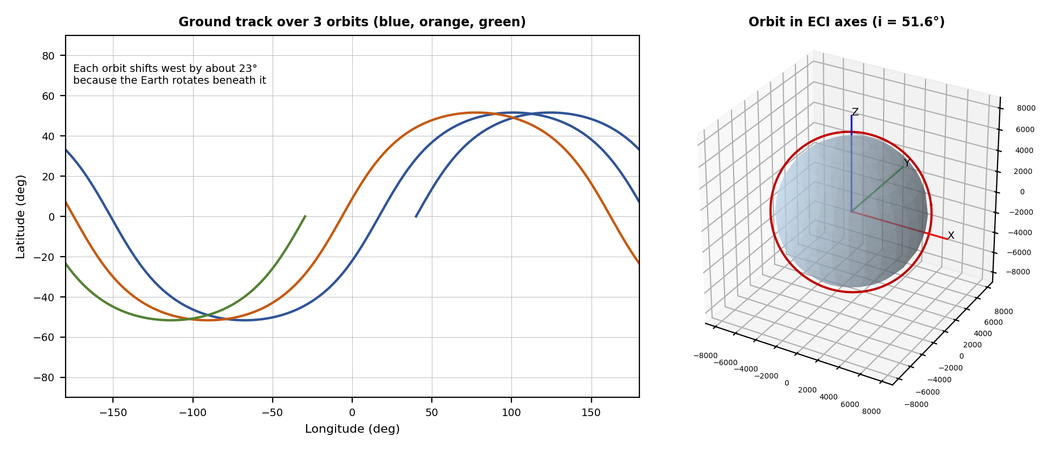
Left: ground track of the satellite over three orbits, computed with the transformations in Section 3. Right: the orbit plane in Earth-centred inertial axes.

2. Coordinate Systems [2.5 Marks]
Marking scheme (2.5 marks): frames defined with origin, axes and purpose (1) + chain of conversions between frames (1) + conventions, units and pitfalls (0.5).
Frame | Origin and axes | Used for | Changes with time?
Perifocal (orbit plane) | Earth centre; P toward the closest-approach point, Q in the orbit plane, W perpendicular | Position of the satellite along its orbit (x = a cos ν, y = a sin ν, z = 0) | Satellite moves in it
ECI (Earth-centred inertial) | Earth centre; X toward the vernal equinox, Z toward the north pole | Physics, orbit propagation, Sun direction | No (fixed with respect to the stars)
ECEF (Earth-centred, Earth-fixed) | Earth centre; X toward longitude 0°, Z toward the north pole | Earth model, ground stations, texture mapping | Rotates with the Earth
Geodetic | Latitude, longitude, altitude | Ground track, ground-station visibility | Derived from ECEF
Satellite body frame | Satellite centre of mass; axes fixed to the vehicle | Attitude, solar panels, antenna pointing | Rotates with the satellite
Camera (view) frame | Camera position; looks down −Z | Viewing transformation | Moves with the camera
Screen (pixel) frame | Top-left corner of the window | Final image | Fixed

Chain of conversions for one vertex
Satellite model vertex (body frame) → ECI by the model matrix (attitude rotation + position) → ECEF if drawing relative to the Earth → scene axes of the engine → view (camera) → clip → normalised device coordinates → pixels. The Earth is drawn in ECEF and rotated into ECI each frame; the satellite and Sun are naturally in ECI.

Conventions and pitfalls
- Handedness and up-axis: astrodynamics uses a right-handed system with Z north, but many graphics engines use Y as up. The conversion (x, y, z) → (x, z, −y) keeps the system right-handed (determinant +1). Using (x, z, y) would mirror the world.
- Units: physics in km (or m), graphics in scene units. A scale such as 1 unit = 1000 km keeps numbers moderate; mixing units gives satellites inside the Earth.
- Angles: rotation functions take radians; orbital data is usually given in degrees.
- Time: an inertial frame is fixed in space, so the Earth rotation angle must be tracked separately (Section 3).

3. Transformations [2.5 Marks]
Marking scheme (2.5 marks): orbit-plane to ECI rotation (1) + Earth rotation and conversion to latitude and longitude (0.75) + worked numeric example (0.75).

(a) Orbit plane to inertial frame
A circular orbit in the perifocal frame is r = (a cos ν, a sin ν, 0) with ν = n·t. It is rotated into the inertial frame by three rotations: r_ECI = Q · r, where Q = R3(Ω) · R1(i) · R3(ω). R3 rotates about the Z axis, R1 about the X axis, Ω is the ascending-node angle, i the inclination and ω the argument of perigee (0 for a circular orbit). For Ω = 40°, i = 51.6°, ω = 0:
Row 1 | Row 2 | Row 3
0.7660 −0.3993 0.5037 | 0.6428 0.4758 −0.6003 | 0.0000 0.7837 0.6211

(b) Earth rotation and geodetic position
The Earth turns at ωE = 7.2921159 × 10⁻⁵ rad/s. The conversion from the inertial to the Earth-fixed frame is r_ECEF = R3(−ωE · t) · r_ECI. The latitude is asin(z / |r|) and the longitude is atan2(y, x) (spherical-Earth approximation). Because the Earth rotates ωE · T = 23.2° during one orbit, each ground track shifts west by about 23.2°.

(c) Worked example at t = 600 s
Stage | Calculation | Result (km)
True anomaly | ν = n·t = 0.0648° × 600 | 38.89°
Perifocal position | (a cos ν, a sin ν, 0) with a = 6778.137 | (5275.5, 4255.8, 0)
ECI position | Q · r_perifocal | (2342.1, 5416.1, 3335.3)
ECEF position | R3(−ωE · 600) · r_ECI, rotation angle 2.51° | (2576.7, 5308.5, 3335.3)
Latitude, longitude | asin(3335.3 / 6778.1), atan2(5308.5, 2576.7) | 29.48° N, 64.11° E

(d) Model matrix for drawing the satellite
M = T(r_ECI / 1000) · R_attitude · S(s). T translates the model to its orbital position in scene units (1 unit = 1000 km), R_attitude points the solar panels to the Sun and the antenna to the Earth, and S enlarges the tiny model so that it is visible at orbital distance. The order is scale, then rotate, then translate (matrix nearest the vertex acts first).

4. Animation Techniques [2.5 Marks]
Marking scheme (2.5 marks): physics-based integration methods explained (1) + measured comparison of the methods (0.75) + time control and interpolation (0.75).

(a) Physics-based animation
The motion can be computed in two ways. The analytic (Kepler) solution gives the position at any time directly, so the user can scrub the timeline freely. The numerical solution integrates a = −μ r / |r|³ step by step; it is needed when forces such as atmospheric drag or thrust are added. Three integrators were compared:
Method | Update rule | Cost and behaviour
Explicit Euler | r′ = r + dt·v; v′ = v + dt·a(r) | 1 force evaluation; adds energy every step, so the orbit spirals outwards
Semi-implicit Euler | v′ = v + dt·a(r); r′ = r + dt·v′ | 1 force evaluation; energy stays bounded, orbit wobbles but stays closed
Runge-Kutta 4 | Weighted average of four slopes | 4 force evaluations; very accurate

(b) Measured comparison
Each method was run for three orbits (16,661 s) from a circular orbit; the table shows the largest error in orbit radius, which should be 0 for a circular orbit.
Time step | Steps for 3 orbits | Explicit Euler | Semi-implicit Euler | Runge-Kutta 4
1 s | 16,661 | 284.2 km | 3.8 km | < 0.01 km
10 s | 1,666 | 2046.5 km | 38.8 km | < 0.01 km
60 s | 278 | 8204.1 km | 245.8 km | 0.01 km
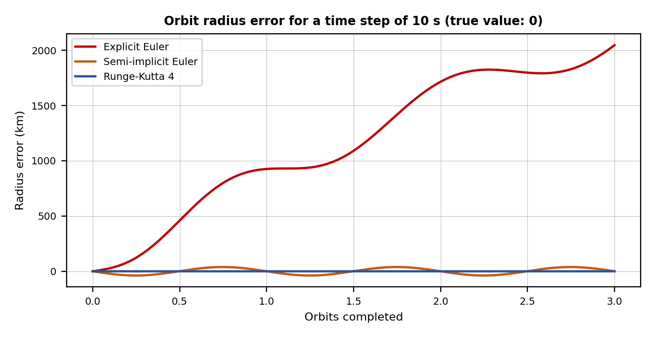
Analysis: explicit Euler gives errors of thousands of kilometres (a satellite visibly leaving its orbit). Semi-implicit Euler is cheap and stable for visual use. Runge-Kutta 4 at a 60 s step (278 steps, about 1,100 force evaluations) is far more accurate than Euler at a 1 s step (16,661 evaluations), so a higher-order method with a larger step is both faster and better.

(c) Time control and interpolation
Technique | Use in OrbitSim
Time scaling | Simulation time advances as t_sim = k · t_real; k = 1 for real time, k = 60 to 10,000 to watch an orbit in seconds.
Fixed time step with accumulator | Physics runs at a fixed dt; leftover real time is kept and the last two states are interpolated for drawing, so the animation is smooth at any frame rate.
Quaternion interpolation (slerp) | Attitude changes (for example Sun-pointing to nadir-pointing) are blended with spherical linear interpolation, which keeps a constant rotation speed and avoids gimbal lock.
Trails and cues | The orbit trail is a ring buffer of recent positions drawn as a fading line; time-scale and clock overlays help the viewer follow the motion.

5. Rendering Challenges [2.5 Marks]
Marking scheme (2.5 marks): scale and numerical precision (1) + depth-buffer precision (0.75) + lighting, aliasing and level of detail (0.75).

(a) Scale and numerical precision
Graphics hardware mostly uses 32-bit floating-point numbers, which have about 7 significant digits. The spacing between representable numbers (computed for this journal) is:
Distance from the origin | 32-bit float spacing | 64-bit float spacing
6.778 × 10⁶ m (orbit radius) | 0.5 m | 9.3 × 10⁻¹⁰ m
1.496 × 10¹¹ m (Earth to Sun) | 16,384 m (about 16 km) | 3.1 × 10⁻⁵ m
Effect: a 10 m satellite would jitter by metres, and the Sun position would be wrong by kilometres. Solutions: keep positions in 64-bit on the CPU and subtract the camera position before sending numbers to the GPU (camera-relative or “floating origin” rendering), and draw the Sun as a distant directional light.

(b) Depth-buffer precision and z-fighting
A 24-bit perspective depth buffer has a resolution at distance z of about z² / (near × 2²⁴). With a near plane of 1 m:
Distance z | Approximate depth resolution | Effect
1 km | 0.06 m | Fine
100 km | about 596 m | Surfaces closer than this flicker (z-fighting)
1,000 km | about 59.6 km | Earth surface and atmosphere layers cannot be separated
Solutions: reversed-Z with a floating-point depth buffer, a logarithmic depth buffer, rendering the scene in several depth ranges (multi-frustum), and increasing the near plane when the camera is far away.

(c) Other challenges
Challenge | Cause | Solution
Lighting and the day/night boundary | Sun direction changes with time; Earth is lit on one side | Directional light from the Sun vector, Lambert shading, a night-light texture blended by N · L, an atmosphere glow
Tiny object, huge distance | At orbital distance the satellite is smaller than one pixel | Billboard icon with a minimum screen size, label, and scale-up of the model for close views
Aliasing of thin lines | Orbit trails and edges are sampled by pixels | Anti-aliased lines, multisampling, fading trail
Earth texture detail | Very large images viewed from orbit and from the ground | Mipmaps and tiled level-of-detail textures streamed by zoom level
Frame rate | Many objects and large textures at 60 frames per second | Frustum culling, level of detail, and fixed-step physics decoupled from rendering

6. Conclusion
A satellite simulation needs several frames (orbit plane, inertial, Earth-fixed, body, camera) linked by rotation and translation matrices. Runge-Kutta integration with interpolation gives stable and fast animation, while camera-relative rendering and an improved depth buffer solve the precision problems caused by planetary scale. The same design applies to vehicle and robot simulations with different frames and forces.

Student Self-Assessment
☐ I designed a simulation scenario.
☐ I analysed the coordinate systems and the conversions between them.
☐ I applied and verified the transformations with a numeric example.
☐ I compared animation methods and explained time control.
☐ I analysed the rendering challenges and their solutions.

Assessment Rubric Mapping (10 Marks)
Criterion | Marks | Where addressed in this journal
Coordinate systems | 2.5 | Section 2: frames (1) + conversion chain (1) + conventions (0.5)
Transformations | 2.5 | Section 3: orbit rotation (1) + Earth rotation (0.75) + worked example (0.75)
Animation techniques | 2.5 | Section 4: integration (1) + measured comparison (0.75) + time control (0.75)
Rendering challenges | 2.5 | Section 5: precision (1) + depth buffer (0.75) + other challenges (0.75)
The header of the sheet says Module 4 while the resources column says Module 5, and its title is the same as Assignments 8 and 9. This journal uses the question text.

References
1. D. A. Vallado, Fundamentals of Astrodynamics and Applications, 4th ed., Microcosm Press, 2013.
2. R. R. Bate, D. D. Mueller and J. E. White, Fundamentals of Astrodynamics, Dover, 1971.
3. P. Cozzi and K. Ring, 3D Engine Design for Virtual Globes, CRC Press, 2011.
4. K. Shoemake, “Animating Rotation with Quaternion Curves,” SIGGRAPH ’85 Proceedings, 1985.
5. D. Hearn and M. P. Baker, Computer Graphics with OpenGL, 4th ed., Pearson, 2011.
6. T. Akenine-Möller, E. Haines and N. Hoffman, Real-Time Rendering, 4th ed., CRC Press, 2018.
7. Course notes and Module 4 and 5 material, Computer Graphics, Semester V.

Declaration: I commit to submitting original work, free from plagiarism or copying from the internet or peers, and to honouring deadlines for a fair and transparent assessment.
Signature of Student: ____________________ Roll No: ____________

