Computer Graphics – Assignment Solution Journal
Computer Graphics, Sem-5
Assignment 8
Research Paper Analysis and Future Enhancement Proposal

Cover Page
Student Name | ______________________________________
Roll No. / Division | ______________________________________
Programme / Semester | B.Tech – Semester V
Course / Code / Scheme | Computer Graphics / PCIT03T / R-2024
Module / Max Marks | Module 1 / 10 Marks
Course Outcome | CO5: Utilize and analyze viewing, clipping, and projection techniques to display 2D and 3D scenes accurately.
Date of Submission | ______________________________________

Assignment Details (from the assignment sheet)
Question | Select two recent research papers related to rendering, VR/AR, animation, medical graphics or computer vision. Analyze the problem addressed, methodology, results, limitations and proposed improvement.
Bloom / Type / Difficulty | Analyze / Review / Medium
Industry Context | Animation Industry
Expected Time / Resources | 2 hrs / Module 1
Assessment Evidence | Written document
Rubric Focus (10 Marks) | Problem addressed (2), Methodology (2), Results (2), Limitations (2), Proposed improvement (2)

Marking Scheme at a Glance (10 Marks)
# | Criterion | Marks | Where in this journal
1 | Problem addressed | 2 | Section 2 (1 mark per paper)
2 | Methodology | 2 | Section 3 (1 mark per paper)
3 | Results | 2 | Section 4 (1 mark per paper)
4 | Limitations | 2 | Section 5 (1 mark per paper)
5 | Proposed improvement | 2 | Section 6 (1 mark per paper)

1. Papers Selected
 | Paper 1 | Paper 2
Title | 3D Gaussian Splatting for Real-Time Radiance Field Rendering | Segment Anything in Medical Images (MedSAM)
Authors | B. Kerbl, G. Kopanas, T. Leimkühler, G. Drettakis | J. Ma, Y. He, F. Li, L. Han, C. You, B. Wang
Venue and year | ACM Transactions on Graphics, vol. 42, no. 4, July 2023 (SIGGRAPH 2023) | Nature Communications, vol. 15, article 654, 2024 (DOI 10.1038/s41467-024-44824-z)
Field | Rendering, VR/AR, computer vision | Medical graphics, computer vision
Why selected | It makes photo-realistic 3D scenes drawable in real time, which matters for VR/AR; it also uses the projection and viewing ideas of CO5. | It brings modern image segmentation to medical images, the first step in building 3D models for visualization and surgical planning.

Important: the statements below come from the abstracts and standard descriptions of the papers (I did not have the full texts). Read the full papers, check every number and claim, and add figures or tables you find in them before submitting.

2. Problem Addressed [2 Marks]
Marking scheme (2 marks): problem clearly stated and motivated for each paper (1 mark per paper).
 | Paper 1: 3D Gaussian Splatting | Paper 2: MedSAM
Background | Radiance-field methods can create new views of a scene from photos or video, but the best-quality methods are slow, and fast methods lose quality. | Segmentation (outlining organs and lesions) is vital for diagnosis and treatment planning, but most models are built for one modality or one disease.
Problem | For complete, unbounded scenes at 1080p, no existing method could give real-time display with top quality. | Task-specific models do not generalise across the wide range of medical images; foundation models trained on natural images work poorly on medical images.
Goal | State-of-the-art image quality, competitive training time, and real-time rendering (at least 30 frames per second at 1080p). | One universal, promptable model for medical image segmentation across modalities and diseases.
Why it matters | Real-time photo-realistic scenes are needed for VR/AR, film and 3D content creation. | Faster, more consistent segmentation speeds up diagnostic tools and personalised treatment planning.

3. Methodology [2 Marks]
Marking scheme (2 marks): methods explained with the main steps and the key idea for each paper (1 mark per paper).
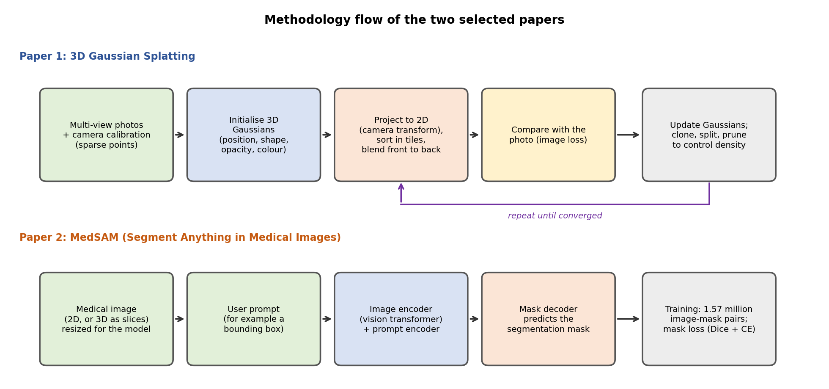
 | Paper 1: 3D Gaussian Splatting | Paper 2: MedSAM
Representation | The scene is a cloud of 3D Gaussians. Each has a position, an anisotropic shape (covariance), opacity and a view-dependent colour. They start from the sparse points produced by camera calibration. | A promptable segmentation network: an image encoder, a prompt encoder and a mask decoder, adapted from the Segment Anything Model.
Training | Interleaved optimization and density control: Gaussians are adjusted, and added (cloned or split) or removed (pruned) so that the scene is represented accurately without waste. | Fine-tuned on a large dataset of 1,570,263 image-mask pairs covering 10 imaging modalities and over 30 cancer types.
Rendering / inference | A fast, visibility-aware rasterizer projects the Gaussians to the screen with the camera transform, sorts them, and blends them front to back; it supports anisotropic splatting. | The user gives a prompt (for example a box around a region); the model returns a mask. 3D scans such as CT and MRI are handled as a series of 2D slices.
Link to Computer Graphics | Viewing and projection transforms (CO5), alpha blending, rasterization and depth ordering. | Image resampling, visualization of masks, and converting masks to 3D meshes for rendering.

4. Results [2 Marks]
Marking scheme (2 marks): main results and evidence summarised for each paper (1 mark per paper).
 | Paper 1: 3D Gaussian Splatting | Paper 2: MedSAM
Evaluation | Compared with earlier radiance-field methods on several established datasets of real scenes. | Evaluated on 86 internal validation tasks and 60 external validation tasks, and compared with modality-specific specialist models.
Main findings | Image quality equal to or better than the best earlier method (Mip-NeRF360); real-time display of at least 30 frames per second at 1080p, whereas faster methods that sacrificed quality reached about 10 to 15 frames per second; competitive training time. | Better accuracy and robustness than modality-wise specialist models, with one model for many tasks.
Significance | Showed that an explicit, point-like scene representation can replace slow volume ray marching for real-time view synthesis. | Showed that a single foundation model can be a strong general tool for medical segmentation.
What to check in the full paper | Tables of PSNR, SSIM and LPIPS per dataset, training time and frame rate. | Per-task Dice scores for internal and external validation.

5. Limitations [2 Marks]
Marking scheme (2 marks): relevant limitations explained for each paper (1 mark per paper).
 | Paper 1: 3D Gaussian Splatting | Paper 2: MedSAM
Data | Needs many calibrated photos; relies on camera calibration for the starting points; designed for static scenes. | Training data is unevenly spread across modalities, so rare modalities have less support.
Quality | Parts of the scene seen from few angles can show artifacts or visible popping when the view changes. | A box prompt can be ambiguous for thin, branching structures such as vessels.
Resources | Large GPU memory use during training and for storing millions of Gaussians; heavy for phones and headsets. | Heavy transformer model; needs a prompt from a user, so it is not fully automatic; 3D scans are processed slice by slice, so context between slices is not used.
Practical | Editing, relighting and dynamic scenes are not directly supported. | Clinical use needs validation, regulatory approval and checks for bias across patient groups.

6. Proposed Improvement [2 Marks]
Marking scheme (2 marks): practical improvement with method, expected benefit and a way to evaluate it for each paper (1 mark per paper).
 | Paper 1: 3D Gaussian Splatting | Paper 2: MedSAM
Proposal | Compact Gaussian Splatting for AR/VR: prune Gaussians that contribute little, quantise their parameters, and add a depth prior (for example from a single-image depth estimator) in poorly observed regions. | 3D-aware MedSAM with confidence: carry the mask from slice to slice using a memory of neighbouring slices, and add an uncertainty map that flags unreliable regions.
How it would work | After training, remove Gaussians with low opacity or small screen footprint; store positions and colours with fewer bits; add a loss term that keeps the depth close to the prior where few photos exist. | Process a few neighbouring slices together; propagate the previous slice mask as an extra prompt; estimate uncertainty by comparing several prompt variants or model outputs.
Expected benefit | Smaller files and less GPU memory, so real-time rendering on headsets and phones; fewer artifacts in sparsely seen areas. | More consistent 3D organ masks, fewer manual corrections, and a safety signal telling the clinician when to check.
Link to the course | Faster viewing and projection pipeline for AR/VR displays. | Feeds mesh generation, volume rendering and AR overlay (Assignment 9).
How to evaluate | Compare PSNR/SSIM, file size, memory and frame rate before and after on the same scenes. | Compare Dice score and slice-to-slice consistency against the original model on external 3D datasets; measure correction time.

Comparison of the two papers
Aspect | Paper 1 | Paper 2
Output | Images of a scene from new viewpoints | Segmentation masks
Role in a graphics pipeline | Rendering and view synthesis | Pre-processing for 3D modelling and visualization
Shared theme | Both replace a slow, specialised step with a learned or optimised representation that is fast and general; both depend on large, good-quality data.

Student Self-Assessment
☐ I read both papers (not only the abstracts).
☐ I stated the problem and methodology in my own words.
☐ I checked the results against the papers.
☐ I identified genuine limitations.
☐ My improvement proposals are realistic and evaluated.

Assessment Rubric Mapping (10 Marks)
Criterion | Marks | Where addressed in this journal
Problem addressed | 2 | Section 2: Paper 1 (1) + Paper 2 (1)
Methodology | 2 | Section 3: Paper 1 (1) + Paper 2 (1)
Results | 2 | Section 4: Paper 1 (1) + Paper 2 (1)
Limitations | 2 | Section 5: Paper 1 (1) + Paper 2 (1)
Proposed improvement | 2 | Section 6: Paper 1 (1) + Paper 2 (1)
The sheet gives the title “Simulation of Object Movement in Virtual Environment” for Assignments 7, 8 and 9. This journal uses the heading of the question itself.

References
1. B. Kerbl, G. Kopanas, T. Leimkühler and G. Drettakis, “3D Gaussian Splatting for Real-Time Radiance Field Rendering,” ACM Transactions on Graphics, vol. 42, no. 4, July 2023. arXiv:2308.04079.
2. J. Ma, Y. He, F. Li, L. Han, C. You and B. Wang, “Segment anything in medical images,” Nature Communications, vol. 15, art. 654, 2024. DOI 10.1038/s41467-024-44824-z.
3. J. T. Barron et al., “Mip-NeRF 360: Unbounded Anti-Aliased Neural Radiance Fields,” CVPR 2022 (the earlier best-quality method that Paper 1 compares with).
4. A. Kirillov et al., “Segment Anything,” ICCV 2023 (the model on which MedSAM is based).
5. Course notes and Module 1 material, Computer Graphics, Semester V.

Declaration: I commit to submitting original work, free from plagiarism or copying from the internet or peers, and to honouring deadlines for a fair and transparent assessment.
Signature of Student: ____________________ Roll No: ____________

