Computer Graphics – Assignment Solution Journal
Computer Graphics, Sem-5
Assignment 9
Computer Graphics Solution for Healthcare / AR Applications

Cover Page
Student Name | ______________________________________
Roll No. / Division | ______________________________________
Programme / Semester | B.Tech – Semester V
Course / Code / Scheme | Computer Graphics / PCIT03T / R-2024
Module / Max Marks | Module 1 / 10 Marks
Course Outcome | CO4: Analyze visible surface detection algorithms and implement illumination and shading models for realistic rendering.
Date of Submission | ______________________________________

Assignment Details (from the assignment sheet)
Question | Design a graphics-based solution for medical image visualization, surgical simulation and AR-assisted diagnosis. Include graphics techniques, transformation methods, rendering approaches and expected benefits.
Bloom / Type / Difficulty | Apply / Application based / Medium
Industry Context | Animation Industry
Expected Time / Resources | 2 hrs / Module 1
Assessment Evidence | Written document
Rubric Focus (10 Marks) | Graphics techniques (2.5), Transformation methods (2.5), Rendering approaches (2.5), Expected benefits (2.5)

Marking Scheme at a Glance (10 Marks)
# | Criterion | Marks | Where in this journal
1 | Graphics techniques | 2.5 | Section 2
2 | Transformation methods | 2.5 | Section 3
3 | Rendering approaches | 2.5 | Section 4
4 | Expected benefits | 2.5 | Section 5

1. Solution Overview
The solution has three applications that share one pipeline: (1) Medical Image Visualization lets a doctor explore CT or MRI volumes in 2D slices and 3D; (2) Surgical Simulation lets a surgeon rehearse an operation on a patient-specific 3D model with deformation and force feedback; (3) AR-Assisted Diagnosis overlays internal anatomy on the real patient seen through a camera or AR glasses.
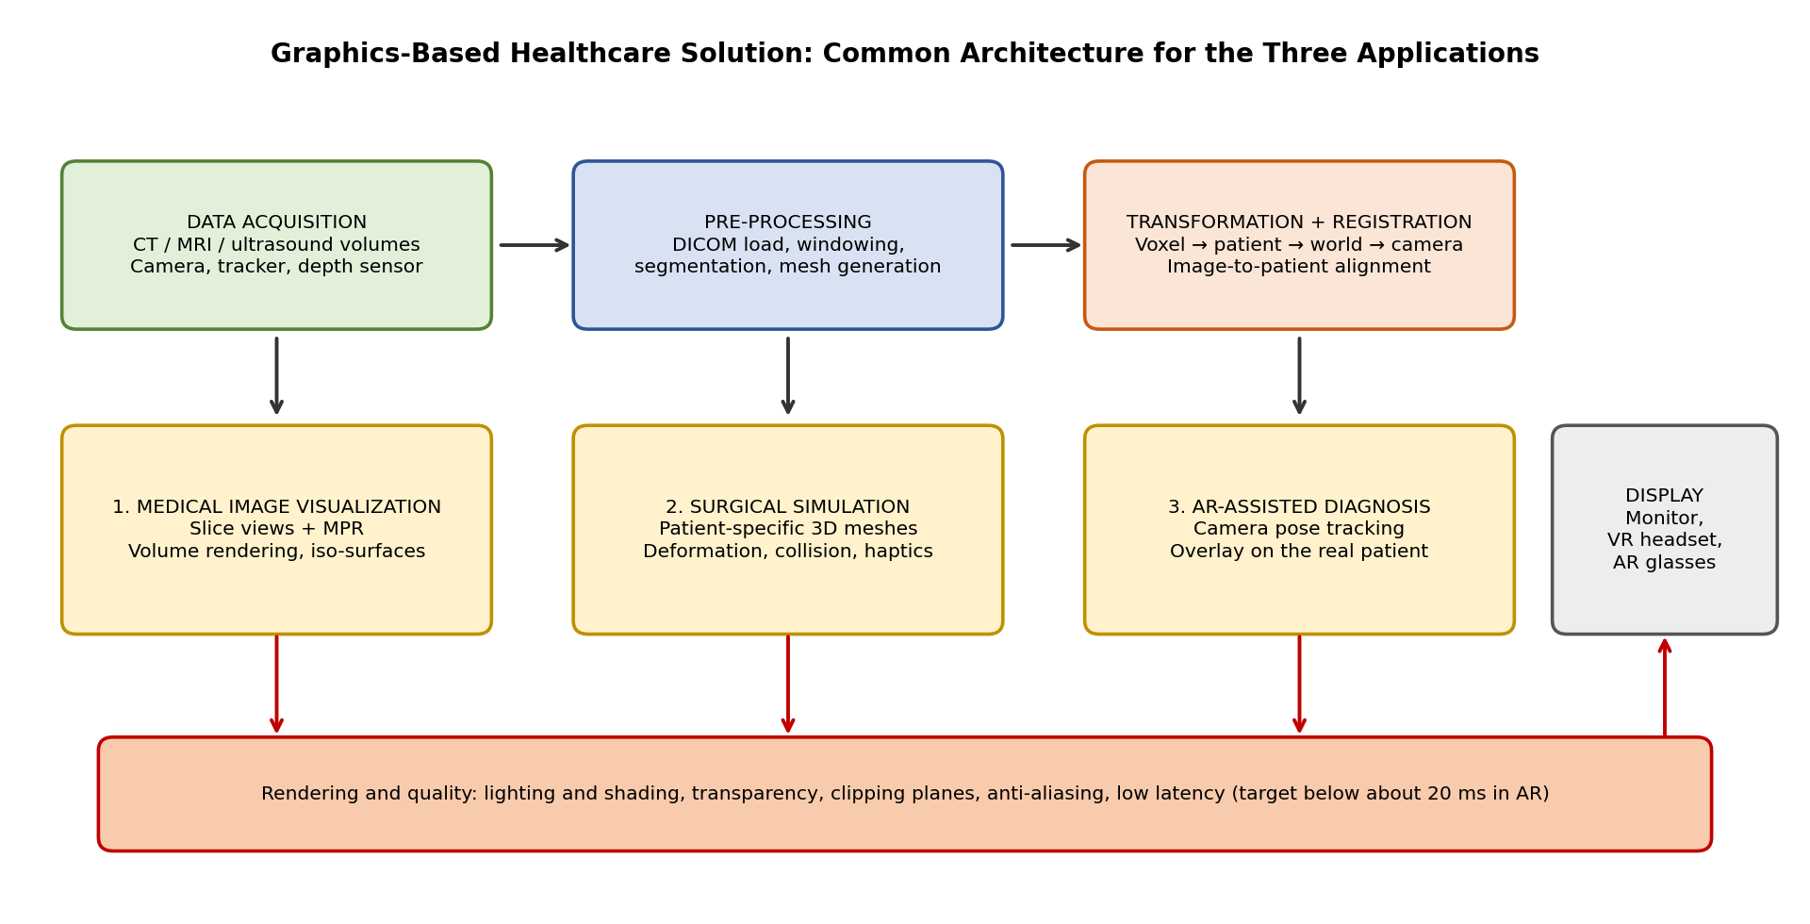
Data flow: scans are loaded and pre-processed (windowing, segmentation, mesh generation), registered to the patient and the display by chains of transformations, and rendered with a method suited to each application.

2. Graphics Techniques [2.5 Marks]
Marking scheme (2.5 marks): medical image visualization (0.85) + surgical simulation (0.85) + AR-assisted diagnosis (0.8), each with techniques named and their role explained.
Application | Graphics techniques | Role
Medical image visualization | Slice display with windowing; multi-planar reconstruction (MPR); direct volume rendering with transfer functions; iso-surface extraction (marching cubes); clipping planes; colour maps and overlays of segmentation masks. | Shows the data as images and 3D structures so the doctor can inspect organs, vessels and lesions from any angle and hide the tissue in front.
Surgical simulation | Patient-specific polygon meshes; deformable-body simulation (mass-spring or finite element); collision detection; texture mapping and shading of tissue; haptic force rendering; camera and tool models. | Makes organs react realistically to instruments so the surgeon can practise cutting, pushing and suturing safely.
AR-assisted diagnosis | Camera calibration and pose tracking; image-to-patient registration; real-time overlay of 3D models; depth-aware transparency and occlusion; labels and measurement graphics. | Places hidden anatomy and findings exactly on the patient so the doctor sees them in context.

Key algorithms
Algorithm | Short description
Windowing | Maps a chosen range of CT values (level L, width W) to grey levels: g = clamp((HU − (L − W/2)) / W, 0, 1).
Marching cubes | Visits each cell of the volume and builds triangles where the data crosses a chosen value (for example bone), giving a 3D surface.
Volume ray casting | Sends a ray through the volume for each pixel, looks up colour and opacity at samples, and composites them front to back: C = Σ Ti · αi · ci with transmittance Ti = Π(1 − αj).
Mass-spring deformation | Tissue is a network of points joined by springs; forces from springs and instruments move the points every step.
Collision detection | Bounding-volume hierarchies find which triangles of the tool touch the organ.
Camera pose estimation | Finds the position and orientation of the camera from known markers or features (Perspective-n-Point).

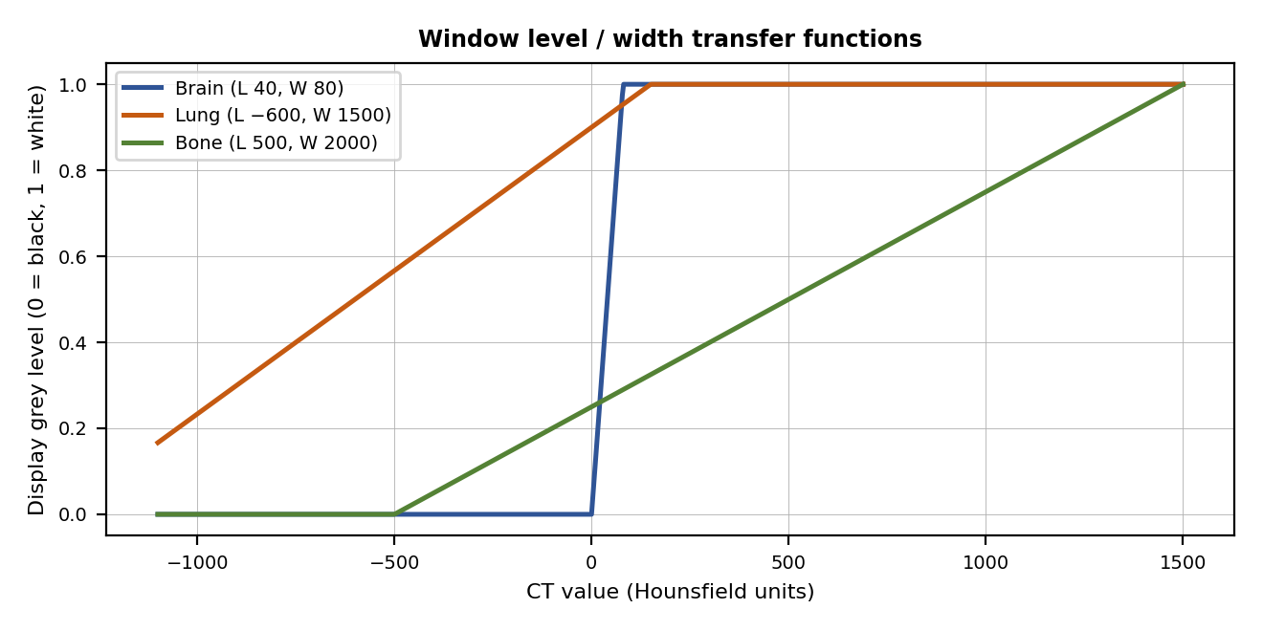
The window level and width decide which tissue is visible: a narrow brain window (width 80) shows small differences in soft tissue, while a wide bone window shows dense structures.

3. Transformation Methods [2.5 Marks]
Marking scheme (2.5 marks): medical image visualization (0.85) + surgical simulation (0.85) + AR-assisted diagnosis (0.8), each with the transformations and a worked example.
Application | Transformations used | Worked example
Medical image visualization | Voxel to patient (affine) transform: p = O · diag(sx, sy, sz) · (i, j, k) + origin, where O is the orientation matrix of the scanner. MPR: rotate the sampling plane to any oblique angle. Zoom, pan and rotation of the 3D view with 4×4 matrices. | CT voxel (256, 256, 150), spacing (0.7, 0.7, 1.0) mm, origin (−180, −180, −150) mm, axis-aligned: x = −180 + 256·0.7 = −0.8 mm; y = −0.8 mm; z = −150 + 150·1.0 = 0 mm. Result (−0.8, −0.8, 0) mm.
Surgical simulation | Rigid transform of the instrument: tool tip in world = T_world←tracker · T_tracker←tool · p_tip. Non-rigid transform of tissue: each mesh vertex is displaced by the simulation (position changes every step). Scaling from mm to scene units. | Tool tip at (0, 0, −120) mm in tool coordinates. The tool is rotated 90° about Y and moved to (50, 0, 0). Rotation: Ry(90°) · (0, 0, −120) = (−120, 0, 0). Translation: (−120, 0, 0) + (50, 0, 0) = (−70, 0, 0) mm.
AR-assisted diagnosis | Chain of rigid transforms: T_camera←patient = T_camera←marker · T_marker←patient (registration). Pinhole projection with camera matrix K: u = fx · X / Z + cx, v = fy · Y / Z + cy. | Point (0.05, −0.02, 0.5) m in camera coordinates, f = 800 px, centre (640, 360): u = 800·0.05 / 0.5 + 640 = 720; v = 800·(−0.02) / 0.5 + 360 = 328. Pixel (720, 328).

Registration chain for AR (reading right to left)
A point in the patient’s CT image is converted to patient coordinates (voxel to patient transform), then to the tracking marker frame (registration found by matching a few landmarks), then to the camera frame (pose from the tracker), then projected with K to a pixel. If any link is wrong by 1 mm or 1 degree, the overlay is misplaced, so registration accuracy is the main quality measure of AR diagnosis.

Matrix conventions
- All rigid transforms are 4×4 homogeneous matrices [R t; 0 1] and are combined by multiplication; the order matters.
- Units must be consistent (millimetres for medical data, metres for many AR devices).
- Left-handed and right-handed conventions differ between medical, graphics and AR software, so axes may need flipping.

4. Rendering Approaches [2.5 Marks]
Marking scheme (2.5 marks): medical image visualization (0.85) + surgical simulation (0.85) + AR-assisted diagnosis (0.8), each with method, quality techniques and a performance consideration.
Application | Rendering method | Illumination and quality | Performance consideration
Medical image visualization | Slice rendering with windowing; direct volume rendering (ray casting) with transfer functions; iso-surfaces as polygons. | Gradient-based shading (Blinn-Phong) of surfaces inside the volume; transparency; colour maps. | A 512×512×300 CT with 16-bit values is 78.6 million voxels = 150 MiB. Ray casting with 512 samples for each pixel at 1920×1080 is 1.06 billion samples per frame, or 64 billion per second at 60 frames. Needs a GPU, early ray termination and empty-space skipping.
Surgical simulation | Real-time polygon rendering of the organ mesh with textures; separate haptic loop for force feedback. | Phong or physically based shading, soft shadows, a wet-tissue specular highlight, approximate subsurface scattering for soft tissue. | Graphics at 60 frames per second or more; haptic loop at about 1,000 updates per second so forces feel smooth. Level of detail keeps the mesh light.
AR-assisted diagnosis | Video see-through (camera image plus virtual model) or optical see-through (glasses). | Semi-transparent overlay; depth-aware occlusion so hidden anatomy looks inside the body; light matching with the room. | Low motion-to-display delay (target below about 20 ms) and steady frame rate; late reprojection of the last frame with the newest pose reduces visible lag.

Choosing between volume rendering and surfaces
 | Direct volume rendering | Iso-surface (marching cubes)
Strength | Shows soft tissue and internal detail without a hard segmentation. | Fast, standard polygon pipeline; suits simulation and 3D printing.
Weakness | Heavy computation; needs good transfer functions. | Hides everything except the chosen surface; stair-step artifacts.
Use here | Image visualization and AR overlay of volumes. | Models for surgical simulation.

5. Expected Benefits [2.5 Marks]
Marking scheme (2.5 marks): medical image visualization (0.85) + surgical simulation (0.85) + AR-assisted diagnosis (0.8), each with clinical benefit, technical benefit and a measurable target. Targets are design goals, not results.
Application | Clinical benefit | Technical benefit | Measurable design target
Medical image visualization | Earlier and clearer detection; better understanding of anatomy; easier communication with the patient. | Interactive exploration of large scans from any angle; one tool for several modalities. | Interactive rendering at 30 frames per second or more on a standard workstation.
Surgical simulation | Safe practice for trainees; rehearsal of difficult cases on the patient’s own anatomy; fewer errors. | Reusable, repeatable scenarios; objective scoring of motion and time. | Visual rate at 60 frames per second or more; haptic update near 1 kHz; trainee scores tracked over sessions.
AR-assisted diagnosis | Findings seen in place on the patient; less looking away from the patient; guidance for biopsies and incisions. | Real-time registration and overlay without extra hardware beyond a camera or glasses. | Overlay error of a few millimetres and delay below about 20 ms.

Limitations and safety
- Accuracy: mis-registration or a wrong segmentation can mislead the doctor, so the system must show uncertainty and leave the decision to the clinician.
- Privacy: medical images are sensitive personal data; remove names from the files (anonymise), encrypt storage and limit access.
- Validation: clinical use requires testing on real cases and approval by the health regulator; it is a decision-support tool, not a replacement for medical judgement.
- Cost and comfort: GPUs and headsets are costly; long AR sessions can cause eye strain, so brightness, latency and weight must be tuned.

Overall benefit
Together the three applications cover the path from understanding the data, to practising the operation, to using the information at the patient’s bedside, using one set of graphics techniques: transformations, rendering, shading, and real-time performance.

Student Self-Assessment
☐ I designed a solution for all three applications.
☐ I named the graphics techniques and explained their role.
☐ I gave transformations with worked examples.
☐ I explained the rendering approaches and their performance.
☐ I described the benefits and limitations.

Assessment Rubric Mapping (10 Marks)
Criterion | Marks | Where addressed in this journal
Graphics techniques | 2.5 | Section 2: three applications (0.85 + 0.85 + 0.8)
Transformation methods | 2.5 | Section 3: three applications with worked examples (0.85 + 0.85 + 0.8)
Rendering approaches | 2.5 | Section 4: three applications (0.85 + 0.85 + 0.8)
Expected benefits | 2.5 | Section 5: three applications with targets (0.85 + 0.85 + 0.8)
The sheet gives the title “Simulation of Object Movement in Virtual Environment” for Assignments 7, 8 and 9. This journal uses the heading of the question itself.

References
1. D. Hearn and M. P. Baker, Computer Graphics with OpenGL, 4th ed., Pearson, 2011.
2. W. E. Lorensen and H. E. Cline, “Marching Cubes: A High Resolution 3D Surface Construction Algorithm,” SIGGRAPH ’87 Proceedings, 1987.
3. M. Levoy, “Display of Surfaces from Volume Data,” IEEE Computer Graphics and Applications, vol. 8, no. 3, 1988.
4. R. A. Drebin, L. Carpenter and P. Hanrahan, “Volume Rendering,” SIGGRAPH ’88 Proceedings, 1988.
5. A. Nealen, M. Müller, R. Keiser, E. Boxerman and M. Carlson, “Physically Based Deformable Models in Computer Graphics,” Computer Graphics Forum, vol. 25, no. 4, 2006.
6. R. T. Azuma, “A Survey of Augmented Reality,” Presence: Teleoperators and Virtual Environments, vol. 6, no. 4, 1997.
7. Course notes and Module 5 material, Computer Graphics, Semester V.

Declaration: I commit to submitting original work, free from plagiarism or copying from the internet or peers, and to honouring deadlines for a fair and transparent assessment.
Signature of Student: ____________________ Roll No: ____________

