AIML Track Engineering Investigation Journal
Artificial Intelligence, Sem-5
Engineering Investigation 11 (EI-11)
Capstone Engineering Investigation – Engineering AI for Society

Cover Page
Student Name | ______________________________________
Roll No. / Division | ______________________________________
Programme / Semester | B.Tech (AIML Track) – Semester V
Course / Module | Artificial Intelligence – Capstone Engineering Investigation
Investigation | EI-11: Capstone Engineering Investigation (10 Marks, Individual)
Course Outcomes | Primary CO6; Supporting CO1, CO2, CO3, CO4, CO5
Role (Scenario) | Junior AI Engineer, FutureAI Innovations Pvt. Ltd.
Challenge | AI for Society Innovation Challenge
Date of Submission | ______________________________________

Investigation Snapshot
Educational Question | How can Artificial Intelligence solve meaningful real-world problems responsibly?
Framework Followed | Identify → Analyse → Design → Evaluate → Improve → Inspire
Primary Competency | Engineering Innovation → System Integration → Professional Communication
Engineering Thought | Technology has value only when it improves lives.
Submission | Engineering Investigation Journal → PDF → MS Teams

Proposal Summary
CropGuard: an AI Crop Health Advisor for small farmers. A smartphone-based system that identifies likely crop diseases from a leaf photo, explains the finding, and recommends a safe treatment plan in the farmer’s own language, with an agronomist available when the AI is unsure.
Domain: Agriculture and rural development. Integrates: agents and PEAS, search, knowledge representation and reasoning, planning, learning and Responsible AI.

Problem Analysis Sheet (Activities 1 and 2)
Problem | Small farmers lose part of their crop each season because plant diseases and pests are noticed late or identified wrongly, and trained agricultural experts are too few to visit every farm.
Current challenges | Late detection; guesswork leading to the wrong or excessive pesticide, which costs money and harms health and soil; few experts per farmer; language and literacy barriers; weak internet in villages.
People affected | Small and marginal farmers and their families, farm workers handling pesticides, consumers of the produce and the local environment.

Stakeholders | Farmers; agronomists and agriculture extension officers; agri-input dealers; government agriculture department; consumers; the research community.
Constraints | Low-cost phones; intermittent internet; many local languages; limited labelled local images; field conditions (bright sun, shadows, dirty leaves); small budget; farmers’ trust.
Available data | Public plant-disease image collections; weather data; soil test records; crop calendars; extension advisories and pesticide guidelines.
Possible risks | Wrong diagnosis leading to the wrong spray; poorer accuracy for crops, regions or lighting not in the data; privacy of farm location; over-reliance on the app; exclusion of farmers without smartphones.
Expected outcomes | Earlier and more accurate detection; less crop loss; fewer unnecessary pesticide sprays; better income and safer farming. Pilot target: correct advice on the covered diseases in at least 90% of expert-verified cases.

AI Solution Design (Activity 3)
Objective | Detect crop diseases early and recommend safe, timely treatment so that small farmers reduce crop loss and pesticide misuse.
Intelligent agent | A goal-based, learning agent. PEAS: Performance = correct diagnosis, timely advice, less crop loss, less pesticide; Environment = farms, crops, weather, farmers; Actuators = advice screen and voice, SMS alerts; Sensors = phone camera, weather and soil data.
Sensors | Phone camera (leaf photo), farmer’s voice or text, GPS and crop type, weather service, optional soil sensor.
Actuators | Advice in local language (voice and text), SMS alert for a nearby outbreak, spray schedule reminder, escalation to an agronomist.
Knowledge representation | Ontology of crops, diseases, symptoms and treatments; frames for each crop; IF–THEN rules, for example: IF yellow spots AND humid weather AND crop is tomato THEN suspect early blight. Reasoning: forward chaining on symptoms and weather, and backward chaining to confirm a suspected disease by asking the farmer short questions.
Search strategy | A* to plan the shortest field-scouting route over plots; best-first selection of treatments ranked by effectiveness, safety and cost.
Planning | A treatment and spray plan that respects constraints such as rain forecast, waiting time before harvest and approved dosage.
Learning component | Supervised deep-learning image classifier trained on labelled leaf images; retrained periodically using photos whose diagnosis was confirmed by an agronomist or the farmer (feedback loop).
Responsible AI measures | Show confidence and an explanation (highlighted leaf area); below a confidence threshold say “consult an expert”; test accuracy across crops, regions and lighting; consent and minimum data; local language and offline mode; agronomist oversight; log decisions for audit.

Block Diagram (Activity 3)
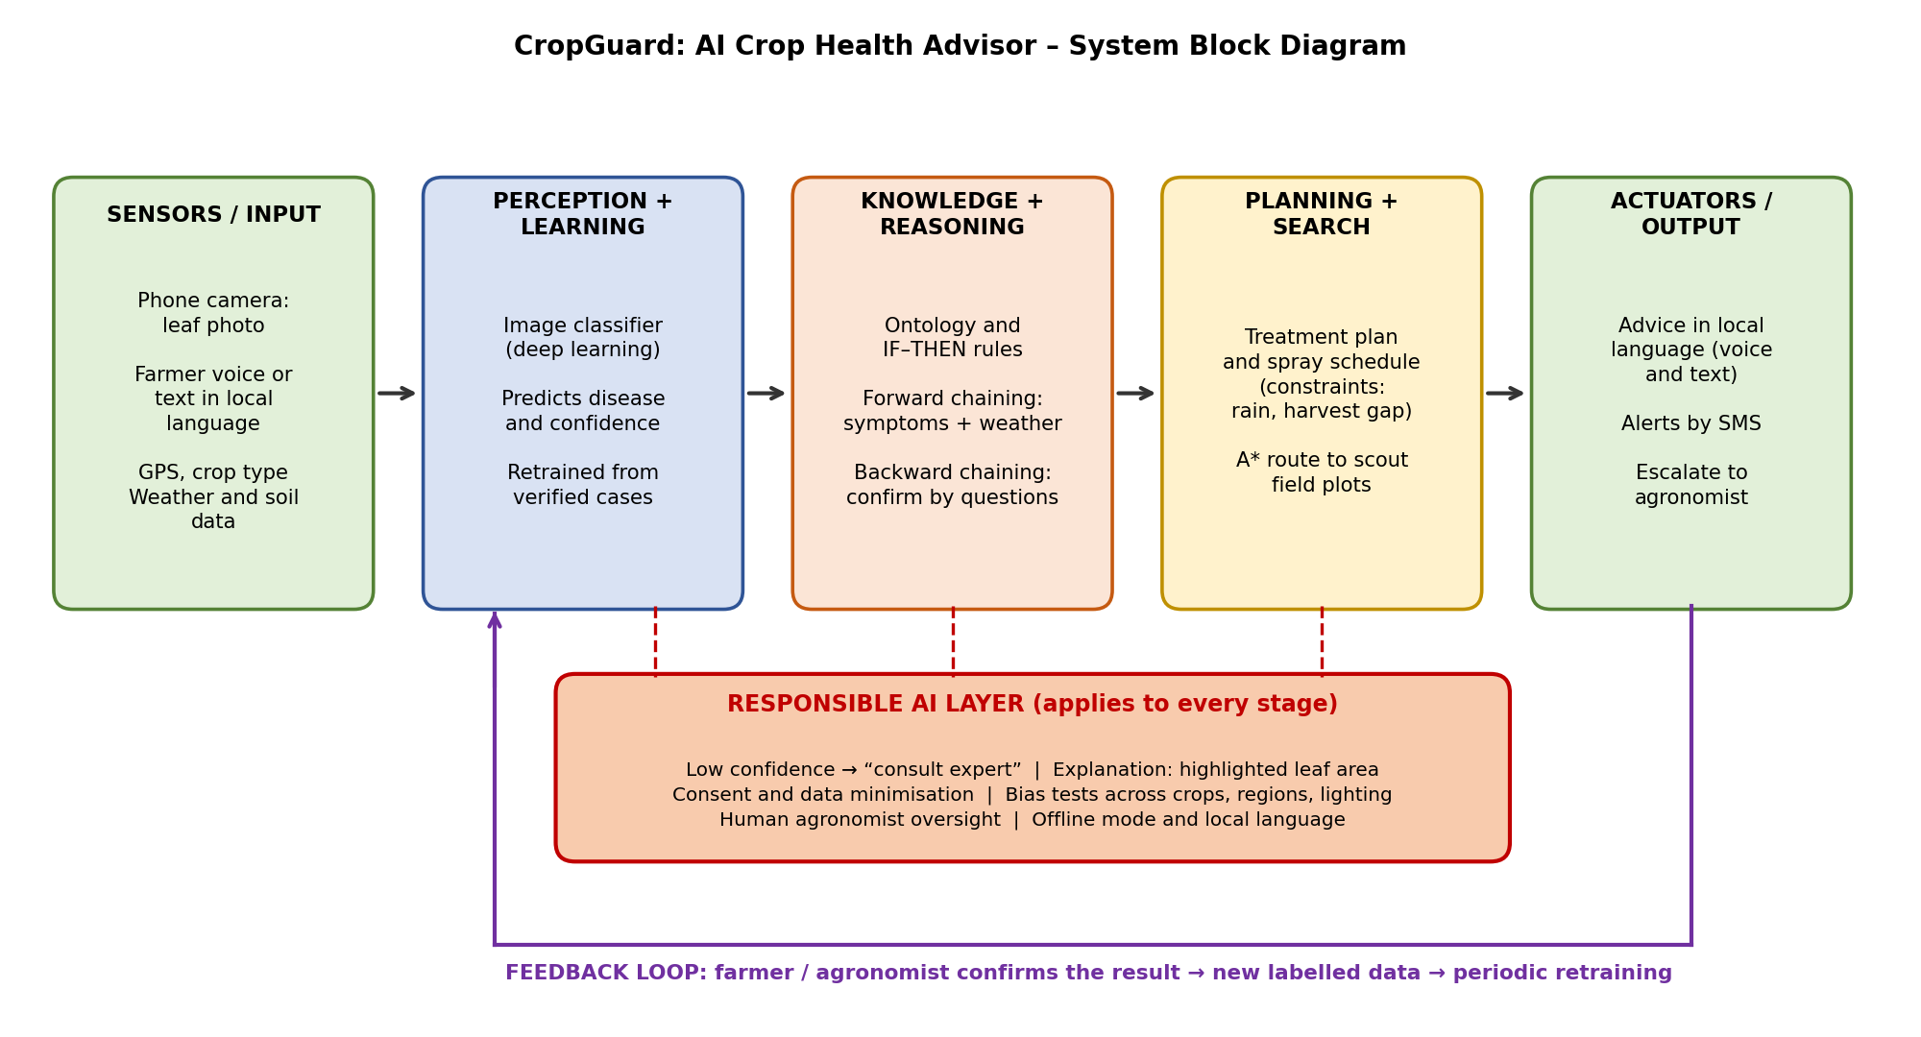
Data flow: the farmer’s photo and context enter through the sensors, the classifier predicts a disease with a confidence value, the reasoning module checks it against stored knowledge and weather, the planner prepares a treatment schedule, and the farmer receives advice. A Responsible AI layer monitors every stage, and confirmed outcomes flow back as new training data.

Integration of the Course
Investigation | How it is used in CropGuard
EI-1, EI-2, EI-3 | AI identified in daily life; the system is modelled as an intelligent agent with PEAS.
EI-4, EI-5 | A* for the scouting route; best-first ranking of treatments; look-ahead thinking about outcomes.
EI-6, EI-7 | Ontology, frames and rules; forward and backward chaining for diagnosis.
EI-8 | Planning of the treatment and spray schedule under constraints.
EI-9 | Supervised learning for the image classifier; the feedback loop.
EI-10 | Bias testing, explanations, privacy, accountability and human oversight.

AI Engineering Canvas (Activity 4): CropGuard
1. Problem Statement  • Small farmers lose crops to late or wrong disease identification.  • Experts are too few to reach every farm. | 2. Goal  • Early, accurate and safe crop-health advice for every farmer in their own language.  • Less crop loss and less pesticide misuse.
3. AI Components  • Image classifier (learning).  • Ontology and rules (knowledge and reasoning).  • A* and best-first search; treatment planner.  • Responsible AI layer. | 4. Input  • Leaf photo, crop type, location.  • Voice or text question.  • Weather and soil data.
5. Processing  • Classify image → confidence check.  • Match symptoms and weather to rules.  • Plan treatment under constraints. | 6. Output  • Likely disease with confidence and explanation.  • Treatment and spray schedule in local language.  • Alert or expert escalation.
7. Benefits  • Saves crops and money.  • Safer, reduced pesticide use.  • Expert knowledge reaches remote villages. | 8. Risks  • Wrong diagnosis and wrong spray.  • Lower accuracy for unseen crops or lighting.  • Over-reliance; digital divide.
9. Ethical Considerations  • Fairness across regions and crops; privacy of farm data.  • Explainable results; human agronomist can override.  • Farmer consent and ownership of data. | 10. Future Scope  • More crops and languages.  • Drone scouting and soil sensors.  • Pest outbreak maps shared with agriculture officers.

Engineering Recommendation (Activity 5)
Criterion | Rating | Evaluation
Technical feasibility | High | Image classification of leaf diseases is a well-studied task, and phones have good cameras. The main work is collecting local data and testing in field conditions.
Economic feasibility | High | Runs on low-cost phones with cloud or on-device models; the cost per farmer is small compared with crop loss. Can be funded by government schemes or cooperatives.
Social impact | High | Brings expert advice to farmers who cannot reach experts and reduces harmful over-spraying.
Sustainability | High | Less pesticide protects soil, water and health; the model improves with feedback and can be maintained by agriculture departments.
Scalability | Medium | New crops and regions need more labelled data and local validation; language support must grow step by step.
Responsible AI compliance | Medium to High | Explanations, confidence thresholds, bias tests and human oversight are designed in; ongoing audits are needed after launch.

Why should society adopt this solution? Because it turns scarce expert knowledge into a tool every farmer can use: it saves crops and money, reduces harmful pesticide use, respects farmers’ language and decisions, and always hands difficult cases to a human expert. It supports farmers rather than replacing them.

Ethics Corner: Final Question
Would I trust it enough for my own family to use? Yes, as an advisory tool for a family farm, but not yet as the only authority. Improvements still required before wide deployment: field trials across several regions and seasons; reported accuracy for each crop and lighting condition; a clear “consult an expert” path for uncertain cases; safe-dosage checks by agriculture experts; protection of farmers’ location and data; and a public process to receive and fix complaints.

Final Reflection (Activity 6)
How my understanding evolved. At the start I thought AI meant robots and chatbots. Over eleven investigations I learnt that AI is a way of designing systems that perceive, reason, plan and learn, and that it already surrounds daily life.
What surprised me. How many everyday systems turned out to be simple automation until they learn and adapt, and how often ethics changed the design, not just the discussion.
What challenged me. Reasoning step by step: tracing forward and backward chaining, pruning game trees and writing complete PEAS models without skipping steps demanded precision.
How my thinking changed. I moved from asking “which algorithm is best?” to “which approach fits this problem and its constraints?”. Search, knowledge, planning and learning stopped being separate chapters; CropGuard needed all of them together.
Using AI responsibly. In my career I will start with the people affected, test for bias, explain decisions, protect data, and keep humans in charge of high-risk decisions. I will treat the Responsible AI checklist as part of the design, and judge success by whether lives improve.

Student Self-Assessment
☐ I identified a meaningful societal problem.
☐ I integrated concepts from multiple Engineering Investigations.
☐ My AI solution is technically feasible.
☐ I considered ethical responsibilities.
☐ My proposal reflects my own engineering thinking.

Assessment Rubric Mapping (10 Marks)
Criterion | Marks | Where addressed in this journal
Problem Identification & Analysis | 2 | Problem Analysis Sheet
AI Solution Design | 2 | AI Solution Design, Block Diagram
System Integration & Innovation | 2 | Integration table, AI Engineering Canvas
Engineering Recommendation | 2 | Feasibility evaluation, Ethics Corner
Reflection & Presentation | 2 | Final Reflection, layout, references

References
1. S. Russell and P. Norvig, Artificial Intelligence: A Modern Approach, 4th ed., Pearson, 2020.
2. S. P. Mohanty, D. P. Hughes and M. Salathé, “Using Deep Learning for Image-Based Plant Disease Detection,” Frontiers in Plant Science, vol. 7, 2016.
3. T. M. Mitchell, Machine Learning, McGraw-Hill, 1997.
4. NITI Aayog, National Strategy for Artificial Intelligence: #AIforAll, Government of India, 2018.
5. NITI Aayog, Principles for Responsible AI, Government of India, 2021.
6. Course notes and lecture material, Artificial Intelligence, Semester V (Engineering Investigations 1–10).

Common Mistakes Avoided
Common mistake | How it was avoided in this journal
Selecting an unrealistic problem | Crop disease advice is a real, well-defined need with available data.
Proposing AI without understanding the problem | Problem Analysis Sheet comes before the design.
Ignoring stakeholder needs | Farmers, agronomists and officials are analysed; local language and offline use are designed in.
Forgetting Responsible AI principles | A Responsible AI layer is part of the block diagram and canvas.
Repeating textbook concepts | Concepts from EI-1 to EI-10 are integrated into one working design.

Declaration: I confirm that the proposal, analysis and reflection in this journal reflect my own work.
Signature of Student: ____________________ Roll No: ____________

