AIML Track Engineering Investigation Journal
Artificial Intelligence, Sem-5
Engineering Investigation 1 (EI-1)
AI Around Me – Discovering Intelligence in Everyday Life

Cover Page
Student Name | ______________________________________
Roll No. / Division | ______________________________________
Programme / Semester | B.Tech (AIML Track) – Semester V
Course / Module | Artificial Intelligence – Module 1: Introduction to Artificial Intelligence
Investigation | EI-1: AI Around Me (10 Marks, Individual)
Course Outcomes | Primary CO1; Supporting CO5
Role (Scenario) | Graduate AI Engineer, InsightAI Consulting
Investigation Period | 1 Week (approx. 2 hours independent work)
Date of Submission | ______________________________________

Investigation Snapshot
Investigation Question | What is intelligence around us, and how can an engineer identify AI systems in everyday life?
Framework Followed | Question → Observe → Collect Evidence → Analyse → Conclude → Recommend
Primary Competency | Observation → Analysis → Reflection
Engineering Thought | Observe before you conclude.
Field Area | Mumbai (college campus, home, commute, local market)
Submission | Handwritten Engineering Investigation Journal → PDF → MS Teams

Investigation Question and Working Definition
Question: How can I tell whether a system I meet in daily life is genuinely intelligent (AI-enabled) or merely automated?
Working test used in this journal: A system was counted as AI-enabled only if it (1) perceives data from its environment, (2) learns or infers from data rather than following only fixed if-then rules, and (3) adapts its output to a new situation or user. Systems failing this test were treated as conventional automation.

Observation Sheet (Activity 1)
Ten AI-enabled systems were observed during one week. The evidence column records what I actually saw; the last column records why the system passes the working test on page 1. (Replace the evidence with your own observations and screenshots/photos before submitting.)
# | System | Where / When observed | Evidence collected | Why it is considered intelligent
1 | Google Maps live traffic and ETA | Daily commute, Andheri to college | Route time changed from 38 to 52 min after a slowdown on the Western Express Highway; app auto-suggested an alternate road. | Predicts travel time from live and historical traffic data (ML); re-plans as conditions change.
2 | Ola / Uber pricing and ETA | Booking a cab at evening peak | Same trip was priced higher at 6 pm than at 3 pm; driver ETA updated as cars moved. | Demand-supply prediction (ML) sets fares and matches drivers; a fixed fare table could not do this.
3 | UPI app fraud / risk alert (GPay / PhonePe) | Paying a new merchant from phone | App showed a warning on an unknown payee and a large first-time amount before confirming. | Anomaly detection learns normal spending behaviour and flags deviations.
4 | Bank website chatbot | Checking card-block steps online | Bot understood a typed sentence in casual wording and gave the correct steps; escalated to an agent when unsure. | Natural Language Processing (intent recognition) rather than keyword menus.
5 | YouTube / Netflix recommendations | Home screen on my phone | Home page differed from my friend’s; after I watched two coding videos, more coding content appeared. | Recommender system learns from watch history and similar users.
6 | Voice assistant (Google Assistant / Alexa) | Voice command at home | Asked “set alarm for six thirty tomorrow” and “what’s the weather like”; both understood despite background noise. | Speech recognition + NLP converts varied speech into intent.
7 | Smartphone face unlock | Unlocking phone several times a day | Worked with glasses, changed hairstyle and in dim light; rejected a photo of my face. | Computer vision; face embedding matched with liveness checks.
8 | Gmail spam filter | Checking my inbox | Promotional and phishing mails were moved to Spam automatically, including new senders I had never seen. | Text classification learned from millions of labelled mails; generalises to unseen senders.
9 | Google Translate / Lens (camera mode) | Reading a Marathi shop board | Pointing the camera at a signboard overlaid an English translation in real time. | Optical character recognition + neural machine translation.
10 | Smartwatch heart-rate alert | Friend’s watch at the gym | Watch flagged an unusually high resting heart rate and suggested rest; graph changed with activity. | Signal analysis with ML compares readings with the personal baseline.

Domain Classification Table (Activity 2) with Ethics Corner
# | System | Domain | AI technique | Ethical issue considered
1 | Google Maps | Transport | ML prediction | Privacy: continuous location tracking of users.
2 | Ola / Uber pricing | Transport | ML prediction | Fairness and transparency: users cannot see why the price surged.
3 | UPI fraud alert | Finance | Anomaly detection | Bias and false alarms: genuine users may be blocked; accountability if money is lost.
4 | Bank chatbot | Finance | NLP | Transparency: user should know they are talking to a bot; data privacy of account queries.
5 | YouTube / Netflix | Entertainment | Recommender system | Filter bubbles and addiction; manipulation of attention.
6 | Voice assistant | Smart Home | Speech + NLP | Privacy: microphones always listening; voice data storage.
7 | Face unlock | Security / Mobile | Computer vision | Bias: accuracy can vary across faces; biometric data must stay on device.
8 | Gmail spam filter | Communication | ML classification (NLP) | Wrongly blocked genuine mail; content scanning raises privacy concerns.
9 | Google Translate / Lens | Education | Vision + NLP | Translation errors can mislead; camera images may be uploaded.
10 | Smartwatch alert | Healthcare | ML signal analysis | Sensitive health data privacy; not a medical diagnosis; accountability for wrong alerts.

Domain Summary
Domain | Count | Systems
Transport | 2 | Google Maps; Ola / Uber
Finance | 2 | UPI fraud alert; Bank chatbot
Entertainment | 1 | YouTube / Netflix
Smart Home | 1 | Voice assistant
Security / Mobile | 1 | Face unlock
Communication | 1 | Gmail spam filter
Education | 1 | Google Translate / Lens
Healthcare | 1 | Smartwatch alert

Chart / Infographic (Activity 4)
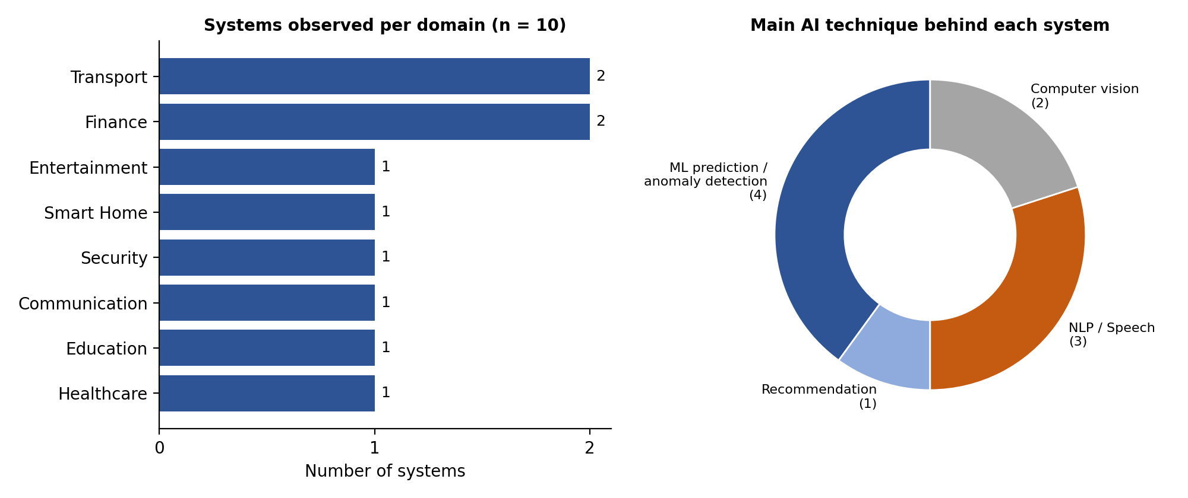

Key Findings from the Chart
- Everyday life: all ten systems were found within one normal day, without visiting any special place.
- Transport and Finance led with two systems each, because both generate large amounts of data.
- Machine learning (prediction and anomaly detection) is behind 4 of 10 systems; language and speech AI behind 3 of 10.
- Most systems are invisible: users notice the result (a warning, a route, a translation), not the AI behind it.

One-page Engineering Analysis (Activity 3)

1. Trends
- Personalisation: feeds, prices, routes and inboxes differ from person to person.
- AI works in the background, embedded in phones and apps people already use.
- Data is the fuel: every system depended on location, history, text, voice, images or sensor signals.

2. Benefits
- Time saved (faster routes, instant translation, automatic spam removal).
- Safety and protection (fraud warnings, health alerts, secure unlock).
- Accessibility and convenience (voice control, camera translation, 24x7 chatbots).

3. Limitations Observed
- Errors: wrong ETAs, wrongly blocked payments, mistranslations.
- Opacity: users cannot see why a price, recommendation or block appeared.
- Dependence on data quality, connectivity and, in many cases, personal data.

4. AI versus Conventional Automation
Aspect | Conventional automation | AI-enabled system
Logic | Fixed rules written by a programmer (if-then). | Patterns learned from data; rules are not fully hand-written.
Adaptation | Same output every time for the same input. | Output changes with context, user and new data.
Handling new cases | Fails or does nothing for unseen input. | Generalises to unseen input (e.g. new spam sender).
Example from my journal | Automatic door, fixed-timer traffic signal, washing-machine timer. | Google Maps ETA, face unlock, Gmail spam filter.

5. Conclusion
Intelligence in everyday systems is recognisable by three signs: the system perceives data, learns from it, and adapts its behaviour. Systems that only repeat a fixed rule (an automatic door, a timer) are automation even when they feel smart. All ten systems in this investigation passed the test, but each raised an ethical question, so an engineer must judge not only whether AI works, but whether it is fair, private and accountable.

One-page Engineering Recommendation (Activity 5)
Recommended solution: An AI-powered College Help-Desk Assistant (chatbot) for students and parents.
Problem identified | Students repeatedly queue at the office or search notice boards for the same information (exam forms, fee dates, timetable changes, scholarship steps, event notices). Staff time is spent answering repeated questions and answers are only available in office hours.
Proposed solution | A chatbot on the college website and MS Teams that understands questions typed in English, Hindi or Marathi and answers from official college documents; unanswered questions are handed to the right office.
How it works | Official circulars and FAQs → cleaned and stored as a knowledge base → NLP finds the intent of the question → retrieves the matching approved answer → shows it with the source document; low-confidence questions go to staff.
Data and tools | College FAQs, circulars, timetables (no personal student data needed for the first version). Open-source NLP tools or a cloud chatbot service.
Justification | Observation 4 (bank chatbot) showed that intent-based bots resolve routine queries and escalate difficult ones. The problem is repetitive, text-based and uses public information, so it is a good fit for AI and low in risk.
Benefits | 24x7 answers, less queueing, less repetitive staff work, consistent information, support for regional languages.
Risks and ethics | Wrong answers (mitigated by showing the source and human escalation); privacy (no personal data stored in version 1); transparency (bot clearly labelled as a bot); accountability (office owns the content).
Pilot and success measure | Pilot with one department for one month. Measure: percentage of queries answered correctly, reduction in office queries, student satisfaction rating (target: over 70% resolved without staff help).
Feasibility | Low cost, no special hardware, can be built by a student team under faculty guidance.

Reflection (Activity 6)
Before this investigation I thought AI meant robots or ChatGPT-type tools. By observing my own day I realised I had already used more than ten AI systems before lunch, and most of them never announced themselves. The biggest change in my understanding is the difference between automation and AI: a timer or an automatic door only follows a rule, while a route planner or spam filter learns and adapts. Writing the working test on page 1 helped me stop calling everything “smart” without evidence.
Recording an ethical issue for each system also changed how I see these tools. Face unlock and voice assistants are convenient, but they depend on personal data, and I had never thought about who controls it. I also noticed that AI makes mistakes, such as wrong ETAs and wrongly flagged payments, so human oversight matters. As a future AI engineer, I want to observe carefully and question data, fairness and accountability before recommending any solution.

Student Self-Assessment
☐ I collected original observations.
☐ I supported findings with evidence.
☐ I analysed instead of merely listing examples.
☐ My recommendation is practical.
☐ My report reflects my own thinking.

Assessment Rubric Mapping (10 Marks)
Criterion | Marks | Where addressed in this journal
Observation Quality | 2 | Observation Sheet (10 systems with evidence)
Evidence & Classification | 2 | Classification Table, Domain Summary
Analysis & Conclusion | 2 | Analysis page, AI vs Automation table, Chart
Recommendation & Innovation | 2 | College Help-Desk Assistant
Reflection & Presentation | 2 | Reflection, neat structured layout

References
1. S. Russell and P. Norvig, Artificial Intelligence: A Modern Approach, 4th ed., Pearson, 2020.
2. C. A. Gomez-Uribe and N. Hunt, “The Netflix Recommender System: Algorithms, Business Value, and Innovation,” ACM Transactions on Management Information Systems, vol. 6, no. 4, 2016.
3. DeepMind, “Traffic prediction with advanced Graph Neural Networks,” DeepMind Blog, 2020 (Google Maps ETA).
4. NITI Aayog, National Strategy for Artificial Intelligence: #AIforAll, Government of India, 2018.
5. Apple Inc., “About Face ID advanced technology,” Apple Support (on-device face recognition).
6. Course notes and lecture material, Artificial Intelligence, Module 1, Semester V.
7. Personal field observations recorded in Mumbai during the investigation week.

Declaration: I confirm that the observations, analysis and reflection in this journal reflect my own work.
Signature of Student: ____________________ Roll No: ____________

