AIML Track Engineering Investigation Journal
Artificial Intelligence, Sem-5
Engineering Investigation 5 (EI-5)
Engineering Intelligent Decision Making – Game Playing, Minimax and Alpha-Beta Pruning

Cover Page
Student Name | ______________________________________
Roll No. / Division | ______________________________________
Programme / Semester | B.Tech (AIML Track) – Semester V
Course / Module | Artificial Intelligence – Module 3: Problem Solving Methods (Adversarial Search)
Investigation | EI-5: Intelligent Decision Making (10 Marks, Individual)
Course Outcomes | Primary CO2; Supporting CO6
Role (Scenario) | AI Engineer, GameMind Technologies Pvt. Ltd.
Investigation Period | 1 Week (approx. 2 hours independent work)
Date of Submission | ______________________________________

Investigation Snapshot
Educational Question | How do intelligent systems make optimal decisions in competitive environments?
Framework Followed | Problem → Predict → Evaluate → Decide → Optimise → Reflect
Primary Competency | Strategic Thinking → Decision Making → Engineering Reasoning
Engineering Thought | Think ahead before making a move.
Techniques Studied | Minimax search and Alpha-Beta pruning
Submission | Handwritten Engineering Investigation Journal → PDF → MS Teams

Adversarial Search in Brief
In a two-player zero-sum game, one player (MAX) tries to maximise the score and the other (MIN) tries to minimise it. Minimax assumes both play their best: MAX picks the child with the highest value, MIN picks the lowest. Alpha-beta pruning gives the same answer while skipping branches that cannot affect the final decision.

Game Observation Table (Activity 1)
# | Game | Players | Strategic decision making | Chance involved | Nature of game | Minimax suitable?
1 | Chess | 2 | Yes, very high | No | Deterministic, perfect information | Yes, with alpha-beta and depth limit
2 | Tic-Tac-Toe | 2 | Yes, small | No | Deterministic, perfect information | Yes, full tree can be searched
3 | Connect Four | 2 | Yes | No | Deterministic, perfect information | Yes, with pruning and depth limit
4 | Sudoku | 1 | Logic only (a puzzle, no opponent) | No | Single-player puzzle | No, not adversarial
5 | Ludo | 2–4 | Some (which token to move) | Yes (dice) | Stochastic, multi-player | Not directly; use expectiminimax

Observation Summary
- Strategy only: Chess, Tic-Tac-Toe and Connect Four.
- Chance and strategy: Ludo, where dice rolls add uncertainty.
- No opponent: Sudoku is solved by search or logic, not by adversarial reasoning.

Minimax Game Tree (Activity 2)
A depth-2 game tree for a two-player game such as Tic-Tac-Toe is used. MAX moves first (root A) and chooses among moves B, C and D. MIN then replies, and each leaf number is the evaluation of the position for MAX (for Tic-Tac-Toe, for example, open lines for X minus open lines for O). (You may replace the leaf values with a drawn Tic-Tac-Toe position of your own.)
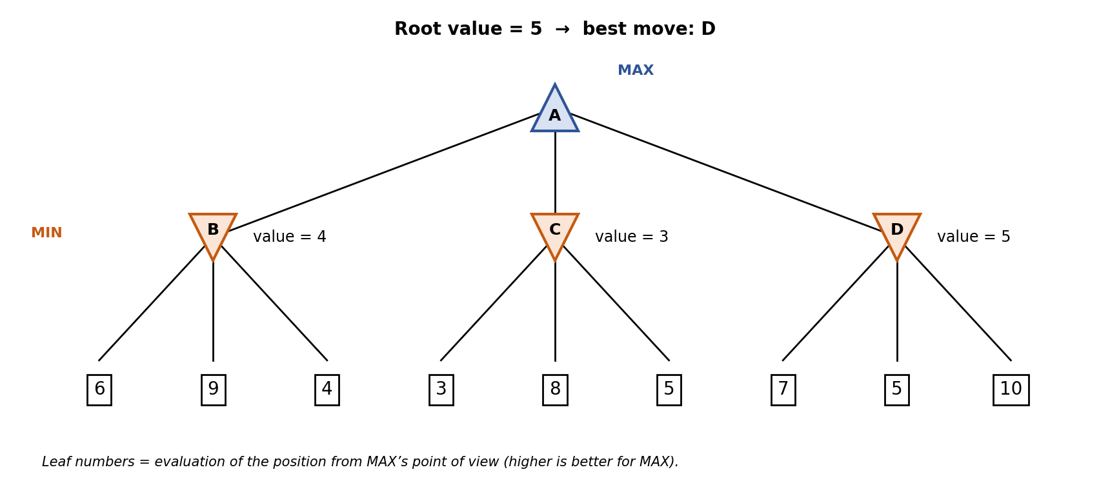
Node | Calculation | Value
B (MIN) | min(6, 9, 4) | 4
C (MIN) | min(3, 8, 5) | 3
D (MIN) | min(7, 5, 10) | 5
A (MAX) | max(4, 3, 5) | 5, so the optimal move is D

Result: MAX should play move D. Even if MIN replies in the best way for MIN, MAX is guaranteed at least 5, whereas B guarantees only 4 and C only 3. Minimax evaluated all 9 leaves.

Alpha-Beta Pruning Illustration (Activity 3)
The same tree is searched left to right. Alpha is the best value MAX can already guarantee; beta is the best value MIN can already guarantee. A branch is cut when beta ≤ alpha.
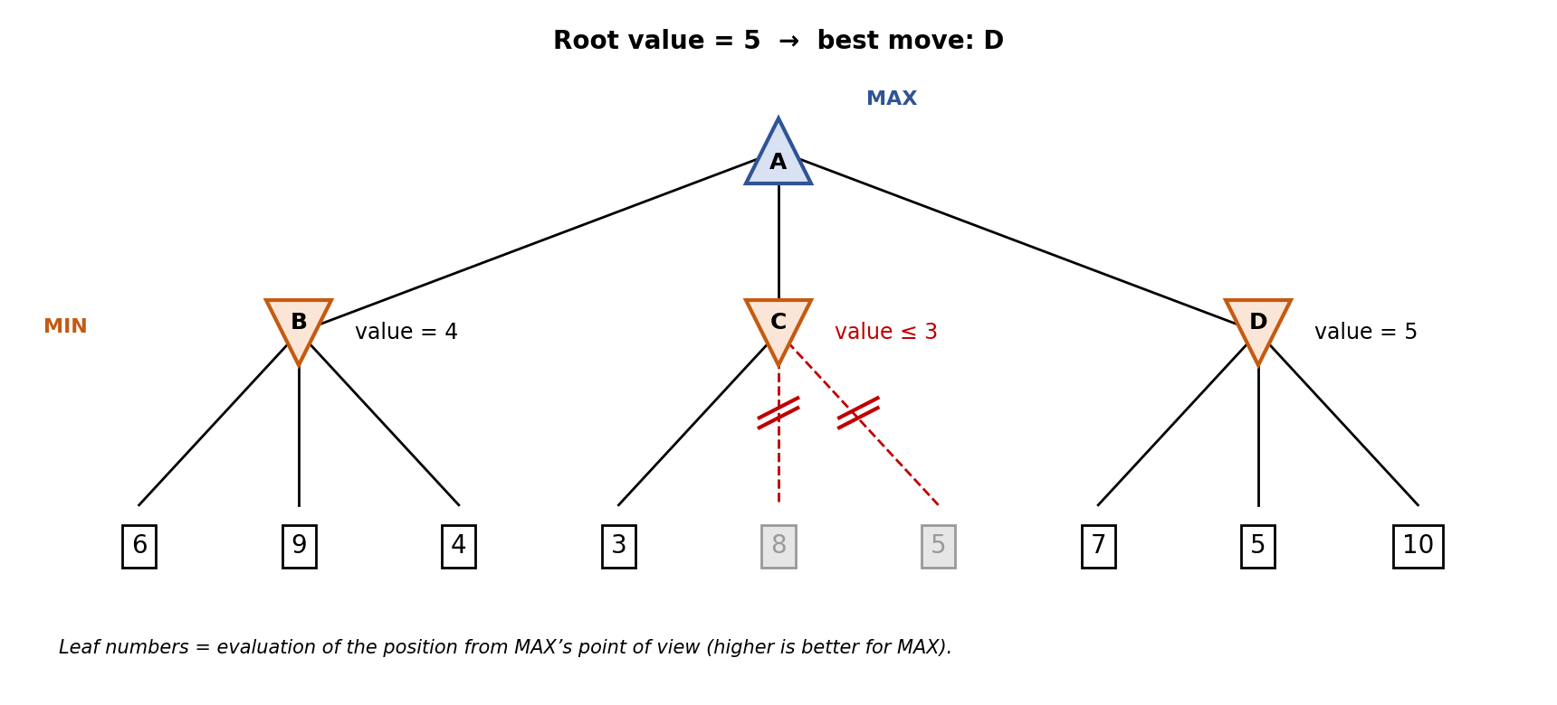
Step | Node visited | α | β | Action
1 | Root A, then B (MIN) | −∞ | +∞ | Start
2 | Leaves 6, 9, 4 under B | −∞ | 6 → 4 | B = 4; at A, α becomes 4
3 | C (MIN), leaf 3 | 4 | 3 | β = 3 ≤ α = 4: prune leaves 8 and 5
4 | D (MIN), leaves 7, 5, 10 | 4 | 7 → 5 | No cut (β stays above 4); D = 5; at A, α becomes 5
5 | Root A | 5 | +∞ | Best move D, value 5

How Pruning Improves Efficiency
- Result is the same as Minimax (move D, value 5) while only 7 of 9 leaves were evaluated.
- In C, MAX already has 4 from B, so MIN choosing 3 or less makes C useless; the remaining leaves cannot matter.
- With good move ordering, alpha-beta examines about O(b^(d/2)) nodes instead of O(b^d), which lets it search roughly twice as deep in the same time.

Engineering Recommendation Sheet (Activity 4)
Rule: Alpha-beta always returns the same decision as Minimax on the same tree, so it is preferred whenever the tree is large. Minimax alone is suitable only for tiny trees or teaching.
Application | Recommended | Justification | Caution
Chess AI | Alpha-Beta | Huge tree (about 35 moves per position). Pruning with good move ordering and iterative deepening allows much deeper lookahead within the clock. | Needs a strong evaluation function
Autonomous Drone Competition | Alpha-Beta (depth-limited) | Drones react to an opponent’s actions under real-time limits; pruning keeps lookahead fast. Use discrete manoeuvres at the strategy level. | Continuous motion needs low-level control too
Robot Soccer | Alpha-Beta for high-level tactics | Decide passes and positions by looking ahead at opponent replies; pruning keeps decisions inside the real-time loop. | Noisy sensing and teammates; combine with reactive control
Financial Trading Simulation | Alpha-Beta for worst-case analysis; Expectimax if markets are random | A worst-case view suits competing traders with clear moves, and pruning speeds it up. | Markets are not purely zero-sum and involve chance
Security Strategy Game | Alpha-Beta | Defender assumes a smart attacker and plans for the worst case; pruning handles the large set of attack and defence moves. | Real attackers may not be perfectly rational

Engineering Improvement Note (Activity 5)
Improvement recommended: combine a better evaluation function with iterative deepening and move ordering.
Existing AI | Depth-limited alpha-beta search with a simple evaluation (for chess, only material count).
Limitation | A weak evaluation misjudges positions at the depth limit, and poor move ordering gives little pruning, so the AI plays short-sighted moves.
Improvement 1: better evaluation | Add features such as king safety, piece mobility, pawn structure and centre control, with tuned weights.
Improvement 2: iterative deepening + move ordering | Search depth 1, 2, 3 and so on until time ends; use the best move from the previous depth first, which improves pruning and always keeps an answer ready.
Optional: learning component | Tune the evaluation weights from many self-played games instead of setting them by hand.
Expected benefit | Deeper effective search, stronger and more consistent play within the same time.
Trade-off | More computation per position and more effort to tune and test.

Ethics Corner
Concern: financial trading. An AI that only maximises profit against other traders may exploit small unfair advantages, trade at extreme speed or amplify a market crash, harming ordinary investors. In other competitive domains, such as online games, an AI may cheat or exploit players.
Balancing optimality with fairness and safety: put fairness and risk limits into the objective and rules (maximum loss, no manipulative patterns), add circuit breakers and human oversight, log decisions for audit, and test the AI under extreme scenarios before deployment. An optimal move is only acceptable if it is also legal, safe and fair.

Reflection (Activity 6)
Intelligent decision making needs prediction because a move changes the situation and the opponent replies. Reacting only to the current position can look good now but lose later, like grabbing a piece in chess that exposes the king. Minimax looks ahead at possible replies and assumes the opponent plays well, so the chosen move holds up in the future. Alpha-beta pruning makes this lookahead affordable by skipping branches that cannot change the decision.
Word count: 73 words.

Student Self-Assessment
☐ I understood strategic decision making.
☐ I correctly analysed a game tree.
☐ I applied Alpha-Beta Pruning logically.
☐ I justified my engineering recommendations.
☐ My reflection demonstrates my own understanding.

Assessment Rubric Mapping (10 Marks)
Criterion | Marks | Where addressed in this journal
Game Observation | 2 | Game Observation Table
Minimax Analysis | 2 | Minimax Game Tree and calculation
Alpha-Beta Pruning | 2 | Pruning illustration and step table
Engineering Recommendation | 2 | Recommendation Sheet, Improvement Note
Reflection & Presentation | 2 | Reflection, ethics corner, layout, references

References
1. S. Russell and P. Norvig, Artificial Intelligence: A Modern Approach, 4th ed., Pearson, 2020 (Adversarial Search and Games).
2. D. E. Knuth and R. W. Moore, “An Analysis of Alpha-Beta Pruning,” Artificial Intelligence, vol. 6, no. 4, 1975.
3. C. E. Shannon, “Programming a Computer for Playing Chess,” Philosophical Magazine, vol. 41, no. 314, 1950.
4. Course notes and lecture material, Artificial Intelligence, Module 3, Semester V.

Declaration: I confirm that the analysis and decisions in this journal reflect my own work.
Signature of Student: ____________________ Roll No: ____________

