AIML Track Engineering Investigation Journal
Artificial Intelligence, Sem-5
Engineering Investigation 6 (EI-6)
Engineering Knowledge Representation – Representing Intelligence Effectively

Cover Page
Student Name | ______________________________________
Roll No. / Division | ______________________________________
Programme / Semester | B.Tech (AIML Track) – Semester V
Course / Module | Artificial Intelligence – Module 4: Knowledge Representation
Investigation | EI-6: Engineering Knowledge Representation (10 Marks, Individual)
Course Outcomes | Primary CO3; Supporting CO6
Role (Scenario) | Knowledge Engineer, IntelliKnowledge Systems Pvt. Ltd.
Investigation Period | 1 Week (approx. 2 hours independent work)
Date of Submission | ______________________________________

Investigation Snapshot
Educational Question | How can engineers represent knowledge so that intelligent systems can reason effectively?
Framework Followed | Problem → Identify Knowledge → Represent → Compare → Recommend → Reflect
Primary Competency | Knowledge Engineering → Representation → Analytical Reasoning
Engineering Thought | Knowledge gains value only when it can be represented and reasoned with.
Selected Application | AI-based clinical decision support (Activities 2 and 5)
Submission | Handwritten Engineering Investigation Journal → PDF → MS Teams

Types of Knowledge Used in This Journal
Type | Meaning
Declarative | Facts about the world (for example, “influenza causes fever”).
Procedural | How to do something (steps, rules, algorithms).
Relational (semantic) | Links between concepts (is-a, part-of, has-symptom).
Heuristic | Rules of thumb from experts, often uncertain.

Knowledge Observation Table (Activity 1)
# | Application | Knowledge required | Example | Suitable representation
1 | Medical diagnosis | Symptom–disease relations, test results, patient history; heuristic and declarative | “Fever + rash + joint pain suggests dengue” | Production (IF–THEN) rules; ontology for medical terms
2 | Chatbot | Language patterns, user intents, dialogue context, domain facts | “Refund” + delivered order → refund-policy answer | Frames (slots) and semantic links between intents
3 | Navigation | Spatial map, distances, travel times, road rules; relational | Junction A connects to B with a 4-minute travel time | Graph / semantic network
4 | Expert system | Domain expert rules and facts; procedural and heuristic | If pressure is high and temperature is rising, open the relief valve | Production rules with a separate inference engine
5 | Recommendation system | User–item preferences, item features, similarity | Users who liked film X also liked film Y | Relational / feature tables with semantic categories

Observation Summary
- No single knowledge type is enough. Medical diagnosis needs facts, relations and heuristics together.
- The form of the knowledge suggests the representation: if-then expertise → rules, linked concepts → networks, structured objects → frames.

IF–THEN Rule Sheet (Activity 2): Clinical Decision Support
Illustrative knowledge base for learning purposes only; it is not medical advice. Facts are symptoms entered for a patient; rules derive conclusions from them.
Rule | IF (conditions) | THEN (conclusion)
R1 | fever AND cough | flu_like_illness
R2 | flu_like_illness AND body_ache | suspect_influenza
R3 | fever AND severe_headache AND joint_pain AND rash | suspect_dengue
R4 | suspect_dengue | recommend_blood_test (platelet count)
R5 | suspect_influenza | advise_rest_and_fluids
R6 | fever AND shortness_of_breath | urgent_referral
R7 | suspect_influenza AND age_above_65 | high_risk AND doctor_review

Example Use
Facts: fever, cough, body_ache. Rule R1 gives flu_like_illness; R2 then gives suspect_influenza; R5 gives advise_rest_and_fluids. Rules R3, R4, R6 and R7 do not fire because their conditions are not met.

Semantic Network / Concept Map
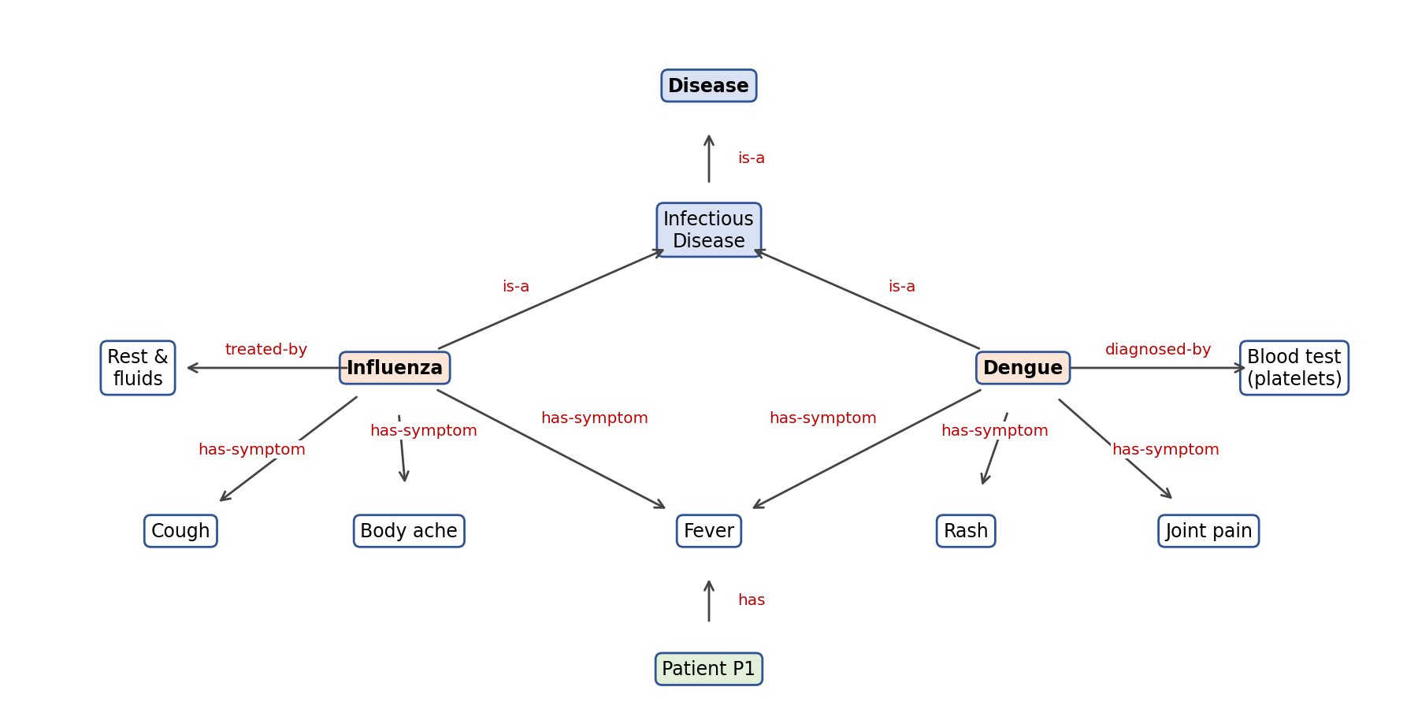
Reading the map: Influenza and Dengue are each an infectious disease (is-a), which is a disease. Each has symptoms, and the patient P1 has fever, so both diseases remain possible until other symptoms or tests separate them.

Engineering Comparison Table (Activity 3)
Aspect | Production rules | Semantic networks | Frames | Ontologies
Structure | IF–THEN statements | Nodes (concepts) joined by labelled links | Objects with slots and values | Formal concepts, properties, relations and axioms
Representation capability | Procedural and heuristic expertise | Relations and hierarchies (is-a, part-of) | Structured objects with defaults and inheritance | Shared vocabulary with precise meaning; supports automated reasoning
Flexibility | High: add or remove rules easily | Good for adding links; meaning of links can be vague | Good for stereotypes; less for unusual cases | High, but design needs effort and agreement
Scalability | Conflicts and slow matching as rules grow | Large networks become hard to read | Manageable if well organised | Scales well with tooling; needs maintenance
Strength | Easy to explain and modify | Clear visual, natural inheritance | Groups related facts in one place | Reusable and shareable between systems
Limitation | Poor for structure; rules may conflict | No standard semantics; exceptions awkward | Rigid slots, weak for procedures | Complex to build and validate
Engineering applications | Expert systems, diagnosis, fault finding | Concept maps, language understanding | Product catalogues, agri or object models | Medical terms (e.g. SNOMED CT), legal and semantic web

Engineering Recommendation (Activity 4)
Application | Recommended technique | Justification | Supporting technique
Hospital Expert System | Production rules | Clinical knowledge is naturally “IF symptoms THEN condition”, and doctors need each conclusion explained by the rule that fired. Rules are easy to review and update. | Ontology for standard medical terms
Smart Agriculture Advisor | Frames | Each crop, soil or pest is an object with slots (water need, season, soil type, pest risk) and default values. Frames group these attributes neatly and inherit from general crop types. | Rules for advice on top of the frames
Legal Advisory System | Ontologies | Law needs precisely defined concepts (contract, party, liability) and relations between acts, cases and clauses. An ontology keeps the meaning consistent and lets cases be linked and queried. | Rules for applying the law to facts
AI Tutor | Semantic network | Topics and their prerequisites form a network (Fractions → Ratios → Percentages). The tutor follows links to find what the student should learn next and what is missing. | Frames for student profile
Industrial Fault Diagnosis | Production rules | Symptom-to-fault expertise from engineers (IF pressure drops AND noise rises THEN bearing failure). Rules are quick to fire on sensor data and explain the fault. | Fault hierarchy as a semantic network

Selection rule: rule-like expertise → production rules; linked concepts → semantic network; objects with attributes → frames; shared and precise vocabulary → ontology. Real systems usually combine two techniques.

Engineering Improvement Note (Activity 5)
Selected model: production rules for the Hospital Expert System.
Problem | A flat list of hundreds of rules becomes slow to match, hard to maintain, and may contain conflicting or duplicate rules.
Improvement 1: modular rule base | Group rules by clinical area (respiratory, fever, cardiac), so only the relevant group is checked. This improves speed and maintainability.
Improvement 2: ontology vocabulary | Link rule terms to a standard medical ontology so “body_ache” and “myalgia” mean the same thing and knowledge can be shared.
Improvement 3: efficient matching and certainty | Use an efficient matching method (such as the Rete algorithm) and attach certainty factors to rules to handle uncertain evidence.
Improvement 4: maintenance process | Keep the knowledge base separate from the inference engine, version each rule, and run test cases after every change.
Expected benefit | Faster inference, easier updates, fewer conflicts and explainable results at larger scale.
Trade-off | Needs initial design effort and expert review time.

Ethics Corner
Incomplete knowledge: if rules were written mainly from male patient data, heart-attack symptoms that appear differently in women may be missed. Biased knowledge: a loan-approval knowledge base using postcode as a proxy can treat some communities unfairly. Incorrect knowledge: a wrong threshold in a legal or medical rule repeats the same error for every case.
Safeguards: review knowledge with diverse domain experts, test on varied cases, show which rule produced each decision, update regularly and keep a human responsible for the final decision.

Reflection (Activity 6)
Storing large amounts of data does not make a system intelligent, because unorganised information cannot support decisions. Correct representation arranges facts, rules and relationships so a system can search, link and infer. A hospital with millions of records but no rules connecting symptoms to diseases can answer nothing, while a small, well-structured rule base can diagnose. Good representation also makes knowledge easier to update, explain and verify, which matters more than sheer volume.
Word count: 73 words.

Student Self-Assessment
☐ I identified different types of knowledge.
☐ I correctly represented knowledge using rules and semantic relationships.
☐ I justified my engineering recommendations.
☐ My comparison was based on engineering reasoning.
☐ My reflection demonstrates my own understanding.

Assessment Rubric Mapping (10 Marks)
Criterion | Marks | Where addressed in this journal
Knowledge Observation | 2 | Knowledge Observation Table
Knowledge Representation | 2 | IF–THEN Rule Sheet, Semantic Network
Engineering Comparison | 2 | Comparison Table (rules, networks, frames, ontologies)
Engineering Recommendation | 2 | Recommendation table, Improvement Note
Reflection & Presentation | 2 | Reflection, ethics corner, layout, references

References
1. S. Russell and P. Norvig, Artificial Intelligence: A Modern Approach, 4th ed., Pearson, 2020 (Knowledge Representation).
2. R. J. Brachman and H. J. Levesque, Knowledge Representation and Reasoning, Morgan Kaufmann, 2004.
3. M. Minsky, “A Framework for Representing Knowledge,” MIT AI Laboratory Memo 306, 1974.
4. M. R. Quillian, “Semantic Memory,” in Semantic Information Processing, M. Minsky (ed.), MIT Press, 1968.
5. T. R. Gruber, “A Translation Approach to Portable Ontology Specifications,” Knowledge Acquisition, vol. 5, no. 2, 1993.
6. Course notes and lecture material, Artificial Intelligence, Module 4, Semester V.

Declaration: I confirm that the representation, analysis and recommendations in this journal reflect my own work.
Signature of Student: ____________________ Roll No: ____________

