AIML Track Engineering Investigation Journal
Artificial Intelligence, Sem-5
Engineering Investigation 7 (EI-7)
Engineering Logical Reasoning – Reasoning with Knowledge

Cover Page
Student Name | ______________________________________
Roll No. / Division | ______________________________________
Programme / Semester | B.Tech (AIML Track) – Semester V
Course / Module | Artificial Intelligence – Module 4: Knowledge Representation and Reasoning
Investigation | EI-7: Engineering Logical Reasoning (10 Marks, Individual)
Course Outcomes | Primary CO3; Supporting CO6
Role (Scenario) | Knowledge Engineer, LogicMind AI Solutions
Investigation Period | 1 Week (approx. 2 hours independent work)
Date of Submission | ______________________________________

Investigation Snapshot
Educational Question | How do intelligent systems draw logical conclusions from stored knowledge?
Framework Followed | Problem → Represent Knowledge → Apply Inference → Analyse → Conclude → Reflect
Primary Competency | Logical Reasoning → Inference → Engineering Decision Making
Engineering Thought | Good engineering decisions are built on sound reasoning.
Techniques Studied | Forward chaining, backward chaining, propositional and first-order logic
Submission | Handwritten Engineering Investigation Journal → PDF → MS Teams

Representation versus Reasoning
Knowledge representation decides how facts and rules are stored. Reasoning (inference) uses those stored rules to derive new facts and conclusions. This journal covers reasoning: the rule base is given and the work is to infer from it.

Reasoning Observation Table (Activity 1)
# | AI system | Knowledge used | How it reasons logically | Reasoning style
1 | Medical diagnosis | Symptom–disease rules, patient facts | From symptoms derives likely conditions, or tests a hypothesis (is it influenza?) by checking its required symptoms | Forward and backward chaining
2 | Chatbot | Intent rules, dialogue state, policies | IF the user says “refund” AND the order is delivered THEN use the refund-policy flow | Forward chaining on dialogue state
3 | Fraud detection | Rules on amount, location, time, history | IF large amount AND new country AND unusual hour THEN flag as high risk | Forward chaining on transaction events
4 | Technical support | Troubleshooting rules and symptom checks | Starts from a goal (find the cause of no internet) and asks only the questions needed to prove or reject it | Backward chaining
5 | Legal advisory | Legal rules, case facts, definitions | IF a contract exists AND it was breached AND loss occurred THEN a claim is valid; uses variables over parties and contracts | First-order logic with chaining

Observation Summary
- Systems that react to incoming data (chatbot, fraud) tend to use forward chaining; systems that test a specific question (support, diagnosis) tend to use backward chaining.
- The legal example needs variables and quantifiers, so propositional logic is not enough there.

Forward Chaining Solution (Activity 2)

Rule Base and Facts
Rule | IF (conditions) | THEN
R1 | fever AND cough | flu_like
R2 | flu_like AND body_ache | influenza
R3 | influenza AND age_above_65 | high_risk
R4 | influenza | advise_rest_fluids
R5 | high_risk | refer_doctor
Given facts: fever, cough, body_ache, age_above_65.

Inference Steps (data-driven)
Cycle | Rule that fires | New fact added | Known facts afterwards
1 | R1: fever, cough are true | flu_like | 4 given + flu_like
2 | R2: flu_like, body_ache are true | influenza | + influenza
3 | R3: influenza, age_above_65 are true | high_risk | + high_risk
3 | R4: influenza is true | advise_rest_fluids | + advise_rest_fluids
4 | R5: high_risk is true | refer_doctor | + refer_doctor
5 | No rule can add a new fact | - | Stop

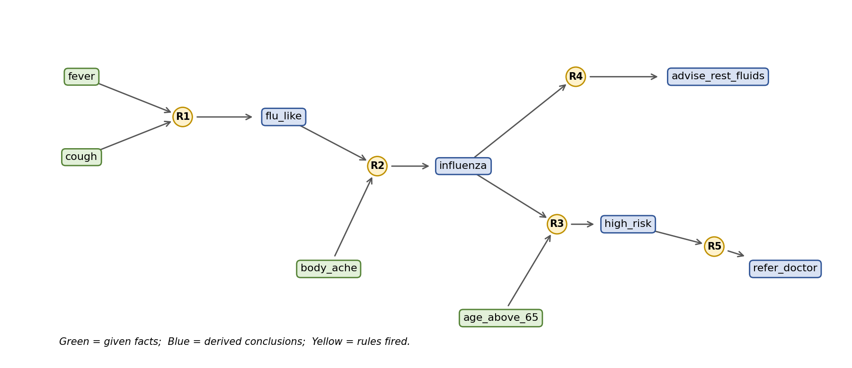
Final conclusion: the patient has influenza, is high risk, should rest and take fluids, and must be referred to a doctor (refer_doctor).

Backward Chaining Solution (Activity 3)
Goal: Can the system prove refer_doctor? (same rule base and facts as the forward chaining solution).
Step | Goal being proved | Rule used / sub-goals created | Result
1 | refer_doctor | R5: needs high_risk | Open
2 | high_risk | R3: needs influenza AND age_above_65 | Open
3 | influenza | R2: needs flu_like AND body_ache | Open
4 | flu_like | R1: needs fever AND cough | Open
5 | fever, cough | Both are given facts | True
6 | body_ache | Given fact | True
7 | age_above_65 | Given fact | True
8 | Back up: flu_like, influenza, high_risk, refer_doctor | Each sub-goal is now proved | True

Conclusion: the goal refer_doctor is achievable. Only rules R5, R3, R2 and R1 were examined; R4 was never needed.

A Goal That Fails
Step | Goal being proved | Reasoning | Result
1 | advise_antibiotics | No rule has advise_antibiotics in its THEN part, and it is not a given fact | False
2 | Outcome | The system cannot establish it, so it would ask the user or report “unknown” | Fails

Observation: forward chaining produced five new facts, while backward chaining worked only on the single goal and explored four rules.

Engineering Comparison (Activity 4)
Aspect | Forward chaining | Backward chaining
Working principle | Data-driven: starts from known facts and applies rules until no new fact appears. | Goal-driven: starts from a goal and works back to find facts that prove it.
Direction | Facts → conclusions | Goal → sub-goals → facts
Efficiency | May derive many facts that are irrelevant to the question. | Explores only rules related to the goal; may re-prove the same sub-goal.
Advantages | Good for monitoring and real-time alerts; discovers all consequences. | Focused, asks only relevant questions; efficient with many rules and a specific goal.
Limitations | Can waste effort on unneeded conclusions. | Needs a clear goal; can loop on circular rules.
Suitable applications | Monitoring, alarms, configuration, fraud detection. | Diagnosis, troubleshooting, question answering.
Example tools | CLIPS, production systems | Prolog, MYCIN-style expert systems

Propositional Logic versus First-Order Logic
Aspect | Propositional logic | First-order logic (FOL)
Basic units | Whole statements that are true or false. | Objects, predicates, variables and quantifiers.
Clinical example | fever ∧ cough → flu_like | ∀p (HasSymptom(p, fever) ∧ HasSymptom(p, cough) → FluLike(p))
Strength | Simple and fast to decide. | Expresses rules for all patients or objects at once.
Limitation | One rule needed for every patient or case. | Harder to reason with; can be undecidable in general.

Engineering Recommendation (Activity 5)
Application | Recommended strategy | Justification | Note
Hospital Diagnosis | Backward chaining | The doctor forms a hypothesis (is it influenza?), and the system asks only for the symptoms and tests that can prove or reject it, avoiding unnecessary questions and tests. | Forward chaining can also monitor live vitals
Customer Support Expert System | Backward chaining | Starts from the goal of finding the cause of the problem and asks the customer short targeted questions, which shortens the call. | Keep a clear question order
Industrial Fault Diagnosis | Forward chaining | Sensor readings stream in continuously; rules fire as data arrives to detect faults quickly. | Add backward chaining to confirm the cause
Smart Agriculture Advisor | Forward chaining | Soil moisture, weather and crop stage are sensed regularly, and recommendations (irrigate, spray, wait) follow from these facts. | Rules should be seasonal
Cybersecurity Alert System | Forward chaining | Events such as failed logins and unusual traffic arrive in real time; rules combine them to raise alerts at once. | Tune rules to reduce false alarms

Ethics Corner
Consequences of incorrect reasoning: in healthcare a wrong inference can delay treatment or cause harm; in autonomous driving, deciding that “the road is clear” from incomplete facts can cause a crash; in legal support, a wrong rule can deny a valid claim.
Improving trustworthiness: show the chain of rules behind each conclusion (explanation), have domain experts verify rules, test with many scenarios, check the rule base for contradictions, keep a human in the loop for high-risk decisions, log decisions for audit, and monitor the system after deployment.

Reflection (Activity 6)
Knowledge alone is passive: a knowledge base stores facts and rules but cannot decide anything. Reasoning applies those rules to new facts and produces conclusions, such as moving from symptoms to a diagnosis and then to a recommended action. Forward chaining derives everything possible from the data, while backward chaining checks one specific goal. Sound, step-by-step inference also makes decisions explainable and trustworthy, which is why reasoning turns stored knowledge into intelligent decisions.
Word count: 73 words. (The sheet says 50–100 words in Activity 6 but 150–200 in the deliverables list; confirm with your teacher and expand if needed.)

Student Self-Assessment
☐ I correctly applied forward chaining.
☐ I correctly applied backward chaining.
☐ I justified my engineering recommendations.
☐ I understood the role of logical inference.
☐ My reflection demonstrates independent thinking.

Assessment Rubric Mapping (10 Marks)
Criterion | Marks | Where addressed in this journal
Reasoning Observation | 2 | Reasoning Observation Table
Inference Solutions | 2 | Forward and Backward Chaining Solutions
Engineering Comparison | 2 | FC vs BC table; propositional vs FOL
Engineering Recommendation | 2 | Recommendation table, Ethics Corner
Reflection & Presentation | 2 | Reflection, layout, references

References
1. S. Russell and P. Norvig, Artificial Intelligence: A Modern Approach, 4th ed., Pearson, 2020 (Logical Agents; First-Order Logic; Inference).
2. R. J. Brachman and H. J. Levesque, Knowledge Representation and Reasoning, Morgan Kaufmann, 2004.
3. B. G. Buchanan and E. H. Shortliffe, Rule-Based Expert Systems: The MYCIN Experiments of the Stanford Heuristic Programming Project, Addison-Wesley, 1984.
4. Course notes and lecture material, Artificial Intelligence, Module 4, Semester V.

Common Mistakes Avoided
Common mistake | How it was avoided in this journal
Confusing representation with reasoning | Cover page separates storing knowledge from inferring with it.
Skipping intermediate steps | Every cycle and sub-goal is listed in the tables.
Choosing a strategy without justification | Each recommendation has a reason and a note.
Treating forward and backward chaining as identical | Separate solutions and a comparison table.
Copying logic examples without analysis | Own clinical rule base, analysed in both directions.

Declaration: I confirm that the reasoning and analysis in this journal reflect my own work.
Signature of Student: ____________________ Roll No: ____________

