AIML Track Engineering Investigation Journal
Artificial Intelligence, Sem-5
Engineering Investigation 8 (EI-8)
Engineering Intelligent Planning – Planning Actions for Goal Achievement

Cover Page
Student Name | ______________________________________
Roll No. / Division | ______________________________________
Programme / Semester | B.Tech (AIML Track) – Semester V
Course / Module | Artificial Intelligence – Module 5: Planning and Learning
Investigation | EI-8: Engineering Intelligent Planning (10 Marks, Individual)
Course Outcomes | Primary CO4; Supporting CO6
Role (Scenario) | AI Planning Engineer, Smart Autonomous Systems Pvt. Ltd.
Investigation Period | 1 Week (approx. 2 hours independent work)
Date of Submission | ______________________________________

Investigation Snapshot
Educational Question | How do intelligent systems plan a sequence of actions to achieve a goal?
Framework Followed | Problem → Define Goal → Plan → Evaluate → Improve → Reflect
Primary Competency | Planning → Goal Formulation → Engineering Decision Making
Engineering Thought | Every intelligent action begins with a well-designed plan.
Selected System | Hospital Medicine Delivery Robot (Activities 2 and 3)
Submission | Handwritten Engineering Investigation Journal → PDF → MS Teams

Planning Terms Used
Term | Meaning
State | A complete description of the world at one moment (robot location, load, battery).
Goal state | The condition that must be true when the task is finished; it must be specific and testable.
Action | A step with preconditions (what must be true first) and effects (what changes).
Constraint | A limit the plan must respect (time, battery, safety, resources).
Plan | An ordered sequence of actions that transforms the initial state into the goal state.
Planning versus search: search is a method for exploring states; planning is the wider task of choosing a sequence of actions with preconditions, effects and constraints. Planners often use search inside them.

Planning Observation Table (Activity 1)
# | System | Initial state | Goal state | Possible actions | Constraints
1 | Autonomous Warehouse Robot | At charging dock, empty; order for item X on shelf B7; battery 90% | Item X delivered to packing station P2 with battery above 20% | Move along aisle, lift item, carry, place, avoid obstacle, recharge | Blocked aisles, other robots, payload limit, battery
2 | Hospital Medicine Delivery Robot | At pharmacy; medicines for Ward 3 ready; battery 80% | Medicine handed to the authorised nurse in Ward 3 within 15 minutes | Load, navigate corridor, call lift, open door, authenticate, hand over | Patient safety, lift availability, locked compartment, time limit
3 | Food Delivery Robot | At restaurant; order packed in the box | Order handed to the customer at the given address before the promised time | Navigate sidewalk, wait at crossing, climb kerb, notify customer, unlock lid | Traffic signals, weather, battery, speed limit, food temperature
4 | Airport Service Robot | At help desk; passenger asks for Gate 14 | Passenger escorted to Gate 14 before boarding closes | Plan route, guide, announce, avoid crowds, answer queries | Crowds, restricted zones, walking speed, boarding time, battery
5 | Smart Irrigation System | Soil moisture 25% (target 45%); tank 60%; no rain expected | Soil moisture 45–50% using the least water | Open valve, run pump, close valve, delay, send alert | Tank level, night-time watering rule, rain forecast, pressure limit

Observation Summary
- All five are goal-based systems: each has a clear goal state, so success can be tested.
- Constraints shape the plan: a plan that ignores battery, safety or time limits is not a valid plan.

Planning Worksheet (Activity 2): Hospital Medicine Delivery Robot
Initial state | Robot at pharmacy, compartment empty, battery 80%, delivery order for Ward 3 (2nd floor) received.
Goal state | Medicine handed to the authorised nurse in Ward 3, delivery recorded, robot back at the dock and charging, within 15 minutes.

Step | Action | Precondition | Intermediate state after action
1 | Load medicines and lock compartment | Order verified by pharmacist | At pharmacy; loaded and locked
2 | Check battery and confirm route | Battery above 30% | Route confirmed; battery sufficient
3 | Navigate to the lift lobby | Corridor clear | At ground-floor lift lobby
4 | Call lift and enter | Lift available and empty enough | Inside the lift
5 | Exit at the 2nd floor | Lift doors open at floor 2 | At 2nd-floor lift lobby
6 | Navigate corridor to Ward 3 nurse station, avoiding people | Path clear; speed within limit | At Ward 3 nurse station
7 | Authenticate nurse (ID card or PIN) | Nurse present | Nurse verified
8 | Unlock compartment and hand over medicine | Nurse verified | Medicine delivered
9 | Confirm delivery in the hospital system | Delivery completed | Delivery logged
10 | Return to dock and charge | Task complete | At dock; charging

Expected final state: medicine delivered and logged, compartment empty and locked, robot docked and charging, no collisions, total time under 15 minutes.
Constraint check: battery (step 2), safety (steps 3 and 6), lift availability (step 4), identity (steps 7 and 8) and time (whole plan) are each handled by a step or precondition.

Engineering Comparison of Two Planning Strategies (Activity 3)
Situation: three routine medicine orders for Wards 3, 5 and 7 are waiting. Plan A: one dedicated trip per order. Plan B: one batched trip that visits all three wards in the planned order. (Figures are illustrative estimates.)
Criterion | Plan A: single-order trips | Plan B: batched multi-stop trip
Number of actions | About 30 (10 actions × 3 trips) | About 18 (shared load, lift and return steps)
Efficiency | Lower: repeated trips through the same corridors and lifts | Higher: shared route and lift use
Resource utilisation | 3 battery cycles and 3 lift rides | 1 battery cycle and 1–2 lift rides
Time required | About 54 minutes for all three | About 30 minutes for all three
Risk | Lower per order; but more time in busy corridors in total | Later wards wait longer; risk of mixing orders; urgent medicine could be delayed

Recommendation
Plan B (batched trip) is better for routine orders because it needs fewer actions, less battery and less time. Its risks are controlled by (1) separate locked compartments for each ward, (2) verification at every handover and (3) a priority rule: an urgent order triggers Plan A (a direct trip) immediately.

Planning Flow Diagram (Activity 4)
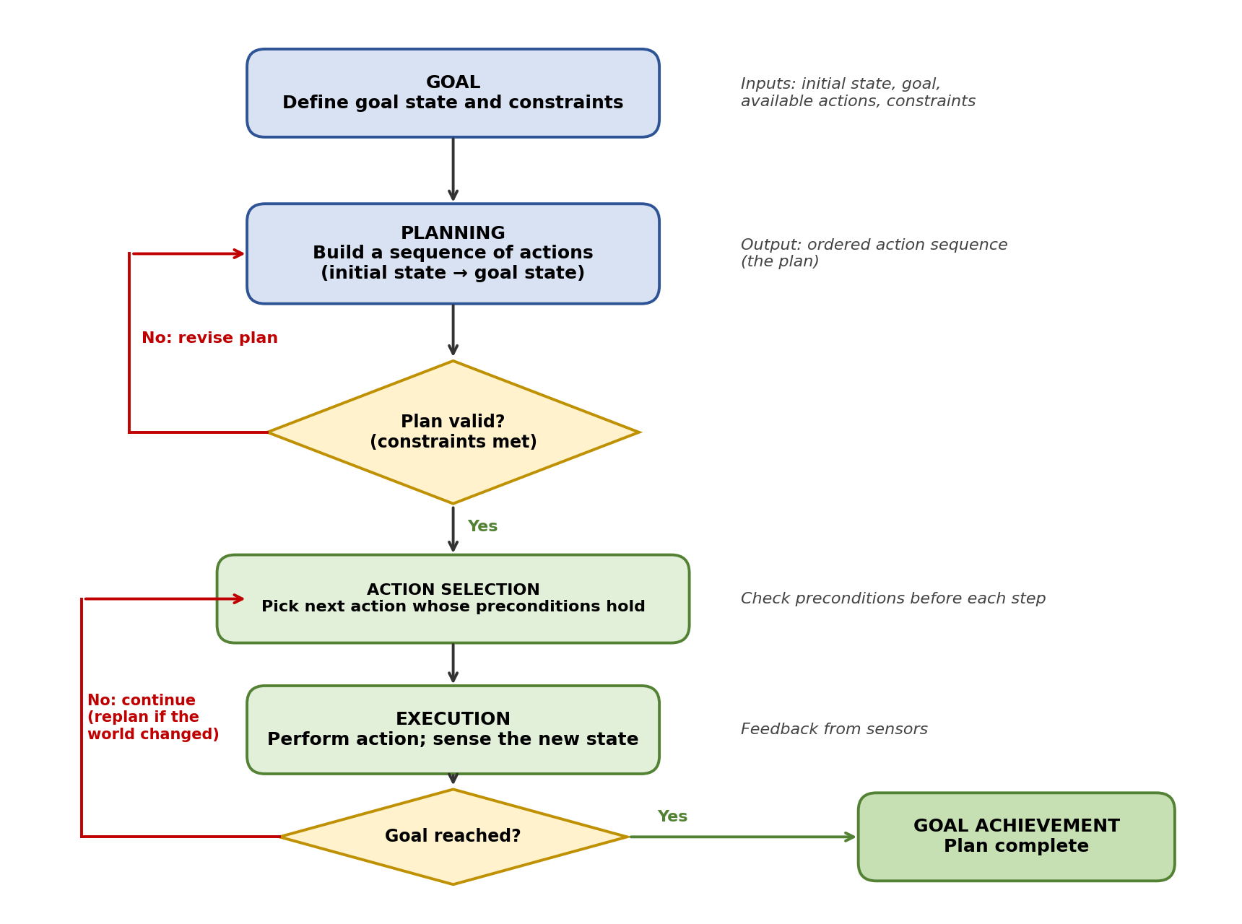
Explanation: the system starts with a clearly defined goal and constraints, builds a plan, and checks that the plan satisfies the constraints. It then selects each action only when its preconditions hold, executes it, and senses the new state. If the goal is not reached, it continues with the next action and replans when the world has changed (for example, a blocked corridor). When the goal test succeeds, the goal is achieved.

Engineering Recommendation Sheet (Activity 5)
Application | Recommended strategy | Justification | Constraint handled
Warehouse Robot | Classical (STRIPS-style) planning with A* path search | The map and actions are known and deterministic, so a complete plan can be made in advance. A* gives shortest paths, and a task allocator assigns orders to robots. | Battery, aisle blocking, multi-robot conflicts
Hospital Robot | Hierarchical task network (HTN) planning with replanning | “Deliver medicine” breaks naturally into sub-tasks (load, travel, authenticate, hand over). Hierarchy keeps the plan clear, and replanning handles blocked corridors. | Safety, identity check, time
Smart Agriculture | Scheduled, forecast-based planning (receding horizon) | Plan watering for the next 24 hours from weather forecast and soil data, and update the plan each day. The environment changes slowly, so a periodic plan is enough. | Water limit, rain forecast, night rule
Disaster Rescue Robot | Conditional planning with online replanning | The environment is unknown and changing (collapsed paths, new victims). Plans must include alternatives and be revised as new information arrives. | Uncertainty, hazards, limited energy
Autonomous Drone | Hybrid: global route planning plus local reactive avoidance | A global plan (A*) gives an efficient route, while fast reactive rules avoid sudden obstacles such as birds or wind gusts that a slow planner could miss. | Battery, no-fly zones, obstacles

Ethics Corner
Situation: a hospital robot plan that does not verify patient identity, or that relies on an out-of-date record (the patient has been transferred), could deliver the wrong medicine to the wrong person, with serious harm.
Engineering measure: make identity verification (barcode or ID match) a mandatory precondition of the hand-over action, and add live monitoring with a safe stop and human confirmation whenever the robot’s state information is uncertain.

Reflection (Activity 6)
Reacting to events handles only the present moment, while planning looks ahead to reach a goal efficiently and safely. A hospital medicine robot that only reacts may head straight for the ward, get stuck at a busy lift or run low on battery. A planning robot checks the battery, selects a route, schedules the lift and includes a patient verification step before moving. Planning avoids dead ends, saves resources and keeps constraints satisfied, making behaviour reliable and safe.
Word count: 78 words.

Student Self-Assessment
☐ I correctly identified goals and constraints.
☐ I prepared a logical planning sequence.
☐ I compared alternative plans objectively.
☐ I justified my engineering recommendations.
☐ My reflection demonstrates my own understanding.

Assessment Rubric Mapping (10 Marks)
Criterion | Marks | Where addressed in this journal
Planning Observation | 2 | Planning Observation Table
Planning Worksheet | 2 | Planning Worksheet (hospital robot)
Planning Analysis | 2 | Plan A vs Plan B comparison, Planning Flow Diagram
Engineering Recommendation | 2 | Recommendation Sheet, Ethics Corner
Reflection & Presentation | 2 | Reflection, layout, references

References
1. S. Russell and P. Norvig, Artificial Intelligence: A Modern Approach, 4th ed., Pearson, 2020 (Classical Planning; Planning and Acting in the Real World).
2. M. Ghallab, D. Nau and P. Traverso, Automated Planning: Theory and Practice, Morgan Kaufmann, 2004.
3. R. E. Fikes and N. J. Nilsson, “STRIPS: A New Approach to the Application of Theorem Proving to Problem Solving,” Artificial Intelligence, vol. 2, nos. 3–4, 1971.
4. K. Erol, J. Hendler and D. S. Nau, “HTN Planning: Complexity and Expressivity,” Proceedings of AAAI-94, 1994.
5. Course notes and lecture material, Artificial Intelligence, Module 5, Semester V.

Common Mistakes Avoided
Common mistake | How it was avoided in this journal
Confusing planning with search | Planning terms page explains the difference; plans use preconditions and effects.
Ignoring constraints | Every worksheet step shows its precondition and constraint check.
Vague goal states | Goals are specific and testable (who, what, where, time).
No justification for recommendations | Each strategy has a reason and a constraint it handles.
Actions without logical sequence | Steps are numbered with state after each action.

Declaration: I confirm that the plans and analysis in this journal reflect my own work.
Signature of Student: ____________________ Roll No: ____________

