Machine Learning – Assignment Solution Journal
Machine Learning
Assignment 10
Unsupervised Learning: Clustering

Cover Page
Student Name | ______________________________________
Roll No. / Division | ______________________________________
Course | Machine Learning
Semester / Course Code | ______________________________________
Batch | ______ (answer only your own batch in Question 3)
Maximum Marks | 15 (as given on the sheet)
Date of Submission | ______________________________________

Questions (from the assignment sheet)
Q. | Question
Q1 | Compare K-Means, hierarchical, DBSCAN and EM clustering: working principles, advantages, limitations and suitable applications (same for all batches).
Q2 | DBSCAN numerical (batchwise): find ε-neighbourhoods, core, border and noise points and the resulting clusters.
Q3 | K-Means numerical (batchwise): distances, assignment, new centroids, repetition until convergence, final clusters and centroids.
Format | Handwritten in the theory notebook; neat diagrams; justify with reasoning; date, name and roll number on the first page.

Marking Scheme at a Glance (15 Marks)
Q. | Component | Marks | Where in this journal
Q1 | Working principles (1.5) + advantages (1) + limitations (1) + applications (1) + summary comparison (0.5) | 5 | Section 1
Q2 | Distances and neighbourhoods (2) + MinPts condition (1) + classification (1) + clusters and justification (1) | 5 | Q2 of your batch
Q3 | Distances (1.5) + assignment (1) + new centroids (1) + repetition (1) + final result (0.5) | 5 | Q3 of your batch
The sheet gives 15 marks but no marks per question. A split of 5 + 5 + 5 is assumed. Q1 is the same for all batches; Q2 and Q3 are solved for all four batches, and you submit only your own batch.

1. Comparison of Clustering Techniques [Q1: 5 Marks]
Marking scheme (5 marks): working principles (1.5) + advantages (1) + limitations (1) + suitable applications (1) + summary comparison (0.5).

Working principles (1.5 marks)
Technique | Working principle
K-Means | Choose K and K initial centroids; assign every point to the nearest centroid; recompute each centroid as the mean of its points; repeat until the assignments do not change. It minimises the within-cluster sum of squares and gives hard (one cluster per point) assignments.
Hierarchical (agglomerative) | Start with every point as its own cluster and repeatedly merge the two closest clusters (distance by single, complete, average or Ward linkage) until one cluster remains. The merges are recorded in a dendrogram, which is cut at a chosen height to get clusters. (Divisive clustering works top-down by splitting.)
DBSCAN | Uses two parameters: radius ε and MinPts. A point with at least MinPts points within ε is a core point. Clusters grow by joining core points and the points in their neighbourhoods (density-reachability); border points join a nearby cluster; points belonging to no cluster are noise.
EM (Expectation Maximization, Gaussian mixture model) | Assumes the data comes from K Gaussian distributions. E-step: compute for each point the probability (responsibility) of belonging to each component, γᵢₖ = πₖ N(xᵢ | μₖ, Σₖ) / Σⱼ πⱼ N(xᵢ | μⱼ, Σⱼ). M-step: update the means, covariances and mixing weights using these responsibilities. Repeat until the log-likelihood stops improving. It gives soft (probabilistic) assignments.

Advantages (1 mark)
Technique | Advantages
K-Means | Simple, fast and scalable to large data; easy to interpret (centroids); works well for compact, well-separated clusters.
Hierarchical | No need to fix K in advance; the dendrogram shows structure at all levels; works with any distance and gives a deterministic result; good for small data and taxonomies.
DBSCAN | Finds clusters of any shape; does not need K; detects noise and outliers; only two parameters.
EM | Soft assignments with probabilities; can model elliptical clusters of different sizes and orientations; gives a full probabilistic model (density estimation); can handle some missing data.

Limitations (1 mark)
Technique | Limitations
K-Means | K must be chosen; results depend on the initial centroids (local optimum); sensitive to outliers; assumes round clusters of similar size; needs numeric, scaled features.
Hierarchical | Slow and memory-heavy for large data (at least O(n²)); merges cannot be undone; sensitive to noise and the linkage choice.
DBSCAN | Sensitive to the choice of ε and MinPts; struggles with clusters of different densities and with high-dimensional data; not suited for very large data without an index.
EM | Needs K and a distribution assumption (usually Gaussian); depends on initialisation and may reach a local optimum; slower than K-Means; can fail when a component collapses onto few points.

Suitable applications (1 mark)
Technique | Applications
K-Means | Customer segmentation, image compression (colour quantisation), document grouping, initial grouping of large data sets.
Hierarchical | Gene expression and biological taxonomies, social network communities, document hierarchies, small data sets where a tree is useful.
DBSCAN | Geographic and spatial data (finding hotspots), anomaly and fraud detection, clustering with noise, irregularly shaped groups.
EM | Speaker and voice recognition, image segmentation, density estimation, anomaly detection, clustering when overlapping groups and probabilities are needed.

Summary comparison (0.5 mark)
 | K-Means | Hierarchical | DBSCAN | EM (Gaussian mixture)
Cluster shape | Spherical | Depends on linkage | Arbitrary | Elliptical (Gaussian)
Number of clusters | Given (K) | Chosen by cutting the dendrogram | Found automatically | Given (K components)
Assignment | Hard | Hard | Hard (noise allowed) | Soft (probabilities)
Outliers | Sensitive | Sensitive | Robust (noise) | Fairly sensitive
Scalability | Very good | Poor | Moderate | Moderate
Parameters | K, initial centroids | Linkage, distance | ε, MinPts | K, initial parameters

Batch 1 : Set 1

Q2. DBSCAN with ε = 2 and MinPts = 3 [5 Marks]
Marking scheme (5 marks): distances and ε-neighbourhoods (2) + MinPts condition (1) + classification into core, border and noise (1) + final clusters with justification (1).
Data points: P1 (1, 1), P2 (1, 2), P3 (2, 1), P4 (7, 7), P5 (8, 7), P6 (7, 8), P7 (14, 14).
Convention: the ε-neighbourhood of a point contains every point (including itself) whose Euclidean distance from it is at most ε, where distance = √((x₁ − x₂)² + (y₁ − y₂)²). A point is a core point if its neighbourhood has at least MinPts points (counting itself). A border point is not core but lies in the neighbourhood of a core point. All other points are noise.
Step 1: pairwise distances (2 marks together with Step 2).
 | P1 | P2 | P3 | P4 | P5 | P6 | P7
P1 (1, 1) | 0.00 | 1.00 | 1.00 | 8.49 | 9.22 | 9.22 | 18.38
P2 (1, 2) | 1.00 | 0.00 | 1.41 | 7.81 | 8.60 | 8.49 | 17.69
P3 (2, 1) | 1.00 | 1.41 | 0.00 | 7.81 | 8.49 | 8.60 | 17.69
P4 (7, 7) | 8.49 | 7.81 | 7.81 | 0.00 | 1.00 | 1.00 | 9.90
P5 (8, 7) | 9.22 | 8.60 | 8.49 | 1.00 | 0.00 | 1.41 | 9.22
P6 (7, 8) | 9.22 | 8.49 | 8.60 | 1.00 | 1.41 | 0.00 | 9.22
P7 (14, 14) | 18.38 | 17.69 | 17.69 | 9.90 | 9.22 | 9.22 | 0.00

Step 2: ε-neighbourhoods and the MinPts condition. Points at distance ≤ 2 are neighbours.
Point | Coordinates | ε-neighbourhood Nε | Count | Count ≥ 3?
P1 | (1, 1) | {P1, P2, P3} | 3 | Yes
P2 | (1, 2) | {P1, P2, P3} | 3 | Yes
P3 | (2, 1) | {P1, P2, P3} | 3 | Yes
P4 | (7, 7) | {P4, P5, P6} | 3 | Yes
P5 | (8, 7) | {P4, P5, P6} | 3 | Yes
P6 | (7, 8) | {P4, P5, P6} | 3 | Yes
P7 | (14, 14) | {P7} | 1 | No

Step 3: classification (1 mark).
Point | Coordinates | Type | Reason
P1 | (1, 1) | Core | Neighbourhood has 3 ≥ 3 points.
P2 | (1, 2) | Core | Neighbourhood has 3 ≥ 3 points.
P3 | (2, 1) | Core | Neighbourhood has 3 ≥ 3 points.
P4 | (7, 7) | Core | Neighbourhood has 3 ≥ 3 points.
P5 | (8, 7) | Core | Neighbourhood has 3 ≥ 3 points.
P6 | (7, 8) | Core | Neighbourhood has 3 ≥ 3 points.
P7 | (14, 14) | Noise | Only 1 point(s) in its neighbourhood (less than 3) and no core point within ε.

Step 4: cluster formation (1 mark).
- Start a new cluster C1 from the unvisited core point P1 (1, 1).
- P1 is core: its neighbourhood {P1, P2, P3} adds {P2, P3} to C1.
- P2 is core: its neighbourhood {P1, P2, P3} adds no new points to C1.
- P3 is core: its neighbourhood {P1, P2, P3} adds no new points to C1.
- Start a new cluster C2 from the unvisited core point P4 (7, 7).
- P4 is core: its neighbourhood {P4, P5, P6} adds {P5, P6} to C2.
- P5 is core: its neighbourhood {P4, P5, P6} adds no new points to C2.
- P6 is core: its neighbourhood {P4, P5, P6} adds no new points to C2.
- The remaining points are not density-reachable from any core point, so they are marked as noise.
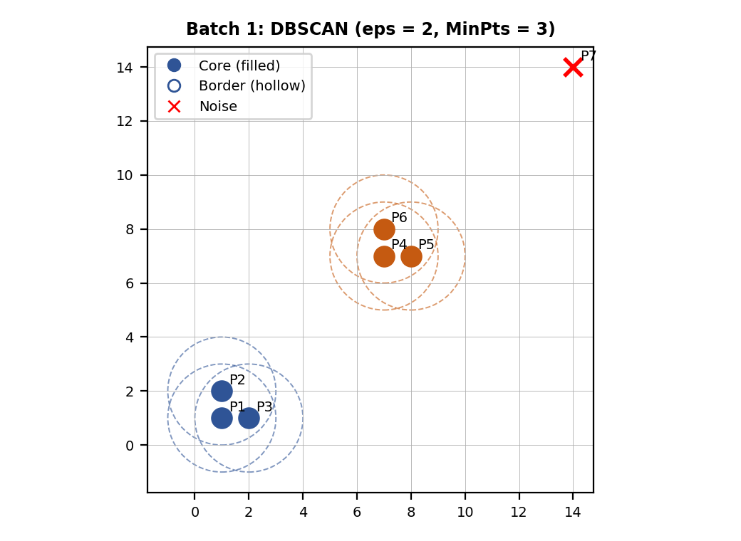
Result: Cluster C1 = {P1, P2, P3}; Cluster C2 = {P4, P5, P6}. Noise = {P7}. Core points: P1, P2, P3, P4, P5, P6. Border points: none.
Justification: each tight group has exactly 3 points, all within ε of each other, so every point of the group has 3 points in its neighbourhood and is a core point; the points of one group are density-reachable from each other and form one cluster. The two groups are far apart (more than ε), so they are separate clusters. The isolated point P7 has only itself in its neighbourhood and is noise. There are no border points because every non-isolated point already satisfies MinPts.

Q3. K-Means Clustering with K = 2 [5 Marks]
Marking scheme (5 marks): distances from the centroids (1.5) + assignment to the nearest centroid (1) + new centroids (1) + repetition until the centroids do not change (1) + final clusters and centroids (0.5).
Data points: P1 (1, 1), P2 (2, 1), P3 (1, 2), P4 (8, 8), P5 (9, 8), P6 (8, 9). Initial centroids: C1 = (1, 1), C2 = (8, 8).
Method: distance d = √((x − cₓ)² + (y − cᵧ)²). Each point goes to the centroid with the smallest distance; each new centroid is the mean of its points. Example: d(P2, C1) with P2 = (2, 1) and C1 = (1, 1) is √((2 − 1)² + (1 − 1)²) = 1.00.
Iteration 1:
Point | d to C1 (1.00, 1.00) | d to C2 (8.00, 8.00) | Assigned to
P1 (1, 1) | 0.00 | 9.90 | C1
P2 (2, 1) | 1.00 | 9.22 | C1
P3 (1, 2) | 1.00 | 9.22 | C1
P4 (8, 8) | 9.90 | 0.00 | C2
P5 (9, 8) | 10.63 | 1.00 | C2
P6 (8, 9) | 10.63 | 1.00 | C2

New centroids: C1 = (1 + 2 + 1) / 3, (1 + 1 + 2) / 3 = (1.33, 1.33); C2 = (8 + 9 + 8) / 3, (8 + 8 + 9) / 3 = (8.33, 8.33).
The centroids have moved, so the assignment is repeated with the new centroids.
Iteration 2 (centroids unchanged: converged):
Point | d to C1 (1.33, 1.33) | d to C2 (8.33, 8.33) | Assigned to
P1 (1, 1) | 0.47 | 10.37 | C1
P2 (2, 1) | 0.75 | 9.69 | C1
P3 (1, 2) | 0.75 | 9.69 | C1
P4 (8, 8) | 9.43 | 0.47 | C2
P5 (9, 8) | 10.16 | 0.75 | C2
P6 (8, 9) | 10.16 | 0.75 | C2

New centroids: C1 = (1 + 2 + 1) / 3, (1 + 1 + 2) / 3 = (1.33, 1.33); C2 = (8 + 9 + 8) / 3, (8 + 8 + 9) / 3 = (8.33, 8.33).
The new centroids are the same as the old ones and no point changes its cluster, so the algorithm stops.
Final result (0.5 mark): Cluster 1 = {(1, 1), (2, 1), (1, 2)} with centroid (1.33, 1.33); Cluster 2 = {(8, 8), (9, 8), (8, 9)} with centroid (8.33, 8.33). Within-cluster sum of squares = 2.67.
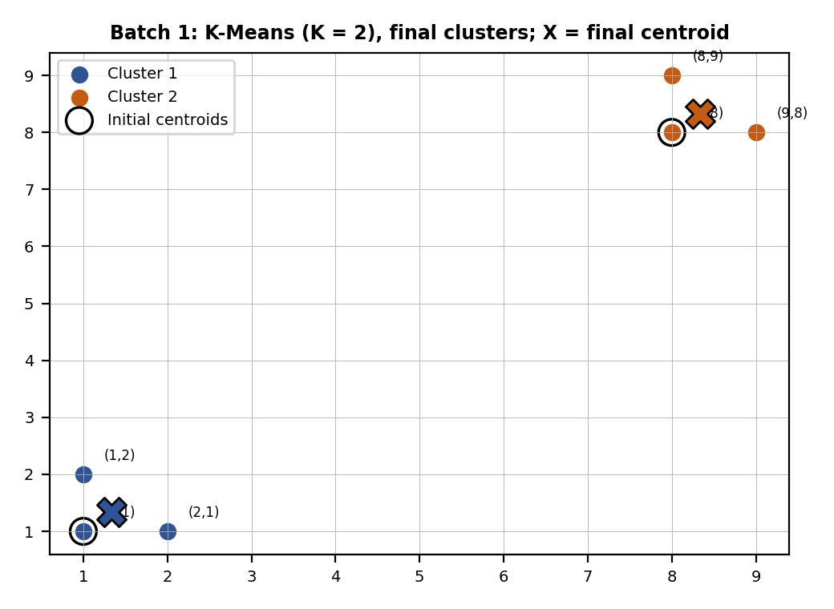

Batch 2 : Set 2

Q2. DBSCAN with ε = 2.5 and MinPts = 3 [5 Marks]
Marking scheme (5 marks): distances and ε-neighbourhoods (2) + MinPts condition (1) + classification into core, border and noise (1) + final clusters with justification (1).
Data points: P1 (2, 2), P2 (3, 2), P3 (2, 3), P4 (10, 10), P5 (10, 11), P6 (11, 10), P7 (18, 18).
Convention: the ε-neighbourhood of a point contains every point (including itself) whose Euclidean distance from it is at most ε, where distance = √((x₁ − x₂)² + (y₁ − y₂)²). A point is a core point if its neighbourhood has at least MinPts points (counting itself). A border point is not core but lies in the neighbourhood of a core point. All other points are noise.
Step 1: pairwise distances (2 marks together with Step 2).
 | P1 | P2 | P3 | P4 | P5 | P6 | P7
P1 (2, 2) | 0.00 | 1.00 | 1.00 | 11.31 | 12.04 | 12.04 | 22.63
P2 (3, 2) | 1.00 | 0.00 | 1.41 | 10.63 | 11.40 | 11.31 | 21.93
P3 (2, 3) | 1.00 | 1.41 | 0.00 | 10.63 | 11.31 | 11.40 | 21.93
P4 (10, 10) | 11.31 | 10.63 | 10.63 | 0.00 | 1.00 | 1.00 | 11.31
P5 (10, 11) | 12.04 | 11.40 | 11.31 | 1.00 | 0.00 | 1.41 | 10.63
P6 (11, 10) | 12.04 | 11.31 | 11.40 | 1.00 | 1.41 | 0.00 | 10.63
P7 (18, 18) | 22.63 | 21.93 | 21.93 | 11.31 | 10.63 | 10.63 | 0.00

Step 2: ε-neighbourhoods and the MinPts condition. Points at distance ≤ 2.5 are neighbours.
Point | Coordinates | ε-neighbourhood Nε | Count | Count ≥ 3?
P1 | (2, 2) | {P1, P2, P3} | 3 | Yes
P2 | (3, 2) | {P1, P2, P3} | 3 | Yes
P3 | (2, 3) | {P1, P2, P3} | 3 | Yes
P4 | (10, 10) | {P4, P5, P6} | 3 | Yes
P5 | (10, 11) | {P4, P5, P6} | 3 | Yes
P6 | (11, 10) | {P4, P5, P6} | 3 | Yes
P7 | (18, 18) | {P7} | 1 | No

Step 3: classification (1 mark).
Point | Coordinates | Type | Reason
P1 | (2, 2) | Core | Neighbourhood has 3 ≥ 3 points.
P2 | (3, 2) | Core | Neighbourhood has 3 ≥ 3 points.
P3 | (2, 3) | Core | Neighbourhood has 3 ≥ 3 points.
P4 | (10, 10) | Core | Neighbourhood has 3 ≥ 3 points.
P5 | (10, 11) | Core | Neighbourhood has 3 ≥ 3 points.
P6 | (11, 10) | Core | Neighbourhood has 3 ≥ 3 points.
P7 | (18, 18) | Noise | Only 1 point(s) in its neighbourhood (less than 3) and no core point within ε.

Step 4: cluster formation (1 mark).
- Start a new cluster C1 from the unvisited core point P1 (2, 2).
- P1 is core: its neighbourhood {P1, P2, P3} adds {P2, P3} to C1.
- P2 is core: its neighbourhood {P1, P2, P3} adds no new points to C1.
- P3 is core: its neighbourhood {P1, P2, P3} adds no new points to C1.
- Start a new cluster C2 from the unvisited core point P4 (10, 10).
- P4 is core: its neighbourhood {P4, P5, P6} adds {P5, P6} to C2.
- P5 is core: its neighbourhood {P4, P5, P6} adds no new points to C2.
- P6 is core: its neighbourhood {P4, P5, P6} adds no new points to C2.
- The remaining points are not density-reachable from any core point, so they are marked as noise.
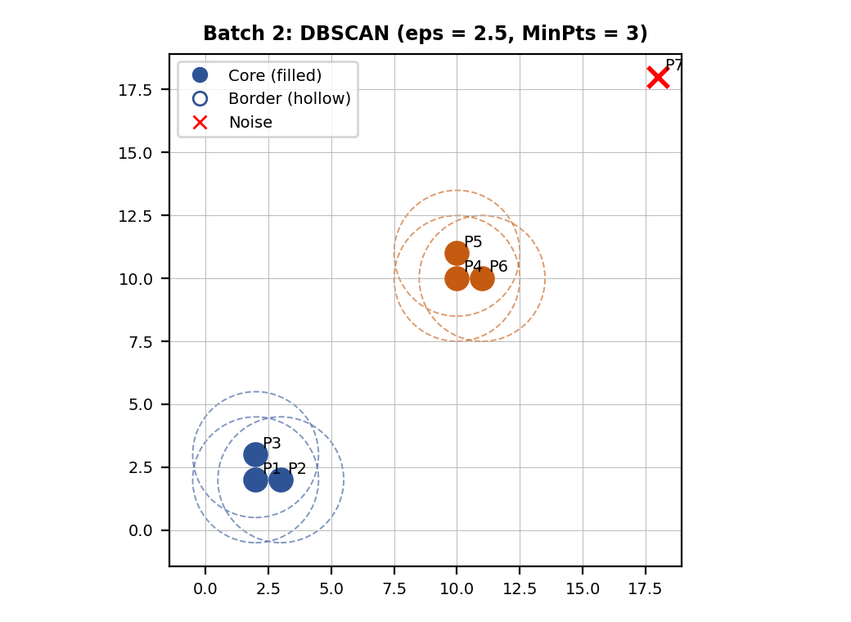
Result: Cluster C1 = {P1, P2, P3}; Cluster C2 = {P4, P5, P6}. Noise = {P7}. Core points: P1, P2, P3, P4, P5, P6. Border points: none.
Justification: each tight group has exactly 3 points, all within ε of each other, so every point of the group has 3 points in its neighbourhood and is a core point; the points of one group are density-reachable from each other and form one cluster. The two groups are far apart (more than ε), so they are separate clusters. The isolated point P7 has only itself in its neighbourhood and is noise. There are no border points because every non-isolated point already satisfies MinPts.

Q3. K-Means Clustering with K = 2 [5 Marks]
Marking scheme (5 marks): distances from the centroids (1.5) + assignment to the nearest centroid (1) + new centroids (1) + repetition until the centroids do not change (1) + final clusters and centroids (0.5).
Data points: P1 (2, 2), P2 (3, 2), P3 (2, 3), P4 (10, 10), P5 (11, 10), P6 (10, 11). Initial centroids: C1 = (2, 2), C2 = (10, 10).
Method: distance d = √((x − cₓ)² + (y − cᵧ)²). Each point goes to the centroid with the smallest distance; each new centroid is the mean of its points. Example: d(P2, C1) with P2 = (3, 2) and C1 = (2, 2) is √((3 − 2)² + (2 − 2)²) = 1.00.
Iteration 1:
Point | d to C1 (2.00, 2.00) | d to C2 (10.00, 10.00) | Assigned to
P1 (2, 2) | 0.00 | 11.31 | C1
P2 (3, 2) | 1.00 | 10.63 | C1
P3 (2, 3) | 1.00 | 10.63 | C1
P4 (10, 10) | 11.31 | 0.00 | C2
P5 (11, 10) | 12.04 | 1.00 | C2
P6 (10, 11) | 12.04 | 1.00 | C2

New centroids: C1 = (2 + 3 + 2) / 3, (2 + 2 + 3) / 3 = (2.33, 2.33); C2 = (10 + 11 + 10) / 3, (10 + 10 + 11) / 3 = (10.33, 10.33).
The centroids have moved, so the assignment is repeated with the new centroids.
Iteration 2 (centroids unchanged: converged):
Point | d to C1 (2.33, 2.33) | d to C2 (10.33, 10.33) | Assigned to
P1 (2, 2) | 0.47 | 11.79 | C1
P2 (3, 2) | 0.75 | 11.10 | C1
P3 (2, 3) | 0.75 | 11.10 | C1
P4 (10, 10) | 10.84 | 0.47 | C2
P5 (11, 10) | 11.57 | 0.75 | C2
P6 (10, 11) | 11.57 | 0.75 | C2

New centroids: C1 = (2 + 3 + 2) / 3, (2 + 2 + 3) / 3 = (2.33, 2.33); C2 = (10 + 11 + 10) / 3, (10 + 10 + 11) / 3 = (10.33, 10.33).
The new centroids are the same as the old ones and no point changes its cluster, so the algorithm stops.
Final result (0.5 mark): Cluster 1 = {(2, 2), (3, 2), (2, 3)} with centroid (2.33, 2.33); Cluster 2 = {(10, 10), (11, 10), (10, 11)} with centroid (10.33, 10.33). Within-cluster sum of squares = 2.67.
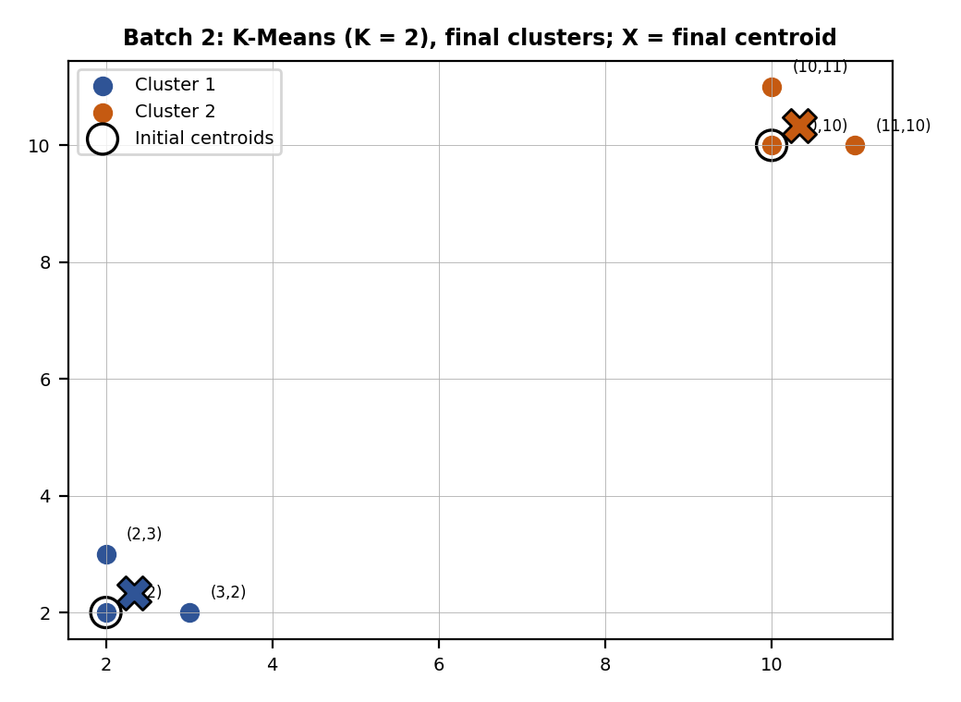

Batch 3 : Set 3

Q2. DBSCAN with ε = 3 and MinPts = 4 [5 Marks]
Marking scheme (5 marks): distances and ε-neighbourhoods (2) + MinPts condition (1) + classification into core, border and noise (1) + final clusters with justification (1).
Data points: P1 (1, 1), P2 (2, 1), P3 (1, 2), P4 (2, 2), P5 (8, 8), P6 (8, 9), P7 (9, 8), P8 (15, 15).
Convention: the ε-neighbourhood of a point contains every point (including itself) whose Euclidean distance from it is at most ε, where distance = √((x₁ − x₂)² + (y₁ − y₂)²). A point is a core point if its neighbourhood has at least MinPts points (counting itself). A border point is not core but lies in the neighbourhood of a core point. All other points are noise.
Step 1: pairwise distances (2 marks together with Step 2).
 | P1 | P2 | P3 | P4 | P5 | P6 | P7 | P8
P1 (1, 1) | 0.00 | 1.00 | 1.00 | 1.41 | 9.90 | 10.63 | 10.63 | 19.80
P2 (2, 1) | 1.00 | 0.00 | 1.41 | 1.00 | 9.22 | 10.00 | 9.90 | 19.10
P3 (1, 2) | 1.00 | 1.41 | 0.00 | 1.00 | 9.22 | 9.90 | 10.00 | 19.10
P4 (2, 2) | 1.41 | 1.00 | 1.00 | 0.00 | 8.49 | 9.22 | 9.22 | 18.38
P5 (8, 8) | 9.90 | 9.22 | 9.22 | 8.49 | 0.00 | 1.00 | 1.00 | 9.90
P6 (8, 9) | 10.63 | 10.00 | 9.90 | 9.22 | 1.00 | 0.00 | 1.41 | 9.22
P7 (9, 8) | 10.63 | 9.90 | 10.00 | 9.22 | 1.00 | 1.41 | 0.00 | 9.22
P8 (15, 15) | 19.80 | 19.10 | 19.10 | 18.38 | 9.90 | 9.22 | 9.22 | 0.00

Step 2: ε-neighbourhoods and the MinPts condition. Points at distance ≤ 3 are neighbours.
Point | Coordinates | ε-neighbourhood Nε | Count | Count ≥ 4?
P1 | (1, 1) | {P1, P2, P3, P4} | 4 | Yes
P2 | (2, 1) | {P1, P2, P3, P4} | 4 | Yes
P3 | (1, 2) | {P1, P2, P3, P4} | 4 | Yes
P4 | (2, 2) | {P1, P2, P3, P4} | 4 | Yes
P5 | (8, 8) | {P5, P6, P7} | 3 | No
P6 | (8, 9) | {P5, P6, P7} | 3 | No
P7 | (9, 8) | {P5, P6, P7} | 3 | No
P8 | (15, 15) | {P8} | 1 | No

Step 3: classification (1 mark).
Point | Coordinates | Type | Reason
P1 | (1, 1) | Core | Neighbourhood has 4 ≥ 4 points.
P2 | (2, 1) | Core | Neighbourhood has 4 ≥ 4 points.
P3 | (1, 2) | Core | Neighbourhood has 4 ≥ 4 points.
P4 | (2, 2) | Core | Neighbourhood has 4 ≥ 4 points.
P5 | (8, 8) | Noise | Only 3 point(s) in its neighbourhood (less than 4) and no core point within ε.
P6 | (8, 9) | Noise | Only 3 point(s) in its neighbourhood (less than 4) and no core point within ε.
P7 | (9, 8) | Noise | Only 3 point(s) in its neighbourhood (less than 4) and no core point within ε.
P8 | (15, 15) | Noise | Only 1 point(s) in its neighbourhood (less than 4) and no core point within ε.

Step 4: cluster formation (1 mark).
- Start a new cluster C1 from the unvisited core point P1 (1, 1).
- P1 is core: its neighbourhood {P1, P2, P3, P4} adds {P2, P3, P4} to C1.
- P2 is core: its neighbourhood {P1, P2, P3, P4} adds no new points to C1.
- P3 is core: its neighbourhood {P1, P2, P3, P4} adds no new points to C1.
- P4 is core: its neighbourhood {P1, P2, P3, P4} adds no new points to C1.
- The remaining points are not density-reachable from any core point, so they are marked as noise.
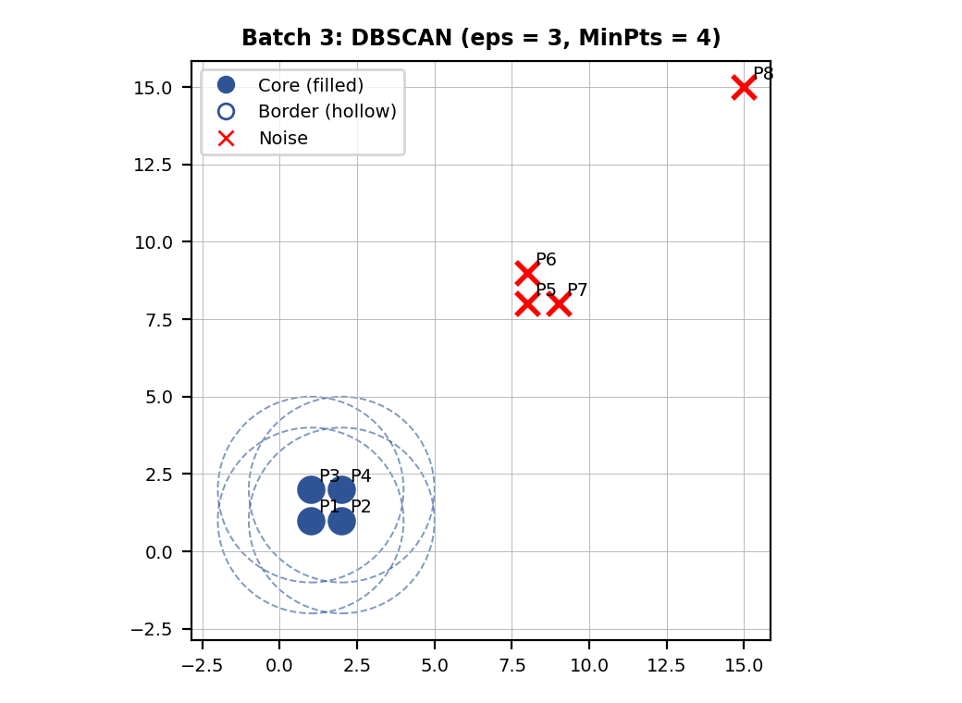
Result: Cluster C1 = {P1, P2, P3, P4}. Noise = {P5, P6, P7, P8}. Core points: P1, P2, P3, P4. Border points: none.
Justification: the first group of 4 points is very dense (every point has all 4 points in its neighbourhood, which meets MinPts = 4), so they are core points and form one cluster. The second group has only 3 points, so each of its points has just 3 points in its neighbourhood, which is less than MinPts = 4; none of them is core, and no core point lies within ε, so they are noise even though they are close to each other. (With MinPts = 3 they would form a cluster, which shows how MinPts controls the result.) The far point is also noise. There are no border points.

Q3. K-Means Clustering with K = 3 [5 Marks]
Marking scheme (5 marks): distances from the centroids (1.5) + assignment to the nearest centroid (1) + new centroids (1) + repetition until the centroids do not change (1) + final clusters and centroids (0.5).
Data points: P1 (1, 1), P2 (2, 1), P3 (1, 2), P4 (8, 8), P5 (9, 8), P6 (8, 9), P7 (15, 15), P8 (16, 15), P9 (15, 16). Initial centroids: C1 = (1, 1), C2 = (8, 8), C3 = (15, 15).
Method: distance d = √((x − cₓ)² + (y − cᵧ)²). Each point goes to the centroid with the smallest distance; each new centroid is the mean of its points. Example: d(P2, C1) with P2 = (2, 1) and C1 = (1, 1) is √((2 − 1)² + (1 − 1)²) = 1.00.
Iteration 1:
Point | d to C1 (1.00, 1.00) | d to C2 (8.00, 8.00) | d to C3 (15.00, 15.00) | Assigned to
P1 (1, 1) | 0.00 | 9.90 | 19.80 | C1
P2 (2, 1) | 1.00 | 9.22 | 19.10 | C1
P3 (1, 2) | 1.00 | 9.22 | 19.10 | C1
P4 (8, 8) | 9.90 | 0.00 | 9.90 | C2
P5 (9, 8) | 10.63 | 1.00 | 9.22 | C2
P6 (8, 9) | 10.63 | 1.00 | 9.22 | C2
P7 (15, 15) | 19.80 | 9.90 | 0.00 | C3
P8 (16, 15) | 20.52 | 10.63 | 1.00 | C3
P9 (15, 16) | 20.52 | 10.63 | 1.00 | C3

New centroids: C1 = (1 + 2 + 1) / 3, (1 + 1 + 2) / 3 = (1.33, 1.33); C2 = (8 + 9 + 8) / 3, (8 + 8 + 9) / 3 = (8.33, 8.33); C3 = (15 + 16 + 15) / 3, (15 + 15 + 16) / 3 = (15.33, 15.33).
The centroids have moved, so the assignment is repeated with the new centroids.
Iteration 2 (centroids unchanged: converged):
Point | d to C1 (1.33, 1.33) | d to C2 (8.33, 8.33) | d to C3 (15.33, 15.33) | Assigned to
P1 (1, 1) | 0.47 | 10.37 | 20.27 | C1
P2 (2, 1) | 0.75 | 9.69 | 19.58 | C1
P3 (1, 2) | 0.75 | 9.69 | 19.58 | C1
P4 (8, 8) | 9.43 | 0.47 | 10.37 | C2
P5 (9, 8) | 10.16 | 0.75 | 9.69 | C2
P6 (8, 9) | 10.16 | 0.75 | 9.69 | C2
P7 (15, 15) | 19.33 | 9.43 | 0.47 | C3
P8 (16, 15) | 20.05 | 10.16 | 0.75 | C3
P9 (15, 16) | 20.05 | 10.16 | 0.75 | C3

New centroids: C1 = (1 + 2 + 1) / 3, (1 + 1 + 2) / 3 = (1.33, 1.33); C2 = (8 + 9 + 8) / 3, (8 + 8 + 9) / 3 = (8.33, 8.33); C3 = (15 + 16 + 15) / 3, (15 + 15 + 16) / 3 = (15.33, 15.33).
The new centroids are the same as the old ones and no point changes its cluster, so the algorithm stops.
Final result (0.5 mark): Cluster 1 = {(1, 1), (2, 1), (1, 2)} with centroid (1.33, 1.33); Cluster 2 = {(8, 8), (9, 8), (8, 9)} with centroid (8.33, 8.33); Cluster 3 = {(15, 15), (16, 15), (15, 16)} with centroid (15.33, 15.33). Within-cluster sum of squares = 4.00.
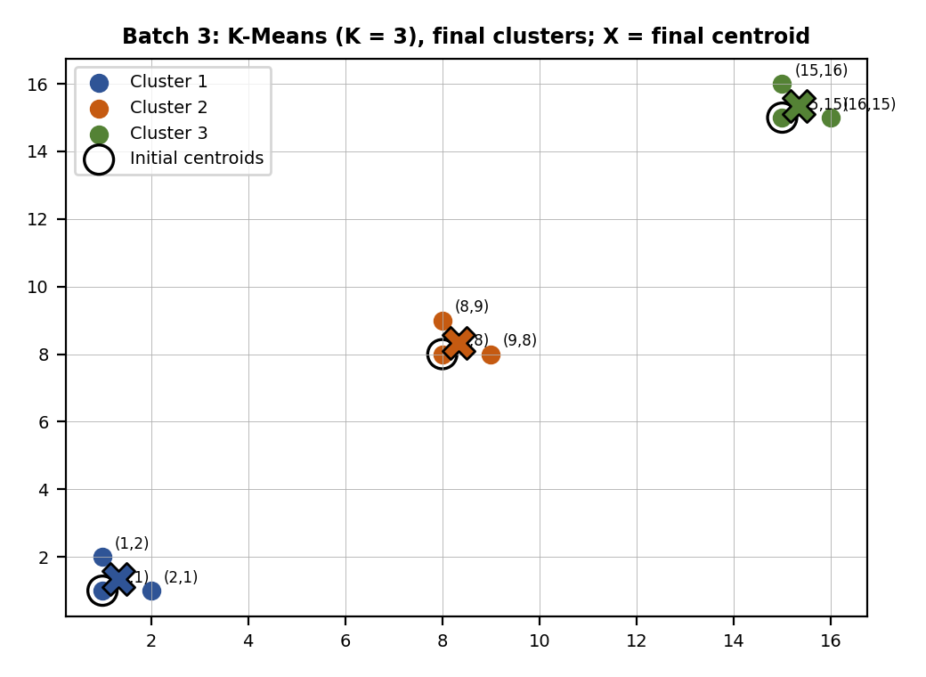

Batch 4 : Set 4

Q2. DBSCAN with ε = 2 and MinPts = 4 [5 Marks]
Marking scheme (5 marks): distances and ε-neighbourhoods (2) + MinPts condition (1) + classification into core, border and noise (1) + final clusters with justification (1).
Data points: P1 (3, 3), P2 (3, 4), P3 (4, 3), P4 (4, 4), P5 (11, 11), P6 (12, 11), P7 (11, 12), P8 (20, 20).
Convention: the ε-neighbourhood of a point contains every point (including itself) whose Euclidean distance from it is at most ε, where distance = √((x₁ − x₂)² + (y₁ − y₂)²). A point is a core point if its neighbourhood has at least MinPts points (counting itself). A border point is not core but lies in the neighbourhood of a core point. All other points are noise.
Step 1: pairwise distances (2 marks together with Step 2).
 | P1 | P2 | P3 | P4 | P5 | P6 | P7 | P8
P1 (3, 3) | 0.00 | 1.00 | 1.00 | 1.41 | 11.31 | 12.04 | 12.04 | 24.04
P2 (3, 4) | 1.00 | 0.00 | 1.41 | 1.00 | 10.63 | 11.40 | 11.31 | 23.35
P3 (4, 3) | 1.00 | 1.41 | 0.00 | 1.00 | 10.63 | 11.31 | 11.40 | 23.35
P4 (4, 4) | 1.41 | 1.00 | 1.00 | 0.00 | 9.90 | 10.63 | 10.63 | 22.63
P5 (11, 11) | 11.31 | 10.63 | 10.63 | 9.90 | 0.00 | 1.00 | 1.00 | 12.73
P6 (12, 11) | 12.04 | 11.40 | 11.31 | 10.63 | 1.00 | 0.00 | 1.41 | 12.04
P7 (11, 12) | 12.04 | 11.31 | 11.40 | 10.63 | 1.00 | 1.41 | 0.00 | 12.04
P8 (20, 20) | 24.04 | 23.35 | 23.35 | 22.63 | 12.73 | 12.04 | 12.04 | 0.00

Step 2: ε-neighbourhoods and the MinPts condition. Points at distance ≤ 2 are neighbours.
Point | Coordinates | ε-neighbourhood Nε | Count | Count ≥ 4?
P1 | (3, 3) | {P1, P2, P3, P4} | 4 | Yes
P2 | (3, 4) | {P1, P2, P3, P4} | 4 | Yes
P3 | (4, 3) | {P1, P2, P3, P4} | 4 | Yes
P4 | (4, 4) | {P1, P2, P3, P4} | 4 | Yes
P5 | (11, 11) | {P5, P6, P7} | 3 | No
P6 | (12, 11) | {P5, P6, P7} | 3 | No
P7 | (11, 12) | {P5, P6, P7} | 3 | No
P8 | (20, 20) | {P8} | 1 | No

Step 3: classification (1 mark).
Point | Coordinates | Type | Reason
P1 | (3, 3) | Core | Neighbourhood has 4 ≥ 4 points.
P2 | (3, 4) | Core | Neighbourhood has 4 ≥ 4 points.
P3 | (4, 3) | Core | Neighbourhood has 4 ≥ 4 points.
P4 | (4, 4) | Core | Neighbourhood has 4 ≥ 4 points.
P5 | (11, 11) | Noise | Only 3 point(s) in its neighbourhood (less than 4) and no core point within ε.
P6 | (12, 11) | Noise | Only 3 point(s) in its neighbourhood (less than 4) and no core point within ε.
P7 | (11, 12) | Noise | Only 3 point(s) in its neighbourhood (less than 4) and no core point within ε.
P8 | (20, 20) | Noise | Only 1 point(s) in its neighbourhood (less than 4) and no core point within ε.

Step 4: cluster formation (1 mark).
- Start a new cluster C1 from the unvisited core point P1 (3, 3).
- P1 is core: its neighbourhood {P1, P2, P3, P4} adds {P2, P3, P4} to C1.
- P2 is core: its neighbourhood {P1, P2, P3, P4} adds no new points to C1.
- P3 is core: its neighbourhood {P1, P2, P3, P4} adds no new points to C1.
- P4 is core: its neighbourhood {P1, P2, P3, P4} adds no new points to C1.
- The remaining points are not density-reachable from any core point, so they are marked as noise.
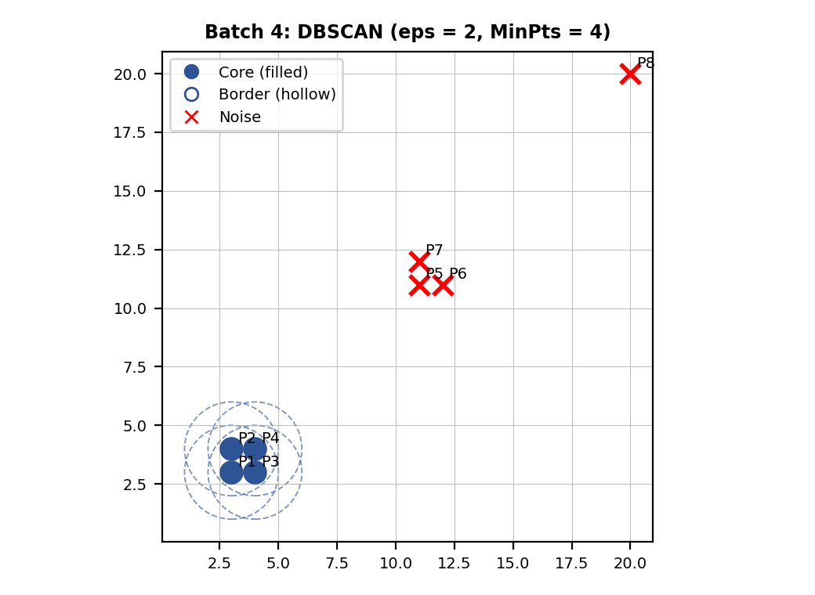
Result: Cluster C1 = {P1, P2, P3, P4}. Noise = {P5, P6, P7, P8}. Core points: P1, P2, P3, P4. Border points: none.
Justification: the first group of 4 points is very dense (every point has all 4 points in its neighbourhood, which meets MinPts = 4), so they are core points and form one cluster. The second group has only 3 points, so each of its points has just 3 points in its neighbourhood, which is less than MinPts = 4; none of them is core, and no core point lies within ε, so they are noise even though they are close to each other. (With MinPts = 3 they would form a cluster, which shows how MinPts controls the result.) The far point is also noise. There are no border points.

Q3. K-Means Clustering with K = 2 [5 Marks]
Marking scheme (5 marks): distances from the centroids (1.5) + assignment to the nearest centroid (1) + new centroids (1) + repetition until the centroids do not change (1) + final clusters and centroids (0.5).
Data points: P1 (3, 3), P2 (4, 3), P3 (3, 4), P4 (12, 12), P5 (13, 12), P6 (12, 13), P7 (20, 20). Initial centroids: C1 = (3, 3), C2 = (12, 12).
Method: distance d = √((x − cₓ)² + (y − cᵧ)²). Each point goes to the centroid with the smallest distance; each new centroid is the mean of its points. Example: d(P2, C1) with P2 = (4, 3) and C1 = (3, 3) is √((4 − 3)² + (3 − 3)²) = 1.00.
Iteration 1:
Point | d to C1 (3.00, 3.00) | d to C2 (12.00, 12.00) | Assigned to
P1 (3, 3) | 0.00 | 12.73 | C1
P2 (4, 3) | 1.00 | 12.04 | C1
P3 (3, 4) | 1.00 | 12.04 | C1
P4 (12, 12) | 12.73 | 0.00 | C2
P5 (13, 12) | 13.45 | 1.00 | C2
P6 (12, 13) | 13.45 | 1.00 | C2
P7 (20, 20) | 24.04 | 11.31 | C2

New centroids: C1 = (3 + 4 + 3) / 3, (3 + 3 + 4) / 3 = (3.33, 3.33); C2 = (12 + 13 + 12 + 20) / 4, (12 + 12 + 13 + 20) / 4 = (14.25, 14.25).
The centroids have moved, so the assignment is repeated with the new centroids.
Iteration 2 (centroids unchanged: converged):
Point | d to C1 (3.33, 3.33) | d to C2 (14.25, 14.25) | Assigned to
P1 (3, 3) | 0.47 | 15.91 | C1
P2 (4, 3) | 0.75 | 15.22 | C1
P3 (3, 4) | 0.75 | 15.22 | C1
P4 (12, 12) | 12.26 | 3.18 | C2
P5 (13, 12) | 12.98 | 2.57 | C2
P6 (12, 13) | 12.98 | 2.57 | C2
P7 (20, 20) | 23.57 | 8.13 | C2

New centroids: C1 = (3 + 4 + 3) / 3, (3 + 3 + 4) / 3 = (3.33, 3.33); C2 = (12 + 13 + 12 + 20) / 4, (12 + 12 + 13 + 20) / 4 = (14.25, 14.25).
The new centroids are the same as the old ones and no point changes its cluster, so the algorithm stops.
Final result (0.5 mark): Cluster 1 = {(3, 3), (4, 3), (3, 4)} with centroid (3.33, 3.33); Cluster 2 = {(12, 12), (13, 12), (12, 13), (20, 20)} with centroid (14.25, 14.25). Within-cluster sum of squares = 90.83.
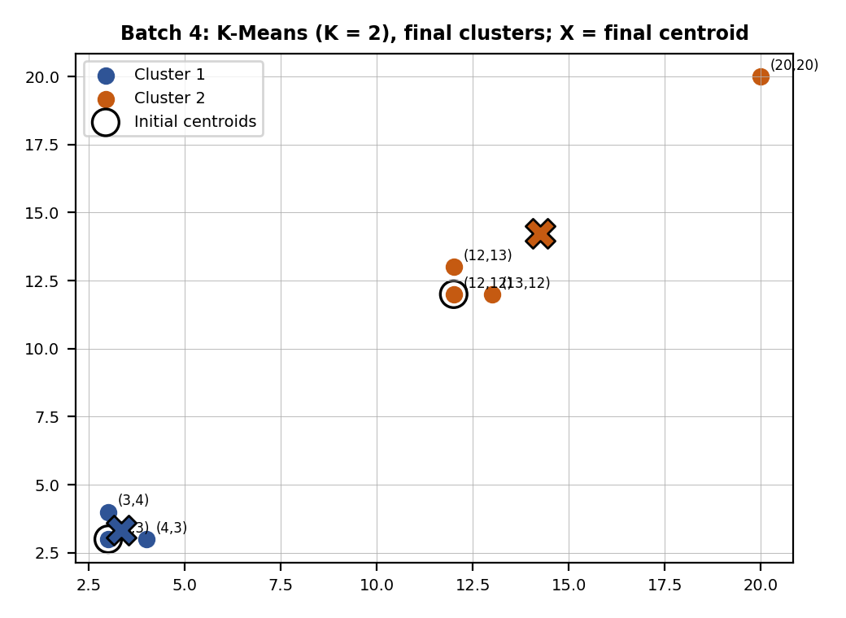
Remark: the outlier (20, 20) was assigned to cluster 2 and pulled its centroid from the natural centre (12.33, 12.33) to (14.25, 14.25). This shows that K-Means is sensitive to outliers; DBSCAN would label (20, 20) as noise, and would also keep the 3-point group dense only if MinPts allowed it.

Student Self-Assessment
☐ I compared the four techniques on working, advantages, limitations and applications.
☐ I calculated all distances and ε-neighbourhoods and classified the points.
☐ I repeated the K-Means steps until the centroids did not change.
☐ I drew neat diagrams and justified my answers.
☐ My answers reflect my own working.

Assessment Rubric Mapping (10 Marks)
Criterion | Marks | Where addressed in this journal
Q1: Comparison of clustering techniques | 5 | Section 1: working (1.5) + advantages (1) + limitations (1) + applications (1) + summary (0.5)
Q2: DBSCAN (your batch) | 5 | Distances and neighbourhoods (2) + MinPts condition (1) + classification (1) + clusters and justification (1)
Q3: K-Means (your batch) | 5 | Distances (1.5) + assignment (1) + new centroids (1) + repetition (1) + final result (0.5)

References
1. T. M. Mitchell, Machine Learning, McGraw-Hill, 1997.
2. J. MacQueen, “Some Methods for Classification and Analysis of Multivariate Observations,” Proc. 5th Berkeley Symposium, 1967 (K-Means).
3. M. Ester, H.-P. Kriegel, J. Sander and X. Xu, “A Density-Based Algorithm for Discovering Clusters in Large Spatial Databases with Noise,” Proc. KDD-96, 1996 (DBSCAN).
4. A. P. Dempster, N. M. Laird and D. B. Rubin, “Maximum Likelihood from Incomplete Data via the EM Algorithm,” Journal of the Royal Statistical Society B, vol. 39, no. 1, 1977.
5. G. James, D. Witten, T. Hastie and R. Tibshirani, An Introduction to Statistical Learning, 2nd ed., Springer, 2021.
6. Course notes and lecture material, Machine Learning (Unsupervised Learning: Clustering).

Declaration: I commit to submitting original work, free from plagiarism or copying from the internet or peers, and to honouring deadlines for a fair and transparent assessment.
Signature of Student: ____________________ Roll No: ____________

