Machine Learning – Assignment Solution Journal
Machine Learning
Assignment 8
Evaluation of Classifier and Regression Models

Cover Page
Student Name | ______________________________________
Roll No. / Division | ______________________________________
Course | Machine Learning
Semester / Course Code | ______________________________________
Batch | ______ (answer only your own batch in Question 3)
Maximum Marks | 15 (as given on the sheet)
Date of Submission | ______________________________________

Questions (from the assignment sheet)
Q. | Question
Q1 / Q2 | Batch-wise numerical problems on classifier metrics (accuracy, precision, recall, specificity, F1-score, confusion matrix) and regression metrics (MAE, MSE, RMSE, R²), each with a comment on performance; Set 2 Q2 asks for a differentiation and Set 3 Q2 asks for a comparison of two classifiers.
Q3 | Guest lecture take-away: topic, speaker, designation, summary of the lecture and own learning.
Format | Handwritten in the theory notebook; draw neat diagrams where necessary; justify answers with reasoning and examples; put date, name and roll number on the first page.

Marking Scheme at a Glance (15 Marks)
Q. | Component | Marks | Where in this journal
Q1 | Classification or regression metrics with comment (batch-specific split shown on each question) | 6 | Q1 of your set
Q2 | Regression metrics, differentiation or comparison of classifiers (split shown on each question) | 6 | Q2 of your set
Q3 | Guest lecture: details (0.5) + summary (1.5) + learning (1) | 3 | Q3 of your set
The sheet gives a maximum of 15 marks but no marks per question. A split of 6 + 6 + 3 is assumed. Solutions for all four sets are given; submit only your own batch and set.

Formulas Used
Measure | Formula
Confusion matrix | TP (positive predicted positive), TN (negative predicted negative), FP (negative predicted positive), FN (positive predicted negative)
Accuracy | (TP + TN) / (TP + TN + FP + FN)
Precision | TP / (TP + FP)
Recall (sensitivity) | TP / (TP + FN)
Specificity | TN / (TN + FP)
F1-score | 2 × Precision × Recall / (Precision + Recall) = 2TP / (2TP + FP + FN)
MAE | (1/n) Σ |y − ŷ|
MSE | (1/n) Σ (y − ŷ)²
RMSE | √MSE
R² | 1 − SSE / SST, where SSE = Σ(y − ŷ)² and SST = Σ(y − mean of y)²

Note: all values were calculated exactly and checked by computer; percentages are rounded to two decimals.

Batch 1 : Set 1

Q1. Classification Metrics [6 Marks]
Marking scheme (6 marks): confusion matrix with formulas (1) + each of the four or five measures (1 each) + comment (1).
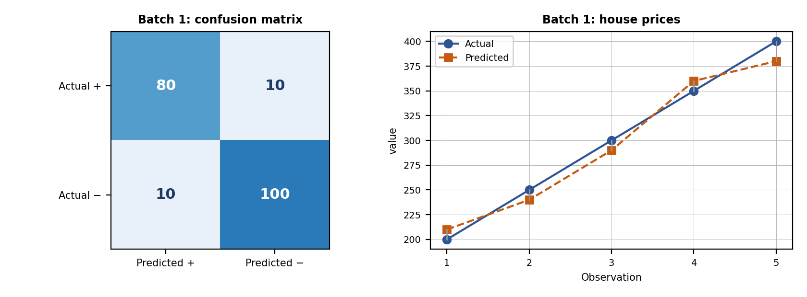
 | Predicted Positive | Predicted Negative
Actual Positive | TP = 80 | FN = 10
Actual Negative | FP = 10 | TN = 100

Measure | Formula and substitution | Value | Marks
Accuracy | (TP + TN) / (TP + TN + FP + FN) = (80 + 100) / 200 | 90.00% | 1
Precision | TP / (TP + FP) = 80 / (80 + 10) = 80 / 90 | 88.89% | 1
Recall / Sensitivity | TP / (TP + FN) = 80 / (80 + 10) = 80 / 90 | 88.89% | 1
F1-score | 2PR / (P + R) = 2 × 0.8889 × 0.8889 / (0.8889 + 0.8889) | 88.89% | 1
Specificity (extra) | TN / (TN + FP) = 100 / 110 | 90.91% | -

(e) Comment on performance (1 mark): the classifier is good: about 9 out of 10 patients are classified correctly. Precision and recall are both 88.9%, so the errors are balanced (10 healthy people flagged as diseased and 10 sick people missed). The classes are fairly balanced (90 sick, 110 healthy), so accuracy is a reliable measure here. In disease prediction the 10 false negatives (missed patients) are the more serious error, so the decision threshold could be lowered to raise recall, accepting more false positives. Cross-validation should confirm the result.

Q2. Regression Metrics [6 Marks]
Marking scheme (6 marks): error table (1) + MAE (1) + MSE (1) + RMSE (1) + R² (1.5) + comment (0.5).
Observation | Actual (y) | Predicted | Error y − ŷ | |Error| | Error²
1 | 200 | 210 | -10 | 10 | 100
2 | 250 | 240 | 10 | 10 | 100
3 | 300 | 290 | 10 | 10 | 100
4 | 350 | 360 | -10 | 10 | 100
5 | 400 | 380 | 20 | 20 | 400
Total | mean y = 300 |  |  | Σ|e| = 60 | Σe² = 800

Measure | Formula and substitution | Value | Marks
MAE | (1/n) Σ|y − ŷ| = 60 / 5 | 12.00 | 1
MSE | (1/n) Σ(y − ŷ)² = 800 / 5 | 160.00 | 1
RMSE | √MSE = √160.00 | 12.6491 | 1
R² | 1 − SSE / SST = 1 − 800 / 25000 (SST = Σ(y − mean)², mean = 300) | 0.9680 | 1.5

Comment on performance (0.5 mark): MAE = 12 means the predictions are off by 12 units on average, about 4% of the mean price (300). RMSE (12.65) is only slightly larger than MAE, so there are no very large errors (the largest is house 5, 20 units). R² = 0.968 means the model explains 96.8% of the variation in house prices: a very good fit. Five houses are too few to be sure, so a larger test set is needed.

Q3. Guest Lecture Take-away [3 Marks]
Marking scheme (3 marks): lecture details (0.5) + summary of content discussed (1.5) + own learning (1). I cannot know what your guest speaker said, so this is a structure to complete from your own notes.
Field | What to write
Topic of the guest lecture | ________________________________
Name of the speaker | ________________________________
Designation (and organisation) | ________________________________
Date and place | ________________________________

Summary of the content discussed (1.5 marks): write 8 to 10 lines in your own words, in this order:
- Who the speaker is and the main theme of the talk (1 to 2 lines).
- The main topics or concepts explained (4 to 6 points, one line each).
- Examples, case studies, tools or demonstrations shown.
- Industry applications and trends mentioned.
- Advice given to students, and questions asked and answered.
My learning (1 mark): write 4 to 5 points: a new concept learnt; how it connects with this subject (for example how model evaluation is done in real projects); a practical skill or tool to try; a career or industry insight; and one action you will take after the lecture.

Batch 2 : Set 2

Q1. Classification Metrics [6 Marks]
Marking scheme (6 marks): confusion matrix with formulas (1) + each of the four or five measures (1 each) + comment (1).
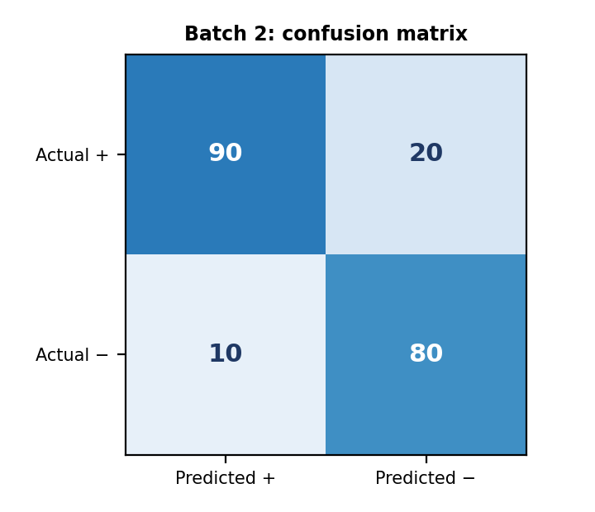
 | Predicted Positive | Predicted Negative
Actual Positive | TP = 90 | FN = 20
Actual Negative | FP = 10 | TN = 80

Measure | Formula and substitution | Value | Marks
Accuracy | (TP + TN) / total = (90 + 80) / 200 | 85.00% | 1
Precision | TP / (TP + FP) = 90 / (90 + 10) | 90.00% | 1
Recall | TP / (TP + FN) = 90 / (90 + 20) = 90 / 110 | 81.82% | 1
Specificity | TN / (TN + FP) = 80 / (80 + 10) = 80 / 90 | 88.89% | 1
F1-score | 2PR / (P + R) = 2 × 0.90 × 0.8182 / (0.90 + 0.8182) | 85.71% | 1

Comment on performance (1 mark): accuracy is 85% and F1 is 85.7%, so the model is reasonably good. Precision (90%) is higher than recall (81.8%): the model is cautious, producing only 10 false alarms but missing 20 real positives. If missing a positive is costly (for example a disease), the threshold should be lowered to improve recall; if false alarms are costly, the present setting is acceptable. Specificity (88.9%) shows that negatives are also identified well.

Q2. Precision, Recall, F1-Score and Specificity [6 Marks]
Marking scheme (6 marks): each of the four measures differentiated with definition, formula, meaning and one real-world application (1.25 each = 5) + comparison summary (1).
Measure | Formula | Question it answers | Real-world application where it matters most
Precision | TP / (TP + FP) | Of everything predicted positive, how much is truly positive? | Spam filtering: a genuine email wrongly sent to spam (false positive) is costly. Also fraud alerts and product recommendations where false alarms waste effort.
Recall (sensitivity) | TP / (TP + FN) | Of all actual positives, how many were found? | Cancer or disease screening: a missed patient (false negative) can be life-threatening. Also security threat and fraud detection.
F1-score | 2PR / (P + R) | How good is the balance between precision and recall in one number? | Fraud detection and information retrieval with imbalanced classes, where accuracy is misleading and both false alarms and misses matter.
Specificity | TN / (TN + FP) | Of all actual negatives, how many were correctly identified as negative? | Confirmatory medical tests and drug tests: healthy people must not be wrongly treated or accused (few false positives); also airport security with limited false alarms.

Summary (1 mark): precision and specificity both care about false positives (precision per predicted positive, specificity per actual negative), while recall cares about false negatives. F1 balances precision and recall. Using the Set 2 data: precision 90%, recall 81.8%, specificity 88.9%, F1 85.7%. There is a trade-off: raising recall by lowering the threshold usually lowers precision.

Q3. Guest Lecture Take-away [3 Marks]
Marking scheme (3 marks): lecture details (0.5) + summary of content discussed (1.5) + own learning (1). I cannot know what your guest speaker said, so this is a structure to complete from your own notes.
Field | What to write
Topic of the guest lecture | ________________________________
Name of the speaker | ________________________________
Designation (and organisation) | ________________________________
Date and place | ________________________________

Summary of the content discussed (1.5 marks): write 8 to 10 lines in your own words, in this order:
- Who the speaker is and the main theme of the talk (1 to 2 lines).
- The main topics or concepts explained (4 to 6 points, one line each).
- Examples, case studies, tools or demonstrations shown.
- Industry applications and trends mentioned.
- Advice given to students, and questions asked and answered.
My learning (1 mark): write 4 to 5 points: a new concept learnt; how it connects with this subject (for example how model evaluation is done in real projects); a practical skill or tool to try; a career or industry insight; and one action you will take after the lecture.

Batch 3 : Set 3

Q1. Regression Metrics [6 Marks]
Marking scheme (6 marks): error table (1) + MAE (1) + MSE (1) + RMSE (1) + R² (1.5) + comment (0.5).
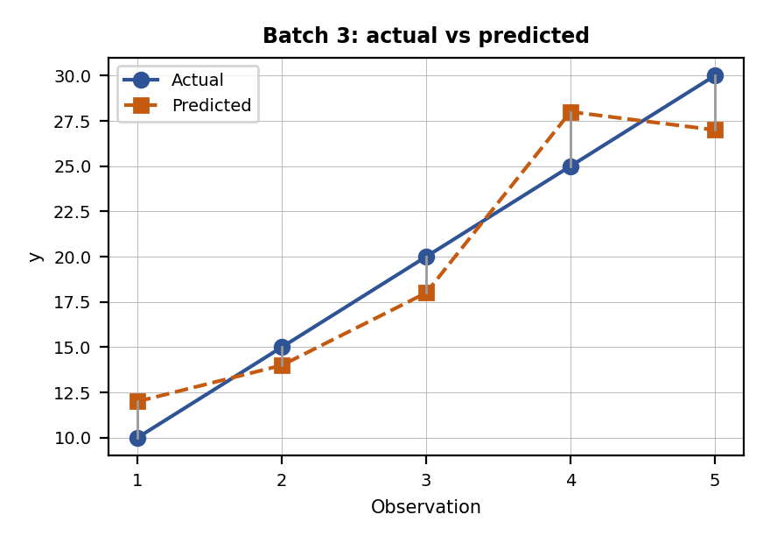
Observation | Actual (y) | Predicted | Error y − ŷ | |Error| | Error²
1 | 10 | 12 | -2 | 2 | 4
2 | 15 | 14 | 1 | 1 | 1
3 | 20 | 18 | 2 | 2 | 4
4 | 25 | 28 | -3 | 3 | 9
5 | 30 | 27 | 3 | 3 | 9
Total | mean y = 20 |  |  | Σ|e| = 11 | Σe² = 27

Measure | Formula and substitution | Value | Marks
MAE | (1/n) Σ|y − ŷ| = 11 / 5 | 2.20 | 1
MSE | (1/n) Σ(y − ŷ)² = 27 / 5 | 5.40 | 1
RMSE | √MSE = √5.40 | 2.3238 | 1
R² | 1 − SSE / SST = 1 − 27 / 250 (SST = Σ(y − mean)², mean = 20) | 0.8920 | 1.5

Comment on performance (0.5 mark): MAE = 2.2 means the predictions are about 2.2 units away from the actual values on average (about 11% of the mean value 20). RMSE (2.32) is a little above MAE because of the two larger errors (3 and 3). R² = 0.892 means the model explains 89.2% of the variation in y, which is a good fit but with room to improve; more data and features, and a separate test set, would give a more reliable estimate.

Q2. Compare Two Classifiers [6 Marks]
Marking scheme (6 marks): (a) model for disease detection, with justification (3) + (b) model for spam detection when false positives matter more, with justification (3).
Parameter | Model A | Model B | Difference (B − A)
Accuracy | 94% | 91% | −3 points
Precision | 82% | 93% | +11 points
Recall | 70% | 95% | +25 points
F1-score | 75% | 94% | +19 points

(a) Disease detection: select Model B (3 marks). In disease detection a false negative means a sick patient is told that they are healthy, so the most important measure is recall. Model B finds 95% of the sick patients against 70% for Model A (A would miss 30% of them). Model B also has the higher precision (93% against 82%), so it has fewer false alarms as well, and its F1-score is much higher (94% against 75%). Model A’s higher accuracy (94% against 91%) is misleading: when most people are healthy, a model can score high accuracy even though it misses many sick patients. Model B is therefore the safer and better choice.
(b) Spam detection with false positives more important: select Model B (3 marks). A false positive here means a genuine email is sent to the spam folder, so the key measure is precision (the share of emails marked spam that really are spam). Model B has precision 93% against 82% for Model A, so only about 7% of its spam decisions are wrong against 18% for Model A. Its recall (95%) is also higher, so it catches more spam. Model B is the better choice. If it were still too aggressive, its threshold could be raised to increase precision further at the cost of some recall.
Consistency check: F1 for Model A = 2 × 0.82 × 0.70 / (0.82 + 0.70) = 0.755 and for Model B = 2 × 0.93 × 0.95 / (0.93 + 0.95) = 0.940, matching the table.

Q3. Guest Lecture Take-away [3 Marks]
Marking scheme (3 marks): lecture details (0.5) + summary of content discussed (1.5) + own learning (1). I cannot know what your guest speaker said, so this is a structure to complete from your own notes.
Field | What to write
Topic of the guest lecture | ________________________________
Name of the speaker | ________________________________
Designation (and organisation) | ________________________________
Date and place | ________________________________

Summary of the content discussed (1.5 marks): write 8 to 10 lines in your own words, in this order:
- Who the speaker is and the main theme of the talk (1 to 2 lines).
- The main topics or concepts explained (4 to 6 points, one line each).
- Examples, case studies, tools or demonstrations shown.
- Industry applications and trends mentioned.
- Advice given to students, and questions asked and answered.
My learning (1 mark): write 4 to 5 points: a new concept learnt; how it connects with this subject (for example how model evaluation is done in real projects); a practical skill or tool to try; a career or industry insight; and one action you will take after the lecture.

Batch 4 : Set 4

Q1. Fraud Detection: Confusion Matrix and Metrics [6 Marks]
Marking scheme (6 marks): TP, FN, FP and TN found with reasoning (2) + accuracy (1) + precision (1) + recall (1) + F1-score (1).
Quantity | Reasoning | Value
Total transactions | Given | 10,000
Actual fraud / actual genuine | Given: 100 are fraudulent, so 10,000 − 100 are genuine | 100 / 9,900
(a) TP | Fraud correctly identified (given) | 80
(b) FN | Fraud missed = actual fraud − TP = 100 − 80 | 20
(c) FP | Genuine marked as fraud (given) | 300
(d) TN | Genuine correctly identified = 9,900 − 300 | 9,600

 | Predicted Positive | Predicted Negative
Actual Positive | TP = 80 | FN = 20
Actual Negative | FP = 300 | TN = 9600

Measure | Formula and substitution | Value | Marks
(e) Accuracy | (TP + TN) / total = (80 + 9,600) / 10,000 | 96.80% | 1
(f) Precision | TP / (TP + FP) = 80 / (80 + 300) = 80 / 380 | 21.05% | 1
(g) Recall | TP / (TP + FN) = 80 / (80 + 20) = 80 / 100 | 80.00% | 1
(h) F1-score | 2PR / (P + R) = 2 × 0.2105 × 0.80 / (0.2105 + 0.80) (also 2TP / (2TP + FP + FN) = 160 / 480) | 33.33% | 1

Interpretation: accuracy (96.8%) looks excellent but is misleading because only 1% of the transactions are fraud: a useless model that calls every transaction genuine would be 99% accurate. The model finds 80% of the frauds (recall), but only about 21% of its fraud alerts are real (precision), because it raises 300 false alarms (3.75 false alarms for each fraud caught). The F1-score of 33.3% shows the poor balance. Improvements: tune the threshold, use cost-sensitive learning or resampling for the imbalance, and add better features.

Q2. Regression Metrics [6 Marks]
Marking scheme (6 marks): error table (1) + MAE (1) + MSE (1) + RMSE (1) + R² (1.5) + comment (0.5).
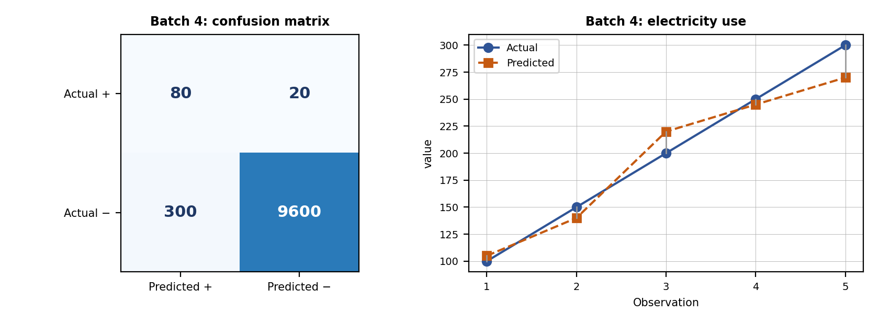
Observation | Actual (y) | Predicted | Error y − ŷ | |Error| | Error²
1 | 100 | 105 | -5 | 5 | 25
2 | 150 | 140 | 10 | 10 | 100
3 | 200 | 220 | -20 | 20 | 400
4 | 250 | 245 | 5 | 5 | 25
5 | 300 | 270 | 30 | 30 | 900
Total | mean y = 200 |  |  | Σ|e| = 70 | Σe² = 1450

Measure | Formula and substitution | Value | Marks
MAE | (1/n) Σ|y − ŷ| = 70 / 5 | 14.00 | 1
MSE | (1/n) Σ(y − ŷ)² = 1450 / 5 | 290.00 | 1
RMSE | √MSE = √290.00 | 17.0294 | 1
R² | 1 − SSE / SST = 1 − 1450 / 25000 (SST = Σ(y − mean)², mean = 200) | 0.9420 | 1.5

Comment on performance (0.5 mark): MAE = 14 means monthly consumption is predicted within 14 units on average (7% of the mean 200). RMSE (17.03) is larger than MAE because of the two bigger errors (household E under-predicted by 30 and C over-predicted by 20). R² = 0.942 means the model explains 94.2% of the variation: a good model, which could be improved by adding features such as household size and season.

Q3. Guest Lecture Take-away [3 Marks]
Marking scheme (3 marks): lecture details (0.5) + summary of content discussed (1.5) + own learning (1). I cannot know what your guest speaker said, so this is a structure to complete from your own notes.
Field | What to write
Topic of the guest lecture | ________________________________
Name of the speaker | ________________________________
Designation (and organisation) | ________________________________
Date and place | ________________________________

Summary of the content discussed (1.5 marks): write 8 to 10 lines in your own words, in this order:
- Who the speaker is and the main theme of the talk (1 to 2 lines).
- The main topics or concepts explained (4 to 6 points, one line each).
- Examples, case studies, tools or demonstrations shown.
- Industry applications and trends mentioned.
- Advice given to students, and questions asked and answered.
My learning (1 mark): write 4 to 5 points: a new concept learnt; how it connects with this subject (for example how model evaluation is done in real projects); a practical skill or tool to try; a career or industry insight; and one action you will take after the lecture.

Student Self-Assessment
☐ I wrote the formula and substitution for every metric.
☐ I commented on the performance of every model.
☐ I wrote the guest lecture summary from my own notes.
☐ I drew neat diagrams where necessary.
☐ My answers reflect my own working.

Assessment Rubric Mapping (10 Marks)
Criterion | Marks | Where addressed in this journal
Q1 (your set) | 6 | Classification or regression metrics (marks shown on the question)
Q2 (your set) | 6 | Regression metrics, differentiation or comparison (marks shown on the question)
Q3 (your set) | 3 | Guest lecture: details (0.5) + summary (1.5) + learning (1)

References
1. T. M. Mitchell, Machine Learning, McGraw-Hill, 1997.
2. C. M. Bishop, Pattern Recognition and Machine Learning, Springer, 2006.
3. G. James, D. Witten, T. Hastie and R. Tibshirani, An Introduction to Statistical Learning, 2nd ed., Springer, 2021.
4. A. Géron, Hands-On Machine Learning with Scikit-Learn, Keras and TensorFlow, 3rd ed., O’Reilly, 2022 (evaluation metrics).
5. Course notes and lecture material, Machine Learning, Module 3.

Declaration: I commit to submitting original work, free from plagiarism or copying from the internet or peers, and to honouring deadlines for a fair and transparent assessment.
Signature of Student: ____________________ Roll No: ____________

