Machine Learning – Assignment Solution Journal
Machine Learning
Assignment 9
Clustering Algorithms: K-Means, Hierarchical Clustering and DBSCAN (Flipped Classroom Activity)

Cover Page
Student Name | ______________________________________
Roll No. / Division | ______________________________________
Course | Machine Learning
Semester / Course Code | ______________________________________
Maximum Marks | 15 (as given on the sheet)
Date of Submission | ______________________________________

Questions (from the assignment sheet)
Q. | Question
QA | 1) What is clustering? Why is it called unsupervised learning? (2M) 2) Explain the working of K-Means in brief. (2M) 3) Differentiate between K-Means and DBSCAN. (2M) 4) What is a dendrogram in hierarchical clustering? (marks not stated)
QB | Six multiple-choice questions, 1 mark each.
QC | Case study on customer segmentation: Q1 suitable technique (1M), Q2 recommended algorithm and why (2M), Q3 algorithm for data with many unusual high spenders (1M), Q4 use of the clusters (2M).

Marking Scheme at a Glance (as printed on the sheet)
Q. | Component | Marks | Where in this journal
QA 1 | Clustering and why it is unsupervised | 2 | Section A1
QA 2 | K-Means working | 2 | Section A2
QA 3 | K-Means vs DBSCAN | 2 | Section A3
QA 4 | Dendrogram (marks not stated; 1 assumed) | 1 | Section A4
QB | Six MCQs, 1 mark each | 6 | Section B
QC | Case study: 1 + 2 + 1 + 2 | 6 | Section C
The marks on the sheet add up to 19 (6 + 1 assumed for QA 4 + 6 + 6) although the maximum is stated as 15. I have followed the marks printed against each question; please check with your teacher how the total is scaled to 15.

The sheet asks you to watch a YouTube video first. I could not watch it, so the answers use standard clustering content; add any extra points you learned from the video.

A. Short Answer Questions

A1. What is clustering? Why is it called unsupervised learning? [2 Marks]
Marking scheme (2 marks): definition of clustering with an example (1) + reason it is unsupervised (1).
Clustering is the task of dividing a set of data points into groups (clusters) so that points in the same cluster are more similar to each other than to points in other clusters. Similarity is usually measured with a distance such as Euclidean distance. Examples: grouping customers by buying behaviour, grouping news articles by topic, grouping genes with similar expression, and segmenting the pixels of an image.
Why it is unsupervised: the data has no labels or target values (no “right answer” is given to the algorithm). The algorithm discovers the structure by itself from the similarity of the data points. In supervised learning (classification, regression) the model learns from examples that have labels and is judged against them. In clustering, no teacher or labelled training set is available, so the groups must be found, not predicted.
 | Supervised learning | Unsupervised learning (clustering)
Data | Labelled (input and output) | Unlabelled (input only)
Goal | Predict a label or value | Find hidden groups or structure
Examples | Spam detection, house price prediction | Customer segmentation, image segmentation

A2. Working of the K-Means algorithm [2 Marks]
Marking scheme (2 marks): steps of the algorithm (1) + objective, example and limitations (1).
Step | Action
1 | Choose the number of clusters K (for example by the elbow method).
2 | Choose K initial centroids (random points, or K-Means++ for better starting points).
3 | Assignment step: assign every point to the nearest centroid, using Euclidean distance.
4 | Update step: recompute each centroid as the mean of the points assigned to it.
5 | Repeat steps 3 and 4 until the assignments no longer change (convergence) or a maximum number of iterations is reached.
Objective: minimise the within-cluster sum of squares (WCSS) = Σ over clusters Σ over points ‖x − μ‖². Limitations: K must be chosen in advance; results depend on the initial centroids; sensitive to outliers; works best for round, similar-sized clusters; needs numeric, scaled features.

Worked example (7 points, K = 2)
Initial centroids: P1 (1, 1) and P4 (5, 7). Iteration 1 distances are shown; the algorithm converged in 3 iterations.
Point | Coordinates | Distance to C1 (1, 1) | Distance to C2 (5, 7) | Cluster
P1 | (1, 1) | 0.00 | 7.21 | C1
P2 | (1.5, 2) | 1.12 | 6.10 | C1
P3 | (3, 4) | 3.61 | 3.61 | C1
P4 | (5, 7) | 7.21 | 0.00 | C2
P5 | (3.5, 5) | 4.72 | 2.50 | C2
P6 | (4.5, 5) | 5.32 | 2.06 | C2
P7 | (3.5, 4.5) | 4.30 | 2.92 | C2
Iteration 1: C1 = {P1, P2, P3}, C2 = {P4, P5, P6, P7}. New centroids: C1 = (1.83, 2.33), C2 = (4.13, 5.38). Iteration 2: P3 is now nearer to C2, so C1 = {P1, P2} and C2 = {P3, P4, P5, P6, P7}; new centroids (1.25, 1.5) and (3.9, 5.1). Iteration 3: no point changes cluster, so the algorithm stops. Final WCSS = 8.52.
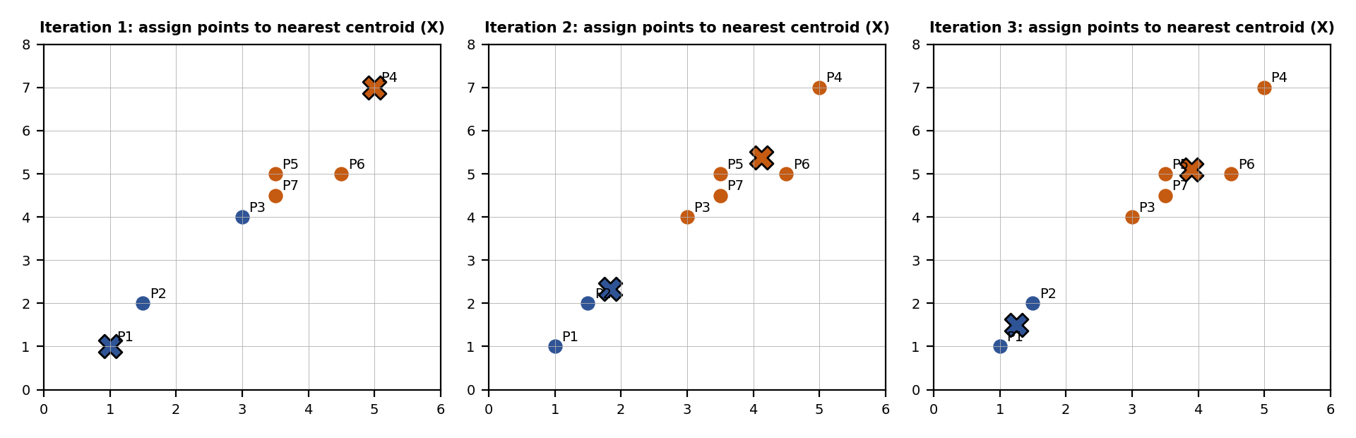

A3. Differentiate between K-Means and DBSCAN [2 Marks]
Marking scheme (2 marks): comparison table of at least six points (1.5) + example or figure (0.5).
Basis | K-Means | DBSCAN
Full form | K-Means clustering | Density-Based Spatial Clustering of Applications with Noise
Basic idea | Partitions data around K centroids (distance to the mean). | Groups points that are densely packed; low-density points are noise.
Number of clusters | Must be specified in advance (K). | Found automatically from the data.
Parameters | K (and initial centroids). | eps (neighbourhood radius) and minPts (minimum points).
Cluster shape | Roughly spherical and of similar size. | Arbitrary shapes (for example crescents, rings).
Noise and outliers | No notion of noise; every point is forced into a cluster; outliers pull the centroids. | Identifies noise points explicitly; robust to outliers.
Cluster density | Works with any density but assumes similar spread. | Struggles when clusters have very different densities.
Scalability | Fast and scalable; time O(n K t). | Slower for large data without a spatial index.
Result | Depends on initialisation; may reach a local optimum. | Deterministic apart from the order of border points.
Best used for | Compact, well-separated groups, such as customer segments. | Spatial data, irregular clusters, and data with outliers.

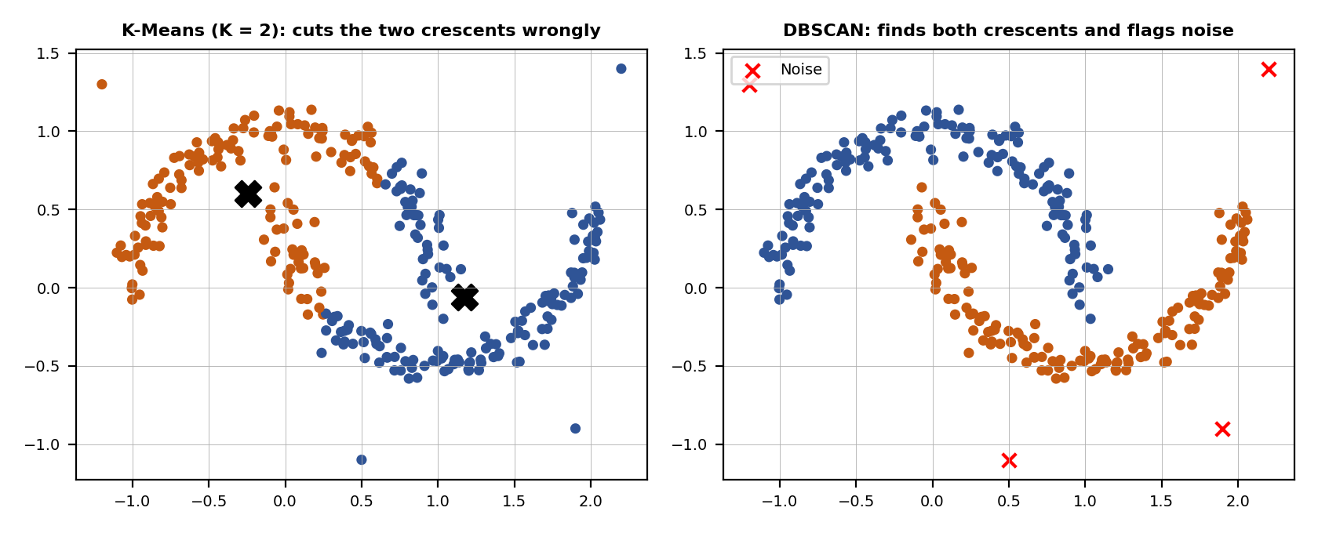
Figure: on two interleaved crescents with four outliers, K-Means (K = 2) splits the data with a straight boundary and agrees poorly with the true groups (adjusted Rand index 0.25), while DBSCAN (eps = 0.18, minPts = 5) recovers both crescents exactly (index 1.00) and marks the 4 outliers as noise.

A4. Dendrogram in hierarchical clustering [1 Mark, assumed]
Marking scheme (1 mark): definition and how to read it (0.5) + how clusters are obtained, with a figure (0.5).
A dendrogram is a tree diagram that records the sequence of merges (agglomerative clustering) or splits (divisive clustering) made by hierarchical clustering. The leaves are the individual data points; each joint shows two clusters being merged, and the height of the joint is the distance (dissimilarity) at which they merge. Low joints mean very similar points; high joints mean dissimilar clusters.
How it is used: draw a horizontal line at a chosen height; the vertical lines it cuts are the clusters. A cut at a lower height gives more, smaller clusters; a higher cut gives fewer clusters. Large gaps between merge heights suggest a natural number of clusters. The distance between clusters depends on the linkage (single, complete, average or Ward). Example (six points, single linkage): A and B merge at 0.71, D and F at 0.5, E joins them at 1.0, C joins at 1.41, and the two groups join at 2.5. Cutting at height 1.2 gives three clusters: {A, B}, {C} and {D, E, F}.
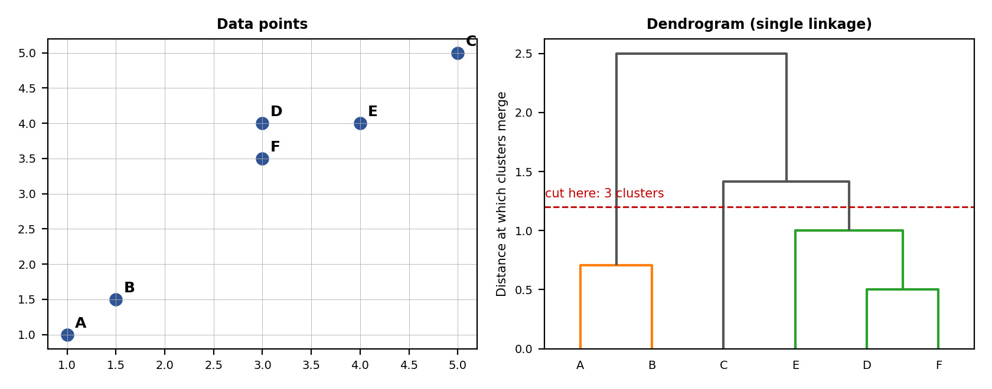

B. Multiple-Choice Questions [6 Marks, 1 each]
Marking scheme: 1 mark for each correct answer; the short reason is given because the instructions ask for justification.
No. | Question | Answer | Reason
1 | Which type of learning does clustering belong to? | (c) Unsupervised learning | No labels are used; the algorithm finds groups by itself.
2 | What does “K” represent in K-Means? | (c) Number of clusters | K is the number of groups (and centroids) to be formed.
3 | Which clustering algorithm uses a dendrogram? | (b) Hierarchical clustering | The dendrogram shows the order and distances of the merges.
4 | DBSCAN stands for: | (a) Density-Based Spatial Clustering of Applications with Noise | It clusters by density and labels sparse points as noise.
5 | Which algorithm handles noise and outliers most effectively? | (d) DBSCAN | It marks low-density points as noise instead of assigning them to a cluster. (Linear regression and decision tree are not clustering algorithms.)
6 | In K-Means, the objective is to: | (b) Minimize within-cluster variance | K-Means minimises the sum of squared distances of points to their cluster centroid.

C. Case Study: Customer Segmentation [6 Marks]
Marking scheme: Q1 (1) + Q2 (2) + Q3 (1) + Q4 (2).
An online retailer wants to group customers using annual spending and purchase frequency; the data has no predefined labels.
Q1. Suitable technique (1 mark): unsupervised learning, specifically clustering, because the data has no labels and the aim is to discover natural groups of similar customers.
Q2. Recommended algorithm and why (2 marks): K-Means. Reasons: (1) the two features are numeric and the customer groups are expected to be compact; (2) it is fast and scalable to a large customer base; (3) it gives easy-to-interpret segments, each with a centroid (average spending and frequency) that marketers can understand; (4) the number of segments K can be chosen with the elbow method and the silhouette score; (5) features should be scaled first so that spending (in thousands) does not dominate frequency.
Demonstration on illustrative (synthetic) data of 250 customers: the elbow of the within-cluster sum of squares appears at K = 4, and the silhouette score is highest at K = 4 (0.67). The four segments found:
Segment | Average annual spending | Purchases per year | Customers (of 250)
Low spenders, frequent buyers | about 8,800 | about 40 | 63
Premium customers | about 90,900 | about 46 | 50
Occasional buyers | about 20,100 | about 12 | 70
Regular mid spenders | about 34,900 | about 30 | 67

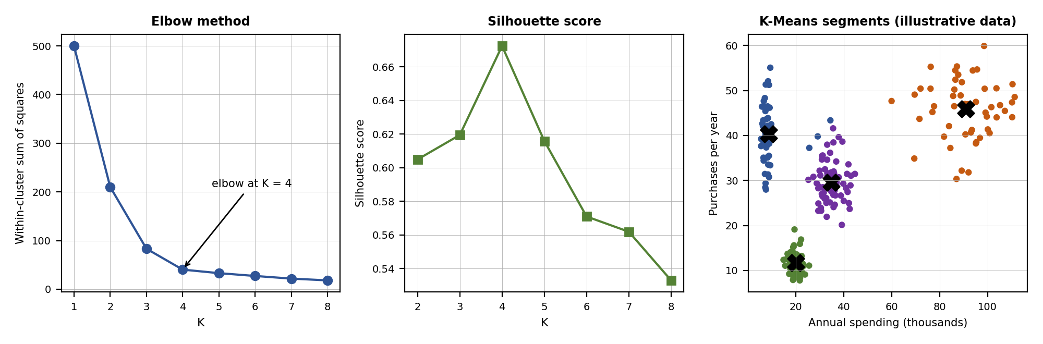
Figure: elbow method, silhouette score and the final K-Means clusters (the data is illustrative, not from a real company).
Q3. Many unusual customers with extremely high spending (1 mark): DBSCAN performs better. It treats the extreme spenders as noise or outliers and does not let them distort the clusters, whereas K-Means must put every point into a cluster and its centroids are pulled toward the outliers. In the demonstration, after adding four extreme spenders, K-Means (K = 4) used one whole cluster for just those 4 customers and merged two real segments, while DBSCAN (eps = 0.25, minPts = 5) kept the four normal segments and labelled 9 customers as noise, including all 4 extreme spenders. These can then be handled separately as VIP accounts.
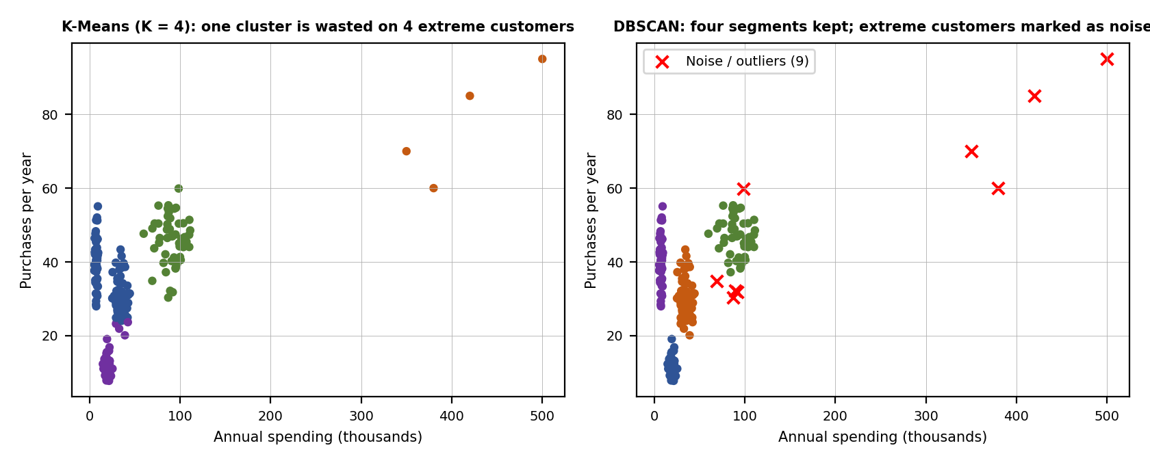
Q4. How the company can use the clusters (2 marks): each segment gets a different strategy.
Segment | Meaning | Action
Premium customers (high spending, frequent) | Most valuable, loyal | VIP programme, early access to products, personal service, retention offers.
Regular mid spenders | Steady revenue | Cross-selling and upselling, loyalty points to increase spending.
Low spenders, frequent buyers | Engaged but small baskets | Bundles, free-shipping thresholds, product recommendations.
Occasional buyers | Low engagement | Re-engagement campaigns, discount coupons, reminders.
Other uses: personalised email and advertising, targeted discounts, better inventory planning for what each segment buys, identification of customers at risk of leaving, pricing decisions, and measuring each campaign by segment. The clusters should be recalculated regularly and used with care for privacy.

Student Self-Assessment
☐ I defined clustering and explained why it is unsupervised.
☐ I explained K-Means and compared it with DBSCAN.
☐ I answered all six multiple-choice questions with reasons.
☐ I answered the case study with justification.
☐ I drew neat diagrams where necessary and used my own words.

Assessment Rubric Mapping (10 Marks)
Criterion | Marks | Where addressed in this journal
QA 1 to QA 3 | 2 each | Sections A1, A2 and A3
QA 4 | 1 (assumed) | Section A4
QB | 6 | Section B
QC | 6 | Section C: Q1 (1) + Q2 (2) + Q3 (1) + Q4 (2)

References
1. T. M. Mitchell, Machine Learning, McGraw-Hill, 1997.
2. J. MacQueen, “Some Methods for Classification and Analysis of Multivariate Observations,” Proc. 5th Berkeley Symposium on Mathematical Statistics and Probability, 1967 (K-Means).
3. M. Ester, H.-P. Kriegel, J. Sander and X. Xu, “A Density-Based Algorithm for Discovering Clusters in Large Spatial Databases with Noise,” Proc. KDD-96, 1996 (DBSCAN).
4. G. James, D. Witten, T. Hastie and R. Tibshirani, An Introduction to Statistical Learning, 2nd ed., Springer, 2021 (Unsupervised learning).
5. A. Géron, Hands-On Machine Learning with Scikit-Learn, Keras and TensorFlow, 3rd ed., O’Reilly, 2022.
6. Course notes and lecture material, Machine Learning, Module: Clustering Algorithms.

Declaration: I commit to submitting original work, free from plagiarism or copying from the internet or peers, and to honouring deadlines for a fair and transparent assessment.
Signature of Student: ____________________ Roll No: ____________

