Software Engineering – Assignment Solution Journal
Software Engineering
Assignment 1
Software Process Models

Cover Page
Student Name | ______________________________________
Roll No. / Division | ______________________________________
Course | Software Engineering
Semester / Course Code | ______________________________________
Batch | ______ (answer only your own batch in Question 3)
Maximum Marks | 10 (assumed; the sheet does not state the marks)
Date of Submission | ______________________________________

Questions (from the assignment sheet)
Q. | Question
Q1 | Differentiate between Prescriptive Models and Evolutionary Models.
Q2 | Differentiate between WATERFALL Model and PROTOTYPE Model.
Q3 | Case study based question (batchwise): Batch 1 birth certificate system, Batch 2 college academic portal, Batch 3 food ordering mobile app, Batch 4 banking security system. Identify the most suitable process model and justify.

Marking Scheme at a Glance (10 Marks)
Q. | Component | Marks | Where in this journal
Q1 | Prescriptive models (0.5) + evolutionary models (0.5) + differentiation table (1.5) + examples, selection guide and conclusion (0.5) | 3 | Section 1
Q2 | Waterfall model with diagram (0.75) + prototype model with diagram (0.75) + comparison table (1) + advantages, limitations and suitability (0.5) | 3 | Section 2
Q3 | Model identified (1) + case-specific justification (2) + limitations or why other models are not suitable (1), for your own batch | 4 | Section 3 (Batch 1 to 4)
The sheet gives no marks. A total of 10 marks is assumed, split 3 + 3 + 4. Question 3 is batchwise, so a solution for all four batches is given; submit only your own batch (4 marks).

1. Prescriptive Models vs Evolutionary Models [3 Marks]
Marking scheme (3 marks): prescriptive models explained (0.5) + evolutionary models explained (0.5) + differentiation table (1.5) + examples, selection guide and conclusion (0.5).

Prescriptive process models (0.5 mark)
Prescriptive models define a fixed, disciplined set of process elements: framework activities (communication, planning, modelling, construction, deployment), tasks, work products, quality assurance and change control. They prescribe how the work flows, usually in a planned order, so that the project is predictable and well documented. Examples: Waterfall model, V-model, Incremental model and Rapid Application Development (RAD).

Evolutionary process models (0.5 mark)
Evolutionary models are iterative: software is built through repeated cycles, and each cycle produces a more complete version than the last. They accept that requirements and design will change as the customer sees the product, so they are suited to changing or unclear requirements and to risky projects. Examples: Prototyping model, Spiral model and Concurrent development model.

Differentiation (1.5 marks)
Basis | Prescriptive models | Evolutionary models
Basic idea | Follow a defined, ordered set of activities and tasks. | Build the product in repeated cycles; each version evolves from the previous one.
Process flow | Linear or planned increments (for example, requirements → design → code → test). | Iterative and cyclic (plan → build → evaluate → refine).
Requirements | Must be clear and stable at the start. | May be unclear or changing; they emerge during the cycles.
Handling change | Difficult and costly after a phase is completed. | Easy; change is expected and welcomed.
Customer involvement | Mainly at the beginning and at the end. | Continuous, through demonstration of each version.
Risk handling | Risks are found late (often during testing). | Risks are found early and reduced in every cycle (especially in the Spiral model).
Delivery | One final product (or planned increments). | Working versions are delivered repeatedly.
Documentation | Heavy and formal at each stage. | Lighter; documentation grows with the product.
Cost and schedule | Easy to estimate when requirements are fixed. | Harder to estimate; may grow with each iteration.
Time to first working version | Late. | Early (for example a prototype or first increment).
Suitable projects | Well-understood problems, small to medium systems, formal contracts. | New or complex problems, uncertain requirements, high-risk systems.
Examples | Waterfall, V-model, Incremental, RAD. | Prototyping, Spiral, Concurrent development.
Main drawback | Inflexible; late discovery of errors. | Needs strong management; may not finish if iterations are not controlled.

Selection guide and conclusion (0.5 mark)
Choose a prescriptive model when requirements are fixed and the process must be controlled and documented (for example a government record system). Choose an evolutionary model when the requirements are unclear, the user interface needs feedback, or risk is high (for example a new mobile app or a banking security system). Many real projects combine both ideas.

2. Waterfall Model vs Prototype Model [3 Marks]
Marking scheme (3 marks): Waterfall model with diagram (0.75) + Prototype model with diagram (0.75) + comparison table (1) + advantages, limitations and suitability (0.5).
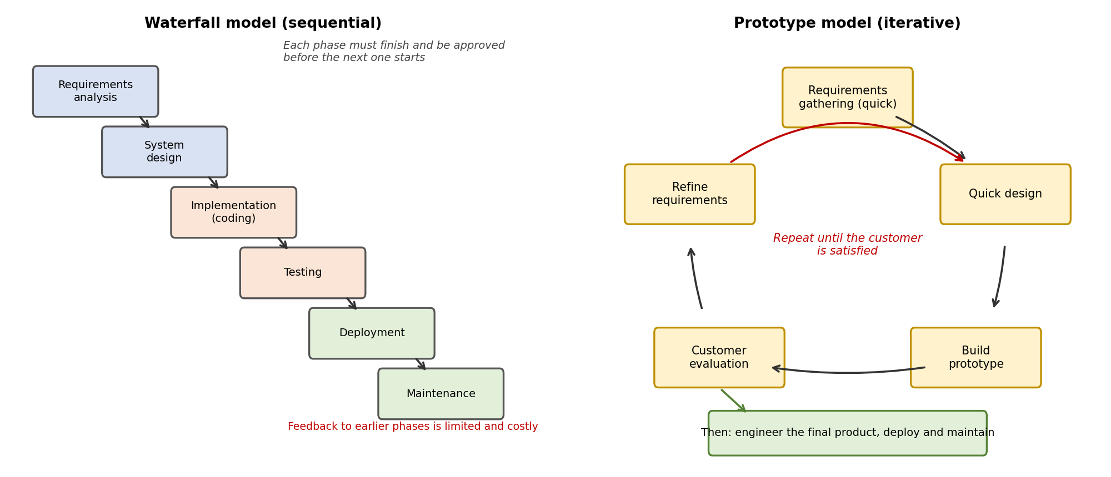

Waterfall model (0.75 mark)
The classic life cycle model (Royce, 1970). The work flows in one direction through the phases: requirements analysis, system design, implementation, testing, deployment and maintenance. Each phase must be completed, reviewed and approved before the next begins, and each produces a document or deliverable (for example the SRS and the design document).

Prototype model (0.75 mark)
A working model of the system is built quickly so that the customer can try it. Steps: quick requirements gathering → quick design → build the prototype → customer evaluation → refine the requirements, repeating until the customer is satisfied, and then the final product is engineered. The prototype may be thrown away (throwaway prototyping) or developed further into the final system (evolutionary prototyping).

Comparison (1 mark)
Basis | Waterfall model | Prototype model
Type | Linear, sequential (prescriptive). | Iterative (evolutionary).
Requirements | Must be complete and clear in the beginning. | Can be unclear; they become clearer through the prototype.
Customer involvement | Low; mainly at the start and end. | High; the customer evaluates every prototype.
Working software | Only at the end of the project. | Early, in the form of a prototype.
Flexibility to change | Very low. | High.
Risk | High: errors and misunderstanding found late. | Lower: misunderstandings are found early.
Documentation | Detailed, at every phase. | Less formal; may be incomplete.
Cost of change | Increases quickly as the project proceeds. | Low in the early iterations.
Time and cost | Predictable. | May increase with the number of iterations.
User interface | Fixed during design. | Refined with user feedback.
Suitable for | Well-understood, stable, formally managed projects. | Unclear requirements, user-interface-heavy and new types of systems.

Advantages, limitations and suitability (0.5 mark)
 | Waterfall model | Prototype model
Advantages | Simple and easy to manage; clear milestones; good documentation; easy to review and audit. | Reduces requirement errors; users see the product early; improves user satisfaction.
Limitations | Inflexible; no early working product; testing at the end; changes are costly. | Customers may mistake the prototype for the final product; poor quality if the prototype is reused carelessly; can continue too long.
Example | Birth certificate management system with fixed rules. | Mobile food ordering app with unclear screens.

3. Case Study: Process Model Selection (Batchwise) [4 Marks]
Marking scheme (4 marks per batch): process model identified (1) + case-specific justification with reasons (2) + limitations, or why other models are not suitable (1). Answers for all four batches follow; submit only your own.

Batch 1: Birth Certificate Management System
Most suitable model: Waterfall model (1 mark).
Justification (2 marks): the case facts match the main features of the Waterfall model.
Case fact | Why Waterfall fits
Requirements are clear, fixed and documented before development | Waterfall needs complete requirements at the start, and freezes them in the requirements phase.
Complete documentation expected | Every phase produces a document (SRS, design document, test plan, user manual).
Formal approval at every stage | Phase gates: the next phase starts only after sign-off by the department.
Government project with fixed scope | Predictable schedule and cost, easy to track milestones and audit.
Well-understood domain (registering births and issuing certificates) | Little risk that requirements will change, so late feedback is not a problem.

Phase | Activity in this project | Deliverable | Approved by
Requirements | Fields of the birth record, hospital and parent details, verification rules, user roles | SRS | Department head
System design | Database, registration and verification modules, certificate format, security | Design document | IT officer
Implementation | Coding of the modules | Source code | Project manager
Testing | Unit, integration, system and acceptance tests | Test report | QA team
Deployment and maintenance | Go-live, training, fixes | Release and manual | Department

Limitations and why other models are not chosen (1 mark): Waterfall gives no working software until late and changes are costly; this is reduced by a thorough requirement review and formal change control. Prototype and Spiral are not needed because requirements are already clear and the risk is low. Agile models favour light documentation and constant change, which conflicts with the formal approval required here.

Batch 2: College Academic Portal
Most suitable model: Incremental model (1 mark).
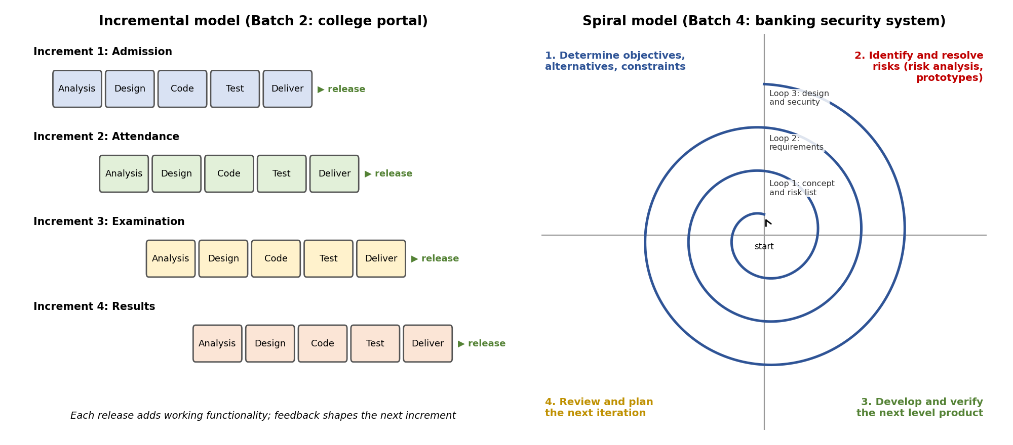
Justification (2 marks): the portal has a clear order of modules, each module is delivered separately, and feedback is used to improve it, which is the idea of the Incremental model. Each increment goes through analysis, design, coding and testing and is released as working software.
Increment | Modules and features | Depends on | How feedback is used
1 (core) | Admission: application form, merit list, fee payment, seat allotment | None | Improve forms and merit rules before the next increment.
2 | Attendance: daily attendance, shortage reports | Student records from Increment 1 | Adjust reports for teachers and parents.
3 | Examination: timetable, hall tickets, marks entry | Students and courses | Improve marks-entry screens.
4 | Results: grade calculation, mark sheets, transcripts | Examination data | Final adjustments to formats and rules.

How the model helps: management gets the most urgent module (admission) first; users learn and give feedback early; each release adds value, so risk is spread; testing is easier because each increment is smaller; and staff can be added gradually.
Limitations and why other models are not chosen (1 mark): the overall architecture and database must be planned at the start so that later modules fit in, and integration effort grows with each increment. Waterfall would deliver nothing until the end; Prototype is not needed because the modules are known; Spiral is heavier than necessary because the main need is staged delivery, not risk analysis.

Batch 3: Mobile Application for Online Food Ordering
Most suitable model: Prototype model (1 mark).
Justification (2 marks): the client does not know the exact user interface or features, wants to see a working sample first, and will then suggest changes. This is exactly the situation the Prototype model is designed for: build a quick model, get feedback, refine.
Case fact | Why the Prototype model fits
Client is unsure about the user interface and features | The prototype makes the ideas visible, so the client can decide what is really needed.
Wants to see a working sample first | The first deliverable is a working (clickable) prototype with sample data.
Will suggest changes before the final development | Customer evaluation and refinement are built into the cycle.
Startup with limited money | Mistakes in screens and flows are found cheaply, before the expensive back-end work.

Step | Activity | Application to the food ordering app
1 | Quick requirements | User types (customer, restaurant, delivery person) and main goals: browse, order, pay, track.
2 | Quick design | Wireframes of the home, restaurant list, menu, cart, checkout and order tracking screens.
3 | Build the prototype | Clickable app with sample restaurants and a fake payment.
4 | Customer evaluation | Demonstration to the client and a few test users; record feedback.
5 | Refine | Update requirements and screens; repeat steps 2 to 4 for a fixed number of rounds.
6 | Final product | Design and build the real back end, payment, location tracking, security and testing.

Limitations and why other models are not chosen (1 mark): the client may think the prototype is the finished app, so expectations must be managed; quick code may be poor and should usually be thrown away or rebuilt; endless changes must be limited by a time-boxed number of rounds; documentation may be thin. Waterfall and Incremental need clear requirements, which are missing here, and Spiral is heavier than needed because the main uncertainty is the interface, not high technical risk.

Batch 4: Banking Security System
Most suitable model: Spiral model (1 mark).
Justification (2 marks): the Spiral model (Boehm, 1988) is risk-driven. Every loop has four steps: set objectives, identify and resolve risks, develop and verify, and plan the next loop. The team wants to identify and reduce risk at every phase, which is the central idea of this model.
Risk | Where it is analysed | Mitigation | Verified by
Data leakage | Loop 1 and 2 (threat model, data classification) | Encryption of data in storage and transit, access control, masking, audit logs | Security review, penetration test
Transaction failure | Loop 2 and 3 (design) | Atomic transactions with rollback, retries without duplicates, backup and failover, daily reconciliation | Failure and load testing
Unauthorized access | Loop 1 to 4 | Multi-factor authentication, role-based access, session timeout, intrusion detection | Penetration test, code review
Requirement and compliance risk | Loop 1 and 2 | Early reviews with the bank’s security and compliance officers | Compliance audit

Spiral loop | Objective | Risk analysis and prototype
1 | Concept and security goals | List main risks; prototype of the security architecture.
2 | Security requirements | Threat model; prototype of login and authorisation.
3 | Design | Review design against threats; prototype of the transaction module.
4 | Build and test | Secure coding, security and failure testing; review remaining risks.
5 | Release and maintenance | Monitoring, patching, periodic risk review.

Limitations and why other models are not chosen (1 mark): the Spiral model is costly, needs experts in risk assessment, and is complex to manage, so it is not suitable for small, low-risk projects (which is not the case here). Waterfall finds risks late, when they are expensive to fix; Incremental and Prototype do not include explicit risk analysis in each phase.

Student Self-Assessment
☐ I explained prescriptive and evolutionary models and compared them.
☐ I compared the Waterfall and Prototype models with diagrams.
☐ I identified the model for my batch and justified it with the case facts.
☐ I explained limitations and why other models are not suitable.
☐ My answers reflect my own understanding.

Assessment Rubric Mapping (10 Marks)
Criterion | Marks | Where addressed in this journal
Q1: Prescriptive vs evolutionary | 3 | Section 1: prescriptive (0.5) + evolutionary (0.5) + table (1.5) + guide (0.5)
Q2: Waterfall vs prototype | 3 | Section 2: waterfall (0.75) + prototype (0.75) + table (1) + pros and cons (0.5)
Q3: Case study (your batch) | 4 | Section 3: model (1) + justification (2) + limitations or alternatives (1)

References
1. R. S. Pressman and B. R. Maxim, Software Engineering: A Practitioner’s Approach, 9th ed., McGraw-Hill, 2020.
2. I. Sommerville, Software Engineering, 10th ed., Pearson, 2015.
3. W. W. Royce, “Managing the Development of Large Software Systems,” Proceedings of IEEE WESCON, 1970.
4. B. W. Boehm, “A Spiral Model of Software Development and Enhancement,” IEEE Computer, vol. 21, no. 5, 1988.
5. P. Jalote, An Integrated Approach to Software Engineering, 3rd ed., Springer, 2005.
6. Course notes and lecture material, Software Engineering.

Declaration: I commit to submitting original work, free from plagiarism or copying from the internet or peers, and to honouring deadlines for a fair and transparent assessment.
Signature of Student: ____________________ Roll No: ____________

