Software Engineering – Assignment Solution Journal
Software Engineering
Assignment 2
Agile Methodology, Extreme Programming and Scrum

Cover Page
Student Name | ______________________________________
Roll No. / Division | ______________________________________
Course | Software Engineering
Semester / Course Code | ______________________________________
Batch | ______ (answer only your own batch in Question 3)
Maximum Marks | 10 (assumed; the sheet does not state the marks)
Date of Submission | ______________________________________

Questions (from the assignment sheet)
Q. | Question
Q1 | Explain Agile Methodology. Discuss principles of Agile software development.
Q2 | Explain Extreme Programming in detail.
Q3 | Case study based question (batchwise): suggest how Scrum can be applied; explain product backlog, sprint planning, sprint review and role of the Scrum Master. Batch 1 e-commerce website, Batch 2 healthcare appointment booking, Batch 3 student result management, Batch 4 travel booking web application.

Marking Scheme at a Glance (10 Marks)
Q. | Component | Marks | Where in this journal
Q1 | Agile concept and values (1) + twelve principles (1.5) + process, benefits and limitations (0.5) | 3 | Section 1
Q2 | Values and principles (0.75) + practices (1.25) + life cycle and roles (0.5) + advantages and limitations (0.5) | 3 | Section 2
Q3 | Product backlog (1) + sprint planning (1) + sprint review (1) + Scrum Master role (1), for your own batch | 4 | Section 3 (Batch 1 to 4)
The sheet gives no marks. A total of 10 marks is assumed, split 3 + 3 + 4. Question 3 is batchwise, so all four batches are solved; submit only your own batch (4 marks).

1. Agile Methodology and its Principles [3 Marks]
Marking scheme (3 marks): concept and values (1) + twelve principles (1.5) + process, benefits and limitations (0.5).

Agile methodology (1 mark)
Agile is a family of iterative and incremental approaches to software development. Instead of planning everything in advance, a small, self-organising team delivers working software in short cycles (iterations or sprints of one to four weeks), gets feedback from the customer after each cycle, and adapts the plan. It grew out of the Agile Manifesto, written in 2001 by a group of software practitioners who were dissatisfied with heavy, document-driven processes. Well-known Agile methods: Scrum, Extreme Programming (XP), Kanban, Feature Driven Development, DSDM and Crystal.
Agile value | Meaning
People and their interactions | are valued more than processes and tools: good communication and a capable team matter most.
Working software | is valued more than comprehensive documentation: the product is the main measure of progress; documents are kept useful and light.
Customer collaboration | is valued more than contract negotiation: the customer works with the team throughout.
Responding to change | is valued more than following a plan: plans are updated as learning occurs.

Principles of Agile software development (1.5 marks)
No. | Principle | Meaning in practice
1 | Satisfy the customer by early and continuous delivery of valuable software. | Release useful features early and often, instead of one big delivery at the end.
2 | Welcome changing requirements, even late in development. | Change is a chance to give the customer a competitive advantage; backlog is reordered each iteration.
3 | Deliver working software frequently. | Cycles of a few weeks (the shorter the better), each ending in a usable increment.
4 | Business people and developers work together daily. | Product Owner or on-site customer is available to answer questions and make decisions.
5 | Build projects around motivated individuals; give them support and trust. | Provide tools and environment and let the team decide how to do the work.
6 | Face-to-face conversation is the best way to share information. | Prefer talking, stand-up meetings and whiteboards to long documents and emails.
7 | Working software is the primary measure of progress. | Progress is shown by running features, not by percentage of documents completed.
8 | Sustainable development: keep a constant pace. | Avoid overtime and burnout; the team can work at the same speed indefinitely.
9 | Continuous attention to technical excellence and good design. | Refactoring, clean code and automated tests keep the product easy to change.
10 | Simplicity: maximise the amount of work not done. | Build only what is needed now; avoid unnecessary features.
11 | The best designs and requirements come from self-organising teams. | Teams decide how to organise work; no heavy command-and-control.
12 | At regular intervals the team reflects and adjusts. | A retrospective at the end of every cycle gives improvements for the next.

Process, benefits and limitations (0.5 mark)
Agile cycle: product vision → prioritised backlog → iteration planning → design, code and test in the iteration → daily stand-up → demo and customer feedback → retrospective → next iteration.
 | Agile | Traditional (Waterfall)
Planning | Adaptive, short horizon | Detailed plan up front
Delivery | Frequent working increments | Single delivery at the end
Change | Welcomed | Resisted and controlled
Customer | Involved throughout | Involved at start and end
Documentation | Light and useful | Heavy and formal

Benefits: faster delivery of value, quick response to change, higher customer satisfaction, early detection of problems and better team morale. Limitations: hard to estimate total cost and time for fixed-price contracts, needs an involved customer and disciplined, experienced team, less documentation, and difficult to scale to very large or distributed projects.

2. Extreme Programming (XP) [3 Marks]
Marking scheme (3 marks): values and principles (0.75) + practices (1.25) + life cycle and roles (0.5) + advantages, limitations and use (0.5).
Extreme Programming is an Agile method created by Kent Beck in the late 1990s. It takes good engineering practices (testing, code review, frequent integration) to an “extreme” level, because they are used constantly. It is designed for small to medium teams working on projects with changing requirements.

Values and principles (0.75 mark)
Value | Meaning
Communication | Everyone shares information face to face; customers, developers and testers talk constantly.
Simplicity | Do the simplest thing that works now; do not build for imagined future needs.
Feedback | Get fast feedback from tests, the customer and the team, at every level.
Courage | Refactor, discard code that does not work and tell the truth about progress.
Respect | Team members respect each other and the customer.
Principles: rapid feedback, assume simplicity, incremental change, embrace change and quality work.

The twelve XP practices (1.25 marks)
Practice | Area | Description
Planning game | Planning | The customer chooses user stories by business value; developers estimate the effort; the release and iteration plans are made together.
Small releases | Planning | A simple working system is released quickly and updated frequently (weeks, not months).
On-site customer | Planning | A real customer sits with the team to answer questions and set priorities.
System metaphor | Design | A shared story or naming scheme describes how the system works.
Simple design | Design | The design is as simple as possible and meets only today’s requirements.
Refactoring | Design | Continuously clean and restructure code without changing behaviour.
Pair programming | Coding | Two programmers share one computer; one writes, the other reviews immediately.
Collective code ownership | Coding | Anyone can change any code; the whole team is responsible for it.
Coding standards | Coding | Common style and rules so that code looks as if one person wrote it.
Continuous integration | Coding | Code is integrated and built many times a day; the build must always pass.
Testing (test-driven development) | Testing | Write the unit test first, then the code; customers write acceptance tests; all tests run constantly.
40-hour week (sustainable pace) | Team | Avoid overtime; tired developers make mistakes.

XP life cycle and roles (0.5 mark)
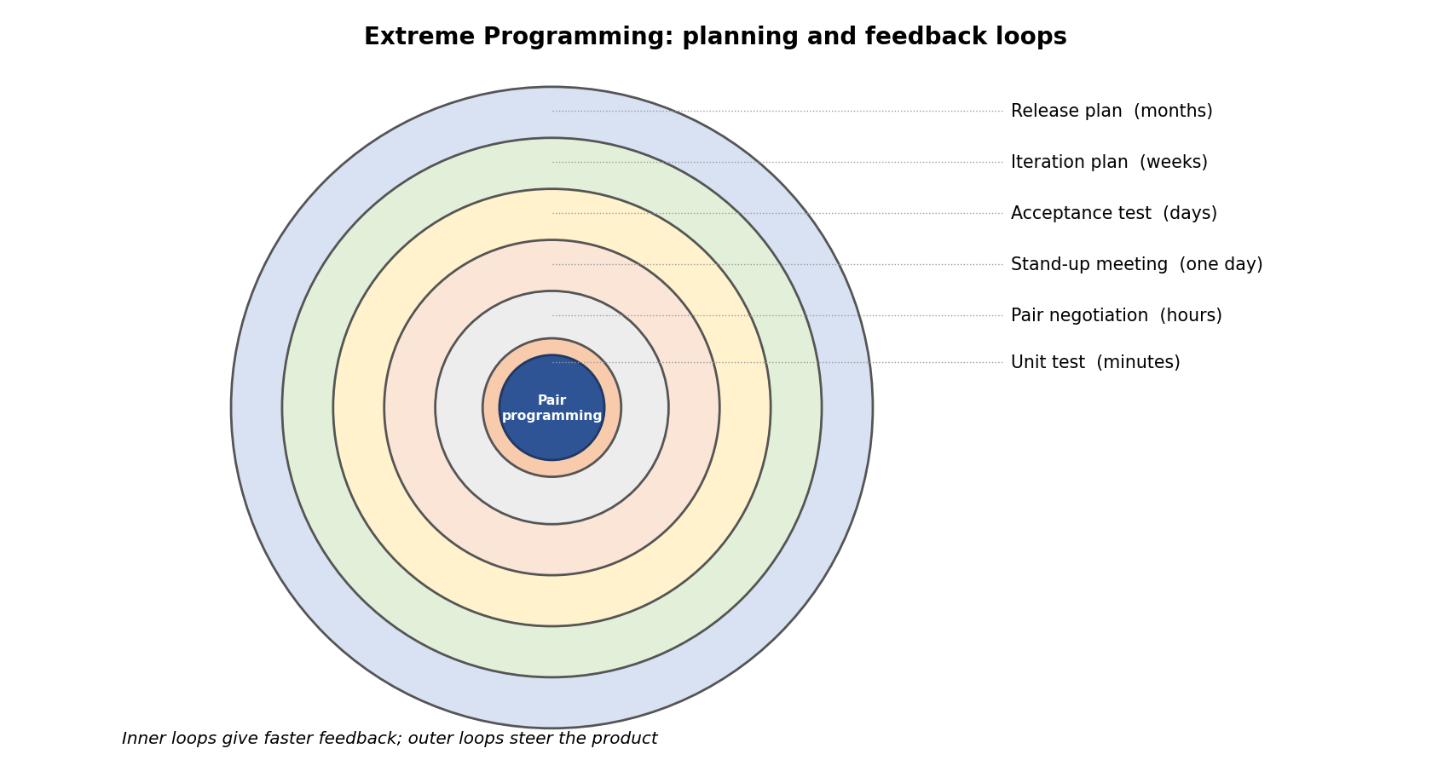
Phase | Activity
Exploration | Customer writes the first user stories; the team tests technology and estimates.
Planning | Stories are prioritised and the first release plan is agreed (about two days).
Iterations to release | Several iterations of 1 to 3 weeks; each plans, designs (CRC cards, spike solutions), codes in pairs with tests, and delivers working software.
Productionizing | Extra testing, performance checks and fixes before the release.
Maintenance | The system is in use while new iterations add features.
Death | The customer has no more stories, or the project is closed.

Roles: Customer (writes stories and acceptance tests), Programmer (designs, codes and tests), Tester (helps the customer write and run tests), Tracker (follows progress and estimates), Coach (guides the process) and Manager (provides resources).

Advantages, limitations and use (0.5 mark)
 | Advantages | Limitations
Points | Fast feedback and flexibility; high code quality from test-driven development and pair programming; customer satisfaction; lower risk because of small releases; shared code knowledge. | Needs an on-site customer and a disciplined team; hard for large or distributed teams; little documentation; pair programming can be costly; difficult with fixed-price and fixed-scope contracts.
When to use: small teams (about 2 to 12 developers), changing requirements and a customer who can be present. XP and Scrum: Scrum organises the management (roles, sprints, backlog) while XP provides engineering practices; they are often combined.

3. Case Study: Applying Scrum (Batchwise) [4 Marks]
Marking scheme (4 marks per batch): product backlog (1) + sprint planning (1) + sprint review (1) + role of the Scrum Master (1). Answers for all four batches follow; submit only your own.
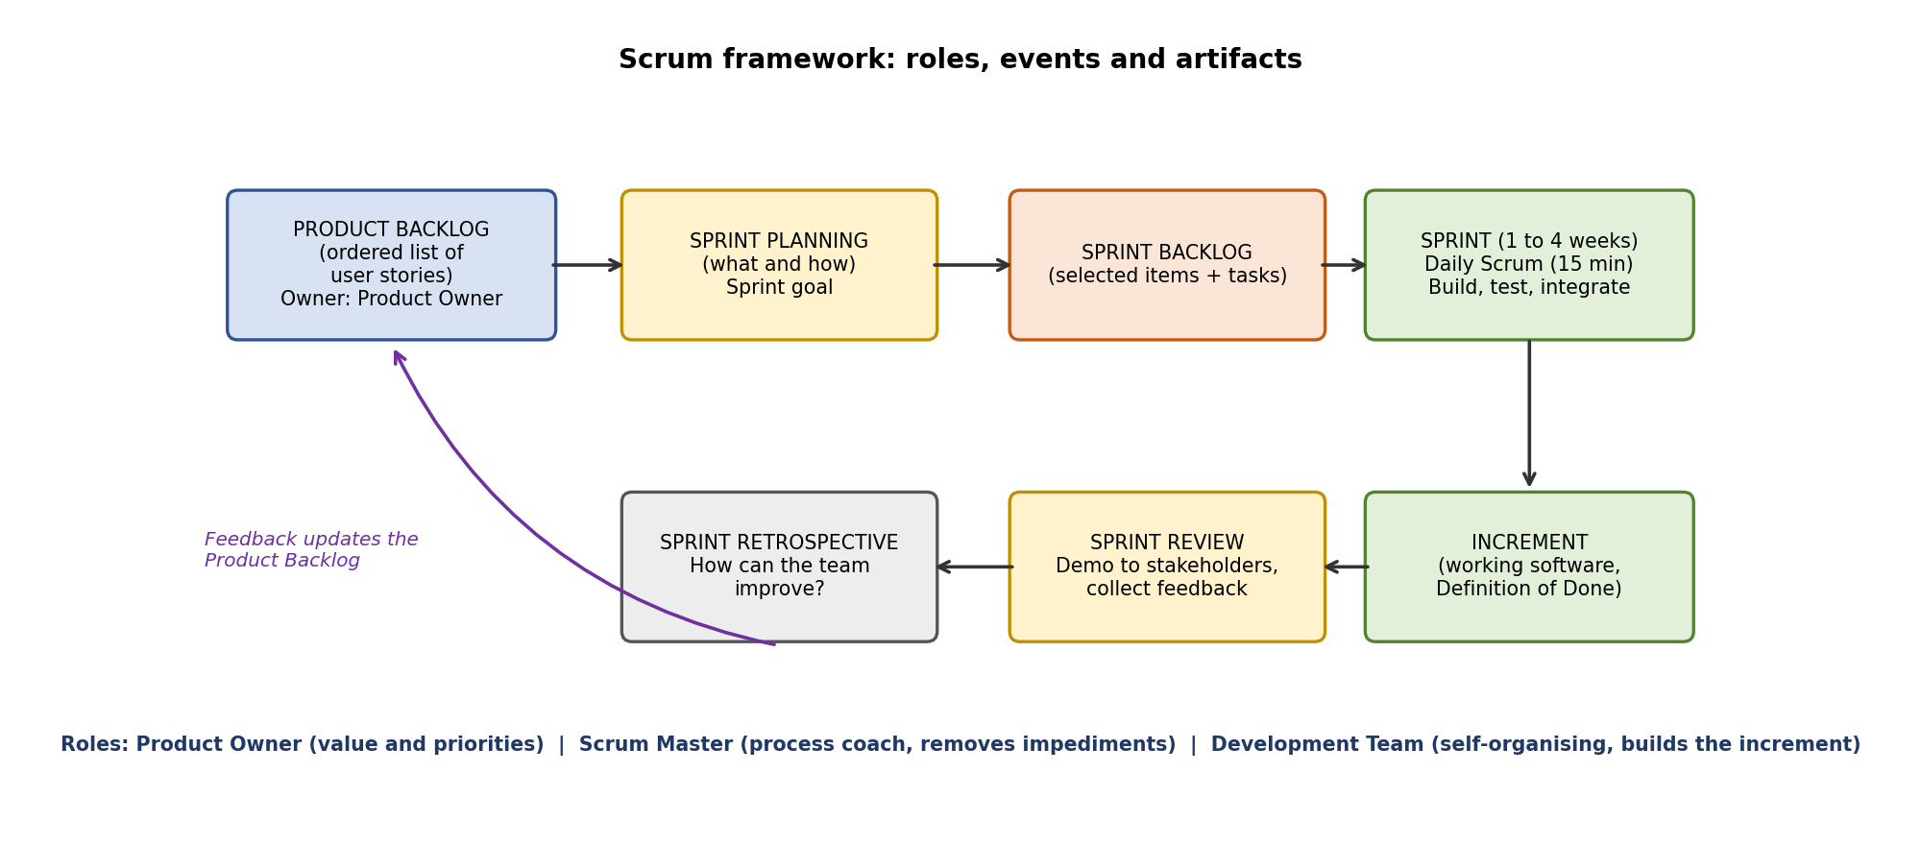
Scrum in one paragraph: a Product Owner keeps the Product Backlog; the team plans a Sprint, builds a working increment while meeting daily for 15 minutes, shows it in a Sprint Review, and improves in a Sprint Retrospective. The Scrum Master coaches the team and removes obstacles. Estimates, velocity and tasks below are assumed examples.

Batch 1: E-commerce Shopping Website
Case: Frequent delivery of working features (user registration, product search, cart, payment, order tracking) and feedback after every short cycle.
(a) Product backlog [1 mark]. The Product Owner keeps an ordered list of everything the product needs. Items are written as user stories and estimated in story points; the list is refined every sprint and can change at any time.
ID | User story / feature | Priority | Points
PB1 | Customer can register and log in | High | 5
PB6 | Admin can add and edit products | High | 5
PB2 | Customer can browse and search products | High | 8
PB3 | Customer can add products to the cart | High | 5
PB4 | Customer can pay online securely | High | 8
PB5 | Customer can track the order status | Medium | 5
PB7 | Email notification for order status | Low | 3

(b) Sprint planning [1 mark]. Held at the start of a 2-week sprint (assumed team velocity of about 18 points per sprint). Sprint goal: a customer can create an account and find products.
Item | Selected for Sprint 1 | Tasks (Sprint Backlog)
PB1 | Registration and login | Screens, API, password hashing, validation, unit tests
PB6 | Admin product management | Admin form, product table, image upload, tests
PB2 | Browse and search | Search API with filters, product list UI, pagination, tests
Forecast: PB1 (5) + PB6 (5) + PB2 (8) = 18 points. Definition of Done: coded, peer-reviewed, unit and integration tests passed, deployed to the test server and accepted by the Product Owner.
(c) Sprint review [1 mark]. At the end of the sprint the team demonstrates the working software to the client and stakeholders, who give feedback; the Product Owner accepts or rejects items against the Definition of Done.
Review element | Content in this case
Demo | Customer registers and logs in; admin adds a product; customer searches for it.
Feedback example | Add price filter; simplify registration with a phone OTP.
Outcome | PB2 extended with a price filter; PB3 and PB4 planned for Sprint 2; velocity of 18 recorded.
Attendees | Product Owner, team, client representatives, Scrum Master.
(d) Role of the Scrum Master [1 mark]. A servant-leader who makes sure Scrum is understood and followed; the Scrum Master does not assign tasks or decide what to build. In this case:
- Ensures the client gives feedback after every sprint and that the Product Owner keeps the backlog ordered by value.
- Removes impediments early, for example getting a payment gateway sandbox account before Sprint 2.
- Protects the sprint: new ideas go to the backlog for the next sprint instead of changing the current one.
- Facilitates sprint planning, the daily Scrum, review and retrospective; tracks the burndown chart.
- Coaches the team on estimating and on automated testing so that every sprint ends with working software.

Batch 2: Healthcare Appointment Booking System
Case: Requirements change often, because doctors, patients and hospital staff keep suggesting improvements; the team wants flexibility and continuous customer involvement.
(a) Product backlog [1 mark]. The Product Owner keeps an ordered list of everything the product needs. Items are written as user stories and estimated in story points; the list is refined every sprint and can change at any time.
ID | User story / feature | Priority | Points
PB1 | Patient registration and login | High | 5
PB2 | Doctor profile and schedule management | High | 8
PB3 | Search doctors by speciality and hospital | High | 5
PB4 | View free slots and book an appointment | High | 8
PB5 | Cancel or reschedule an appointment | Medium | 5
PB6 | SMS and email reminders | Medium | 3
PB7 | Hospital admin dashboard and reports | Low | 8
PB8 | Patient feedback and ratings | Low | 3

(b) Sprint planning [1 mark]. Held at the start of a 2-week sprint (assumed team velocity of about 18 points per sprint). Sprint goal: doctors publish schedules and patients can find a doctor.
Item | Selected for Sprint 1 | Tasks (Sprint Backlog)
PB1 | Patient registration | Form, verification, privacy consent, tests
PB2 | Doctor schedule | Schedule screen, availability rules, leave days, tests
PB3 | Doctor search | Search by speciality and hospital, results page, tests
Forecast: PB1 (5) + PB2 (8) + PB3 (5) = 18 points. Definition of Done: coded, peer-reviewed, unit and integration tests passed, deployed to the test server and accepted by the Product Owner.
(c) Sprint review [1 mark]. Representative doctors, patients and hospital staff see the working software and give feedback; the backlog is changed on the spot.
Review element | Content in this case
Demo | A doctor sets a weekly schedule; a patient registers and finds a doctor.
Feedback example | Doctors want to block leave days; patients want search by location.
Outcome | New items added and reordered; booking (PB4) moved to Sprint 2.
Attendees | Product Owner, team, doctor and patient representatives, hospital admin.
(d) Role of the Scrum Master [1 mark]. A servant-leader who makes sure Scrum is understood and followed; the Scrum Master does not assign tasks or decide what to build. In this case:
- Makes continuous customer involvement possible: fixes review times that suit busy doctors.
- Handles changing requirements by adding them to the backlog and keeping the current sprint stable.
- Removes impediments such as access to hospital systems and clarity on patient-data privacy rules.
- Coaches the Product Owner to keep the backlog short, ordered and visible to all stakeholders.
- Runs a retrospective after each sprint so the team improves how it responds to change.

Batch 3: Student Result Management System
Case: Frequent testing, pair programming, simple design, continuous integration and regular customer feedback are required to reduce defects.
(a) Product backlog [1 mark]. The Product Owner keeps an ordered list of everything the product needs. Items are written as user stories and estimated in story points; the list is refined every sprint and can change at any time.
ID | User story / feature | Priority | Points
PB1 | Role-based login (admin, faculty, student) | High | 5
PB2 | Course and student master data | High | 5
PB3 | Faculty enters marks for a course | High | 8
PB4 | Result calculation (grades, pass or fail) | High | 8
PB5 | Students view results online | High | 5
PB6 | Revaluation request | Medium | 5
PB7 | Mark sheet as PDF | Medium | 3

(b) Sprint planning [1 mark]. Held at the start of a 2-week sprint (assumed team velocity of about 18 points per sprint). Sprint goal: a faculty member can enter marks for a course.
Item | Selected for Sprint 1 | Tasks (Sprint Backlog)
PB1 | Role-based login | Roles and permissions, login page, security tests
PB2 | Master data | Student and course tables, import from a file, tests
PB3 | Marks entry | Entry screen with validation, save and edit, unit tests
Forecast: PB1 (5) + PB2 (5) + PB3 (8) = 18 points. Definition of Done: coded, peer-reviewed, unit and integration tests passed, deployed to the test server and accepted by the Product Owner.
(c) Sprint review [1 mark]. The examination cell and faculty see the working marks-entry module and give feedback.
Review element | Content in this case
Demo | Admin imports students; faculty enters and saves marks; invalid marks are rejected.
Feedback example | Faculty ask for bulk upload from a spreadsheet.
Outcome | Bulk upload added to the backlog; PB4 (calculation) planned for Sprint 2; test coverage and defect count reported.
Attendees | Product Owner (examination controller), team, faculty representatives.
(d) Role of the Scrum Master [1 mark]. A servant-leader who makes sure Scrum is understood and followed; the Scrum Master does not assign tasks or decide what to build. In this case:
- Makes engineering practices part of the Definition of Done: automated unit tests, a green continuous-integration build and a pair or peer review before an item is done.
- Arranges time for pair programming and for setting up the build server.
- Removes impediments such as getting last year’s mark formats and test data.
- Keeps the sprint stable, so test-driven work is not interrupted.
- Facilitates the review and retrospective and tracks defects found per sprint to show the effect of frequent testing.

Batch 4: Travel Booking Web Application
Case: The product has hotel booking, ticket booking, payment, cancellation and customer support; the company wants a working version every two weeks and the ability to adapt to changes.
(a) Product backlog [1 mark]. The Product Owner keeps an ordered list of everything the product needs. Items are written as user stories and estimated in story points; the list is refined every sprint and can change at any time.
ID | User story / feature | Priority | Points
PB1 | User account and login | High | 5
PB2 | Search hotels (city, dates, price) | High | 8
PB3 | Hotel booking | High | 8
PB4 | Ticket booking through partner services | High | 8
PB5 | Online payment | High | 8
PB6 | Cancellation and refund | Medium | 8
PB7 | Customer support (chat or tickets) | Medium | 5

(b) Sprint planning [1 mark]. Held at the start of a 2-week sprint (assumed team velocity of about 18 points per sprint). Sprint goal: users can sign in and search hotels, and the partner ticket service is chosen.
Item | Selected for Sprint 1 | Tasks (Sprint Backlog)
PB1 | User account | Sign-up, login, profile, tests
PB2 | Hotel search | Search API, filters, results page, tests
Spike (5) | Ticket service study | Compare partner services, test a sample request, write a recommendation
Forecast: PB1 (5) + PB2 (8) + Spike (5) = 18 points. A spike is a short study that removes uncertainty. Definition of Done: coded, peer-reviewed, unit and integration tests passed, deployed to the test server and accepted by the Product Owner.
(c) Sprint review [1 mark]. Each sprint ends with a working, deployable version that stakeholders can try; their feedback decides the next sprint.
Review element | Content in this case
Demo | User signs up and searches hotels by city and dates; spike results are presented.
Feedback example | Add a map view; business wants ticket booking earlier.
Outcome | Backlog reordered (PB4 raised); PB3 continued in Sprint 2; a deployable version is available after every sprint.
Attendees | Product Owner, team, support and payment stakeholders, Scrum Master.
(d) Role of the Scrum Master [1 mark]. A servant-leader who makes sure Scrum is understood and followed; the Scrum Master does not assign tasks or decide what to build. In this case:
- Makes sure there is a working, releasable version at the end of every two weeks.
- Helps the team adapt to change: changes go to the backlog, are re-prioritised by the Product Owner and picked up in the next sprint.
- Removes dependencies on partner services and payment providers (accounts, test keys, API limits).
- Coordinates between the team and the support and business groups so that feedback arrives on time.
- Coaches the team to keep stories small and to improve each sprint through the retrospective.

Student Self-Assessment
☐ I explained Agile and its twelve principles.
☐ I explained Extreme Programming in detail.
☐ I applied Scrum to my batch with backlog, planning, review and Scrum Master role.
☐ My estimates and tasks are consistent with the case.
☐ My answers reflect my own understanding.

Assessment Rubric Mapping (10 Marks)
Criterion | Marks | Where addressed in this journal
Q1: Agile methodology and principles | 3 | Section 1: concept and values (1) + twelve principles (1.5) + process and pros and cons (0.5)
Q2: Extreme Programming | 3 | Section 2: values (0.75) + practices (1.25) + life cycle and roles (0.5) + pros and cons (0.5)
Q3: Scrum case study (your batch) | 4 | Section 3: product backlog (1) + sprint planning (1) + sprint review (1) + Scrum Master (1)

References
1. K. Beck et al., “Manifesto for Agile Software Development,” 2001 (agilemanifesto.org) and “Principles behind the Agile Manifesto.”
2. K. Beck and C. Andres, Extreme Programming Explained: Embrace Change, 2nd ed., Addison-Wesley, 2004.
3. K. Schwaber and J. Sutherland, The Scrum Guide, 2020 (scrumguides.org).
4. R. S. Pressman and B. R. Maxim, Software Engineering: A Practitioner’s Approach, 9th ed., McGraw-Hill, 2020.
5. I. Sommerville, Software Engineering, 10th ed., Pearson, 2015.
6. Course notes and lecture material, Software Engineering.

Declaration: I commit to submitting original work, free from plagiarism or copying from the internet or peers, and to honouring deadlines for a fair and transparent assessment.
Signature of Student: ____________________ Roll No: ____________

