Software Engineering – Assignment Solution Journal
Software Engineering
Assignment 3
Software Requirements and Requirements Engineering

Cover Page
Student Name | ______________________________________
Roll No. / Division | ______________________________________
Course | Software Engineering
Semester / Course Code | ______________________________________
Batch | ______ (answer only your own batch in Question 3)
Maximum Marks | 10 (assumed; the sheet does not state the marks)
Date of Submission | ______________________________________

Questions (from the assignment sheet)
Q. | Question
Q1 | Explain the concept of requirements in software engineering. Describe the different types of requirements with suitable examples.
Q2 | Explain requirement gathering and requirement engineering tasks. Discuss the importance of requirement analysis, validation and management in software development.
Q3 | Case study (answer the one allotted to your batch): identify the functional and non-functional requirements and mention suitable requirement gathering techniques. Batch 1 college admission system, Batch 2 hospital appointment booking, Batch 3 e-commerce website, Batch 4 mobile banking application.

Marking Scheme at a Glance (10 Marks)
Q. | Component | Marks | Where in this journal
Q1 | Concept and characteristics (1) + types with examples (1.5) + functional vs non-functional comparison and requirements document (0.5) | 3 | Section 1
Q2 | Requirement gathering (0.75) + requirement engineering tasks (1) + importance of analysis, validation and management (1) + consequences of weak requirements (0.25) | 3 | Section 2
Q3 | Functional requirements (1.5) + non-functional requirements (1.5) + gathering techniques (1), for your own batch | 4 | Section 3 (Batch 1 to 4)
The sheet gives no marks. A total of 10 marks is assumed, split 3 + 3 + 4. Question 3 is batchwise, so all four batches are solved; submit only your own batch (4 marks).

1. Requirements and their Types [3 Marks]
Marking scheme (3 marks): concept and characteristics (1) + types with examples (1.5) + functional vs non-functional comparison and requirements document (0.5).

Concept of requirements (1 mark)
A software requirement describes what the system should do, the services it must provide, and the limits within which it must work. It is a condition or capability that a user needs to solve a problem or reach a goal, or that the system must have to satisfy a contract, standard or specification. Requirements are the starting point of the whole project: they are the basis for design, cost and schedule estimation, coding, testing and acceptance by the customer. Most project failures that are blamed on technology actually start with missing, unclear or changing requirements.
Characteristic of a good requirement | Meaning
Correct and necessary | Reflects a real stakeholder need.
Unambiguous | Has only one meaning; avoids words such as “fast”, “user-friendly” without numbers.
Complete and consistent | Nothing is missing and requirements do not contradict each other.
Verifiable (testable) | It is possible to check by a test, inspection or measurement that it is met.
Feasible | Can be achieved within the time, budget and technology available.
Traceable and modifiable | Has a unique ID, can be traced to its source and to design and tests, and is easy to change.
Prioritised | Importance is known (for example Must, Should, Could).

Types of requirements (1.5 marks)
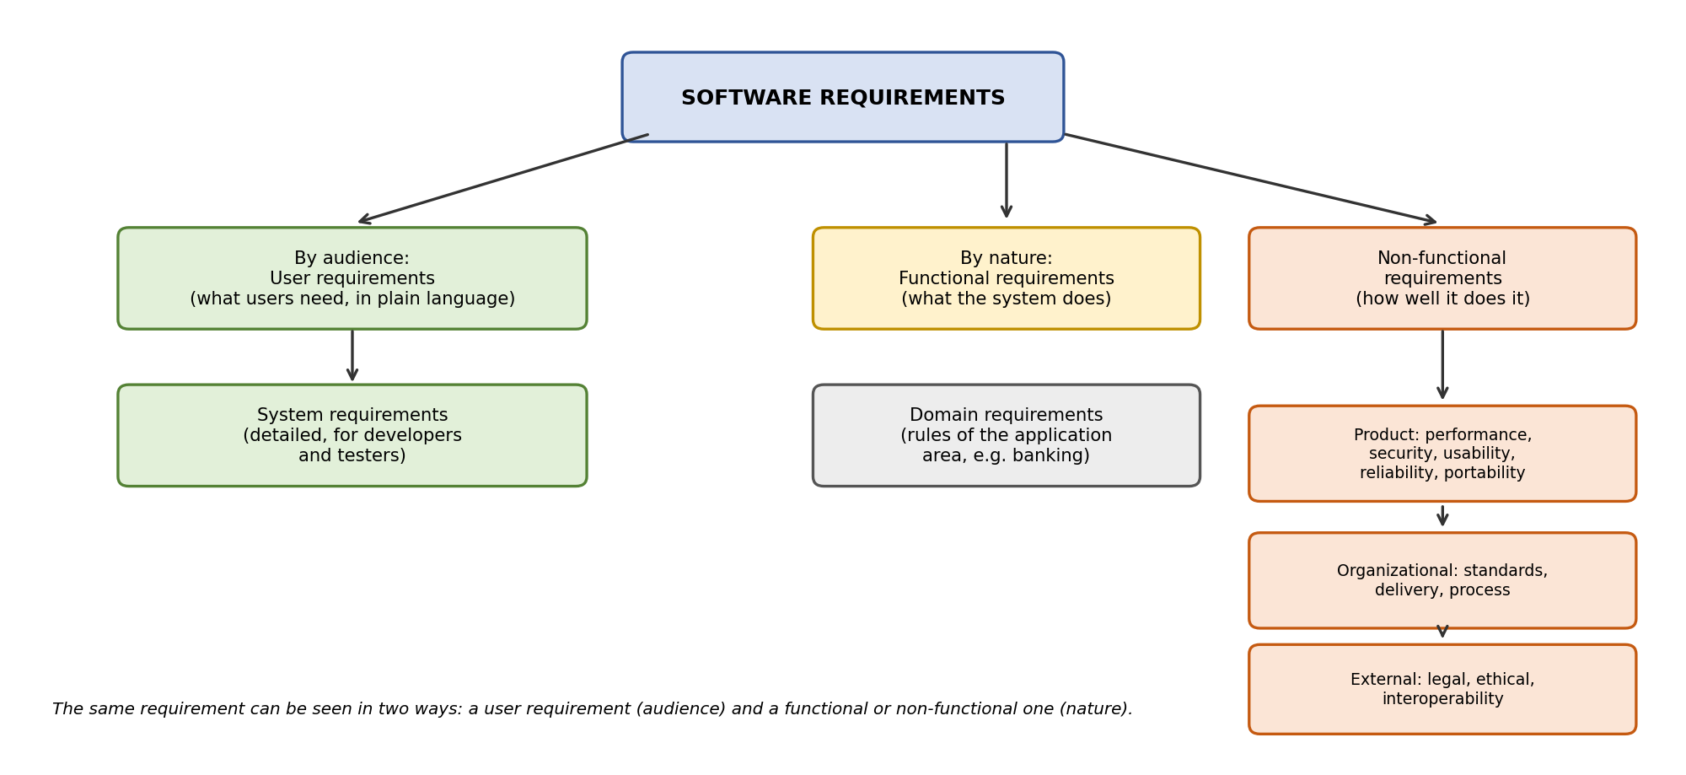
Type | Meaning | Example (online library system)
User requirements | Statements, in plain language, of what the users need from the system. | “A member must be able to search for a book and see if it is available.”
System requirements | Detailed description of the system functions, inputs, outputs and constraints, written for developers and testers. | “The system shall search by title, author or ISBN and return results sorted by relevance within 2 seconds.”
Functional requirements | Services and behaviour of the system: what it does for given inputs. | “The system shall allow a member to reserve a book that is on loan.”
Non-functional requirements | Qualities and constraints on the system: how well it does its work. | “The system shall be available 99.5% of the time.”
Product requirements (non-functional) | Performance, security, usability, reliability, portability. | “Passwords shall be stored in encrypted form.”
Organizational requirements (non-functional) | Standards, delivery dates, development process. | “The system shall follow the college IT policy and be delivered by 30 June.”
External requirements (non-functional) | Legal, ethical, interoperability. | “Member data shall be handled as required by the data protection law.”
Domain requirements | Rules from the application area that the system must follow. | “A member may borrow at most 5 books at a time.”

Functional vs non-functional, and the requirements document (0.5 mark)
Basis | Functional requirements | Non-functional requirements
Describe | What the system does | How well, and under what limits, the system works
Example | Generate a monthly report | Report is generated in under 10 seconds
Failure effect | A feature is missing | The system is slow, insecure or hard to use, even if all features exist
Verified by | Functional testing | Performance, security, usability and reliability tests
Both kinds are written in the Software Requirements Specification (SRS), the agreed document that is used by the customer, designers and testers.

2. Requirement Gathering and Requirements Engineering [3 Marks]
Marking scheme (3 marks): requirement gathering (0.75) + requirement engineering tasks (1) + importance of analysis, validation and management (1) + consequences of weak requirements (0.25).

Requirement gathering (elicitation) (0.75 mark)
Requirement gathering is the activity of finding out what stakeholders (users, customers, managers, operators, regulators) need from the system. It is difficult because stakeholders may not know exactly what they want, use their own vocabulary, disagree with each other or change their minds. The main techniques are:
Technique | How it works | Advantage | Limitation
Interviews | Structured or open questions to individual stakeholders. | Detailed, personal answers. | Time-consuming; opinions may differ.
Questionnaires and surveys | Written questions to many people. | Reaches many users cheaply. | Little depth; low response.
Observation (ethnography) | Watch users doing the real work. | Finds unspoken needs and real process. | Slow; people may behave differently when watched.
Workshops (JAD) and brainstorming | Stakeholders and analysts meet and decide together. | Fast agreement and conflict resolution. | Needs good facilitation; dominant people.
Prototyping | Show a quick sample of screens or functions. | Users react to something real. | Can raise unrealistic expectations.
Document and existing system analysis | Study forms, manuals, rules, old software. | Gives rules and data details. | May be out of date.
Use cases and user stories | Describe how users interact with the system. | Easy to understand; user focused. | May miss non-functional needs.

Requirements engineering tasks (1 mark)
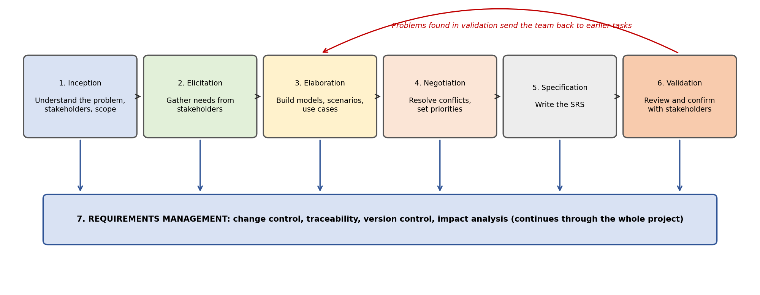
Task | What happens | Output
Inception | Understand the problem, the business need, the stakeholders and the scope; check feasibility. | Project scope and vision
Elicitation | Gather requirements with the techniques above. | Raw list of needs
Elaboration | Expand and refine into models, use cases and scenarios; find missing details. | Analysis models
Negotiation | Resolve conflicts, agree priorities, and balance cost, time and wishes. | Agreed, prioritised requirements
Specification | Write the requirements clearly in a standard document. | Software Requirements Specification (SRS)
Validation | Review and check that the requirements are correct, complete, consistent and testable. | Approved SRS and review report
Requirements management | Control changes, keep versions, trace requirements to design and tests throughout the project. | Change log, traceability matrix

Importance of analysis, validation and management (1 mark)
Activity | What it does | Why it is important
Requirement analysis | Classifies requirements, models them, finds conflicts, gaps and duplicates, and sets priorities. | Gives a clear, consistent and feasible set of requirements; helps in estimating cost and time; avoids building the wrong features.
Requirement validation | Checks the SRS with reviews, inspections, prototypes and by writing test cases. | Finds errors while they are cheap to fix; confirms that the product will meet the real need; reduces rework and disputes.
Requirement management | Controls change with a change process, version control, impact analysis and traceability. | Requirements always change; managing change keeps the project in control, protects schedule and cost, and keeps design, code and tests consistent.

Consequences of weak requirements (0.25 mark)
Errors in requirements are much cheaper to correct during analysis than after coding or deployment. Poor requirements lead to missing features, rework, cost and schedule overruns, unhappy customers and sometimes failed projects. Good requirements engineering is therefore one of the most effective ways of improving software quality.

3. Case Study (Batchwise) [4 Marks]
Marking scheme (4 marks per batch): functional requirements (1.5) + non-functional requirements (1.5) + suitable requirement gathering techniques (1). Answers for all four batches follow; submit only your own.

Batch 1: College Admission Management System
(a) Functional requirements [1.5 marks]. What the system must do. Priority uses MoSCoW: Must, Should, Could.
ID | Requirement (the system shall ...) | Actor | Priority
FR1 | Register and log in with a unique account | Student | Must
FR2 | Fill in the online admission form (personal and academic details), save it as a draft and edit before submission | Student | Must
FR3 | Upload documents (mark sheets, ID, photo) with checks on file type and size | Student | Must
FR4 | Pay admission fees online and receive a receipt | Student | Must
FR5 | Track the admission status (submitted, under verification, accepted, rejected) | Student | Must
FR6 | View, verify and accept or reject applications with remarks | Admission staff | Must
FR7 | Generate reports: admitted students, pending applications, rejected applications | Admission staff | Must
FR8 | Send email or SMS when the status changes | System | Should
FR9 | Manage users, roles and admission cycles | Administrator | Should

(b) Non-functional requirements [1.5 marks]. How well the system must work. Numbers are assumed example targets, to be confirmed with the client.
Category | Requirement | How it can be checked
Security | Role-based access; documents and personal data are encrypted and visible only to authorised staff. | Security testing, access review
Performance and scalability | Pages respond in 3 seconds or less with up to 2,000 applicants online at the same time near the deadline (assumed). | Load test
Availability | Available 99.5% of the time during the admission period. | Monitoring
Reliability | No lost applications or duplicate payments; payment and status stay consistent. | Failure and recovery tests
Usability | Simple form that works on mobile phones; clear error messages. | Usability test with students
Compliance and backup | Follow the university and data protection rules; daily backup of data. | Audit, restore test

(c) Suitable requirement gathering techniques [1 mark].
Technique | Use in this project | Stakeholders
Interviews | Admission officers and clerks explain rules, steps and report formats. | Admission department, principal
Questionnaire | Applicants and parents tell what information and help they need. | Students, parents
Observation | Watch the current manual process at the admission counter. | Admission staff, applicants
Document analysis | Study admission forms, brochures, circulars and old registers. | Admission office
Prototyping / workshop | Show the form and status screens; agree the report layouts. | Department staff, IT team

Batch 2: Hospital Patient Appointment Booking System
(a) Functional requirements [1.5 marks]. What the system must do. Priority uses MoSCoW: Must, Should, Could.
ID | Requirement (the system shall ...) | Actor | Priority
FR1 | Patients register and log in | Patient | Must
FR2 | Search doctors by name, speciality or hospital | Patient | Must
FR3 | View a doctor’s free slots and book an appointment online | Patient | Must
FR4 | Cancel or reschedule an appointment | Patient | Must
FR5 | Doctors view their daily schedule and patient list | Doctor | Must
FR6 | Receptionist books, cancels and reschedules appointments (including walk-ins) for patients | Receptionist | Must
FR7 | Doctors or receptionist set and change availability and leave | Doctor, receptionist | Should
FR8 | Send confirmation and reminder by SMS or email | System | Should
FR9 | Keep appointment history for each patient | System | Could

(b) Non-functional requirements [1.5 marks]. How well the system must work. Numbers are assumed example targets, to be confirmed with the client.
Category | Requirement | How it can be checked
Security and privacy | Patient data is encrypted and access is by role (patient, doctor, receptionist); every access to a record is logged. | Security review, audit log check
Performance (fast) | Search and slot display in 2 seconds or less; booking confirmed in 3 seconds or less. | Performance test
Usability (easy to use) | A booking is done in three steps or fewer; large text and simple language, usable by elderly patients. | Usability test
Reliability and availability | Available 24 hours a day; two patients cannot book the same slot (no double booking). | Concurrency and failure tests
Compatibility | Works on common browsers and mobile phones. | Compatibility testing
Backup | Daily backup and recovery within 4 hours. | Restore test

(c) Suitable requirement gathering techniques [1 mark].
Technique | Use in this project | Stakeholders
Interviews | Doctors and receptionists explain scheduling rules, leave and walk-in handling. | Doctors, receptionists
Observation | Watch how the front desk handles calls and appointment registers. | Reception staff
Questionnaire | Patients tell how they prefer to book and what reminders they want. | Patients
Document analysis | Study the appointment register and doctor timetables. | Hospital administration
Prototype and workshop | Show the booking flow and agree on it with all user groups. | Doctors, reception, IT

Batch 3: E-commerce Shopping Website
(a) Functional requirements [1.5 marks]. What the system must do. Priority uses MoSCoW: Must, Should, Could.
ID | Requirement (the system shall ...) | Actor | Priority
FR1 | Customers register and log in | Customer | Must
FR2 | Search products by keyword, category and filters, and sort the results | Customer | Must
FR3 | View product details, price, images and stock status | Customer | Must
FR4 | Add, update and remove items in the cart | Customer | Must
FR5 | Check out and pay online with several payment methods | Customer | Must
FR6 | Track order status and view order history | Customer | Must
FR7 | Manage products, prices, stock and orders | Administrator | Must
FR8 | Send order confirmation and shipping notifications | System | Should
FR9 | Offer discount coupons for festival sales | Administrator | Could

(b) Non-functional requirements [1.5 marks]. How well the system must work. Numbers are assumed example targets, to be confirmed with the client.
Category | Requirement | How it can be checked
Performance and scalability | Handle heavy festival traffic: for example 10 times the normal number of users, with page response of 3 seconds or less at peak (assumed); use caching and automatic scaling. | Load and stress tests
Availability | At least 99.9% available, especially during sales. | Monitoring, failover test
Security | HTTPS everywhere; secure payment handling according to payment-card standards; passwords stored as hashes. | Security scan, penetration test
Reliability | Orders and payments stay consistent; no order is lost or charged twice during peak load. | Failure tests
Usability and compatibility | Works well on mobile and desktop browsers; checkout in few steps. | Usability and cross-browser tests
Maintainability | Modular design so that offers and payment methods can be changed quickly. | Code and design review

(c) Suitable requirement gathering techniques [1 mark].
Technique | Use in this project | Stakeholders
Interviews | Business owner, sales and customer-support teams describe products, offers and complaints. | Management, sales, support
Survey and questionnaire | Customers tell how they search, pay and what problems they face. | Customers
Competitor and existing system analysis | Study similar shopping sites to find expected features. | Analysts
Data and document analysis | Use previous sales and traffic logs to estimate festival load. | IT and sales
Prototype and user stories | Show screens for search, cart and checkout and collect feedback. | Business, customers, team

Batch 4: Mobile Banking Application
(a) Functional requirements [1.5 marks]. What the system must do. Priority uses MoSCoW: Must, Should, Could.
ID | Requirement (the system shall ...) | Actor | Priority
FR1 | Secure login with PIN, password or biometrics and a one-time password | Customer | Must
FR2 | Check account balance and view recent transactions | Customer | Must
FR3 | Transfer money between own accounts and to other beneficiaries; add and manage beneficiaries | Customer | Must
FR4 | Pay bills and set up scheduled or recurring payments | Customer | Must
FR5 | Download account statements for a chosen period | Customer | Must
FR6 | Receive transaction alerts by notification or SMS | System | Must
FR7 | Log out automatically after inactivity; block the app on suspected fraud | System | Should
FR8 | Support the customer through help and complaint requests | Customer, support | Could

(b) Non-functional requirements [1.5 marks]. How well the system must work. Numbers are assumed example targets, to be confirmed with the client.
Category | Requirement | How it can be checked
Security (high) | Encrypted communication and storage; multi-factor authentication; session timeout; fraud detection; audit logs. | Penetration test, security audit
Reliability | Each transaction either completes fully or not at all; no duplicate debits; 99.95% availability (assumed). | Failure and consistency tests
Performance (quick response) | Balance in 2 seconds or less and a transfer confirmed within 5 seconds under normal load (assumed). | Performance test
Usability and accessibility | Simple screens, large buttons, language options; usable by first-time users. | Usability test
Compatibility | Works on supported Android and iOS versions and screen sizes. | Device testing
Compliance and auditability | Follow banking regulations; keep transaction logs for audit. | Compliance review

(c) Suitable requirement gathering techniques [1 mark].
Technique | Use in this project | Stakeholders
Interviews | Bank operations, security and compliance officers explain rules and risks. | Bank staff
Questionnaire and focus group | Customers tell which features they use and what they fear (security, speed). | Customers
Document analysis | Study the regulations that apply to banks, existing app reviews and complaint records. | Analysts, compliance
Observation | Watch customers at branches and call centres to see common tasks and problems. | Branch staff, customers
Prototype and workshop | Show app screens and agree on the main flows with business and security teams. | Business, security, IT

Student Self-Assessment
☐ I explained requirements and their types with examples.
☐ I explained the requirement engineering tasks and gathering techniques.
☐ I explained the importance of analysis, validation and management.
☐ I listed functional and non-functional requirements for my batch.
☐ My answers reflect my own understanding.

Assessment Rubric Mapping (10 Marks)
Criterion | Marks | Where addressed in this journal
Q1: Requirements and types | 3 | Section 1: concept (1) + types with examples (1.5) + comparison and SRS (0.5)
Q2: Requirements engineering | 3 | Section 2: gathering (0.75) + tasks (1) + analysis, validation, management (1) + consequences (0.25)
Q3: Case study (your batch) | 4 | Section 3: functional (1.5) + non-functional (1.5) + techniques (1)

References
1. I. Sommerville, Software Engineering, 10th ed., Pearson, 2015 (Requirements Engineering).
2. R. S. Pressman and B. R. Maxim, Software Engineering: A Practitioner’s Approach, 9th ed., McGraw-Hill, 2020 (Understanding Requirements).
3. IEEE Std 830-1998, Recommended Practice for Software Requirements Specifications; ISO/IEC/IEEE 29148:2018, Requirements Engineering.
4. K. Wiegers and J. Beatty, Software Requirements, 3rd ed., Microsoft Press, 2013.
5. P. Jalote, An Integrated Approach to Software Engineering, 3rd ed., Springer, 2005.
6. Course notes and lecture material, Software Engineering.

Declaration: I commit to submitting original work, free from plagiarism or copying from the internet or peers, and to honouring deadlines for a fair and transparent assessment.
Signature of Student: ____________________ Roll No: ____________

