Software Engineering – Assignment Solution Journal
Software Engineering
Assignment 5
Project Scheduling: CPM and PERT

Cover Page
Student Name | ______________________________________
Roll No. / Division | ______________________________________
Course | Software Engineering
Semester / Course Code | ______________________________________
Batch | ______ (answer only your own batch in Question 3)
Maximum Marks | 10 (assumed; the sheet does not state the marks)
Date of Submission | ______________________________________

Questions (from the assignment sheet)
Q. | Question
Q1 | CPM problem (batchwise): draw the network diagram; calculate ES, EF, LS, LF, total float, critical path and total project duration.
Q2 | PERT problem (batchwise): calculate the expected time of each activity, draw the network diagram, identify the critical path and calculate the expected project duration.

Marking Scheme at a Glance (10 Marks)
Q. | Component | Marks | Where in this journal
Q1 | Network diagram (1) + forward pass (1) + backward pass (1) + total float and critical path (1) + project duration (1) | 5 | Q1 of your batch
Q2 | Expected times (1.5) + network diagram (1) + forward and backward pass with float (1) + critical path (0.75) + expected duration (0.75) | 5 | Q2 of your batch
The sheet gives no marks. A total of 10 marks is assumed (5 + 5). Solutions for all four batches are given; submit only your own batch.

Method Used
Term | Meaning and formula
Activity-on-node network | Each activity is a node; arrows show precedence (an activity starts only after all its predecessors finish).
ES (earliest start) | Largest EF among the predecessors (0 if there is none).
EF (earliest finish) | EF = ES + duration.
LF (latest finish) | Smallest LS among the successors; for the last activity, LF = project duration.
LS (latest start) | LS = LF − duration.
Total float (slack) | LS − ES (equal to LF − EF). The time an activity can be delayed without delaying the project.
Critical path | The longest path from start to finish; all its activities have total float 0. Its length is the project duration.
PERT expected time | te = (O + 4M + P) / 6, with O optimistic, M most likely and P pessimistic time.
PERT variance | ((P − O) / 6)²; the project variance is the sum of the variances on the critical path.

Note: PERT times are given with two decimals (for example 6.33). All values were calculated exactly and checked by listing every path from start to finish; the longest path equals the project duration.

Batch 1

Q1. CPM Problem [5 Marks]
Marking scheme (5 marks): network diagram (1) + forward pass ES and EF (1) + backward pass LS and LF (1) + total float and critical path (1) + total project duration (1).
Network diagram (1 mark).
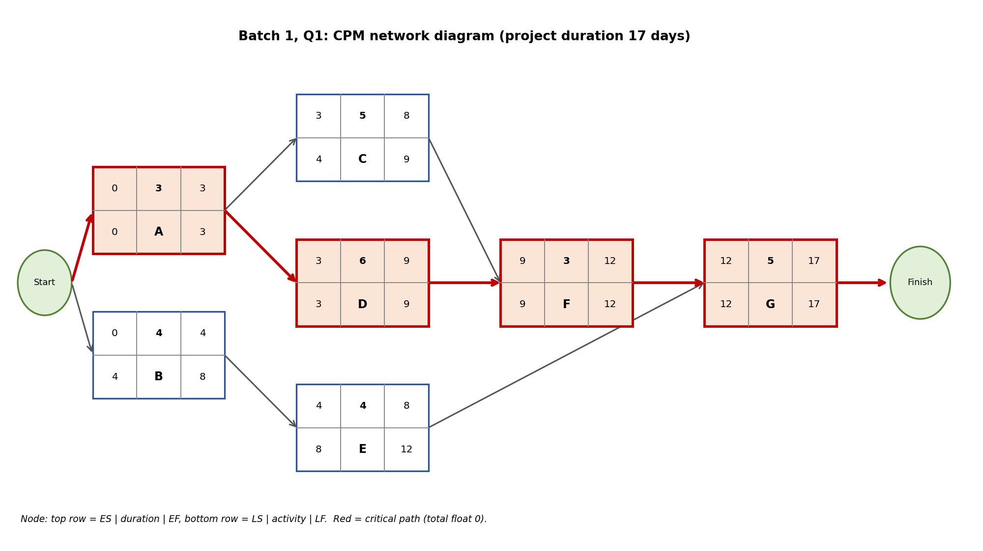
Forward pass, backward pass and float (3 marks). ES = largest EF of the predecessors; EF = ES + duration; LF = smallest LS of the successors (for the last activity, the project duration); LS = LF − duration; total float = LS − ES.
Activity | Predecessor | Duration | ES | EF | LS | LF | Total float | Critical?
A | - | 3 | 0 | 3 | 0 | 3 | 0 | Yes
B | - | 4 | 0 | 4 | 4 | 8 | 4 | No
C | A | 5 | 3 | 8 | 4 | 9 | 1 | No
D | A | 6 | 3 | 9 | 3 | 9 | 0 | Yes
E | B | 4 | 4 | 8 | 8 | 12 | 4 | No
F | C,D | 3 | 9 | 12 | 9 | 12 | 0 | Yes
G | E,F | 5 | 12 | 17 | 12 | 17 | 0 | Yes

Activity | Forward pass (ES, EF) | Backward pass (LF, LS)
A | ES = 0; EF = 0 + 3 = 3 | LF = min(LS of C, LS of D) = min(4, 3) = 3; LS = 3 - 3 = 0
B | ES = 0; EF = 0 + 4 = 4 | LF = LS of E = 8; LS = 8 - 4 = 4
C | ES = EF of A = 3; EF = 3 + 5 = 8 | LF = LS of F = 9; LS = 9 - 5 = 4
D | ES = EF of A = 3; EF = 3 + 6 = 9 | LF = LS of F = 9; LS = 9 - 6 = 3
E | ES = EF of B = 4; EF = 4 + 4 = 8 | LF = LS of G = 12; LS = 12 - 4 = 8
F | ES = max(EF of C, EF of D) = max(8, 9) = 9; EF = 9 + 3 = 12 | LF = LS of G = 12; LS = 12 - 3 = 9
G | ES = max(EF of E, EF of F) = max(8, 12) = 12; EF = 12 + 5 = 17 | LF = project duration = 17; LS = 17 - 5 = 12

Paths from start to finish (check).
Path | Length (days) | Critical?
A-C-F-G | 16 | No
A-D-F-G | 17 | Yes (longest)
B-E-G | 13 | No

Critical path (activities with total float 0): A-D-F-G.
Total project duration: 17 days. Any delay in a critical activity delays the project; the other activities can slip by their total float without affecting the finish date.

Q2. PERT Problem [5 Marks]
Marking scheme (5 marks): expected times by the PERT formula (1.5) + network diagram (1) + forward and backward pass with float (1) + critical path (0.75) + expected project duration (0.75).
Expected time of each activity (1.5 marks). te = (O + 4M + P) / 6 and variance = ((P − O) / 6)².
Activity | Predecessor | O | M | P | Expected time te | Variance
A | - | 2 | 4 | 6 | 4 | 0.44
B | - | 3 | 5 | 7 | 5 | 0.44
C | A | 4 | 6 | 8 | 6 | 0.44
D | A | 2 | 3 | 4 | 3 | 0.11
E | B,C | 3 | 4 | 5 | 4 | 0.11
F | D,E | 5 | 6 | 9 | 6.33 | 0.44

Network diagram (1 mark).
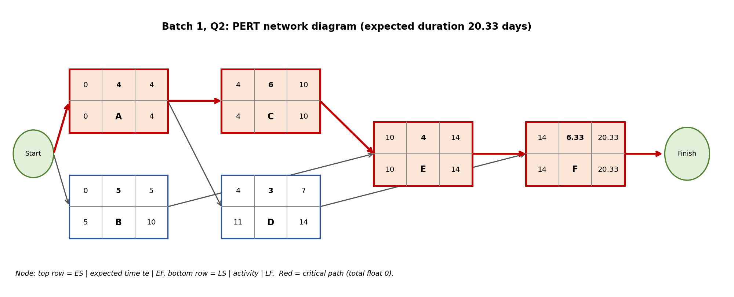
Forward and backward pass with float (1 mark), using te as the duration.
Activity | Predecessor | Duration | ES | EF | LS | LF | Total float | Critical?
A | - | 4 | 0 | 4 | 0 | 4 | 0 | Yes
B | - | 5 | 0 | 5 | 5 | 10 | 5 | No
C | A | 6 | 4 | 10 | 4 | 10 | 0 | Yes
D | A | 3 | 4 | 7 | 11 | 14 | 7 | No
E | B,C | 4 | 10 | 14 | 10 | 14 | 0 | Yes
F | D,E | 6.33 | 14 | 20.33 | 14 | 20.33 | 0 | Yes

Activity | Forward pass (ES, EF) | Backward pass (LF, LS)
A | ES = 0; EF = 0 + 4 = 4 | LF = min(LS of C, LS of D) = min(4, 11) = 4; LS = 4 - 4 = 0
B | ES = 0; EF = 0 + 5 = 5 | LF = LS of E = 10; LS = 10 - 5 = 5
C | ES = EF of A = 4; EF = 4 + 6 = 10 | LF = LS of E = 10; LS = 10 - 6 = 4
D | ES = EF of A = 4; EF = 4 + 3 = 7 | LF = LS of F = 14; LS = 14 - 3 = 11
E | ES = max(EF of B, EF of C) = max(5, 10) = 10; EF = 10 + 4 = 14 | LF = LS of F = 14; LS = 14 - 4 = 10
F | ES = max(EF of D, EF of E) = max(7, 14) = 14; EF = 14 + 6.33 = 20.33 | LF = project duration = 20.33; LS = 20.33 - 6.33 = 14

Paths from start to finish (check).
Path | Length (days) | Critical?
A-C-E-F | 20.33 | Yes (longest)
A-D-F | 13.33 | No
B-E-F | 15.33 | No

Critical path (0.75 mark): A-C-E-F.
Expected project duration (0.75 mark): 20.33 days. Extra: the variance of the project is the sum of the variances of the critical activities = 1.44, so the standard deviation is about 1.20 days; the project is therefore likely to finish within roughly 20.33 ± 1.20 days.

Batch 2

Q1. CPM Problem [5 Marks]
Marking scheme (5 marks): network diagram (1) + forward pass ES and EF (1) + backward pass LS and LF (1) + total float and critical path (1) + total project duration (1).
Network diagram (1 mark).
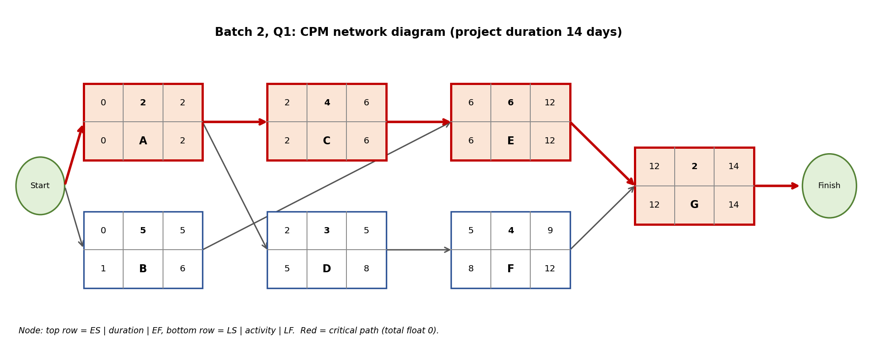
Forward pass, backward pass and float (3 marks). ES = largest EF of the predecessors; EF = ES + duration; LF = smallest LS of the successors (for the last activity, the project duration); LS = LF − duration; total float = LS − ES.
Activity | Predecessor | Duration | ES | EF | LS | LF | Total float | Critical?
A | - | 2 | 0 | 2 | 0 | 2 | 0 | Yes
B | - | 5 | 0 | 5 | 1 | 6 | 1 | No
C | A | 4 | 2 | 6 | 2 | 6 | 0 | Yes
D | A | 3 | 2 | 5 | 5 | 8 | 3 | No
E | B,C | 6 | 6 | 12 | 6 | 12 | 0 | Yes
F | D | 4 | 5 | 9 | 8 | 12 | 3 | No
G | E,F | 2 | 12 | 14 | 12 | 14 | 0 | Yes

Activity | Forward pass (ES, EF) | Backward pass (LF, LS)
A | ES = 0; EF = 0 + 2 = 2 | LF = min(LS of C, LS of D) = min(2, 5) = 2; LS = 2 - 2 = 0
B | ES = 0; EF = 0 + 5 = 5 | LF = LS of E = 6; LS = 6 - 5 = 1
C | ES = EF of A = 2; EF = 2 + 4 = 6 | LF = LS of E = 6; LS = 6 - 4 = 2
D | ES = EF of A = 2; EF = 2 + 3 = 5 | LF = LS of F = 8; LS = 8 - 3 = 5
E | ES = max(EF of B, EF of C) = max(5, 6) = 6; EF = 6 + 6 = 12 | LF = LS of G = 12; LS = 12 - 6 = 6
F | ES = EF of D = 5; EF = 5 + 4 = 9 | LF = LS of G = 12; LS = 12 - 4 = 8
G | ES = max(EF of E, EF of F) = max(12, 9) = 12; EF = 12 + 2 = 14 | LF = project duration = 14; LS = 14 - 2 = 12

Paths from start to finish (check).
Path | Length (days) | Critical?
A-C-E-G | 14 | Yes (longest)
A-D-F-G | 11 | No
B-E-G | 13 | No

Critical path (activities with total float 0): A-C-E-G.
Total project duration: 14 days. Any delay in a critical activity delays the project; the other activities can slip by their total float without affecting the finish date.

Q2. PERT Problem [5 Marks]
Marking scheme (5 marks): expected times by the PERT formula (1.5) + network diagram (1) + forward and backward pass with float (1) + critical path (0.75) + expected project duration (0.75).
Expected time of each activity (1.5 marks). te = (O + 4M + P) / 6 and variance = ((P − O) / 6)².
Activity | Predecessor | O | M | P | Expected time te | Variance
A | - | 1 | 2 | 3 | 2 | 0.11
B | - | 2 | 4 | 6 | 4 | 0.44
C | A | 3 | 5 | 7 | 5 | 0.44
D | A,B | 4 | 5 | 8 | 5.33 | 0.44
E | C | 2 | 3 | 4 | 3 | 0.11
F | D,E | 3 | 6 | 9 | 6 | 1

Network diagram (1 mark).
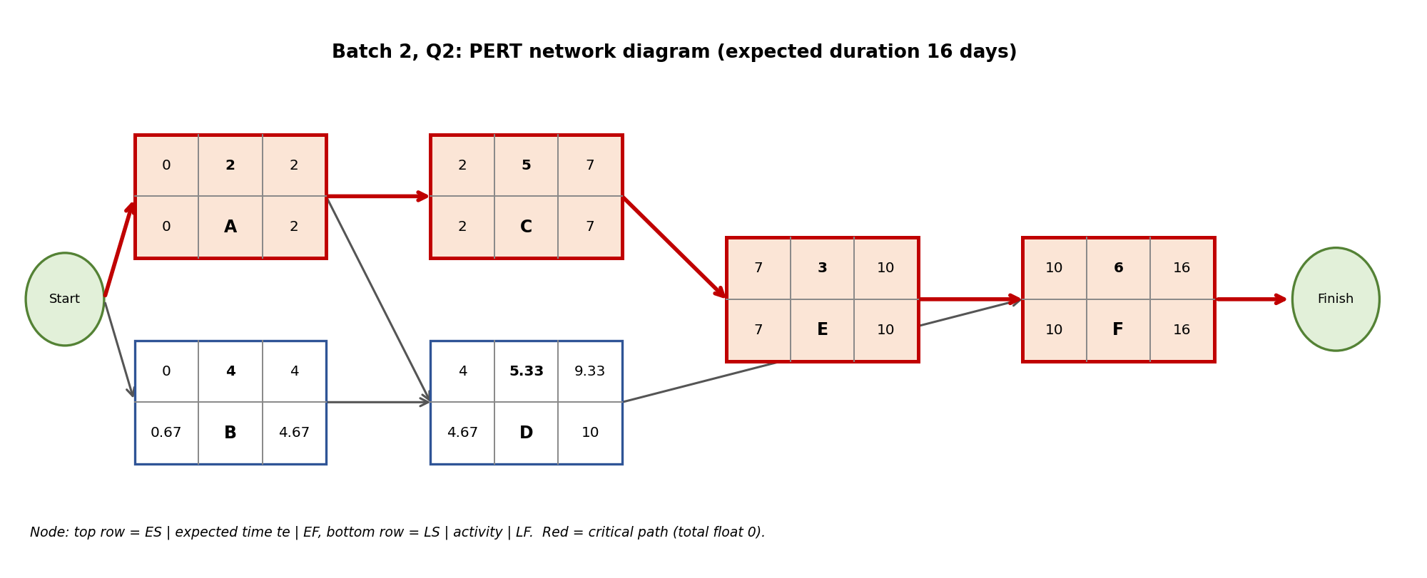
Forward and backward pass with float (1 mark), using te as the duration.
Activity | Predecessor | Duration | ES | EF | LS | LF | Total float | Critical?
A | - | 2 | 0 | 2 | 0 | 2 | 0 | Yes
B | - | 4 | 0 | 4 | 0.67 | 4.67 | 0.67 | No
C | A | 5 | 2 | 7 | 2 | 7 | 0 | Yes
D | A,B | 5.33 | 4 | 9.33 | 4.67 | 10 | 0.67 | No
E | C | 3 | 7 | 10 | 7 | 10 | 0 | Yes
F | D,E | 6 | 10 | 16 | 10 | 16 | 0 | Yes

Activity | Forward pass (ES, EF) | Backward pass (LF, LS)
A | ES = 0; EF = 0 + 2 = 2 | LF = min(LS of C, LS of D) = min(2, 4.67) = 2; LS = 2 - 2 = 0
B | ES = 0; EF = 0 + 4 = 4 | LF = LS of D = 4.67; LS = 4.67 - 4 = 0.67
C | ES = EF of A = 2; EF = 2 + 5 = 7 | LF = LS of E = 7; LS = 7 - 5 = 2
D | ES = max(EF of A, EF of B) = max(2, 4) = 4; EF = 4 + 5.33 = 9.33 | LF = LS of F = 10; LS = 10 - 5.33 = 4.67
E | ES = EF of C = 7; EF = 7 + 3 = 10 | LF = LS of F = 10; LS = 10 - 3 = 7
F | ES = max(EF of D, EF of E) = max(9.33, 10) = 10; EF = 10 + 6 = 16 | LF = project duration = 16; LS = 16 - 6 = 10

Paths from start to finish (check).
Path | Length (days) | Critical?
A-C-E-F | 16 | Yes (longest)
A-D-F | 13.33 | No
B-D-F | 15.33 | No

Critical path (0.75 mark): A-C-E-F.
Expected project duration (0.75 mark): 16 days. Extra: the variance of the project is the sum of the variances of the critical activities = 1.67, so the standard deviation is about 1.29 days; the project is therefore likely to finish within roughly 16 ± 1.29 days.

Batch 3

Q1. CPM Problem [5 Marks]
Marking scheme (5 marks): network diagram (1) + forward pass ES and EF (1) + backward pass LS and LF (1) + total float and critical path (1) + total project duration (1).
Network diagram (1 mark).
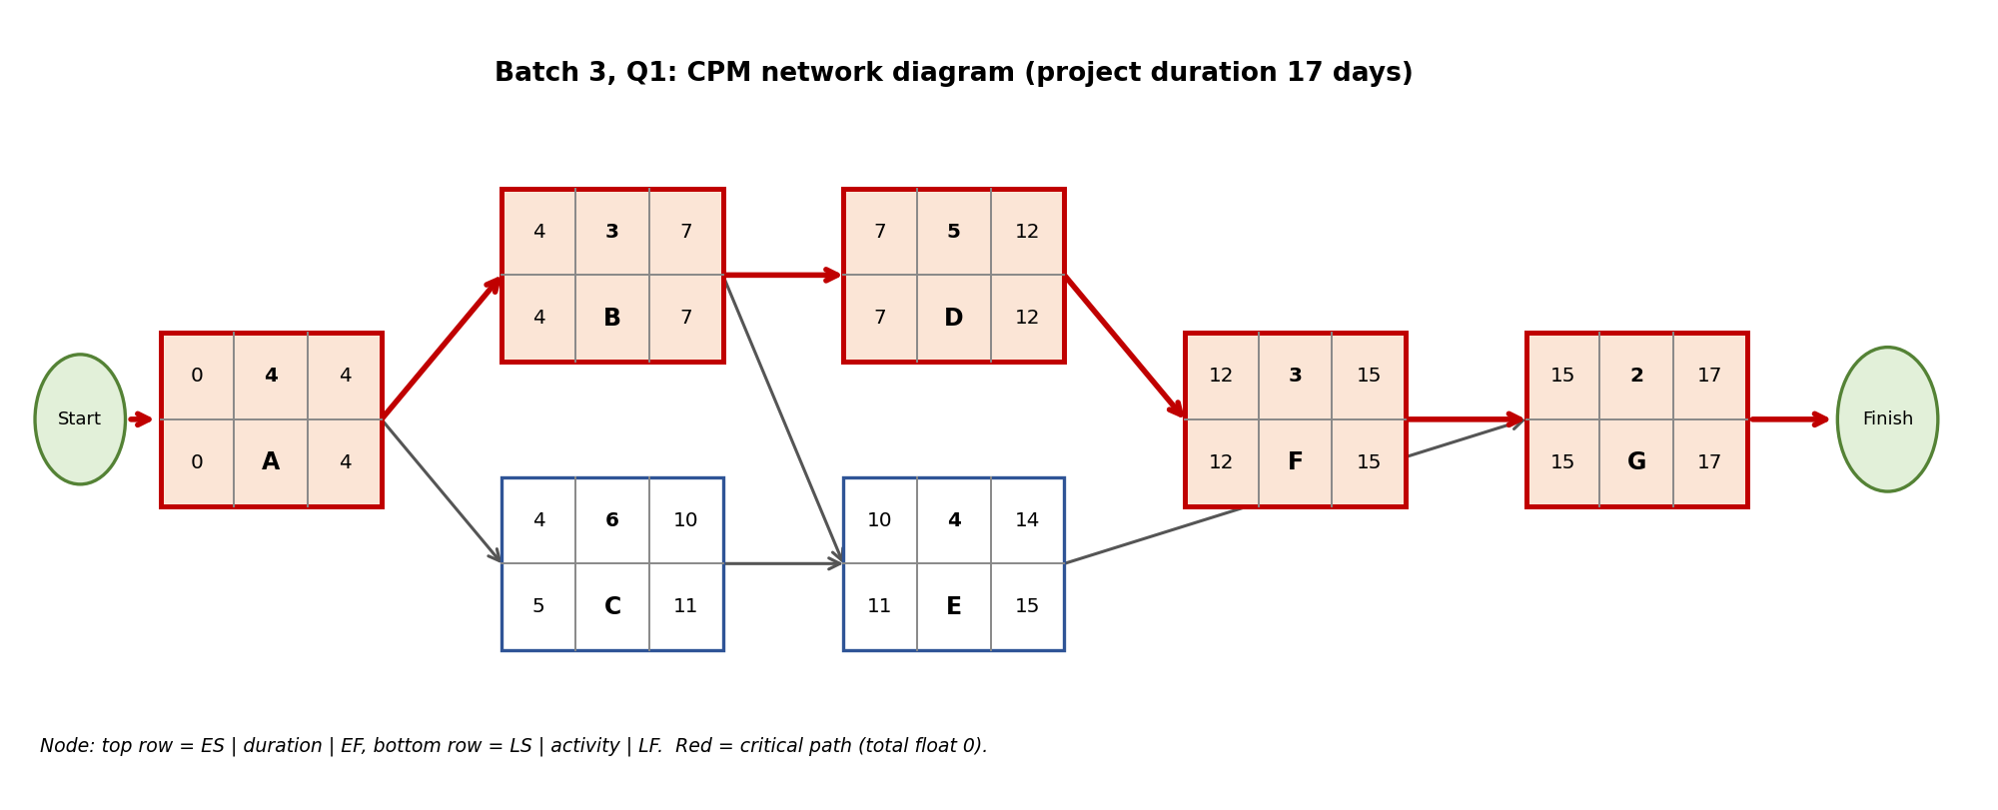
Forward pass, backward pass and float (3 marks). ES = largest EF of the predecessors; EF = ES + duration; LF = smallest LS of the successors (for the last activity, the project duration); LS = LF − duration; total float = LS − ES.
Activity | Predecessor | Duration | ES | EF | LS | LF | Total float | Critical?
A | - | 4 | 0 | 4 | 0 | 4 | 0 | Yes
B | A | 3 | 4 | 7 | 4 | 7 | 0 | Yes
C | A | 6 | 4 | 10 | 5 | 11 | 1 | No
D | B | 5 | 7 | 12 | 7 | 12 | 0 | Yes
E | B,C | 4 | 10 | 14 | 11 | 15 | 1 | No
F | D | 3 | 12 | 15 | 12 | 15 | 0 | Yes
G | E,F | 2 | 15 | 17 | 15 | 17 | 0 | Yes

Activity | Forward pass (ES, EF) | Backward pass (LF, LS)
A | ES = 0; EF = 0 + 4 = 4 | LF = min(LS of B, LS of C) = min(4, 5) = 4; LS = 4 - 4 = 0
B | ES = EF of A = 4; EF = 4 + 3 = 7 | LF = min(LS of D, LS of E) = min(7, 11) = 7; LS = 7 - 3 = 4
C | ES = EF of A = 4; EF = 4 + 6 = 10 | LF = LS of E = 11; LS = 11 - 6 = 5
D | ES = EF of B = 7; EF = 7 + 5 = 12 | LF = LS of F = 12; LS = 12 - 5 = 7
E | ES = max(EF of B, EF of C) = max(7, 10) = 10; EF = 10 + 4 = 14 | LF = LS of G = 15; LS = 15 - 4 = 11
F | ES = EF of D = 12; EF = 12 + 3 = 15 | LF = LS of G = 15; LS = 15 - 3 = 12
G | ES = max(EF of E, EF of F) = max(14, 15) = 15; EF = 15 + 2 = 17 | LF = project duration = 17; LS = 17 - 2 = 15

Paths from start to finish (check).
Path | Length (days) | Critical?
A-B-D-F-G | 17 | Yes (longest)
A-B-E-G | 13 | No
A-C-E-G | 16 | No

Critical path (activities with total float 0): A-B-D-F-G.
Total project duration: 17 days. Any delay in a critical activity delays the project; the other activities can slip by their total float without affecting the finish date.

Q2. PERT Problem [5 Marks]
Marking scheme (5 marks): expected times by the PERT formula (1.5) + network diagram (1) + forward and backward pass with float (1) + critical path (0.75) + expected project duration (0.75).
Expected time of each activity (1.5 marks). te = (O + 4M + P) / 6 and variance = ((P − O) / 6)².
Activity | Predecessor | O | M | P | Expected time te | Variance
A | - | 2 | 3 | 4 | 3 | 0.11
B | A | 3 | 4 | 5 | 4 | 0.11
C | A | 4 | 6 | 8 | 6 | 0.44
D | B | 2 | 5 | 8 | 5 | 1
E | B,C | 3 | 5 | 7 | 5 | 0.44
F | D,E | 4 | 6 | 8 | 6 | 0.44

Network diagram (1 mark).
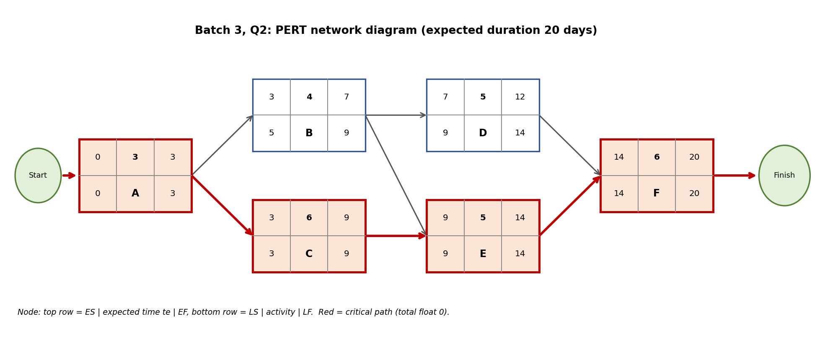
Forward and backward pass with float (1 mark), using te as the duration.
Activity | Predecessor | Duration | ES | EF | LS | LF | Total float | Critical?
A | - | 3 | 0 | 3 | 0 | 3 | 0 | Yes
B | A | 4 | 3 | 7 | 5 | 9 | 2 | No
C | A | 6 | 3 | 9 | 3 | 9 | 0 | Yes
D | B | 5 | 7 | 12 | 9 | 14 | 2 | No
E | B,C | 5 | 9 | 14 | 9 | 14 | 0 | Yes
F | D,E | 6 | 14 | 20 | 14 | 20 | 0 | Yes

Activity | Forward pass (ES, EF) | Backward pass (LF, LS)
A | ES = 0; EF = 0 + 3 = 3 | LF = min(LS of B, LS of C) = min(5, 3) = 3; LS = 3 - 3 = 0
B | ES = EF of A = 3; EF = 3 + 4 = 7 | LF = min(LS of D, LS of E) = min(9, 9) = 9; LS = 9 - 4 = 5
C | ES = EF of A = 3; EF = 3 + 6 = 9 | LF = LS of E = 9; LS = 9 - 6 = 3
D | ES = EF of B = 7; EF = 7 + 5 = 12 | LF = LS of F = 14; LS = 14 - 5 = 9
E | ES = max(EF of B, EF of C) = max(7, 9) = 9; EF = 9 + 5 = 14 | LF = LS of F = 14; LS = 14 - 5 = 9
F | ES = max(EF of D, EF of E) = max(12, 14) = 14; EF = 14 + 6 = 20 | LF = project duration = 20; LS = 20 - 6 = 14

Paths from start to finish (check).
Path | Length (days) | Critical?
A-B-D-F | 18 | No
A-B-E-F | 18 | No
A-C-E-F | 20 | Yes (longest)

Critical path (0.75 mark): A-C-E-F.
Expected project duration (0.75 mark): 20 days. Extra: the variance of the project is the sum of the variances of the critical activities = 1.44, so the standard deviation is about 1.20 days; the project is therefore likely to finish within roughly 20 ± 1.20 days.

Batch 4

Q1. CPM Problem [5 Marks]
Marking scheme (5 marks): network diagram (1) + forward pass ES and EF (1) + backward pass LS and LF (1) + total float and critical path (1) + total project duration (1).
Network diagram (1 mark).
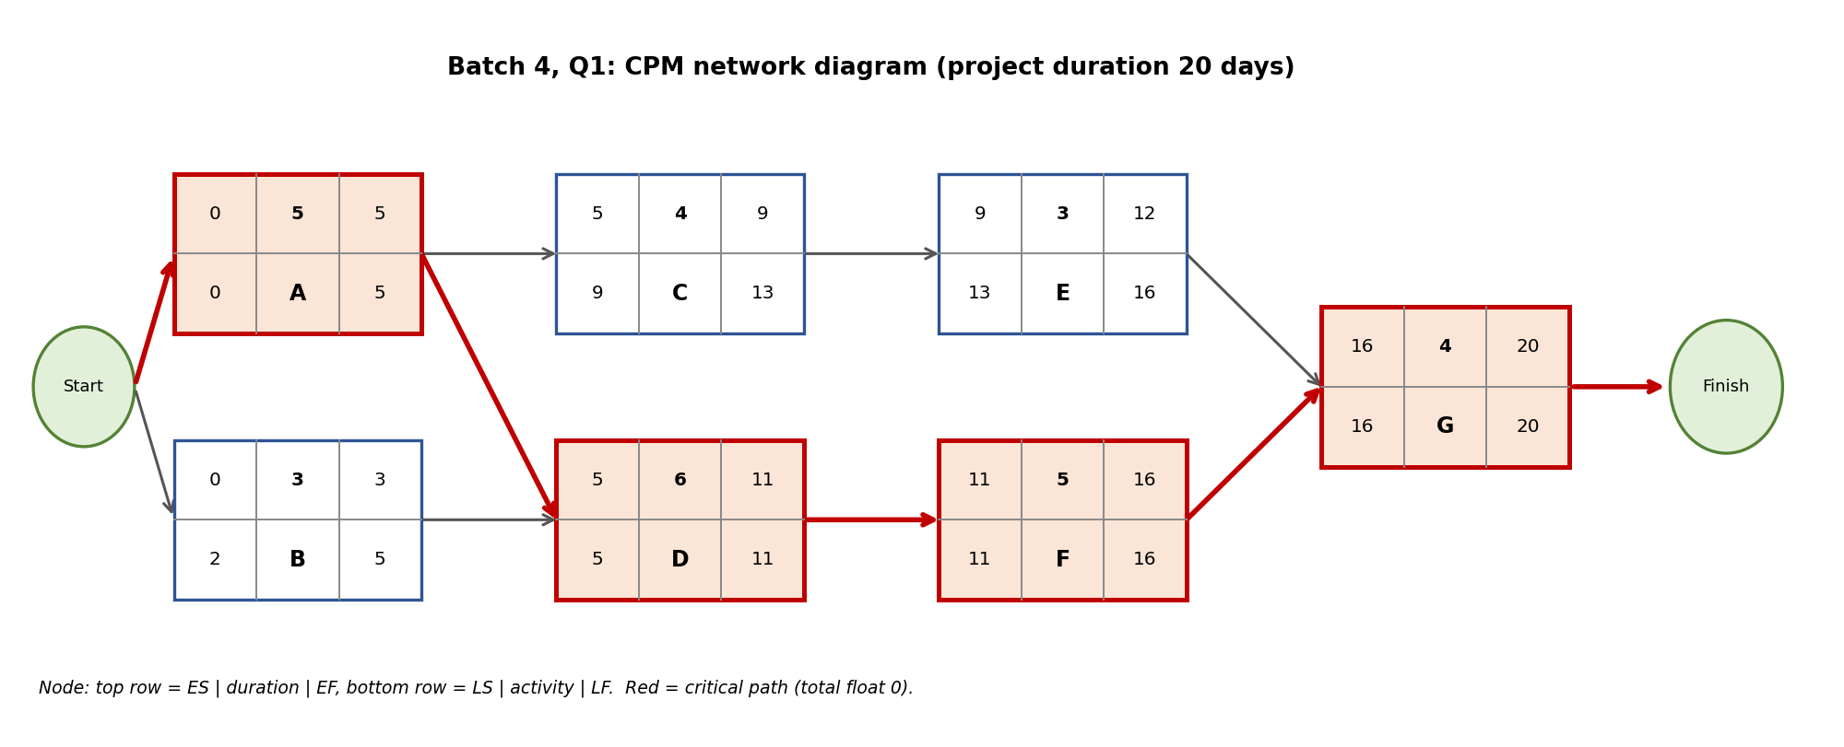
Forward pass, backward pass and float (3 marks). ES = largest EF of the predecessors; EF = ES + duration; LF = smallest LS of the successors (for the last activity, the project duration); LS = LF − duration; total float = LS − ES.
Activity | Predecessor | Duration | ES | EF | LS | LF | Total float | Critical?
A | - | 5 | 0 | 5 | 0 | 5 | 0 | Yes
B | - | 3 | 0 | 3 | 2 | 5 | 2 | No
C | A | 4 | 5 | 9 | 9 | 13 | 4 | No
D | A,B | 6 | 5 | 11 | 5 | 11 | 0 | Yes
E | C | 3 | 9 | 12 | 13 | 16 | 4 | No
F | D | 5 | 11 | 16 | 11 | 16 | 0 | Yes
G | E,F | 4 | 16 | 20 | 16 | 20 | 0 | Yes

Activity | Forward pass (ES, EF) | Backward pass (LF, LS)
A | ES = 0; EF = 0 + 5 = 5 | LF = min(LS of C, LS of D) = min(9, 5) = 5; LS = 5 - 5 = 0
B | ES = 0; EF = 0 + 3 = 3 | LF = LS of D = 5; LS = 5 - 3 = 2
C | ES = EF of A = 5; EF = 5 + 4 = 9 | LF = LS of E = 13; LS = 13 - 4 = 9
D | ES = max(EF of A, EF of B) = max(5, 3) = 5; EF = 5 + 6 = 11 | LF = LS of F = 11; LS = 11 - 6 = 5
E | ES = EF of C = 9; EF = 9 + 3 = 12 | LF = LS of G = 16; LS = 16 - 3 = 13
F | ES = EF of D = 11; EF = 11 + 5 = 16 | LF = LS of G = 16; LS = 16 - 5 = 11
G | ES = max(EF of E, EF of F) = max(12, 16) = 16; EF = 16 + 4 = 20 | LF = project duration = 20; LS = 20 - 4 = 16

Paths from start to finish (check).
Path | Length (days) | Critical?
A-C-E-G | 16 | No
A-D-F-G | 20 | Yes (longest)
B-D-F-G | 18 | No

Critical path (activities with total float 0): A-D-F-G.
Total project duration: 20 days. Any delay in a critical activity delays the project; the other activities can slip by their total float without affecting the finish date.

Q2. PERT Problem [5 Marks]
Marking scheme (5 marks): expected times by the PERT formula (1.5) + network diagram (1) + forward and backward pass with float (1) + critical path (0.75) + expected project duration (0.75).
Expected time of each activity (1.5 marks). te = (O + 4M + P) / 6 and variance = ((P − O) / 6)².
Activity | Predecessor | O | M | P | Expected time te | Variance
A | - | 2 | 3 | 4 | 3 | 0.11
B | - | 1 | 3 | 5 | 3 | 0.44
C | A | 3 | 5 | 7 | 5 | 0.44
D | A,B | 4 | 6 | 8 | 6 | 0.44
E | C | 2 | 4 | 6 | 4 | 0.44
F | D,E | 3 | 5 | 7 | 5 | 0.44

Network diagram (1 mark).
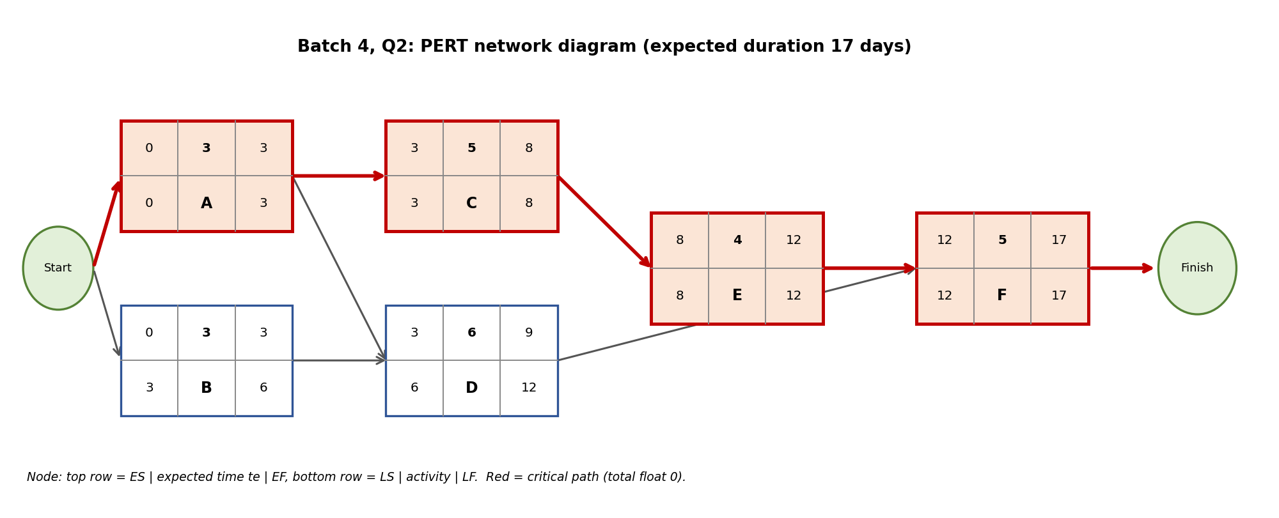
Forward and backward pass with float (1 mark), using te as the duration.
Activity | Predecessor | Duration | ES | EF | LS | LF | Total float | Critical?
A | - | 3 | 0 | 3 | 0 | 3 | 0 | Yes
B | - | 3 | 0 | 3 | 3 | 6 | 3 | No
C | A | 5 | 3 | 8 | 3 | 8 | 0 | Yes
D | A,B | 6 | 3 | 9 | 6 | 12 | 3 | No
E | C | 4 | 8 | 12 | 8 | 12 | 0 | Yes
F | D,E | 5 | 12 | 17 | 12 | 17 | 0 | Yes

Activity | Forward pass (ES, EF) | Backward pass (LF, LS)
A | ES = 0; EF = 0 + 3 = 3 | LF = min(LS of C, LS of D) = min(3, 6) = 3; LS = 3 - 3 = 0
B | ES = 0; EF = 0 + 3 = 3 | LF = LS of D = 6; LS = 6 - 3 = 3
C | ES = EF of A = 3; EF = 3 + 5 = 8 | LF = LS of E = 8; LS = 8 - 5 = 3
D | ES = max(EF of A, EF of B) = max(3, 3) = 3; EF = 3 + 6 = 9 | LF = LS of F = 12; LS = 12 - 6 = 6
E | ES = EF of C = 8; EF = 8 + 4 = 12 | LF = LS of F = 12; LS = 12 - 4 = 8
F | ES = max(EF of D, EF of E) = max(9, 12) = 12; EF = 12 + 5 = 17 | LF = project duration = 17; LS = 17 - 5 = 12

Paths from start to finish (check).
Path | Length (days) | Critical?
A-C-E-F | 17 | Yes (longest)
A-D-F | 14 | No
B-D-F | 14 | No

Critical path (0.75 mark): A-C-E-F.
Expected project duration (0.75 mark): 17 days. Extra: the variance of the project is the sum of the variances of the critical activities = 1.44, so the standard deviation is about 1.20 days; the project is therefore likely to finish within roughly 17 ± 1.20 days.

Summary of Results
Batch | CPM critical path | CPM duration | PERT critical path | PERT expected duration
Batch 1 | A-D-F-G | 17 days | A-C-E-F | 20.33 days
Batch 2 | A-C-E-G | 14 days | A-C-E-F | 16 days
Batch 3 | A-B-D-F-G | 17 days | A-C-E-F | 20 days
Batch 4 | A-D-F-G | 20 days | A-C-E-F | 17 days

Student Self-Assessment
☐ I drew the network diagrams correctly with all dependencies.
☐ I calculated ES, EF, LS, LF and float for every activity.
☐ I identified the critical path by float and by listing all paths.
☐ I calculated the PERT expected times with the formula.
☐ My answers reflect my own working.

Assessment Rubric Mapping (10 Marks)
Criterion | Marks | Where addressed in this journal
Q1: CPM (your batch) | 5 | Network (1) + forward pass (1) + backward pass (1) + float and critical path (1) + duration (1)
Q2: PERT (your batch) | 5 | Expected times (1.5) + network (1) + passes with float (1) + critical path (0.75) + duration (0.75)

References
1. R. S. Pressman and B. R. Maxim, Software Engineering: A Practitioner’s Approach, 9th ed., McGraw-Hill, 2020 (Project scheduling).
2. I. Sommerville, Software Engineering, 10th ed., Pearson, 2015 (Project planning and scheduling).
3. J. E. Kelley and M. R. Walker, “Critical-Path Planning and Scheduling,” Proc. Eastern Joint Computer Conference, 1959 (CPM).
4. D. G. Malcolm, J. H. Roseboom, C. E. Clark and W. Fazar, “Application of a Technique for Research and Development Program Evaluation,” Operations Research, vol. 7, no. 5, 1959 (PERT).
5. Course notes and lecture material, Software Engineering (SEWDL).

Declaration: I commit to submitting original work, free from plagiarism or copying from the internet or peers, and to honouring deadlines for a fair and transparent assessment.
Signature of Student: ____________________ Roll No: ____________

