TASK-1:
Create a custom Docker network named webnet. This network will be used to allow communication between your database container and web application container.
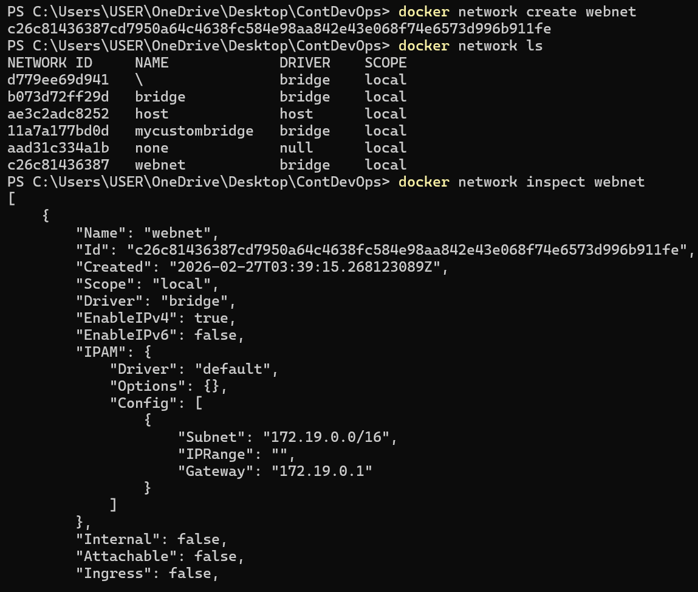

TASK-2:
Deploy a MySQL database container named mydb that uses a Docker volume for persistent storage and environment variables for configuration.
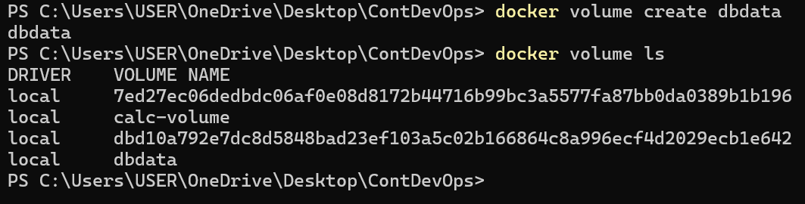
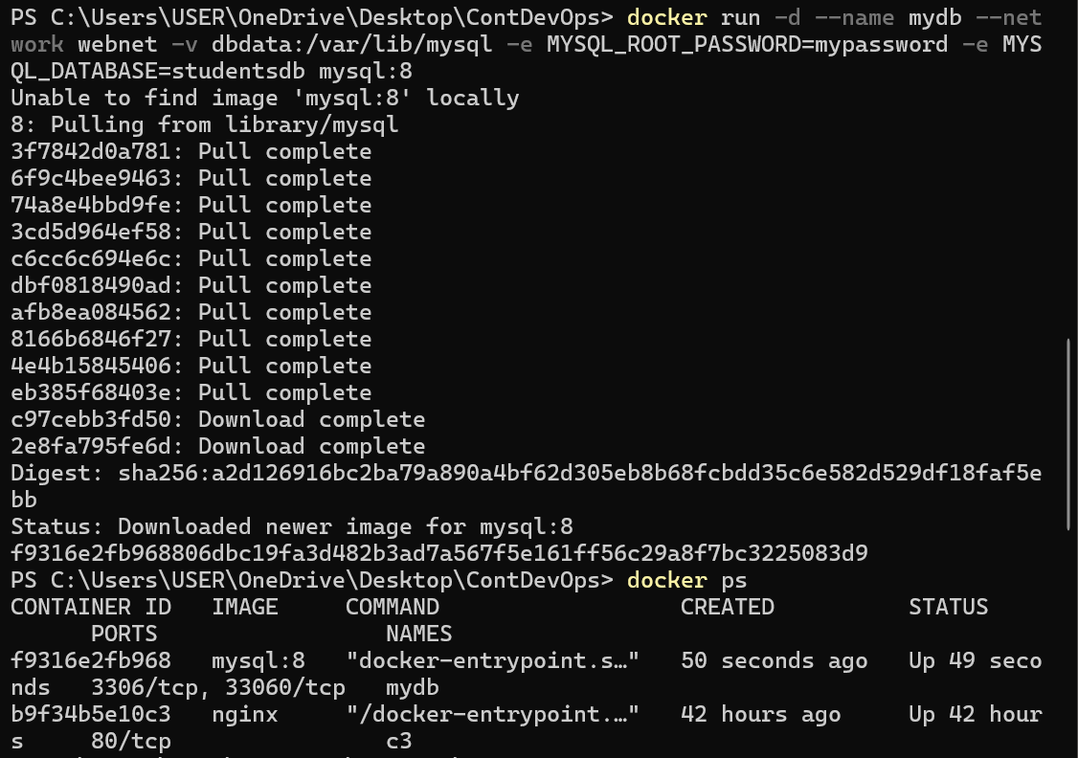
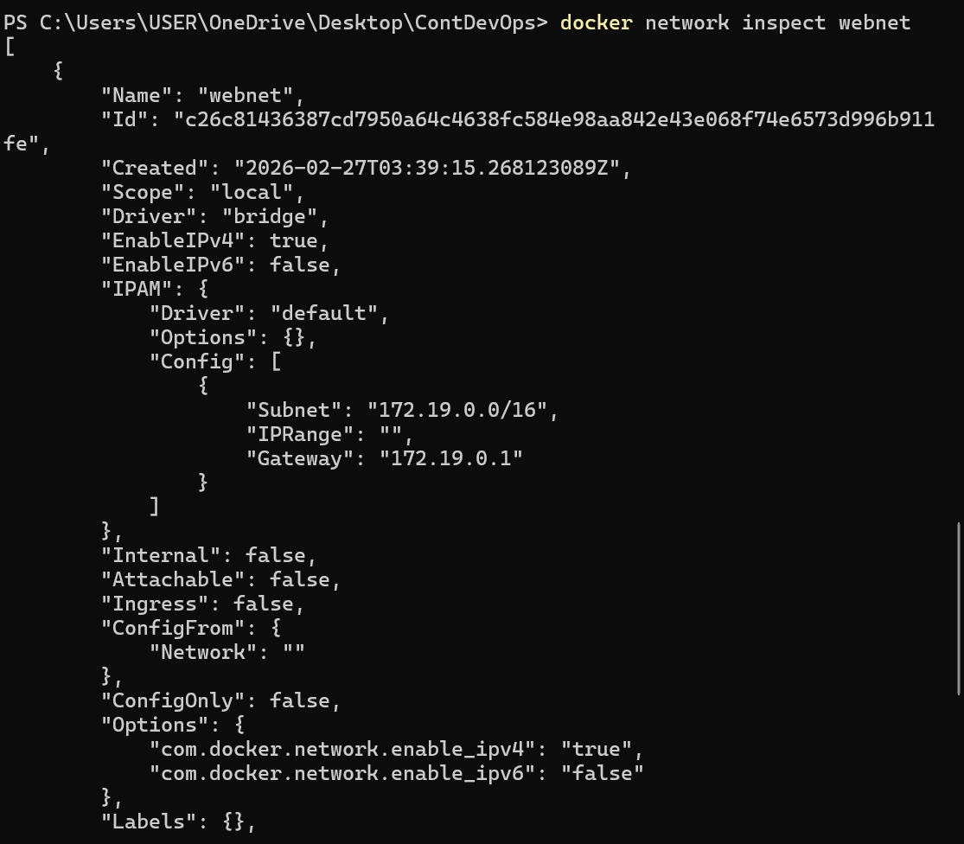
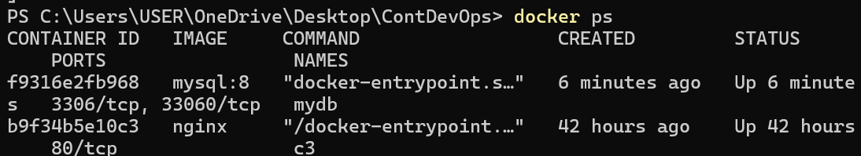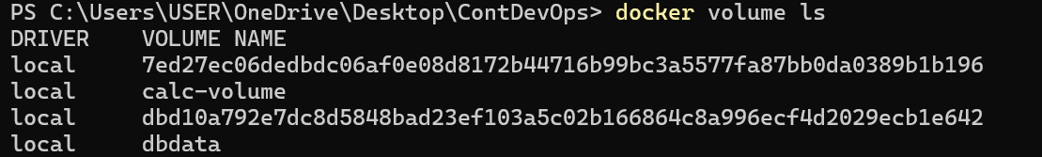

TASK-3:
Run a simple web application container named webapp that connects to the MySQL database container using environment variables.
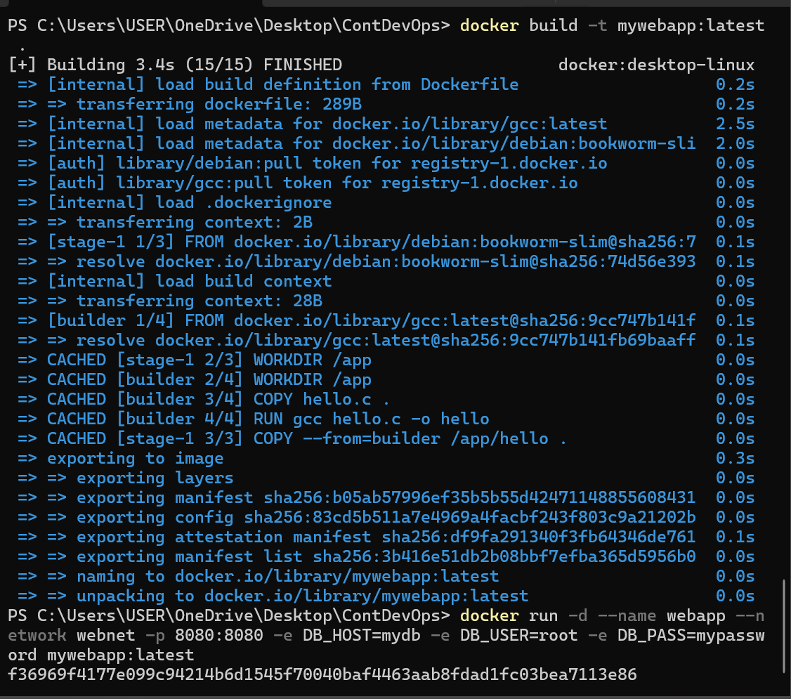
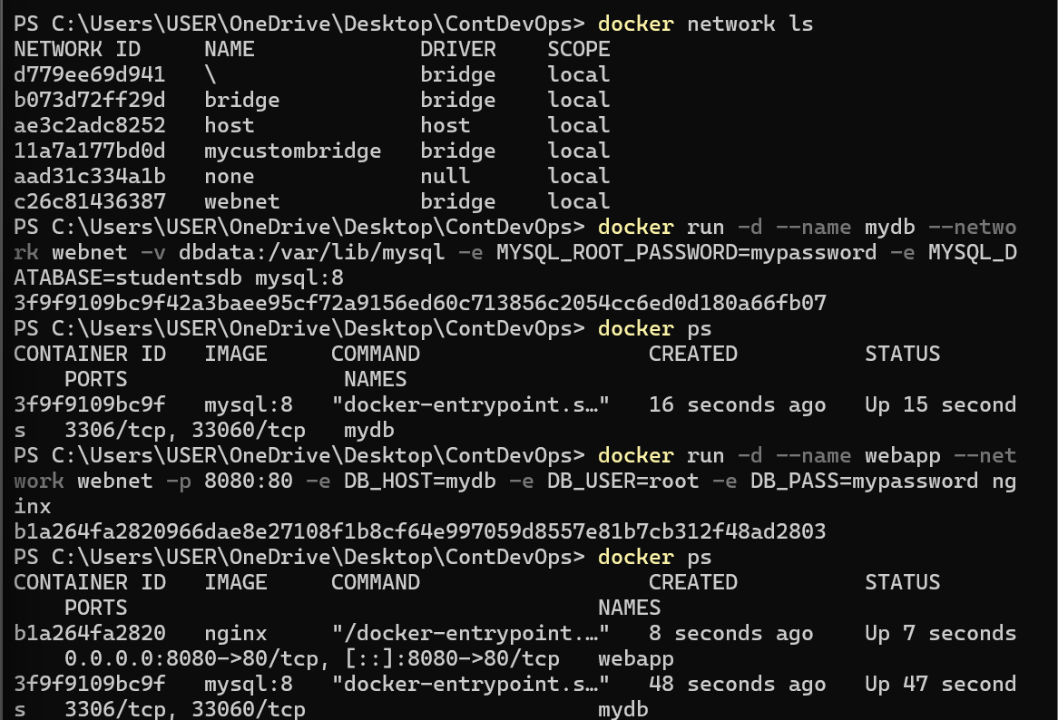

TASK-4:
Use Docker’s monitoring command to check the performance of your running containers.
docker stats
The docker stats command displays real-time resource usage of running containers.
From the output, we can observe the CPU usage percentage, which shows how much processor capacity each container is consuming.
The memory usage indicates how much RAM is being used out of the allocated limit.
Network I/O shows the amount of data sent and received by each container.
If the containers are idle, CPU usage will be very low and memory usage will remain stable.
This helps in monitoring performance and detecting resource bottlenecks in containers.
TASK-5:
Verify that the MySQL data stored using a Docker volume persists even after deleting the container.
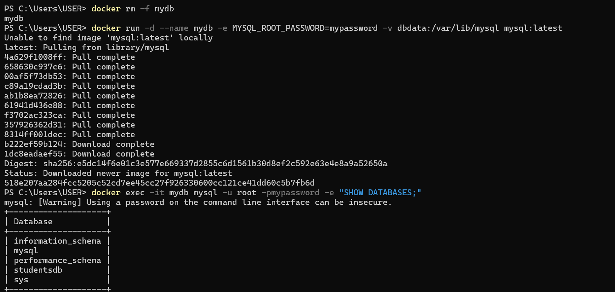
The data persisted because Docker named volumes store data outside the container’s writable layer.
When the container was deleted, the dbdata volume was not removed.
After recreating the container with the same volume, MySQL reused the existing data directory.
Therefore, the studentsdb database still exists.

