Part A: Environment Setup 1. Install Docker Desktop (if not already installed). 2. Verify the installation by executing: o docker --version o docker compose version 3. Create a project directory for the experiment. 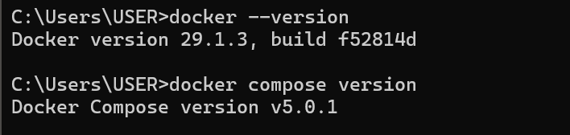
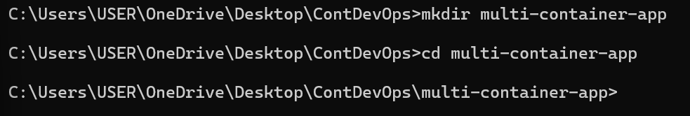--------------------------------------------------------------------------------------------------------------
Part B: Application Development
4. Develop a simple web application (e.g., Flask application) that connects to a MySQL database.
5. Create the following files inside your project directory:
- app.py (web application source code)
- requirements.txt (dependencies)
- Dockerfile (for building the web service image)
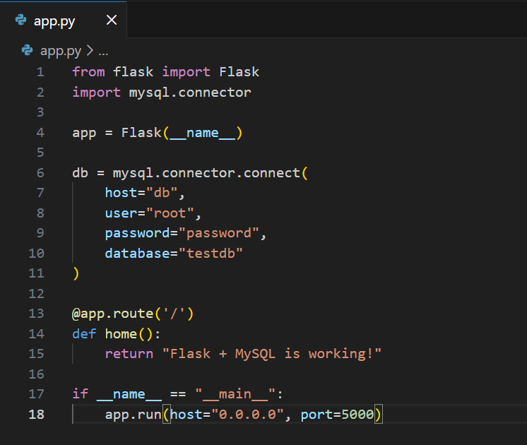
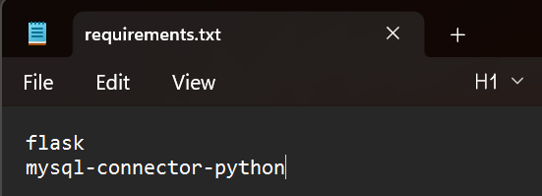

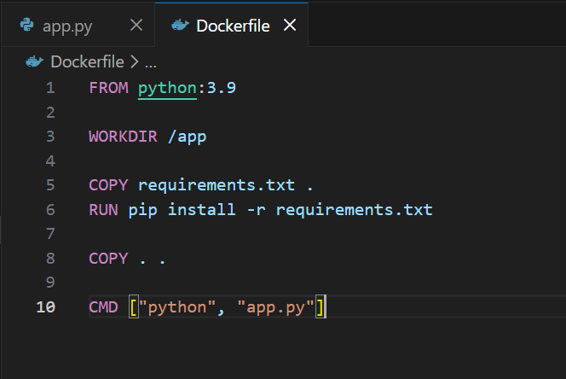
--------------------------------------------------------------------------------------------------------------
Part C: Docker Compose Configuration
6. Create a docker-compose.yml file that includes:
- A web service built using the Dockerfile.
- A database service using an official MySQL image.
- Proper environment variables for database initialization.
- A user-defined network for inter-container communication.
- A named volume for persistent database storage.
- depends_on to define service startup order.
- Port mapping to expose the web service on the host machine
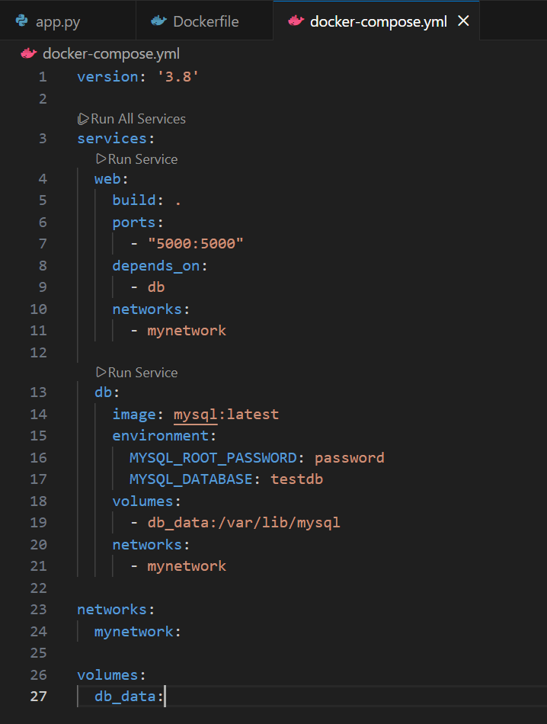
--------------------------------------------------------------------------------------------------------------
Part D: Deployment and Stack Management
7. Build and launch the multi-container application using:
docker compose up --build
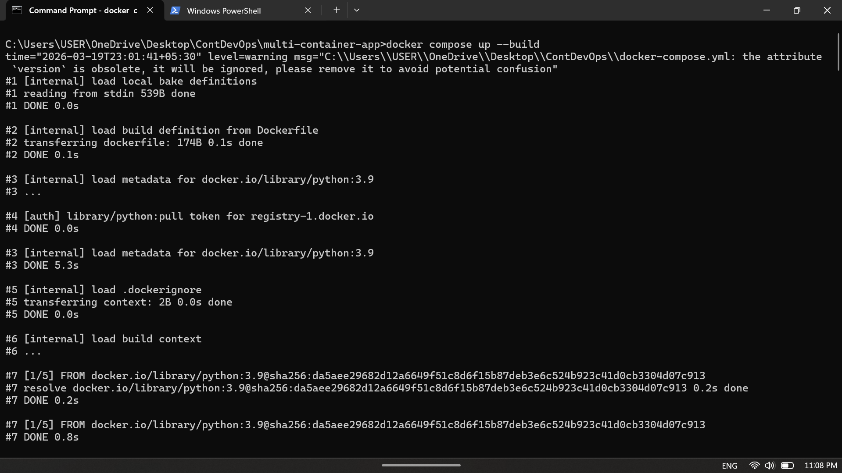
8. Monitor the running services using:
- docker compose ps
- docker compose logs
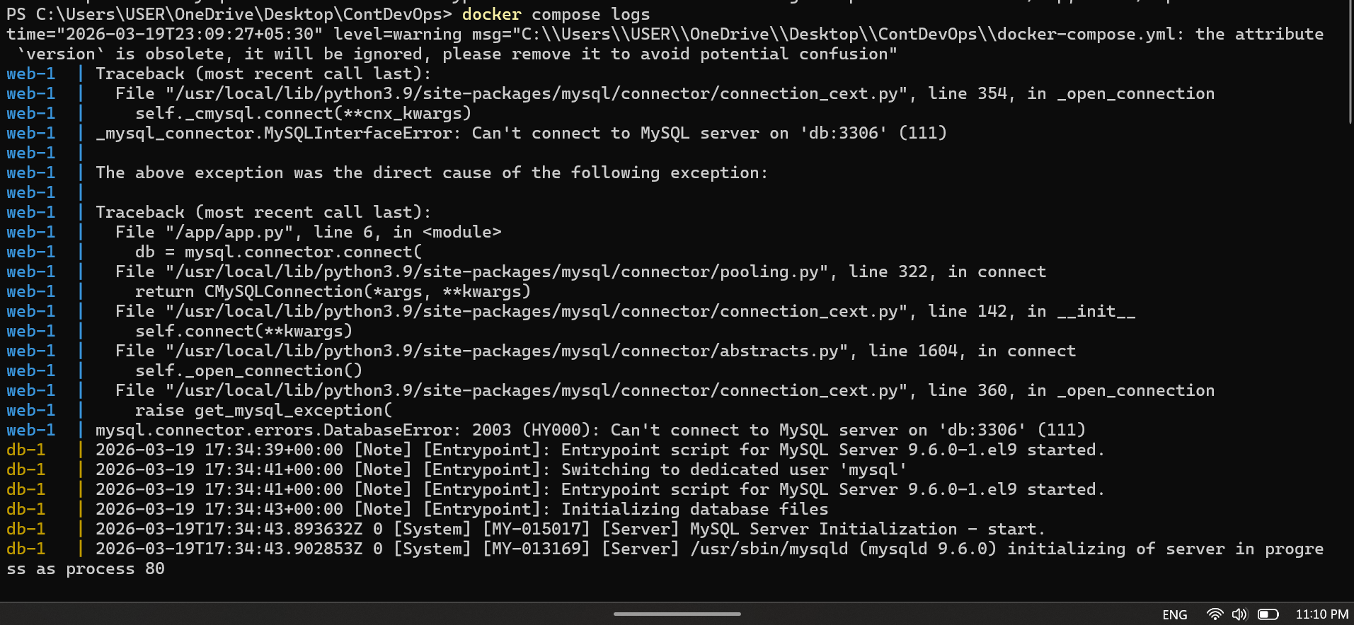
9. Stop and remove the application stack using:
- docker compose down
- docker compose down -v
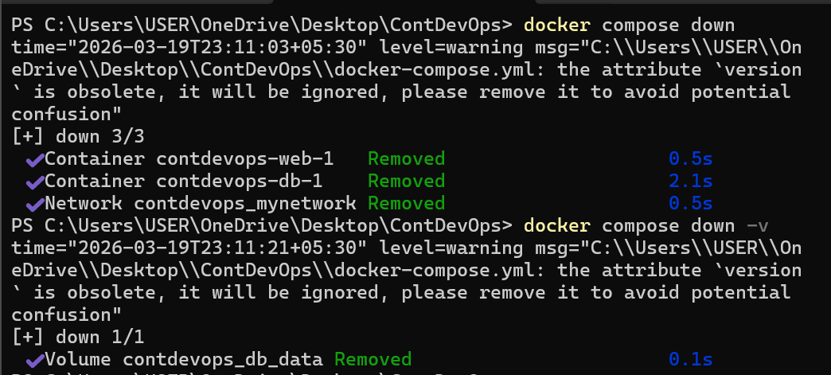
--------------------------------------------------------------------------------------------------------------

Part E: Testing and Verification
10. Verify that the web service is accessible from the browser (e.g., http://localhost:5000).

11.Confirm that:
- The web service can communicate with the database service using the service name as the hostname.
- Both services are connected to the same Docker network.
- The database data persists after container restart (volume verification).
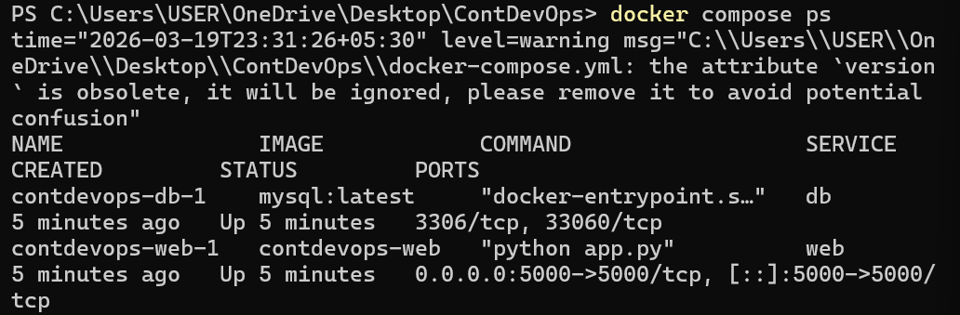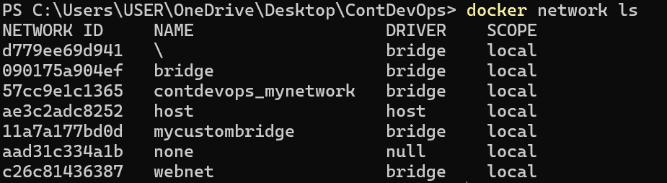
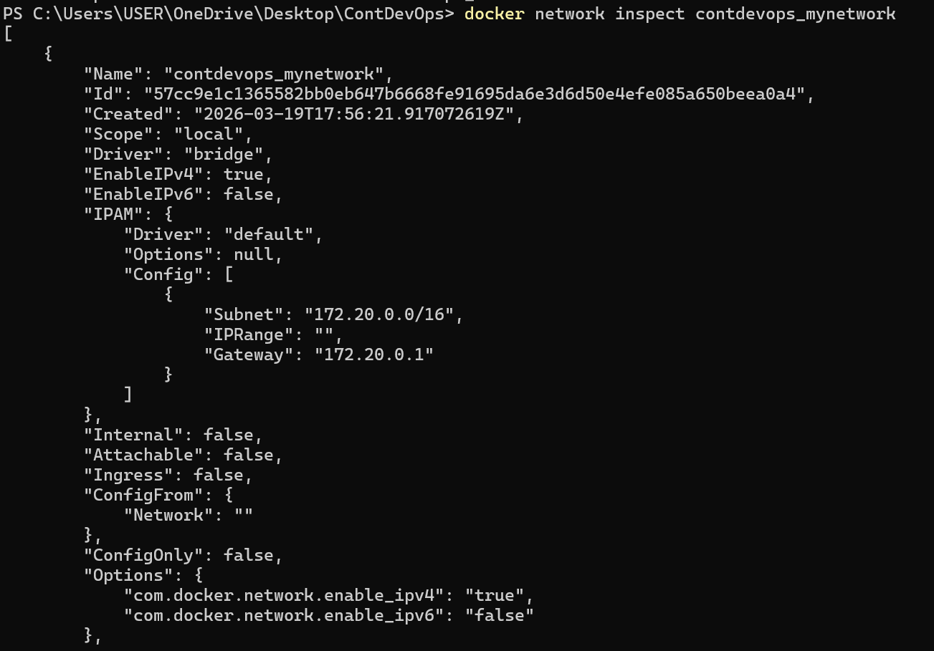
12. Enter the running web container and test connectivity to the database container using appropriate commands.
