Persistent and Non-persistent HTTP Connections

Name : Pranjal Ghaste
Mis. : 612303061

Ques.

- Create a web page with N (e.g. 10) embedded images.
- Configure your browser (Firefox) with following settings (each setting requires repeat of experiment) ∙
- Non persistent connection and persistent connections ∙
- Note down the time taken to display the entire page in each of the settings. Ensure that (cache is cleared before starting the web request). Explain the response time differences. What is the optimal number of persistent connections for best performance? Explain your answer.
- Use Wireshark to capture the packets between the client and the server while the file is accessed.
- Calculate the time taken to load objects from the server for non-persistent and persistent connections.
- Find out the optimal number of HTTP persistent connections based on your observations.

Ans.

System Configuration
- Operating System: Ubuntu Linux
- Browser: Mozilla Firefox
- Web Server: Python HTTP Server
- Protocol: HTTP over TCP
- Packet Analyzer: Wireshark
- Server Address: 127.0.0.1 (localhost)

Experimental Setup

Web Page Creation
A web page (index.html) was created containing 10 embedded image files. All images were stored locally in an images/ directory. The web page was served using Python’s built-in HTTP server.
Command: python3 -m http.server 8000
The web page was accessed using: http://127.0.0.1:8000

index.html file:

<!DOCTYPE html>
<html>
<head>
<title>HTTP Persistent vs Non-Persistent</title>
</head>
<body>
<h1>HTTP Experiment</h1>

<img src="images/image1.jpeg" width="300">
<img src="images/image2.jpeg" width="300">
<img src="images/image3.jpeg" width="300">
<img src="images/image4.jpeg" width="300">
<img src="images/image5.jpeg" width="300">
<img src="images/image6.jpeg" width="300">
<img src="images/image7.jpeg" width="300">
<img src="images/image8.jpeg" width="300">
<img src="images/image9.jpeg" width="300">
<img src="images/image10.jpeg" width="300">

</body>
</html>

Non-Persistent HTTP Configuration
Firefox settings were modified using about:config:
- network.http.keep-alive = false
- network.http.max-persistent-connections-per-server = 1
This forces a new TCP connection for each object.

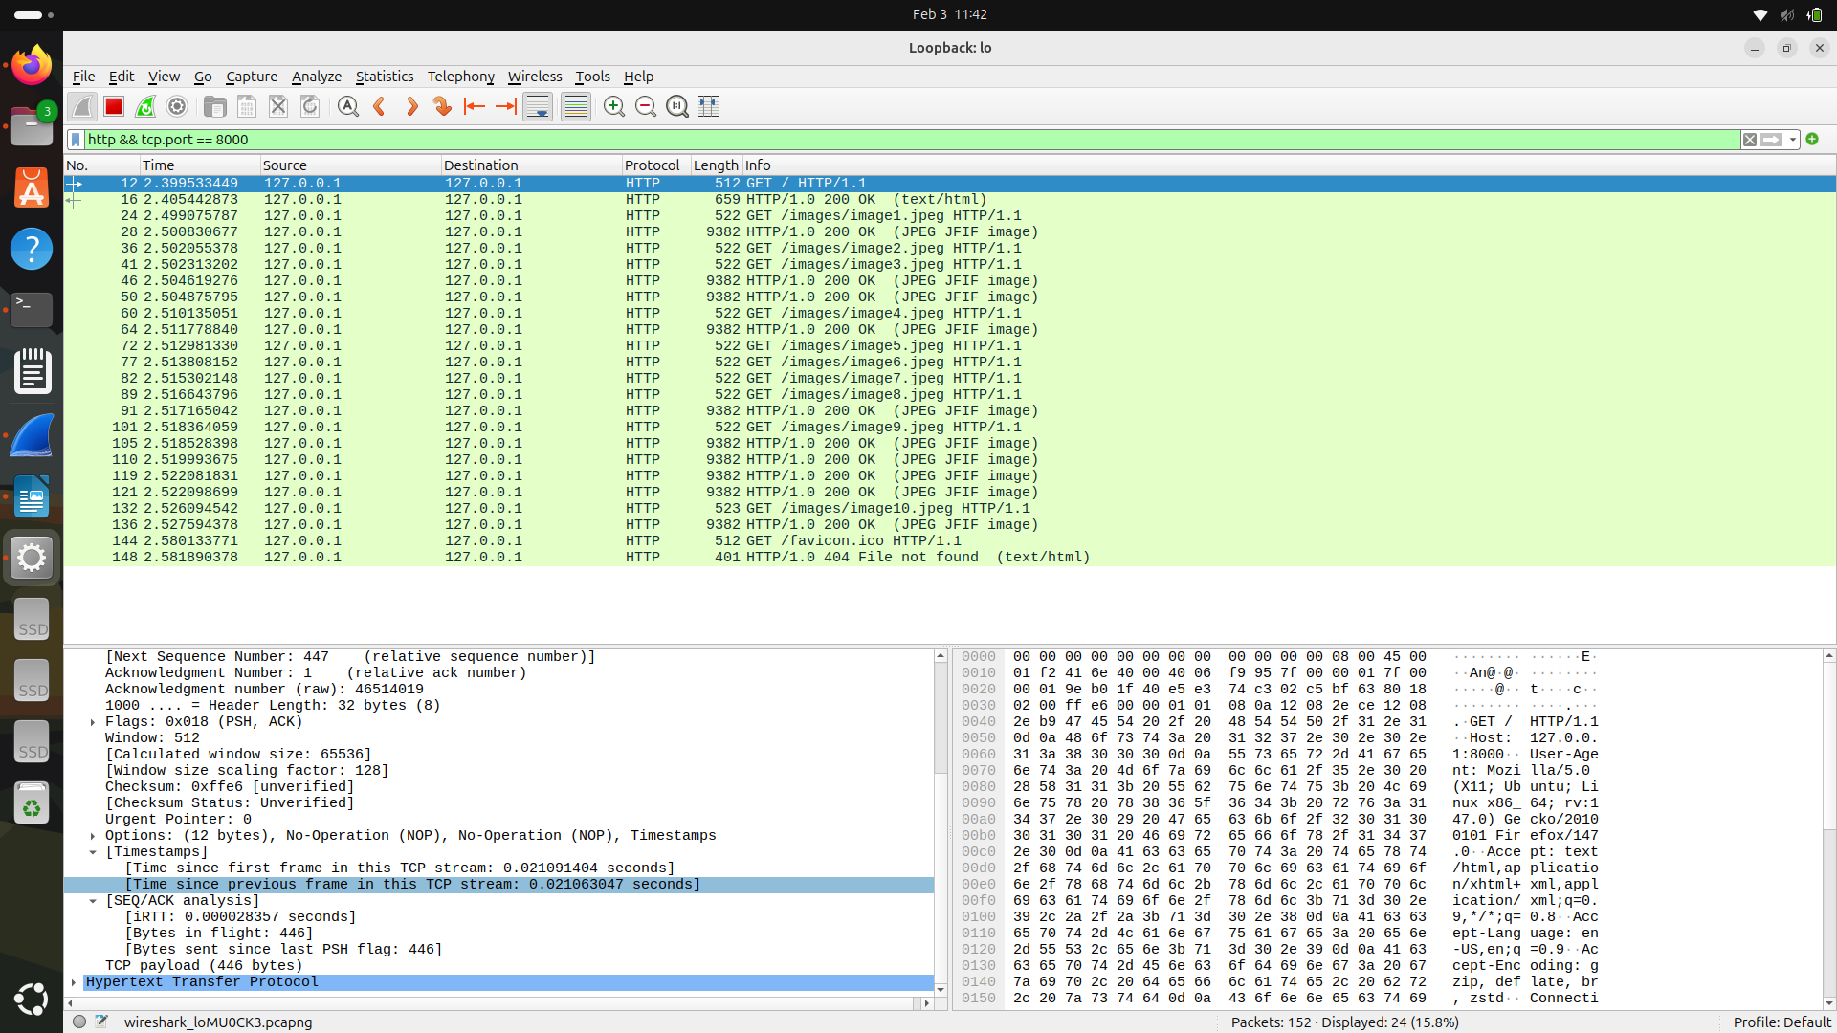
Time : 2.581890378 - 2.399533449 = 0.182356929 secs

Persistent HTTP Configuration
Persistent connections were enabled and the maximum number of connections was varied:
- network.http.keep-alive = true
- network.http.max-persistent-connections-per-server = 2, 4, 5, 6, 8.

1) 2 connections:

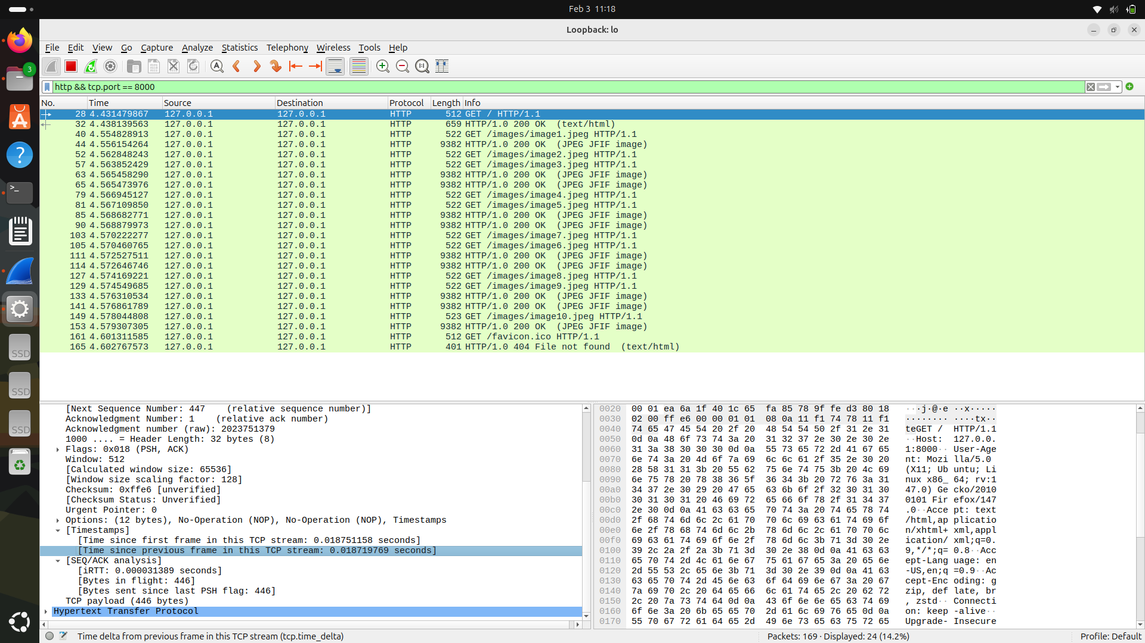
Time: 4.602767573 – 4.431479867 = 0.171287706 secs

2) 4 connections:

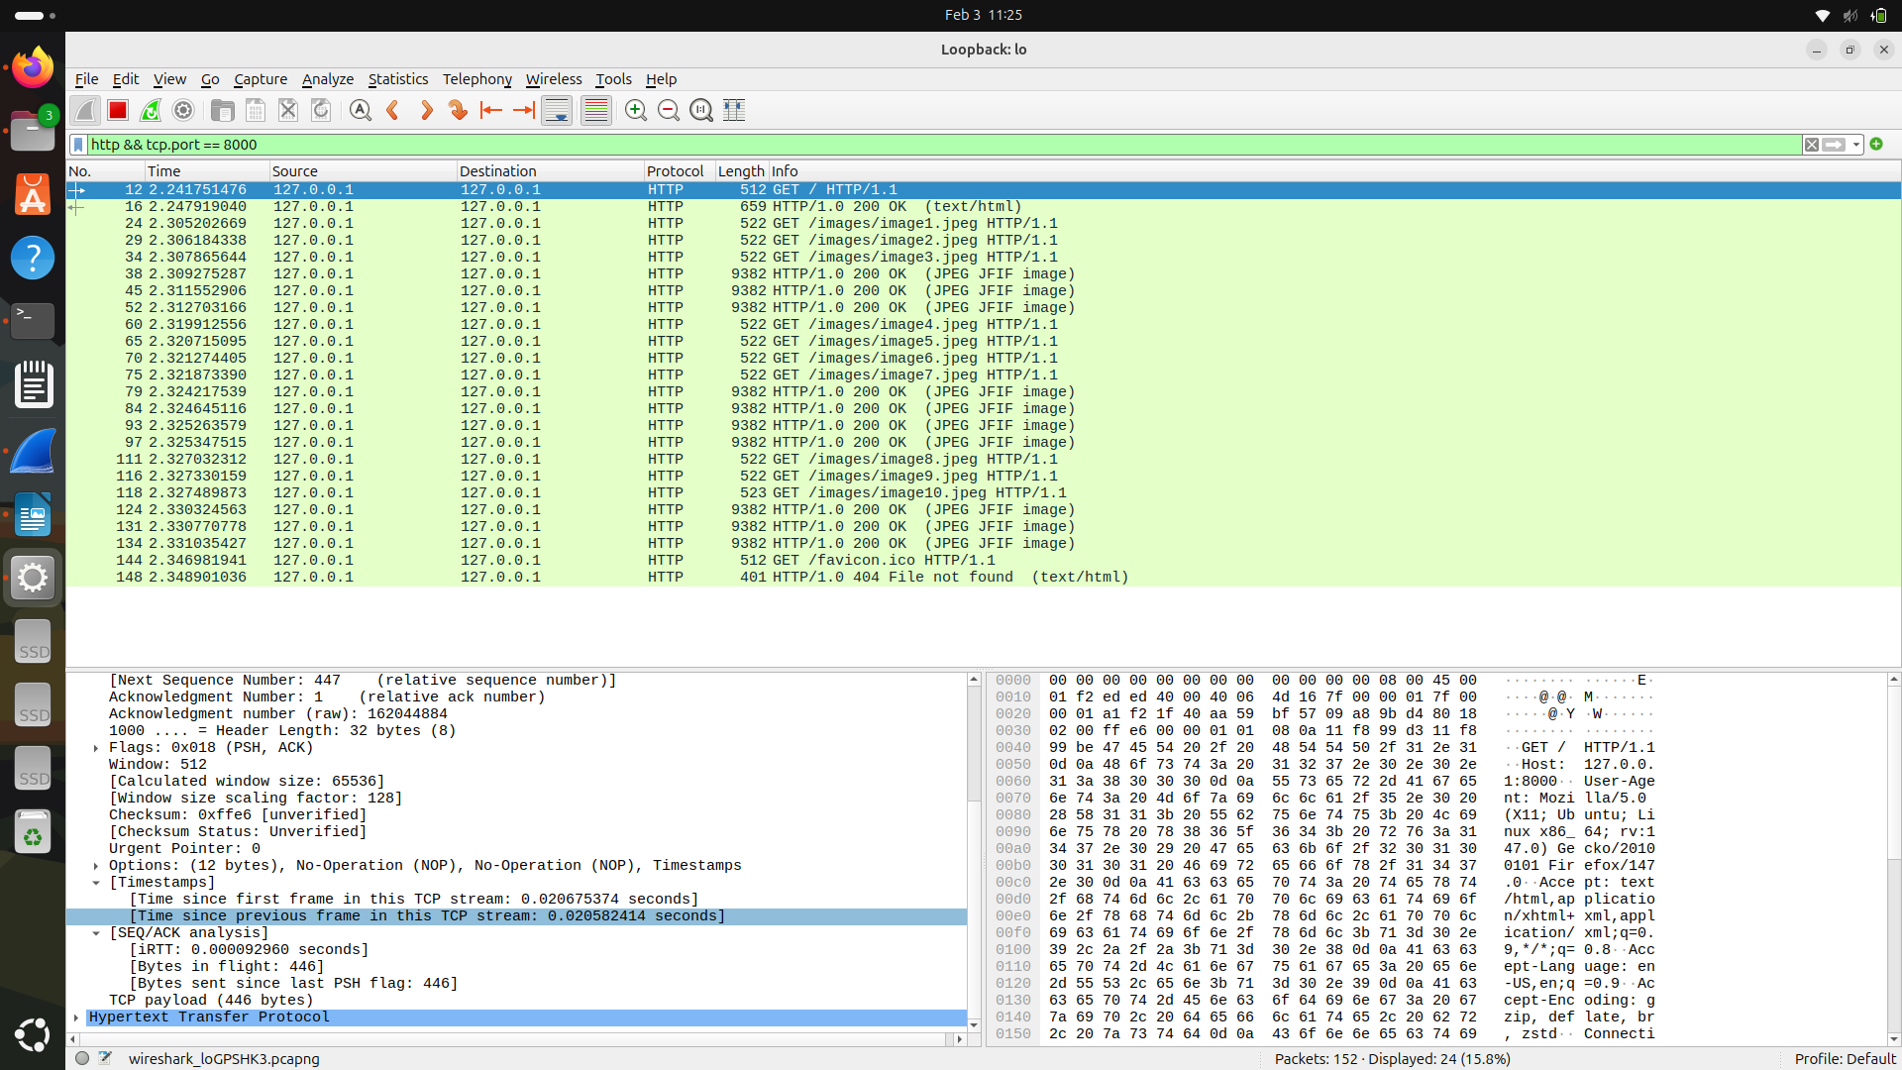
Time : 2.348901036 – 2.241751476 = 0.10714956 secs

4) 6 connections:

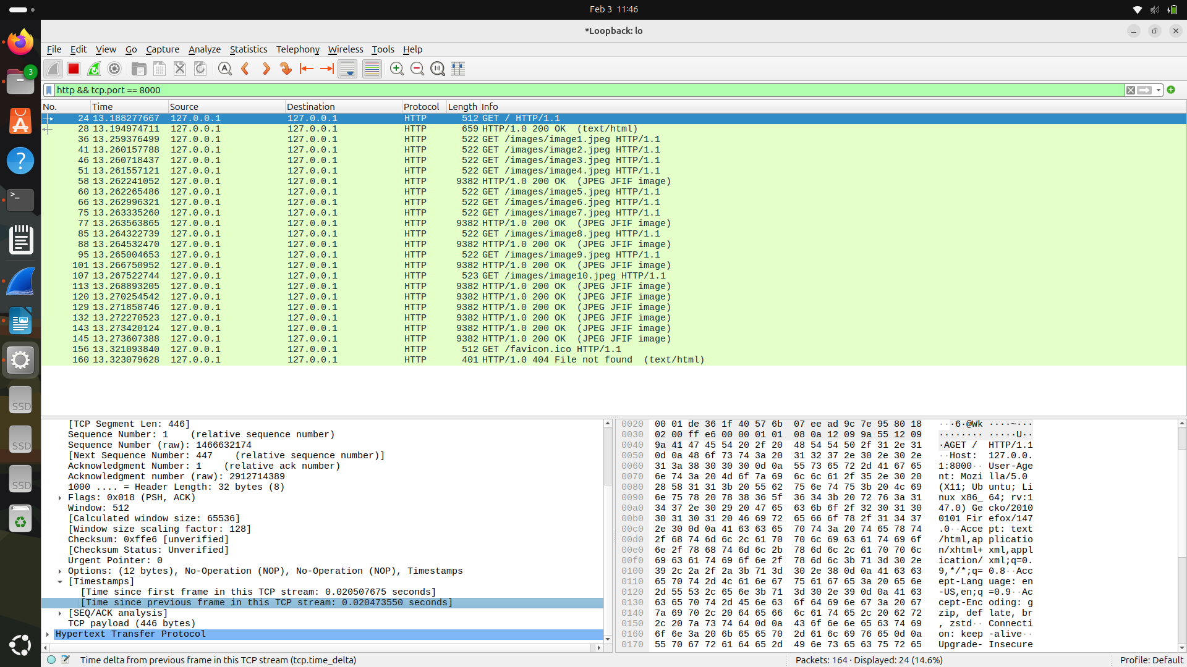
Time : 13.323079628 – 13.188277667 = 0.134801961 secs

5) 8 connections:

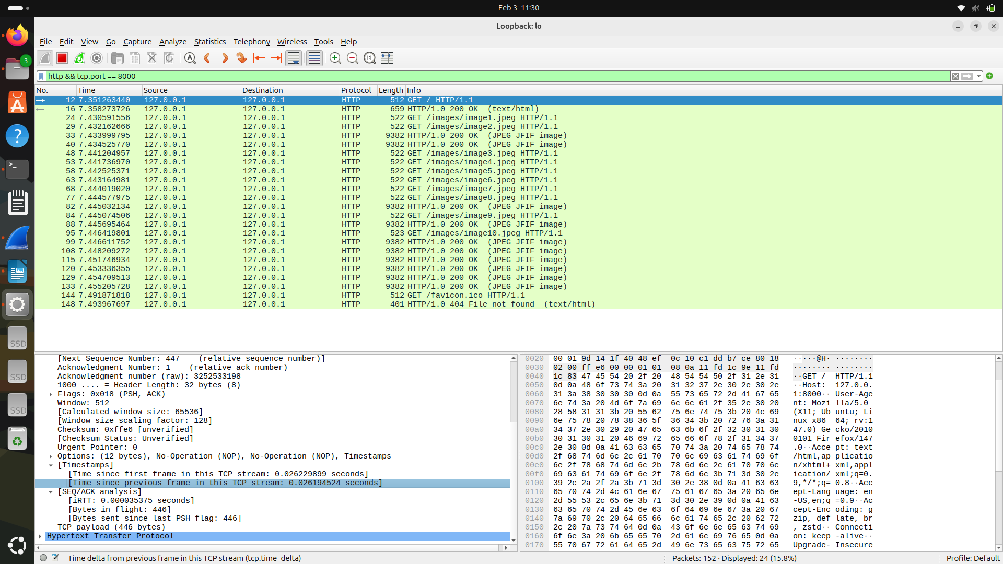
Time: 7.493967697 – 7.351263440 = 0.142704257 secs

Observation Table for Persistent and Non-Persistent:
Connection-Type | Max-connections | Time(in seconds)
Non-persistent | -- | 0.182356929
Persistent | 02 | 0.171287706
Persistent | 04 | 0.10714956
Persistent | 06 | 0.134801961
Persistent | 08 | 0.142704257

Packet Capture Using Wireshark:
- Wireshark was used to capture packets on the loopback interface (lo) while loading the web page.
- Filter used: http && tcp.port == 8000

Time Calulations:
Total Load Time =
Timestamp of last HTTP response − Timestamp of first HTTP GET request

Terminal Output:
1. Terminal html file execution output:
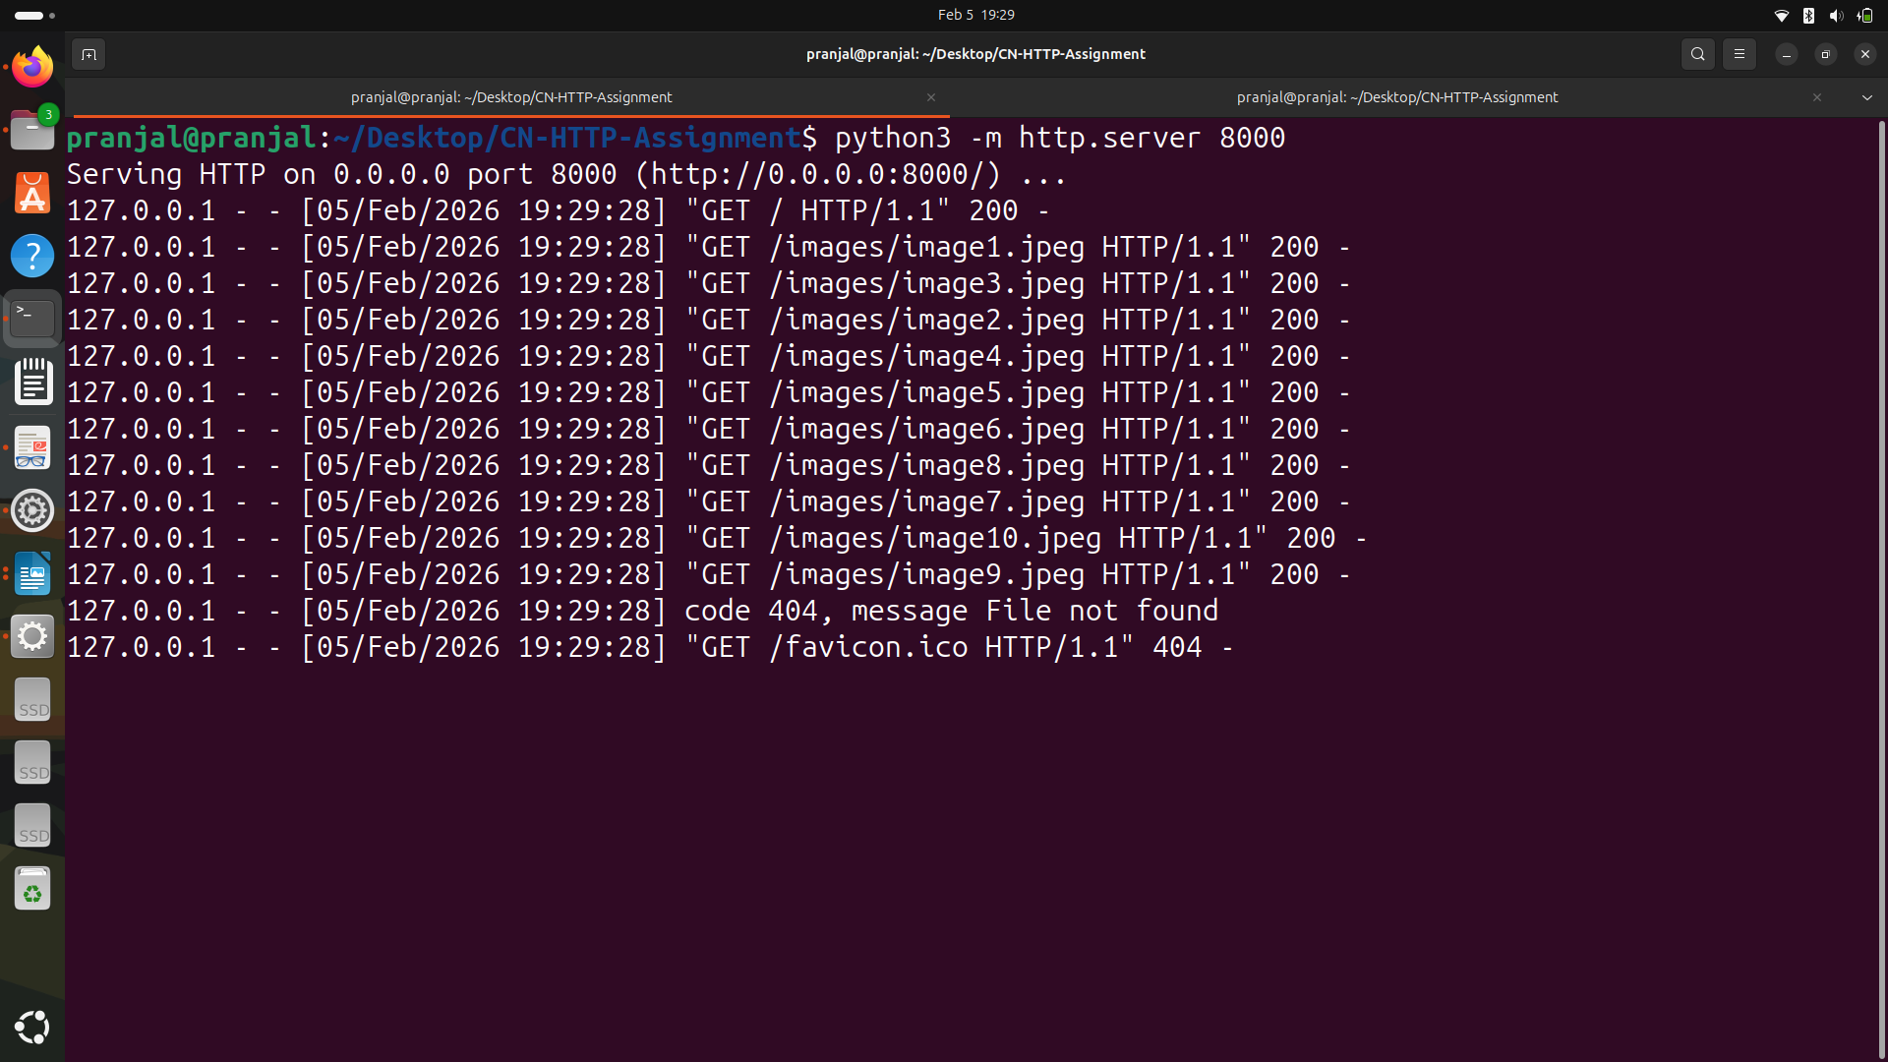
2. Wireshark running output on terminal:

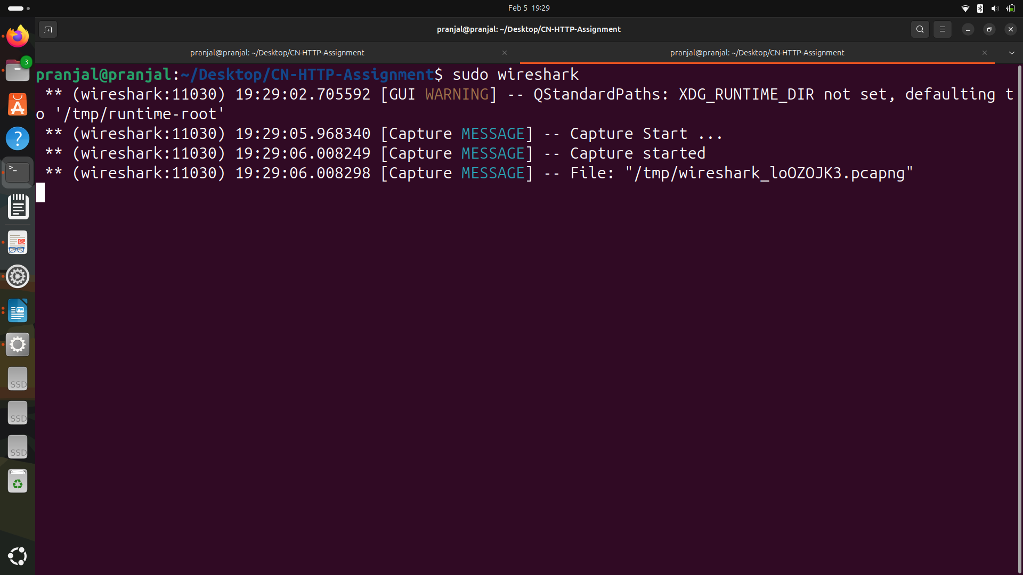

Wireshark Analysis
- Non-Persistent HTTP
  - Separate TCP connection for HTML and each image.
  - Multiple TCP handshakes observed.
  - Higher total connection overhead.
- Persistent HTTP
  - Same TCP connection reused for multiple HTTP requests.
  - Reduced TCP handshakes.
  - Improved response time.

Inference:

- Non-persistent HTTP is slower because each object requires a separate TCP connection, involving connection setup and termination overhead.
- Persistent HTTP improves performance by reusing the same TCP connection for multiple object transfers.
- Increasing the number of persistent connections initially reduces page load time due to parallel downloads. However, beyond a certain limit, the improvement becomes negligible due to increased connection management overhead and TCP congestion control effects.
- From the observations, the optimal number of persistent connections is approximately 4–6, which provides minimum page load time without unnecessary overhead.

Conclusion:
- Persistent HTTP significantly improves webpage load time compared to non-persistent HTTP.
- However, using an excessively large number of persistent connections does not yield further performance gains and may introduce overhead.
- Therefore, a moderate number of persistent connections (4–6) provides the best performance.

Result:
- The optimal number of HTTP persistent connections for the given setup is 4–6, and persistent HTTP performs better than non-persistent HTTP.

