Computer Networks Assignment

Name – Pranjal Ghaste
Mis: 612303061
Batch : T2 Div-1

Study of Linux Networking Commands:
Ques. Type the following commands on the terminal and take a snapshot of the output, paste it into a word file and write a short description of the command.

1. ifconfig :

It is a command-line utility in Unix like operationg systems used to view, configure, and manage network interface parameters. It’s full form is interface configuration.
It displays active user interfaces like IP addresses, networks, and MAC addresses, and can enable/disable interfaces or assign IP addresses.

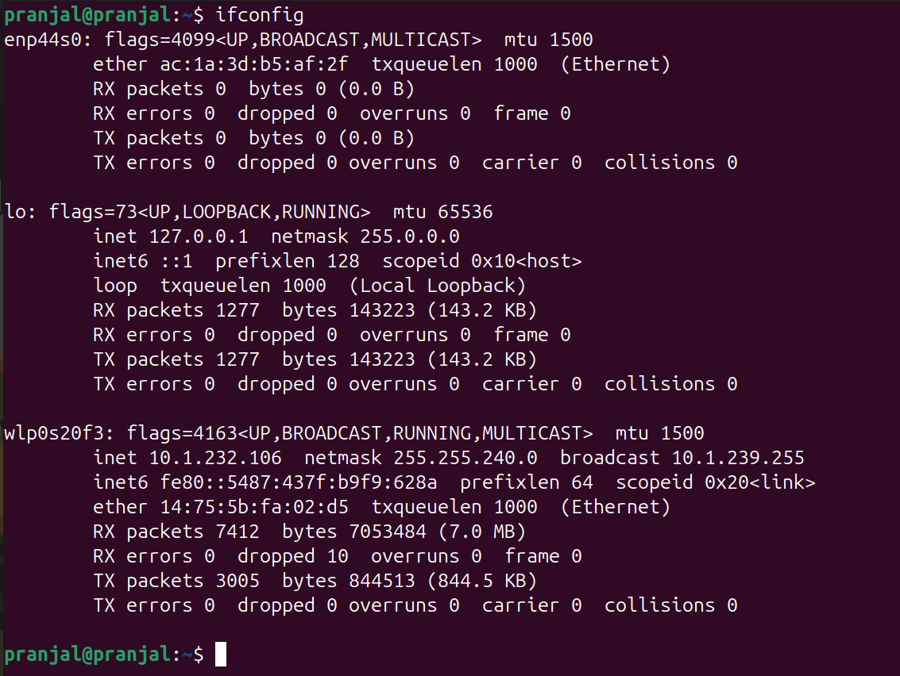

2. ip:

It is used to view and control network interfaces , IP addresses. Routing tables, and network status. It’s full form is Internet Protocol.
It is the modern and recommended version of ifconfig, because it offers faster, more detailed, and real-time networking information.

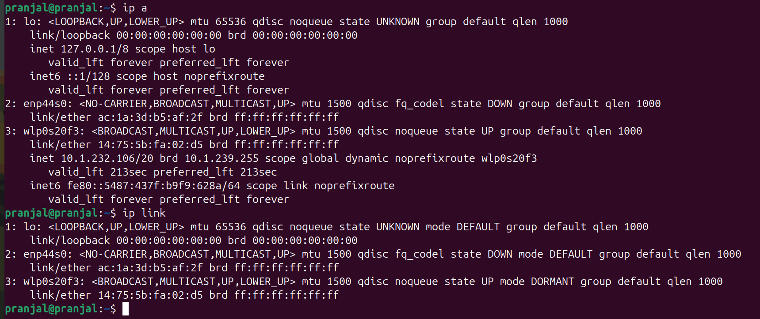

3. traceroute:

It display the path and measure transit delays of packets across an Internet Protocol (IP) network. It works by mapping out all the intermediate routers (hops) between a source computer
and a specified destination.

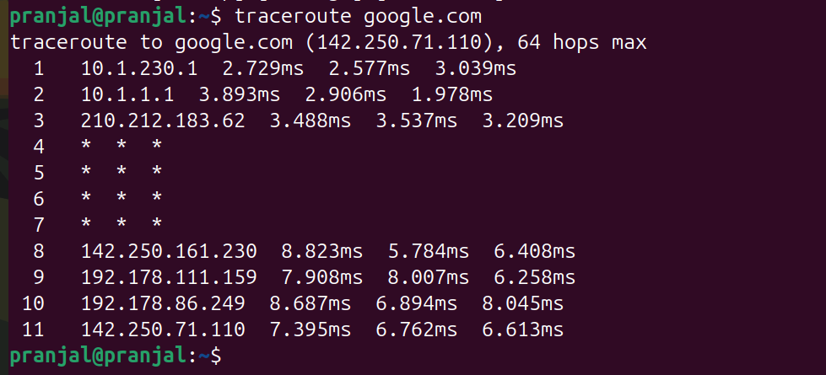
4. tracepath:

Traces network path to a destination without requiring root privileges.
It is a Linux network diagnostic tool that traces a route packets take to a destination, specifically identifying the Maximum Transmission Unit (MTU) at each hop.

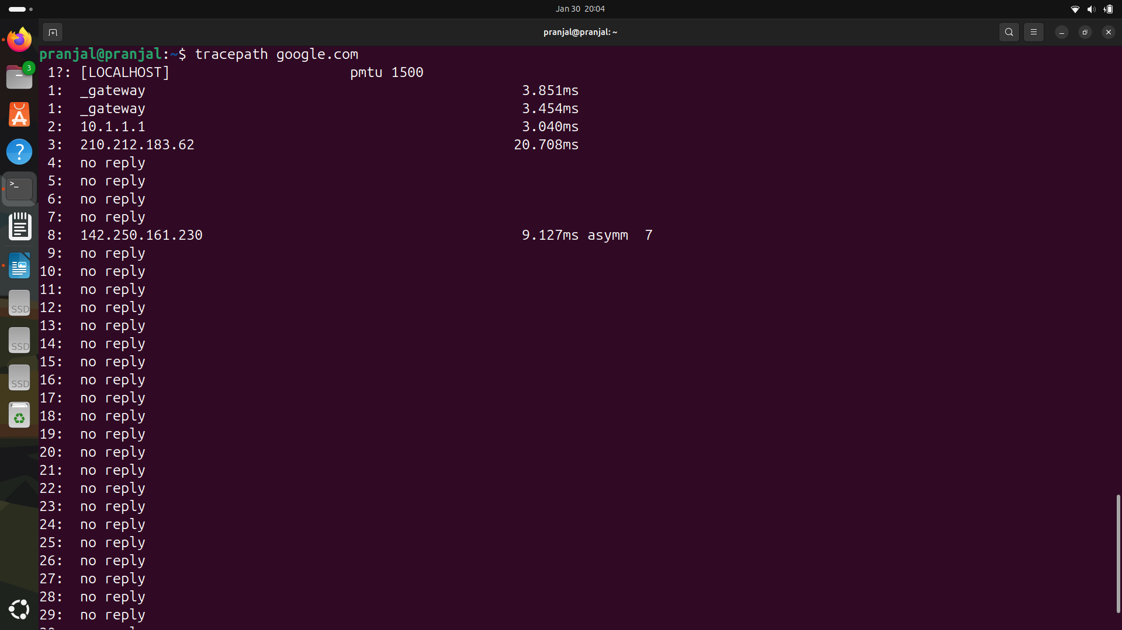

5. ping:

It is a fundamental network diagnostic tool used to test the reachability of a host and measure round-trip latency by sending ICMP Echo Request packets to a target IP address or domain. It helps to verify connectivity, troubleshoot network issues, and determine packet loss.

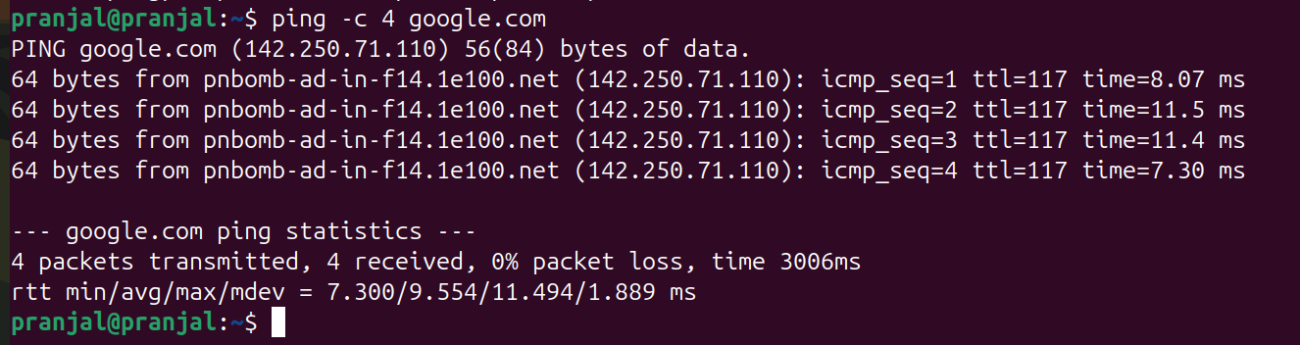
6. netstat:

netstat (network statistics) is a command line tool used to monitor and troubleshoot network connections, routing tables, and interfaces statistics. . It displays active TCP/UDP ports, listening services, and process IDs (PID) to help identify network issues or unauthorized connections.

netstat -tuln is a network diagnostic command used to show all listening network ports on your system without resolving names.

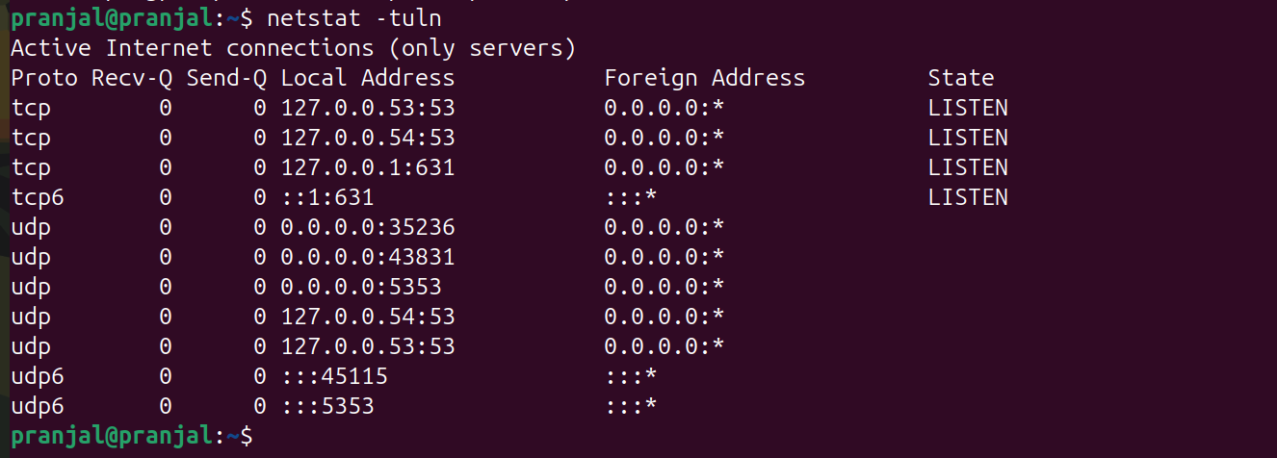

7. nslookup

nslookup (Name Server Lookup) is a command-line utility used to query DNS servers to map domain names to IP addresses or perform reverse lookups (finding a domain from an IP). It is essential for troubleshooting DNS connectivity, verifying DNS records (MX, A, TXT), and diagnosing network issues on Windows, macOS, and Linux.

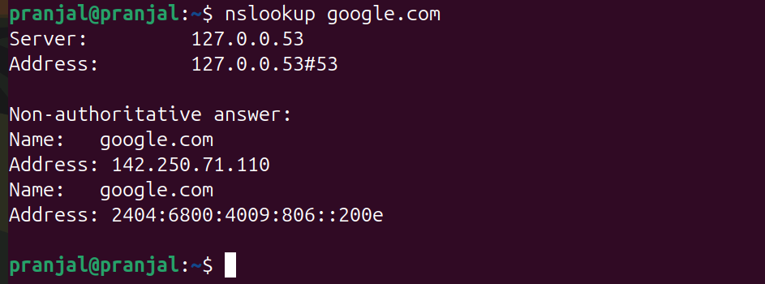

8. dig:

The dig (Domain Information Groper) command is command-line tool used to query DNS name servers for troubleshooting, diagnosing, and verifying network domain information. It is standard on Linux/macOS and displays detailed, authoritative records (A, MX, TXT).
It provides detailed DNS information.
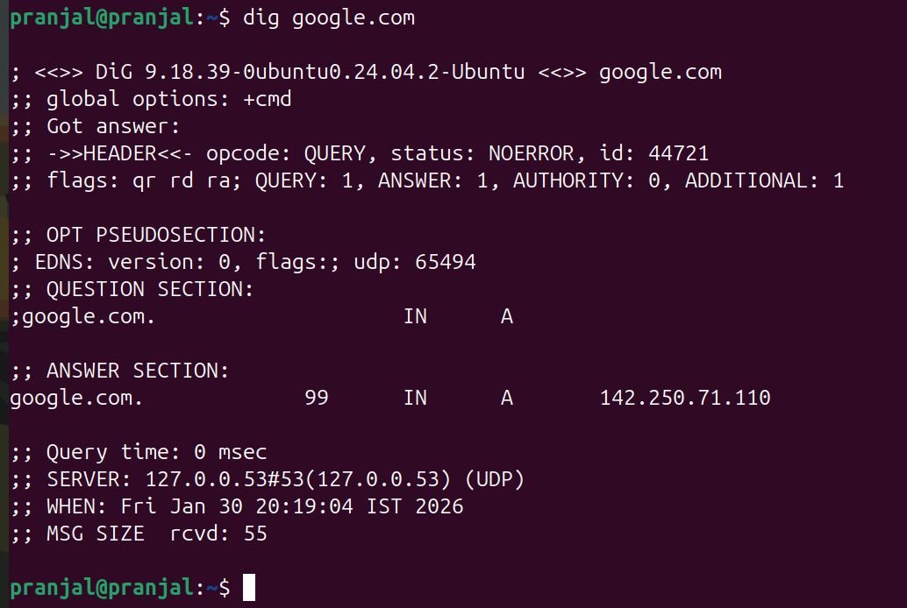

9. route:

The route command is a command-line utility used to view and manipulate the IP routing table. It is primarily used to manually configure static routes, allowing administrators to manage network traffic flow, define gateways, and specify interfaces for specific network destinations.
It displays or modifies the system’s routing table.

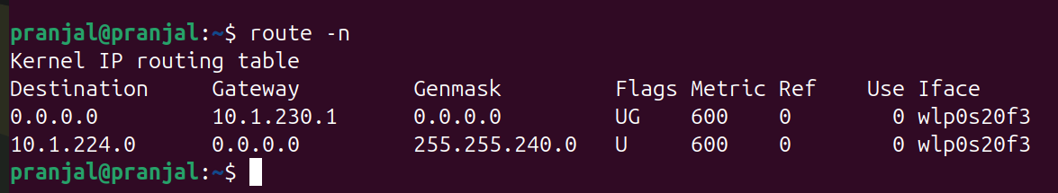

10. host:

It is a simple and powerful command-line utility used for performing Domain Name System(DNS) lookups. Its primary purpose is to resolve a hostname (like google.com) into an IP address (IPv4 or IPv6) or an IP address back into a hostname (reverse DNS lookup).

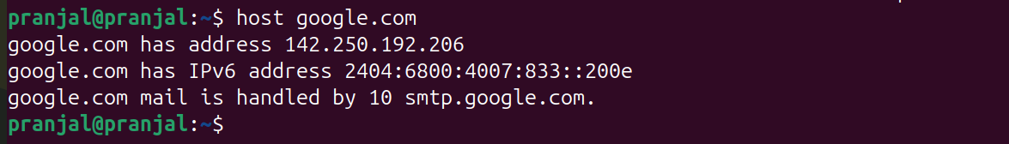
11. arp:

The arp (Address Resolution Protocol) command is a networking utility used for displaying and modifying the ARP cache, which maps IP addresses (Layer 3) to physical MAC addresses (Layer 2) on a local network. It is essential for troubleshooting connectivity issues, viewing neighboring devices, and managing IP-to-MAC address mappings.

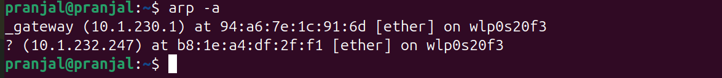
12. iwconfig:

The iwconfig is Linux command-line utility used to view and configure wireless network interface parameters, such as SSID, frequency, channel, and encryption keys.
It is similar to ifconfig but designed specifically for Wi-Fi, displaying statistics like link quality and signal strength.

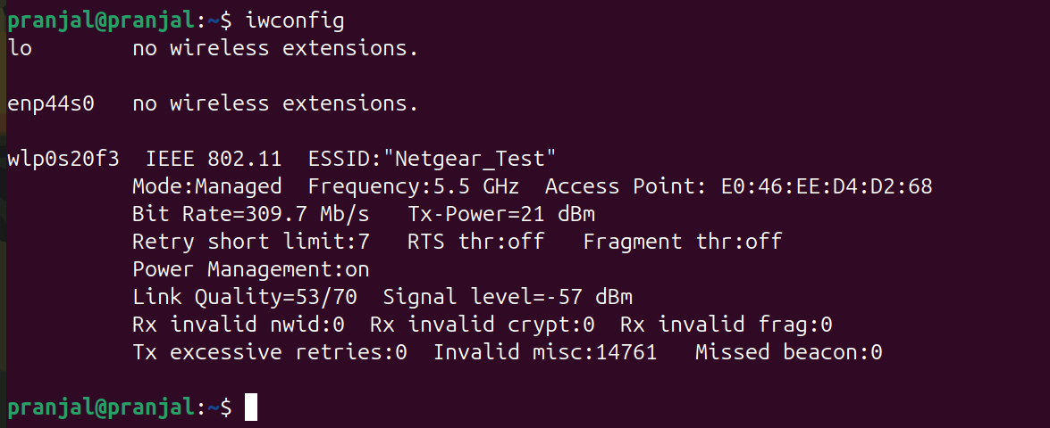
13. curl:

The curl command is the short of “client url”. It is a command-line tool and library used for transferring data to or from a server using a wide variety of network protocols.
Transfers data to or from a server using protocols like HTTP, HTTPS, FTP.

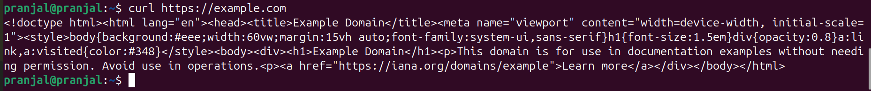

14. wget:

The wget command is a free, non-interactive command-line utility for downloading files and data from the internet using HTTP, HTTPS and FTP protocols. Its name is derived from “World Wide Web” and “get”.

A key feature of wget is its non-interactive nature, which means it can run in the background without user input and automatically handle issues like slow or unstable network connections by retrying failed downloads until the file is completely retrieved. This makes it ideal for use in scripts or automated tasks.

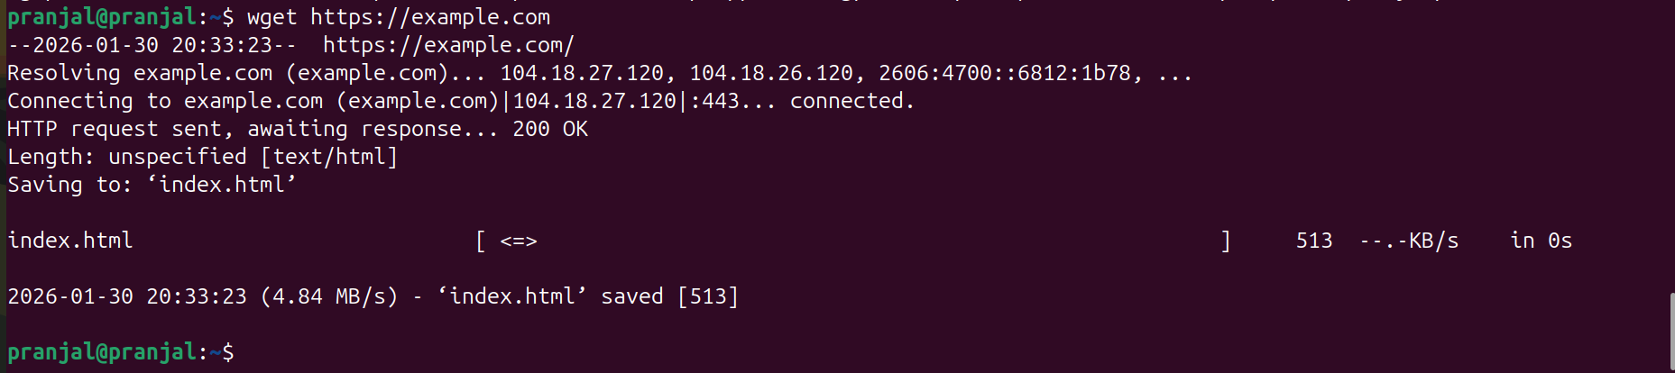
15. telnet:

The telnet command is a network utility used to establish a remote, text-based terminal session with another host or device via the TCP/IP protocol.
It operates in a client/server model, primarily for remote administration, testing open ports, and troubleshooting network connectivity. Due to lack of encryption, it is generally replaced by Secure Shell (SSH).

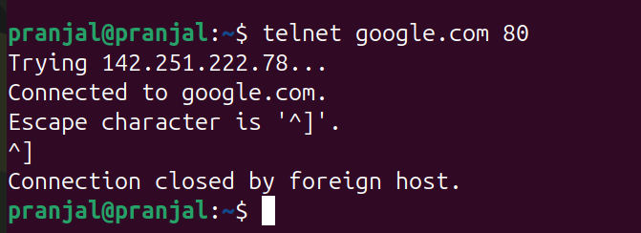
16. whois:

The whois comand is a command-line utility used to query database that store registration information for the internet resources, including domain names, IP address blocks and autonomous system.
It provides details on domain ownership, registrar information, registration/expiration dates, and name servers. It is commonly used for network troubleshooting and security investigations.

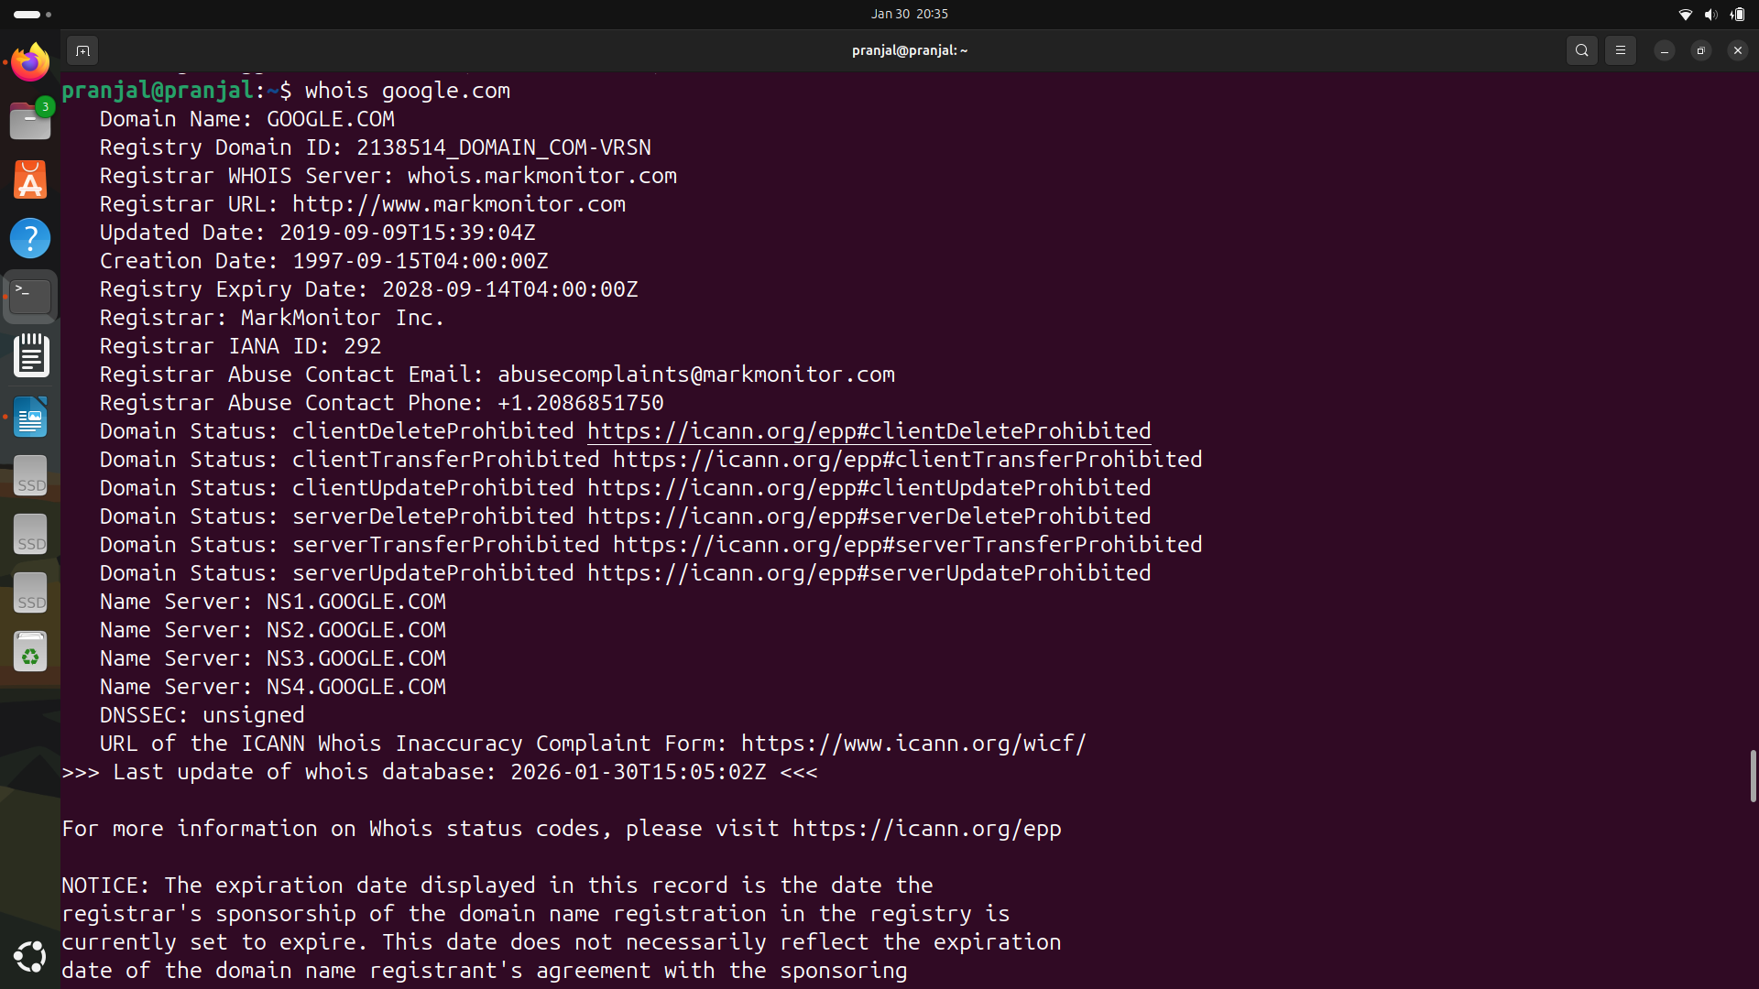

17. ifplugstatus:

It is a command line utility used to detect whether a physical network cable is connected (link beat) or disconnected from a specific network interface. It supports various APIs like ethtool, mii-diag, and wlan extensions, returning the status as a scriptable exit code.


18. nload:

It is a console-based command-line tool for Linux and Unix-like systems used to monitor traffic and bandwidth usage in real-time.
It provides a visual representation of incoming and outgoing traffic using graphs and displays metrics like current, average, minimum, and maximum transfer rates.

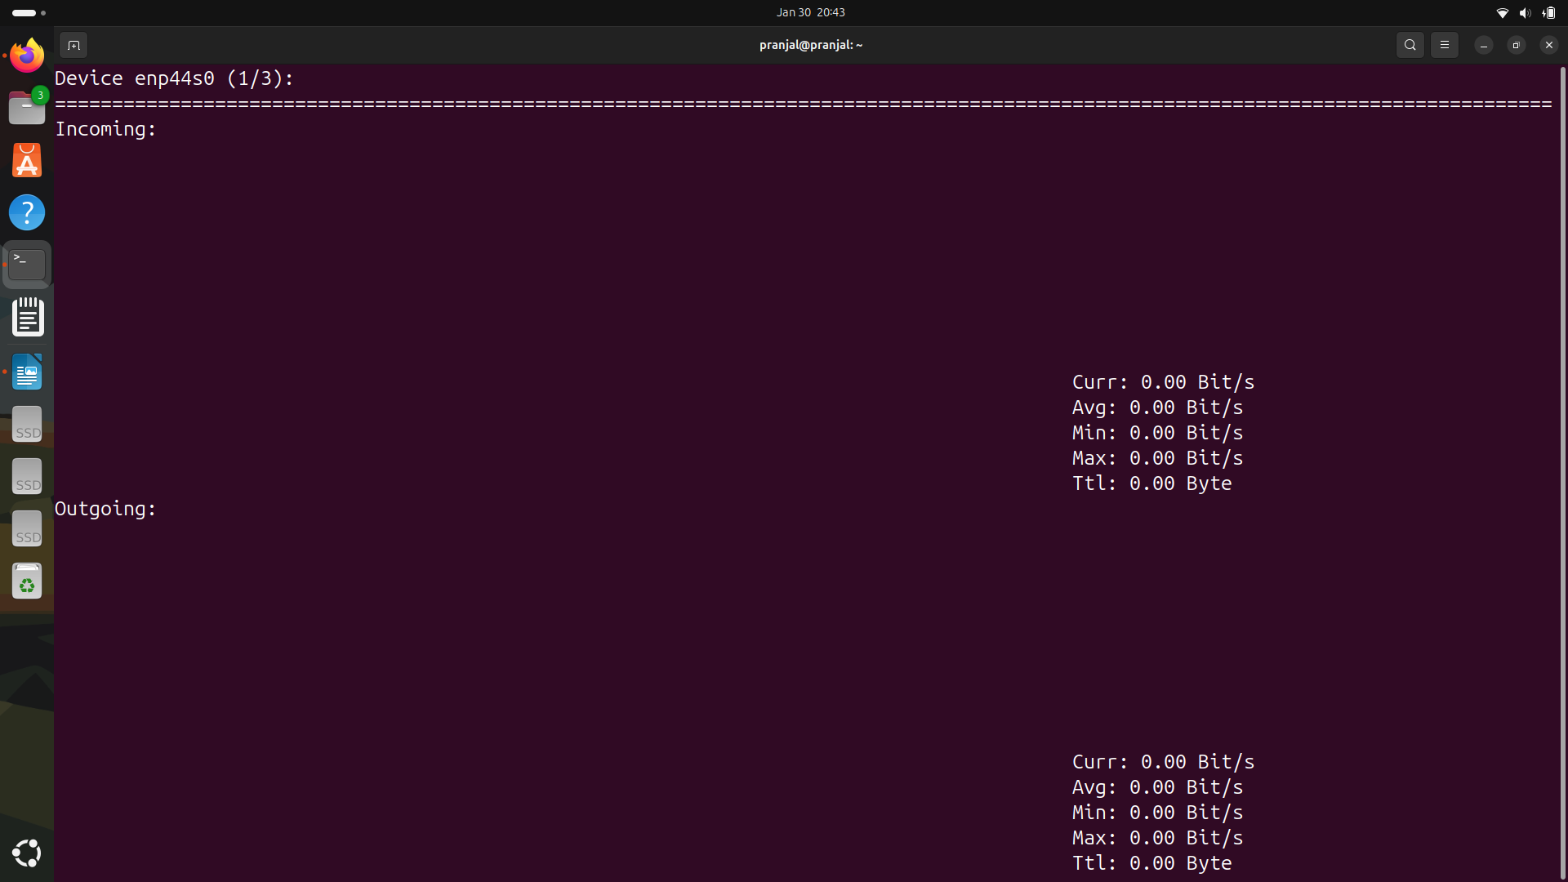
19. mail:

The mail command in Linux is a command-line utility used to. It is commonly used for automation, such as sending system alerts or reports via scripts, and requires a configured mail transfer agent (MTA) like Postfix or Sendmail to function.

The output indicates that no mailbox exists for the current user because no local mail has been received or mail services are not configured.

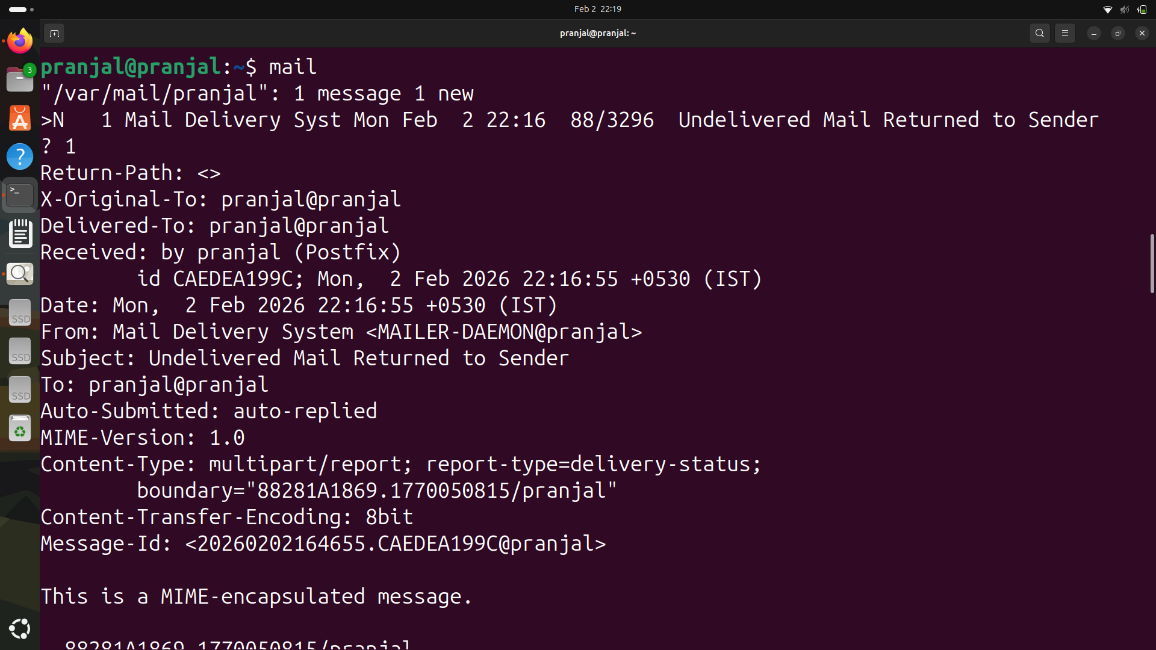

20. hostname:

The hostname command displays or sets the network name (hostname) of a computer, acting as its unique, human-readable identifier on a network.
Running hostname without arguments shows the current name, while root privileges are needed to change it, often used by system administrators for identifying servers and for network services.


21. mtr:

The mtr (My Traceroute) command is a network diagnostic tool that combines the functionality of traceroute and ping into one, constantly updating interface.
It maps the network path between a source and destination, providing real-time statistics on latency and packet loss for every intermediate hop.

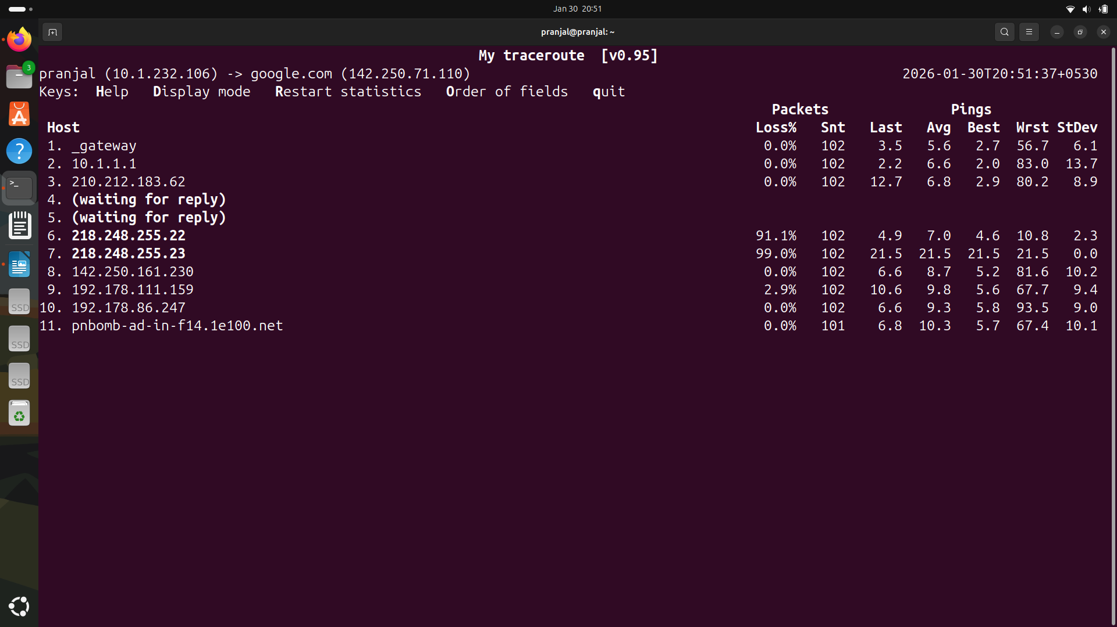

22. nmap:

Nmap (“Network Mapper”) is a open-source command-line tool used for network discovery, security auditing, and port scanning.
It identifies active devices on a network, discovers open ports and running services, detects operating systems, and helps assess security vulnerabilities by sending packets and analyzing responses.

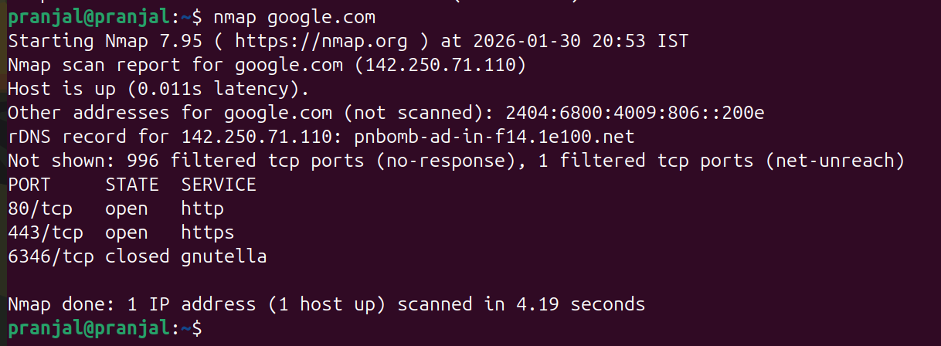
23. ssh:

The ssh command is used from logging into the remote machine, transferring files between the two machines, and for executing commands on the remote machine.

ssh (SSH client) is a program for logging into a remote machine and for executing commands on a remote machine. It is intended to provide secure encrypted communications between two untrusted hosts over an insecure network. X11 connections, arbitrary TCP ports and Unix-domain sockets can also be forwarded over the secure channel.

ssh connects and logs into the specified destination, which may be specified as either [user@]hostname or a URI of the form ssh://[user@]hostname[:port].

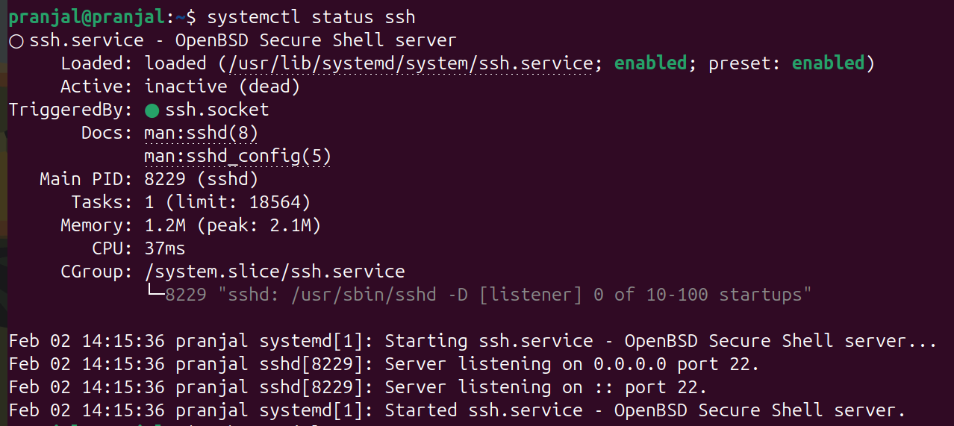
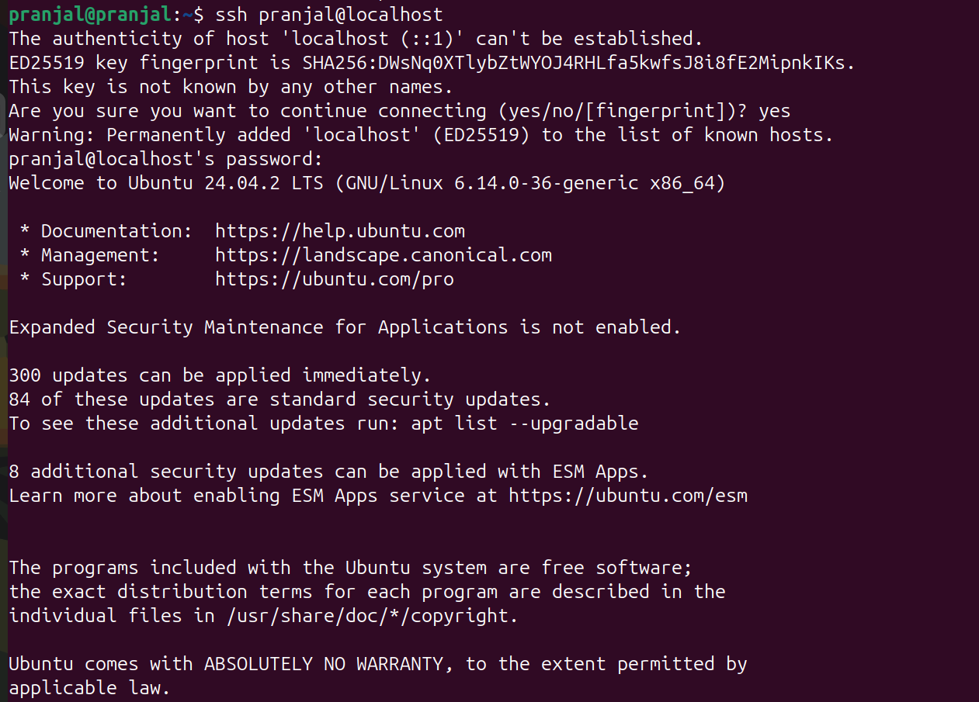
24. nmcli:

The nmcli (NetworkManager Command Line Interface) command is a powerful tool used to control NetworkManager, create, edit, activite, deactivate, and delete network connections, as well as display network device status in Linux systems.
It acts as a command-line alternative to GUI network tools, making it essential for scripting, server management, and headless environments.

