## Drowsiness Detection

*A*

***Project Report***

*submitted*

*in partial fulfillment*

*for the award of the Degree of*

***Bachelor of Technology***

***in Department of Computer Science and Engineering***



### Project Mentor: Submitted By :

Name: Ankit Kumar Pranjal Agarwal (16eskcs739)

Designation : C.S.E Professor

**Department of Computer Science and Engineering Swami Keshvanand Institute of Technology, M & G, Jaipur**

**Rajasthan Technical University, Kota Session 2019-2020**

## Swami Keshvanand Institute of Technology, Management & Gramothan, Jaipur

**Department of Computer Science and Engineering**

# CERTIFICATE

This is to certify that Mr Pranjal Agarwal, a student of B.Tech(Computer Science

& Engineering). 8th semester has submitted his/her Project Report entitled

”Drowsiness Detection” under my guidance.

**Mentor Coordinator**

Name Ankit Kumar Name Ankit Kumar

Designation CSE Professor Designation CSE Professor

Signature............ Signature............

*Department of Computer Engineering, SKIT College, Jaipur* 2

# DECLARATION

We hereby declare that the report of the project entitled ”Drowsiness Detection” is a record of an original work done by us at Swami Keshvanand Institute of Technology, Management and Gramothan, Jaipur under the mentor- ship of ”Ankit Kumar” (Dept. of Computer Science and Technology) and coordi- nation of ”Ankit Kumar” (Dept.of Computer Science and Technology). This project report has been submitted as the proof of original work for the partial fulfillment of the requirement for the award of the degree of Bachelor of Technology (B.Tech) in the Department of Computer Sci- ence and Technology.It has not been submitted anywhere else, under any other program to the best of our knowledge and belief.

## Team Members Signature

PranjalAgarwal(16eskcs739)

## Acknowledgement

A project of such a vast coverage cannot be realized without help from numer- ous sources and people in the organization.We take this opportunity to express our gratitude to all those who have been helping us in making this project successful.

We are highly indebted to our faculty mentor Ankit Kumar. .He has been a guide, motivator source of inspiration for us to carry out the necessary proceedings for the project to be completed successfully. We also thank our project coordinator Ankit Kumar for his co-operation, encouragement, valuable suggestions and critical remarks that galvanized our efforts in the right direction.

We would also like to convey our sincere thanks to Prof. Dr. Mukesh Gupta, HOD, Department of Computer Science and Engineering, for facilitating, motivating and supporting us during each phase of development of the project.Also, we pay our sincere gratitude to all the Faculty Members of Swami Keshvanand Institute of Technology, Management and Gramothan, Jaipur and all our Colleagues for their co-operation and support.

Last but not least we would like to thank all those who have directly or indirectly helped and cooperated in accomplishing this project.

**Team Members**:

PranjalAgarwal(16eskcs739)

# Contents

1. Project Chapter 1
   1. Problem Statement and Objective . . . . . . . . . . . . 1
   2. Introduction to Project . . . . . . . . . . . . . . . . . 1
   3. Proposed Logic / Algorithm / Business Plan / Solution

/ Device . . . . . . . . . . . . . . . . . . . . . . . . . 2

1.5 Scope of the Project . . . . . . . . . . . . . . . . . . . 2

1. Software Requirement Specification 3

2.1 Overall Description . . . . . . . . . . . . . . . . . . . 3

* + 1. Product Perspective . . . . . . . . . . . . . . . 4
       1. System Interfaces . . . . . . . . . . 4
       2. User Interfaces . . . . . . . . . . . . 4
       3. Hardware Interfaces . . . . . . . . . 4
       4. Software Interfaces . . . . . . . . . 4

### SYSTEM DESIGN SPECIFICATION 5

### METHODOLOGY AND TEAM 7

* 1. Introduction to Waterfall Framework 8

### System Testing 11

### TEST EXECUTION SUMMARY 12

1. **PROJECT SCREENSHOTS 13**
2. **PROJECT SUMMARY AND CONCLUSIONS 14**
   1. Conclusion 14

### FUTURE SCOPE 15

### References 16

# Chapter 1

**Project Chapter**

### Problem Statement and Objective

This project is focused on the localization of the eyes, which involves looking at the entire image of the face, and determining the position of the eyes by a self developed image-processing algorithm. Once the position of the eyes is located, the system is designed to determine whether the eyes are opened or closed, and detect fatigue.**.**

### Introduction to Project

Driver fatigue is a significant factor in a large number of vehicle accidents. Recent statistics estimate that annually 1,200 deaths and 76,000 injuries can be attributed to fatigue related crashes . The development of technologies for detecting or preventing drowsiness at the wheel is a major challenge in the field of accident avoidance systems. Because of the hazard that drowsiness presents on the road, methods need to be developed for counteracting its affects. The aim of this project is to develop a prototype drowsiness detection system. The focus will be placed on designing a system that will accurately monitor the open or closed state of thedriver’s eyes in real-time. By monitoring the eyes, it is believed that the symptoms of driver fatigue can be detected early enough to avoid a car accident. Detection of fatigue involves a sequence of images of a face, and the observation of eye movements and blink patterns.

*Department of Computer Science and Engineering, SKIT, Jaipur* 1

### Proposed Logic / Algorithm / Business Plan / Solution / De- vice

The general flow of our drowsiness detection algorithm is fairly straight forward .First, we’ll setup a camera that monitors a stream for faces .If a face is found, we apply facial landmark detection and extract the eye regions Now that we have the eye regions, we can compute the eye aspect ratio to determine if the eyes are closed.If the eye aspect ratio indicates that the eyes have been closed for a sufficiently long enough amount of time, we’ll sound an alarm to wake up the driver. we’ll implement the drowsiness detection algorithm detailed above using OpenCV, dlib, and Python.

### Scope of the Project

Our model is designed for detection of drowsy state of eye and give and

Alert signal or warning in the form of audio alarm. But the response of

Driver after being warned may not be enough to stop causing the

accident meaning that if the driver is slow in responding towards the

warning signal then accident may occur.

*Department of Computer Engineering, SKIT College, Jaipur* 2

# Chapter 2

**Software Requirement Specification**

### Overall Description

One of the challenges in developing an economical drowsiness detection system is a way to acquire proper drowsiness information. Because of safety reasons, drowsiness cannot be manipulated during a real environment, Therefore thedrowsiness detection system needs to be developed and tested in a laboratory setting. However, in a laboratory setting, theforemost reliable and informative information that pertains to driver drowsiness depends only on the approach in which the driver falls into the drowsy state. Driver drowsiness principally depends on the quality of the last sleep, the biological time (time of day) and the rise within the period of the driving task. In some analysis experiments, the subjects were totally deprived of sleep, whereas they were only part deprived of sleep in others. Additionally, some researchers recruited night shift staff as their subjects, in this case, the subjects were entirely deprived of sleep as results of the experiments were conducted within the morning. Kokonozi, et al. Conducted an experiment during which they monitored the participants for twenty four before the experiment began to make sure that they were utterly sleep deprived [1]. In certain experiments, researches partly deprived the subjects of sleep by permitting them to sleep for less than a half dozen. Peters, et al. Studies an equivalent subject throughout four consecutive days and regarded the results of no sleep deprivation , partial sleep deprivation and total sleep deprivation on their drowsiness level [2]. They discovered that, even within the case of partial sleep deprivation, the subjects tend to urge drowsy after a while. Hence, the standard of the last sleep is a crucial criterion that influences drowsiness. Otamani, et al. Found that sleep deprivation alone doesn’t directly influence the brain signals that control, drowsiness, whereas the period of the task includes a strong influence [3]. Researchers have additionally inferred that prolonged driving on a boring setting stimulates drowsiness. In fact, it has been discovered that the subjects will become drowsy at intervals twenty to twenty five min of diving.

### _____________________________________________

*Department of Computer Engineering, SKIT College, Jaipur* 3

### __________________________________________________________

### Product Perspective

### System Interfaces

The requirements for an effective drowsy driver detection system are as follows:

• A non-intrusive monitoring system that will not distract the driver.

• A real-time monitoring system, to insure accuracy in detecting drowsiness.

• A system that will work in both daytime and nighttime conditions.

### Hardware Interfaces

Hardware Requirements are as follow:

Intel Core i3 / i5 / i7 2.27 GHz and higher

QWERTY Keyboard (U.S. Design)

USB 2.0 Optical Mouse

RAM - 1024mb

Disk Space - 1 Gb

**Software Interfaces**

Any Microsoft Windows 7 and higher (Windows 7 / 8 / 8.1 / 10) or equivalent Linux based operating systemwith minimum kernel support 3.X.

Jupyter Notebook(or Pycharm)

Window Media Player

*Department of Computer Science and Engineering, SKIT, Jaipur* 4

_____________________________________________

# Chapter 3

* + 1. **SYSTEM DESIGN SPECIFICATION**
    2. **High Level Design Diagrams**
    3. 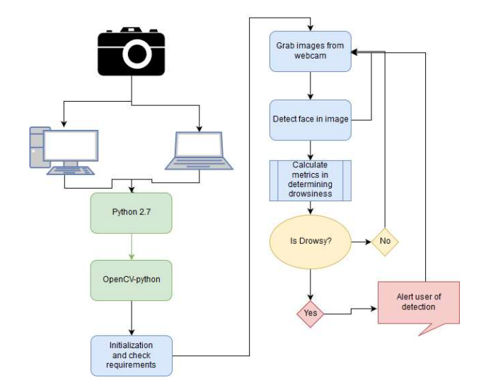

**_______________________________________________________________________________________________**

*Department of Computer Science and Engineering, SKIT, Jaipur* 5

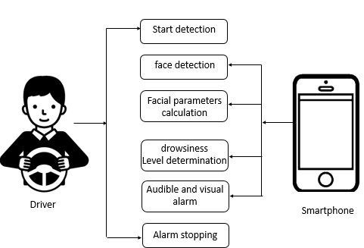

**______________________________________________________________________________________________**

*Department of Computer Science and Engineering, SKIT, Jaipur* 6

# Chapter 4

**METHODOLOGY AND TEAM**

### Introduction to Waterfall Framework

The Waterfall Model was first Process Model to be introduced. It is also referred to as a linear-sequential life cycle model. It is very sim- ple to understand and use. In a waterfall model, each phase must be completed before the next phase can begin and there is no overlapping in the phases. The waterfall Model illustrates the software develop- ment process in a linear sequential flow; hence it is also referred to as a linear-sequential life cycle model. This means that any phase in the development process begins only if the previous phase is complete. In waterfall model phases do not overlap. In ”The Waterfall” approach, the whole process of software development is divided into separate phases. In Waterfall model, typically, the outcome of one phase acts as an input for the next phase sequentially. Following is a diagram- matic representation of different phases of waterfall model.

*Department of Computer Science and Engineering, SKIT, Jaipur* 7

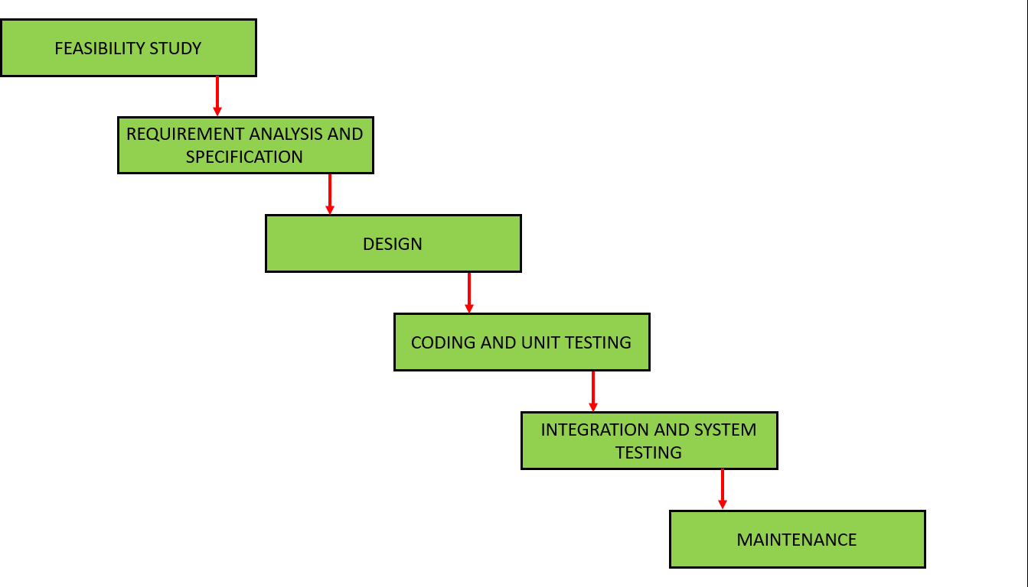 The sequential phases in Waterfall model are-

* + 1. **Requirement Gathering and analysis:** All possible requirements of the system to be developed are captured in this phase and doc- umented in a requirement specification doc.
    2. **System Design:** The requirement specifications from first phase are studied in this phase and system design is prepared. System Design helps in specifying hardware and system requirements and also helps in defining overall system architecture.
    3. **Implementation:** With inputs from system design, the system is first developed in small programs called units, which are inte- grated in the next phase. Each unit is developed and tested for its functionality which is referred to as Unit Testing.
    4. **Integration and Testing:** All the units developed in the imple-

*Department of Computer Engineering, SKIT College, Jaipur* 8

mentation phase are integrated into a system after testing of each unit. Post integration the entire system is tested for any faults and failures.

* + 1. **Deployment of system:** All the units developed in the imple- mentation phase are integrated into a system after testing of each unit. Post integration the entire system is tested for any faults and failures.
    2. **Maintenance:** All the units developed in the implementation phase are integrated into a system after testing of each unit. Post inte- gration the entire system is tested for any faults and failures.

All these phases are cascaded to each other in which progress is seen as flowing steadily downwards (like a waterfall) through the phases. The next phase is started only after the defined set of goals are achieved for previous phase and it is signed off, so the name ”Waterfall Model”. In this model phases do not overlap.

### Waterfall Model Pros Cons

**Advantage** The advantage of waterfall development is that it allows for departmentalization and control. A schedule can be set with dead- lines for each stage of development and a product can proceed through the development process model phases one by one. Development moves from concept, through design, implementation, testing, instal- lation, troubleshooting, and ends up at operation and maintenance. Each phase of development proceeds in strict order.

*Department of Computer Engineering, SKIT College, Jaipur* 9

**Disadvantage** The disadvantage of waterfall development is that it does not allow for much reflection or revision. Once an application is in the testing stage, it is very difficult to go back and change something that was not well-documented or thought upon in the concept stage.

­­­­­­­­­­­­­­­­­______________________________________________________________________________________

*Department of Computer Science and Engineering, SKIT, Jaipur* 10

# Chapter 5

**System Testing**

I would then suggest testing the

detect_drowsiness.py

In my case, once I was sufficiently happy with my implementation, I moved my laptop + webcam out to my car.

once the video stream was up and running, I carefully started testing the drowsiness detector in the parking garage by my apartment to ensure it was indeed working properly.

After a few tests, I then moved on to some back roads and parking lots were there was very little traffic (it was a major holiday in the United States, so there were very few cars on the road) to continue testing the drowsiness detector.

Remember, driving with your eyes closed, even for a second, is dangerous, so I took extra special precautions to ensure that the only person who could be harmed during the experiment was myself.

As the results show, our drowsiness detector is able to detect when I’m at risk of dozing off and then plays a loud alarm to grab my attention.

The drowsiness detector is even able to work in a variety of conditions, including direct sunlight when driving on the road and low/artificial lighting while in the concrete parking garage.

­

­­­­­­­­­­­­­­­­­______________________________________________________________________________________-*Department of Computer Science and Engineering, SKIT, Jaipur* 11

# Chapter 6

**TEST EXECUTION SUMMARY**

Various samples with various accuracies were taken and a table plotted for them.

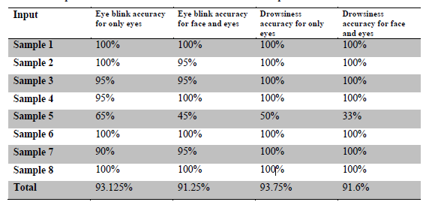

Each volunteer was asked to blink 20 times and become drowsy 6 times during the testing process.

The accuracy for eye blink was calculated by the formula

Accuracy = 1 - |total no. of blinks -no. of blinks detected| / total no. of blinks.

The same formula was used for calculating accuracy of drowsiness detection.

It can be seen from the above table that if sample 5 is not taken into consideration then the system has an accuracy of nearly 100%. That said; the high amount of errors in sample 5 shows that the system is prone to error and has certain limitations which we will discuss in the next section. In sample 5 we did not use the backlight of the webcam. The resulting poor lighting conditions gave a highly erroneous output.

*Department of Computer Science and Engineering, SKIT, Jaipur* 12

# Chapter 7

**PROJECT SCREENSHOTS**

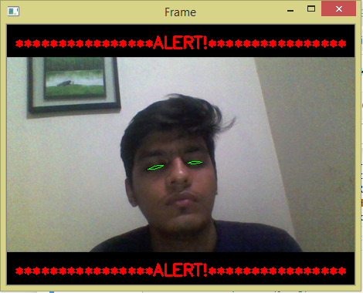

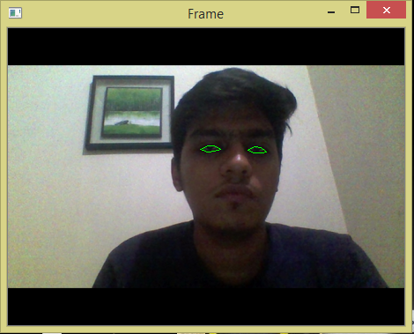

____________________________________________________________________________________

*Department of Computer Science and Engineering, SKIT, Jaipur* 13

# Chapter 8

**PROJECT SUMMARY AND CONCLUSIONS**

### Conclusion

The driver abnormality monitoring system developed is capable of detecting drowsiness, drunken and reckless behaviours of driver in a short time. The Drowsiness Detection System developed based on eye closure of the driver can differentiate normal eye blink and drowsiness and detect the drowsiness while driving. The proposed system can prevent the accidents due to the sleepiness while driving. The system works well even in case of drivers wearing spectacles and even under low light conditions if the camera delivers better output. Information about the head and eyes position is obtained through various self-developed image processing algorithms. During the monitoring, the system is able to decide if the eyes are opened or closed. When the eyes have been closed for too long, a warning signal is issued. processing judges the driver’s alertness level on the basis of continuous eye closures.

_______________________________________________________________________________________________

*Department of Computer Science and Engineering, SKIT, Jaipur* 14

# Chapter 9

**FUTURE SCOPE**

The system does not work for dark skinned individuals. This can be corrected by having an adaptive light source. The adaptive light source would measure the amount of light being reflected back. If little light is being reflected, the intensity of the light is increased. Darker skinned individual need much more light, so that when the binary image is constructed, the face is white, and the background is black.

___________________________________________________________________

*Department of Computer Science and Engineering, SKIT, Jaipur* 15

# References

[1] http://www.ee.ryerson.ca/~phiscock/thesis/drowsy-detector/drowsy-detector.pdf

[2] http://www.cnblogs.com/skyseraph/archive/2011/02/24/1963765.html

[3] http://www.scribd.com/doc/15491045/Learning-OpenCV-Computer-Vision-with-the-OpenCV-Library

[4]http://opencv.willowgarage.com/documentation/reading_and_writing_images_and_video.html

[5] http://www.scribd.com/doc/46566105/opencv

[6] Learning OpenCV by Gary Bradski and Adrian Kaehler

[7] http://note.sonots.com/SciSoftware/haartraining.html

­­­­­­­­­­­­­­­­­___________________________________________________________________

*Department of Computer Science and Engineering, SKIT, Jaipur* 16