Time Series Analysis (24AM7PCTSA) — Lab AAT
Domain-Based Time Series Forecasting · Domain: Smart City

Hourly Urban Water Demand Forecasting Using SARIMA and Multi-Seasonal Decomposition Enhancement

Team members (name — USN):
[Member 1 name] — [USN]
[Member 2 name] — [USN]
[Member 3 name] — [USN]
[Member 4 name] — [USN]

Course instructor: [Name]
Department: [Department], [College]
Submission date: 30 October 2026

Dataset: Weyrauch et al. (2024), Hourly Water Demand of a Mixed District Recorded by Supplier, Zenodo, doi:10.5281/zenodo.11045013 (CC-BY-4.0). All results in this report were produced by the code in the accompanying repository (README.md).

Abstract
Water utilities schedule pumps and reservoir levels a day in advance, so they need reliable hourly demand forecasts. We study 46,032 hourly consumption records (January 2016 – April 2021) from a German pumping station that serves residential, commercial and industrial customers. Exploratory analysis on the training period shows a dominant daily cycle (MSTL seasonal strength 0.96) and a clear weekly cycle (strength 0.67). After lag-24 differencing, the autocorrelation at lag 168 remains 0.53: weekly structure that a daily-seasonal SARIMA cannot absorb. We compare a validation-tuned SARIMA(3,0,1)(0,1,1)₂₄ baseline with an enhanced model that decomposes a trailing 12-week window using MSTL (periods 24 h and 168 h), extends each seasonal component by its latest cycle and forecasts the seasonally adjusted series with ARIMA(1, 1, 1). Both models produce rolling day-ahead (24-hour) forecasts for the same 6,912 unseen test hours (18 June 2020 – 1 April 2021). The enhanced model reduces MAE from 270.7 to 199.1 m³/h (26.4%; block-bootstrap 95% CI 21.8–31.9%), RMSE from 381.9 to 277.7 m³/h and MAPE from 15.9% to 11.2%. A Diebold–Mariano test on daily losses rejects equal accuracy (p < 10⁻¹⁵). An ablation without the 168-hour component performs worse than SARIMA (MAE 288.8), which shows that the gain comes from modelling the weekly cycle. Most of the gain appears on weekends and during the morning demand ramp.
Keywords: water demand forecasting; smart city; SARIMA; MSTL; multiple seasonality; day-ahead forecasting; Diebold–Mariano test; SDG 6

1. Introduction
Drinking-water networks move water from sources through pumps into storage tanks and then to consumers. Because electricity prices, pump wear and tank capacity all depend on when water is pumped, operators plan pump schedules ahead of time. A forecast of the next day's hourly demand is therefore a basic input to operational planning (Donkor et al., 2014; Pacchin et al., 2019). The dataset provider makes the same point: demand prediction can help optimise pump operating cost, guarantee supply and avoid storing more water than needed (Weyrauch et al., 2024, dataset description).
Hourly demand is dominated by human routines: low use at night, a morning peak, and a second peak in the evening. Routines also differ between working days and weekends. A forecasting model must capture both cycles. Classical SARIMA models, which this course covers in depth, represent only one seasonal period in their seasonal part. This project asks whether explicitly modelling both the daily and the weekly pattern improves accuracy on the same unseen data.

2. Problem Statement
Given the hourly water consumption observed up to 23:00 on day D−1, forecast the consumption for each of the 24 hours of day D (a day-ahead forecast with a 1–24 hour horizon). Forecast quality is measured on a held-out final period with MAE, RMSE and MAPE. The target is the hourly volume in m³/h. Weather variables are not used, because their future values would not be known at forecast time without a separate weather forecast (Section 11.4).

3. Domain Background and Motivation
- Smart-city relevance: pumping is a major energy cost for water utilities; better short-term forecasts are a prerequisite for optimised pump schedules and tank management (Weyrauch et al., 2024; Arandia et al., 2016).
- Mixed district: the station serves residential, commercial and industrial consumers, so both household routines and working-week effects can appear in the data.
- Why time-series forecasting: demand at a given hour depends strongly on demand at the same hour on previous days and weeks (autocorrelation), so methods built on past values are natural candidates.
- Sustainability link: forecasts can support planning related to SDG 6 (Clean Water and Sanitation). This study measures forecast accuracy only; it does not measure energy or water savings.

4. Research Objectives and Questions
Main research question (RQ): Does explicitly modelling multiple seasonal patterns improve hourly water demand forecasting compared with a conventional SARIMA baseline evaluated on the same unseen observations?
Hypothesis H1: an MSTL-based model with daily (24 h) and weekly (168 h) components achieves lower test MAE and RMSE than a validation-tuned SARIMA with s = 24 under an identical rolling day-ahead protocol. H0: no difference in expected loss (tested with the Diebold–Mariano test).
- Audit the dataset and document every publisher-made change (Section 6).
- Identify trend and seasonal structure and test stationarity (Section 7).
- Build a reproducible, validation-tuned SARIMA baseline (Section 8).
- Design a leakage-free multi-seasonal enhancement (Section 9).
- Compare both on identical test timestamps, quantify the change and its uncertainty (Sections 10–11).
- Isolate the contribution of the weekly component with an ablation (Section 11.3).

5. Literature Review
We reviewed seven sources. Each was checked against the publisher, repository or arXiv record (DOI, authors, venue) on 29 October 2026. Where only the abstract was accessible, Table 1 says so and reports no numbers beyond what the abstract states.

5.1 Thematic synthesis
Short-term water demand models. Herrera et al. (2010) compared machine-learning regressors (ANN, MARS, random forests, SVR, projection pursuit) with a simple weighted demand-profile model for hourly demand in a Spanish city. Pacchin et al. (2019) compared six models on seven district-metered areas over two years of hourly data with a 24-hour horizon. They found that very different techniques reach comparable accuracy and that moving-window pattern models are the most robust and easiest to set up. Donkor et al. (2014) reviewed the 2000–2010 literature and noted that ANNs dominate short-term studies while probabilistic forecasting is under-used.
SARIMA for water demand. Arandia et al. (2016) built SARIMA models with daily and weekly periodicities, updated online with a Kalman filter. They report that weekly-seasonal models remove autocorrelation more efficiently than daily-seasonal ones and that online updating helps. Our baseline follows the same idea: parameters are estimated once, and the Kalman filter state is updated with every new day of data.
Multiple seasonality. Taylor (2003) showed for half-hourly electricity demand that a double-seasonal (daily + weekly) Holt-Winters method beat both single-seasonal Holt-Winters and a double-seasonal ARIMA. Bandara et al. (2021) proposed MSTL, an extension of STL (Cleveland et al., 1990) that estimates one seasonal component per period by iterating STL. They report competitive decomposition accuracy at low computational cost. MSTL decomposes a series but does not forecast it, so a forecasting step must be added.
Same dataset. Weyrauch et al. (2024) used this exact dataset to benchmark Transformer-type deep learning models (7-day horizon). On the water data, their simple 'recent historic profile' (RHP) reference achieved a MAPE (13.9%) almost equal to the best deep model (13.8%, PatchTST + ReCycle). The authors describe the water series as very noisy. They report no classical statistical baseline such as SARIMA.

5.2 Literature matrix
Table 1. Literature-review matrix (seven verified sources).
Paper / authors / source | Objective & dataset | Methods & metrics | Verified results | Limitations | Relevance here
ReCycle: Fast and Efficient Long Time Series Forecasting with Residual Cyclic Transformers  Weyrauch, Steens, Taubert, Hanke, Eqbal, Götz E., Streit, Götz M., Debus (2024)  arXiv:2405.03429 (IEEE CAI 2024); https://arxiv.org/abs/2405.03429 | Cut the compute cost of Transformer forecasters for long, cyclic series. Data: Same Zenodo water dataset (hourly, 2016–2021) plus electricity/ETT benchmarks; 21 days input → 7 days (168 h) output; 6:2:2 split | Transformer, FEDformer, PatchTST, NHiTS with/without ReCycle; RHP (recent historic profile). Metrics: MSE, MAPE | Water data (full text, Table I): RHP MAPE 13.9 %, best deep model PatchTST+ReCycle 13.8 %, plain FEDformer lowest MSE; authors call the water series 'very noisy' | Deep models barely beat a simple profile on this data; no MAE/RMSE; no classical statistical baseline (SARIMA/ETS) reported | Shows simple cycle-based structure is hard to beat on this exact dataset → motivates a transparent statistical multi-seasonal approach
Tailoring Seasonal Time Series Models to Forecast Short-Term Water Demand  Arandia, Ba, Eck, McKenna (2016)  J. Water Resour. Plann. Manage. 142(3), 04015067; doi:10.1061/(ASCE)WR.1943-5452.0000591 | Short-term urban water demand forecasting with SARIMA + data assimilation. Data: Utility demand at 15-min, hourly and daily resolution | SARIMA with daily and weekly periodicities; offline re-estimation vs online Kalman-filter updating. Metrics: Normalised forecast deviation (abstract) | Abstract: errors ≈4.2 % to 1.3 %, falling with coarser granularity; weekly-seasonal models remove autocorrelation more efficiently than daily-seasonal ones; online updating helps | Single utility; SARIMA handles one seasonal period per model (full text not accessed) | Direct precedent for our SARIMA baseline with Kalman-filter updating; its weekly-vs-daily finding motivates modelling both cycles together
A Comparison of Short-Term Water Demand Forecasting Models  Pacchin, Gagliardi, Alvisi, Franchini (2019)  Water Resour. Manage. 33(4):1481–1497; doi:10.1007/s11269-019-02213-y | Compare six short-term water demand models across real networks. Data: Seven district-metered areas / networks, two years of hourly data | ANN, pattern-based, two moving-window pattern models, Markov chain (probabilistic), naïve benchmark. Metrics: Accuracy indices (abstract does not list them; full text not accessed) | Abstract: different techniques reach comparable medium–high accuracy; moving-window models most robust and easiest to set up | Italian DMAs only; numerical scores not verified here | Supports a 24-h-ahead hourly protocol, a naïve benchmark and a moving (trailing) window design
Predictive Models for Forecasting Hourly Urban Water Demand  Herrera, Torgo, Izquierdo, Pérez-García (2010)  J. Hydrology 387(1–2):141–150; doi:10.1016/j.jhydrol.2010.04.005 | Compare machine-learning predictors for hourly urban demand. Data: Hourly consumption, hydraulic sector of a city in south-eastern Spain | ANN, projection pursuit regression, MARS, random forests, SVR, weighted demand-profile model. Metrics: Not stated in abstract (full text restricted) | Abstract: data highly non-linear; accuracy judged adequate for operational management; best model not verified here | Single sector; ML models need feature engineering and give limited interpretability | Establishes hourly demand forecasting as an operational problem and the value of demand-profile (seasonal pattern) information
MSTL: A Seasonal-Trend Decomposition Algorithm for Time Series with Multiple Seasonal Patterns  Bandara, Hyndman, Bergmeir (2021)  arXiv:2107.13462; https://arxiv.org/abs/2107.13462 | Decompose series with several seasonal cycles efficiently. Data: Synthetic series and a perturbed real-world dataset | MSTL (iterated STL per period) vs other decomposition benchmarks. Metrics: Decomposition accuracy and computation time | Abstract: competitive accuracy with lower computational cost than benchmarks | A decomposition, not a forecaster by itself; seasonal components must be extrapolated | Method used for our enhancement (statsmodels MSTL implementation)
Short-Term Electricity Demand Forecasting Using Double Seasonal Exponential Smoothing  Taylor (2003)  J. Oper. Res. Soc. 54(8):799–805; doi:10.1057/palgrave.jors.2601589 | Model intraday and intraweek cycles in utility demand. Data: Half-hourly electricity demand (daily and weekly cycles) | Double-seasonal Holt-Winters with AR error correction vs standard Holt-Winters and double-seasonal multiplicative ARIMA. Metrics: Forecast accuracy over lead times (per abstract) | Abstract: double-seasonal Holt-Winters outperformed both standard Holt-Winters and the double-seasonal ARIMA | Electricity rather than water; parametric two-cycle structure | Classic evidence that modelling two seasonal cycles improves short-term utility demand forecasts
Urban Water Demand Forecasting: Review of Methods and Models  Donkor, Mazzuchi, Soyer, Roberson (2014)  J. Water Resour. Plann. Manage. 140(2):146–159; doi:10.1061/(ASCE)WR.1943-5452.0000314 | Review urban water demand forecasting literature 2000–2010. Data: Literature review | Time-series, regression, econometric, ANN, hybrid models. Metrics: — | ANNs common for short-term forecasting; econometric/scenario models for long-term planning; calls for more probabilistic forecasting | Covers literature only up to 2010 | Frames forecast horizons and model families; supports noting uncertainty as a limitation

5.3 Research gap and proposed contribution
What is established: (i) hourly demand has strong daily and weekly patterns (Herrera et al., 2010; Arandia et al., 2016); (ii) SARIMA with Kalman updating is a credible statistical baseline (Arandia et al., 2016); (iii) modelling two cycles helps in electricity demand (Taylor, 2003); (iv) simple pattern-based methods are hard to beat in water demand (Pacchin et al., 2019; Weyrauch et al., 2024).
Gap addressed (scoped to this dataset and protocol): for this publicly available German mixed-district dataset, the only published benchmark we found compares deep-learning models and does not report a classical single-seasonal SARIMA baseline or a decomposition-based multi-seasonal statistical model, and reports MSE/MAPE but not MAE/RMSE. We therefore test, under a leakage-free rolling day-ahead protocol, whether a lightweight MSTL (24 h + 168 h) + ARIMA pipeline improves on a validation-tuned SARIMA(s = 24), and we isolate the weekly component's contribution with an ablation. We do not claim that multi-seasonal decomposition has never been applied to water demand; our search covered seven sources.

6. Dataset Description and Data-Quality Assessment

6.1 Source
Table 2. Dataset metadata (from the Zenodo record).
Item | Value
Name | Hourly Water Demand of a Mixed District Recorded by Supplier
Publisher / DOI | Zenodo (Weyrauch, Taubert, Götz, Streit, Götz, Debus, Wolter), doi:10.5281/zenodo.11045013
Licence | Creative Commons Attribution 4.0 International
Provider | Siemens AG, for a study at Karlsruhe Institute of Technology
Location / users | Pumping station of a regional supply network in Germany; residential, commercial, industrial
Period / frequency | 2016-01-01 00:00:00 to 2021-04-01 23:00:00 (the page says 'March 2021'; the files end 1 April 2021); hourly
Files | rawdata.csv; noNaN.csv (interpolated, June 2017 gap filled with multi-year averages); noNaN_fixedTimechange.csv (also 24 h per day); MD5 checksums verified
Variables | Date, Time (interval), Consumption (m³), Temperature (°C), Rain (arb. units), Sun (arb. units)

6.2 Audit of the three published variants
Table 3. Programmatic audit of the raw and the selected processed file.
Check | Raw file | noNaN_fixedTimechange (used)
Rows / days | 46,031 / 1,918 | 46,032 / 1,918
Hours per day | 24 h: 1907, 23 h: 6, 25 h: 5 | 24 h: 1918
Missing Consumption | 509 | 0
Missing Rain | 25 | 25
Duplicate rows / timestamps | 0 / 0 | 0 / 0
Negative / zero consumption | 0 / 0 | 0 / 0
Irregular time labels | 01:00-03:00, 02:00-02:00 (DST days) | none
Sorted chronologically | True | True

Missing consumption in the raw file occurs in six runs: four single hours, one 3-hour gap (6 Jan 2020) and one 502-hour gap starting 1 June 2017 02:00. The publisher filled that long gap with averages from previous years (Figure 1, shaded).

6.3 Feature audit table
Table 4. Feature-level audit (raw file).
Feature | Type | Description | Unit | Missing (raw) | % missing | Unique | Validity concerns | Treatment
Date | string (M/D/YYYY) | Calendar date | - | 0 | 0.00 | 1918 | None | Combined with Time into a timestamp index
Time | string (HH:MM-HH:MM) | Hourly interval | - | 0 | 0.00 | 26 | 23/25-hour days at DST changes | Start hour parsed; DST labels resolved by publisher
Consumption | float | Water volume delivered in the hour | m^3 per hour | 509 | 1.11 | 4523 | 509 missing; night lows down to 1 m³/h; summer-evening peaks | Target. Publisher-filled values kept and flagged; no deletion
Temperature | float | Local air temperature | deg C | 0 | 0.00 | 528 | None found | EDA only (not a model input)
Rain | float | Local precipitation | arbitrary units | 25 | 0.05 | 18 | Arbitrary units; 25 missing | EDA only; 25 missing left as NaN
Sun | float | Local sunshine intensity | arbitrary units | 0 | 0.00 | 15 | Arbitrary units | EDA only

6.4 Preprocessing decisions
- Variant choice: the time-change-fixed file is the only one with exactly 24 rows per day, which seasonal periods of 24 and 168 hours require. We use it, and reconstruct which hours the publisher created or altered by comparing it with the raw file on the (date, start hour) key.
- Flags: 509 hours were imputed (raw NaN), 17 were inserted or adjusted at DST changes and 18 were changed by rounding a .5 value to an integer (≤ 0.5 m³). In total 544 hours (1.18%) are flagged.
- Timestamp index: Date + start hour → naive local time; checked strictly increasing, unique and gap-free at 1-hour frequency ({'0 days 01:00:00': 46031}).
- No rows removed: 46,032 rows before and 46,032 after cleaning (100% retained).
- Outliers: low night values and summer-evening peaks were screened (robust z-score within each hour; 137 training hours with |z| > 5). They look like real consumption patterns (night-time minima, hot-weather irrigation peaks), so they were not deleted.
- Derived calendar features (hour, weekday, weekend, month) are used for EDA and error analysis only.
- Sensitivity: test metrics are reported both on all hours and on observed (unflagged) hours only (Section 11.1). The test period contains only 5 flagged hours.

6.5 Train / validation / test protocol
Table 5. Chronological split (≈70/15/15%, whole days, no shuffling).
Split | Start | End | Hours (days) | Flagged hours | Purpose
Training | 2016-01-01 00:00:00 | 2019-09-03 23:00:00 | 32,208 (1342) | 532 | EDA statistics, model design
Validation | 2019-09-04 00:00:00 | 2020-06-17 23:00:00 | 6,912 (288) | 7 | Select orders / windows (both families)
Test | 2020-06-18 00:00:00 | 2021-04-01 23:00:00 | 6,912 (288) | 5 | Single final evaluation

Rolling day-ahead protocol (identical for every model): at 00:00 of each forecast day a model may use only observations up to 23:00 of the previous day and must output the next 24 hourly values. This gives 288 forecast origins and 6,912 forecasts in each of the validation and test periods. Selection rule for both model families: lowest validation MAE. The test period was used once, after both configurations had been frozen.

7. Exploratory Data Analysis

7.1 Descriptive statistics
Table 6. Descriptive statistics of hourly consumption (full series after publisher filling).
Statistic | Value (m³/h) | Statistic | Value
Count | 46,032 | Std. deviation | 1,032.1
Mean | 2,314.3 | Coefficient of variation | 44.6%
Median | 2,550.0 | IQR | 1,621.0
Minimum | 1.0 | Skewness | -0.267
25% / 75% | 1,461.0 / 3,082.0 | Maximum | 6,514.0

The median (2,550.0) is above the mean (2,314.3) and the distribution is slightly left-skewed: many hours sit near the daytime plateau and a minority are night-time lows. The coefficient of variation of 44.6% reflects the large swing within each day rather than noise. The mean level rises across splits (train 2255.6, validation 2363.7, test 2538.9 m³/h). This matters for forecasting because models must adapt to a moving level.
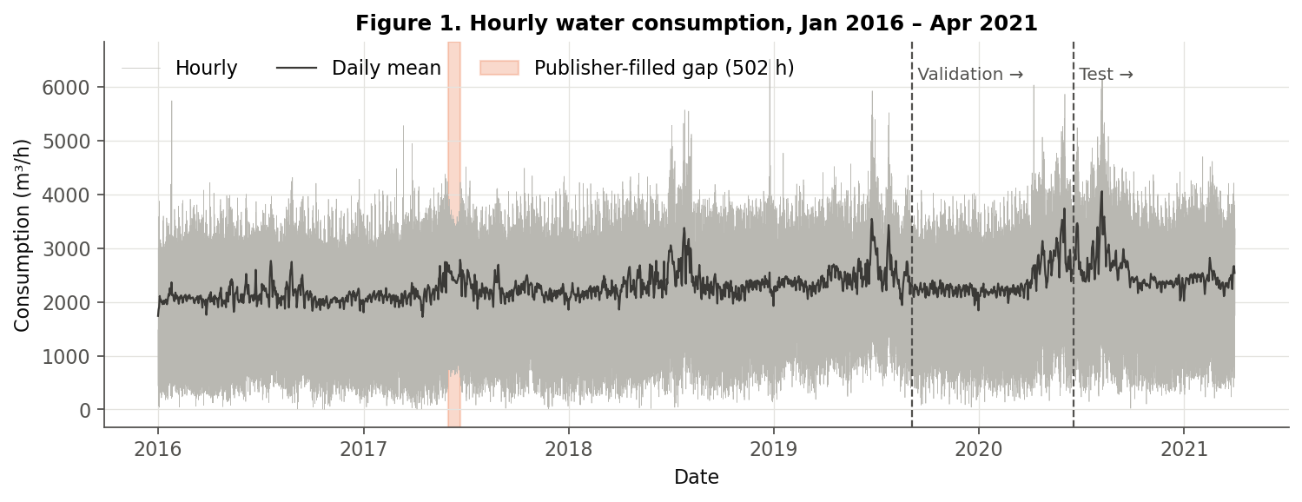
Figure 1. Full hourly series (grey) and daily mean (black). Dashed lines mark the start of validation and test; the shaded band is the 502-hour gap filled by the publisher.
Long-term behaviour: annual mean demand increased from 2096.6 m³/h (2016) to 2533.5 m³/h (2020). Summers (especially 2018–2020) show higher daily means and more extreme evening peaks (Figure 4). The spring/summer 2020 level is the highest in the record and partly overlaps the test period. We note this as a possible structural change but do not attribute it to a cause.
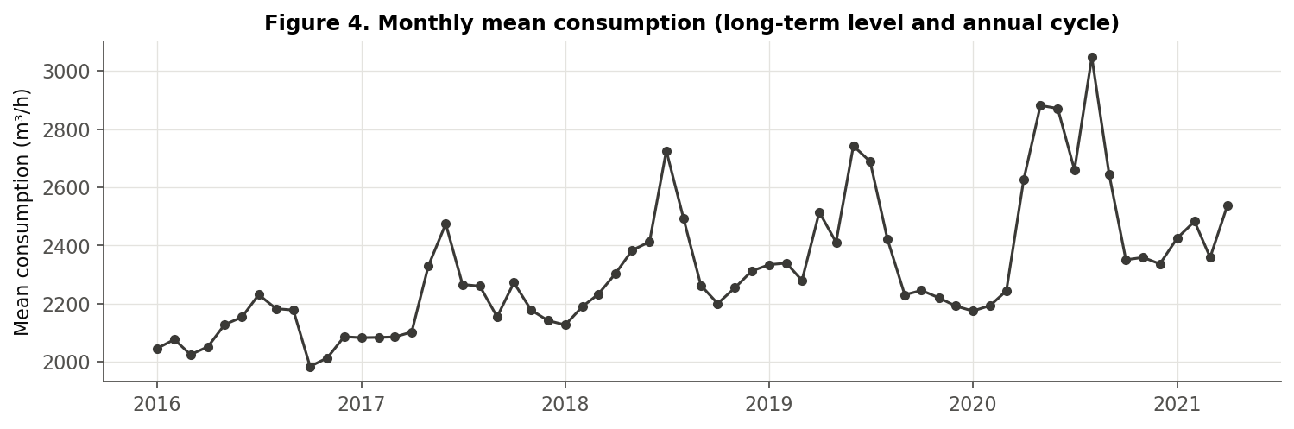
Figure 4. Monthly mean consumption: upward level and summer peaks.

7.2 Trend and seasonality
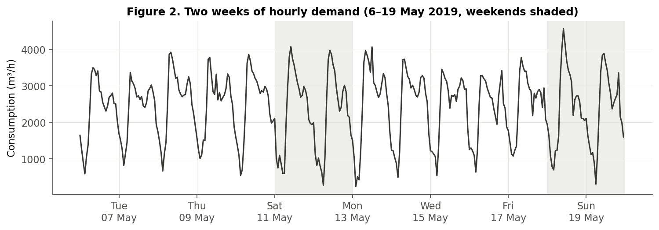
Figure 2. Two weeks in May 2019: a strong daily cycle, with different morning behaviour on weekends (shaded).
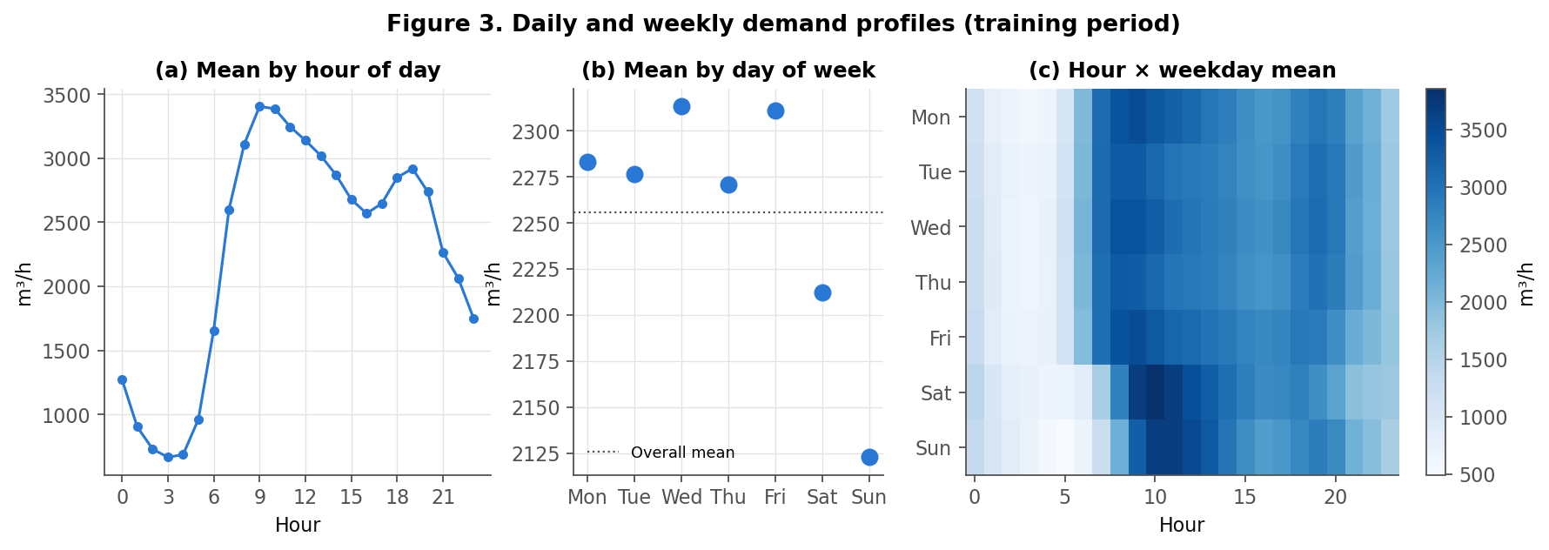
Figure 3. Training-period profiles: (a) mean by hour — trough at 03:00, peak at 09:00, second peak around 19:00; (b) mean by weekday; (c) hour × weekday heat map showing a later, higher morning peak on Saturday and Sunday.
Daily cycle: mean demand falls to 666.0 m³/h at 03:00 and rises to 3404.9 m³/h at 09:00, a factor of about five. Weekly cycle: weekend mean (2167.4) is only 5.4% below the weekday mean (2290.9). The weekly effect is mainly a change in the shape of the day: on weekends the morning rise starts later and peaks higher (Figure 3c). A model that only remembers 'yesterday' will get Saturday and Monday mornings wrong.

7.3 MSTL decomposition
MSTL (Bandara et al., 2021) was applied to the training series with periods 24 and 168 hours. Seasonal strength F = max(0, 1 − Var(R)/Var(S + R)) (Hyndman & Athanasopoulos, 2021) is 0.96 for the daily and 0.67 for the weekly component; trend strength is 0.57. The central 90% range of the daily component is -1623 to +1146 m³/h and of the weekly component -364 to +403 m³/h. Both cycles are therefore empirically present, not assumed. The weekly component is weaker but still large in practical units.
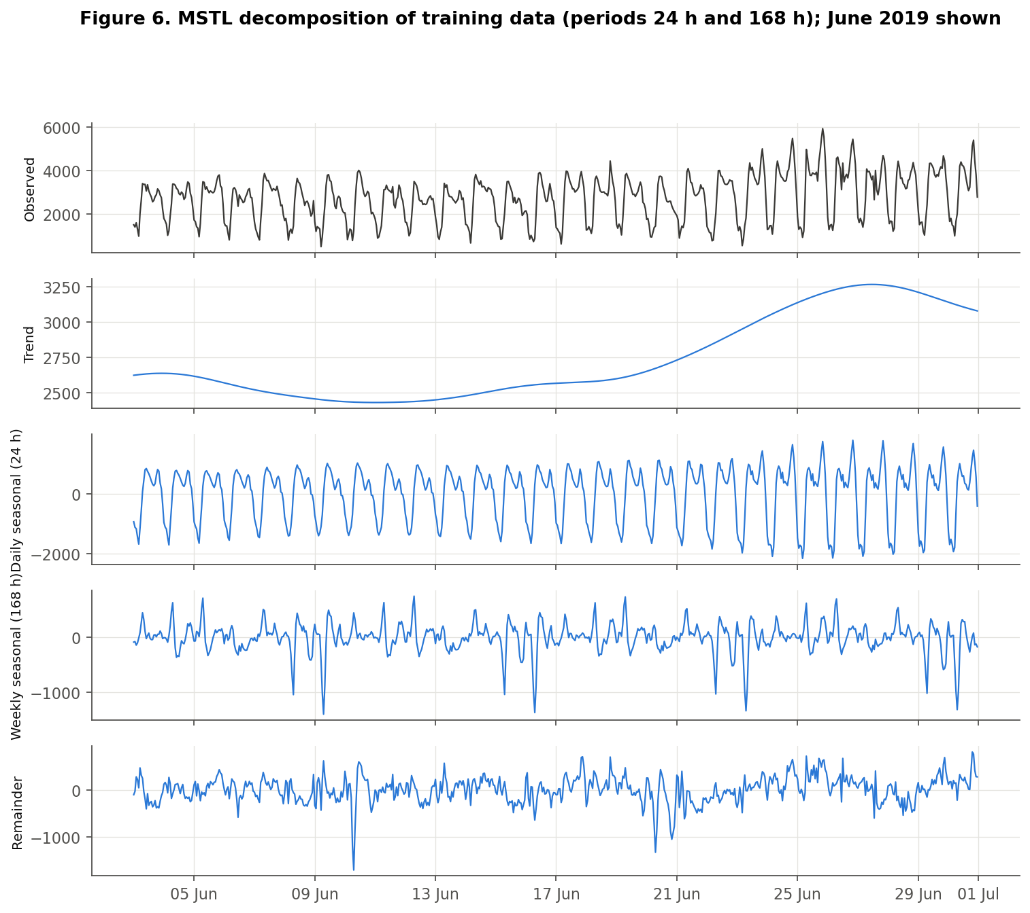
Figure 6. MSTL components of the training series (June 2019 shown for readability).

7.4 Stationarity
The Augmented Dickey–Fuller (ADF) test has H0: unit root (non-stationary). KPSS has the opposite null, H0: (level-)stationary. Using both helps because each can fail in different situations. Tests used the training series only, at α = 0.05; ADF lag length was chosen by AIC.
Table 7. ADF and KPSS results on the training series (ADF 5% critical value ≈ −2.86).
Series | ADF stat | ADF p | Lags | Obs. | KPSS stat | KPSS p | Reading
level | -9.201 | 2.0e-15 | 50 | 32,157 | 9.097 | ≤ 0.01 | Conflict: ADF rejects unit root, KPSS rejects stationarity → seasonal/level non-stationarity
seasonal difference (lag 24) | -31.694 | <1e-16 | 51 | 32,132 | 0.003 | ≥ 0.10 | Both agree: stationary → D = 1 at s = 24 is sufficient
lag-24 then lag-1 difference | -39.79 | <1e-16 | 51 | 32,131 | 0.05 | ≥ 0.10 | Over-differenced (not needed); kept for comparison

Interpretation: the level series has no stochastic trend in the ADF sense, but KPSS rejects stationarity because the mean shifts with the daily cycle and the slowly rising level. After one seasonal difference at lag 24, both tests agree that the series is stationary. We therefore set d = 0 and D = 1 (s = 24) for SARIMA, consistent with the Box–Jenkins approach (Box et al., 2015).

7.5 ACF and PACF
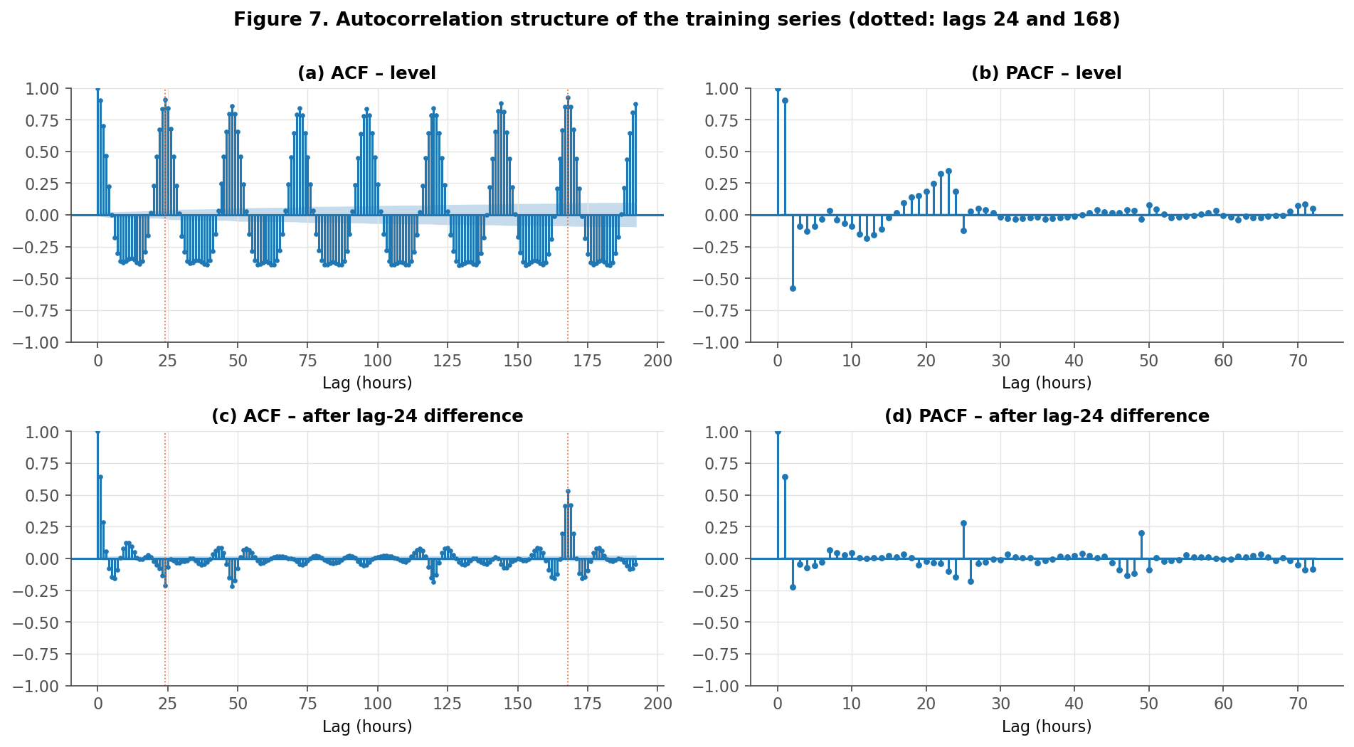
Figure 7. ACF/PACF of the training series before and after lag-24 differencing; dotted lines at lags 24 and 168.
On the level series the ACF oscillates with period 24 and peaks at lag 168 (0.924), slightly above lag 24 (0.908). The same hour one week earlier is the single most similar past value. After lag-24 differencing: (i) the ACF decays quickly from lag 1 (0.646) and the PACF cuts off after about two lags, which suggests a low-order AR part; (ii) there is a negative spike at lag 24 (-0.215), the classic signature of a seasonal MA(1); (iii) a large spike remains at lag 168 (0.53). SARIMA with s = 24 cannot represent point (iii). This is the empirical motivation for the enhancement. The plots guided the candidate SARIMA orders; the final choice was made on validation accuracy.

7.6 Exogenous variables
Daily consumption correlates with daily mean temperature (r = 0.517, training data; Figure 8). Using temperature or rain in a day-ahead model would require weather forecasts, which the dataset does not contain. Using observed future weather would leak information, so weather variables are excluded and listed as future work.
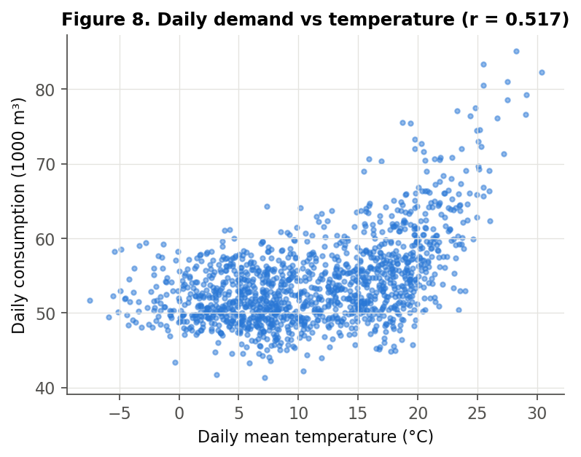
Figure 8. Daily consumption vs daily mean temperature (training period).

8. Baseline: SARIMA Methodology
A SARIMA(p,d,q)(P,D,Q)ₛ model applies non-seasonal and seasonal differencing and then models the result with autoregressive (AR) and moving-average (MA) terms at short lags and at multiples of s:
φ(B) Φ(Bˢ) (1 − B)ᵈ (1 − Bˢ)ᴰ yₜ = θ(B) Θ(Bˢ) εₜ
Here B is the backshift operator (Byₜ = yₜ₋₁). p and q are the non-seasonal AR and MA orders. d is the number of ordinary differences. P, D and Q are the seasonal AR, differencing and MA orders. s is the seasonal period (24 hours). εₜ is white noise.

8.1 Parameter search
Candidate orders follow from Section 7.5: d = 0, D = 1, s = 24, seasonal MA(1), and AR orders 1–3 with or without an MA(1) term, plus one seasonal-AR variant (6 orders). Fitting SARIMA by maximum likelihood on all 32,208 training hours is impractical with s = 24 on a laptop, so parameters are estimated on the most recent 4, 8 or 12 weeks before the forecast period (3 windows; 18 configurations). After estimation, parameters stay fixed and the Kalman filter state is updated with each new day of observations (statsmodels results.extend), following the online-updating idea of Arandia et al. (2016). No configuration produced a convergence warning.
Table 8. Best six of 18 SARIMA configurations on the validation period (sorted by MAE). AIC is only comparable within the same estimation window.
Order | Seasonal | Est. weeks | AIC | Val MAE | Val RMSE | Val MAPE %
(3, 0, 1) | (0, 1, 1, 24) | 4 | 9,150 | 280.9 | 382.7 | 19.2
(3, 0, 1) | (0, 1, 1, 24) | 12 | 28,214 | 282.6 | 384.2 | 19.3
(1, 0, 0) | (0, 1, 1, 24) | 12 | 28,433 | 290.2 | 394.5 | 19.3
(1, 0, 0) | (0, 1, 1, 24) | 4 | 9,203 | 290.2 | 393.5 | 19.3
(1, 0, 1) | (0, 1, 1, 24) | 4 | 9,172 | 290.6 | 393.8 | 19.4
(2, 0, 0) | (0, 1, 1, 24) | 4 | 9,173 | 290.7 | 393.8 | 19.4

Selected baseline: SARIMA(3,0,1)(0,1,1)₂₄, parameters re-estimated for the test on the 4 weeks before the test period (2020-05-21 00:00:00 – 2020-06-17 23:00:00; AIC 9144.6). Estimates: AR = (1.993, -1.353, 0.356), MA = -0.941, seasonal MA = -0.850, σ² = 72,845; all p < 0.001 (summary in Appendix B). The AR coefficients sum to 0.997, close to 1. The model behaves almost like an integrated process, which lets it follow level shifts.

8.2 Residual diagnostics
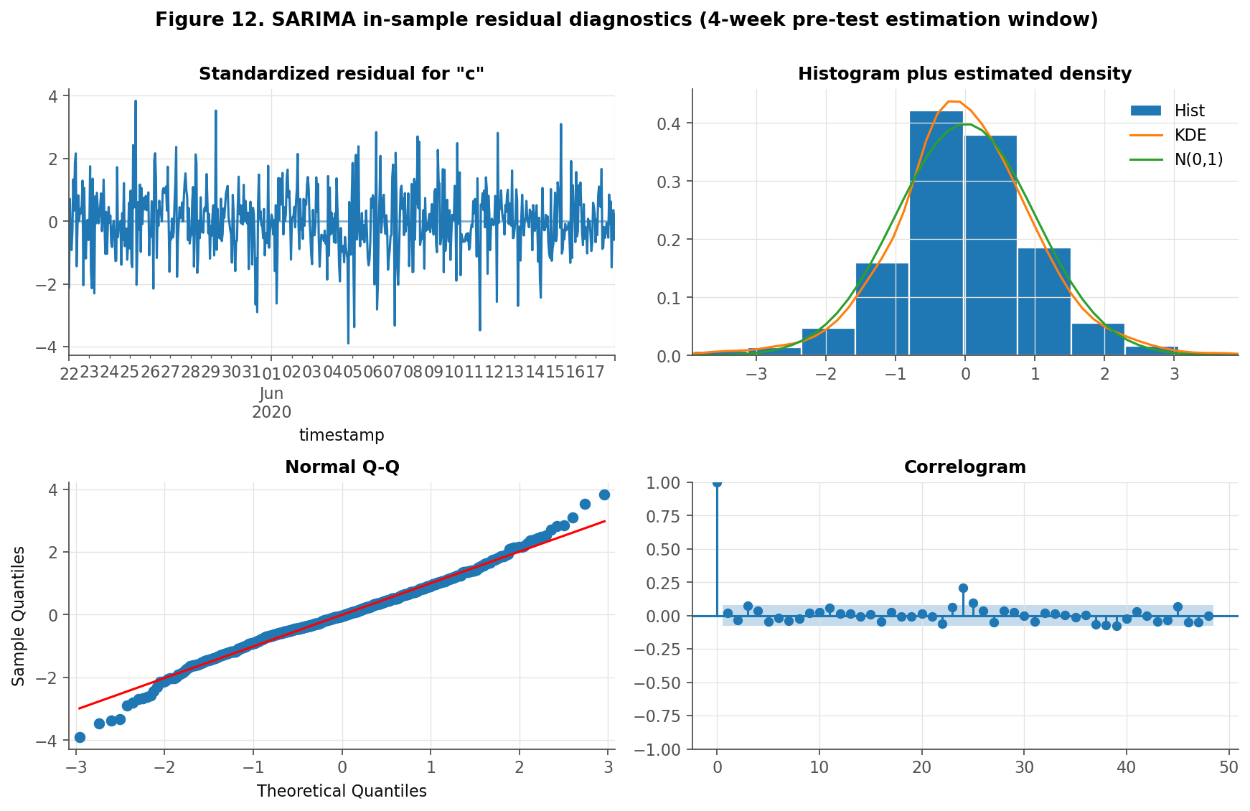
Figure 12. In-sample residual diagnostics of the selected SARIMA (test-period estimation window).
Residuals are centred and roughly normal with slightly heavy tails (kurtosis 4.2). The correlogram is mostly inside the bands, but a spike remains at lag 24, and Ljung–Box rejects white noise at lag 24 (Q = 46.1, p = 0.004) and marginally at lag 168 (Q = 199.5, p = 0.049). The baseline is a reasonable model but leaves some seasonal dependence unexplained.
Strengths: interpretable, few parameters, fast to update, well-founded uncertainty quantification. Weaknesses: one seasonal period, so the weekly pattern is invisible. The model also needs a short estimation window for computational reasons, and it assumes the same daily shape every day.

9. Enhanced Model: MSTL Decomposition + ARIMA

9.1 Algorithm
At every forecast origin t (00:00), using only the trailing window of W hours before t:
- Decompose: yₛ = Tₛ + S⁽²⁴⁾ₛ + S⁽¹⁶⁸⁾ₛ + Rₛ for s in [t − W, t − 1], using MSTL (statsmodels 0.14.4; STL inner settings default, seasonal_deg = 0).
- Extend seasonality: Ŝ⁽ᵖ⁾ₜ₊ₕ = S⁽ᵖ⁾ₜ₋ₚ₊ₕ for p ∈ {24, 168}, h = 0…23, so the most recent cycle of each component is repeated (seasonal naive on the component).
- Seasonally adjust: aₛ = yₛ − S⁽²⁴⁾ₛ − S⁽¹⁶⁸⁾ₛ (= trend + remainder).
- Forecast the adjusted series with ARIMA(1, 1, 1) fitted on the same window: âₜ₊ₕ.
- Recombine: ŷₜ₊ₕ = âₜ₊ₕ + Ŝ⁽²⁴⁾ₜ₊ₕ + Ŝ⁽¹⁶⁸⁾ₜ₊ₕ.
Pipeline: history window → MSTL → {daily component → repeat last day; weekly component → repeat last week; trend + remainder → ARIMA} → sum → 24-hour forecast. The window then rolls forward by one day and everything is refitted. MSTL is the decomposition step; the forecast comes from steps 2–5.

9.2 Configuration search (validation)
Table 9. All nine MSTL-ARIMA configurations on validation (sorted by MAE).
Window (weeks) | ARIMA order | Trend | Val MAE | Val RMSE | Val MAPE %
12 | (1, 1, 1) | n | 205.7 | 290.0 | 13.5
12 | (2, 1, 2) | n | 205.8 | 290.0 | 13.5
12 | (2, 0, 1) | c | 206.7 | 291.3 | 13.6
8 | (1, 1, 1) | n | 207.2 | 292.6 | 13.6
8 | (2, 1, 2) | n | 207.3 | 292.3 | 13.6
8 | (2, 0, 1) | c | 209.9 | 294.0 | 13.7
4 | (2, 1, 2) | n | 216.2 | 303.5 | 14.0
4 | (1, 1, 1) | n | 216.6 | 306.1 | 14.0
4 | (2, 0, 1) | c | 227.0 | 319.5 | 14.2

Selected: W = 12 weeks, ARIMA(1, 1, 1) without constant (validation MAE 205.7 vs 280.9 for the selected SARIMA). Longer windows were consistently better: four weeks give MSTL only four weekly cycles to estimate the 168-hour component. The ARIMA order mattered much less than the window length. No ARIMA fit raised an error or produced a non-finite forecast (fallbacks = 0 on test). Note: optimiser convergence warnings inside the daily rolling ARIMA fits were suppressed and not counted, so some daily fits may have stopped at the iteration limit. The reported accuracy already includes any such fits.

9.3 Leakage control and fair comparison
- Decomposition, seasonal extension and ARIMA fitting use only data before each origin; nothing is fitted on the full series.
- Both families were tuned with the same rule (lowest validation MAE) on the same 288 validation days.
- Both forecast the same target, at the same 6,912 test timestamps, with the same 24-hour horizon and the same metric code.
- The test set was evaluated once; no configuration was changed after seeing test results.
- Ablation: an identical pipeline with only the 24-hour period ('MSTL-24 only') isolates the weekly component.
- Reference benchmarks: seasonal naive with lag 24 and lag 168.

9.4 Computational requirements
On a 16-thread laptop (Python 3.13, statsmodels 0.14.4) one MSTL + ARIMA forecast takes about 1 s, so a 288-day evaluation takes about 5–8 minutes per configuration. The full validation grid ran in parallel in about 10 minutes. Estimating SARIMA once takes about 10–40 s, and daily updates are almost instant. In operation, one forecast per day is computationally trivial for either model.

10. Evaluation Metrics
MAE = (1/n) Σ |yₜ − ŷₜ| RMSE = √[(1/n) Σ (yₜ − ŷₜ)²] MAPE = (100/n) Σ |(yₜ − ŷₜ)/yₜ|
MAE is the average error in m³/h and is easy to explain. RMSE penalises large misses, which matter for tank safety margins. MAPE is scale-free, but it becomes unstable when actual values are near zero. The test period's minimum is 21 m³/h and 1 test hour lies below 100 m³/h, so MAPE is computable but inflated by night hours. We therefore also report WAPE (100 · Σ|e| / Σ|y|) and treat MAE/RMSE as the primary metrics. Actual values were never modified to make MAPE computable. Percentage reduction = (baseline − enhanced) / baseline × 100. Positive values mean the enhanced model has lower error.
Uncertainty: (i) Diebold–Mariano (DM) test (Diebold & Mariano, 1995) on daily mean losses (288 days; Newey–West variance with 7 lags to allow weekly dependence; two-sided t-test). (ii) A moving-block bootstrap of whole days (7-day blocks, 2,000 resamples) gives a 95% confidence interval for the percentage reduction.

11. Experimental Results

11.1 Quantitative comparison
Table 10. Headline test-set comparison (6,912 day-ahead forecasts, 18 Jun 2020 – 1 Apr 2021).
Metric | SARIMA baseline | MSTL-ARIMA (enhanced) | Difference | % reduction | Interpretation
MAE (m³/h) | 270.68 | 199.14 | -71.54 | 26.4% | Average hourly error falls by about 72 m³/h
RMSE (m³/h) | 381.92 | 277.73 | -104.18 | 27.3% | Large misses shrink even more than typical errors
MAPE (%) | 15.87 | 11.18 | -4.69 | 29.5% | Relative error falls by ~4.7 points (inflated by night hours)
WAPE (%) | 10.66 | 7.84 | -2.82 | 26.4% | Volume-weighted error falls by ~2.8 points

Worked calculation (MAE): (270.68 − 199.14) / 270.68 × 100 = 26.43%. RMSE: (381.92 − 277.73) / 381.92 × 100 = 27.28%.
Table 11. All models on the test set. The last column excludes the 5 publisher-modified hours (sensitivity check).
Model | MAE | RMSE | MAPE % | WAPE % | MAE (observed hours only)
Seasonal naive (24h) | 285.6 | 426.9 | 15.9 | 11.3 | 285.7
Seasonal naive (168h) | 283.4 | 408.1 | 14.7 | 11.2 | 283.4
SARIMA | 270.7 | 381.9 | 15.9 | 10.7 | 270.7
MSTL-24 only | 288.8 | 406.9 | 16.8 | 11.4 | 288.8
MSTL-ARIMA | 199.1 | 277.7 | 11.2 | 7.8 | 199.1

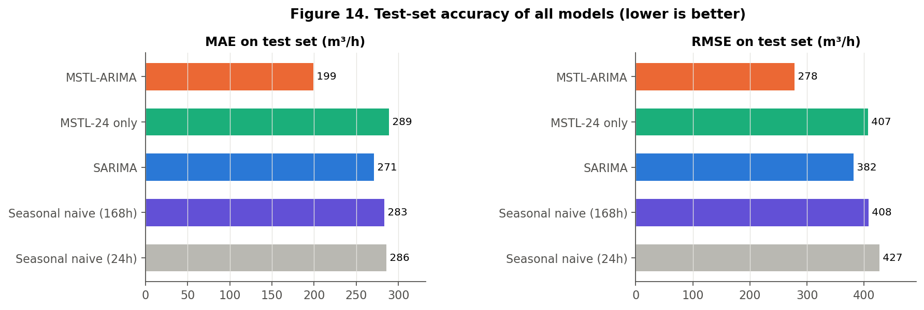
Figure 14. Test MAE and RMSE of all models.

11.2 Statistical significance
Table 12. Diebold–Mariano tests on 288 daily mean losses (positive statistic: B more accurate).
Comparison (A vs B) | Loss | Mean daily loss diff (A − B) | DM statistic | p-value
SARIMA vs MSTL-ARIMA | absolute | 71.5 | 10.89 | 2.5e-23
SARIMA vs MSTL-ARIMA | squared | 68,725 | 11.08 | 5.5e-24
MSTL-24 only vs MSTL-ARIMA | absolute | 89.6 | 11.68 | 4.8e-26
Seasonal naive 168 vs MSTL-ARIMA | absolute | 84.2 | 6.06 | 4.3e-09
Seasonal naive 168 vs SARIMA | absolute | 12.7 | 0.79 | 0.43

The enhanced model is significantly more accurate than SARIMA for both absolute and squared loss. The block-bootstrap 95% CI for the MAE reduction is 21.8% to 31.9% and for RMSE 22.2% to 33.3%. The interval excludes zero by a wide margin. MSTL-ARIMA had the lower daily MAE on 237 of 288 test days. In contrast, the SARIMA baseline is not significantly better than a simple weekly seasonal-naive forecast (p = 0.43).

11.3 Ablation: is the weekly component responsible?
Removing the 168-hour component (MSTL-24 only, otherwise identical) raises test MAE to 288.8 m³/h, worse than SARIMA (270.7). Adding the weekly component reduces MAE by 31.0% and RMSE by 31.7% (DM p = 4.8e-26). The improvement over SARIMA therefore comes from explicitly modelling the weekly cycle, not from the decomposition approach as such.

11.4 Forecast plots and error structure
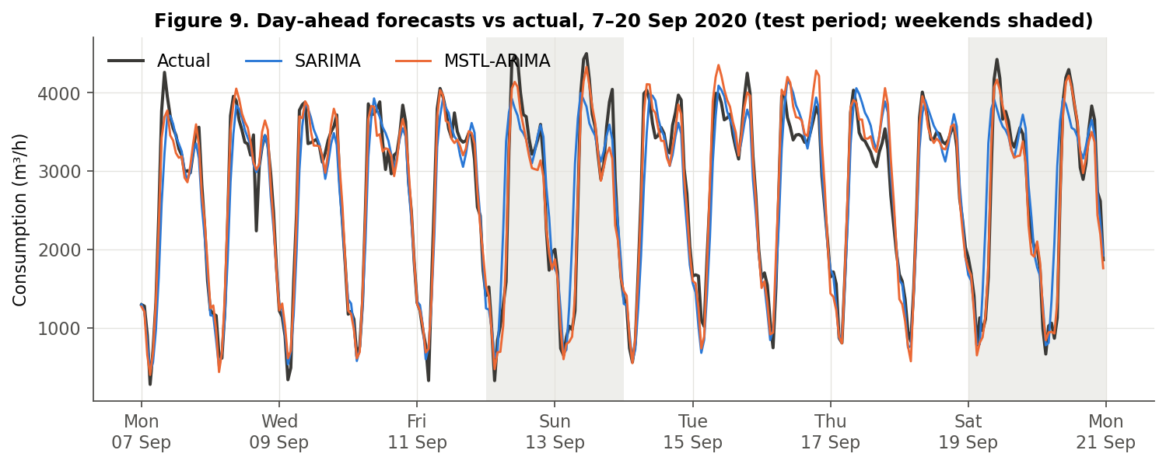
Figure 9. Two test weeks (7–20 Sep 2020). SARIMA (blue) copies Saturday's late morning ramp into Sunday and Sunday's into Monday; MSTL-ARIMA (orange) follows the weekday/weekend shape.
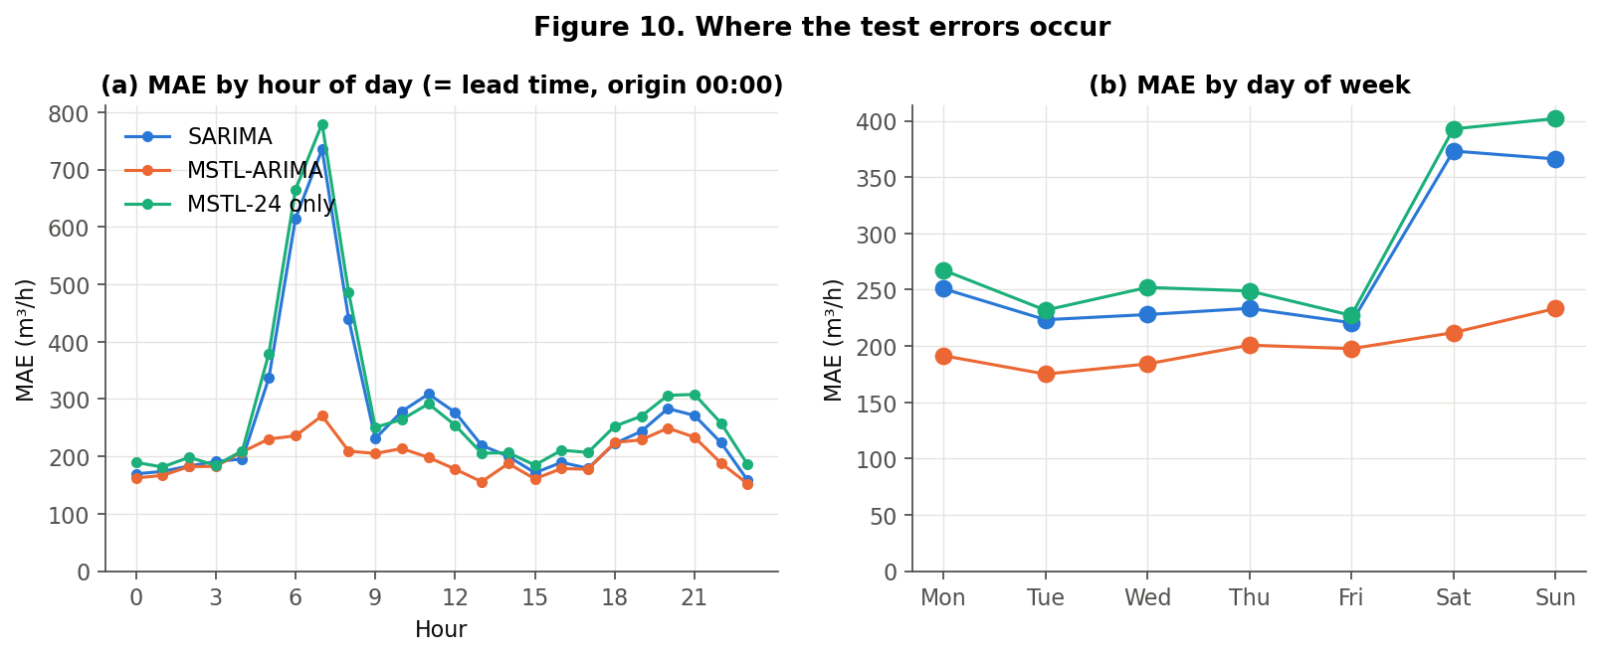
Figure 10. Test MAE by hour of day (equivalent to lead time, since origins are at 00:00) and by weekday.
Where the gain comes from. (a) Hour of day: SARIMA's error peaks at 07:00 (735.6 m³/h) during the morning ramp, whose timing differs between weekdays and weekends; MSTL-ARIMA's 07:00 MAE is 270.8 m³/h. At night (00:00–04:00) both models perform similarly. (b) Day of week: SARIMA's weekend MAE is 369.7 vs 231.3 on weekdays, while MSTL-ARIMA's is 222.6 vs 189.8. Mondays also improve, because SARIMA's 'yesterday' is a Sunday. Error does not grow steadily with lead time: the shape of the day matters more than distance from the origin.
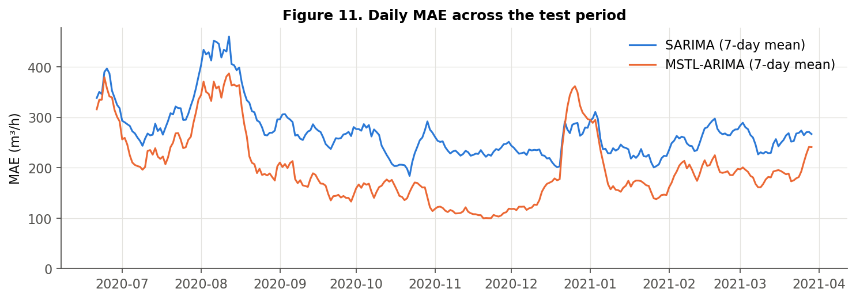
Figure 11. Seven-day rolling mean of daily MAE across the test period.
MSTL-ARIMA has the lower MAE in every test month (e.g. Nov 2020: 110.3 vs 239.0; Jun 2020: 322.6 vs 343.9). The advantage is small in June–August 2020, when weather-driven evening peaks dominate. Both models' largest errors occur on summer evenings (e.g. 9 Aug 2020 19:00: actual 2436 m³/h, both models forecast about 5,400 m³/h). Neither model can anticipate these weather-related changes.
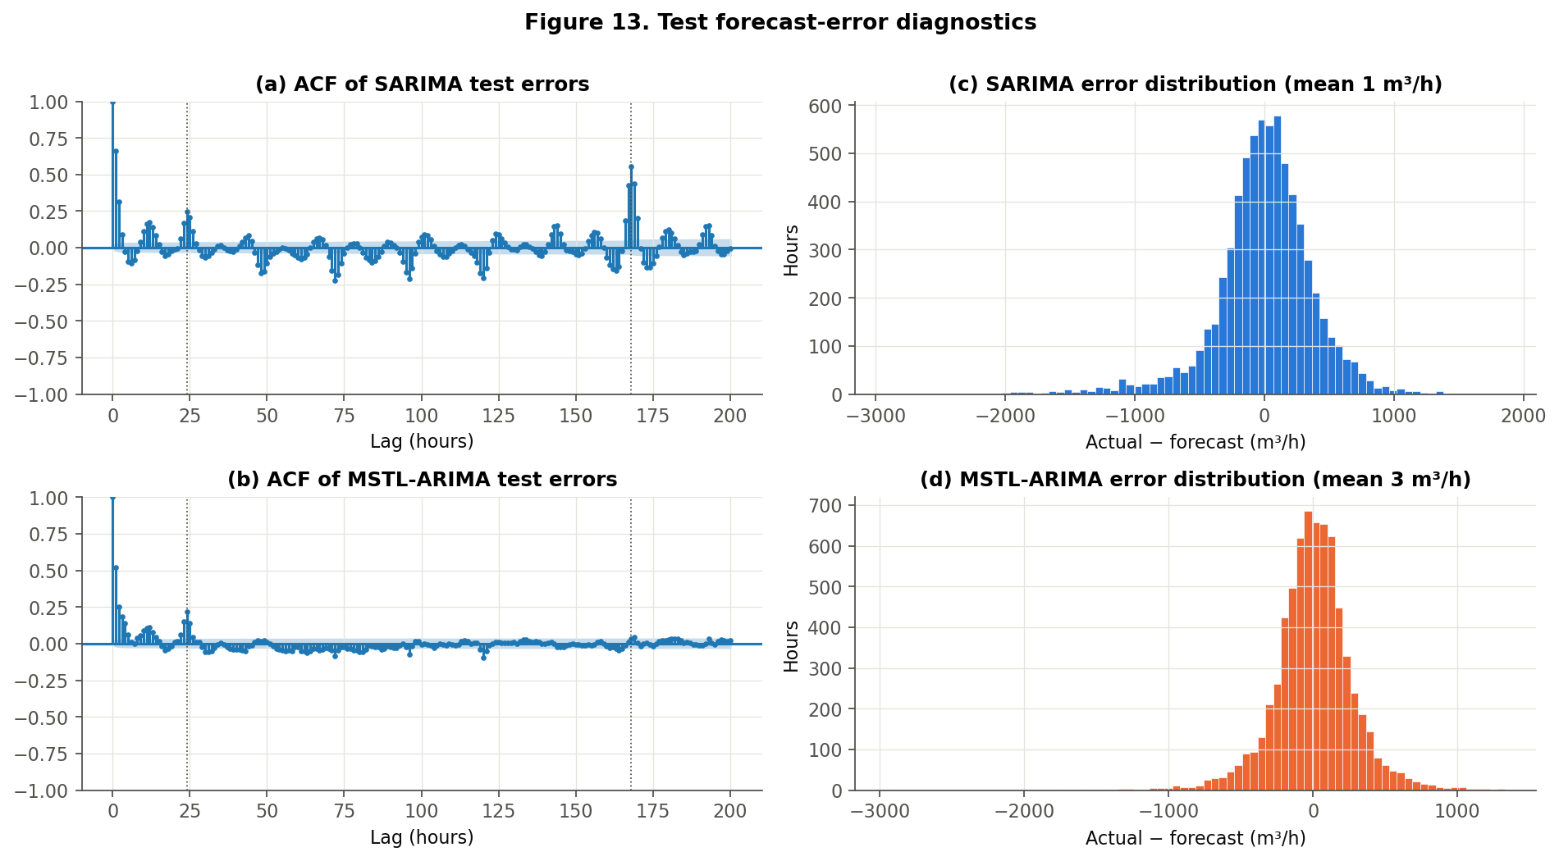
Figure 13. ACF and distribution of test forecast errors.
Forecast errors of both models remain autocorrelated (Ljung–Box at lag 168: Q = 14,999 for SARIMA vs 4,571 for MSTL-ARIMA; both p < 0.001). Some autocorrelation is expected for multi-step forecasts, whose errors share information within a day. The error autocorrelation at lag 168 is 0.56 for SARIMA but only 0.03 for MSTL-ARIMA. The enhancement removes almost all of the weekly structure, while short-lag dependence (lag 1: 0.66 vs 0.52) remains for both. Mean errors are small (SARIMA 0.7, MSTL-ARIMA 2.6 m³/h), so neither model is noticeably biased.

12. Discussion and Interpretation
- RQ answered / H1 supported: on identical unseen data, explicit daily + weekly modelling reduced MAE by 26.4% and RMSE by 27.3%, which is statistically significant and consistent across months.
- Why it works: in this district the week changes the shape of the day, especially the morning ramp. SARIMA(s = 24) only differences against the previous day, so after each weekday/weekend switch it carries the wrong shape for at least a day. The weekly MSTL component stores the 168-hour profile explicitly.
- What the baseline handled well: night hours, smooth weekdays and level adaptation (its AR polynomial is close to a unit root). It is also better than the 24-hour seasonal naive in MAE and RMSE.
- Complexity: the enhanced pipeline refits a decomposition and an ARIMA every day (about 1 s each) and has two main tuning choices (window length, ARIMA order). This cost is small compared with the accuracy gain.
- Relation to literature: the result agrees with Taylor (2003) for electricity and with Arandia et al. (2016), who found weekly-seasonal SARIMA removes autocorrelation better than daily-seasonal SARIMA. It also echoes Pacchin et al. (2019): a moving-window, pattern-based approach is robust. Our MAPE (11.2% for 24-hour horizons) is not directly comparable with Weyrauch et al. (2024) (7-day horizon, different split), so we make no claim of beating their models.

13. Real-World Implications
A day-ahead forecast whose average error is about 72 m³/h lower (≈ 2.8% of mean test demand, i.e. error falls from 10.7% to 7.8% of volume), with the largest gains on weekends and in the morning ramp, could support pump scheduling and tank-level planning. Both methods use only past consumption and standard Python libraries, so they are cheap to run daily. These are potential applications: the study did not simulate pump schedules, energy costs or supply security, so no savings are claimed.

14. Limitations and Threats to Validity
- Single site and period (one German district, 2016–2021). Results may not generalise to other networks.
- The test period (June 2020 – April 2021) overlaps the COVID-19 period and the highest demand level in the record; behaviour may differ from normal years. We did not model this explicitly.
- Publisher preprocessing (1.18% of hours, mainly in 2017) is mostly in training. The test metrics barely change when flagged hours are excluded.
- SARIMA parameters were estimated on short windows (4–12 weeks) for computational reasons. A longer estimation window or alternative multi-seasonal baselines (TBATS, Fourier-term regression, double-seasonal Holt-Winters) were not tested.
- No holidays, weather forecasts or network events are modelled, and the largest errors are weather-related.
- Point forecasts only. Prediction intervals were not evaluated.
- The validation grid was small (18 + 9 configurations). The DM test assumes the loss differential is covariance-stationary.
- Topic/dataset uniqueness: we could not access the class registration sheet. The team must confirm registration before submission.

15. Conclusion and Future Work
Hourly demand in this mixed German district has a dominant daily cycle and a weekly cycle that changes the shape of the day. A validation-tuned SARIMA(3,0,1)(0,1,1)₂₄ captures the daily cycle but not the weekly one, and it is not significantly better than a weekly seasonal-naive rule. A simple, leakage-free MSTL (24 h + 168 h) + ARIMA pipeline reduced day-ahead test MAE from 270.7 to 199.1 m³/h (26.4%) and RMSE by 27.3%. The ablation confirmed that the weekly component is responsible. Future work: add public-holiday effects; use weather forecasts as predictors; evaluate prediction intervals; compare with TBATS and double-seasonal Holt-Winters; and test on further district-metered areas.

References
[1] Arandia, E., Ba, A., Eck, B., & McKenna, S. (2016). Tailoring seasonal time series models to forecast short-term water demand. Journal of Water Resources Planning and Management, 142(3), 04015067. https://doi.org/10.1061/(ASCE)WR.1943-5452.0000591
[2] Bandara, K., Hyndman, R. J., & Bergmeir, C. (2021). MSTL: A seasonal-trend decomposition algorithm for time series with multiple seasonal patterns. arXiv:2107.13462. https://doi.org/10.48550/arXiv.2107.13462
[3] Box, G.E.P., Jenkins, G.M., Reinsel, G.C., Ljung, G.M. (2015). Time Series Analysis: Forecasting and Control, 5th ed. Wiley.
[4] Cleveland, R.B., Cleveland, W.S., McRae, J.E., Terpenning, I. (1990). STL: A seasonal-trend decomposition procedure based on loess. Journal of Official Statistics, 6(1), 3–73.
[5] Diebold, F.X., Mariano, R.S. (1995). Comparing predictive accuracy. Journal of Business & Economic Statistics, 13(3), 253–263.
[6] Donkor, E. A., Mazzuchi, T. A., Soyer, R., & Roberson, J. A. (2014). Urban water demand forecasting: Review of methods and models. Journal of Water Resources Planning and Management, 140(2), 146–159. https://doi.org/10.1061/(ASCE)WR.1943-5452.0000314
[7] Herrera, M., Torgo, L., Izquierdo, J., & Pérez-García, R. (2010). Predictive models for forecasting hourly urban water demand. Journal of Hydrology, 387(1–2), 141–150. https://doi.org/10.1016/j.jhydrol.2010.04.005
[8] Hyndman, R.J., Athanasopoulos, G. (2021). Forecasting: Principles and Practice, 3rd ed. OTexts. https://otexts.com/fpp3/
[9] Pacchin, E., Gagliardi, F., Alvisi, S., & Franchini, M. (2019). A comparison of short-term water demand forecasting models. Water Resources Management, 33(4), 1481–1497. https://doi.org/10.1007/s11269-019-02213-y
[10] Seabold, S., Perktold, J. (2010). statsmodels: Econometric and statistical modeling with Python. Proc. 9th Python in Science Conference.
[11] Taylor, J. W. (2003). Short-term electricity demand forecasting using double seasonal exponential smoothing. Journal of the Operational Research Society, 54(8), 799–805. https://doi.org/10.1057/palgrave.jors.2601589
[12] United Nations (2015). Transforming our world: the 2030 Agenda for Sustainable Development (A/RES/70/1). Goal 6: Clean Water and Sanitation.
[13] Weyrauch, A., Steens, T., Taubert, O., Hanke, B., Eqbal, A., Götz, E., Streit, A., Götz, M., & Debus, C. (2024). ReCycle: Fast and efficient long time series forecasting with residual cyclic transformers. IEEE Conference on Artificial Intelligence (CAI) 2024. arXiv:2405.03429.
[14] Weyrauch, A., Taubert, O., Götz, E., Streit, A., Götz, M., Debus, C., Wolter, F. (2024). Hourly Water Demand of a Mixed District Recorded by Supplier [Dataset]. Zenodo. https://doi.org/10.5281/zenodo.11045013 (CC-BY-4.0).

Appendix A. Reproducibility
Repository layout: data/raw (Zenodo CSVs), data/processed, src/ (config, data_preprocessing, exploratory_analysis, models, experiments, evaluation, common), outputs/ (figures, metrics, forecasts), report/, presentation/, blog/. Run from the project root:
pip install -r requirements.txt
python src/data_preprocessing.py
python src/exploratory_analysis.py
python src/experiments.py # ~15 min, 12 workers
python src/evaluation.py
python report/build_report.py
Versions: Python 3.13.5, pandas 2.2.3, numpy 2.1.3, statsmodels 0.14.4, matplotlib 3.10.0, scipy 1.15.3, joblib 1.4.2. Random seed 42 (bootstrap only; all models are deterministic). Machine-readable results: outputs/metrics/results.json and selected_configs.json; forecasts: outputs/forecasts/test_forecasts.csv.

Appendix B. SARIMA summary (test-period estimation window)
SARIMAX Results
==========================================================================================
Dep. Variable: consumption No. Observations: 672
Model: SARIMAX(3, 0, 1)x(0, 1, 1, 24) Log Likelihood -4566.309
Date: Thu, 29 Oct 2026 AIC 9144.618
Time: 06:45:42 BIC 9171.461
Sample: 05-21-2020 HQIC 9155.031
- 06-17-2020
Covariance Type: opg
==============================================================================
coef std err z P>|z| [0.025 0.975]
------------------------------------------------------------------------------
ar.L1 1.9935 0.035 57.575 0.000 1.926 2.061
ar.L2 -1.3526 0.060 -22.485 0.000 -1.471 -1.235
ar.L3 0.3564 0.032 11.042 0.000 0.293 0.420
ma.L1 -0.9410 0.013 -74.062 0.000 -0.966 -0.916
ma.S.L24 -0.8502 0.021 -41.351 0.000 -0.891 -0.810
sigma2 7.284e+04 3254.002 22.386 0.000 6.65e+04 7.92e+04
===================================================================================
Ljung-Box (L1) (Q): 0.23 Jarque-Bera (JB): 39.23
Prob(Q): 0.63 Prob(JB): 0.00
Heteroskedasticity (H): 0.84 Skew: -0.03
Prob(H) (two-sided): 0.21 Kurtosis: 4.20
===================================================================================

Warnings:
[1] Covariance matrix calculated using the outer product of gradients (complex-step).

Appendix C. Core enhancement code (src/models.py)
def mstl_arima_one(hist, periods, order, trend):
"""One forecast from one origin.

1. MSTL splits the trailing window into trend + one seasonal component per
period + remainder.
2. Each seasonal component is extended by repeating its most recent cycle
(seasonal naive on the component).
3. ARIMA forecasts the seasonally adjusted series (trend + remainder).
4. Forecast = ARIMA forecast + sum of extended seasonal components.
"""
res = MSTL(hist, periods=periods, stl_kwargs={"seasonal_deg": 0}).fit()
seas = res.seasonal if res.seasonal.ndim == 2 else res.seasonal.to_frame()
s_fc = np.zeros(H)
for i, p in enumerate(periods):
comp = seas.iloc[:, i].to_numpy()
s_fc += np.array([comp[len(comp) - p + (h % p)] for h in range(H)])
adj = hist.to_numpy() - seas.sum(axis=1).to_numpy()
failed = False
try:
with warnings.catch_warnings():
warnings.simplefilter("ignore")
a = ARIMA(adj, order=order, trend=trend).fit()
a_fc = np.asarray(a.forecast(H))
if not np.all(np.isfinite(a_fc)):
raise ValueError("non-finite forecast")
except Exception:
# Fallback keeps the run going; the count is reported.
a_fc, failed = np.repeat(adj[-1], H), True
return a_fc + s_fc, failed

def mstl_arima_rolling(y, start, n_days, window_weeks, order, trend="n", periods=(C.DAILY, C.WEEKLY)):
out, fails = [], 0
w = window_weeks * 168
for o in origins(start, n_days):
f, failed = mstl_arima_one(y.iloc[o - w:o], periods, order, trend)
out.append(f)
fails += failed
return np.concatenate(out), fails

Appendix D. Team contribution statement
Table 13. Contributions (to be completed by the team).
Member | Contribution
[Member 1] | [e.g. data audit & EDA / SARIMA baseline / MSTL model & evaluation / report & slides]
[Member 2] | [e.g. data audit & EDA / SARIMA baseline / MSTL model & evaluation / report & slides]
[Member 3] | [e.g. data audit & EDA / SARIMA baseline / MSTL model & evaluation / report & slides]
[Member 4] | [e.g. data audit & EDA / SARIMA baseline / MSTL model & evaluation / report & slides]

