Pranjal Singh

Mobile Pokemon TCG documentation

**Challenges in Turning Pokemon Into an App**

Turning a Java Pokémon project into a fully functional mobile app seemed like an exciting and rewarding challenge. However, I encountered a series of roadblocks that I ultimately could not overcome, despite exploring numerous approaches. My first attempt involved converting the project into an Android application using Android Studio. This seemed like the natural path, as creating an IOS app was a much bigger challenge. I began by familiarizing myself with Android development concepts such as Activities, XML layouts, and the Android lifecycle. However, integrating the console-based game logic into an interactive touch-based interface posed significant challenges. The original project relied heavily on Scanner for input, which didn’t translate well into the Android environment. I tried replacing console inputs with buttons and other UI components, but I struggled to map it to an intuitive mobile interface.

Apart from the Scanner, there were many changes I had to make to the game. The way I had coded my Pokemon game, was not the correct setup for an app. I was basically changing my entire game while trying to fit it into an app, and it still wasn’t working. After days of research and coding, I didn’t even get it to run it with any type of display on the screen, there were always numerous errors before it would even get to display anything.

Lastly, I explored online services that convert Java code into mobile apps, hoping for a quicker solution. Unfortunately, these services were either too simplistic to handle the complexity of the game or required manual adjustments that brought me back to square one. The automated tools couldn’t grasp the structure of my code, especially when it came to linking different game components like the player, deck, and card mechanics.

By the end of these attempts, I realized that while the project had potential, I could not bridge the gap between console-based Java applications and fully functional mobile apps. Each method I tried taught me valuable lessons about app development, such as the limitations of direct code translation and the necessity of selecting the right tools for the task. Though I ultimately could not transform the Pokémon project into a mobile app, the journey deepened my appreciation for the complexity of app development.

I was able to get the app to run “Hello Android” on the android phone vm.

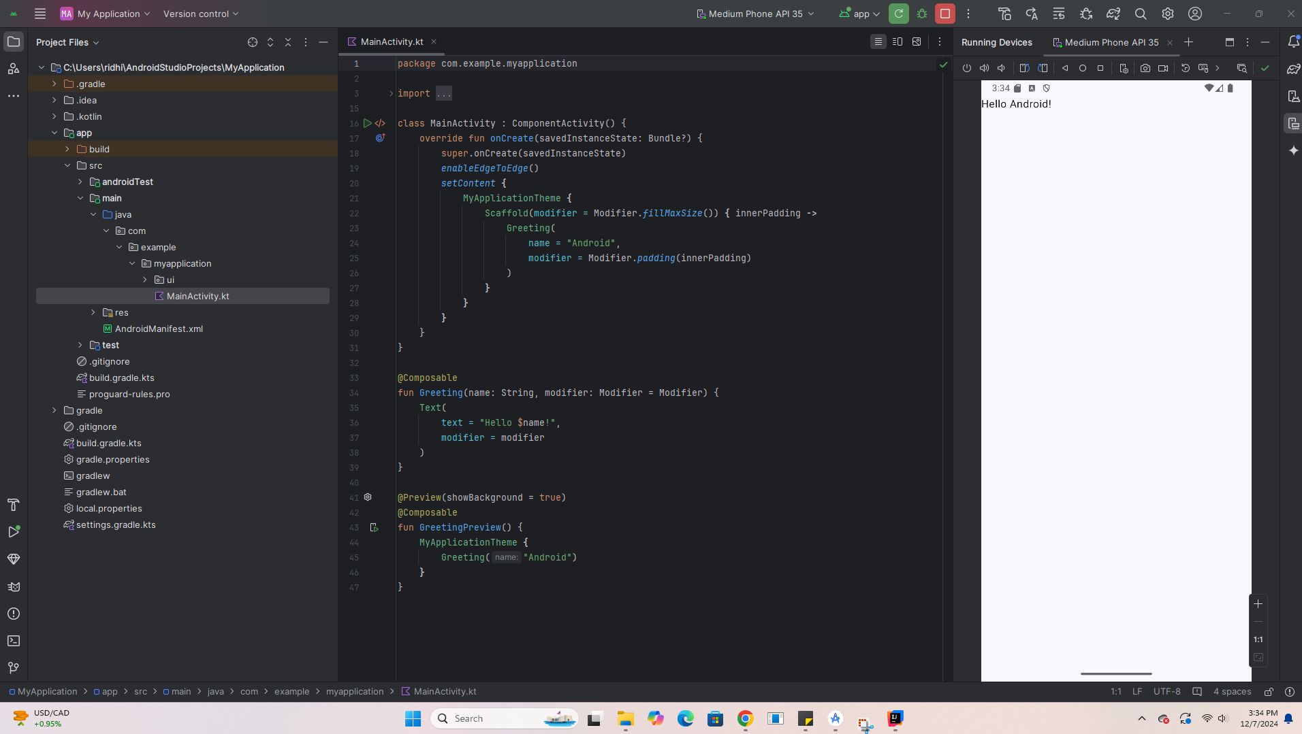

I was also able to get my Stats library from the last project to run on my phone through an IDE app but I could not get my Pokemon game to run on that app

