Pranjal Singh

Plot Salt Smooth #1 Documentation

For my tests, I use the function . For my initial part, I have a program that plots a function and assigns it to a hash map for a given range. For this, my bounds are -1000, 1000 so you can see the parabola from both sides of the y-axis. This hash map is then output into a CSV file. Later in the project, I started using array lists but never changed the hashmap because it makes no difference for this implementation. My graph below is the CSV file read in Excel and plotted.

Initially -1000 to 1000

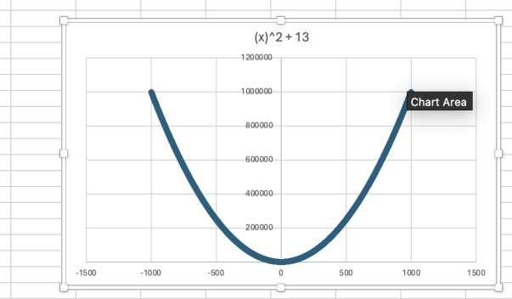

Salting is the act of randomizing data on a graph to make it more scattered and accurate. This program takes the CSV created in the last file and salts the data. The program has an assign value method. This stores the information from the CSV and puts the x and y axes into separate ArrayLists. Now that I have the initial data stored from the CSV, I have a salt function. This takes a y value for the data and min/max parameters. Using the Math. random function, I generate a random number within the given range. Since the salting has PLUS OR MINUS, I created another random variable that randomizes two numbers and if it is 1, add the value and if it is zero, subtract the value. The print function was just to test the arrays.

For the first test, I made the salt value range the same as the points. From this zoomed-out, it is hard to see, but there is not that much variance.

Salt Value -1000, 1000

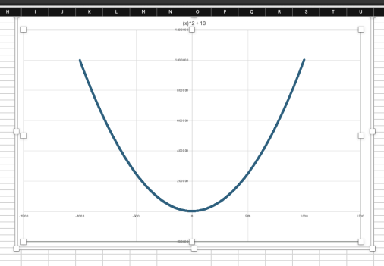

For the range of -5000 - 5000, It still looks relatively smooth until you zoom in.

Salt value -5000, 5000

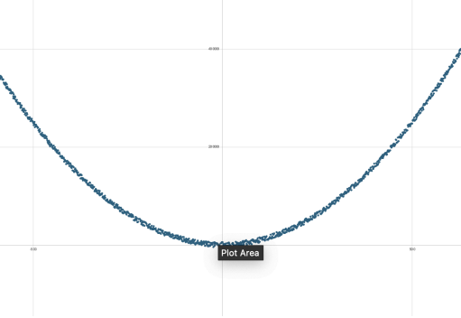

Then, I started changing the range in larger increments. With this range, it is more obvious that the points are scattered.

Salt Value -100000, 100000

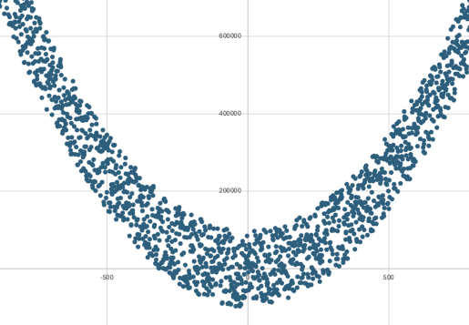

For the highest amount, I used the range -1000000-1000000. As you can see, the amount of random values makes the plot very scattered. For this amount of points and current zoom level, there is a visible behavior of every salt value.

Salt value -1000000, 1000000

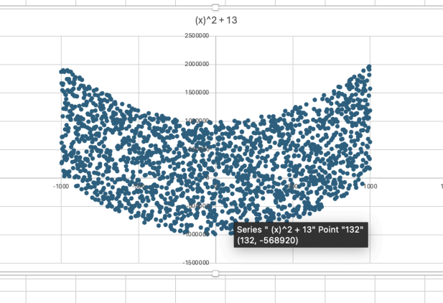

For smoothing, I am using the data from the salting range of -100000 to 100000. The smoothing program takes the salted data as a CSV and attempts to smooth it back to the original function. The smoothing function takes the average of the specified window and assigns that to the point of the new data. After the salting of the original data, it exports it to a CSV just like the other programs above. For the initial smoothing value, I input 5. This means for each point, it takes an average of 5 above and 5 below. The bigger the salt value, the larger the smoothing value will have to be to smooth out that large variance. As you can see, the graph points are much less scattered already.

Smoothing with -100000, 100000

Smooth value 5

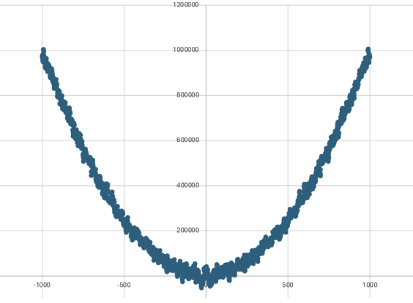

Smooth value 10

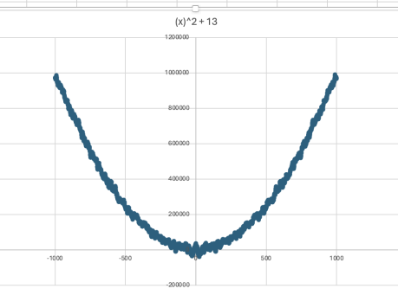

Smooth Value 20

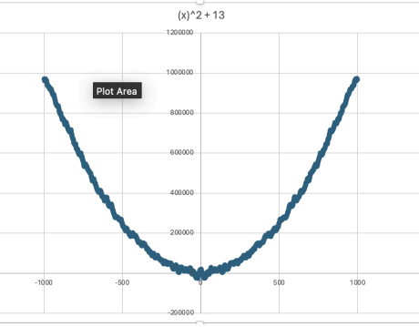

The higher the smooth value goes, you can start to see some irregularities at the ends of the graph. It is less noticeable here but after smooth value 50 it gets very irregular

Smooth value 50

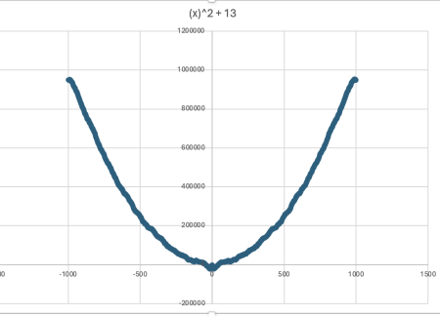

Smooth value 500

